**HELLO WORLD!**

Output “Hello World!” to the console via a **System.out.println()** statement in your main method.

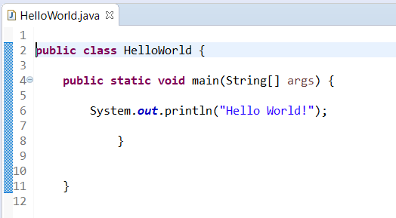

**ASSIGNMENT**

Store “Hello World!” in a variable, then output it to the console via a **System.out. println()** statement in your main method.

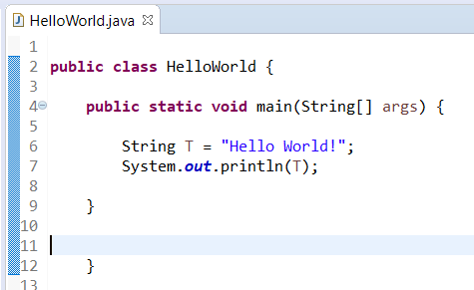

**RETURN TYPES**

Create a method to return “Hello World!” once called, which you call from your main method, to then output the text to the screen.

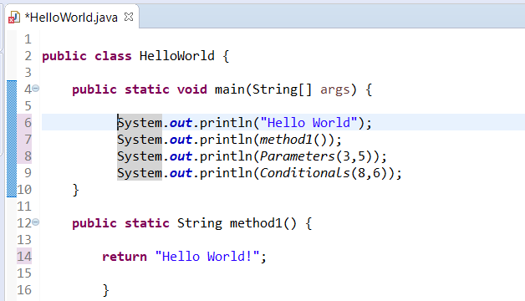

**PARAMETERS/OPERATORS**

Create a method that accepts two integers as parameters, then returns an integer that is a sum of the two integers given, then call this method from your main meth­od and output the returned result.

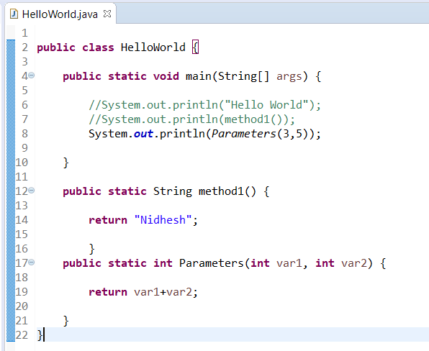

**CONDITIONALS**

Modify your method from the previous task to accept another parameter, a Boolean, which if it is true, the method will return a sum of the two numbers, and if it is false it will return the multiplication of the two numbers.

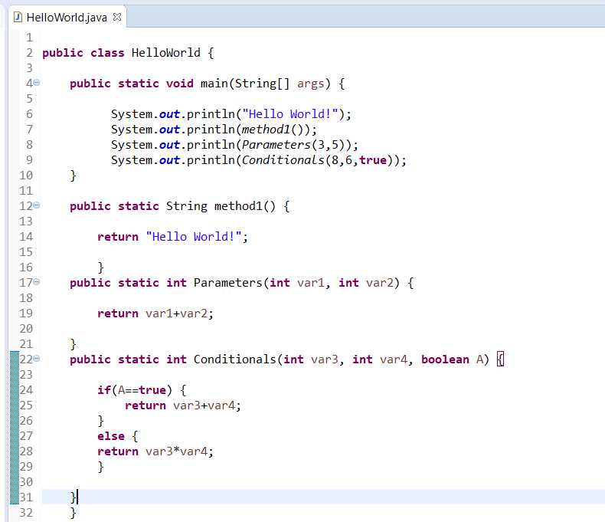

**CONDITIONALS 2**

Modify your method from the previous task to have another if statement that checks if one of the numbers is 0, if this is true then return the other non-0 number.

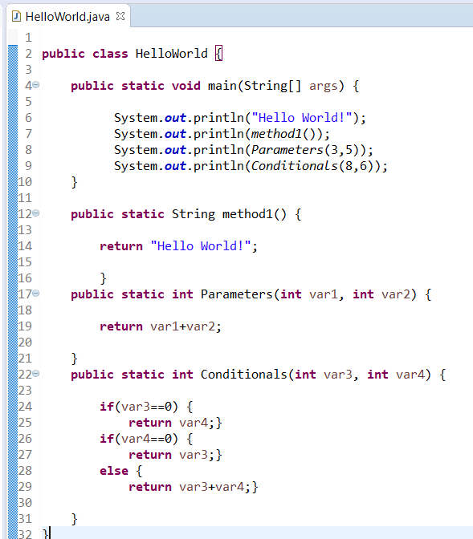

**ITERATION**

Create a for loop that will call and output the result of your method from Condition­als 2 10 times, using the current iteration as one of the parameters you pass to it.

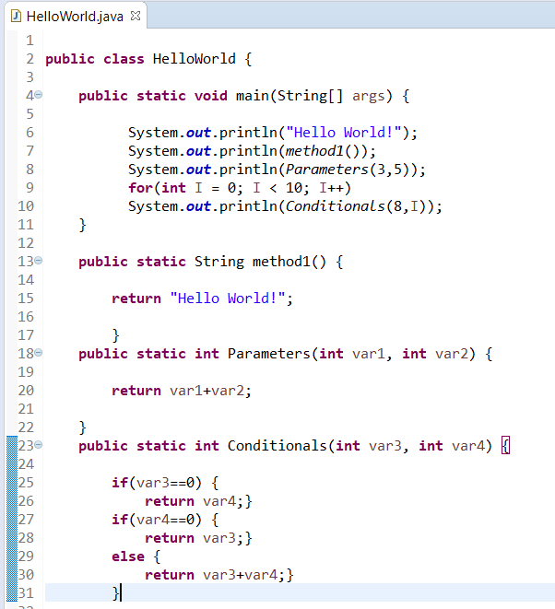

**ARRAYS**

Create an array that will hold 10 integer values, populate the array with values, then call and output the result of your method from Conditionals 2, passing values that are stored in the array as arguments to the method.



**ITERATION/ARRAYS**

Using your array that you created in Task 9, create a for loop that iterates through your array, outputting the values contained within it.

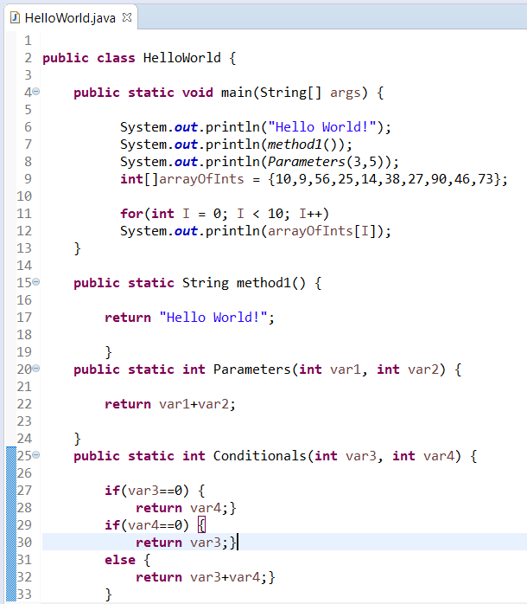

**ITERATION/ARRAYS 2**

Create a for loop that populates an integer array with values, outputting them at each iteration. Then create another loop that iterates through the array, changing the values at each point to equal itself times 10, outputting them at each iteration.

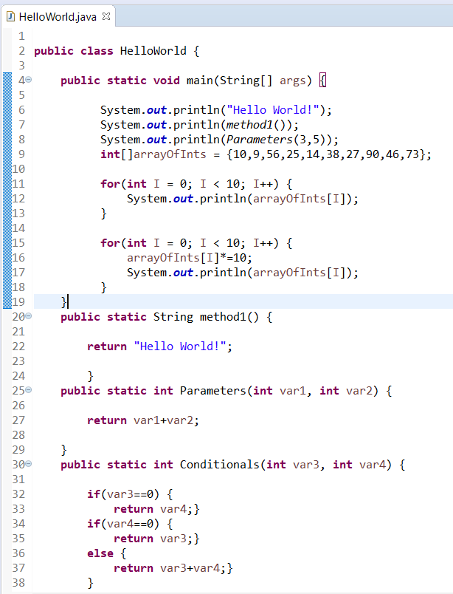

**BLACKJACK**

Given 2 integer values greater than 0, return whichever value is closest to 21 with­out going over 21. If they both go over 21 then return 0

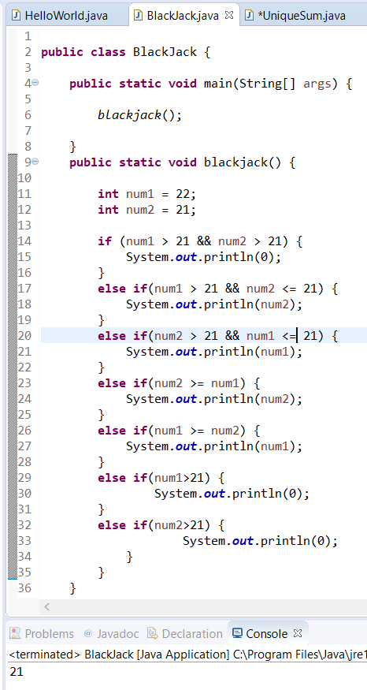

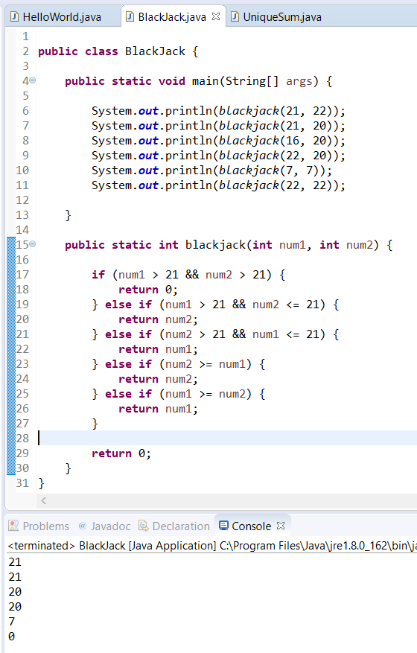

**UNIQUE SUM**

Given 3 integer values, return their sum. If one value is the same as another value, they do not count towards the sum. Aka only return the sum of unique numbers given.

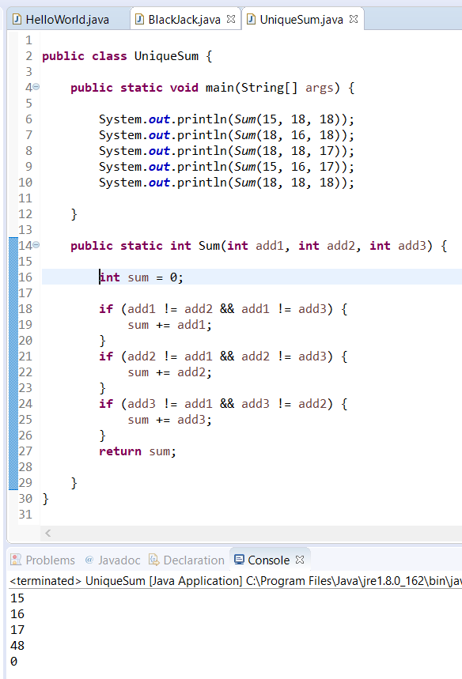

**TOO HOT?**

Given an integer value and a Boolean value, temperature and isSummer, if temper­ature is between 60 and 90 (inclusive), unless its summer where the upper limit is 100 instead of 90. Return true if the temperature falls within the range, false other­wise.

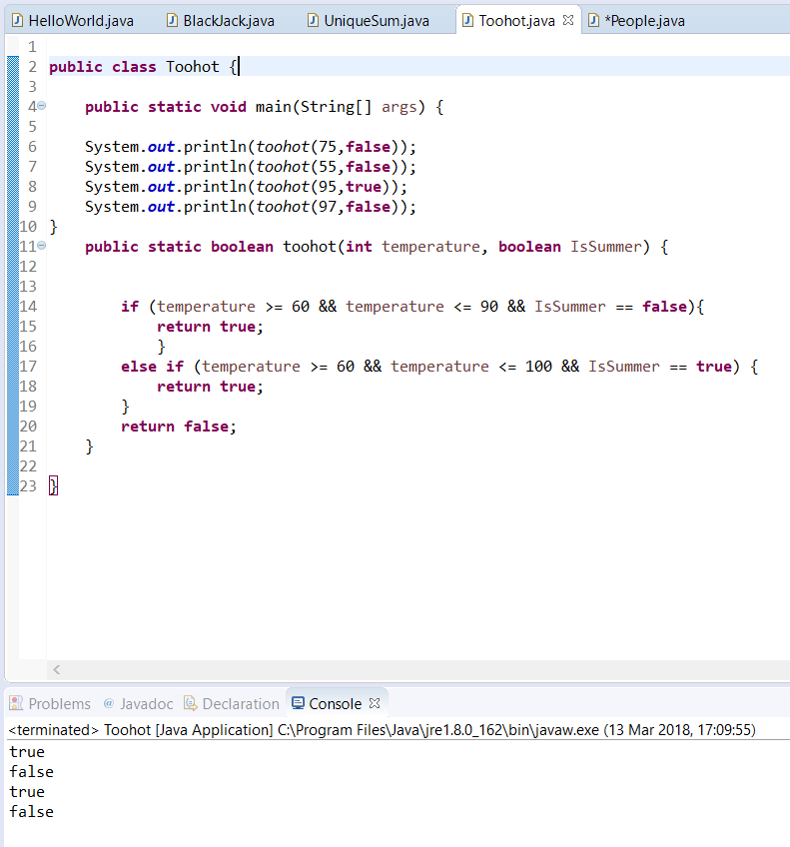

**PEOPLE**

Create a Person class that models the following:

1. Name, Age, Job Title

And has a method to return all three of these in a formatted string. (Override the toString() method!)

Create some example objects with this class.

Create an ArrayList and store those objects inside.

Use an enhanced for loop to output all of your people to the console.

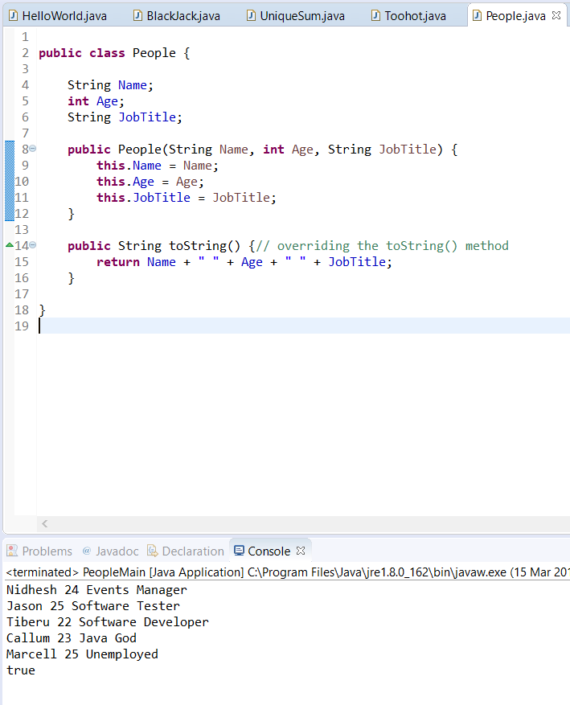Create a method that searches for the Person object by their name.

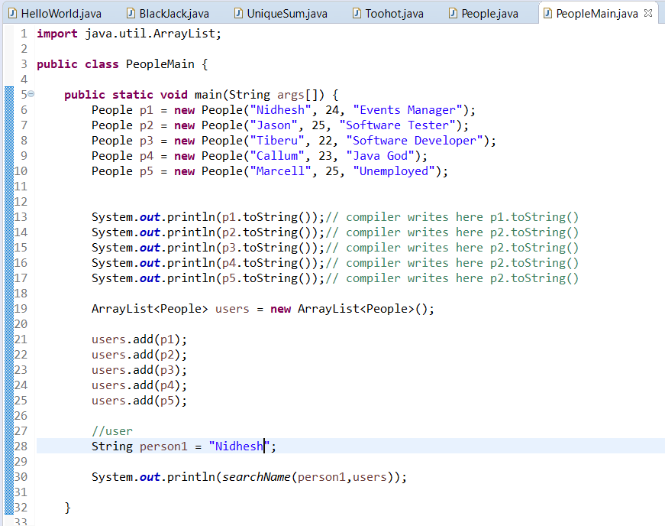

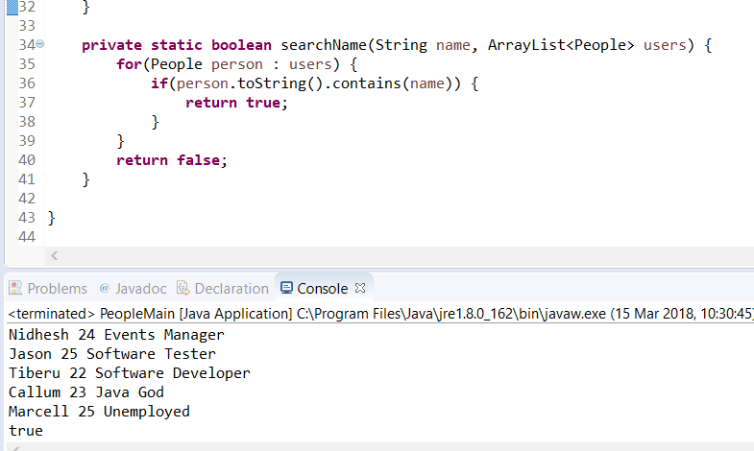

**GARAGE**

Using Vehicle as a base class, create three derived classes (car, motorcycle etc.), each derived class should have its own individual attribute in addition to the nor­mal Vehicle attributes that it inherits.

Using a List implementation store all your vehicles in a Garage class (e.g. ArrayList)

Create a method in Garage that iterates through each Vehicle, calculating a bill for each type of Vehicle in a different way, depending on the type of vehicle it is.

Garage should have methods that add Vehicle, remove Vehicle(s) (By ID, By Vehi­cle Type) fix Vehicle (Calculate bill) and empty the garage.

**WORKING WITH FILES**

Create a class representing a person with 3 attributes Name, Occupation, Age

Create an array list and populate it with 5 of these objects (Make up the values etc.)

Create a loop to iterate through the ArrayList, writing each object to one file, rec­ommended IO library is BufferedWriter (Think about how you format this)

Separately, create another ArrayList and populate it with the data from the file you just created. Recommended IO library is BufferedReader (You’re going to have to parse it back in the format you wrote it in, use **String.split())**