**Project Planning**

**Description**

Project Scope:

The overall scope of the project is to have a deeper knowledge of the techniques in Machine Learning, Deep Learning and Data Analysis in order to generate concise summaries of news articles, which lets a user see a summary given a news article or of the latest news. The scope also involves understanding of why recurrent neural nets are successful at phrasing sentences and how they treat some input words more important than the others by assigning the appropriate weights, and have a better overview internally of how recurrent neural nets work. The scope of this project can be extended by generating sentiment analysis of those concise summaries.

Objective:

•Implement Recurrent Neural Nets, so that they can generate concise summaries of news articles, so that the user does not need to read the whole article.

• To evaluate this approach with other summarization algorithms like TextRank and LexRank, and observe how RNNs perform, and compare the summaries generated from a user’s perspective and using other evaluation techniques.

• To have an interface which lets a potential user to interact with the back-end system to see the summaries for the latest news in an intuitive way.

Assignment of Roles and Responsibility:

Coding/Website: Aanshula Shetty and Nidhi Worah

Presentation and report: Harshvardhan Thakur

**Timeline Chart:**

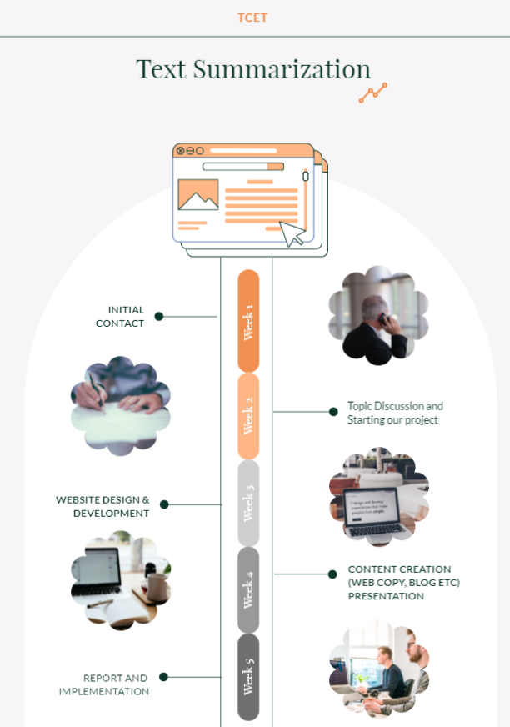

**OUTCOME**

Gantt Chart:

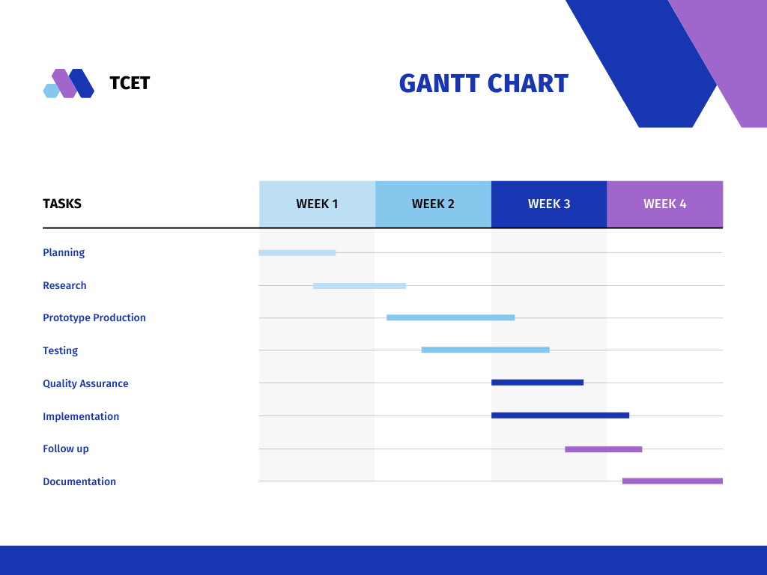

Scope:

Text summarization is defined as the process of refining the most useful information from the source document to provide an abridged version for the specific task. This paper focuses on developing a multi-document text summarization approach.

Objective and Motivation of Project:

The main objective of a text summarization system is to identify the most important information from the given text and present it to the end users.

Some of the reasons for motivation of text summarization are as follows: To keep up with the world affairs by listening to news. People base investment decisions on stock market updates. People even go to movies largely on the basis of reviews they've seen.

Members:

Aanshula Shetty(45)

Nidhi Worah(60)

Harshvardhan Thakur(55)