**EventPro**

**A Minor Project Report**

Submitted to

Rajiv Gandhi prodhyogiki Vishva Vidhyalaya towards partial fulfillment for the award of

**Bachelor of Engineering (COMPUTER SCIENCE AND ENGINEERING)**

**Guided By**: Submitted by: **Name - Vijay Yadav Nidhi Yadav (0805CS211072) Designation Vaishali Rathod (0805CS211129)** Department **- Cse Nandani Yadav (0805CS211067 )**

Department of Computer Science and Engineering

**JAWAHARLAL INSTITUTE OF TECHNOLOGY**

**BORAWAN (KHARGONE)**

**JAWAHARLAL INSTITUTE OF TECHNOLOGY**

**BORAWAN (KHARGONE)**



**RECOMMENDATION**

The main work on **“…………………………………………”** submitted by **……………** student of third year computer science & engineering is satisfactory and this project report is recommended for submission to Rajiv Gandhi Prodhyogiki Vishva Vidhyalaya, Bhopal (M.P.) towards the partial fulfillment for the award of **Bachelor of Engineering** degree in computer science & engineering.

**Head of Department** Name

**Computer Science & engg. Project Guide**

**Principal**

**JAWAHARLAL INSTITUTE OF TECHNOLOGY**

**BORAWAN (KHARGONE)**



**CERTIFICATE**

Thi is to certify that the minor project report entitled**“……………………………………………………”** submitted by **………………..** Student of third year Computer Science & Engineering is approved as partial fulfillment for the award of the **Bachelor of Engineering** degree in computer science & engineering.

**Internal Examiner External Examiner**

**Date: Date:**

**Acknowledgements**

I owe this moment of satisfaction with a deepest sense of gratitude towards my project guid**e Mr./Mrs.……….** withoutwhom this project couldn’t be neither oriented nor successfully completed. His steady encouragement and furtherance boosted my moral and kept me working on in right direction.

I am thankful to Mr**……….** for providing constant encouragement and support.

I am thankful to the Principal, D**r. Atul Upadhyay,** for providing me inspiration, guidance and infrastructure for the completion of this dissertation work.

I am thankful to all my teachers who taught me in BE course without whom I cannot even think of working out this project.

Submitted By

..……………..

………………

………………

**JAWAHARLAL INSTITUTE OF TECHNOLOGY BORAWAN (KHARGONE)**

Index

Content:- Page no

1. **Introduction:-**
   1. Abstract
   2. Purpose
   3. Scope
   4. Definition
   5. Keyword
   6. Technology
2. **Requirement gathering analysis:-**
   1. Questionnaires
   2. Feasibility Analysis
      1. Technical Feasibility
      2. Economical Feasibility
   3. Hardware Requirement
   4. Software Requirement
3. **Design**
   1. Database design
      1. Data dictionary
   2. Use Case Diagram
   3. E-R diagram
   4. Class Diagram
   5. Data Flow diagram
4. **Snapshot**
5. **Conclusion**
6. **Limitation**
7. **Future Enhancement**
8. **Reference**

**INTRODUCTION :**

Welcome to EventPro, your go-to partner for event organization. We specialize in planning and executing various types of events, making them stress-free and unforgettable.

At EventPro, we understand the importance of every event, whether it's a corporate conference, a wedding, a birthday party, or any special occasion. Our mission is to take the burden of event management off your shoulders.

With our easy-to-use platform, you can effortlessly plan, organize, and manage your event, saving you time and resources. We blend modern technology with a personal touch, ensuring every event is a success.

**Abstract :**

EventPro is an innovative event organization service dedicated to making your events memorable and stress-free. We offer a one-stop solution for planning, managing, and executing a wide range of events, from corporate conferences to weddings and parties. Our user-friendly platform simplifies event management, helping clients save time and resources while ensuring a seamless and successful event experience.

EventPro combines cutting-edge technology with personalized service to deliver tailored solutions that cater to all your event needs. Join us in the journey of turning your vision into a remarkable reality. Leave the event logistics to us, and enjoy every moment of your special occasion.

**Problem Domain:**

Organizing events can be overwhelming. People often struggle with planning, coordinating, and executing events efficiently. The challenges include budget management, vendor selection, and ensuring a smooth guest experience.

DIY event planning can lead to stress, miscommunication, and missed opportunities. Without the right tools and expertise, events may not reach their full potential, causing frustration and disappointment.

EventPro recognizes these common issues and aims to simplify event organization. We address the pain points in event planning, offering a solution that streamlines the process and guarantees success. With EventPro, you leave the worries behind, focusing on enjoying your event while we take care of the rest.

**Solution Domain:**

EventPro is the answer to your event planning woes. We provide an all-in-one solution that simplifies event organization. Our platform offers intuitive tools for budget management, vendor selection, and guest coordination.

With EventPro, you have a stress-free experience. We bring expertise and resources to ensure your event's success. Our team guides you through the entire process, from planning to execution.

By using EventPro, you eliminate the frustrations of DIY event planning and get a professional touch. We turn your ideas into reality, allowing you to relax and enjoy your event, knowing it's in capable hands.

**Technology Proposed:**

EventPro utilizes a powerful combination of web technologies to make event planning a breeze. We've harnessed the versatility of HTML, the styling capabilities of CSS, and the interactive features of JavaScript to create a user-friendly platform.

HTML forms the foundation of our web-based service, structuring content and providing the backbone for seamless navigation. CSS takes care of the aesthetics, ensuring that your event planning experience is visually appealing and user-friendly.

JavaScript adds interactivity to the platform, making it dynamic and responsive. It enables real-time updates, ensuring you're always in control of your event details. These technologies work together harmoniously to offer a smooth, intuitive, and efficient event planning experience for all our users.

**Requirement Gathering Analysis:**

Before creating EventPro, we conducted extensive research and gathered insights from both event organizers and attendees. We interviewed potential users and carried out surveys to understand their needs and pain points.

Through this analysis, we identified key requirements, such as user-friendly navigation, budget management tools, vendor selection assistance, and real-time communication features. We also recognized the importance of a mobile-responsive platform to cater to a diverse user base.

The data we collected informed our design and development process, ensuring that EventPro addresses the most crucial needs of event planners. Our commitment to user-centric design and functionality is a result of this comprehensive requirement gathering analysis, making EventPro a practical and effective solution for event organization.

**SRS Overview:**

The Software Requirements Specification (SRS) for EventPro serves as the blueprint for our platform. It outlines the functional and non-functional requirements that drive its development.

**Functional Requirements:**

- User registration and profile management

- Event creation and customization

- Budget management tools

- Vendor selection and communication features

- Real-time updates and notifications

- Mobile-responsive design

**Non-Functional Requirements**:

- User data security and privacy

- High performance and reliability

- Scalability to accommodate various event sizes

- User-friendly and intuitive interface

- Accessibility for a diverse user base

**Feasibility Analysis:**

Before embarking on the development of EventPro, we conducted a comprehensive feasibility study to assess both technical and economic viability.

**Technical Feasibility:**

- Our team possesses the necessary technical expertise and skills.

- The technologies we employ, HTML, CSS, and JavaScript, are well-established and widely supported.

- The infrastructure required for web hosting and database management is readily available and cost-effective.

**Economic Feasibility:**

- EventPro offers a cost-effective solution for event planning, reducing the need for expensive event management services.

- We evaluated development and maintenance costs, ensuring the project remains financially sustainable.

- Through market research, we identified a demand for an affordable, user-friendly event planning platform.

The results of our feasibility analysis confirmed that EventPro is both technically and economically viable, assuring a reliable and budget-friendly solution for event organization.

**Hardware Requirements:**

- Standard personal computer or laptop

- Internet connection for online access

**Software Requirements:**

- Web browser (e.g., Chrome, Firefox, Safari)

- Operating System: Windows, macOS, or Linux

- Development tools: Text editor, IDE for coding and development

- Database management system (e.g., MySQL, PostgreSQL) for data storage

These basic hardware and software requirements ensure that EventPro is accessible and functional for users on various devices and platforms

**Design Overview**

The design of EventPro focuses on providing an intuitive, user-friendly, and aesthetically pleasing experience for our users.

Key Design Principles:

1. User-Centric:Our design prioritizes the needs and preferences of event organizers and attendees. It ensures easy navigation and accessibility.

2. Aesthetics: We use a clean, visually appealing design with a harmonious color scheme to create an engaging platform.

3. Mobile- Responsive: Event Pro is designed to adapt to various screen sizes, making it accessible on both desktop and mobile devices.

4. Intuitiveness:The interface is designed for easy understanding and minimal learning curve, allowing users to quickly utilize its features.

5. Efficiency: We've optimized the design to support efficient event planning, vendor selection, and communication.

The design of EventPro is a crucial element in providing a positive user experience, ensuring that users can easily plan and manage their events with style and simplicity.

**Snapshot -**

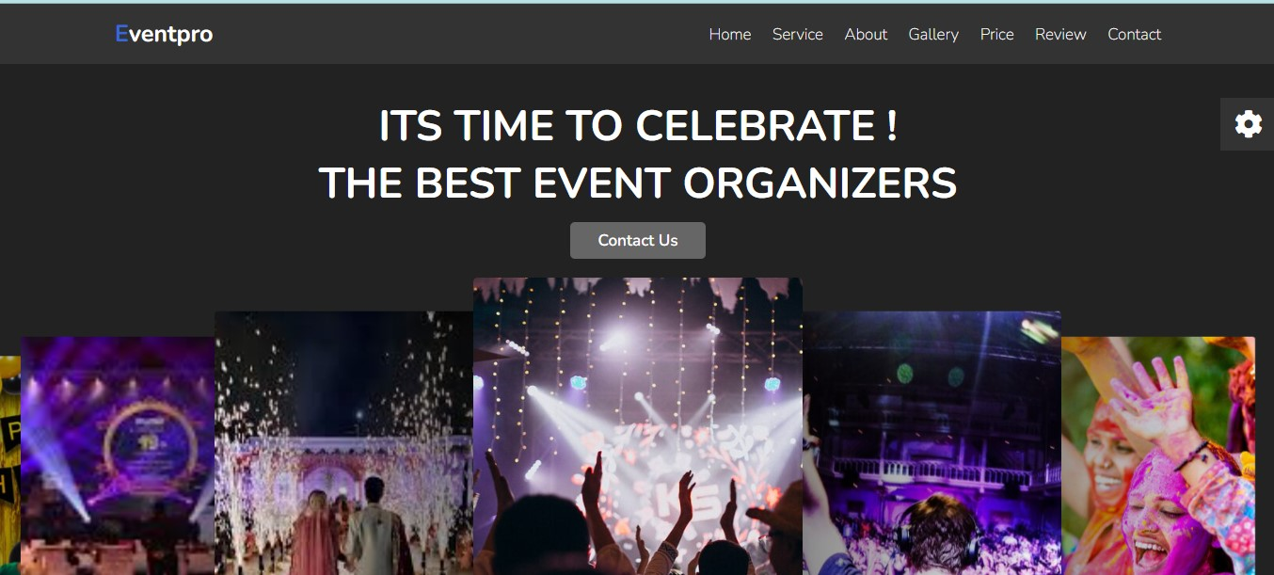

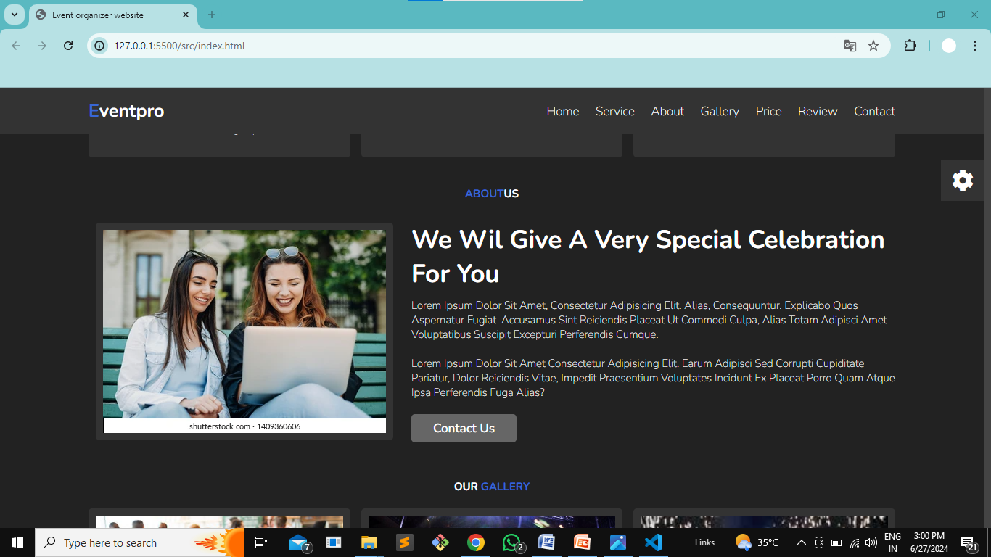

**TESTING**

Testing Overview:

Testing is a crucial phase in ensuring the quality and reliability of EventPro. We conduct thorough testing to identify and address any issues before releasing the platform to users.

**Types of Testing**:

1. **Functionality Testing**: Ensures all features work as intended.

2. **Usability Testing**: Evaluates how easy it is for users to navigate and use the platform.

3. **Security Testing**: Verifies data protection and user privacy.

4. **Performance Testing**: Assesses the platform's speed and responsiveness.

5. **Compatibility Testing**: Ensures EventPro works on different devices and web browsers.

Testing ensures that EventPro is a dependable and user-friendly platform, guaranteeing a smooth and secure event planning experience for all users.

**Conclusion**

In conclusion, EventPro is the result of our commitment to simplifying event organization. It offers an accessible, user-friendly platform for planning, managing, and enjoying events of all kinds.

With the integration of HTML, CSS, and JavaScript, EventPro is designed to be efficient, aesthetically pleasing, and mobile-responsive. It has been thoroughly tested to ensure functionality, security, and performance.

EventPro is not just a solution; it's a seamless experience for our users, eliminating the challenges of event planning. We look forward to helping you make your events memorable, stress-free, and successful. Thank you for choosing EventPro.

**Limitations :**

While EventPro aims to simplify event organization, it's essential to acknowledge its limitations. Some of the constraints include:

1. **Internet Connectivity:** EventPro relies on internet access, which may be a limitation in areas with poor connectivity.

2. **Device Dependence:** Users must have access to a computer or mobile device to utilize the platform.

3. **Learning Curve:** While we've designed EventPro for ease of use, there may be a slight learning curve for new users.

4. **Browser Compatibility:** EventPro's functionality can vary depending on the web browser used, so we recommend using modern browsers for the best experience.

Understanding these limitations will help users make the most of EventPro while planning their events.