**SauceLabs Demo** –

1. To automate the given requirement, I have used selenium and Java as programming language
2. Junit is used here as Testing framework with its annotations wherever required
3. Page Object model is used here to provide proper skeleton and flow to the project
4. Assertions are used wherever required
5. Junit reporting is used to serve the purpose of Reports

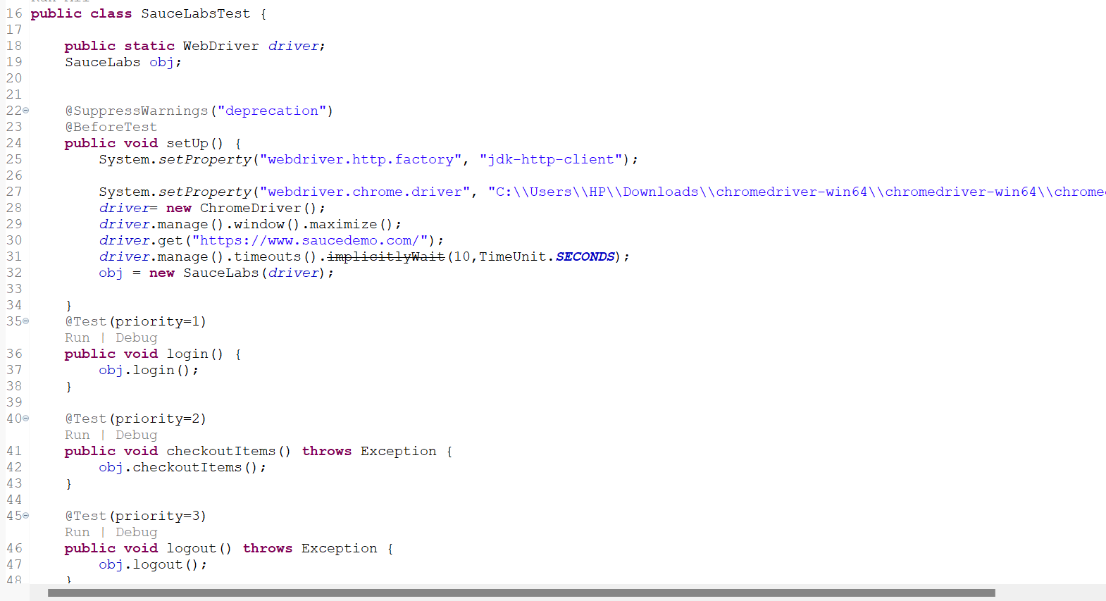

I have used 3 methods in Test class – login, checkoutItems and logout. Under these methods, I called the actual implementation of these methods from Object Class. All the dependencies are added in pom.xml file.

