1. Display Employeeid , first name and last name of employees

select employeeid,firstname,lastname

from employee

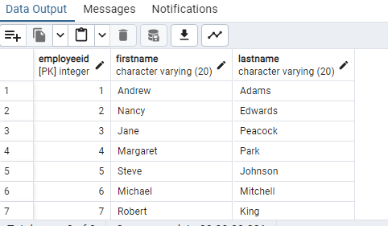

2. Write a SQL query to calculate the total number of employees working at Chinook

select count(*) as EmployeeCount

from employee

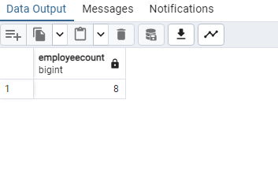

3. Write SQL queries to calculate the total number customers, total number of artists and total number of tracks in the database.

select count(*)

from customer

UNION

select count(*)

from track

UNION

select count(*)

from artist

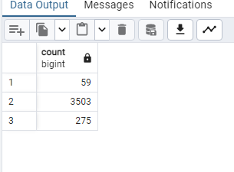

4. List all the albums by artists with the word ‘black’ in their name.

select alb.title

from album alb

join artist art on art.artistid=alb.artistid

where art.name like '%Black%'

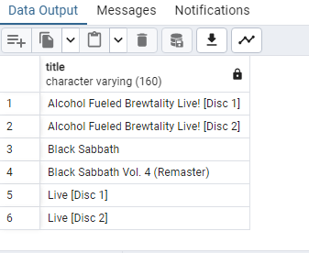

5. Provide a query showing a unique/distinct list of billing countries from the Invoice table

select distinct(billingcountry)

from invoice

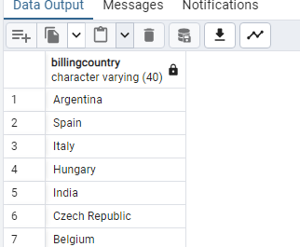

6. How many customers are from the city Prague and Berlin?

select count(*) as CustomerCountOFBerlinPrague

from customer

where city in ('Berlin','Prague')

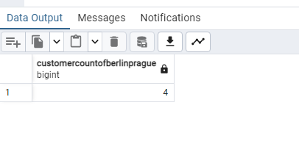

7. Write a SQL query to show the top 5 albums with the highest number of tracks. The result should contain 2 columns: album ID and number of tracks in the album (name the column "Tracks").

select a.albumid,count(t.trackid)as Tracks

from album a

join track t on t.albumid=a.albumid

group by a.albumid

order by Tracks Desc

limit 5

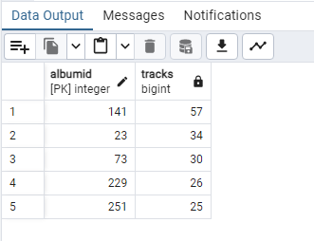

8. List the top 5 albums with the highest number of tracks

select a.albumid,a.title,count(t.trackid)as Tracks

from album a

join track t on t.albumid=a.albumid

group by a.albumid

order by Tracks Desc

limit 5

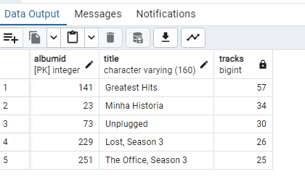

9. Use your query to return the email, first name, last name, and Genre of all Rock Music listeners. Return your list ordered alphabetically by email address

select c.email,c.firstname,c.lastname,g.name

from customer c

join invoice i on i.customerid=c.customerid

join invoiceline inv on inv.invoiceid=i.invoiceid

join track t on t.trackid=inv.trackid

join genre g on g.genreid=t.genreid

where g.name='Rock'

order by c.email

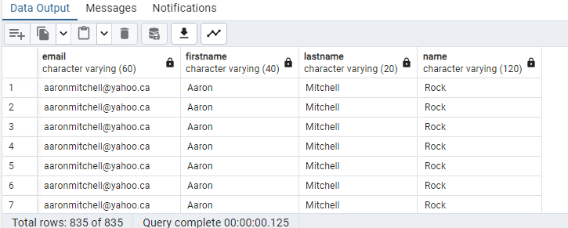

10. List the top 5 artists with the highest number of tracks.

select art.artistid,art.name,count(t.trackid)TrackCount

from artist art

join album alb on alb.artistid=art.artistid

join track t on t.albumid=alb.albumid

group by art.artistid

order by TrackCount DESC

limit 5

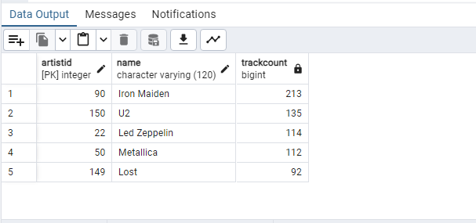

11. Show a list of the top 5 customer with the highest total spend in 2012. Calculate the total amount spent by each customer by adding the totals from all their invoices in the year 2012. Order the list by the invoice total (decreasing order). The result should contain the rows CustomerId, FirstName, LastName and TotalSpend.

Note: SQLite doesn't support the YEAR function. Instead use strftime("%Y", Invoice.InvoiceDate) to extract the year from the column InvoiceDate as a string. [strftime("%Y", i.InvoiceDate)='2012']

Hint: First try to write down a step-by-step solution to the problem in plain English, and then try to convert it to a SQL query. Use the empty cells below to experiment with intermediate queries.

select c.CustomerId,c.FirstName,c.LastName,SUM(i.Total) AS TotalSpent,extract(YEAR from i.InvoiceDate) AS invoiceYear

from Customer c

join Invoice i ON c.CustomerId = i.CustomerId

where extract(YEAR from i.InvoiceDate)='2012'

group By c.CustomerId,c.FirstName,c.LastName,invoiceYear

order by TotalSpent DESC

limit 5

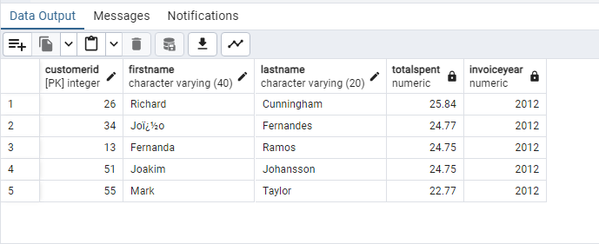

12. Show the following information for all the tracks by the Artist "Metallica": Track ID, Track Name, Album Title, Artist Name, Composer, Media Type, Genre and track length in milliseconds

select t.trackid,t.name,alb.title,art.name,t.composer,m.name,g.name,t.milliseconds

from track t,genre g, mediatype m,album alb,artist art

where alb.albumid=t.albumid and art.artistid=alb.artistid and g.genreid=t.genreid and

t.mediatypeid=m.mediatypeid

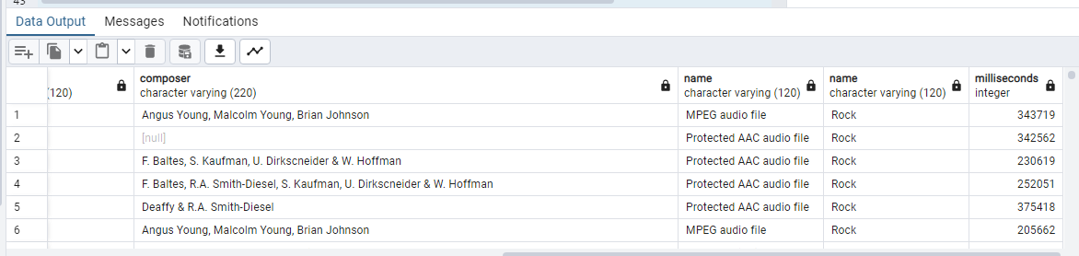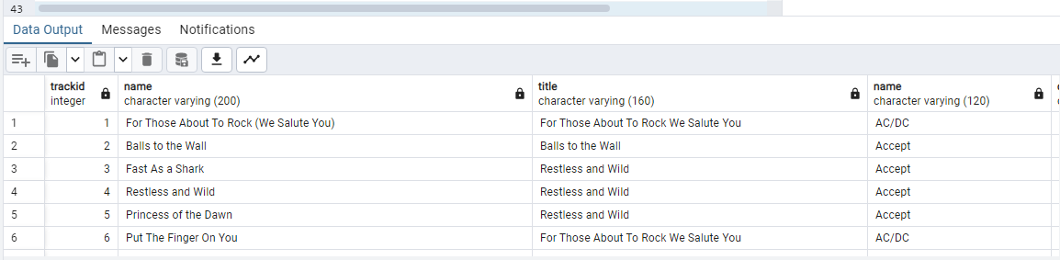

13. Create a new table HallOfFame to track the list of artists who have been added into the Chinook Hall of Fame. The table should contain three columnsOnce created, add 5 entries to the table (any artists of your choice). HallOfFameId (int): Primary key with Auto Increment

ArtistId (int): Foreign key (from the Artist table)

YearAdded (int): The year the artist was added to the hall of fame

Once created, add 5 entries to the table (any artists of your choice).

create table HallOfFame (halloffameid INT AUTO_INCREMENT primary key,

artistid INT,

yearadded INT,

FOREIGN KEY (artistid) references artist(artistid)

)

INSERT INTO HallOfFame (artistid, yearadded) VALUES (1, 2020);

INSERT INTO HallOfFame (artistid, yearadded) VALUES (3, 2023);

INSERT INTO HallOfFame (artistid, yearadded) VALUES (7, 2018);

INSERT INTO HallOfFame (artistid, yearadded) VALUES (4, 2015);

INSERT INTO HallOfFame (artistid, yearadded) VALUES (10, 2020);

select * from halloffame

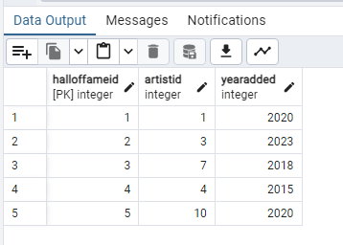

14. Show how may albums are present from Hall of fame artist

The albums title from the artists who are in hall of fame

select album.title,art.artistid,art.name

from album

join artist art on album.artistid=art.artistid

join halloffame h on h.artistid=art.artistid

Total albums count from hall of fame artist

select count(album.title) as CountOfAlbums

from album

join artist art on album.artistid=art.artistid

join halloffame h on h.artistid=art.artistid

