Group 3 Banking System
Software Requirements Specification
https://github.com/syfabo/CS-401-Project
Revision History

Date | Revision | Description | Author
09/26/2025 | 1.0 | Completed 1.1, 1.4, 2.1, 2.2 and 2.3  Added Requirements to 3.1.1 | Sydney Boone
09/27/2025 | 1.1 | Added 5 Constraints | Sydney Boone, Nidhi Prajapati, Gladwin Prabhu Rajkumar
9/27/2025 | 1.2 | Added to 2.4, 2.5 and multiple sections in 3.1 | Sydney Boone
9/29/2025 | 1.3 | Completed 1.3.3, 2.4, 2.5, 3.1.1 3.1.2, 3.1.5, 3.1.6, 3.2, and 3.3 Started 4.1 | Sydney Boone
9/29/2025 | 1.4 | Completed 3.1.3, 3.1.4, and 1.3.4  Added to 3.1.5 | Nidhi Prajapati
9/29/2025 | 1.6 | Completed 4.1, 4.2, 4.3, 1.3.1, and 1.3.2 | Gladwin Prabhu Rajkumar
10/12/2025 | 1.7 | Created New Gannt Chart | Sydney Boone, Gladwin Prabhu Rajkumar
10/31/2025 | 2.1 | Updated the UML Class Diagram for Phase 2 | Gladwin Prabhu Rajkumar
10/31/2025 | 2.2 | Updated the Gannt Chart | Sydney Boone
10/31/2025 | 2.3 | Uploaded Use Case Specifications & Use Case Diagram | Nidhi Prajapati
11/14/25 | 2.4 | Completed the UML Class Diagram | Sydney Boone  Gladwin Prabhu Rajkumar

Table of Contents
1. Purpose 4
1.1. Scope 4
1.2. Definitions, Acronyms, Abbreviations 4
1.3. References 4
1.4. Overview 4
2. Overall Description 5
2.1. Product Perspective 5
2.2. Product Architecture 5
2.3. Product Functionality/Features 5
2.4. Constraints 5
2.5. Assumptions and Dependencies 5
3. Specific Requirements 6
3.1. Functional Requirements 6
3.2. External Interface Requirements 6
3.3. Internal Interface Requirements 7
4. Non-Functional Requirements 8
4.1. Security and Privacy Requirements 8
4.2. Environmental Requirements 8
4.3. Performance Requirements 8

Purpose
This document outlines the requirements for the Banking System.

Scope
This document will catalog the user, system, and hardware requirements for the Banking system. It will not, however, document how these requirements will be implemented.

Definitions, Acronyms, Abbreviations
No Definitions, Acronyms, or Abbreviations

References
1.3.1 Use Case Specification – Pages 11-17 of this document
1.3.2 UML Use Case Diagrams – Page 18 of this document
1.3.3 Class Diagrams – Page 19 of this document
1.3.4 Sequence Diagrams – Pages 20 - 21 of this document
1.3.5 Gannt Chart – Page 22 of this document

Overview
The Banking System is designed to provide banking services through an interface for authorized bank employees and a separate ATM application. Security and fraud prevention are ever-present concerns.

Overall Description

Product Perspective
The Banking System is an application that provides access to standard banking services for customers through both bank employees and ATM machines. The Banking System protects customers’ accounts from unauthorized access and minimizes fraud. The system is a java application that uses a client–server design over TCP/IP, and manages requests such as withdrawals, deposits, balance inquiries, and transfers. The system accommodates two types of users with different privileges and levels of access, authorized bank employees and ATM customers. The system also keeps a persistent log of user activity for record and fraud detection

Product Architecture
The system will be organized into 5 major modules:
(3.1.2) The Authentication module
(3.1.3) The Teller module
(3.1.4) The ATM module
(3.1.5) The Logging module
(3.1.6) The Fraud Prevention Module

Product Functionality/Features
The high-level features of the system are as follows:
(see section 3 of this document for more detailed requirements that address these features)
    - Authentication process for bank tellers and ATM customers
    - Bank Teller application interface for authorized employees
    - ATM application interface for self-serve customer usage
    - Deposit and withdrawal of money, balance inquiries, and electronic transfers
    - Logging of account activity and transaction history
    - A server and client application that communicate over TCP/IP

Constraints
2.4.1 The system must present a graphical interface
2.4.2 The system must be implemented in Java
2.4.3 The system must have a server and client application that operate using TCP/IP
2.4.4 The system must not have a web or HTML component
2.4.5 The system must not rely on any databases, libraries, or frameworks
2.4.6 The system must require users are authenticated before receiving access to any part
2.4.7 The system must be scalable to a very large number of users

Assumptions and Dependencies
2.5.1 It is assumed that the system’s clock will be accurate and consistent to keep accurate records
2.5.2 It is assumed that all users of the system will be responsible with their credentials, logging in, and logging out as expected
2.5.3 It is assumed that the external card scanner reliably reads card numbers from customers’ physical cards
2.5.4 It is assumed that two accounts will never have the same account number
2.5.5 It is assumed that credit scores will automatically update accordingly

Specific Requirements

Functional Requirements

Common Requirements:
3.1.1.1 The system has an interface for bank employees and another for ATM services
3.1.1.2 The system writes card numbers, account pins, balances, and transaction history to an external file
3.1.1.3 The system allows accounts to be opened or closed, and allows new people to be added to existing accounts
3.1.1.7 The system allows the creation of 3 types of accounts: checking, savings, and a line of credit
3.1.1.8 The system must generate a receipt/confirmation message after every transaction showing the transaction details (type, amount, date, and updated balance)
3.1.1.9 The system charges fees and provides interest appropriately
3.1.1.10 The system will give Bank employees access to change passwords, close accounts, or adjust credit limits.

Authentication Module Requirements:
      - This module will store account usernames, passwords and pins, for verification
      - This module will accept employees’ usernames and passwords and verify validity
3.1.2.3 This module will accept a pin associated with a customer’s profile and verify its validity

Teller Module Requirements:
3.1.3.1 This module allows money to be deposited, withdrawn, or transferred between accounts
3.1.3.2 This module allows bank employees to manage customer accounts, including opening accounts, closing existing accounts, and adding new users to accounts.
3.1.3.3 This module will allow bank employees to change passwords or reset account credentials, such as passwords and account PINs.
3.1.3.4 This module will allow bank employees to change passwords or reset account PINs.
3.1.3.5 This module allows bank employees to set or adjust credit limits on line of credit accounts.
3.1.3.6 This module lets bank employees have access to view customer profiles, including balances and transaction history.
3.1.3.7 This module must display warnings when a transaction or account change exceeds configured thresholds.

ATM Module Requirements:
      - This module allows customers to perform self- service transactions, including deposits, withdrawals and transfers between their own accounts.
      - This module allows customers to view account balances and transaction history for the past 30 days.
      - This module must generate a receipt or confirmation message after every transaction showing transaction type, amount, date and updated balance.
      - This module must log all login attempts, ATM transactions and account actions into the logging module.
      - This module must terminate the session and log out the customer automatically after a period of inactivity.
      - This module must display an error message and deny access after repeated failed login attempts.
      - This module must prevent customers from making withdrawals if the account balance is insufficient.

Logging Module Requirements:
3.1.5.1 This module must record all successful and failed logins.
3.1.5.2 This module must record all transaction performed through the Teller at the ATM modules, including deposits ,withdrawals, transfers and Line of Credit(LOC) borrowing/repayment.
3.1.5.3 This module should record all account management activities, including account creation , closure , passwords/PIN resets, changes of LOC.
3.1.5.4 This module should store logins in a secure and immutable format that prevents unauthorized modification or deletion.
3.1.5.5 This module must ensure all logs are timestamped, include the user ID or employee ID , and reference to affected account number.
3.1.5.6 This module must provide log data to the fraud prevention module for fraud analysis of suspicious activity.

Fraud Prevention Module Requirements:
3.1.6.1 This module will make a note of suspicious activity as it is reported by the logging module
3.1.6.2 This module will flag a single profile being accessed at the same time from multiple programs as suspicious activity
3.1.6.3 The Fraud Prevention module will flag 3 or more consecutive failed login attempts as suspicious activity
3.1.6.4 The Fraud Prevention module will flag access from an ATM or Teller located more than 50 miles from the last transaction as suspicious activity
3.1.6.5 The Fraud Prevention module will flag transactions that exceed a set threshold amount as suspicious activity
3.1.6.6 The Fraud Prevention module will flag more than 3 transactions within a set time window as suspicious activity

External Interface Requirements
3.2.1 The Authentication Module receives card information from an external card reader
3.2.2 The System will display a welcome screen where employees can enter credentials in the teller application
3.2.3 The system will display a screen where users can provide card information or username and enter a pin or password to verify identity in the ATM and teller applications
3.2.4 The system will display the customer profile, which will display all open accounts with account number and balance after validating credentials
3.2.5 The system will display a menu for each account on the profile with an option to make a transaction, open an account or close an account
3.2.6 The system will have an interface for transactions that accepts the amount and the location it will move to (deposit, withdraw, or transfer to another account)
3.2.7 The system will display a confirmation screen after any transaction/ account action

Internal Interface Requirements
3.3.2 The Authentication Module communicates customer information to the Teller or ATM module to open the correct profile
3.3.3 The Teller and ATM module will report all transactions to the logging module for them to be saved
3.3.4 The logging module will communicate all information it receives with the Fraud Prevention module to monitor for suspicious activity
3.3.5 The Fraud Prevention module will send any suspicious log entries back to the logging module for them to be flagged

Non-Functional Requirements

Security and Privacy Requirements
4.1.1 The system must not grant access to any profiles or accounts without valid user authentication
4.1.2 The system must enforce role-based access so every user can only access relevant and appropriate customer data
4.1.3 The system must log all transactions and actions taken without leaking information to outside sources

Environmental Requirements
Example:
4.2.1 System cannot require that any software other than a web browser be installed on user computers.
4.2.2 System must make use of the University’s existing Oracle 9i implementation for its database.
4.2.3 System must be deployed on existing Linux-based server infrastructure.

4.2.1 The system must run on Java SE with no external libraries, frameworks, or databases.
4.2.2 The system must not require a web browser
4.2.3 The system must work on any Mac or Windows operating system within the last 2 years with at least the latest secure Java SE
4.2.4 The system must be able to use both graphical and command line user interfaces.

Performance Requirements
Example:
4.3.1 System must render all UI pages in no more than 9 seconds for dynamic pages. Static pages (HTML-only) must be rendered in less than 3 seconds.

4.3.1 The system must operate server and client requests securely through both regular and unexpected network delays.
4.3.2 The system must take no more than 30 seconds to load an accounts information

1.3.1 Use Case Specification

Use Case ID | 1
Use Case Name | Customer Authentication
Relevant Requirements | 3.2.4 – The system will display the customer profile with account numbers and balances after validating credentials.  4.1.1 – The system must not grant access to any profiles or accounts without valid user authentication.
Primary Actor | Customer (via ATM)
Pre-conditions | • Customer has a valid bank card.  • ATM is connected to the bank server.
Post-conditions | • Customer profile is logged in.  • Customer can access their accounts through the ATM.
Basic Workflow | 1. Customer inserts card with card number.  2. System prompts for PIN.  3. Customer enters PIN.  4. System validates PIN with stored credentials.  5. If valid, system grants access to ATM services and displays profile.
Alternative Workflow | 1. Invalid PIN entered → System prompts for retry.  2. Three consecutive invalid PINs → Card locked.
Exceptions | • ATM out of service.  • Network error prevents validation.
Related Use Cases | Withdraw Cash, Deposit Funds, Balance Inquiry.

Use Case ID | 2
Use Case Name | View All Accounts (Balance Inquiry)
Relevant Requirements | 3.1.4.2 – The system allows customers to view account balances and transaction history for the past 30 days.
Primary Actor | Customer (via ATM)
Pre-conditions | • Customer is authenticated and logged in.
Post-conditions | • Account balance(s) are displayed.
Basic Workflow | 1. Customer selects “View Balance.”  2. System prompts for account selection if multiple accounts exist.  3. System retrieves current balance and recent history.  4. System displays account information.
Alternative Workflow | • If no account exists → System displays message and returns to menu.
Exceptions | • Network error while retrieving data.
Related Use Cases | Customer Authentication, Print Receipt.

Use Case ID | 3
Use Case Name | Withdraw Cash (ATM)
Relevant Requirements | 3.1.4.1 – ATM module allows customers to perform withdrawals.  3.1.4.7 – The system must prevent withdrawals if the account balance is insufficient.
Primary Actor | Customer (via ATM)
Pre-conditions | • Customer is authenticated.  • Account has sufficient balance.
Post-conditions | • Account balance is updated.  • Cash dispensed to customer.  • Transaction logged.
Basic Workflow | 1. Customer selects “Withdraw Cash.”  2. Customer enters withdrawal amount.  3. System validates available funds.  4. ATM dispenses cash.  5. System updates balance and prints receipt.  6. System logs transaction.
Alternative Workflow | • Insufficient balance → System denies transaction.  • Invalid amount entered → System prompts for retry.
Exceptions | • ATM out of service.  • Network error prevents validation.
Related Use Cases | Customer Authentication, Deposit Funds, Balance Inquiry.

Use Case ID | 4
Use Case Name | Deposit Funds (ATM)
Relevant Requirements | 3.1.4.1 – ATM module allows deposits.  3.1.4.3 – System must generate a receipt after every transaction.
Primary Actor | Customer (via ATM)
Pre-conditions | • Customer is authenticated.  • ATM supports deposit function.
Post-conditions | • Account balance increased.  • Transaction logged.
Basic Workflow | 1. Customer selects “Deposit Funds.”  2. Customer inserts cash/check into ATM.  3. System validates deposit amount.  4. System updates account balance.  5. System prints receipt.
Alternative Workflow | • Invalid deposit item → System cancels transaction and returns item.
Exceptions | • ATM hardware failure.  • Network/server error in updating balance.
Related Use Cases | Withdraw Cash, Balance Inquiry.

Use Case ID | 5
Use Case Name | Transfer Funds (ATM)
Relevant Requirements | 3.1.4.1 – ATM module allows transfers.  3.2.6 – Transaction interface accepts the amount and destination account.  4.1.3 – System must log all transactions.
Primary Actor | Customer (via ATM)
Pre-conditions | • Customer authenticated with card and PIN.  • Source account has sufficient funds.  • Destination account valid.
Post-conditions | • Source account debited; destination credited.  • Transaction receipt printed or displayed.
Basic Workflow | 1. Customer selects “Transfer Funds.”  2. ATM prompts for transfer details.  3. Customer enters details.  4. System validates accounts and funds.  5. System performs transfer.  6. System logs and confirms transaction.
Alternative Workflow | • Invalid PIN or destination account → Cancelled.  • Insufficient funds → Denied.
Exceptions | • Network or hardware error.
Related Use Cases | Withdraw Cash, Deposit Funds.

Use Case ID | 6
Use Case Name | Employee Authentication (Teller)
Relevant Requirements | 3.1.2.2 – Authentication module verifies employee credentials.  4.1.1 – System must not grant access without valid credentials.
Primary Actor | Bank Teller (via Teller App)
Pre-conditions | • Teller has valid username and password.
Post-conditions | • Teller session established.  • Teller gains access to customer service functions.
Basic Workflow | 1. Teller opens Teller App.  2. Enters username and password.  3. System validates credentials.  4. Teller granted access to system.
Alternative Workflow | • Invalid credentials → Retry.  • Three failed attempts → Account locked.
Exceptions | • Login error due to connectivity issue.
Related Use Cases | Open Customer Profile, Perform Transaction.

Use Case ID | 7
Use Case Name | Open Customer Profile (Teller)
Relevant Requirements | 3.1.3.6 – Employees can view customer profiles, balances, and transaction history.
Primary Actor | Bank Teller (via Teller App)
Pre-conditions | • Teller logged in successfully.
Post-conditions | • Customer profile opened; available accounts displayed.
Basic Workflow | 1. Teller searches for customer.  2. System verifies and loads profile.  3. Profile and account info displayed.
Alternative Workflow | • Customer not found → Retry or create new profile.
Exceptions | • Network/server error retrieving profile.
Related Use Cases | Manage Accounts, Perform Transaction.

Use Case ID | 8
Use Case Name | Perform Transaction (Teller)
Relevant Requirements | 3.1.3.1 – Teller module allows deposits, withdrawals, and transfers.  4.1.3 – System must log all transactions.
Primary Actor | Bank Teller (via Teller App)
Pre-conditions | • Teller logged in.  • Customer profile open.
Post-conditions | • Account balances updated.  • Transaction logged.
Basic Workflow | 1. Teller selects transaction type.  2. Enters details.  3. System validates.  4. Performs transaction.  5. Displays confirmation.  6. Logs action.
Alternative Workflow | • Insufficient funds → Denied.  • Invalid data → Correction required.
Exceptions | • Network or database error.
Related Use Cases | Open Customer Profile, Log Transaction.

Use Case ID | 9
Use Case Name | Manage Accounts (Teller)
Relevant Requirements | 3.1.3.2 – Teller can open/close accounts and add users.  3.1.3.5 – Teller can adjust credit limits.  3.1.3.7 – Warnings when thresholds are exceeded.
Primary Actor | Bank Teller (via Teller App)
Pre-conditions | • Teller logged in.  • Customer profile open.
Post-conditions | • Account info modified and logged.
Basic Workflow | 1. Teller opens profile.  2. Selects “Manage Accounts.”  3. Chooses action.  4. System validates.  5. Updates info.  6. Logs action.
Alternative Workflow | • Invalid input → Correction.  • Threshold exceeded → Warning.
Exceptions | • Network/server error.
Related Use Cases | Perform Transaction, Reset Credentials.

Use Case ID | 10
Use Case Name | Fraud Detection (Internal / Automatic)
Relevant Requirements | 3.1.5.6 – Logging module provides data for analysis.  3.1.6.1–3.1.6.6 – Fraud module flags suspicious activity.
Primary Actor | System (automated internal process)
Pre-conditions | • Transaction or login data logged.
Post-conditions | • Suspicious activity flagged; report recorded.
Basic Workflow | 1. Logging sends data.  2. Fraud module analyzes.  3. Flags unusual patterns.  4. Stores alerts in log.
Alternative Workflow | • Rules updated dynamically.
Exceptions | • Missing or corrupted log data.
Related Use Cases | Log Transaction, Customer Authentication, Employee Authentication.

1.3.2 Use Case Diagrams

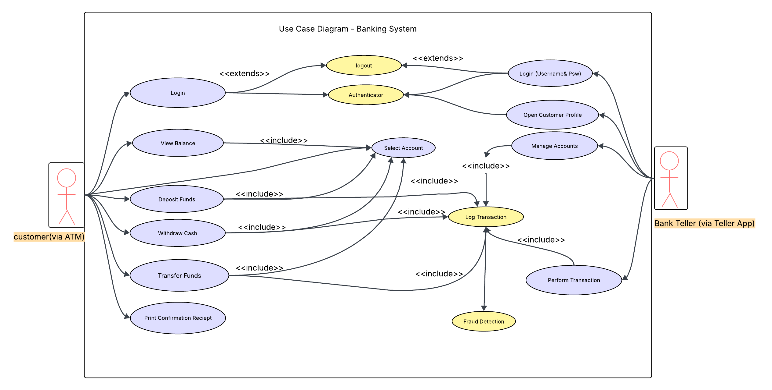

1.3.3 UML Class Diagram

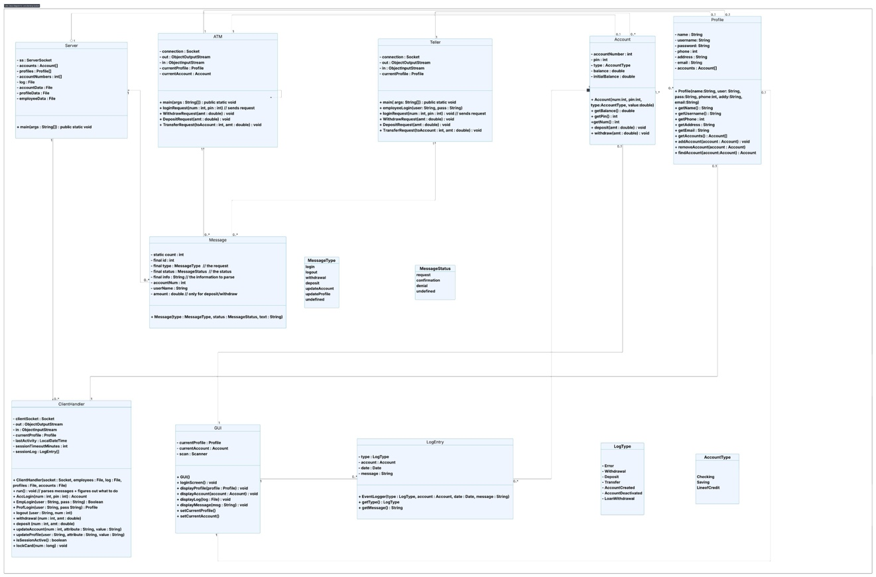

1.3.4 Sequence Diagrams
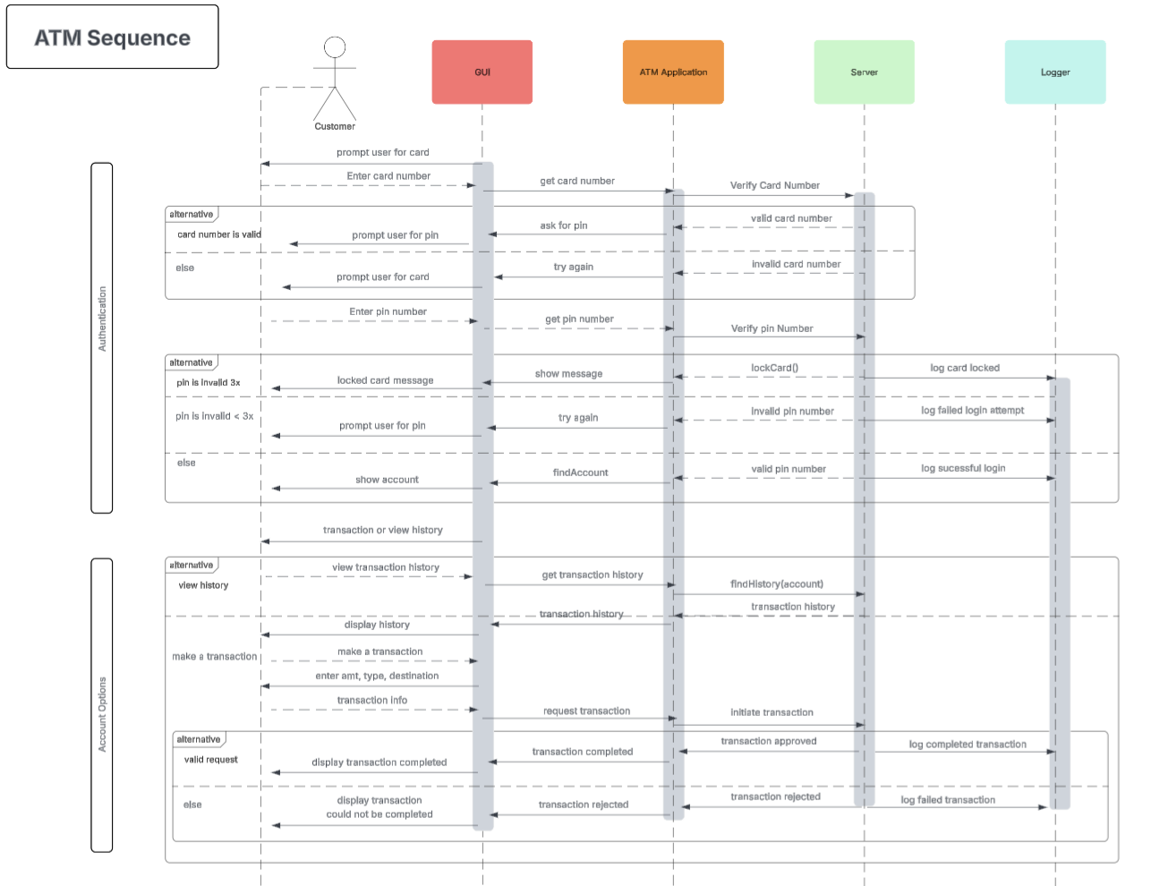
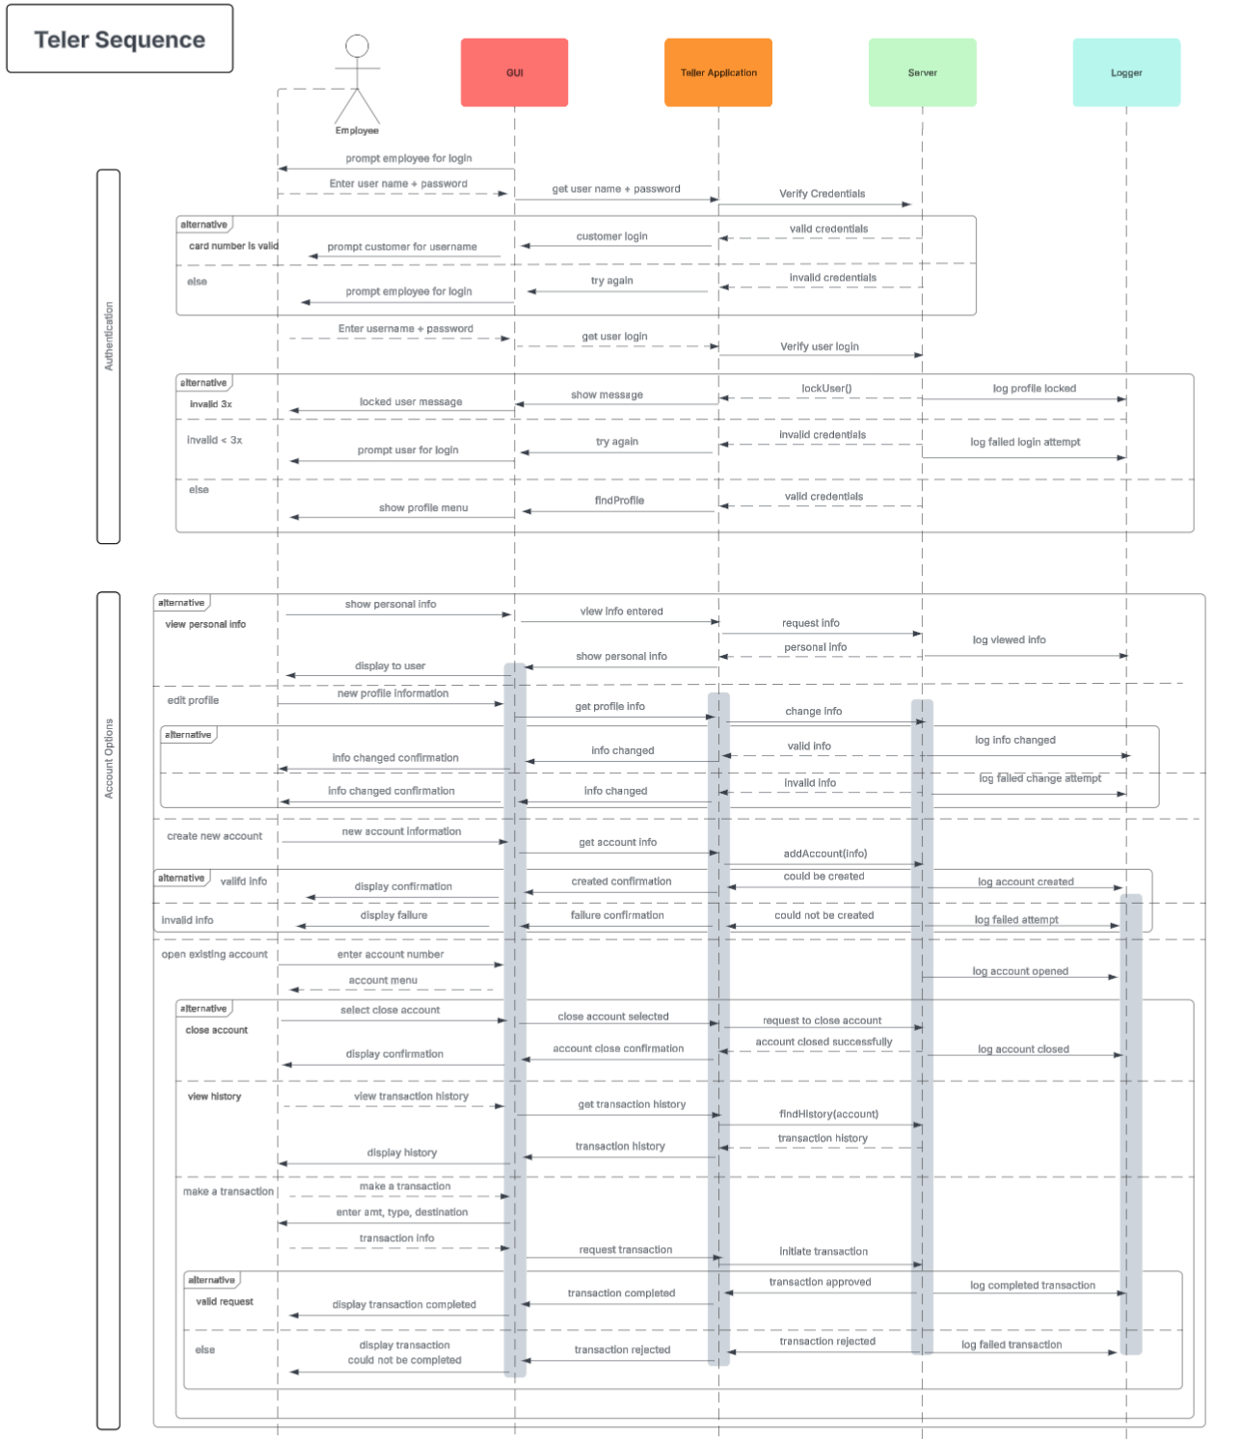

Gannt Chart
