**Instructions**

* There are **2** questions in this assignment.
* Email/paper/other modes of submissions will not be accepted.
* Upload a word **version** of this document.
* Assignment submitted after due date will not be evaluated and a score of zero will be awarded.
* Plagiarism may lead to award of zero marks.

**Due Date: 5pm, 28th October 2024**

**Submitting this Assignment**

You will submit (upload) this assignment in MS Teams. Name this document as GLA1_AJPODD2024_John_Doe.doc in case your name is John Doe, and this graded lab assignment is 1 of course whose acronym is AJP, and offered in ODD 2024. Paste your code after each question, paste the screenshot of output, save and upload the document.

**Grading Scheme:** This assignment has5 marks.

**Question 1:**

**JSP with Include and Forward Directives**

* Create a JSP page with a **header.jsp** (common header) and **footer.jsp** (common footer).
* Use **<jsp:include>** to include them in the main JSP page

**Question 2:**

**Form Handling in JSP**

* Create a JSP page with a form to take user input (name and age).
* On submission, the page should display a greeting based on the user’s age (e.g., “Hello, Youngster!” if age < 18).

Answer 1 : --

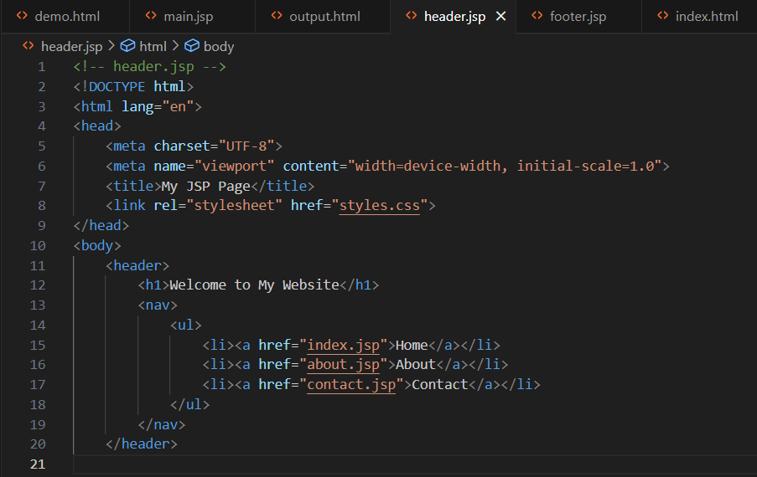

Main.jsp –

Output –

Answer 2 :

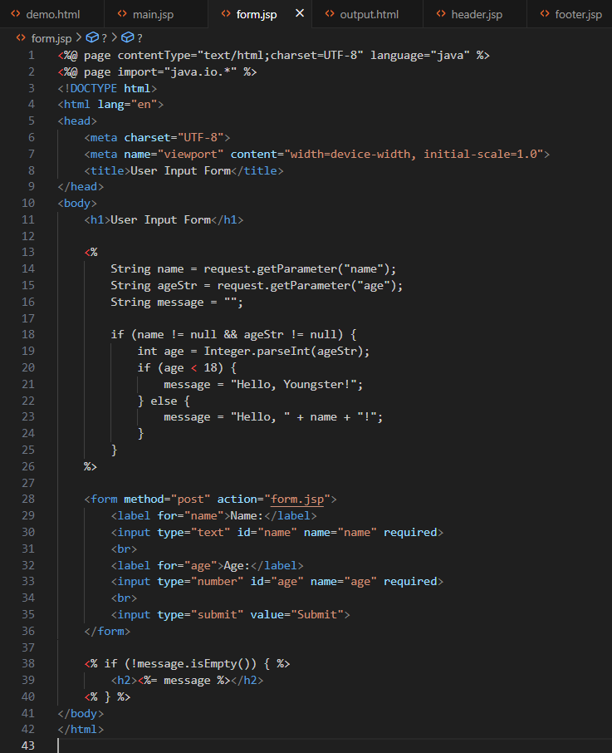

Output –

