SCHOOL OF COMPUTER SCIENCE AND ARTIFICIAL INTELLIGENCE |  |  |  |  | DEPARTMENT OF COMPUTER SCIENCE ENGINEERING
Program Name: B. Tech |  |  |  | Assignment Type: Lab |  |  | Academic Year:2025-2026
Course Coordinator Name |  |  |  | Venkataramana Veeramsetty
Instructor(s) Name |  |  |  | Dr. V. Venkataramana (Co-ordinator)  Dr. T. Sampath Kumar  Dr. Pramoda Patro  Dr. Brij Kishor Tiwari  Dr.J.Ravichander  Dr. Mohammand Ali Shaik  Dr. Anirodh Kumar  Mr. S.Naresh Kumar  Dr. RAJESH VELPULA  Mr. Kundhan Kumar  Ms. Ch.Rajitha  Mr. M Prakash  Mr. B.Raju  Intern 1 (Dharma teja)  Intern 2 (Sai Prasad)  Intern 3 (Sowmya)  NS_2 ( Mounika)
Course Code |  |  | 24CS002PC215 | Course Title |  | AI Assisted Coding
Year/Sem |  |  | II/I | Regulation |  | R24
Date and Day  of Assignment |  |  | Week7 - Monday | Time(s)
Duration |  |  | 2 Hours | Applicable to  Batches
AssignmentNumber:13.5(Present assignment number)/24(Total number of assignments)
 | Q.No. | Question |  |  |  |  |  | Expected Time  to complete
 | 1 | Lab 13: Code Refactoring – Improving Legacy Code with AI Suggestions  Lab Objectives:  - Identify code smells and inefficiencies in legacy Python scripts.  - Use AI-assisted coding tools to refactor for readability, maintainability, and performance.  - Apply modern Python best practices while ensuring output correctness.  Task 1: Refactoring a Legacy Calculator Script  Scenario:  A university has a legacy Python script for a basic calculator that uses long, repetitive if-else statements for each operation. The code is difficult to maintain.  - Upload the calculator script to a GitHub repository.  - Use GitHub Copilot to suggest a more modular and cleaner version (e.g., functions, dictionary-based mapping).  - Compare the AI-suggested refactoring with the original code and document improvements.  Before:  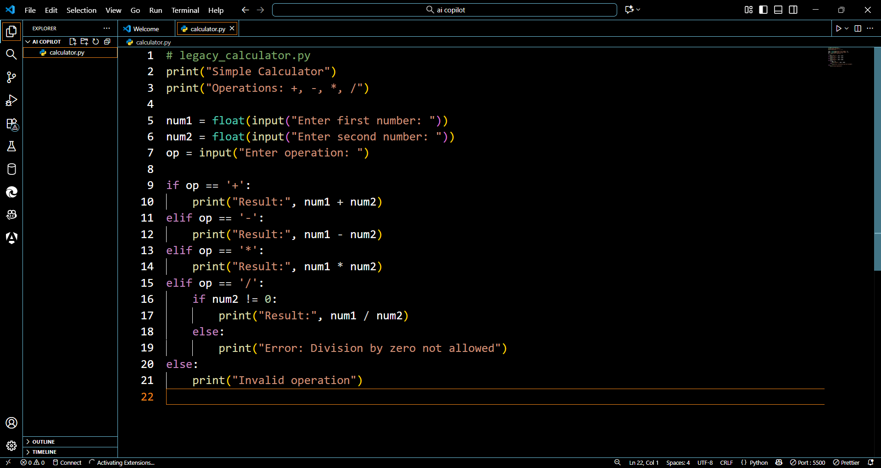  Prompt: Refactor this calculator script to make it modular using functions and dictionary-based operation mapping. Include proper error handling for division by zero and invalid inputs.  Code:  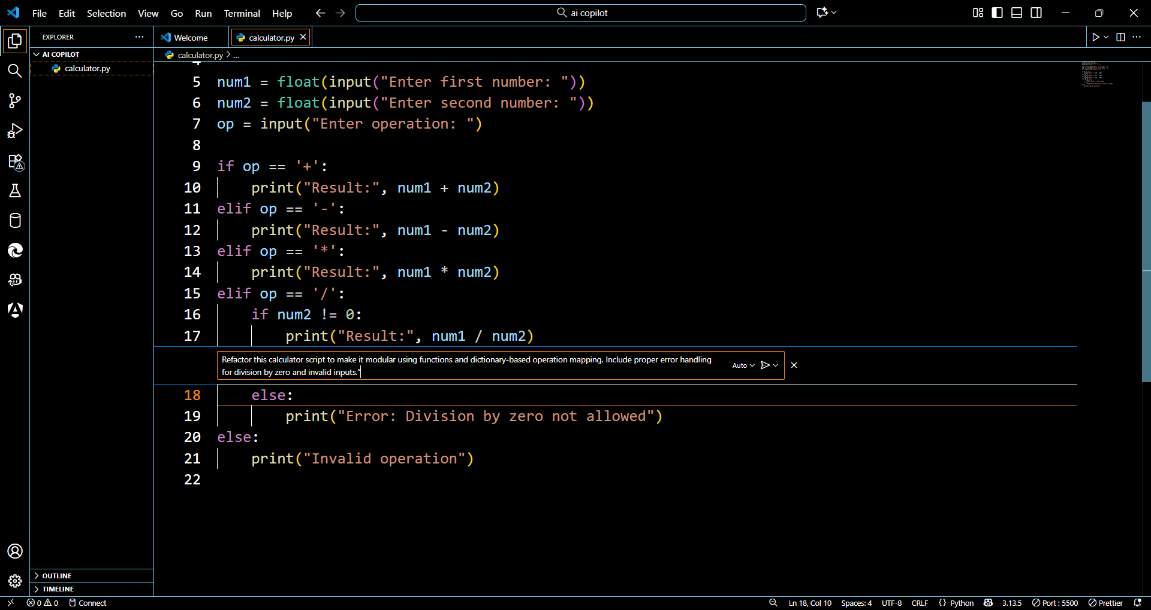  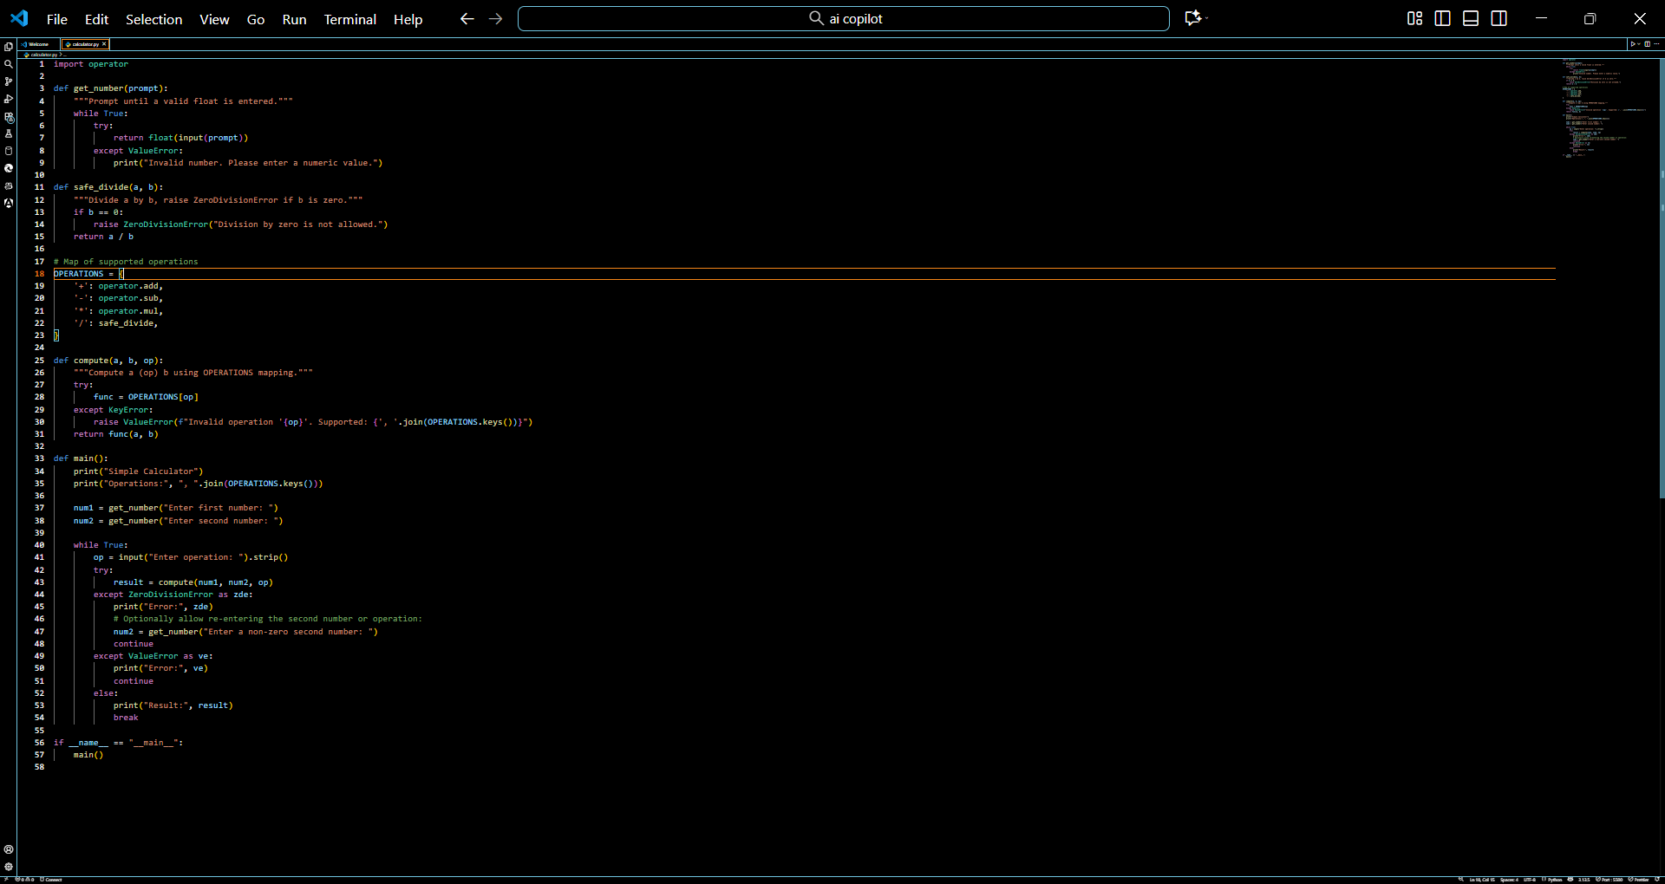  Output: 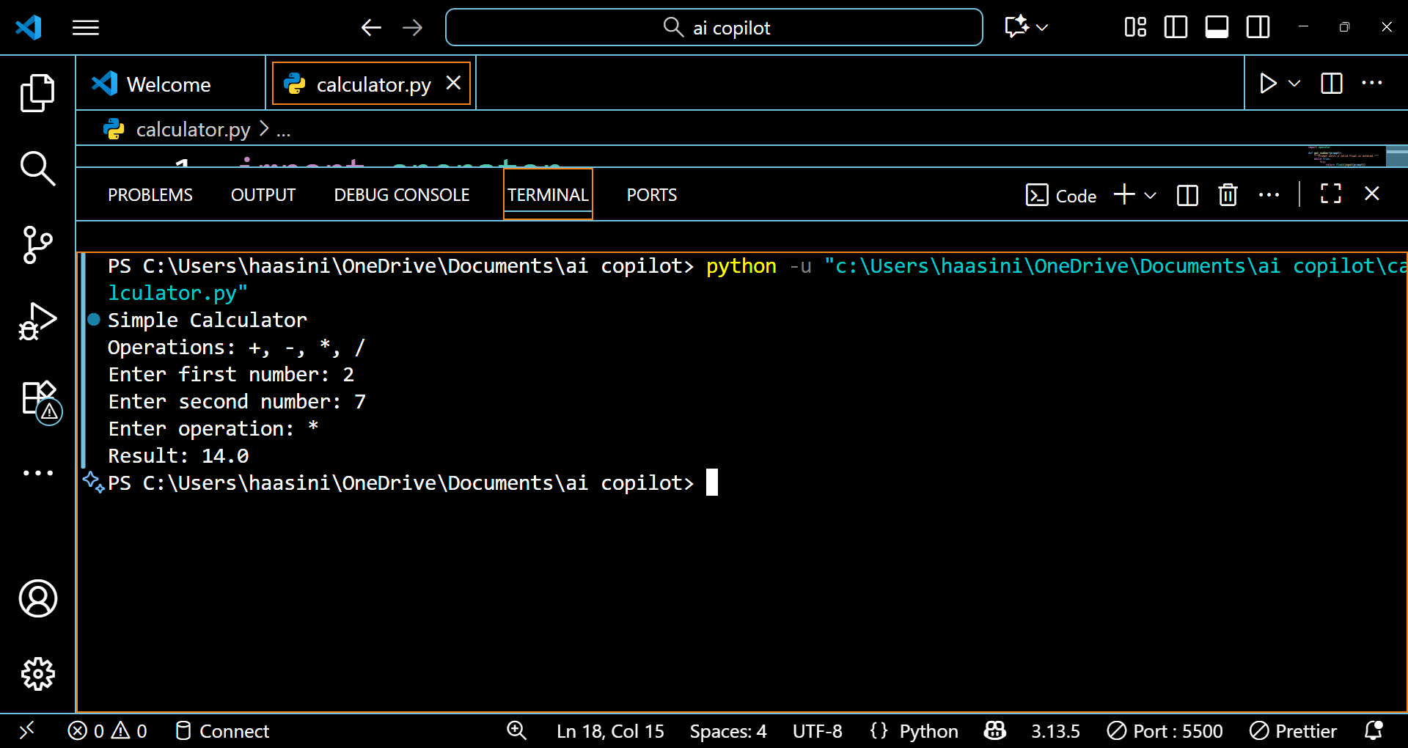  Comparison:  Aspect Legacy Code Refactored Code (AI-Suggested)  Code Structure Single large block with if-else Modular functions (add, subtract, etc.)  Maintainability Hard to modify or extend Easy to add new ops via dictionary  Error Handling Manual and scattered Centralized and exception-based  Readability Long repetitive logic Clean and short mapping-based logic  Reusability Not reusable Functions can be imported elsewhere  Extensibility Adding new ops requires new if-else Just add new key-function in dictionary  AI Suggestion Source None GitHub Copilot suggested dictionary-based approach  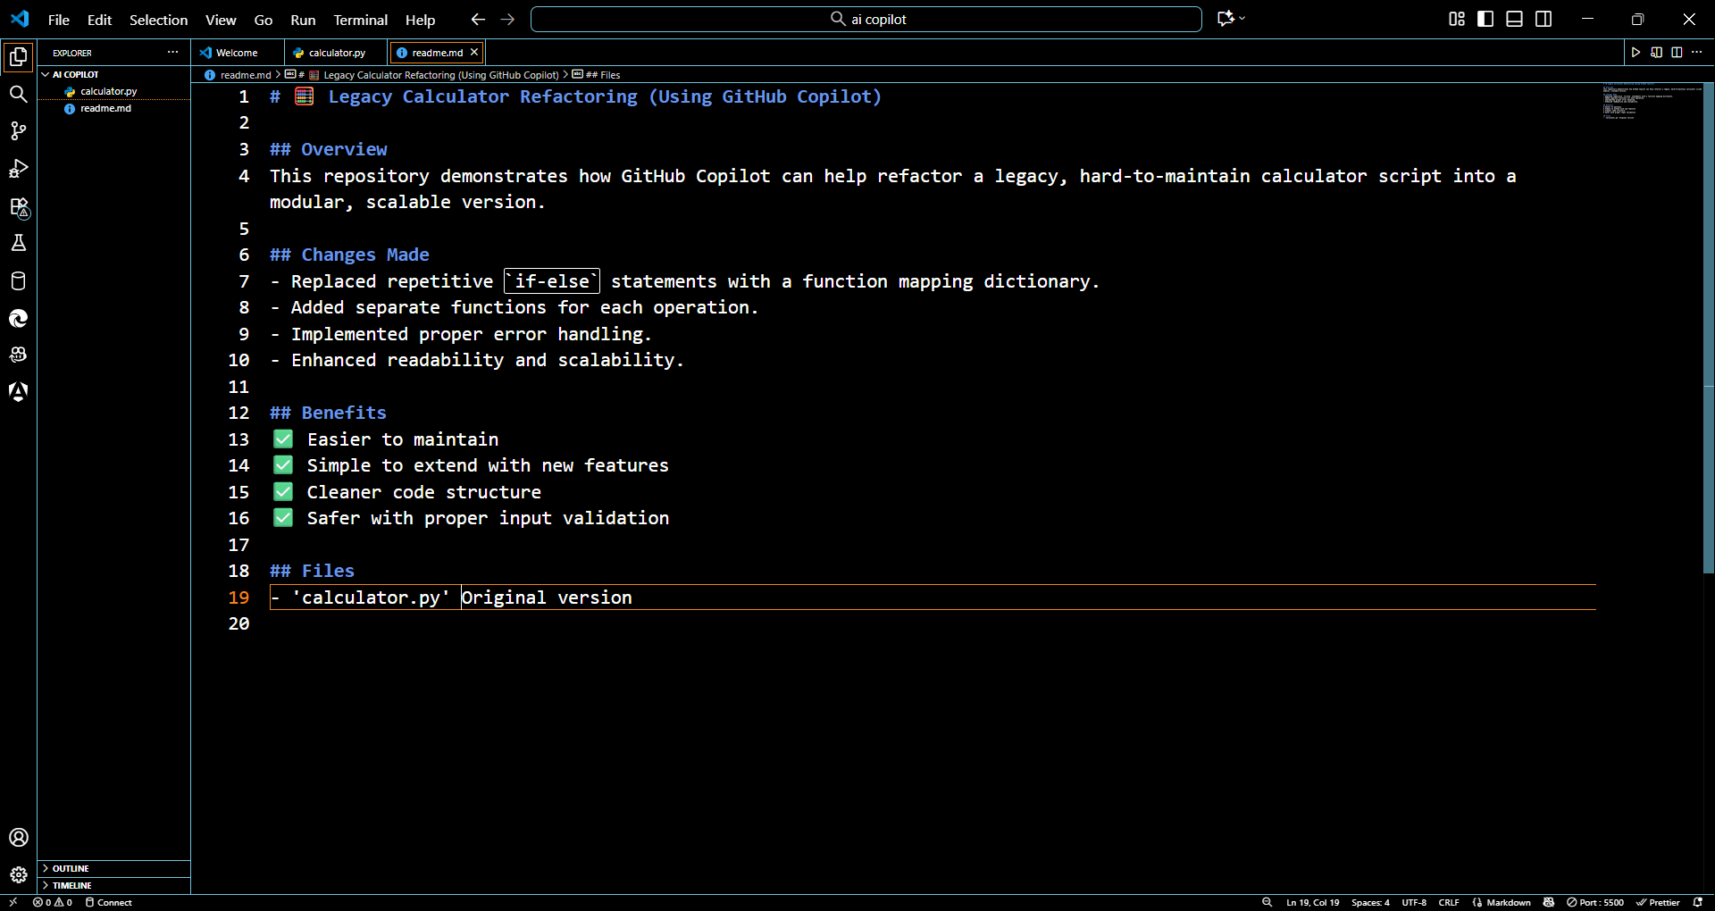  Task 2: Modernizing a Student Database Program  Scenario:  An old student management program uses procedural code with global variables and no error handling. The program frequently crashes when handling incorrect inputs.  - Push the legacy code into your GitHub repo.  - Ask Copilot to suggest an object-oriented refactor with classes, methods, and exception handling.  - Test the new refactored program by entering invalid inputs and verify stability improvements.  - Original:  - 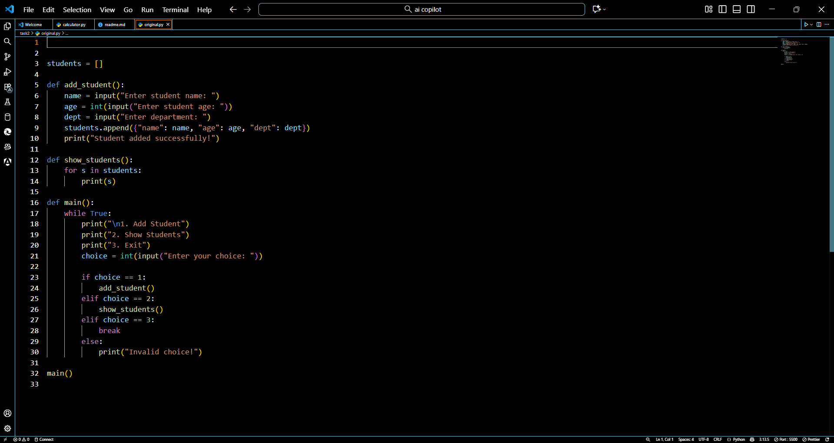  Prompt:  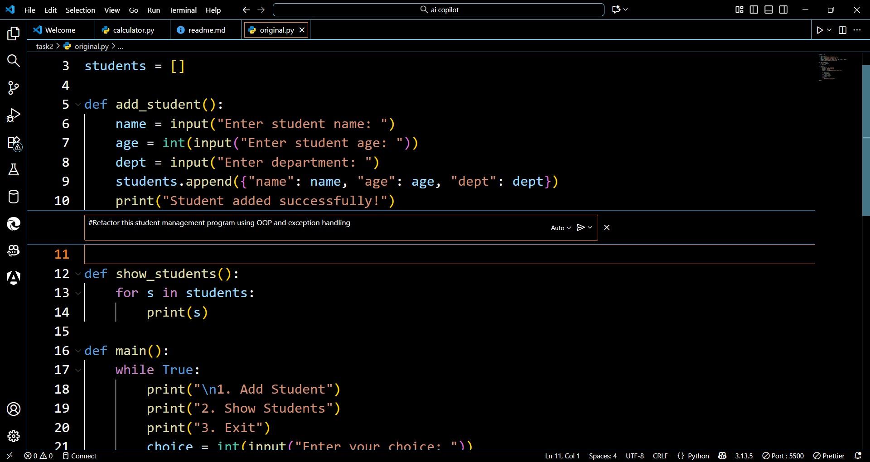Refactored code:  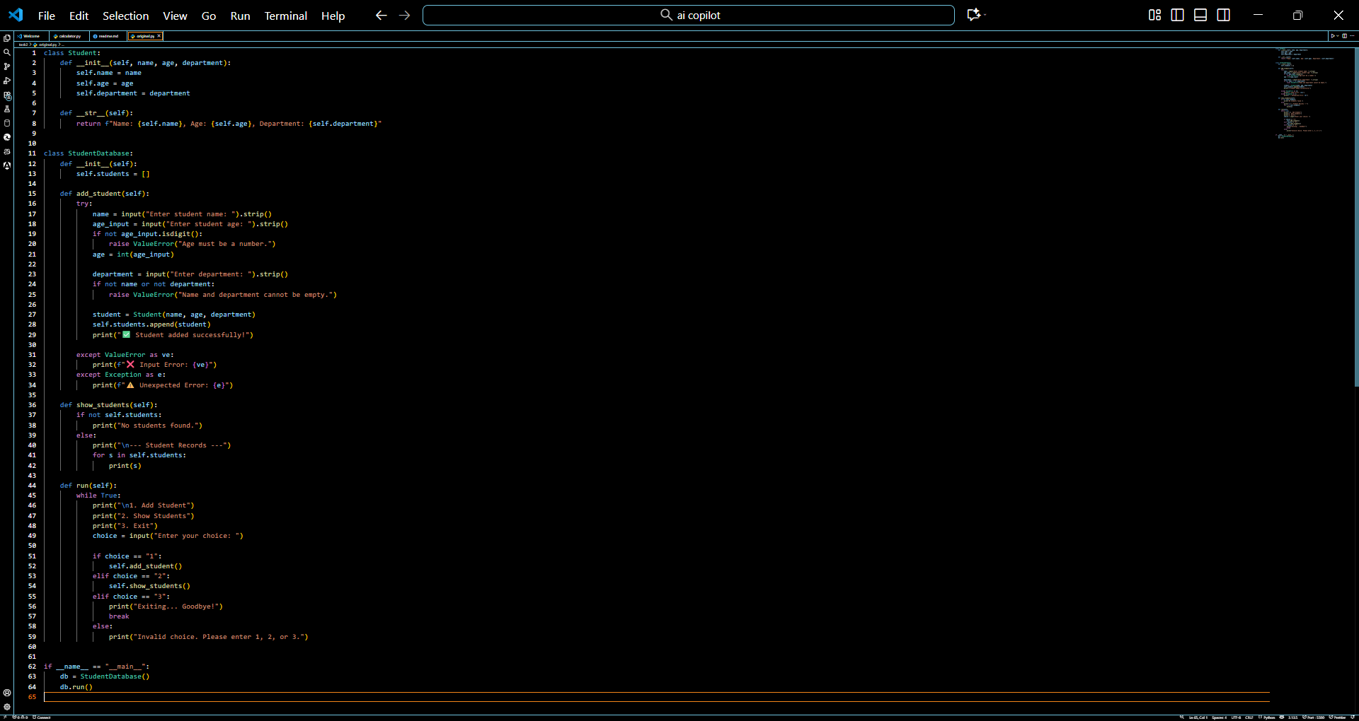  Output: 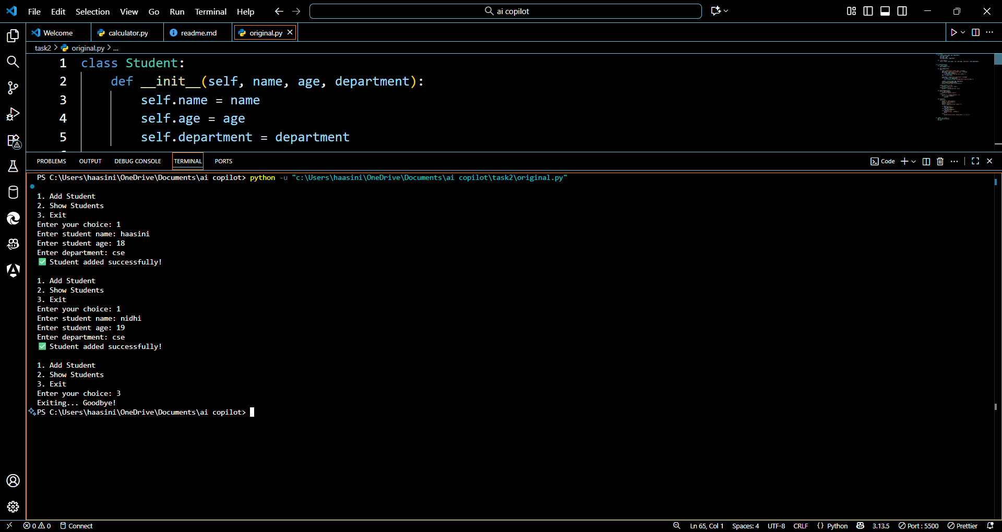  Feature Legacy Refactored  Structure Procedural Object-Oriented  Error Handling None Robust with try/except  Data Management Global list Encapsulated in class  User Experience Crashes on wrong input Graceful error messages  Redme file  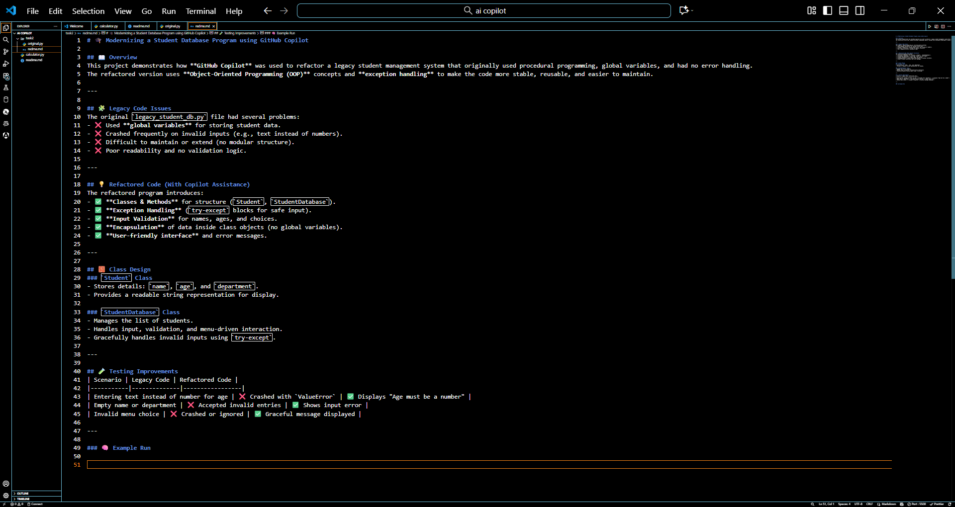  Task 3: Optimizing Performance in File Processing  Scenario:  A company’s file-processing script reads large log files line by line using inefficient loops, causing delays.  - Commit the original file-processing script to GitHub.  - Use Copilot suggestions to replace inefficient loops with more optimized approaches (e.g., list comprehension, built-in functions, generators).  - Compare the execution time of legacy vs. refactored versions and document the performance gains.  - Original:  - 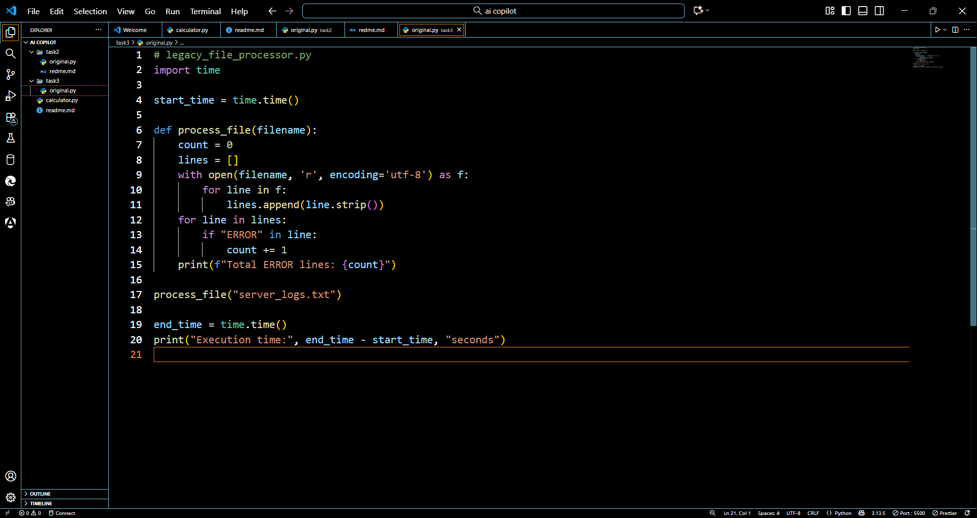  Prompt:  Optimize this file processing script using generators, list comprehension, and built-in functions  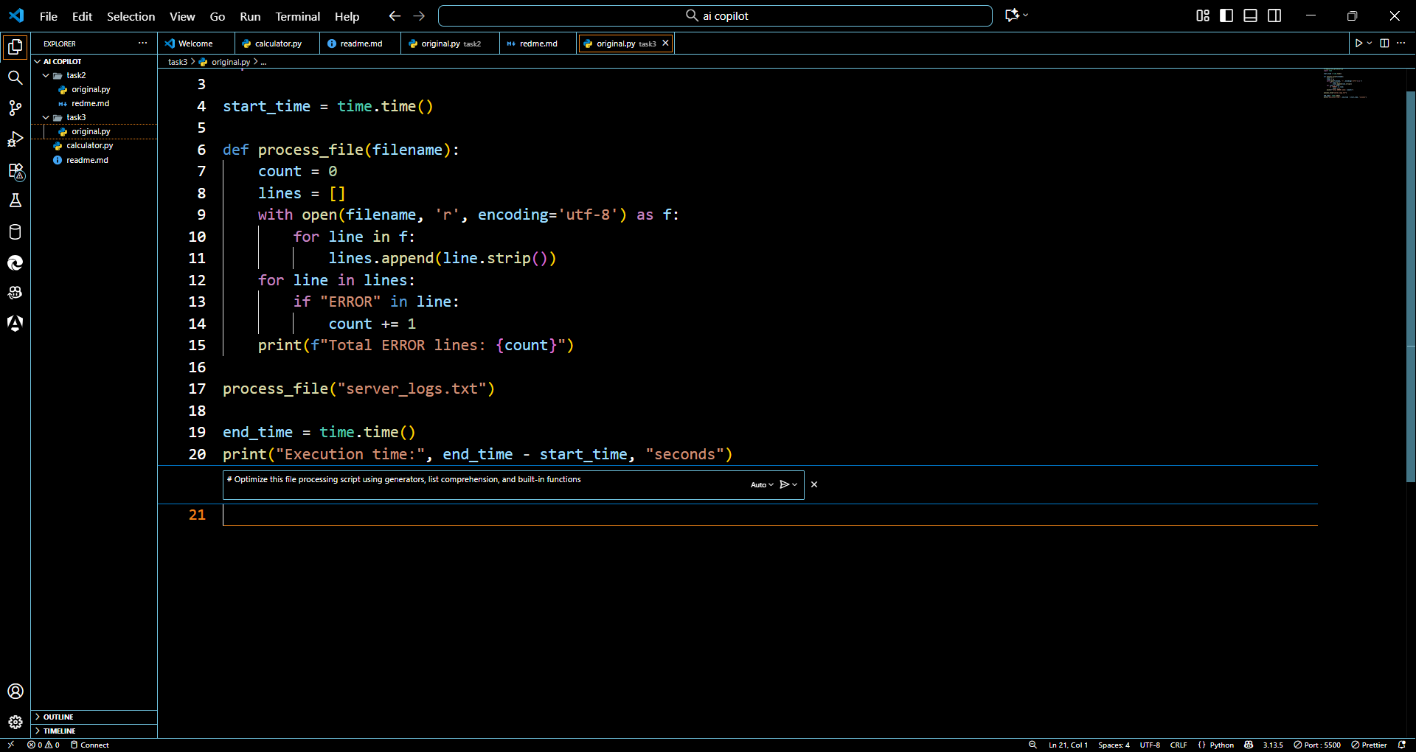  Refactored:  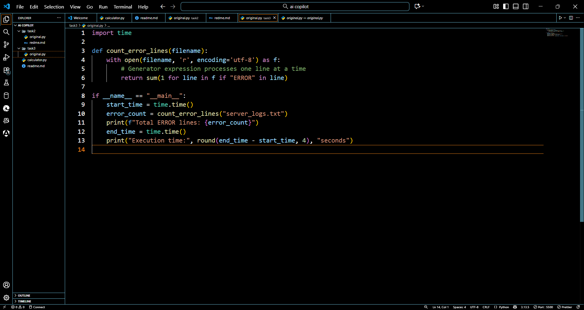  Readme file  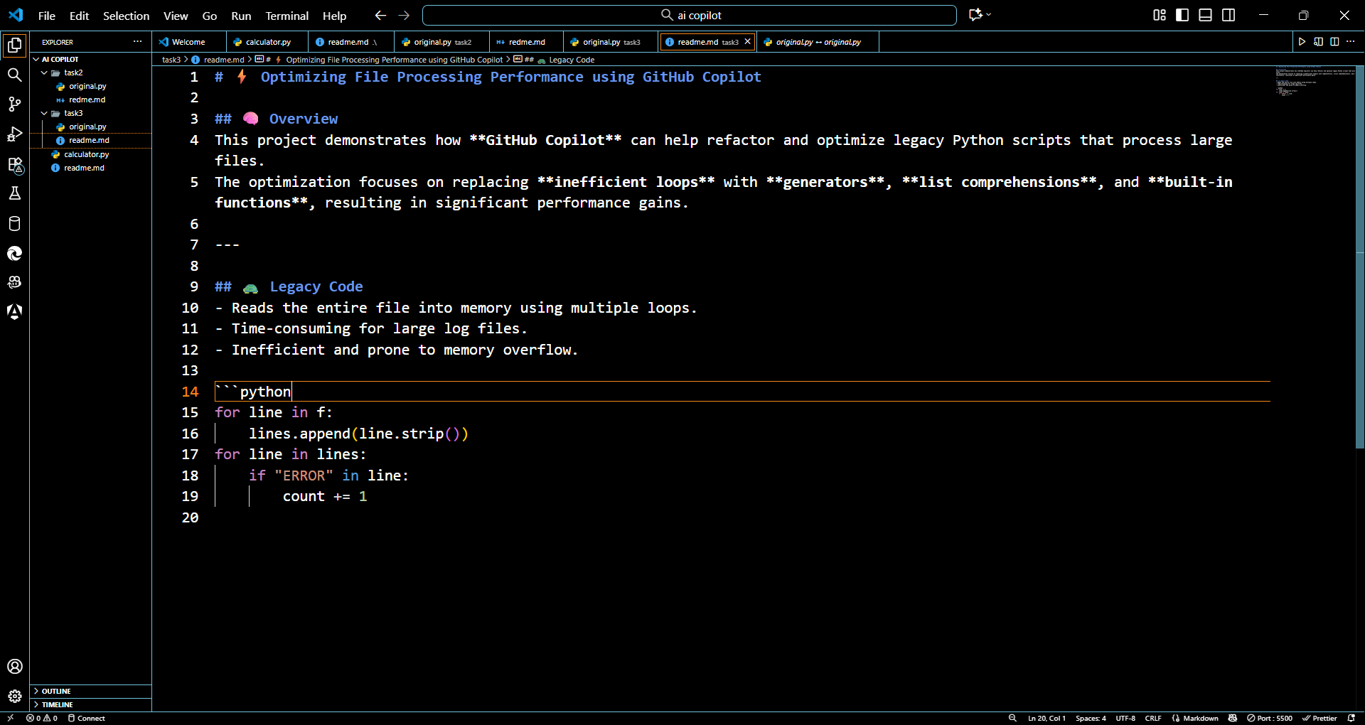  Task 4: Enhancing Readability and Documentation  Scenario:  A research group has shared a scientific computation script with minimal comments, inconsistent naming, and poor readability.  - Upload the legacy code to GitHub.  - Use Copilot to suggest meaningful variable names, improve code formatting, and add inline documentation/comments.  - Generate an AI-assisted README.md file for the project explaining usage, inputs, and outputs.  - Original code:  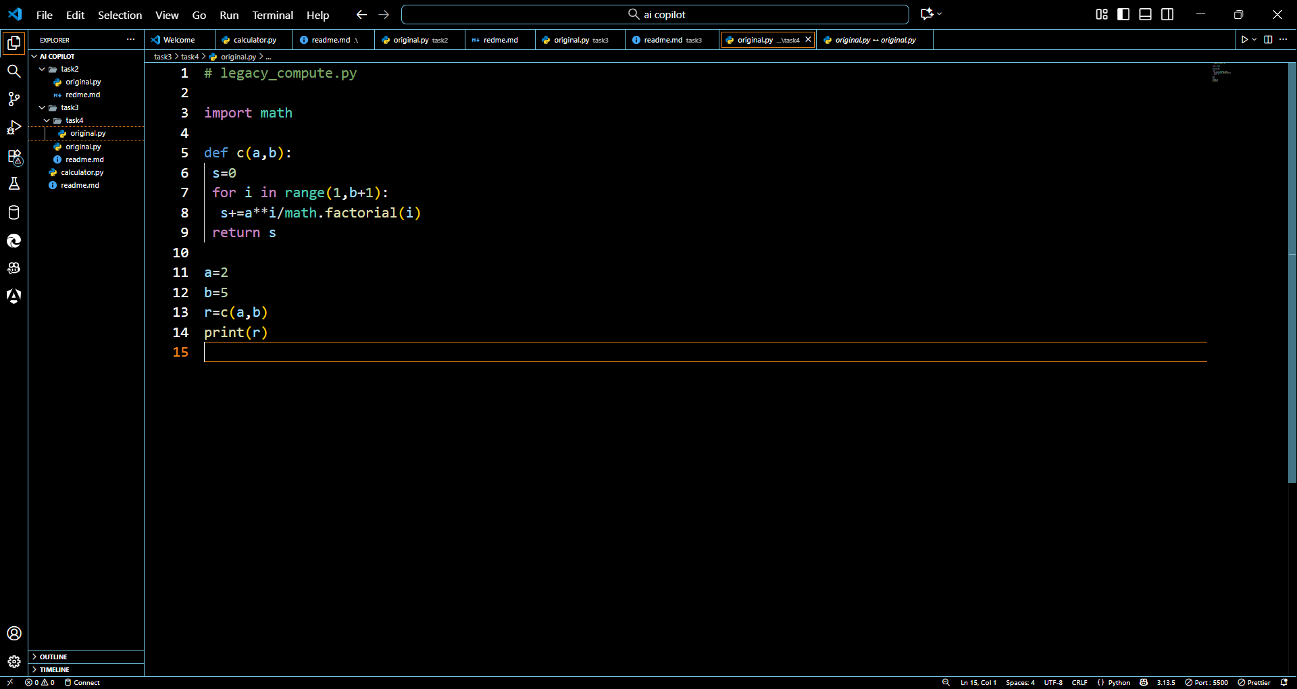  Prompt:  Refactor this scientific computation code with better variable names, docstrings, comments, and readability  Refactored code:  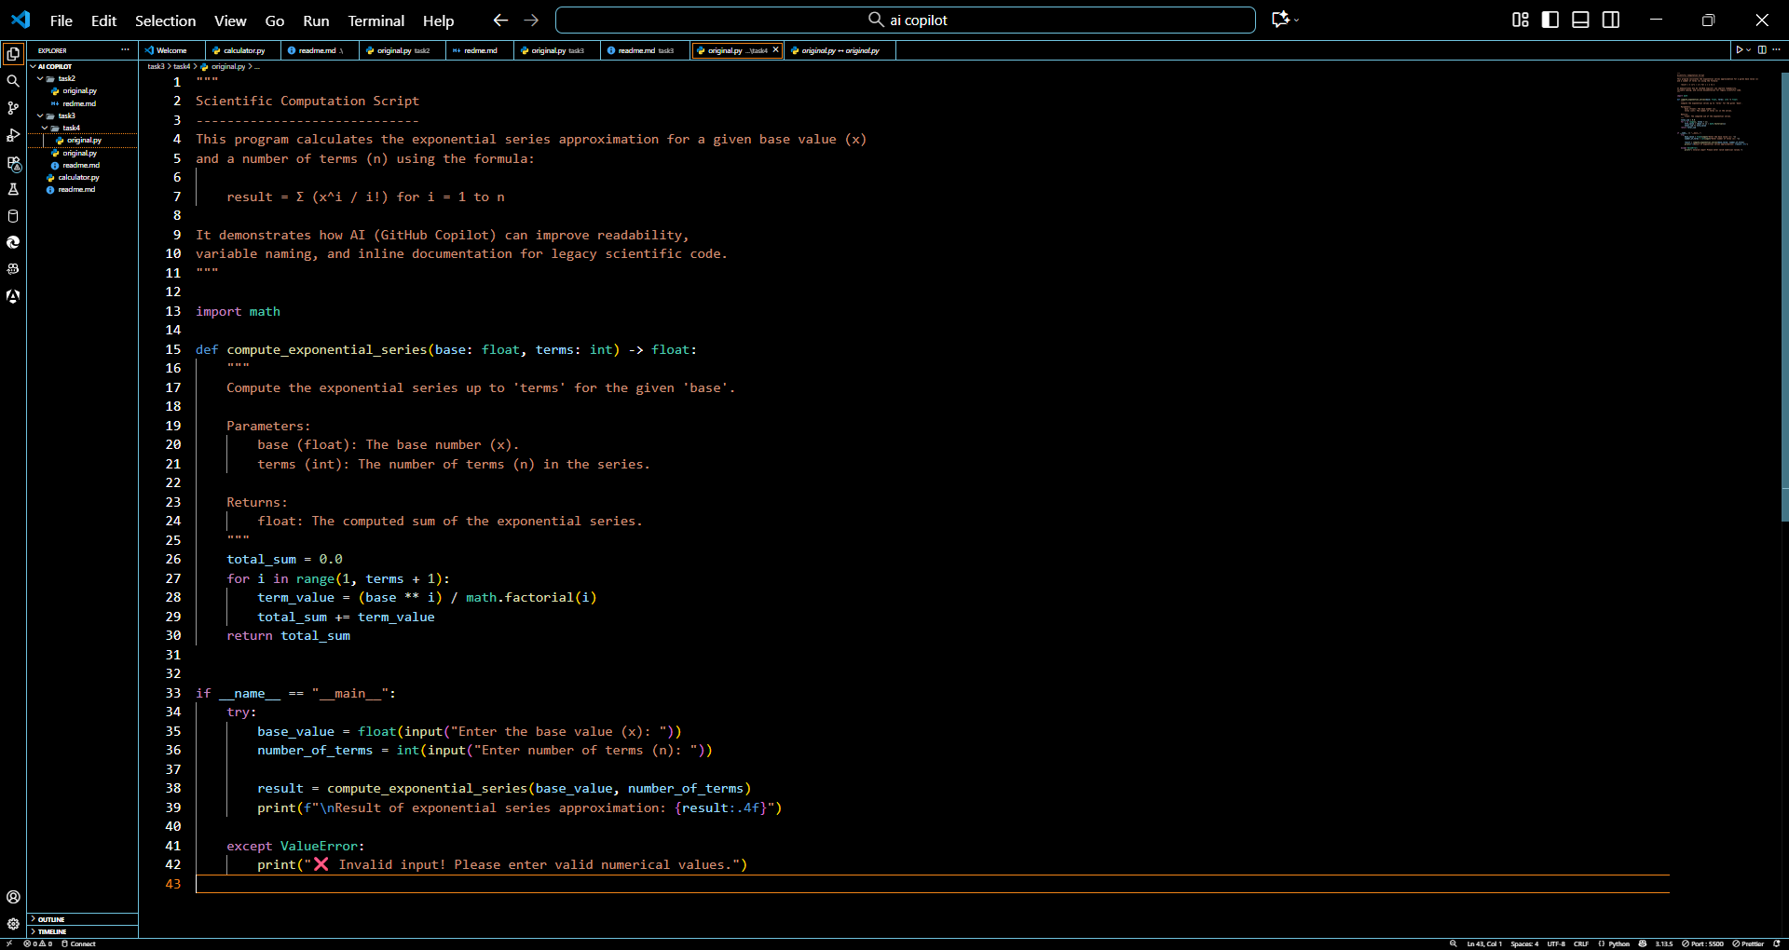  Output:  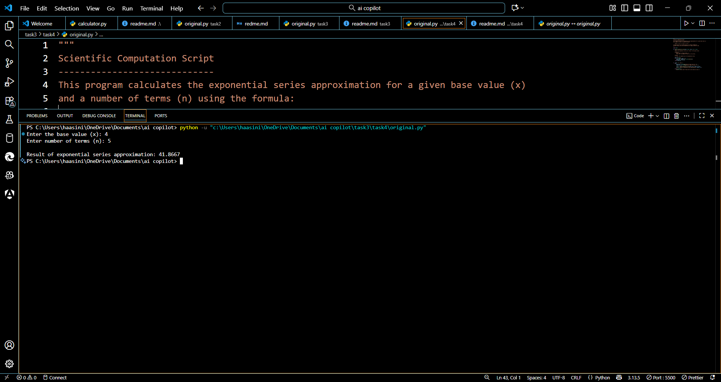Improvements Made  Renamed variables → a → base_value, b → number_of_terms, s → total_sum.  Added function docstrings and inline comments.  Included error handling.  User-friendly input and formatted output.  Enhanced readability and structure.  Readme file:  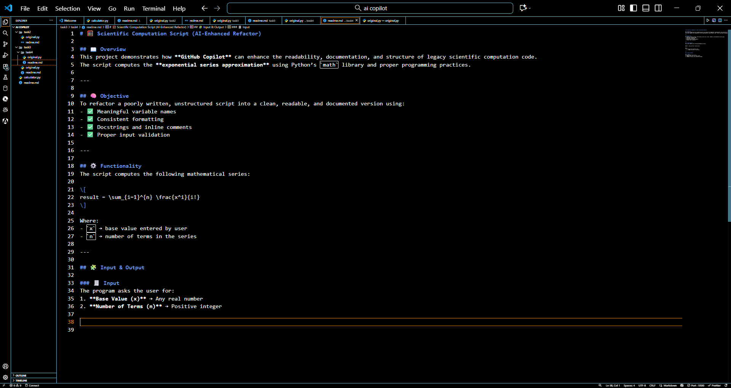 |  |  |  |  |  | Week 7 - Friday

