SCHOOL OF COMPUTER SCIENCE AND ARTIFICIAL INTELLIGENCE |  |  |  |  | DEPARTMENT OF COMPUTER SCIENCE ENGINEERING
Program Name: B. Tech |  |  |  | Assignment Type: Lab |  |  | Academic Year:2025-2026
Course Coordinator Name |  |  |  | Venkataramana Veeramsetty
Instructor(s) Name |  |  |  | Dr. V. Venkataramana (Co-ordinator)  Dr. T. Sampath Kumar  Dr. Pramoda Patro  Dr. Brij Kishor Tiwari  Dr.J.Ravichander  Dr. Mohammand Ali Shaik  Dr. Anirodh Kumar  Mr. S.Naresh Kumar  Dr. RAJESH VELPULA  Mr. Kundhan Kumar  Ms. Ch.Rajitha  Mr. M Prakash  Mr. B.Raju  Intern 1 (Dharma teja)  Intern 2 (Sai Prasad)  Intern 3 (Sowmya)  NS_2 ( Mounika)
Course Code |  |  | 24CS002PC215 | Course Title |  | AI Assisted Coding
Year/Sem |  |  | II/I | Regulation |  | R24
Date and Day  of Assignment |  |  | Week7 - Monday | Time(s)
Duration |  |  | 2 Hours | Applicable to  Batches
AssignmentNumber:14.1(Present assignment number)/24(Total number of assignments)
 | Q.No. | Question |  |  |  |  |  | Expected Time  to complete
 | 1 | Lab 14: Web Design Application – AI-Assisted HTML/CSS/JS Generation  Lab Objectives  - Design functional, visually appealing web applications using HTML, CSS, and JavaScript with AI assistance.  - Apply responsive, accessible, and interactive design principles.  - Create practical UI components for real-world web applications.  - Use AI to optimize layout, UX, and performance.  Task 1: AI-Assisted Portfolio Website  Scenario:  A student wants to showcase their projects, skills, and contact details in a portfolio website. Instead of writing all code manually, they want to speed up the process using GitHub Copilot.  - Use Copilot to generate an HTML structure for a personal portfolio page (sections: Home, About, Projects, Contact).  - Ask Copilot to suggest responsive CSS styling for the layout (e.g., grid/flexbox).  - Customize Copilot’s suggestions to add a hover effect on project cards.  Prompt: Generate a responsive personal portfolio webpage using HTML and CSS with sections: Home, About, Projects, and Contact. Use semantic HTML5, Flexbox/Grid for layout, and add hover effects on project cards. Include a navbar, contact form, and footer. Suggest responsive CSS using flexbox/grid for the portfolio layout  - Code:  - 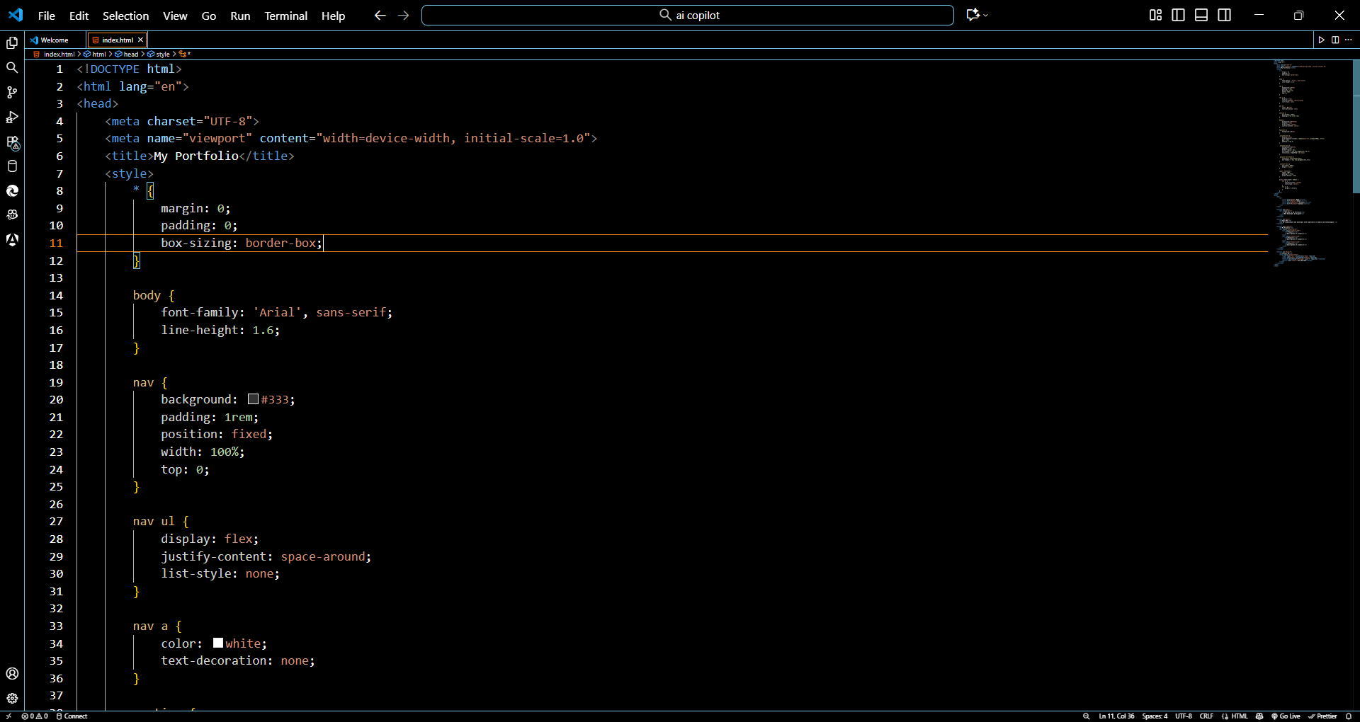  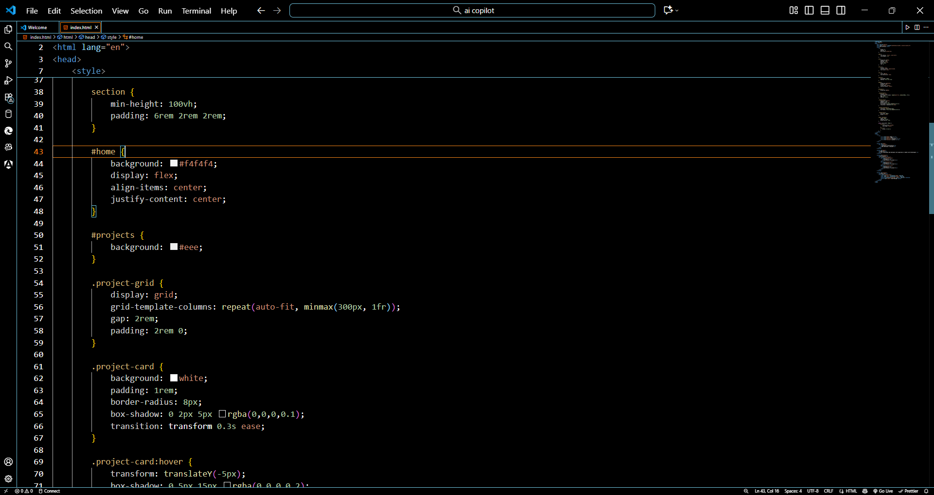  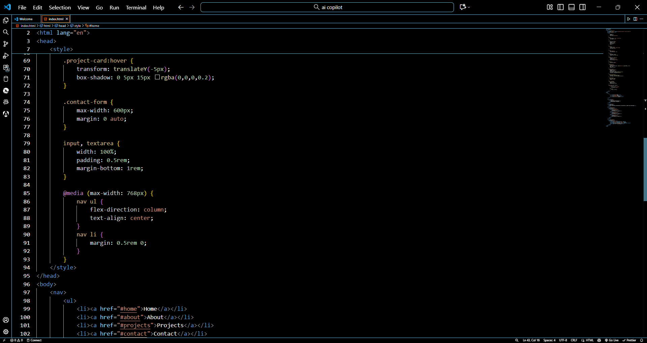  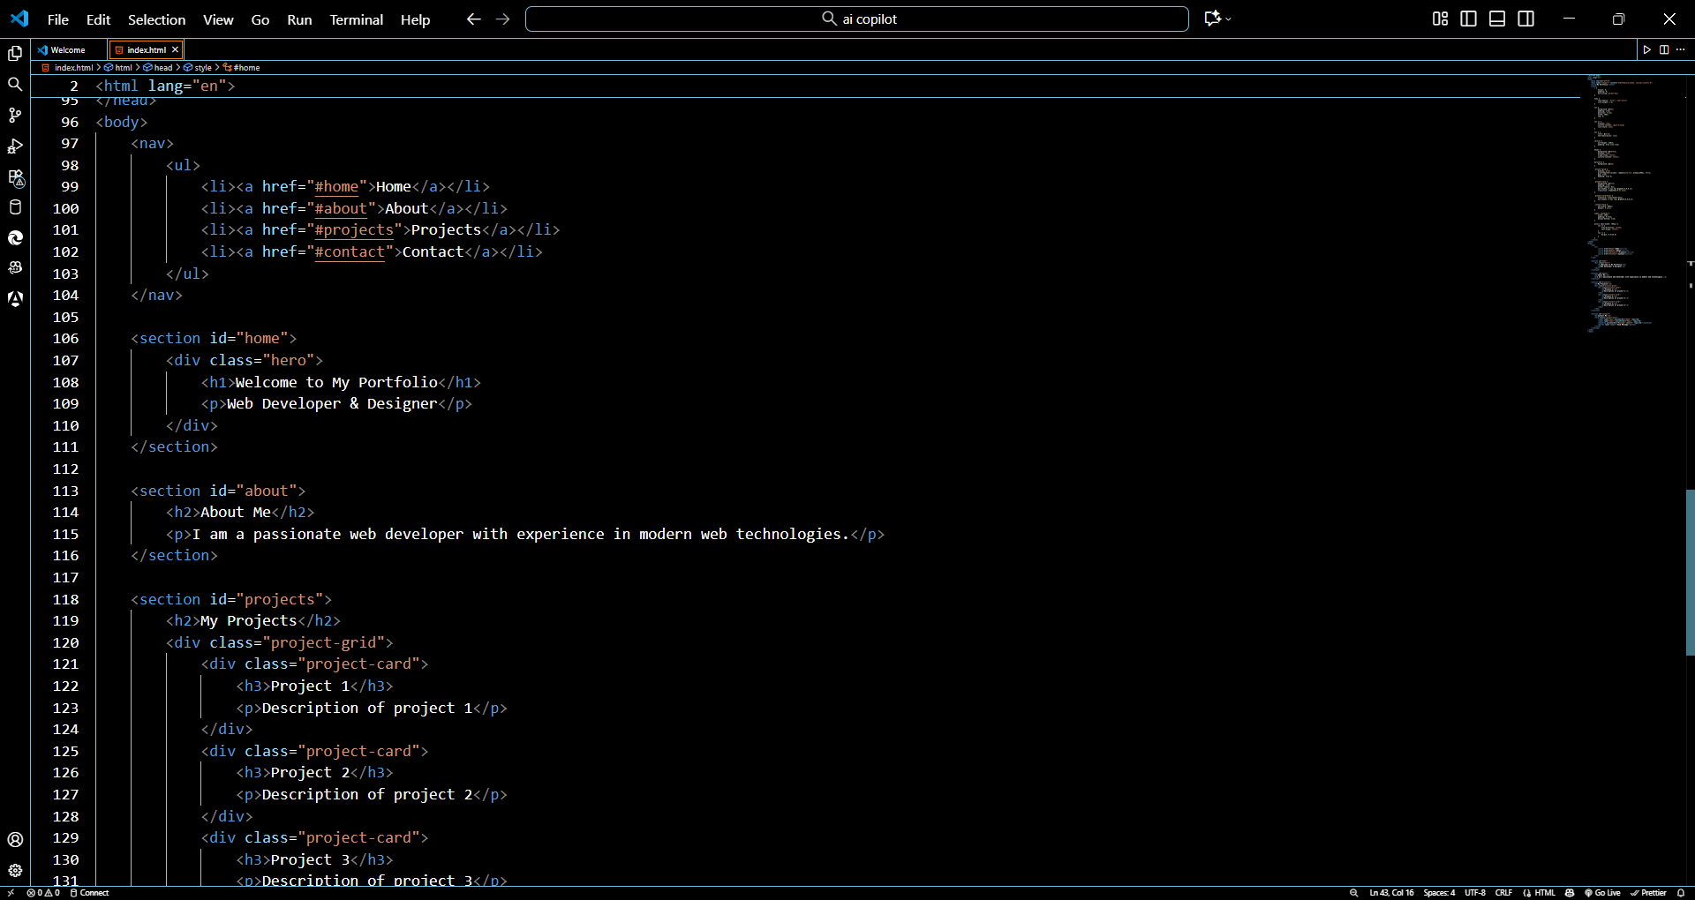  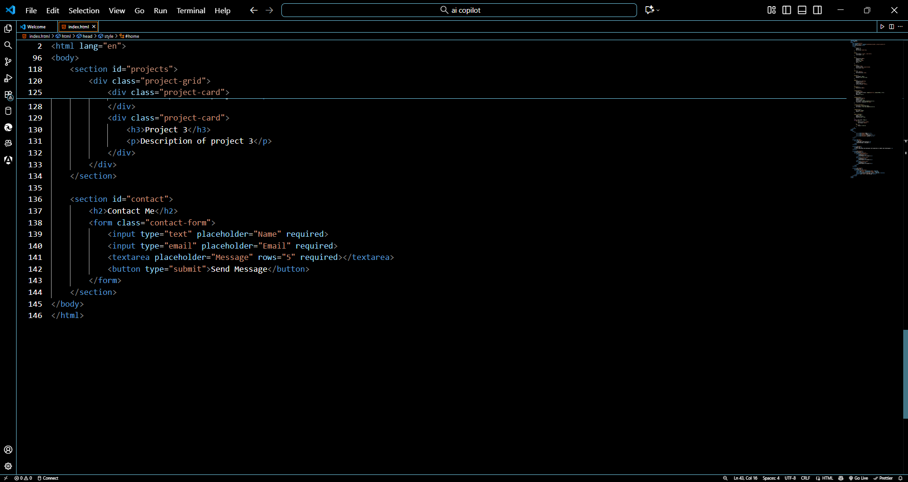  Output:  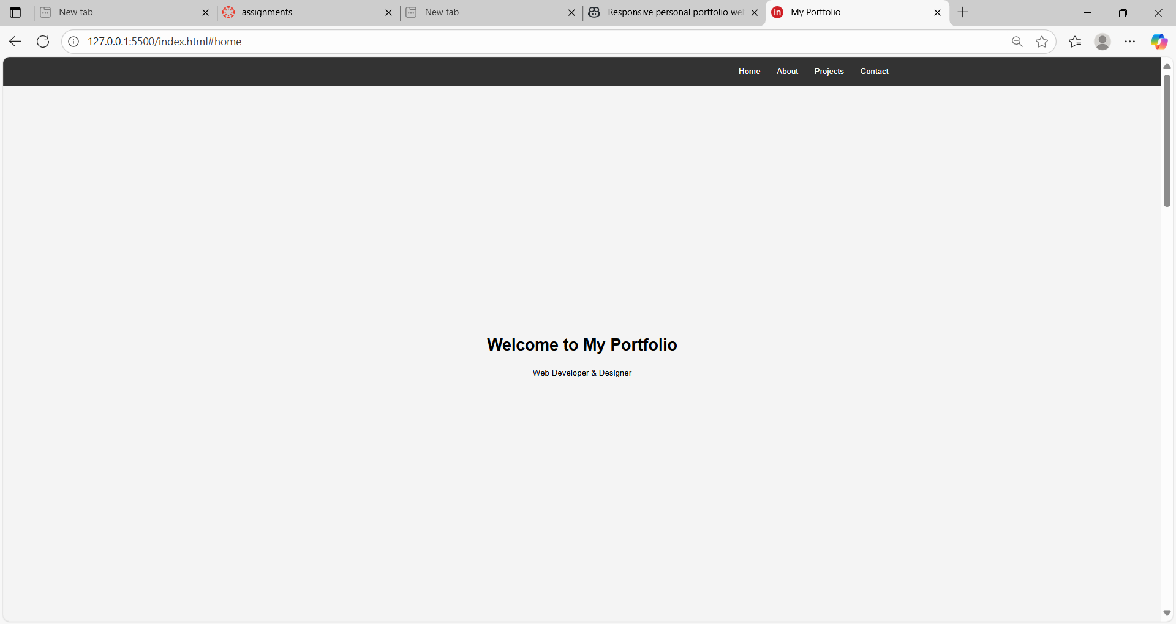  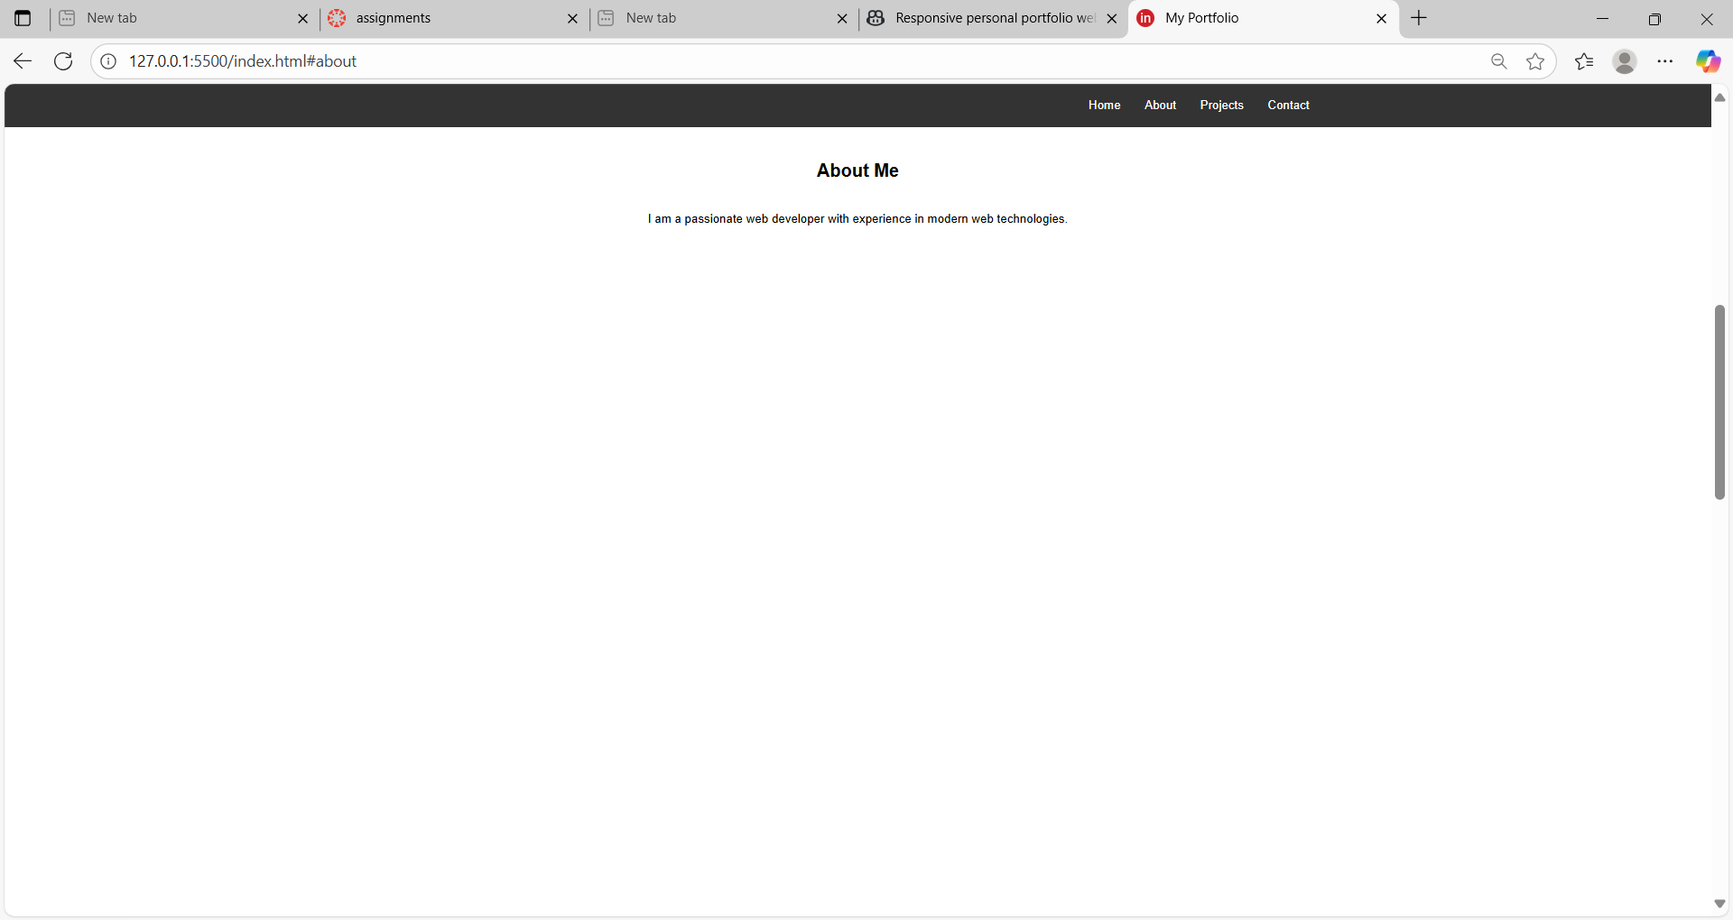  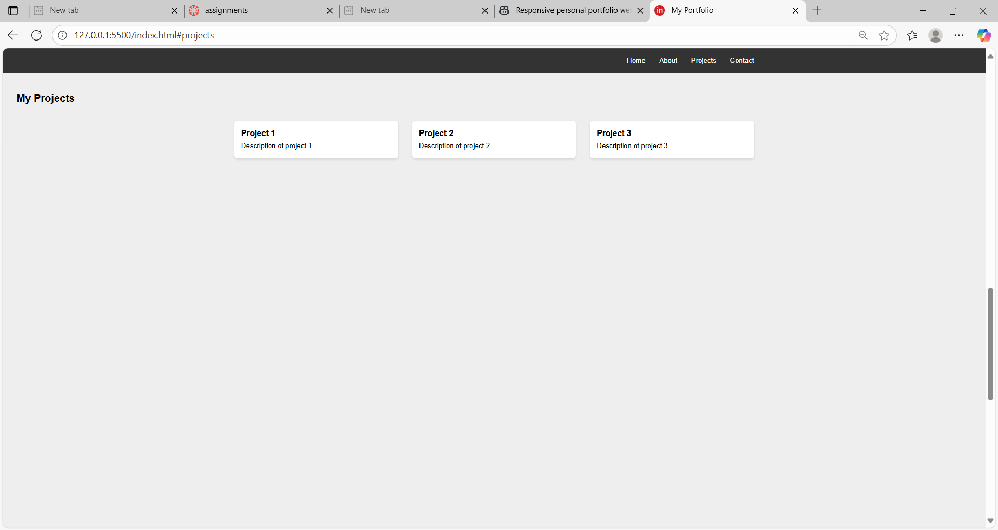  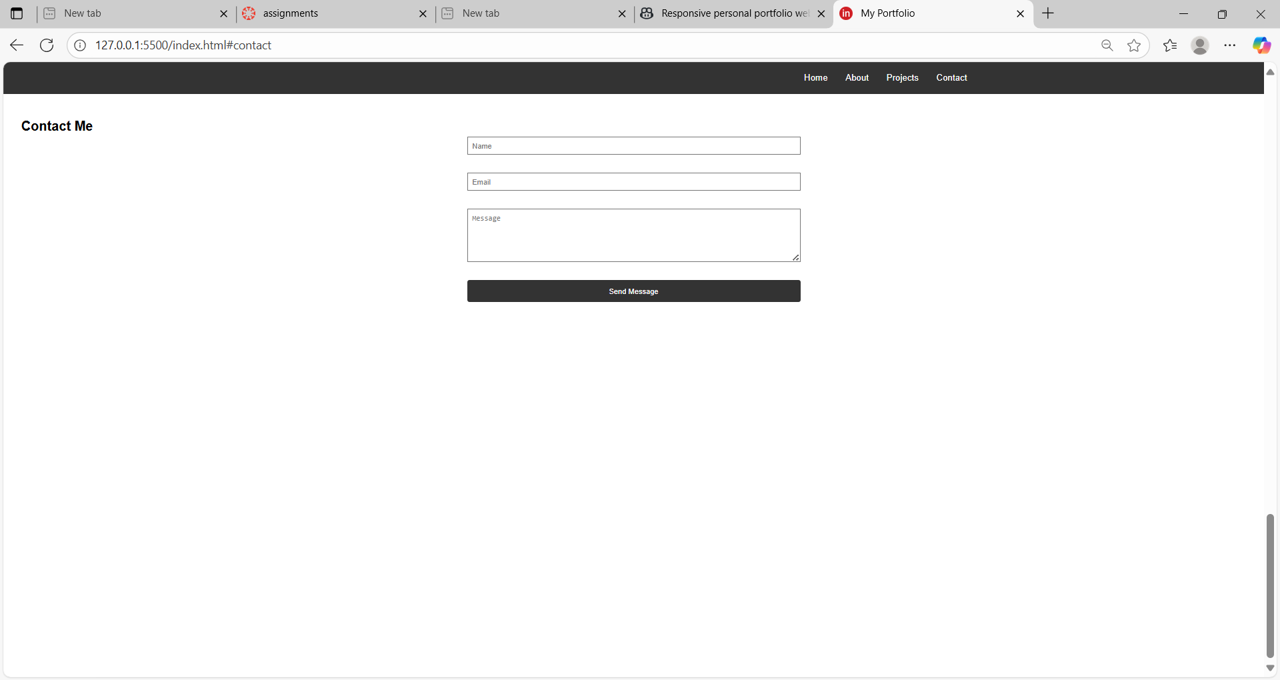  Task 2: AI-Generated Restaurant Landing Page  Scenario:  A local restaurant needs a simple landing page with a navigation bar, menu highlights, and an image gallery. The developer wants to quickly generate it using AI assistance.  - Use Copilot to create a navigation bar with links (Home, Menu, Gallery, Contact).  - Generate a menu section styled with CSS cards.  - Add a JavaScript-based image slider for the gallery, with Copilot suggesting the base code.  Prompt: Create a simple restaurant landing page with a navigation bar containing links (Home, Menu, Gallery, Contact). Below that, add a “Menu Highlights” section styled with CSS cards for dishes. Finally, create an image gallery with a JavaScript-based image slider (auto-sliding every 3 seconds) and navigation arrows. Make the design clean and modern using HTML, CSS, and JavaScript—all in one file.  Code:  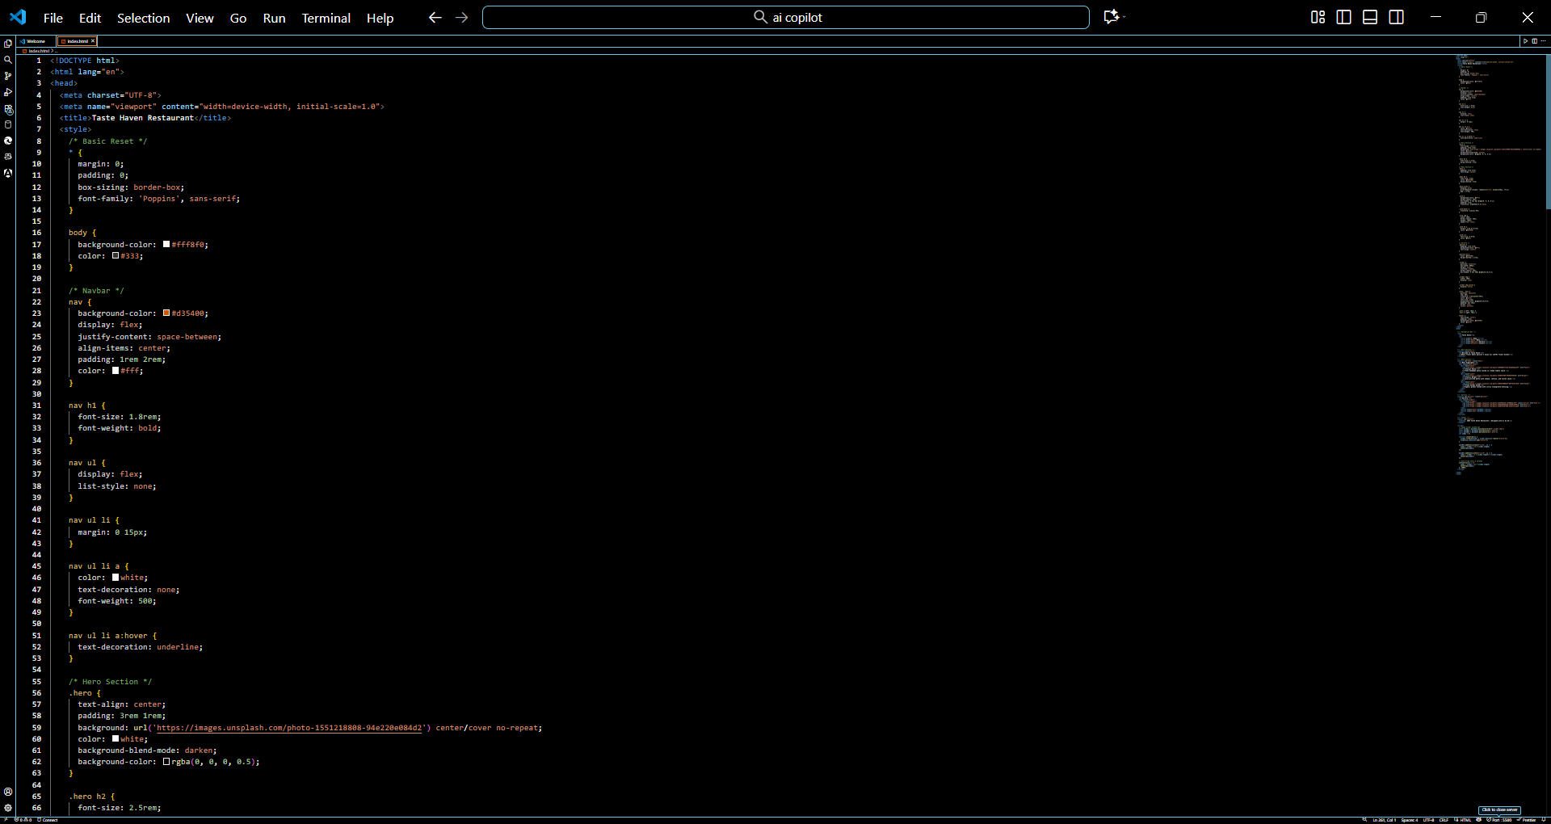  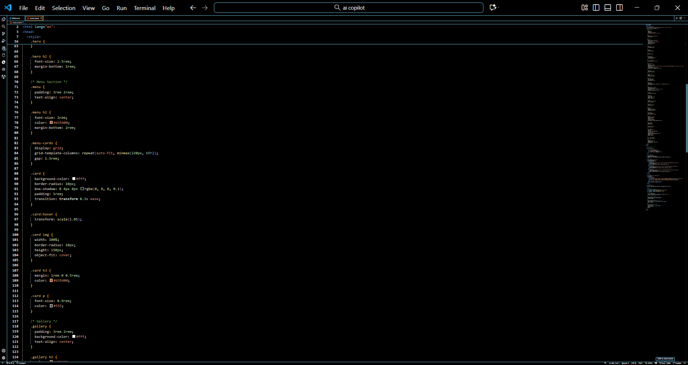  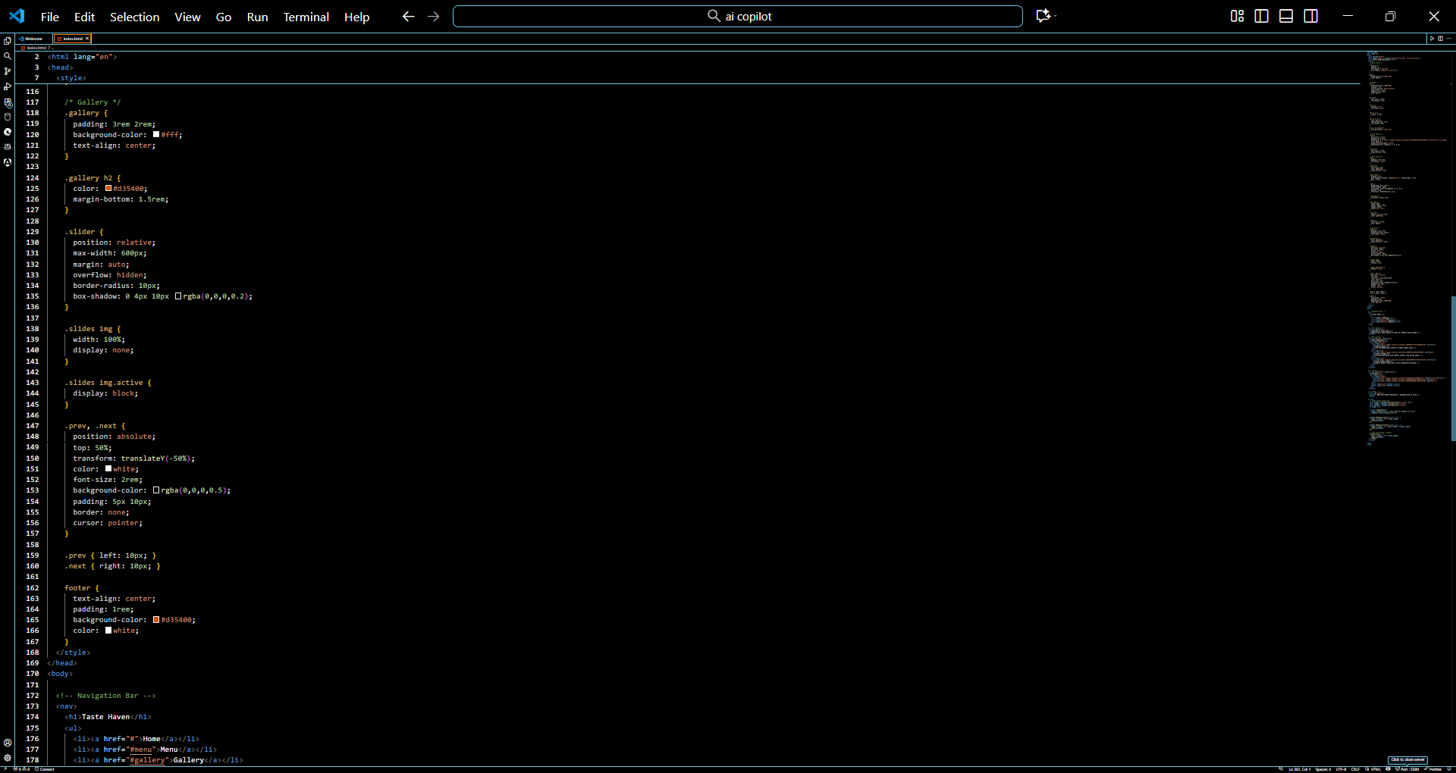  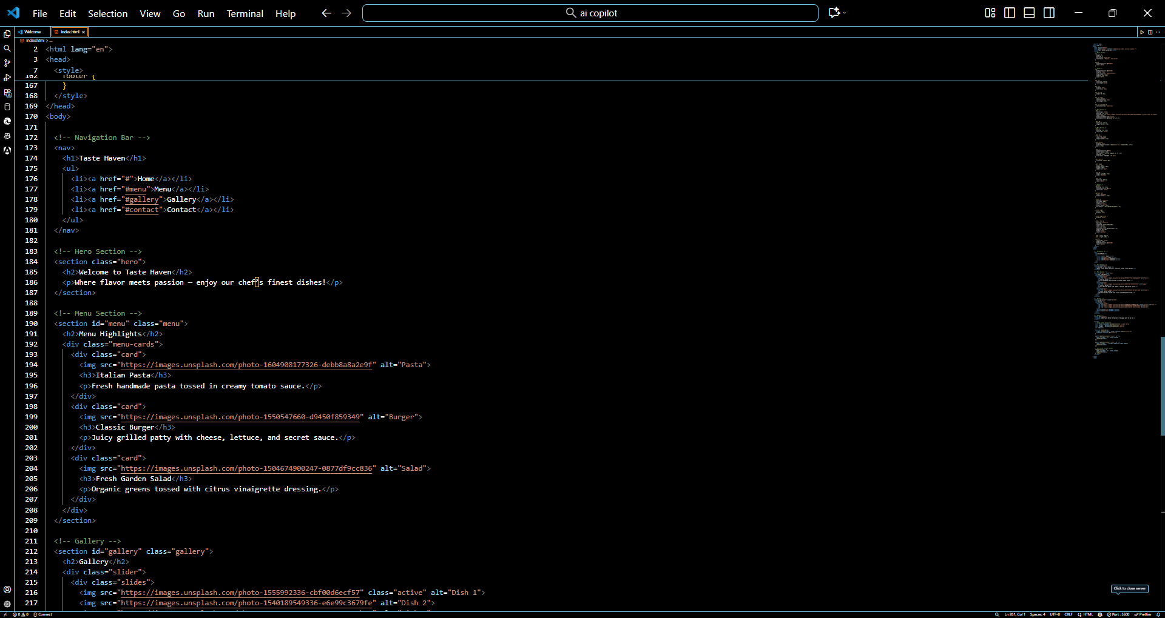  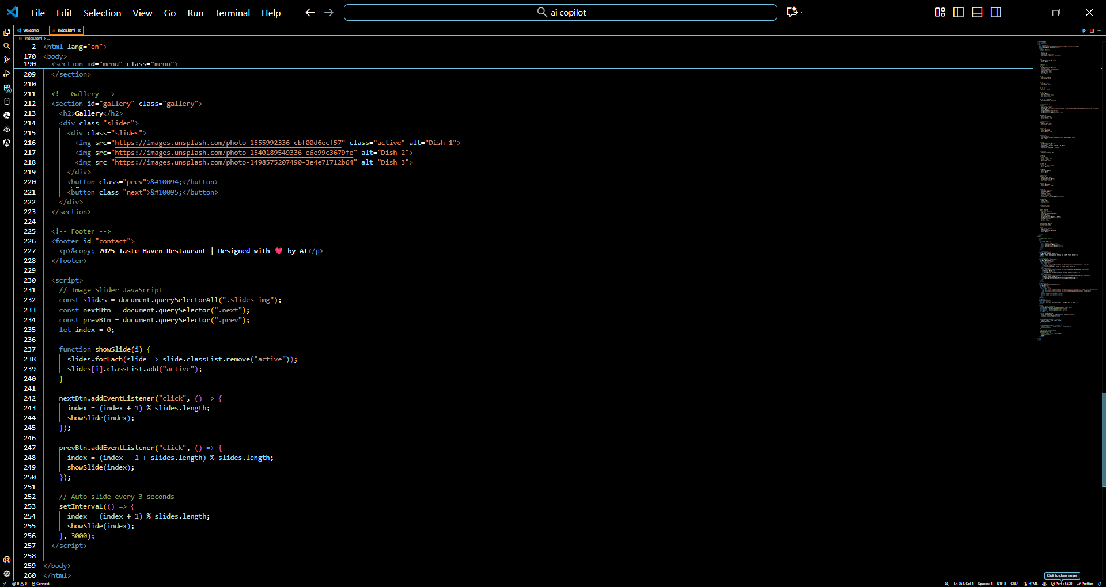  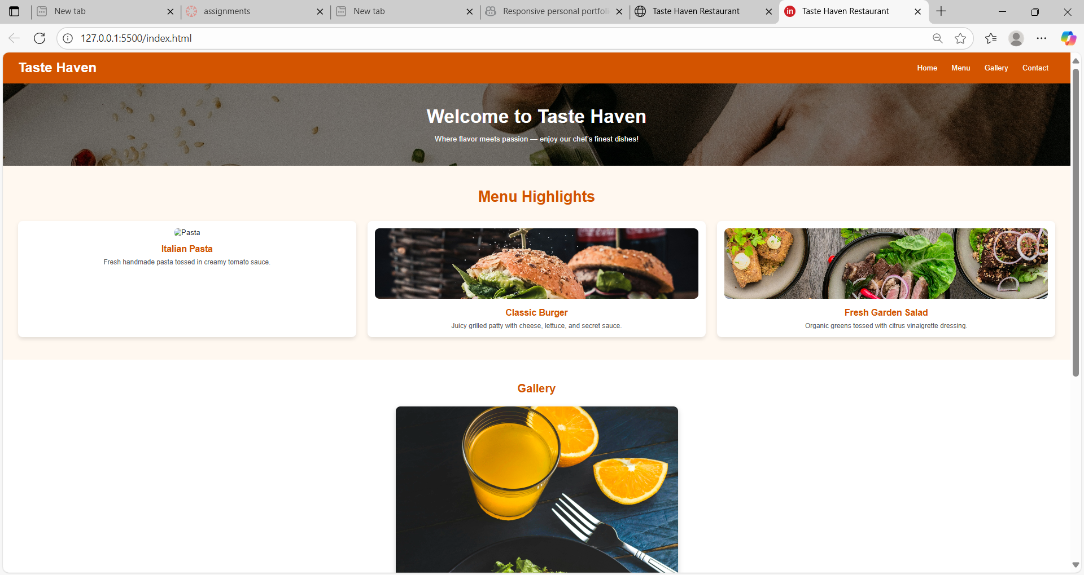  Task 3: AI-Powered Event Registration Form  Scenario:  SR University is hosting a tech fest. They need a web-based registration form for students. The form must validate user input in real-time.  - Ask Copilot to generate an HTML form (fields: Name, Email, Phone, Department, Event Selection).  - Use Copilot to assist in adding CSS styling for an attractive form layout.  - Implement JavaScript validation (e.g., email format check, phone number length check) using Copilot’s suggestions.  - Prompt: Create a web-based event registration form for SR University’s tech fest. The form should include fields for Name, Email, Phone, Department, and Event Selection. Add attractive CSS styling for a modern layout. Use JavaScript for real-time validation — check that the email is in a valid format and the phone number has exactly 10 digits. Display error messages dynamically below each field. Include a submit button that shows a success message when all validations pass.  Code:  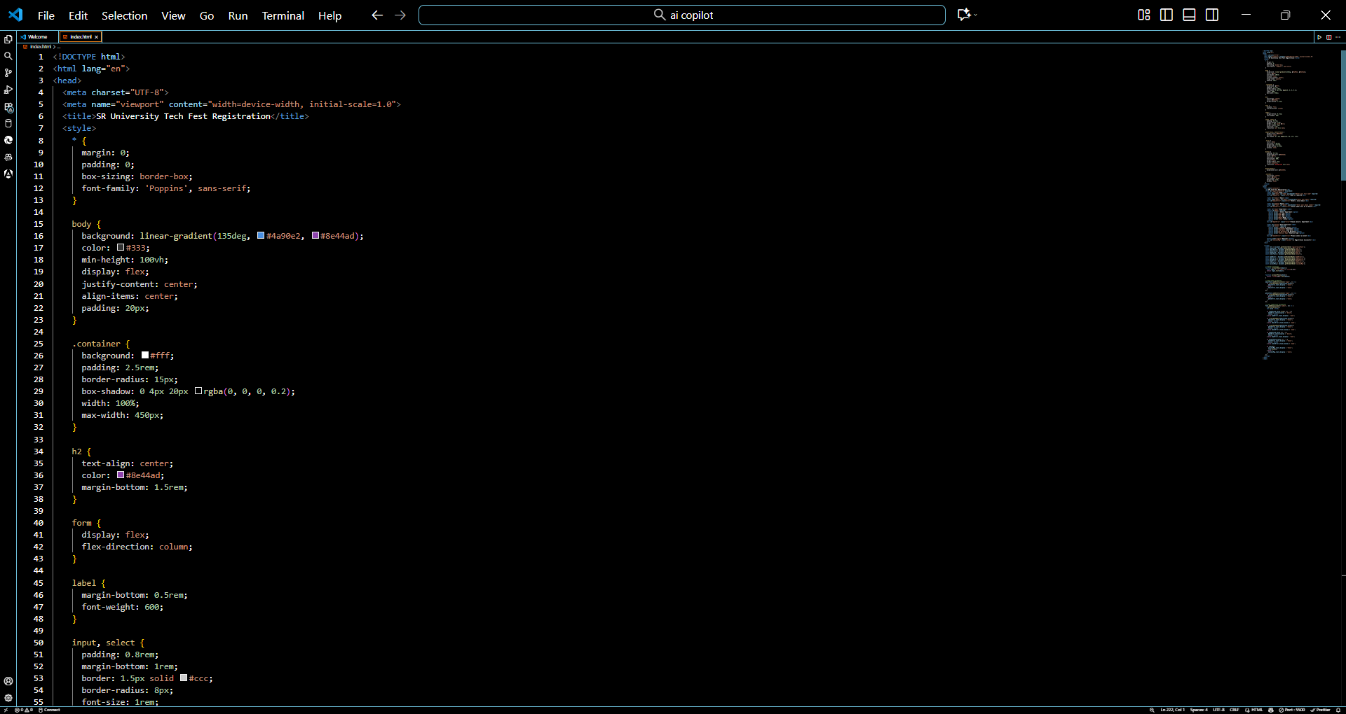  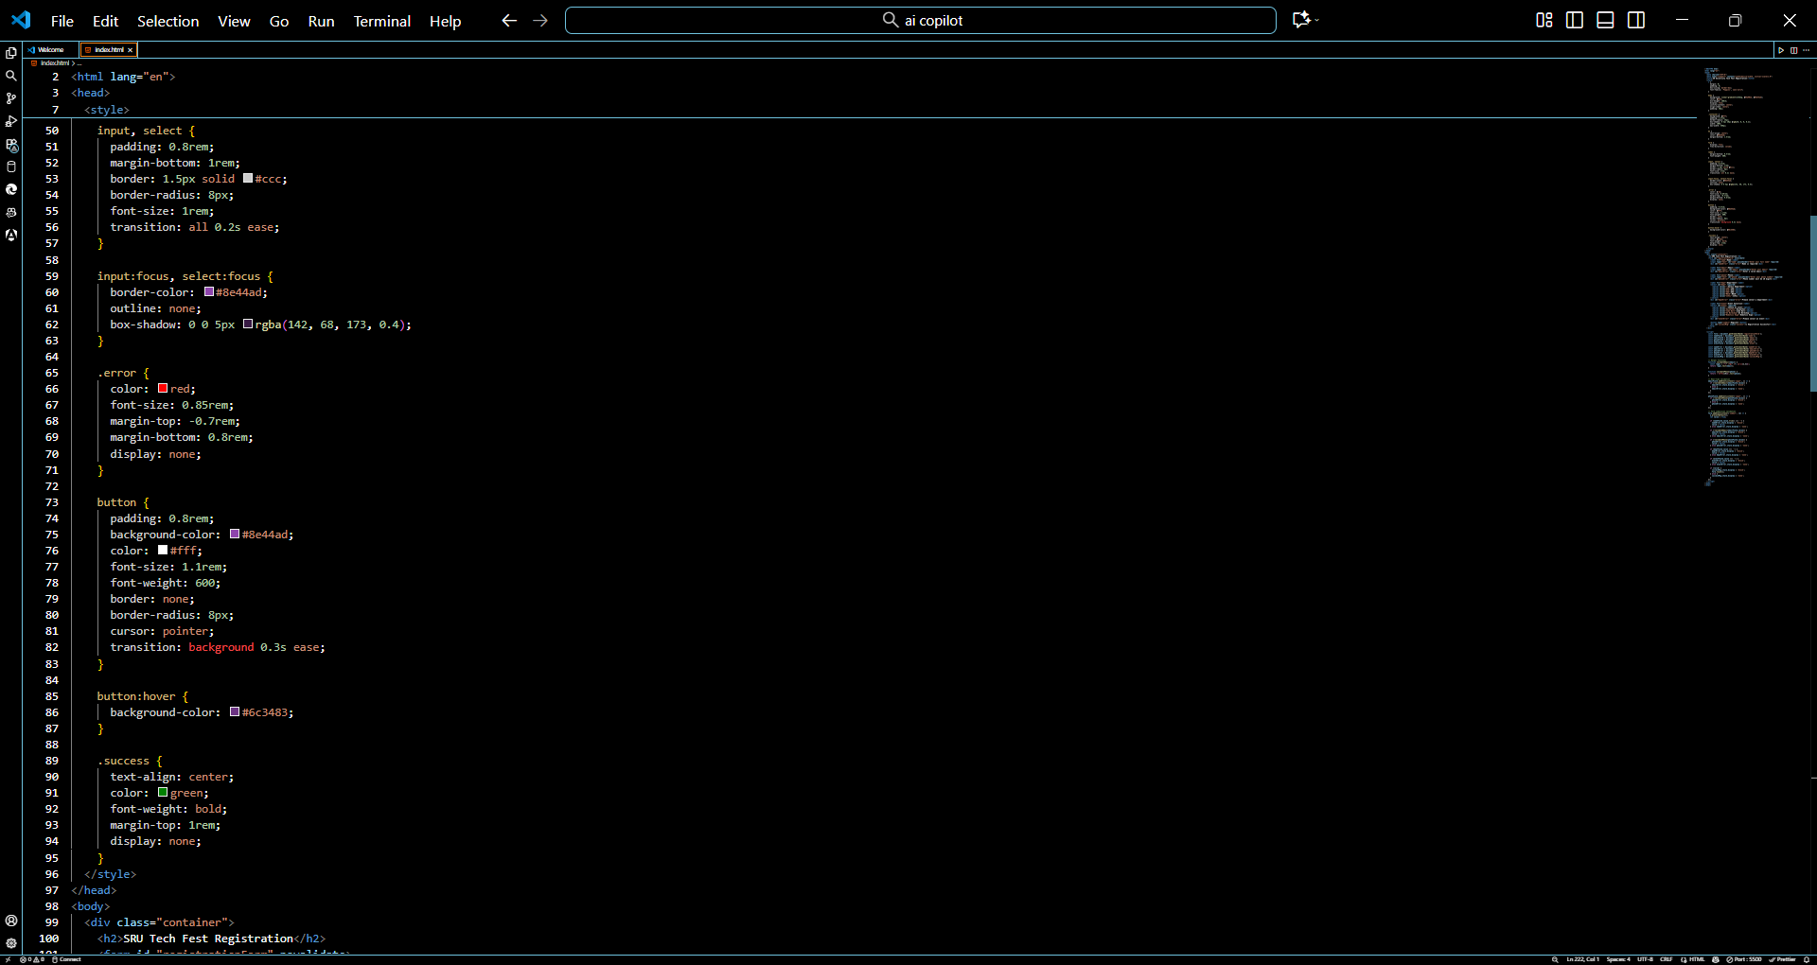  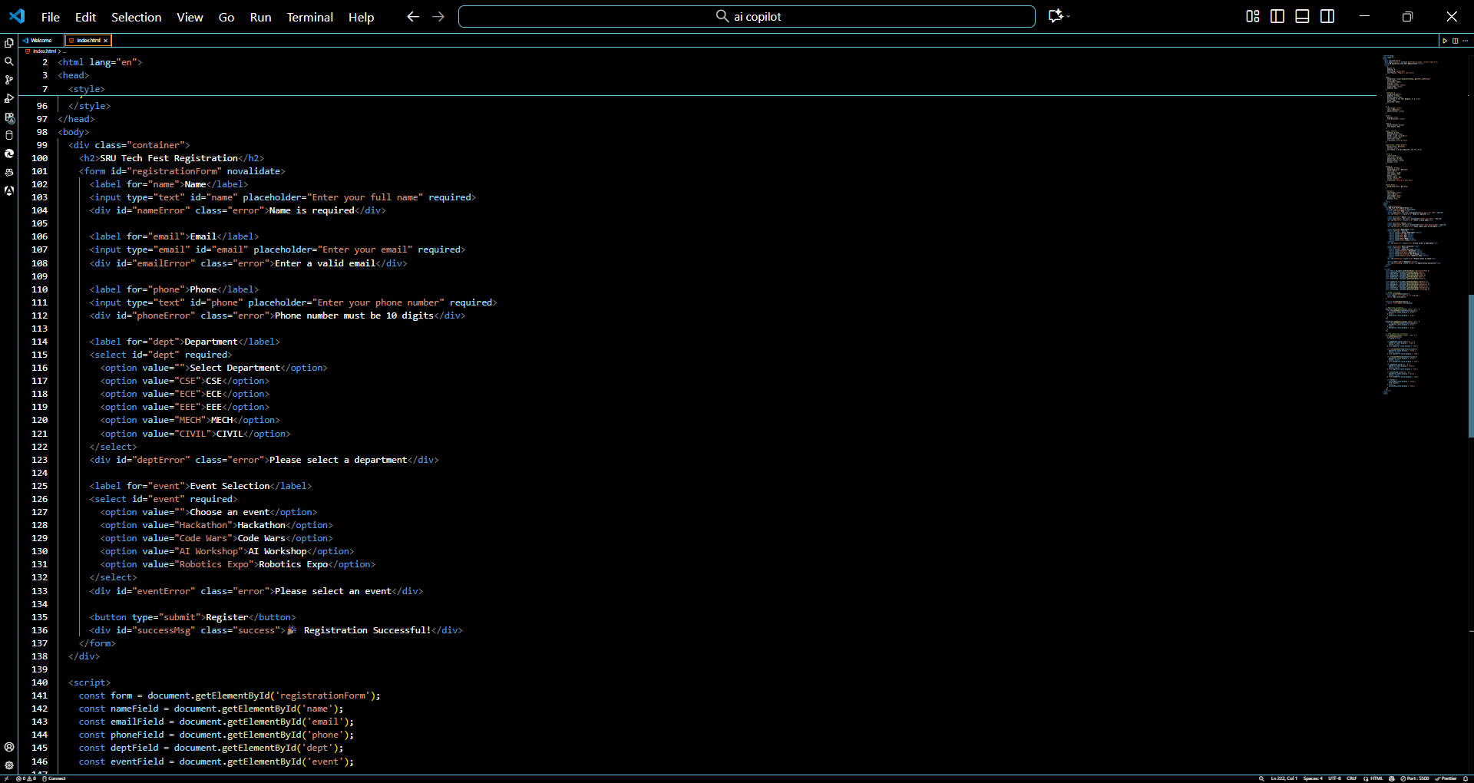  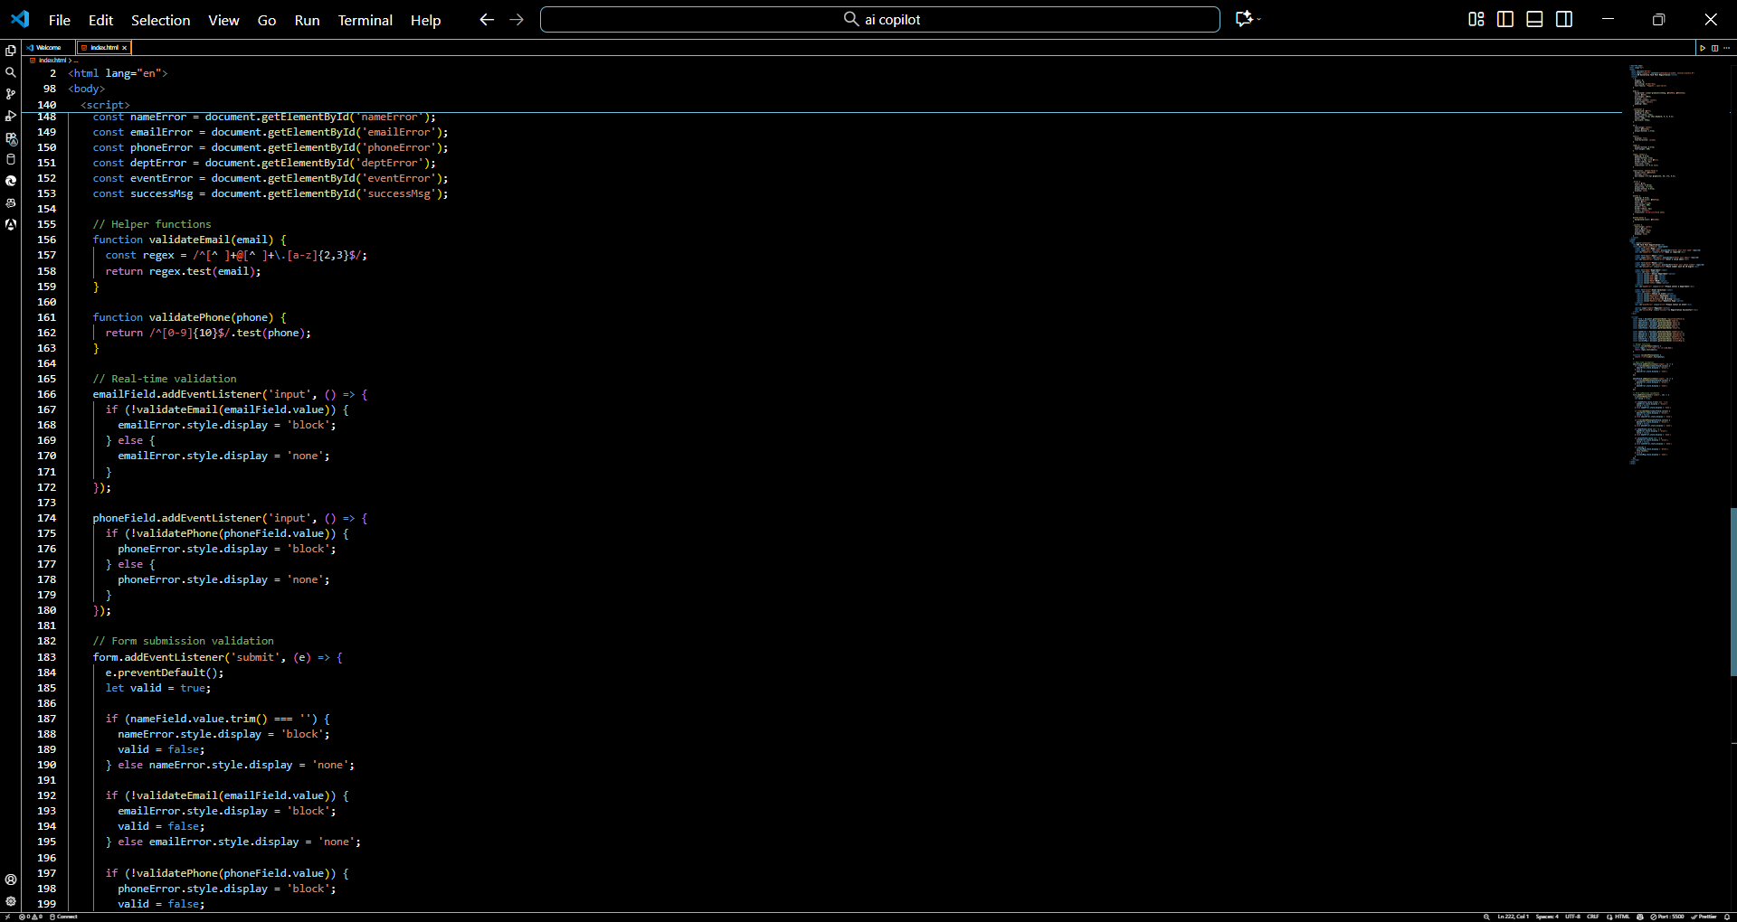  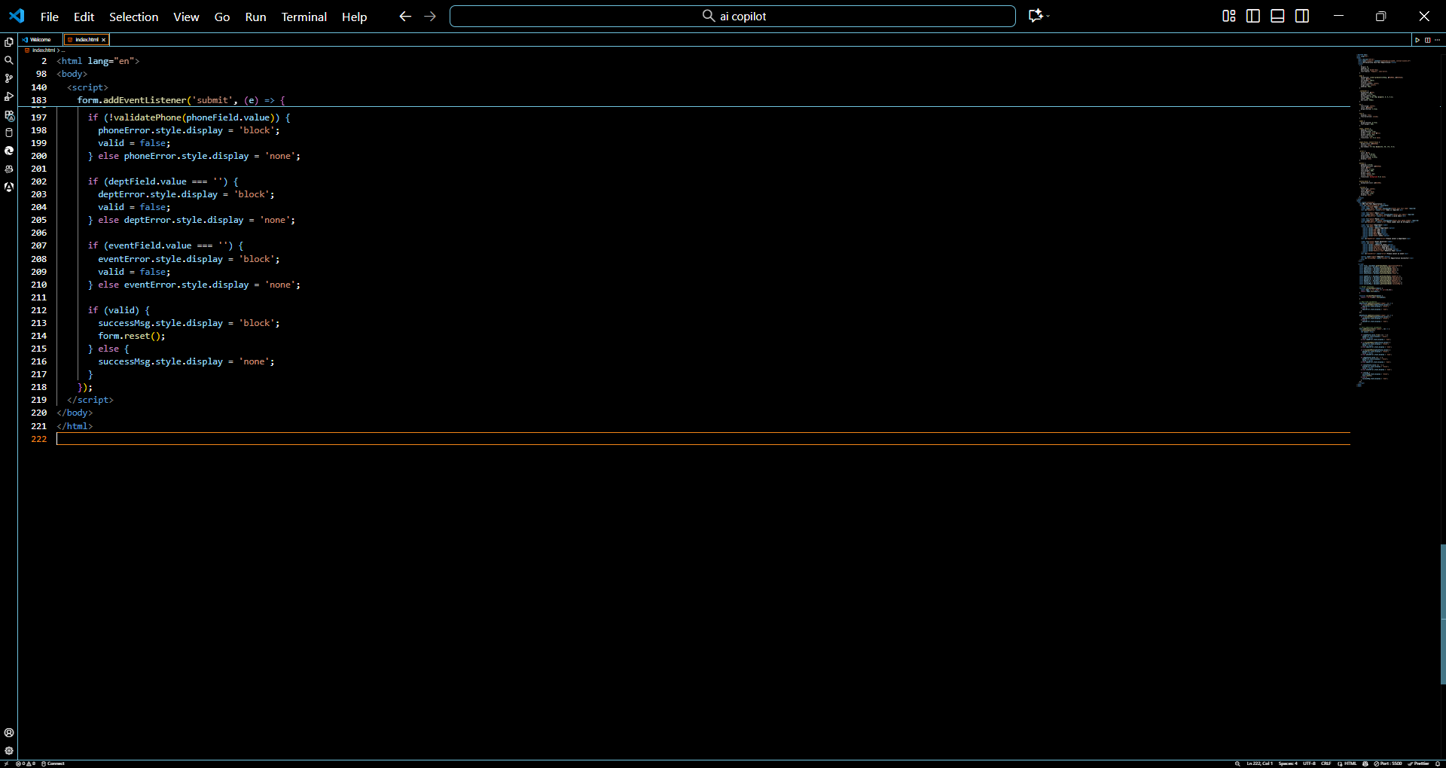  Output:  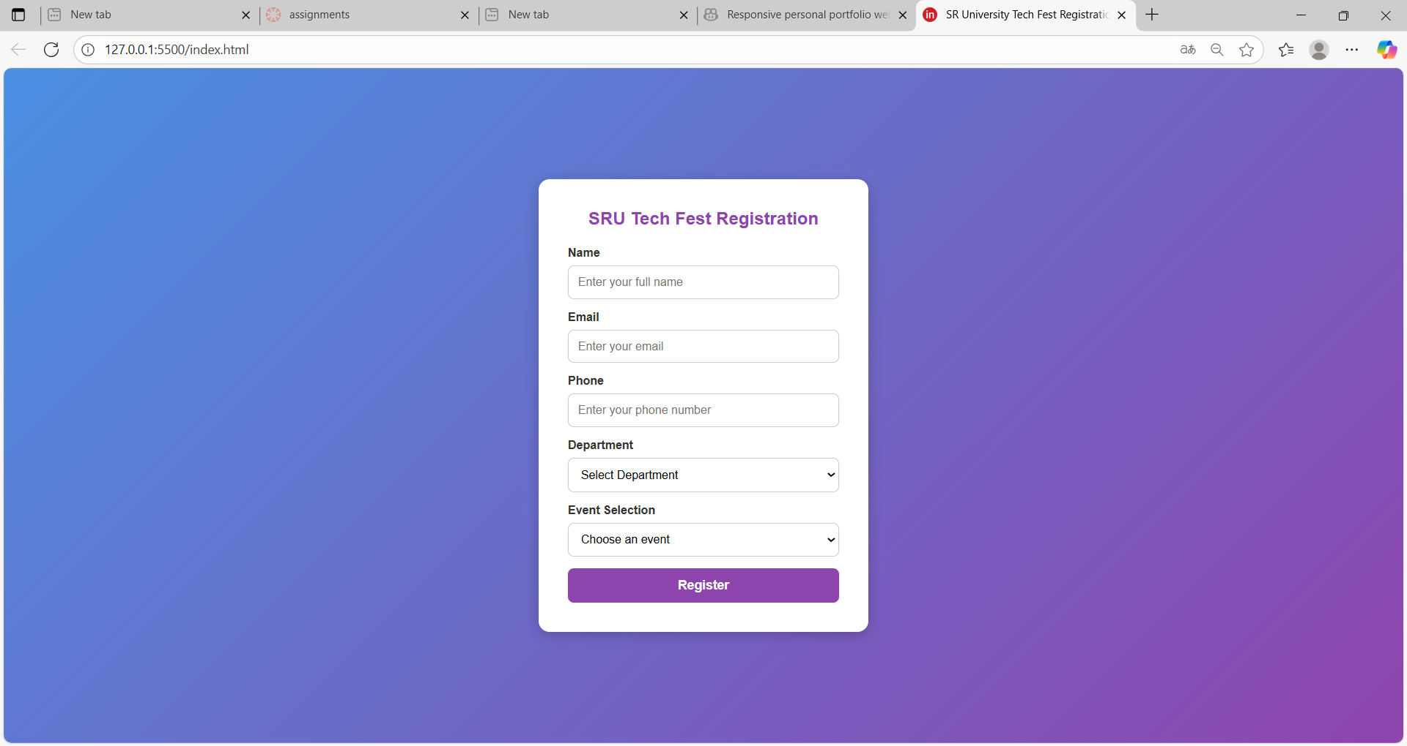  Task 4: AI-Assisted E-Commerce Product Page  Scenario:  A startup wants a basic e-commerce product page to display products with prices and an “Add to Cart” button.  - Use Copilot to generate a grid-based product catalog in HTML/CSS.  - Implement a JavaScript “Add to Cart” functionality with Copilot’s guidance.  - Modify Copilot’s suggestions to include a cart counter at the top-right corner of the page.  Prompt:  Create a simple e-commerce product page using HTML, CSS, and JavaScript. Use a grid layout to display multiple products with images, names, prices, and an “Add to Cart” button. Implement JavaScript functionality to update a cart counter at the top-right corner whenever a product is added. Style the page with a modern look using soft colors and hover effects. Include 4–6 sample products.  Code:  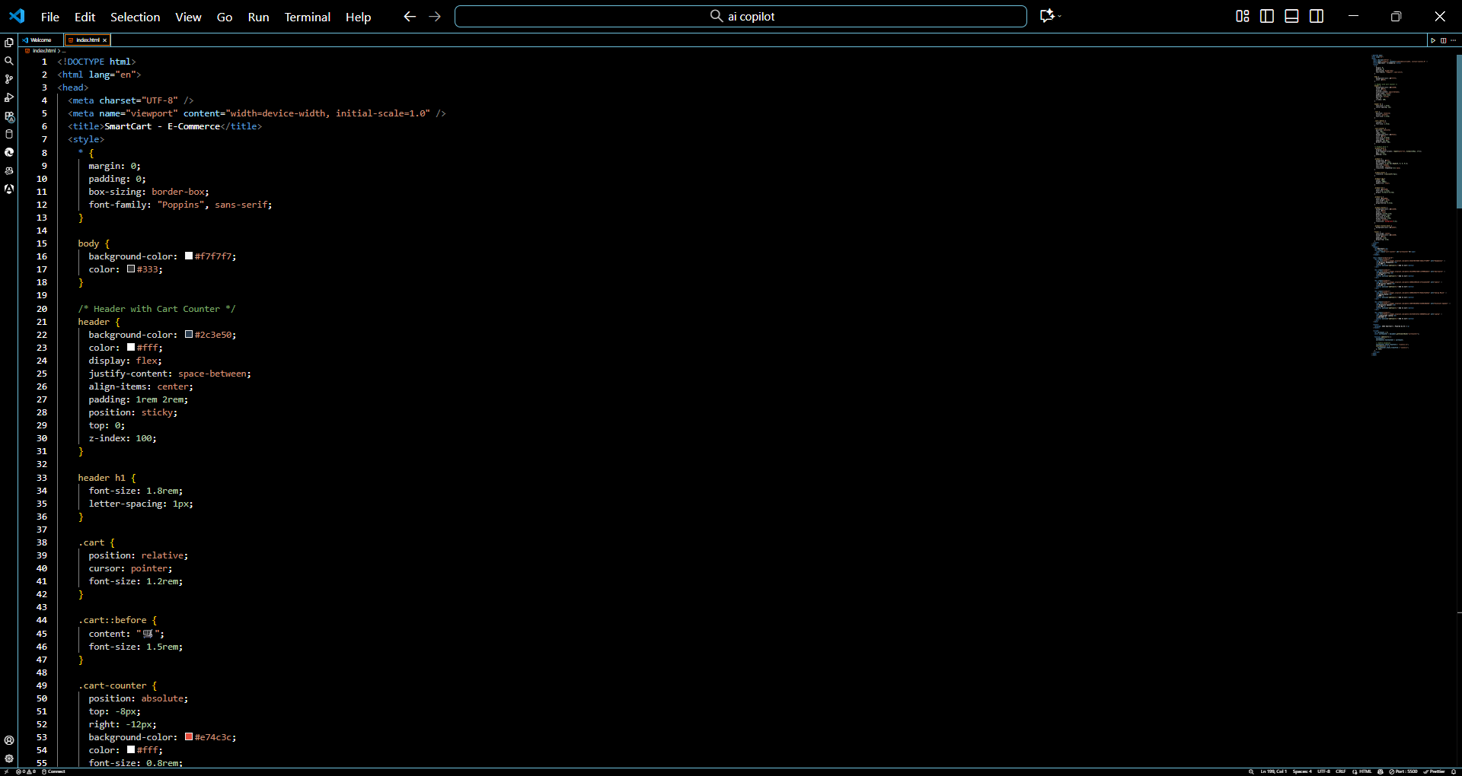  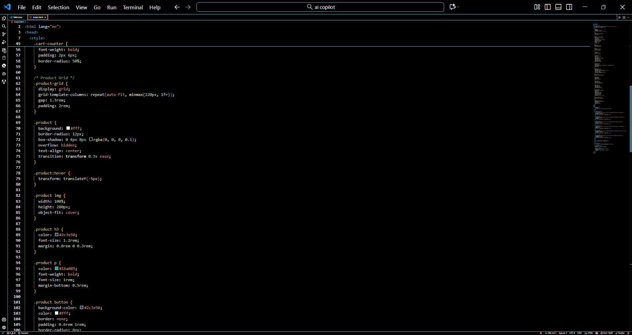  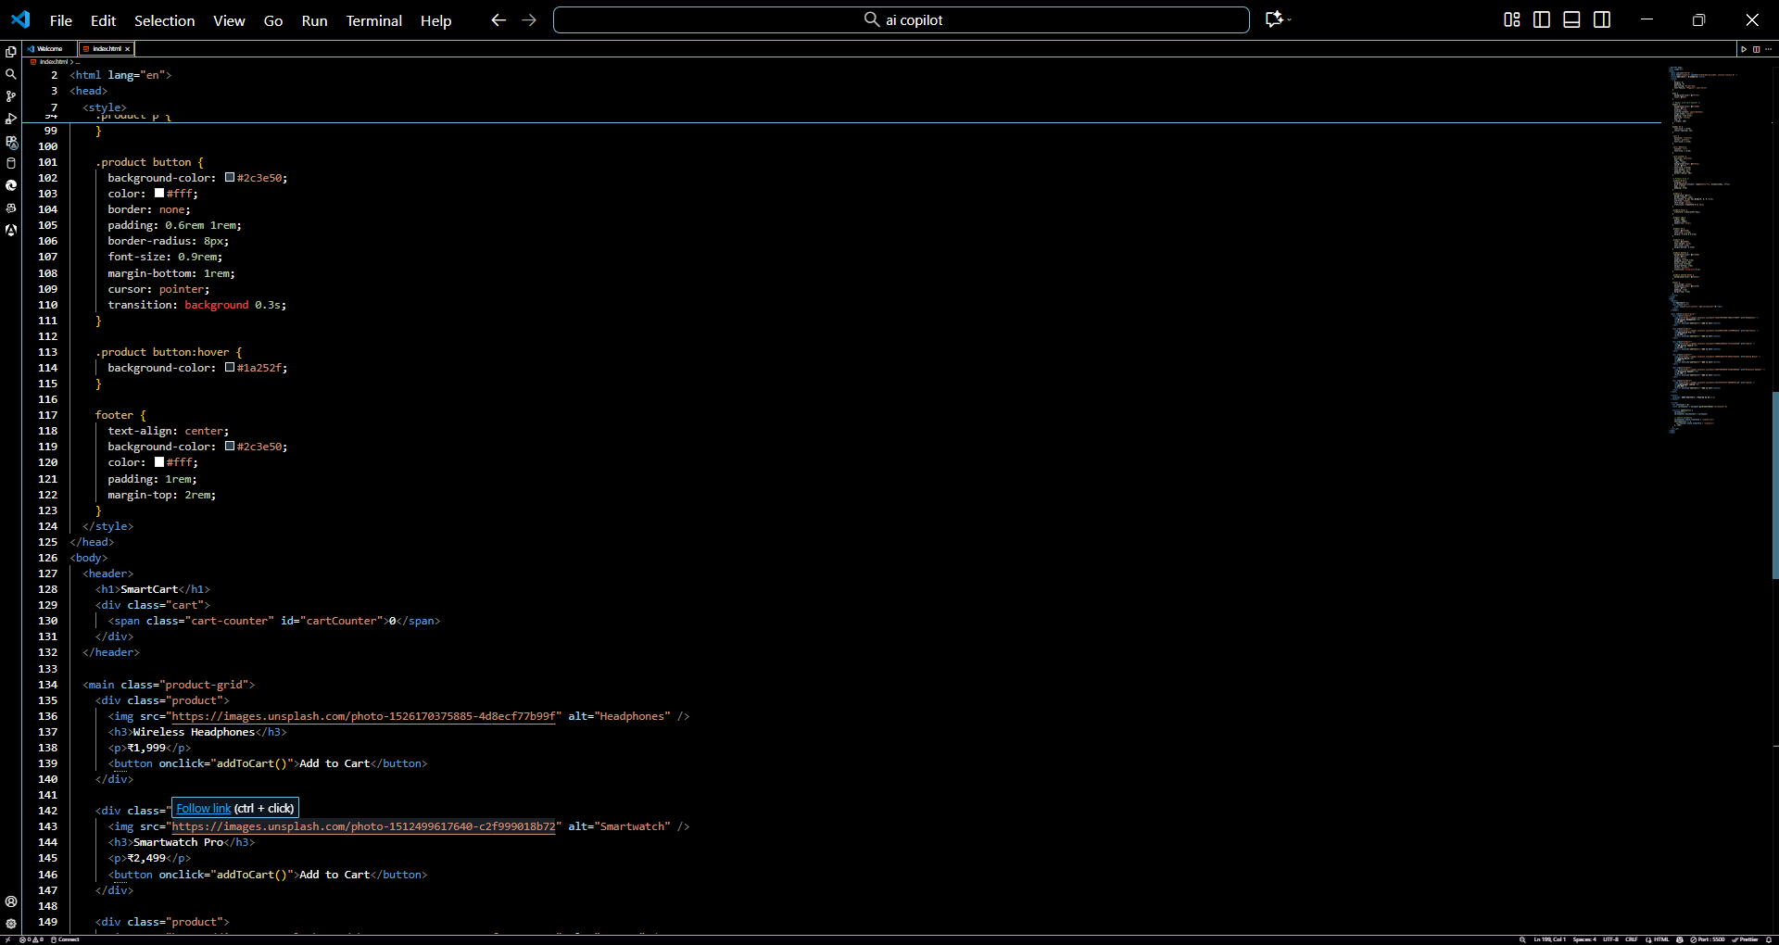  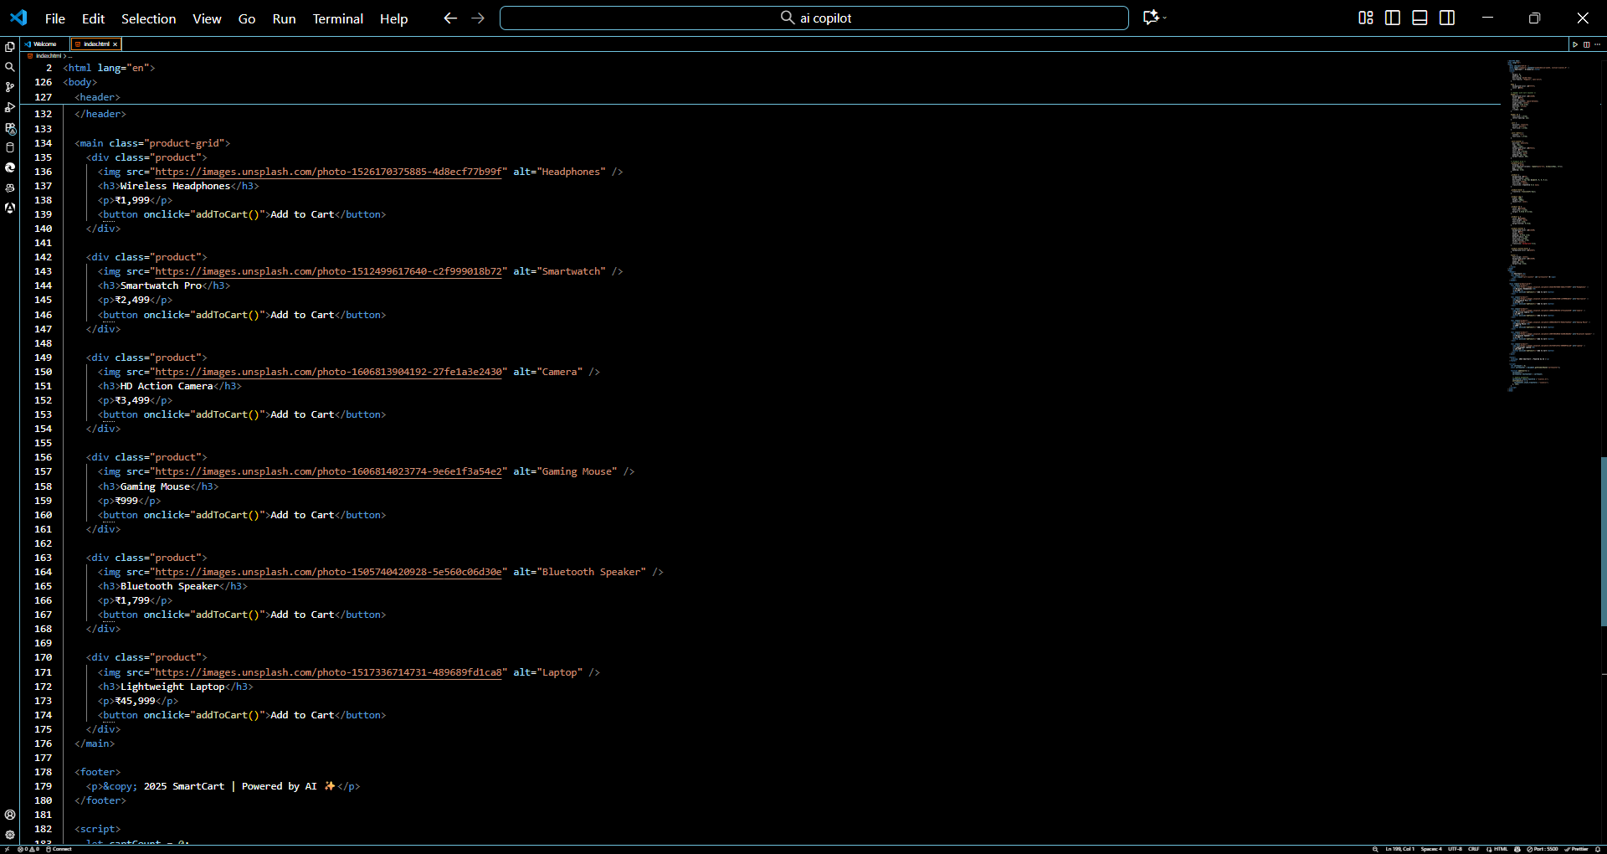  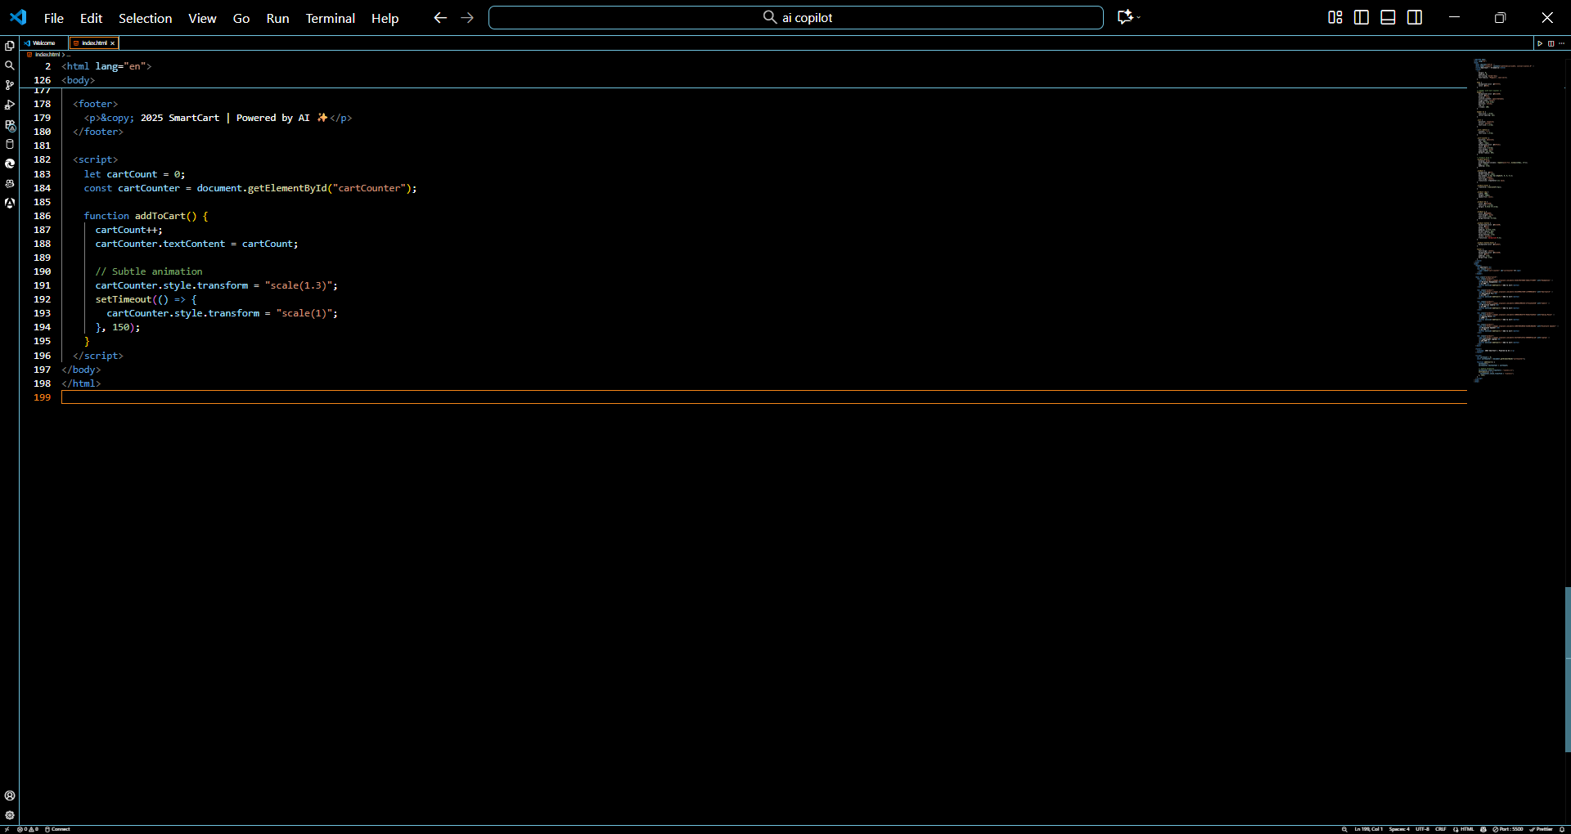  Output:  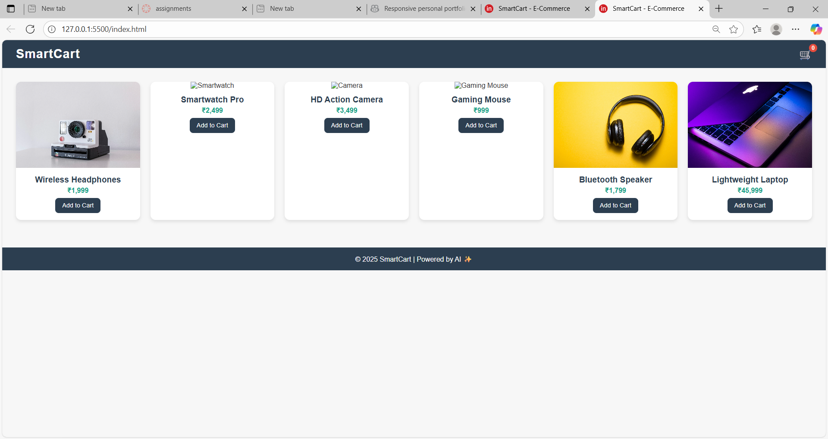 |  |  |  |  |  | Week 7 - Friday

