SCHOOL OF COMPUTER SCIENCE AND ARTIFICIAL INTELLIGENCE |  |  |  |  | DEPARTMENT OF COMPUTER SCIENCE ENGINEERING
Program Name: B. Tech |  |  |  | Assignment Type: Lab |  |  | Academic Year:2025-2026
Course Coordinator Name |  |  |  | Venkataramana Veeramsetty
Instructor(s) Name |  |  |  | Dr. V. Venkataramana (Co-ordinator)  Dr. T. Sampath Kumar  Dr. Pramoda Patro  Dr. Brij Kishor Tiwari  Dr.J.Ravichander  Dr. Mohammand Ali Shaik  Dr. Anirodh Kumar  Mr. S.Naresh Kumar  Dr. RAJESH VELPULA  Mr. Kundhan Kumar  Ms. Ch.Rajitha  Mr. M Prakash  Mr. B.Raju  Intern 1 (Dharma teja)  Intern 2 (Sai Prasad)  Intern 3 (Sowmya)  NS_2 ( Mounika)
Course Code |  |  | 24CS002PC215 | Course Title |  | AI Assisted Coding
Year/Sem |  |  | II/I | Regulation |  | R24
Date and Day  of Assignment |  |  | Week 10 - Friday | Time(s)
Duration |  |  | 2 Hours | Applicable to  Batches
AssignmentNumber:20.5(Present assignment number)/24(Total number of assignments)
 | Q.No. | Question |  |  |  |  |  | Expected Time  to complete
 | 1 | Lab 20: Security Testing: Identifying vulnerabilities in AI-generated code  Lab Objective  The objective of this lab is to equip students with the ability to critically analyze, test, and secure AI-generated code. Students will:  - Understand common security vulnerabilities that can arise in automatically generated scripts (e.g., hardcoded secrets, input validation issues, insecure dependencies).  - Learn how to use AI-assisted coding to generate test cases that identify and mitigate these vulnerabilities.  - Practice writing secure alternatives to AI-generated code by applying secure coding principles.  - Develop a mindset of trust but verify when using AI for code generation in real-world applications.  Lab Question 1: SQL Injection in AI-Generated Database Script  You used an AI tool to generate a Python script that queries a database for customer records based on user input. However, the generated code directly concatenates user input into the SQL query.  - Task 1: Identify the security vulnerability in the AI-generated code by running a malicious input (e.g., "' OR '1'='1"). Document the results.  - Task 2: Rewrite the script (with AI assistance) using parameterized queries to prevent SQL injection. Test both safe and malicious inputs.  PROMPT:  Generate Python code that demonstrates SQL injection vulnerability by querying a database using direct string concatenation of user input, then show how to fix it using parameterized queries to prevent SQL injection. For both versions, run with a safe input and a malicious input (e.g., "' OR '1'='1") and print the results.  CODE:  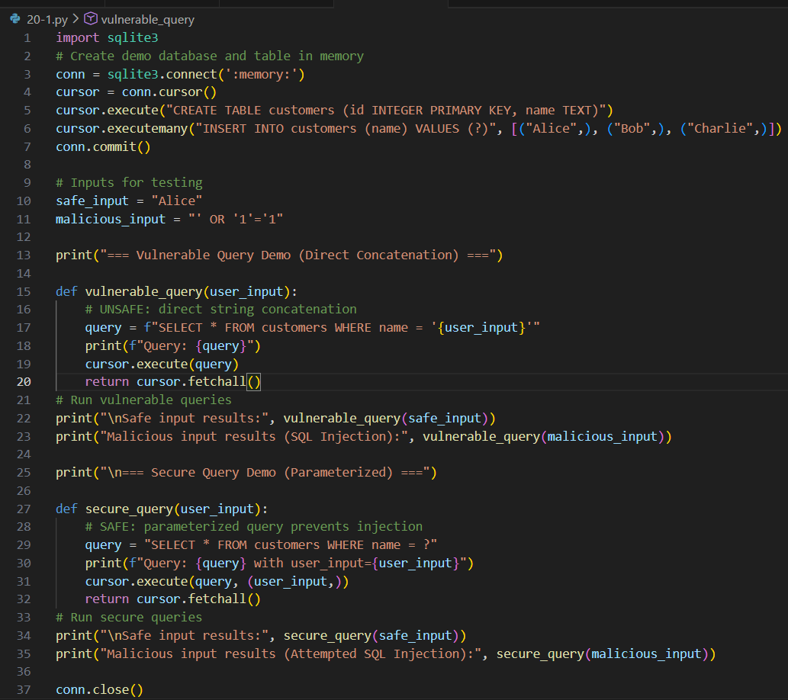  OUTPUT:  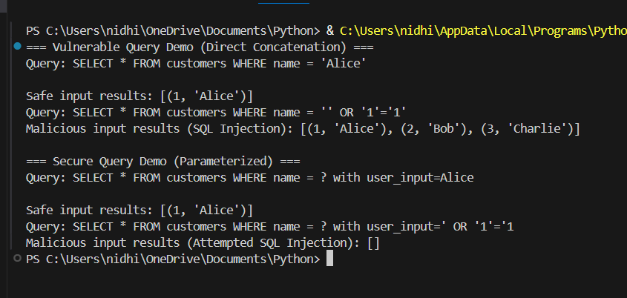  Lab Question 2: Hardcoded API Keys in AI-Generated Code  An AI-generated script for accessing a weather API contains the API key directly inside the code. This can lead to credential leaks if the code is shared publicly.  - Task 1: Identify and explain the vulnerability. Modify the script to securely fetch the API key from an environment variable.  - Task 2: Use AI assistance to generate unit tests that check whether the script throws a clear error when the environment variable is missing or invalid.  PROMPT:  Generate Python code for secure API access using an environment variable to store and fetch an API key instead of hardcoding it inside the script. Explain the credential leak risk of hardcoded keys. Also generate unit tests that check if the script throws a clear error when the environment variable is missing or invalid.  CODE:  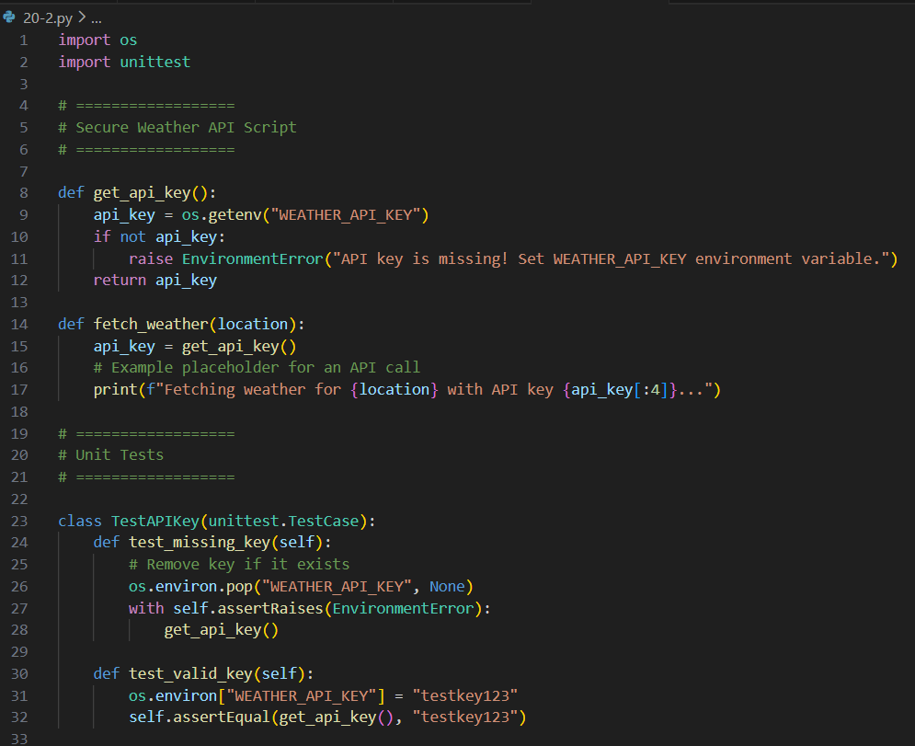  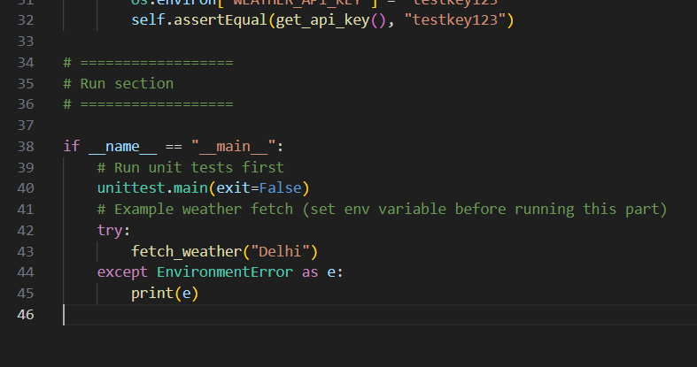  OUTPUT:  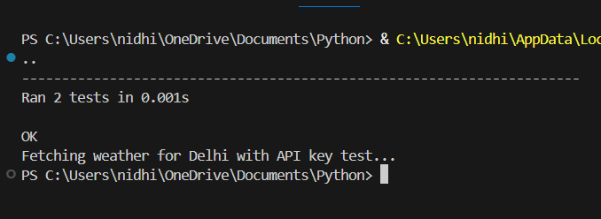  Lab Question 3: Command Injection in AI-Generated File Utility  An AI tool generated a shell-based Python function that takes user input for filenames and executes a system command (os.system("cat " + filename)), creating a command injection vulnerability.  - Task 1: Demonstrate the vulnerability by entering a malicious filename input (e.g., "test.txt; rm -rf *"). Document the outcome in a controlled environment.  - Task 2: Secure the script by replacing the unsafe method with Python’s built-in file I/O operations. Add exception handling for missing or inaccessible files.  PROMPT:  Generate Python code that demonstrates command injection vulnerability by taking a filename input and executing it as a shell command (os.system). Then modify the script to use safe file I/O operations instead, with proper exception handling for missing files. Run both safe and malicious inputs to show the vulnerability and its fix.  CODE:  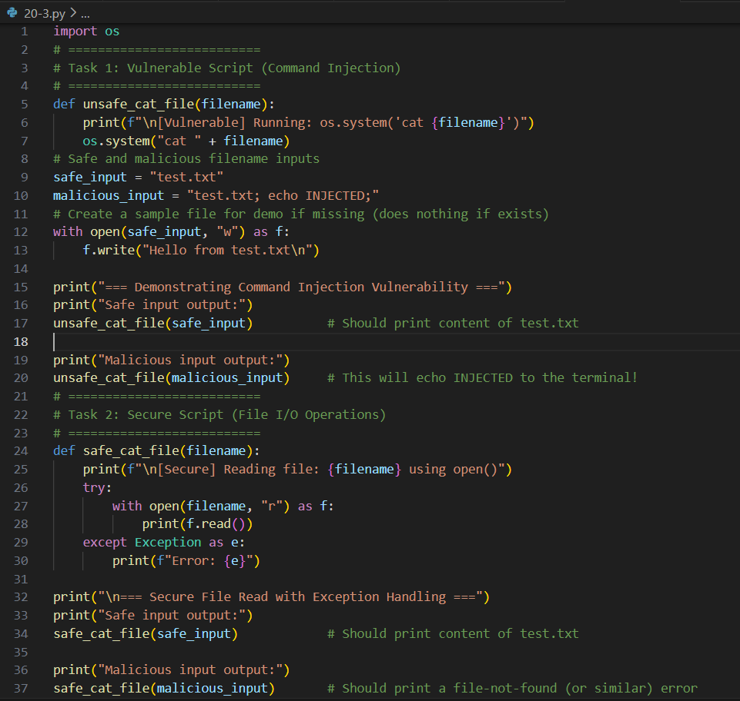  OUTPUT:  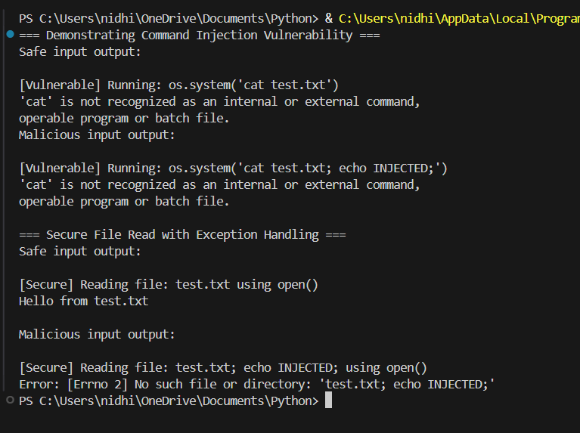 |  |  |  |  |  | Week 10 - Friday

