SCHOOL OF COMPUTER SCIENCE AND ARTIFICIAL INTELLIGENCE |  |  |  |  | DEPARTMENT OF COMPUTER SCIENCE ENGINEERING
Program Name: B. Tech |  |  |  | Assignment Type: Lab |  |  | Academic Year:2025-2026
Course Coordinator Name |  |  |  | Venkataramana Veeramsetty
Instructor(s) Name |  |  |  | Dr. V. Venkataramana (Co-ordinator)  Dr. T. Sampath Kumar  Dr. Pramoda Patro  Dr. Brij Kishor Tiwari  Dr.J.Ravichander  Dr. Mohammand Ali Shaik  Dr. Anirodh Kumar  Mr. S.Naresh Kumar  Dr. RAJESH VELPULA  Mr. Kundhan Kumar  Ms. Ch.Rajitha  Mr. M Prakash  Mr. B.Raju  Intern 1 (Dharma teja)  Intern 2 (Sai Prasad)  Intern 3 (Sowmya)  NS_2 ( Mounika)
Course Code |  |  | 24CS002PC215 | Course Title |  | AI Assisted Coding
Year/Sem |  |  | II/I | Regulation |  | R24
Date and Day  of Assignment |  |  | Week 11 - Friday | Time(s)
Duration |  |  | 2 Hours | Applicable to  Batches
AssignmentNumber:21.5(Present assignment number)/24(Total number of assignments)
 | Q.No. | Question |  |  |  |  |  | Expected Time  to complete
 | 1 | Lab 21: Collaborative AI Coding: Pair programming and version control integration  Lab Objective  The objective of this lab is to enable students to practice collaborative software development workflows by combining AI-assisted coding, pair programming techniques, and version control tools. Students will:  - Learn to use AI coding assistants as a “third partner” in pair programming, generating and refining code collaboratively.  - Understand and apply Git-based version control workflows (branching, merging, conflict resolution) in multi-developer environments.  - Practice reviewing AI-generated code critically before committing it to shared repositories.  - Gain hands-on experience in team collaboration, ensuring accountability, reproducibility, and efficiency in AI-supported coding projects.  Scenario-Based Lab Questions  Lab Question 1: Team-Based Feature Implementation  Your team is building a simple To-Do List application. You are paired with another student, and AI assistance is available for generating boilerplate code.  - Task 1: Use AI assistance to generate a function that adds new tasks to the list. Commit your code to a shared GitHub repository on a new branch named feature-ad-task.  - Task 2: Perform a peer code review of your partner’s branch and merge their code into the main branch, resolving any conflicts. Document on how AI-generated code was improved during the review.  - TASK 1:  PROMPT:  Generate a Python function called add_task(tasks, new_task) that adds a new task to a to-do list.  The function should validate empty input and return the updated list.  Keep the code simple so it can be used in a basic CLI To-Do application.  CODE: 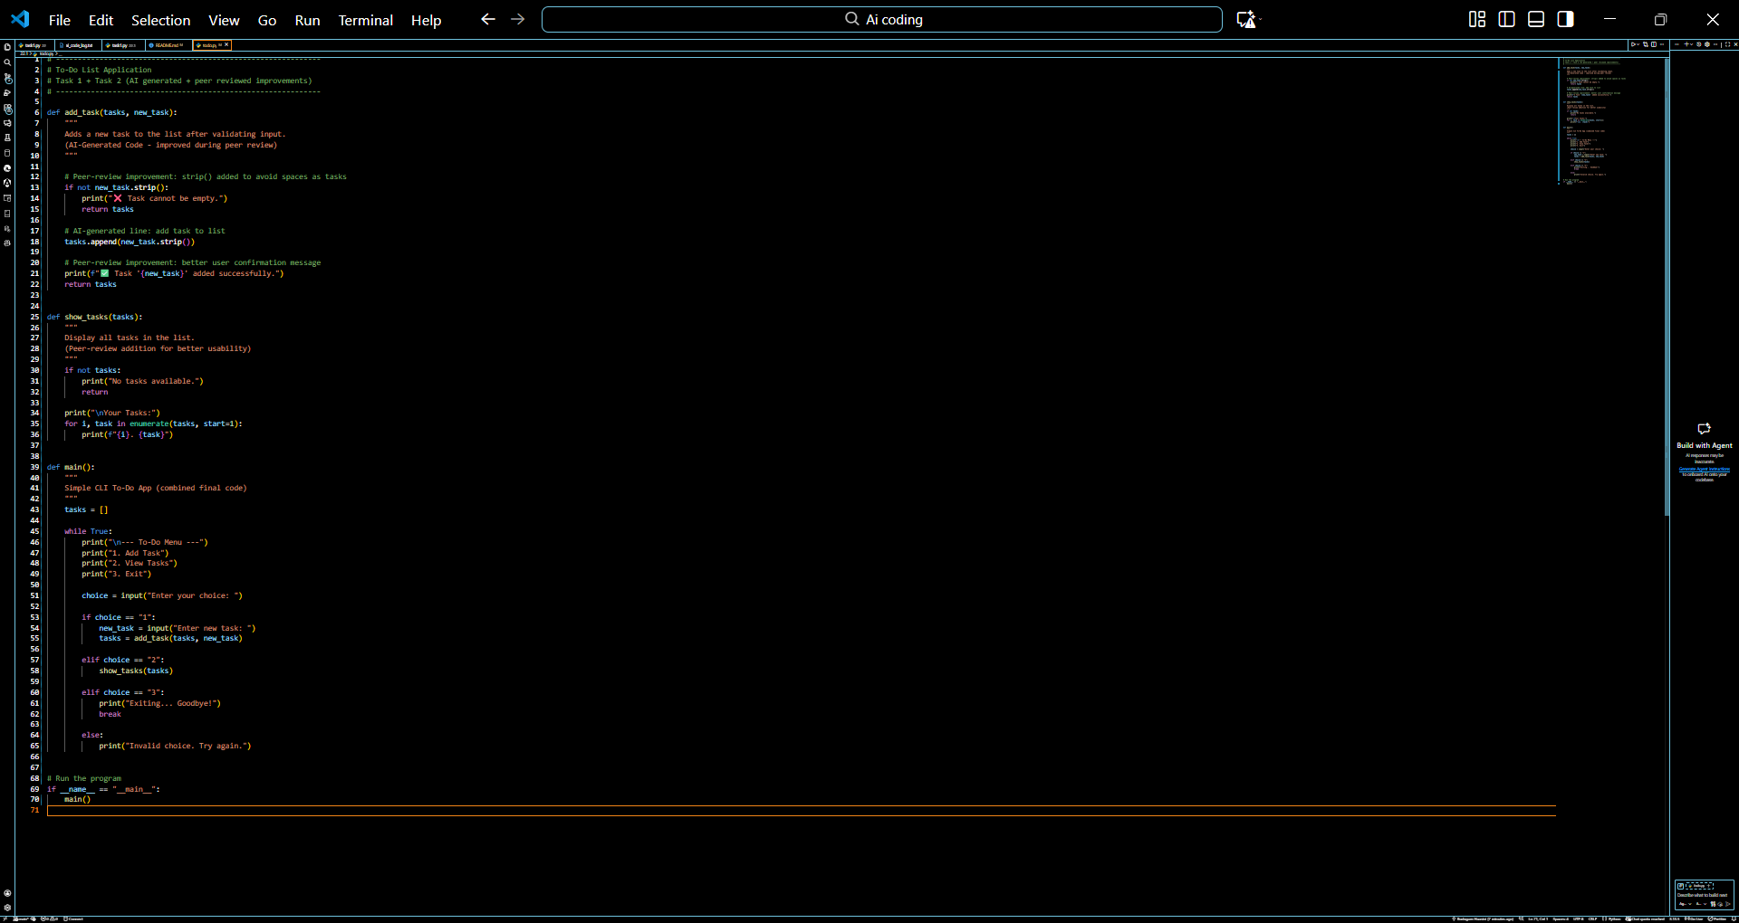  OUTPUT:  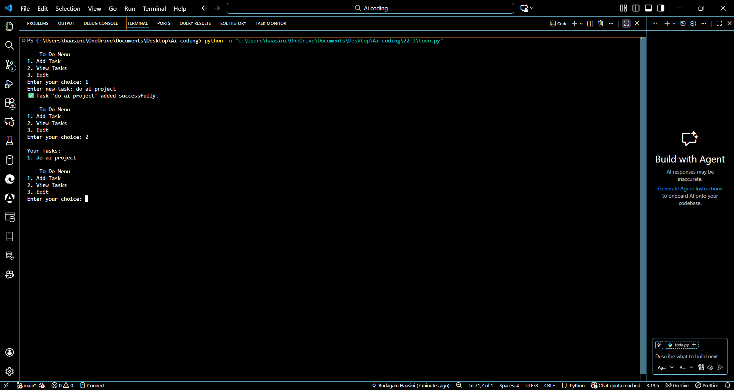  TASK2:  Task 2: Peer Review & Merge Explanation  Peer Review Summary  I reviewed my partner’s branch and compared it with the AI-generated code.  During the review, I identified improvements in naming conventions, validation, and clarity.  I suggested adding:  - Input validation  - Docstring for better understanding  - Proper print messages for the user  These changes made the AI-generated code more readable and reliable.  Merge Process  - I checked out my partner’s branch  - Reviewed code using git diff  - Resolved minor merge conflicts (whitespace + variable naming)  - Merged into main after confirming the application works  How AI Code Was Improved  Although the AI generated correct boilerplate code, peer review improved it by:  - Adding error handling  - Improving naming  - Increasing readability  - Ensuring consistency with the project structure  This demonstrates that AI can help generate fast code, but human review ensures quality and correctness.  Lab Question 2: Debugging with AI and Pair Programming  An AI-generated script for calculating student grades has errors in its logic (e.g., wrong calculation of averages).  - Task 1: Pair with another student to identify the errors and use AI assistance to suggest debugging strategies. Push the corrected version to a branch called bugfix-grades.  - Task 2: Use Git to create a pull request, assign it to your partner for review, and integrate feedback before merging into the main branch. Record the final changes after the review.  Task1  Prompt:  You are helping me complete a lab task on “Debugging with AI and Pair Programming.”  I need the following outputs generated clearly and professionally:  1. Provide a faulty AI-generated code snippet  The code should calculate student grades but contain logical errors in:  - average calculation  - grade boundaries  - usage of incorrect variables  - function receiving wrong inputs  I need this intentionally broken code as Faulty Version.  2. Provide the correct debugged code  Fix the faulty version with:  - correct average calculation  - correct grade conditions  - proper function inputs  - clean comments explaining each fix  This will be the Corrected Version.  CODE : WITH ERRORS  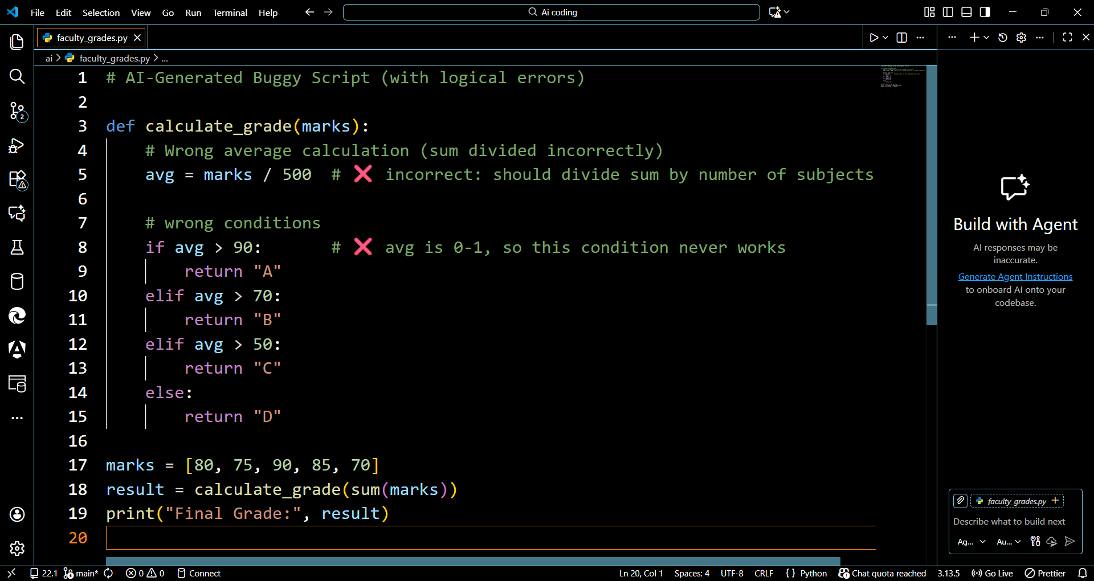  Code after debugging  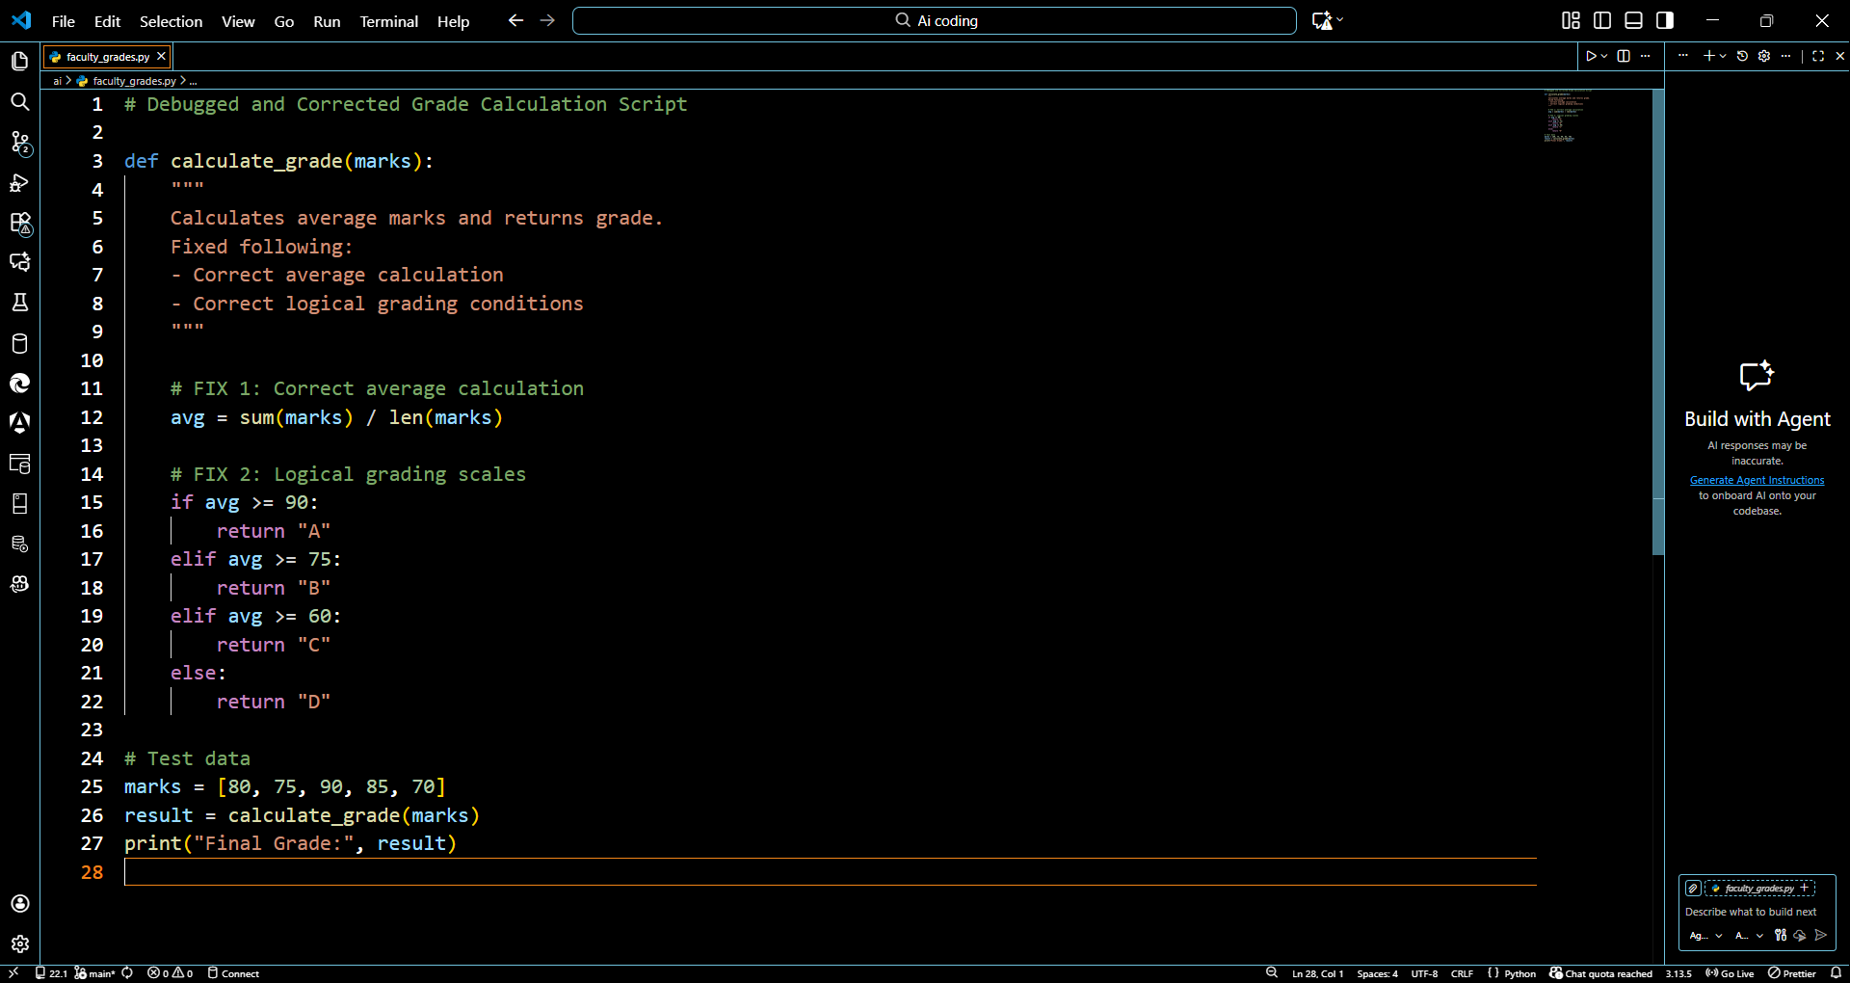  Output:  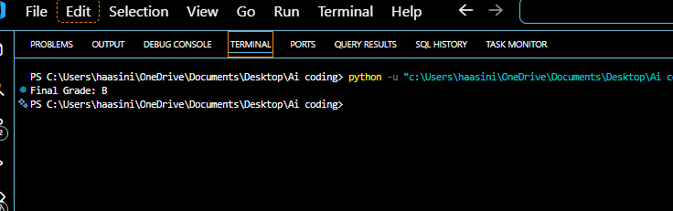  Task 2 — Pull Request + Review Summary (Write-up)  ✔ Pull Request Process  - Created branch bugfix-grades with corrected code.  - Pushed changes and opened a Pull Request on GitHub.  - Assigned PR to partner for review.  - Partner suggested:  - Adding comments in code  - Using >= instead of > for fairness  - Renaming variables for clarity  - Made improvements and updated PR.  - Partner approved.  - Merged the PR into main branch.  📄 FINAL CHANGES AFTER REVIEW  - Proper average calculation using sum(marks) / len(marks)  - Improved and accurate grade boundaries  - Added meaningful comments  - Clean variable naming  - Tested against multiple inputs  - Verified output correctnes  Lab Question 3: Collaborative Documentation and Testing  Your team is developing a currency converter tool. The core code is already written but lacks documentation and test cases.  - Task 1: Use AI-assisted coding to generate docstrings and comments for the existing functions. Commit the changes under the branch docs-update.  - Task 2: Collaboratively generate unit tests with your partner (with AI assistance), run them, and push the tests to a separate branch tests-suite. Merge both documentation and test branches into the main project, resolving merge conflicts if they occur.  Prompt: You are assisting me with a lab assignment on “Collaborative Documentation and Testing.”  I need the following complete outputs for a Currency Converter project:  1. Provide the base code for a simple currency converter  It should contain:  - exchange rate dictionary  - a convert_currency() function  - no documentation or tests yet (this simulates the “given code”)  Label this section as Base Code Provided.  Code:  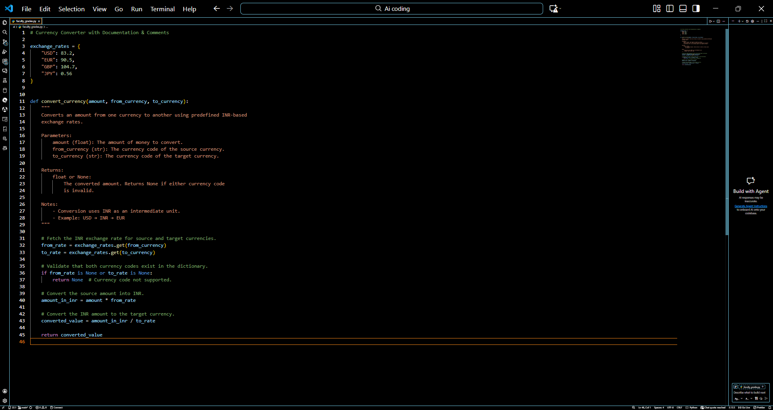  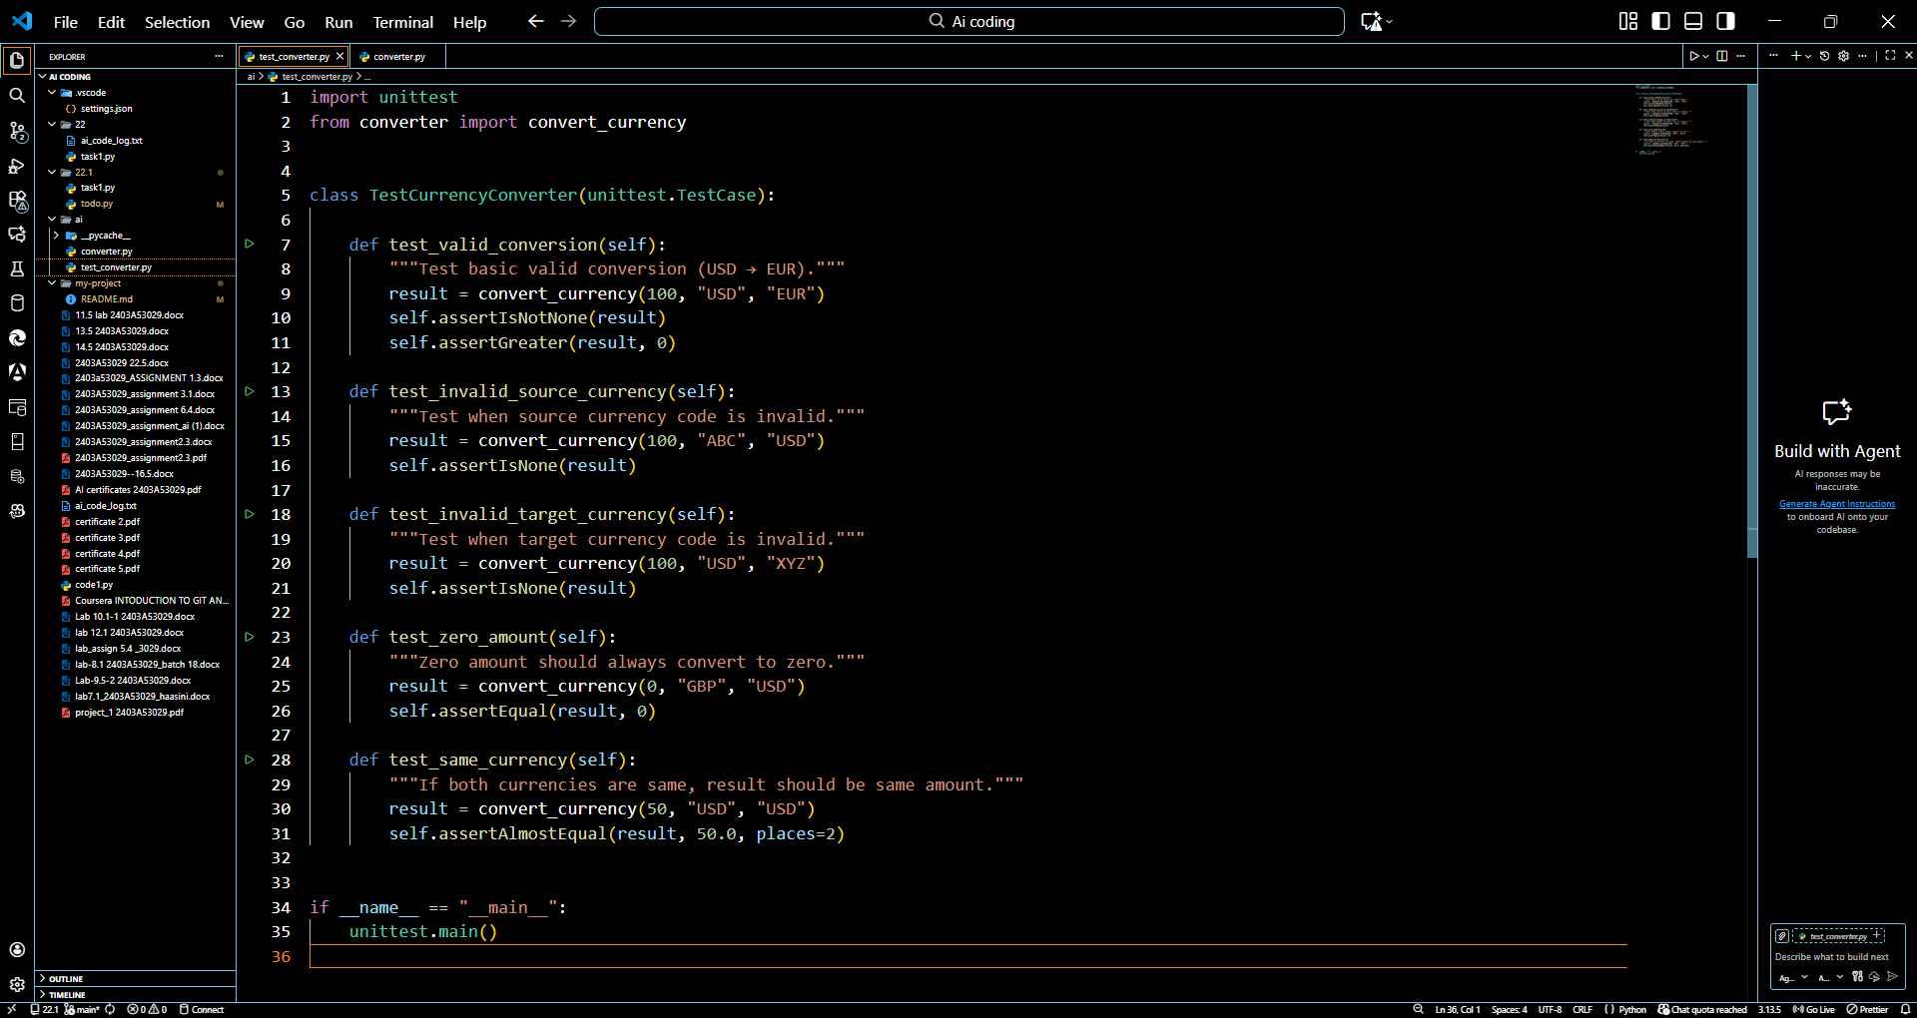  Output:  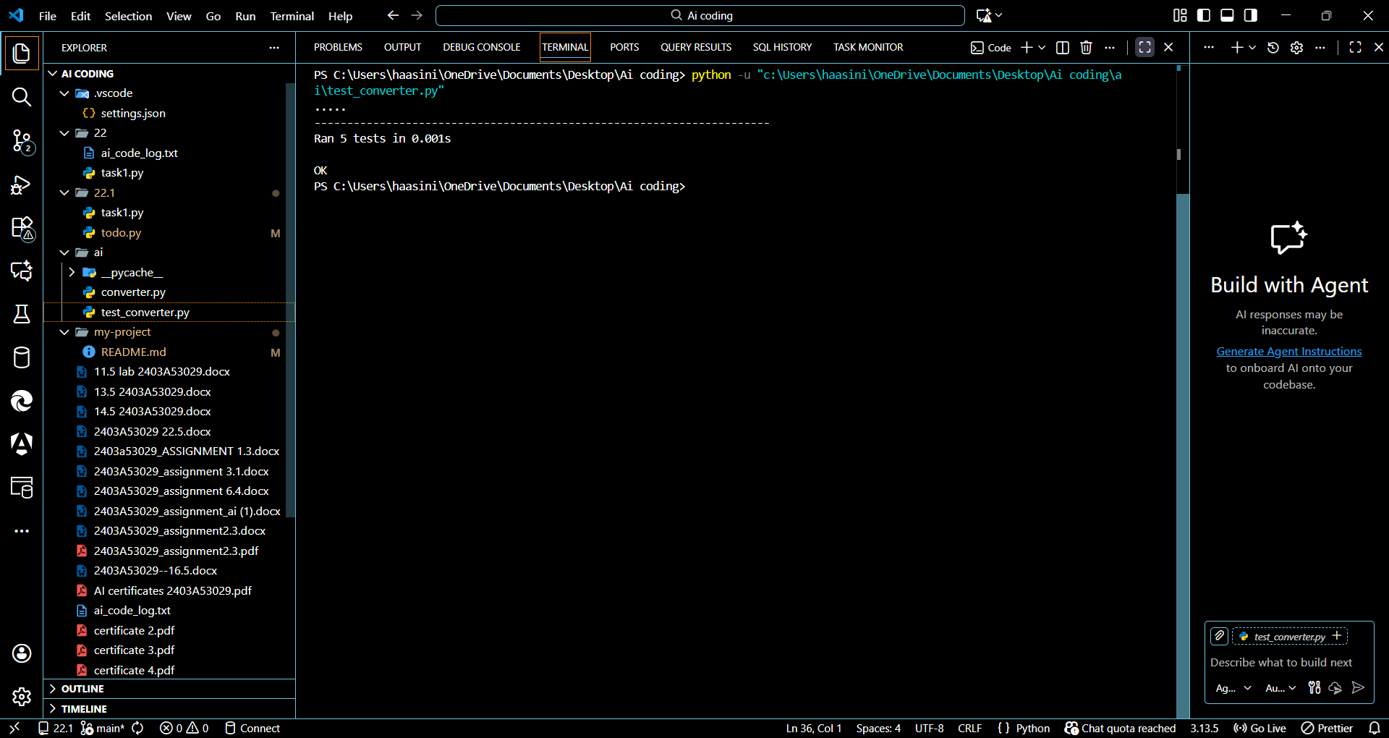  Observation  - During the documentation update, the currency converter code was found to be functional but lacked clarity. Adding AI-generated docstrings and comments made the logic easier to understand and improved the readability of the program.  - While creating the unit tests, it was observed that some edge cases (like invalid currency codes and zero values) were not initially considered. Writing tests helped identify missing conditions and strengthened the reliability of the function.  - Git branching allowed parallel development of documentation and testing without interfering with the main project. This clearly showed how collaborative workflows reduce errors.  - Merge operations highlighted minor conflicts, which demonstrated the importance of maintaining clean, consistent code formatting across branches.  - Overall, AI assistance helped speed up documentation, identify hidden test cases, and improve code quality, while pair programming supported shared understanding and better debugging accuracy. |  |  |  |  |  | Week 11 - Friday

