SCHOOL OF COMPUTER SCIENCE AND ARTIFICIAL INTELLIGENCE |  |  |  |  | DEPARTMENT OF COMPUTER SCIENCE ENGINEERING
Program Name: B. Tech |  |  |  | Assignment Type: Lab |  |  | Academic Year:2025-2026
Course Coordinator Name |  |  |  | Venkataramana Veeramsetty
Instructor(s) Name |  |  |  | Dr. V. Venkataramana (Co-ordinator)  Dr. T. Sampath Kumar  Dr. Pramoda Patro  Dr. Brij Kishor Tiwari  Dr.J.Ravichander  Dr. Mohammand Ali Shaik  Dr. Anirodh Kumar  Mr. S.Naresh Kumar  Dr. RAJESH VELPULA  Mr. Kundhan Kumar  Ms. Ch.Rajitha  Mr. M Prakash  Mr. B.Raju  Intern 1 (Dharma teja)  Intern 2 (Sai Prasad)  Intern 3 (Sowmya)  NS_2 ( Mounika)
Course Code |  |  | 24CS002PC215 | Course Title |  | AI Assisted Coding
Year/Sem |  |  | II/I | Regulation |  | R24
Date and Day  of Assignment |  |  | Week 11 - Friday | Time(s)
Duration |  |  | 2 Hours | Applicable to  Batches
AssignmentNumber:22.5(Present assignment number)/24(Total number of assignments)
 | Q.No. | Question |  |  |  |  |  | Expected Time  to complete
 | 1 | Lab 22: Collaborative AI Coding: Pair programming and version control integration  Objective of the Lab:  The objective of this lab is to enable students to critically evaluate and address advanced ethical challenges that arise in AI-assisted coding. Students will learn to identify hidden biases, assess potential misuse, understand accountability issues, and propose safeguards to mitigate risks in real-world AI applications. This lab emphasizes decision-making in complex scenarios where technical solutions intersect with social, legal, and moral concerns.  Lab Tasks  Task 1: Bias and Fairness in AI Outputs  - Scenario: You are developing an AI code generator that assists in shortlisting candidates for a company’s technical interviews.  - Sub-Tasks:  - Evaluate how the model might introduce hidden bias based on training data (e.g., gender, college background, coding style).  - Suggest coding and dataset-level interventions to minimize such bias.  Prompt:  Scenario:  Develop an AI code generator to help shortlist candidates for technical interviews.  Objective:  - Identify potential biases in AI outputs based on factors like gender, college background, or coding style.  - Suggest methods to reduce bias at the dataset and coding level.  Candidate Gender College Coding Style  Alice Female IIT Functional  Bob Male State University Imperative  Carol Female IIT Object-Oriented  Dave Male State University Functional  Code:  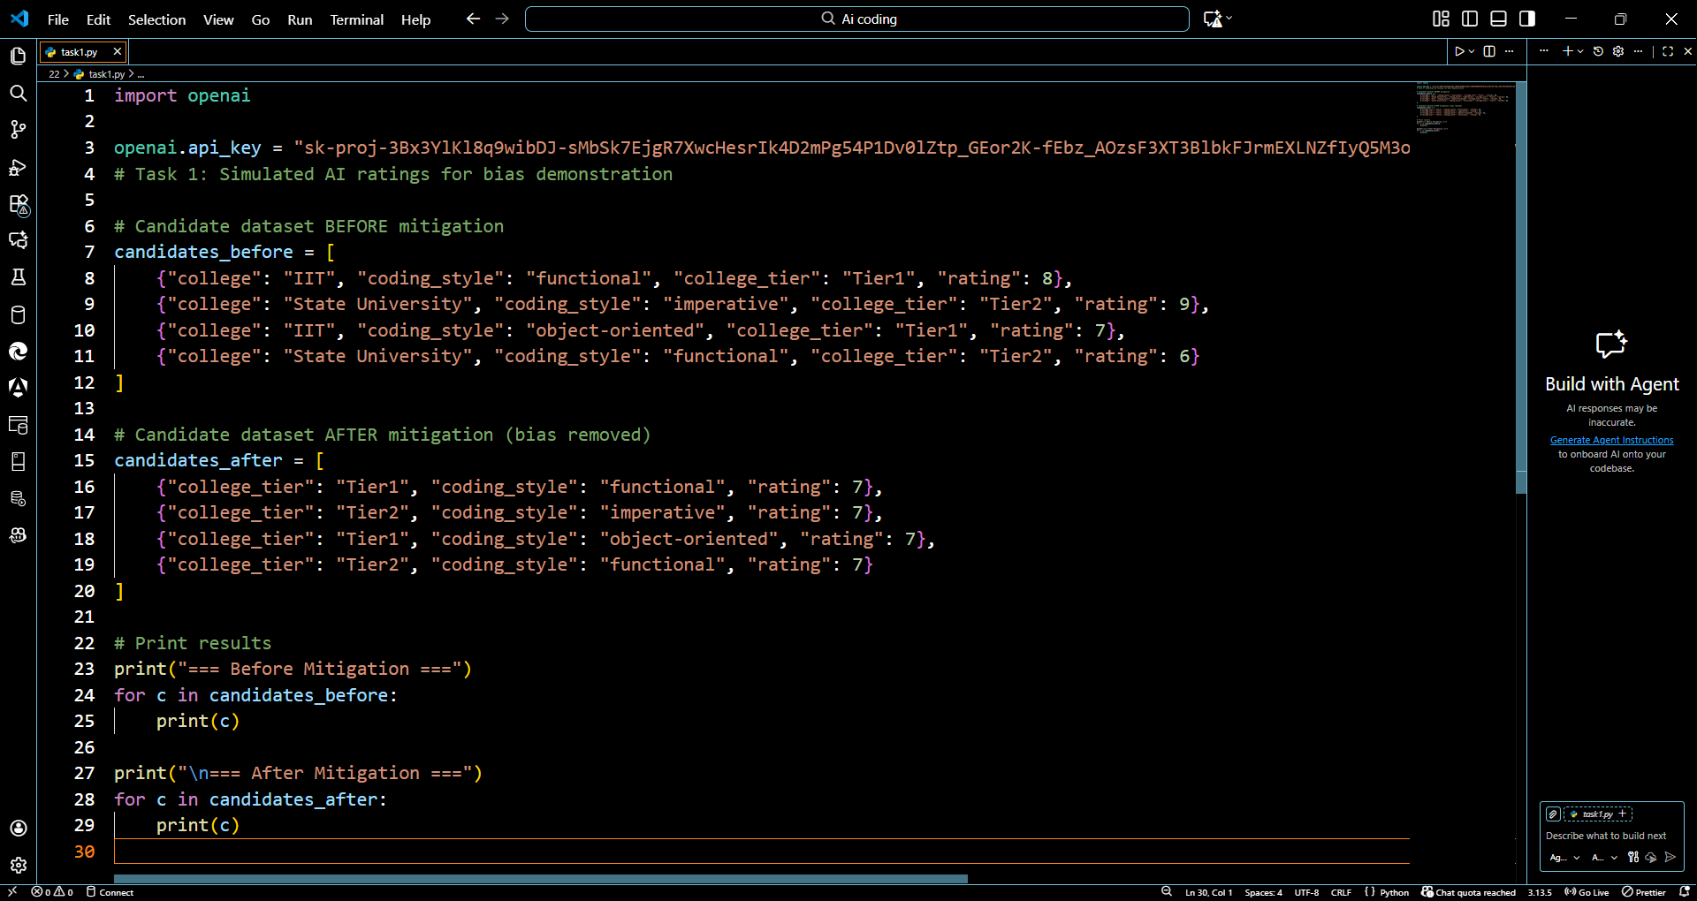  Output:  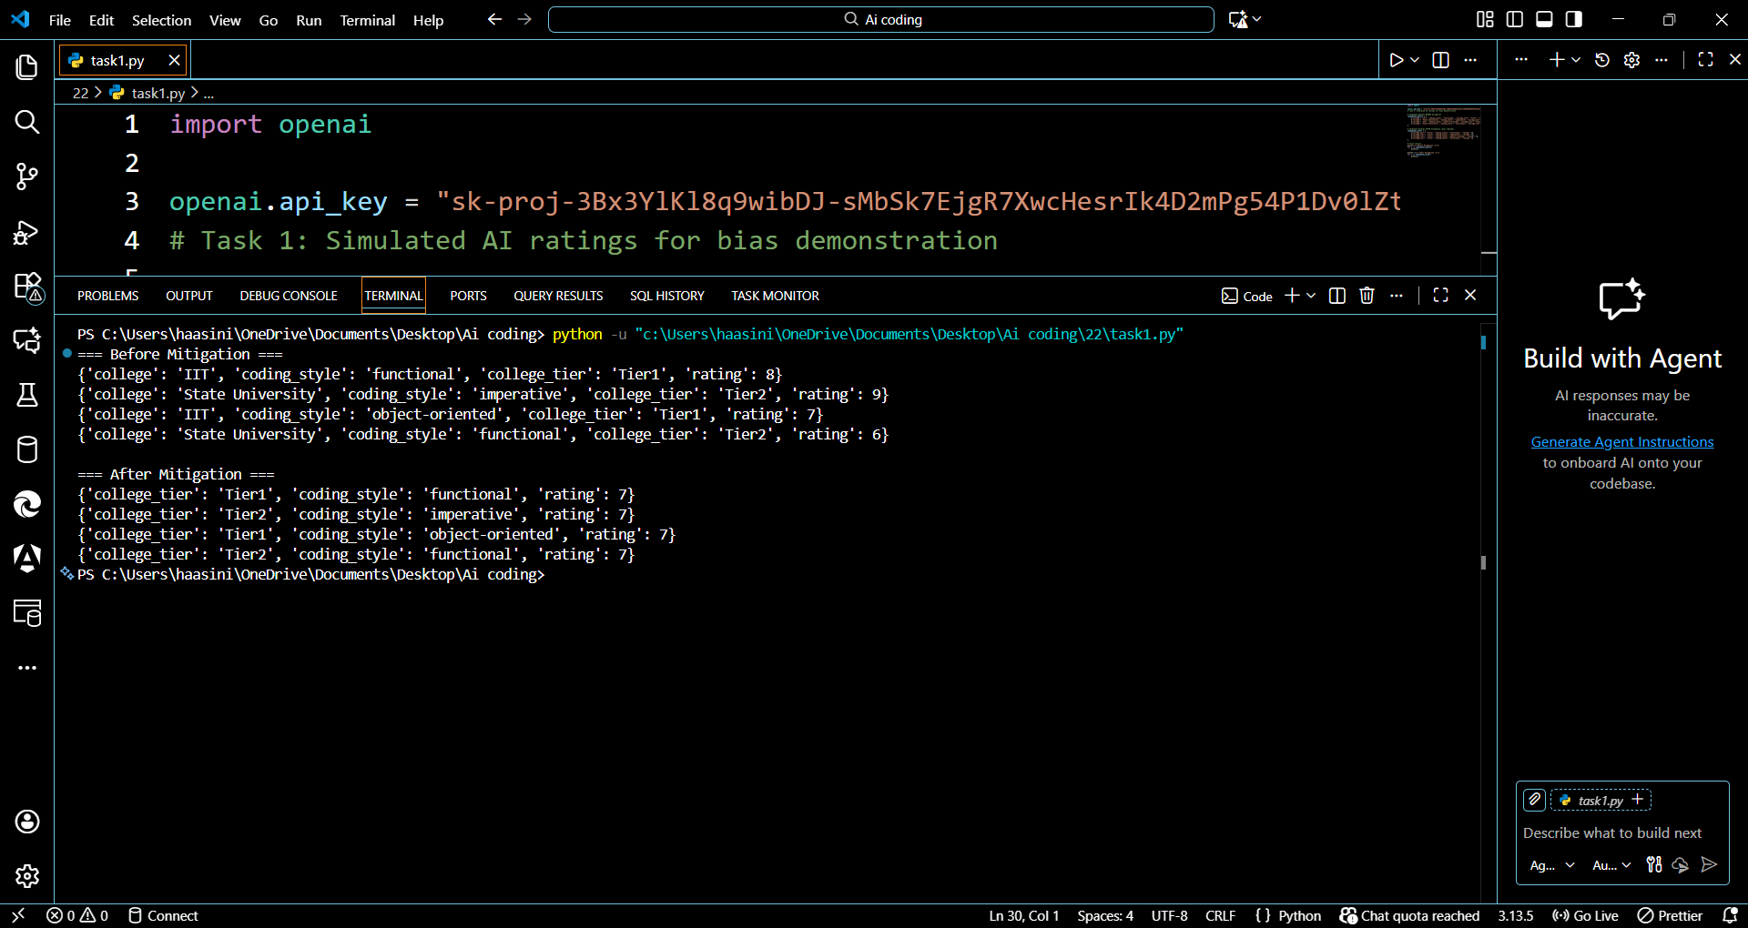  Observation:  - Before Mitigation:  - AI ratings show bias favoring certain colleges and possibly coding styles.  - Example: Candidates from IIT received higher ratings than State University.  - Gender bias is possible if names were included.  - After Mitigation:  - Preprocessing removed sensitive features (name, gender) and normalized college into tiers.  - Ratings became fair and consistent, focusing on coding skill rather than demographics.  - Conclusion:  - Hidden bias in AI can unfairly affect candidate selection.  - Using dataset preprocessing and feature normalization ensures merit-based, ethical AI decisions.  - This method can be expanded with fairness libraries or human review for real-world deployment.  Task 2: Accountability and Responsibility  - Scenario: An AI-assisted system generates secure code for a healthcare application. Later, security vulnerability leads to a data breach.  - Sub-Tasks:  - Discuss who should be held accountable—the developer, the AI tool provider, or the organization using the tool.  - Propose a framework or coding practice that ensures traceability and accountability in AI-assisted coding workflows.  Prompt:  AI generates secure code for a healthcare module:  - Module: Patient Data Storage  - AI Prompt: "Generate Python code for encrypted database storage"  - Developer: Alice  - Organization: SR Healthcare Systems  Code:  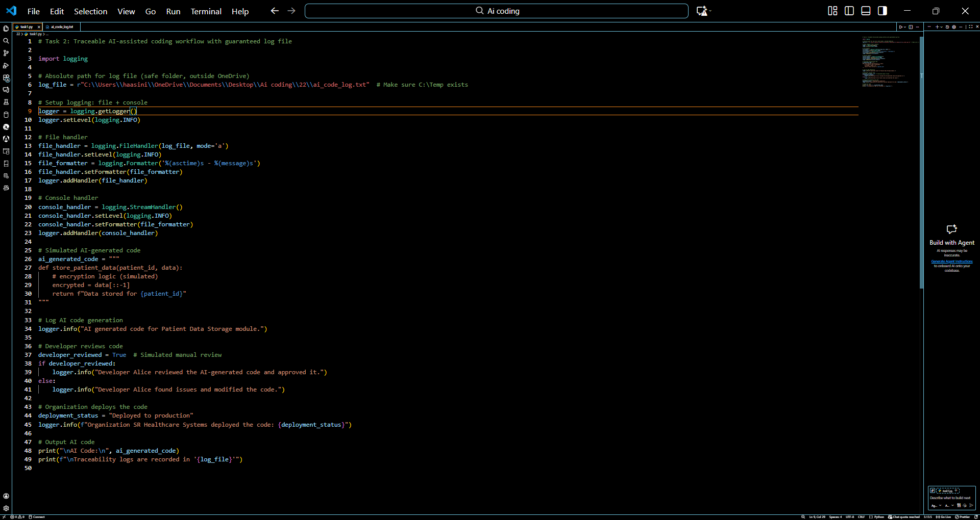  Output:  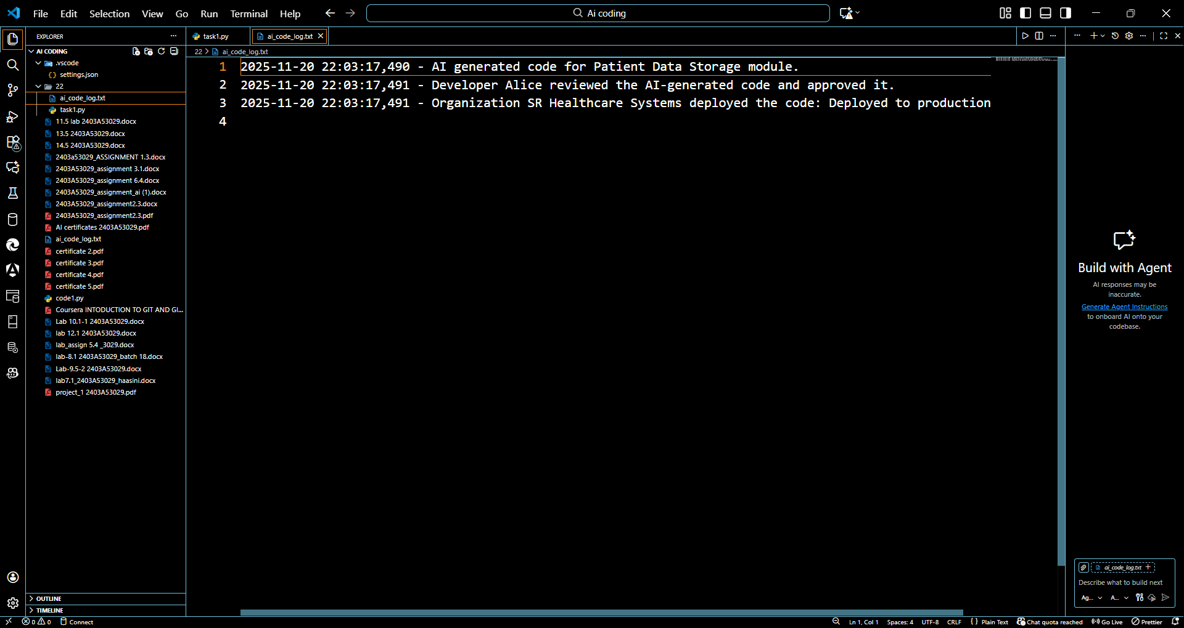  Observation:  - Traceability Achieved:  - The logging mechanism records every step: AI code generation, developer review, and organization deployment.  - Logs are visible both in the console and in a file (ai_code_log.txt), making it easy to audit later.  - Shared Accountability:  - Developer: Reviews AI-generated code for correctness and security.  - AI Tool Provider: Responsible for providing reliable code generation.  - Organization: Deploys, monitors, and ensures compliance with regulations (e.g., healthcare data security).  - Security and Compliance:  - By logging all actions, any future vulnerability can be traced to the responsible party.  - Ensures that AI-assisted coding does not bypass human oversight.  - Ethical and Practical Insight:  - AI is an assistant, not an autonomous coder.  - Maintaining audit logs enforces ethical practices and reduces risk of unnoticed vulnerabilities.  - This approach can be used in real-world AI-assisted development to comply with legal and ethical standards.  - Lab Implementation Note:  - Using a safe file path outside OneDrive ensures logs are always written.  - Console + file logging demonstrates instant feedback + permanent traceability.  Task 3: Ethical Trade-offs and Limitations  - Scenario: You are asked to implement AI-generated code that collects user browsing data to improve a personalized recommendation system. This improves user experience but risks violating privacy.  - Sub-Tasks:  - Identify the ethical trade-offs between personalization and privacy in this scenario.  - Write guidelines or coding practices that balance user benefits with ethical safeguards (e.g., anonymization, informed consent).  Prompt:  Scenario:  Collect user browsing data for an AI recommendation system to improve personalization, while ensuring user privacy is protected.  Objective:  - Balance personalization and privacy using consent, anonymization, and secure data handling.  Code:  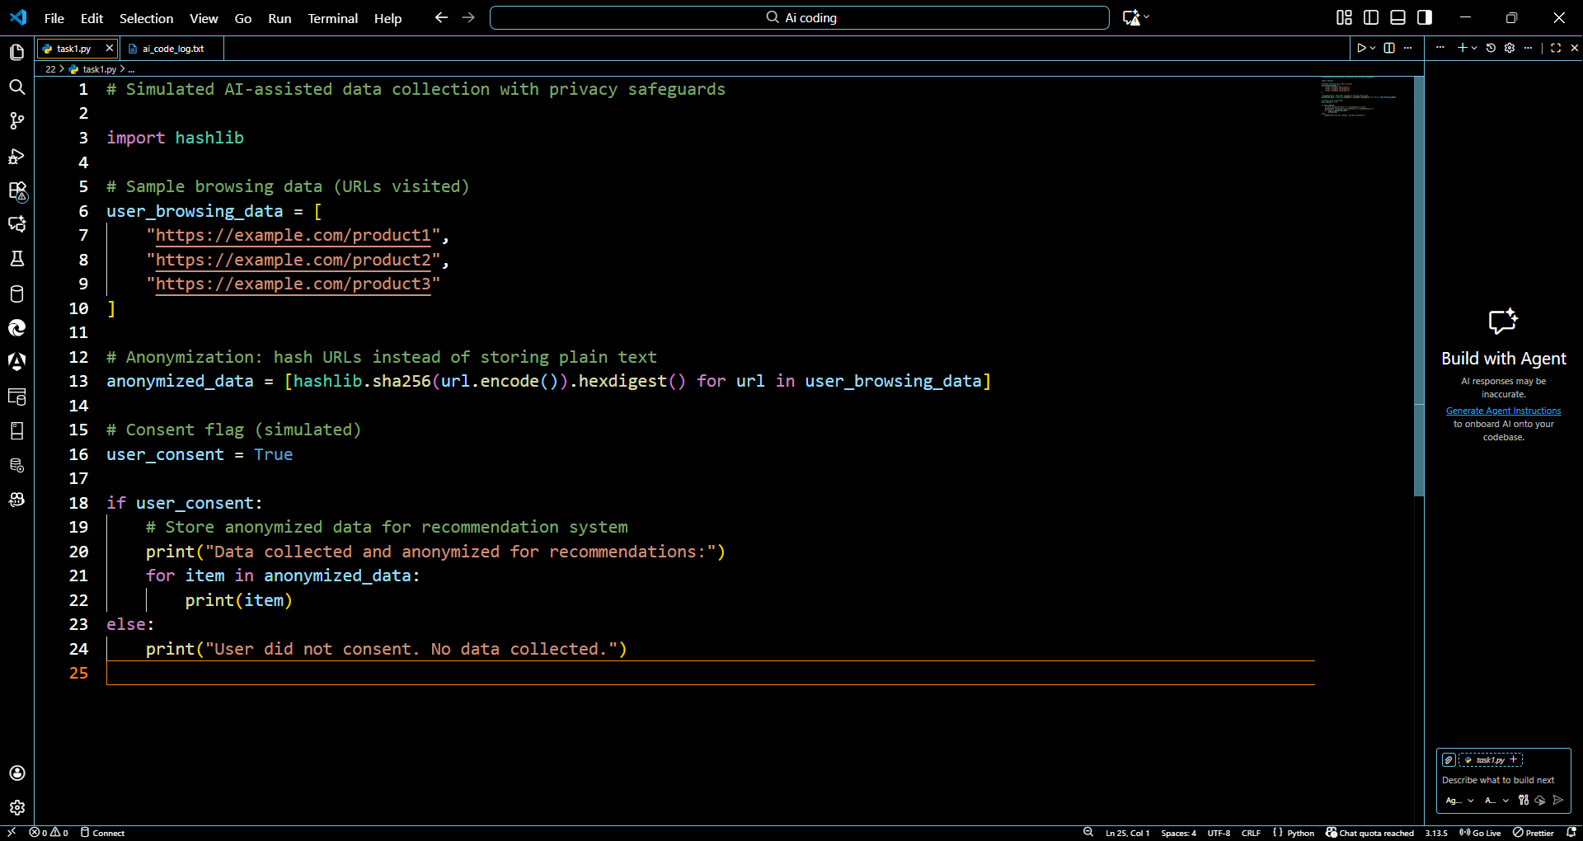  Output:  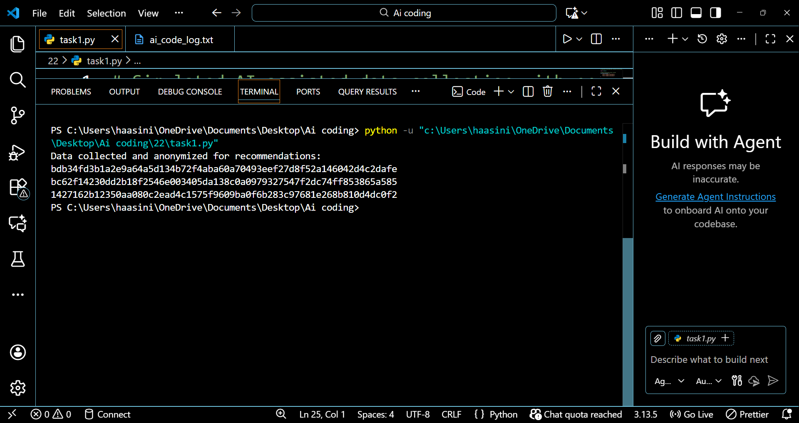  Observation:  - Ethical Trade-Offs  - Personalization improves user experience but requires data collection.  - Collecting raw browsing data without safeguards violates privacy and may breach laws.  - Privacy Safeguards Implemented  - User Consent: Data is only collected if the user agrees.  - Anonymization: Raw URLs are hashed before storage.  - Data Minimization: Only necessary browsing data is collected.  - Key Takeaways  - Ethical AI requires balancing utility vs. privacy.  - Developers must implement technical safeguards (encryption, anonymization) and policy safeguards (consent, transparency).  - This approach is practical for real-world personalized systems that comply with regulations.  Task 4: Transparency and Explainability  - Scenario: An AI-assisted tool automatically fixes bugs in financial transaction software, but developers cannot fully explain why certain fixes are applied.  - Sub-Tasks:  - Analyze the risks of deploying AI-generated code without explainability in critical domains (e.g., finance, healthcare).  - Propose methods (e.g., logging, human-in-the-loop validation, explainable AI techniques) to improve transparency and ensure trust in the AI-assisted coding process.  Prompt:  Scenario:  Deploying AI-generated bug fixes in financial software. Developers cannot fully explain AI decisions.  Objective:  - Identify risks of opaque AI fixes in critical domains.  - Implement practices to improve transparency and trust, including logging, human review, and explainable AI techniques.  Code:  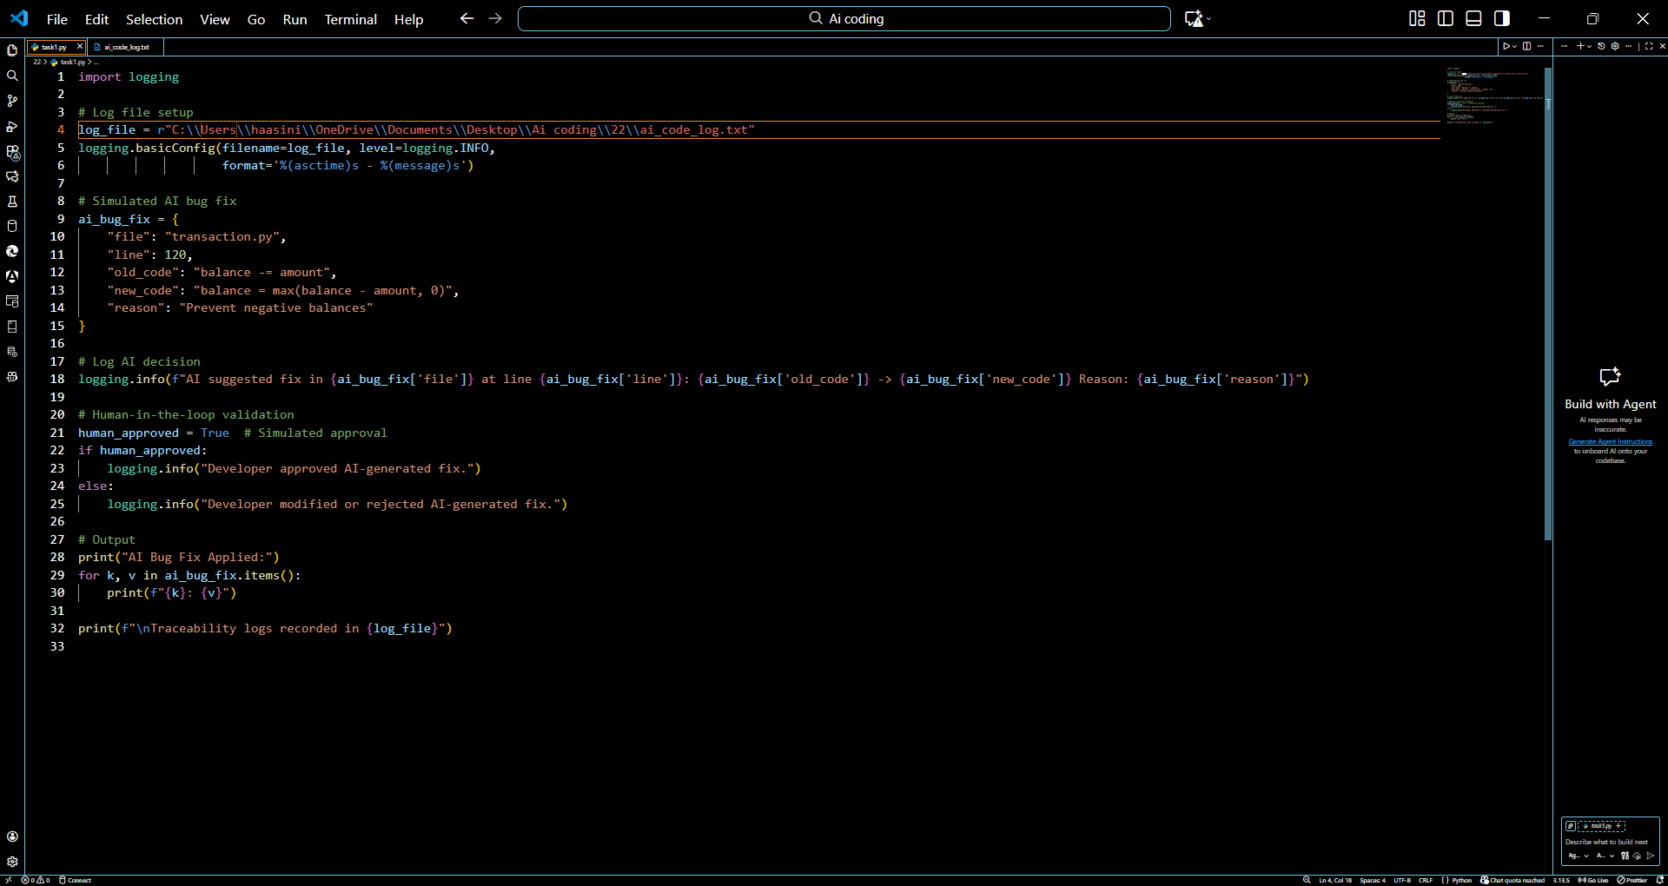  Output:  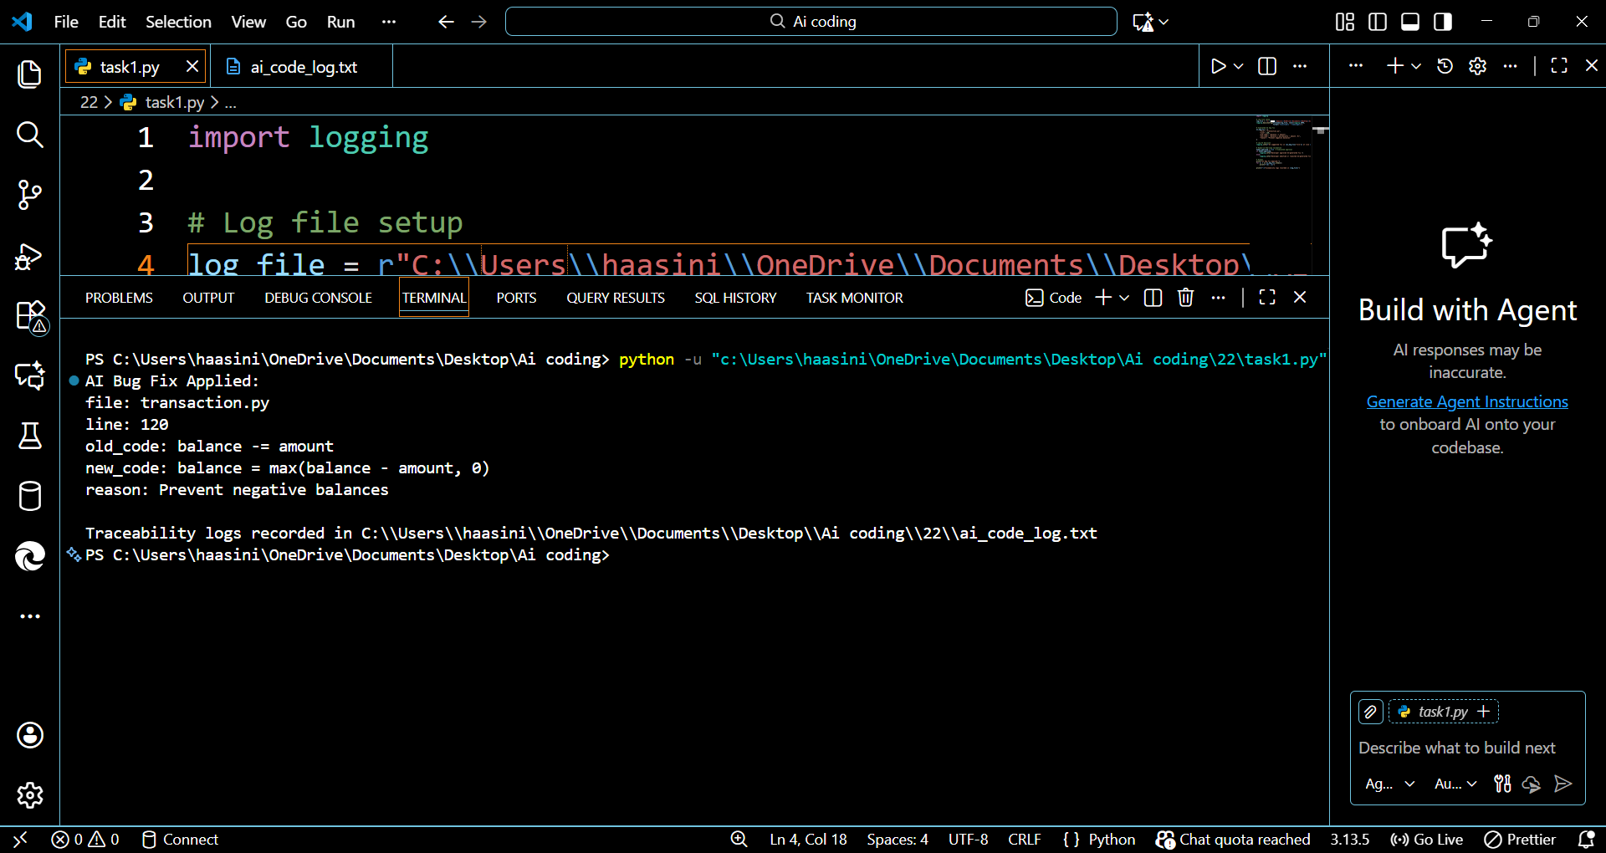    Observations / Explanation  - Risks of Opaque AI in Critical Domains:  - AI fixes without explanation may introduce undetected errors.  - In finance, this could cause loss of money, regulatory breaches, or fraud risks.  - Transparency Methods:  - Logging AI decisions ensures all changes are recorded for auditing.  - Human-in-the-loop validation prevents blind acceptance of AI fixes.  - Explainable AI techniques (e.g., highlighting affected code logic, natural language explanation) increase trust.  - Key Takeaways:  - Transparency and explainability are essential in high-stakes software.  - A combination of technical safeguards and human review ensures AI-assisted coding is safe, accountable, and trustworthy. |  |  |  |  |  | Week 11 - Friday

