SCHOOL OF COMPUTER SCIENCE AND ARTIFICIAL INTELLIGENCE |  |  |  |  | DEPARTMENT OF COMPUTER SCIENCE ENGINEERING
Program Name: B. Tech |  |  |  | Assignment Type: Lab |  |  | Academic Year:2025-2026
Course Coordinator Name |  |  |  | Venkataramana Veeramsetty
Instructor(s) Name |  |  |  | Dr. V. Venkataramana (Co-ordinator)  Dr. T. Sampath Kumar  Dr. Pramoda Patro  Dr. Brij Kishor Tiwari  Dr.J.Ravichander  Dr. Mohammand Ali Shaik  Dr. Anirodh Kumar  Mr. S.Naresh Kumar  Dr. RAJESH VELPULA  Mr. Kundhan Kumar  Ms. Ch.Rajitha  Mr. M Prakash  Mr. B.Raju  Intern 1 (Dharma teja)  Intern 2 (Sai Prasad)  Intern 3 (Sowmya)  NS_2 ( Mounika)
Course Code |  |  | 24CS002PC215 | Course Title |  | AI Assisted Coding
Year/Sem |  |  | II/I | Regulation |  | R24
Date and Day  of Assignment |  |  | Week12 - Thursday | Time(s)
Duration |  |  | 2 Hours | Applicable to  Batches
AssignmentNumber:23.4(Present assignment number)/24(Total number of assignments)
 | Q.No. | Question |  |  |  |  |  | Expected Time  to complete
 | 1 | Lab 23 – Capstone Project Workshop: End-to-End Application Development  Lab Objectives:  - Integrate all previously learned AI-assisted coding concepts into a complete project.  - Develop an end-to-end software application using AI tools for coding, documentation, testing, and deployment.  - Practice teamwork, version control, and project presentation.  - Demonstrate the ability to solve a real-world problem using AI-assisted programming.  Task 1: Define the Problem and Project Setup  - Instructions:  - Form small teams and select a project idea (e.g., healthcare chatbot, student attendance system, expense tracker).  - Create a GitHub repository and initialize it with a README.  - Use AI tools to draft a project description, objectives, and high-level architecture in the README.  - Expected Output:  - A GitHub repo with:  - README.md containing problem statement, goals, and architecture diagram (text/ASCII or AI-generated).  - Clear description of team roles.  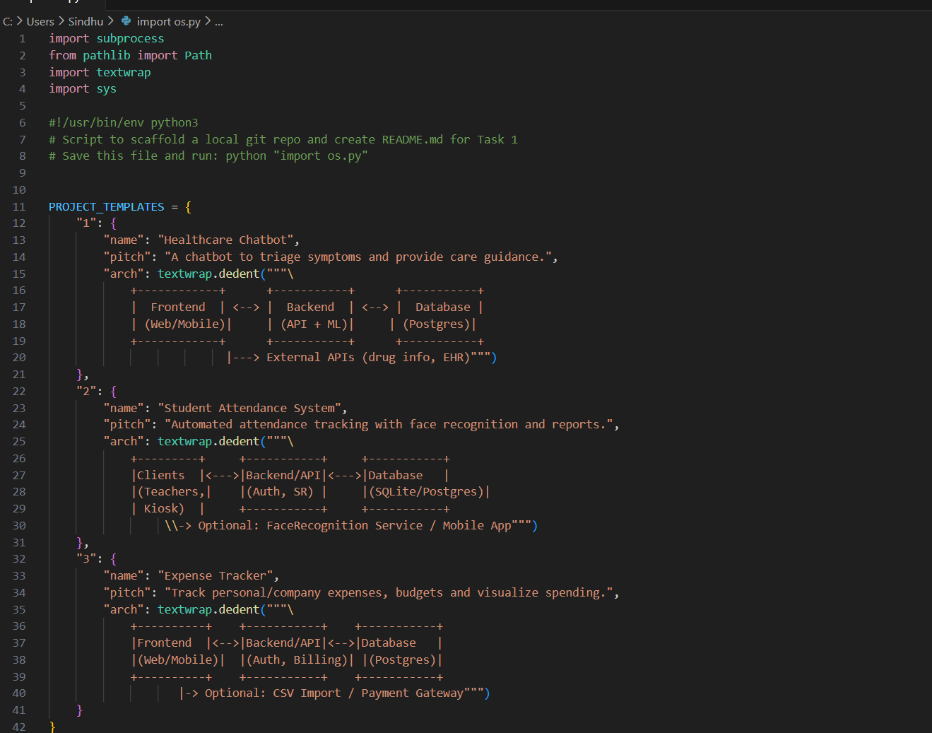  Task 2: Build the Backend API  - Instructions:  - Use AI tools to generate backend code (Python Flask/FastAPI or Node.js Express).  - Implement at least two REST API endpoints (e.g., POST /addUser, GET /getUser).  - Add basic error handling (e.g., invalid requests return proper error messages).  - Expected Output:  - Working backend API that responds with JSON.  - Example:  {"status": "success", "message": "User added successfully"}  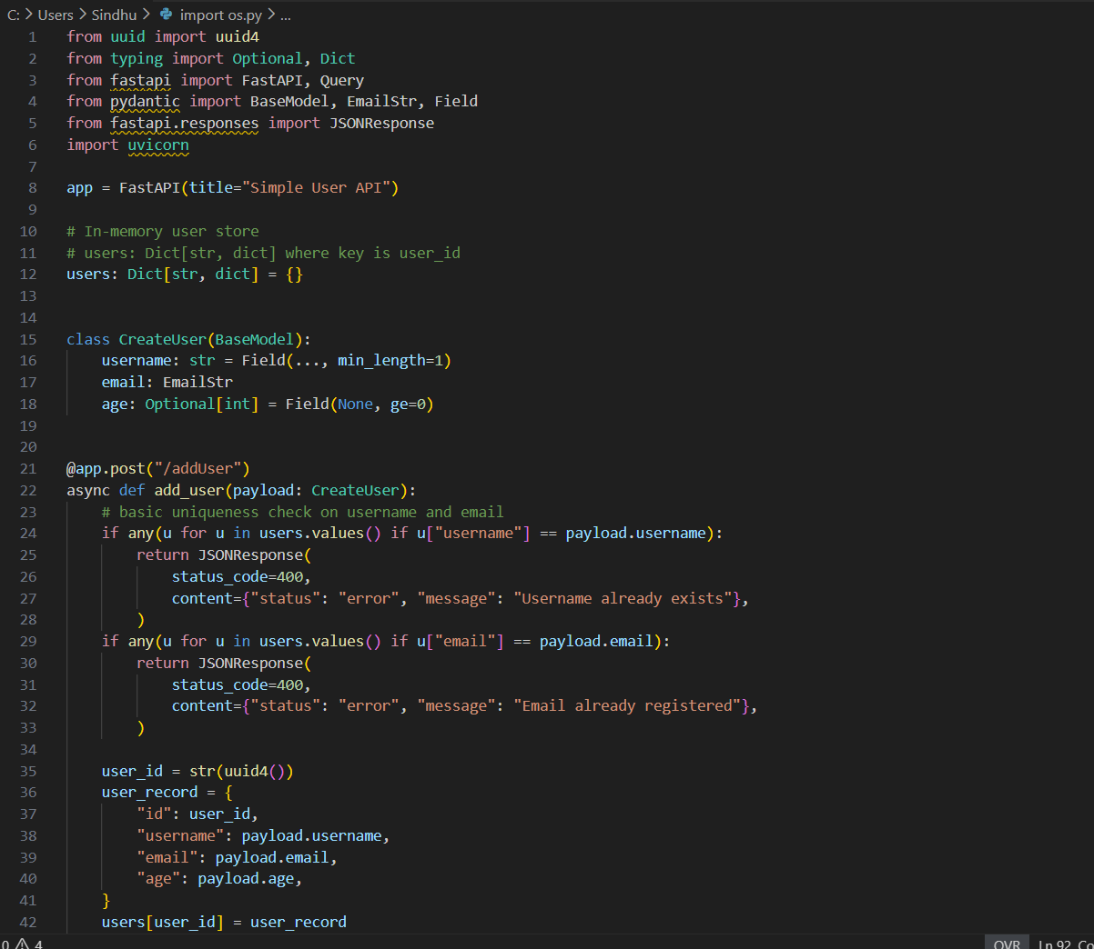  Task 3: Develop the Frontend Interface  - Instructions:  - Use AI to scaffold a frontend (React/HTML + CSS).  - Connect the frontend to the backend API using fetch/axios calls.  - Create a simple UI form (e.g., enter user details, submit to backend, display response).  - Expected Output:  - A functional frontend that allows users to interact with the backend.  - Example: Entering a new user in the form shows confirmation from backend.  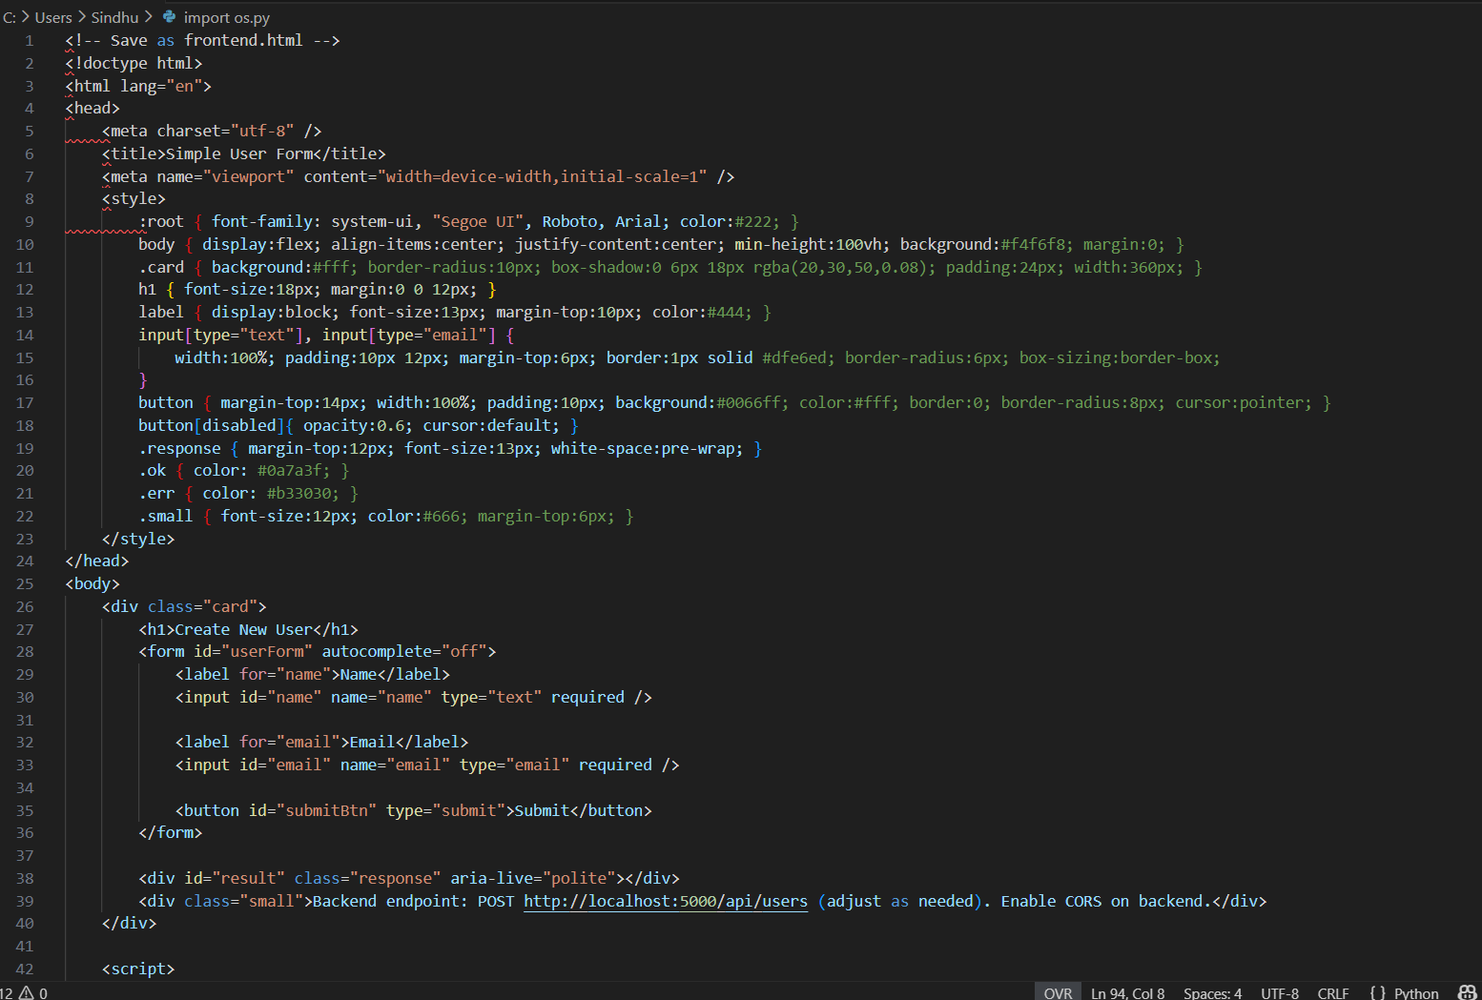  Task 4: Add Database Integration  - Instructions:  - Use AI to generate code that connects the backend with a database (SQLite, MySQL, or MongoDB).  - Implement CRUD operations (Create, Read, Update, Delete).  - Ensure queries are safe (parameterized queries, no SQL injection).  - Expected Output:  - A persistent database storing application data.  - Example: Adding a user → stored in DB → retrieving displays correct data.  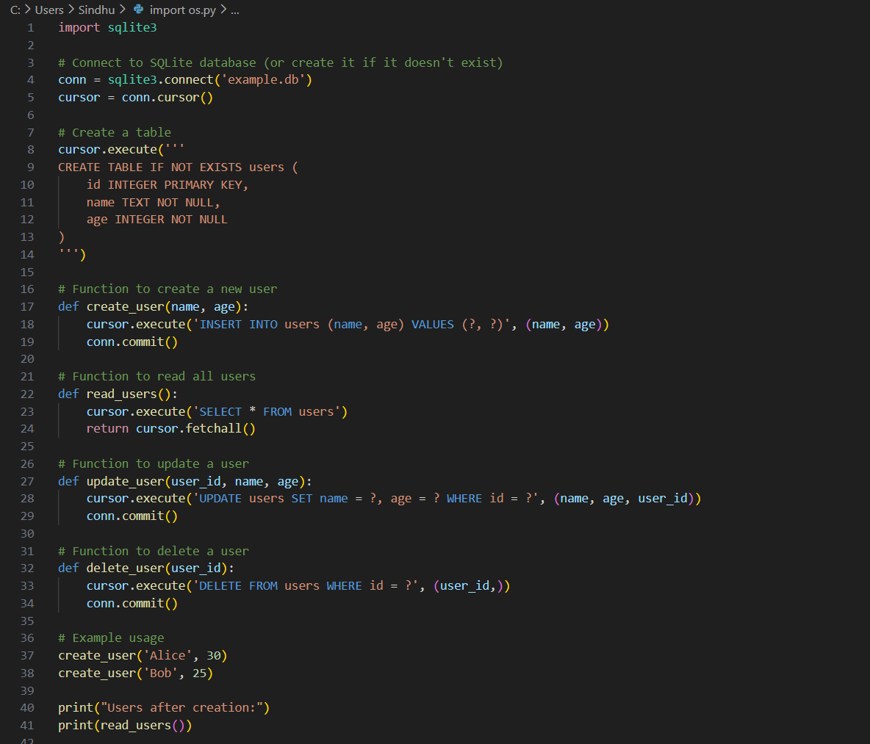  Task 5: Testing, Deployment, and Documentation  - Instructions:  - Write unit tests (AI-assisted) for both backend and frontend.  - Set up GitHub Actions to run tests automatically on every push.  - Deploy the application (Heroku, Vercel, or Render).  - Update README with usage guide, limitations, and future improvements.  - Expected Output:  - Passing test results.  - Live deployed application link.  - README.md with sections: Installation, Usage, Limitations, Future Scope.  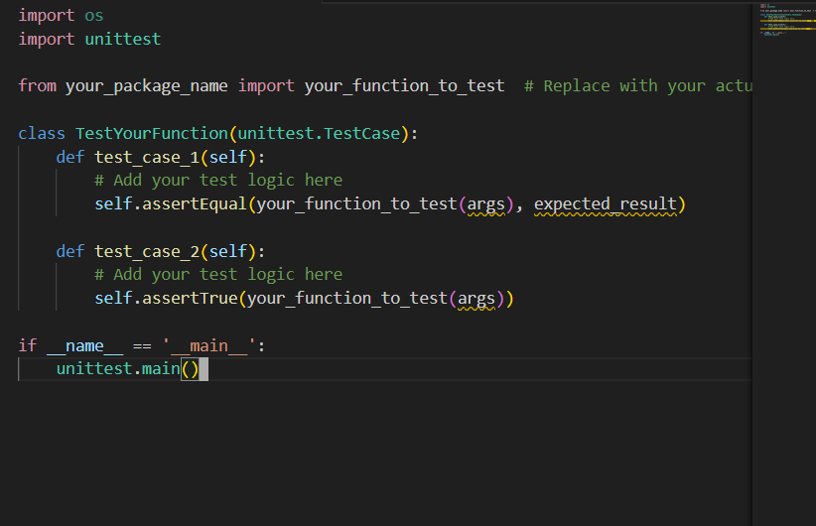  These 5 tasks simulate a real-world software development lifecycle (SDLC):  - Problem Definition & Setup  - Backend Development  - Frontend Development  - Database Integration  - Testing, Deployment, Documentation |  |  |  |  |  | Week12 - Thursday

