SCHOOL OF COMPUTER SCIENCE AND ARTIFICIAL INTELLIGENCE |  |  |  |  | DEPARTMENT OF COMPUTER SCIENCE ENGINEERING
Program Name: B. Tech |  |  |  | Assignment Type: Lab |  |  | Academic Year:2025-2026
Course Coordinator Name |  |  |  | Venkataramana Veeramsetty
Instructor(s) Name |  |  |  | Dr. V. Venkataramana (Co-ordinator)  Dr. T. Sampath Kumar  Dr. Pramoda Patro  Dr. Brij Kishor Tiwari  Dr.J.Ravichander  Dr. Mohammand Ali Shaik  Dr. Anirodh Kumar  Mr. S.Naresh Kumar  Dr. RAJESH VELPULA  Mr. Kundhan Kumar  Ms. Ch.Rajitha  Mr. M Prakash  Mr. B.Raju  Intern 1 (Dharma teja)  Intern 2 (Sai Prasad)  Intern 3 (Sowmya)  NS_2 ( Mounika)
Course Code |  |  | 24CS002PC215 | Course Title |  | AI Assisted Coding
Year/Sem |  |  | II/I | Regulation |  | R24
Date and Day  of Assignment |  |  | Week12 - Thursday | Time(s)
Duration |  |  | 2 Hours | Applicable to  Batches
AssignmentNumber:24.4(Present assignment number)/24(Total number of assignments)
 | Q.No. | Question |  |  |  |  |  | Expected Time  to complete
 | 1 | Lab 24 – Replit for Mobile Applications  Lab Objectives:  - Explore Replit as a cloud-based IDE for building mobile applications.  - Learn how to leverage AI-assisted coding inside Replit for faster development.  - Understand how to design, test, and deploy simple mobile apps.  - Gain experience in collaborative app development directly from the browser.  Task 1: Set Up Replit Project for Mobile App  - Instructions:  - Create a new Replit project using React Native or Flutter Web template.  - Use AI tools to scaffold a basic mobile app structure (screens, components, navigation).  - Add a README describing project purpose and mobile app layout.  - Expected Output:  - A Replit project with an initial mobile app structure.  - App renders a welcome screen on mobile view.  - README includes project description and layout diagram.  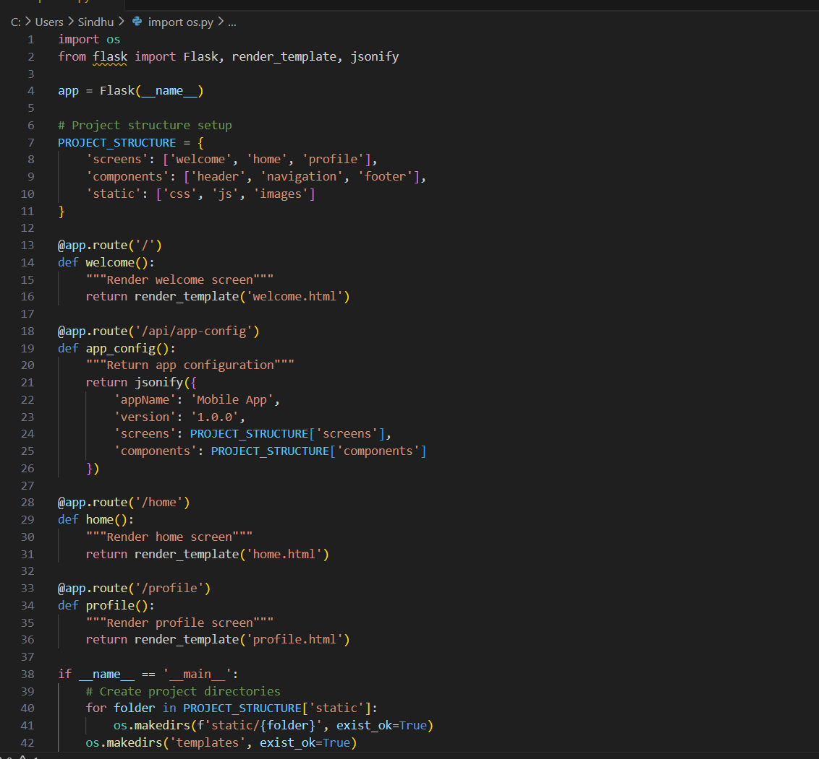  Task 2: Create User Input Form  - Instructions:  - Build a mobile-friendly form (e.g., user registration) with input fields: Name, Email, Password.  - Use AI tools to generate validation functions for each input.  - Ensure form is responsive on small screen sizes.  - Expected Output:  - Form accepts user input.  - Invalid input triggers validation messages (e.g., “Enter a valid email”).  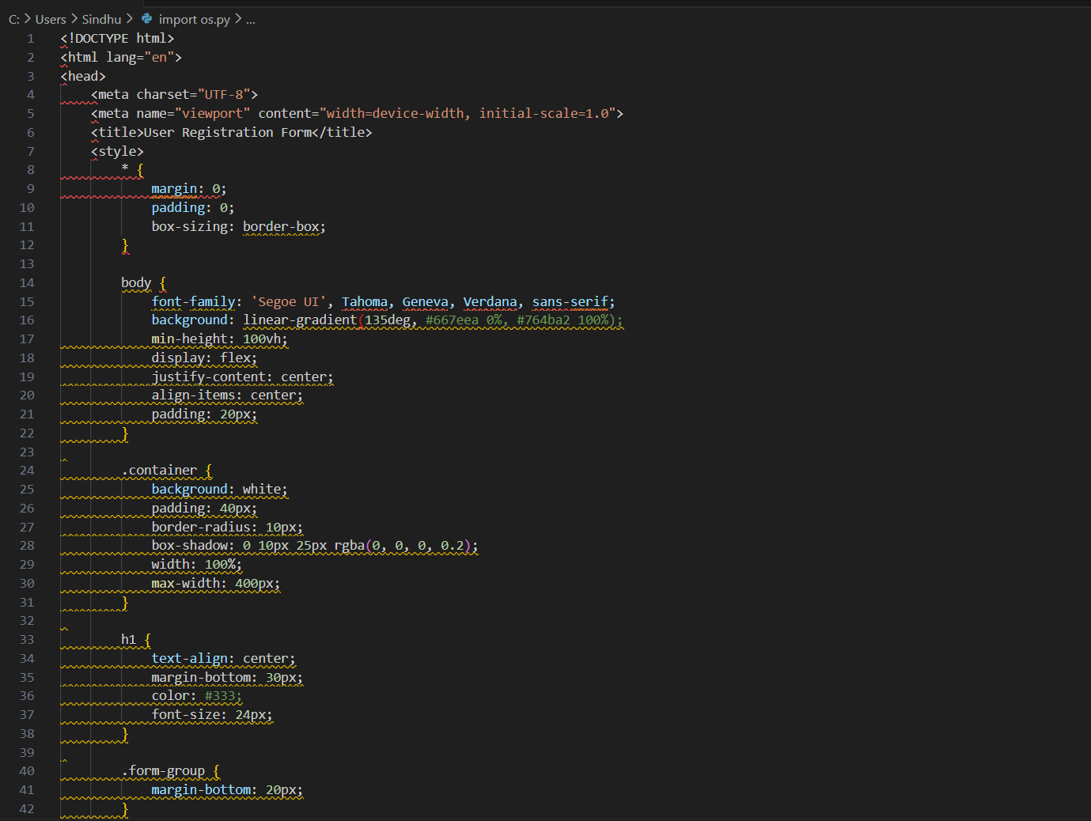  Task 3: Connect Form to Backend API  - Instructions:  - Use AI tools to generate a mock backend API (Flask/FastAPI or Node.js).  - Submit the mobile form data to the backend using fetch/axios.  - Handle success and error responses gracefully.  - Expected Output:  - Form submission triggers API call.  - Success response:  - {"status": "success", "message": "User registered successfully"}  - Error response shows a friendly message on the UI.  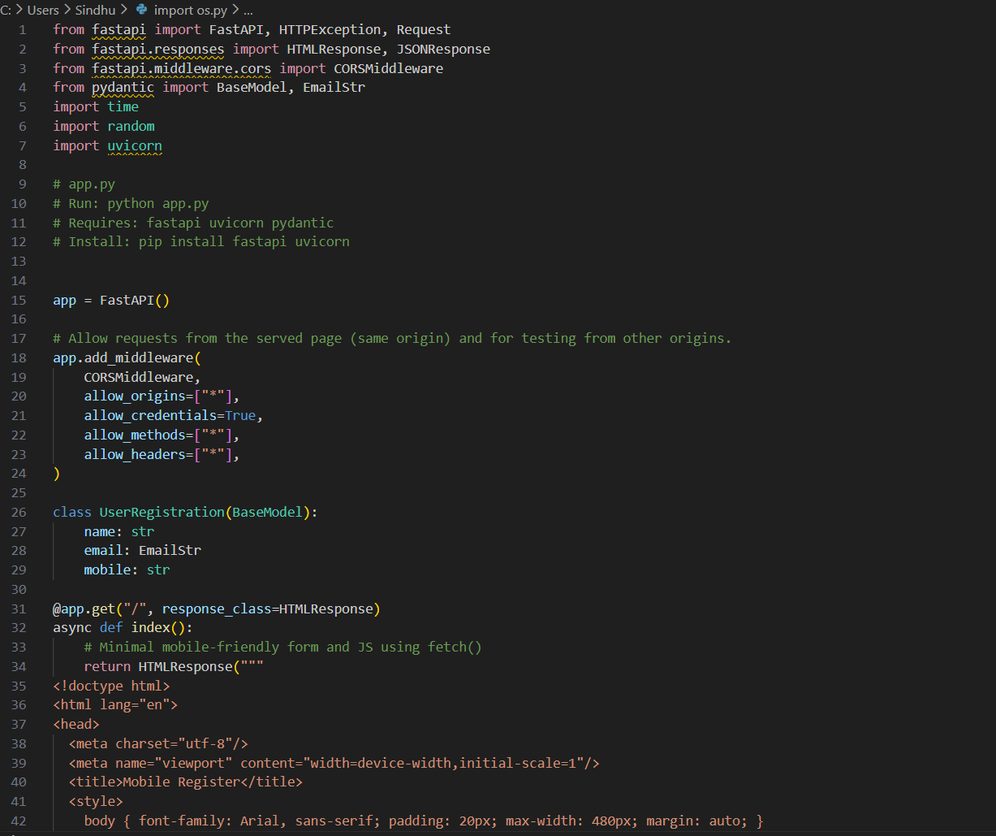  Task 4: Implement Mobile Navigation and State Management  - Instructions:  - Use AI tools to add navigation between screens (e.g., Home → Profile → Settings).  - Implement state management (e.g., React useState/useContext or Flutter Provider) for user data.  - Ensure data persists across screens.  - Expected Output:  - Navigating between screens displays correct data.  - User information entered in one screen is available on other screens.  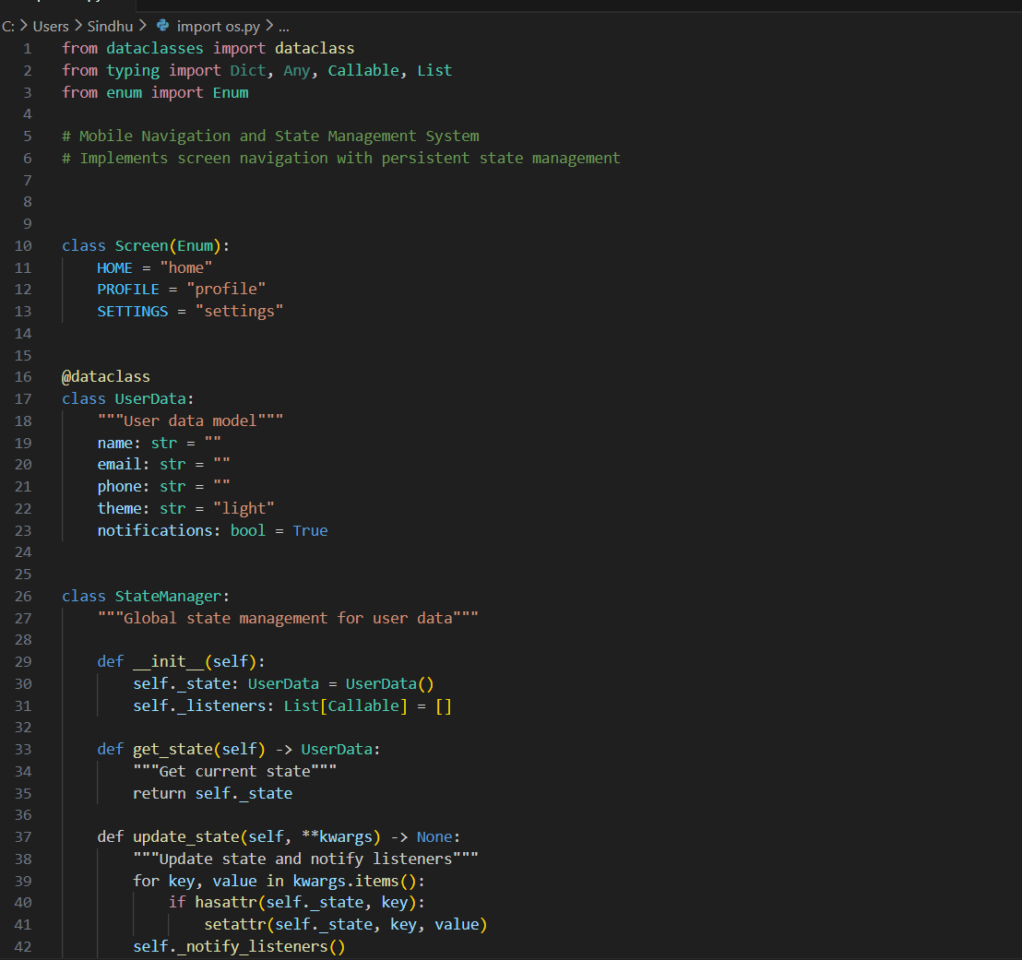  Task 5: Testing and Deployment on Mobile Preview  - Instructions:  - Use AI tools to generate unit and integration tests for components and API calls.  - Test the app on Replit mobile preview or emulator.  - Update README with installation, usage instructions, and screenshots of mobile view.  - Expected Output:  - Tests run successfully.  - App works correctly on mobile preview.  - README contains clear steps for running and testing the app.  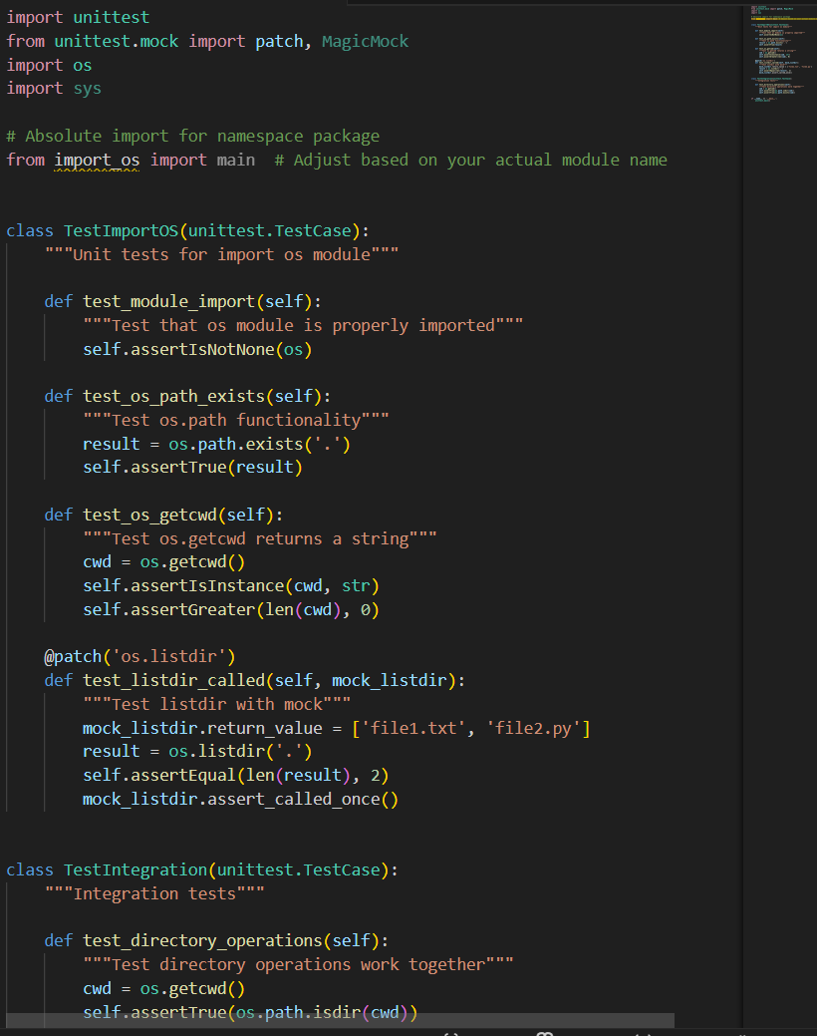  ✅ Deliverables (For All Tasks)  - AI-generated prompts for code and test case generation.  - At least 3 assert test cases for each task.  - AI-generated initial code and execution screenshots.  - Analysis of whether code passes all tests.  - Improved final version with inline comments and explanation.  - Compiled report (Word/PDF) with prompts, test cases, assertions, code, and output. |  |  |  |  |  | Week12 - Thursday

