SCHOOL OF COMPUTER SCIENCE AND ARTIFICIAL INTELLIGENCE |  |  |  |  | DEPARTMENT OF COMPUTER SCIENCE ENGINEERING
Program Name: B. Tech |  |  |  | Assignment Type: Lab |  |  | Academic Year:2025-2026
Course Coordinator Name |  |  |  | Venkataramana Veeramsetty
Instructor(s) Name |  |  |  | Dr. V. Venkataramana (Co-ordinator)  Dr. T. Sampath Kumar  Dr. Pramoda Patro  Dr. Brij Kishor Tiwari  Dr.J.Ravichander  Dr. Mohammand Ali Shaik  Dr. Anirodh Kumar  Mr. S.Naresh Kumar  Dr. RAJESH VELPULA  Mr. Kundhan Kumar  Ms. Ch.Rajitha  Mr. M Prakash  Mr. B.Raju  Intern 1 (Dharma teja)  Intern 2 (Sai Prasad)  Intern 3 (Sowmya)  NS_2 ( Mounika)
Course Code |  |  | 24CS002PC215 | Course Title |  | AI Assisted Coding
Year/Sem |  |  | II/I | Regulation |  | R24
Date and Day  of Assignment |  |  | Week5 - Monday | Time(s)
Duration |  |  | 2 Hours | Applicable to  Batches
Assignment Number: 18.5(Present assignment number)/24(Total number of assignments)
 | Q.No. | Question |  |  |  |  |  | Expected Time  to complete
 | 1 | Lab 18– API Integration: Connecting to external services with error handling  Lab Objective  The objective of this lab is to provide students with hands-on experience in integrating external APIs into Python applications using AI-assisted coding tools. Students will:  - Understand the fundamentals of API requests, responses, and authentication mechanisms.  - Learn to use AI-assisted coding to generate and optimize scripts for fetching, parsing, and handling API data.  - Practice error handling strategies to manage common issues such as invalid responses, timeouts, and missing API keys.  - Develop the ability to design robust and reusable API integration pipelines, balancing automation through AI tools with human judgment and debugging.  Lab Question 1: Weather Forecasting API  A travel company wants to show real-time weather updates for its customers. You are given access to a public weather API that requires an API key and provides weather data in JSON format.  - Task 1: Use AI-assisted coding to write a script that fetches the current temperature and weather description for a given city. The script should handle errors if the API key is invalid or missing.  - Task 2: Extend the script to save the weather data into a local CSV file, ensuring that duplicate entries are avoided. Implement error handling for file I/O exceptions.  PROMPT:  Write a Python script (for VSCode) that uses a public weather API with an API key to fetch current temperature and weather description for a given city, handles invalid/missing API key errors, saves results to a CSV file without duplicate entries, and includes file I/O error handling.  CODE:  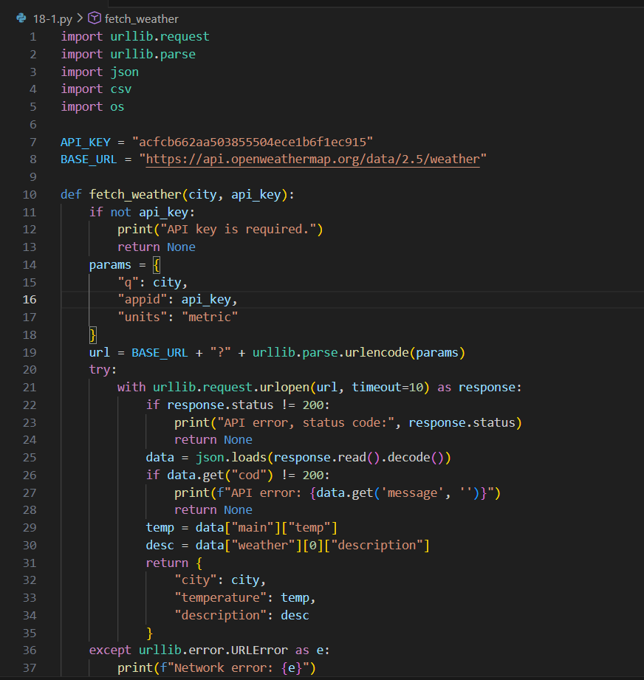  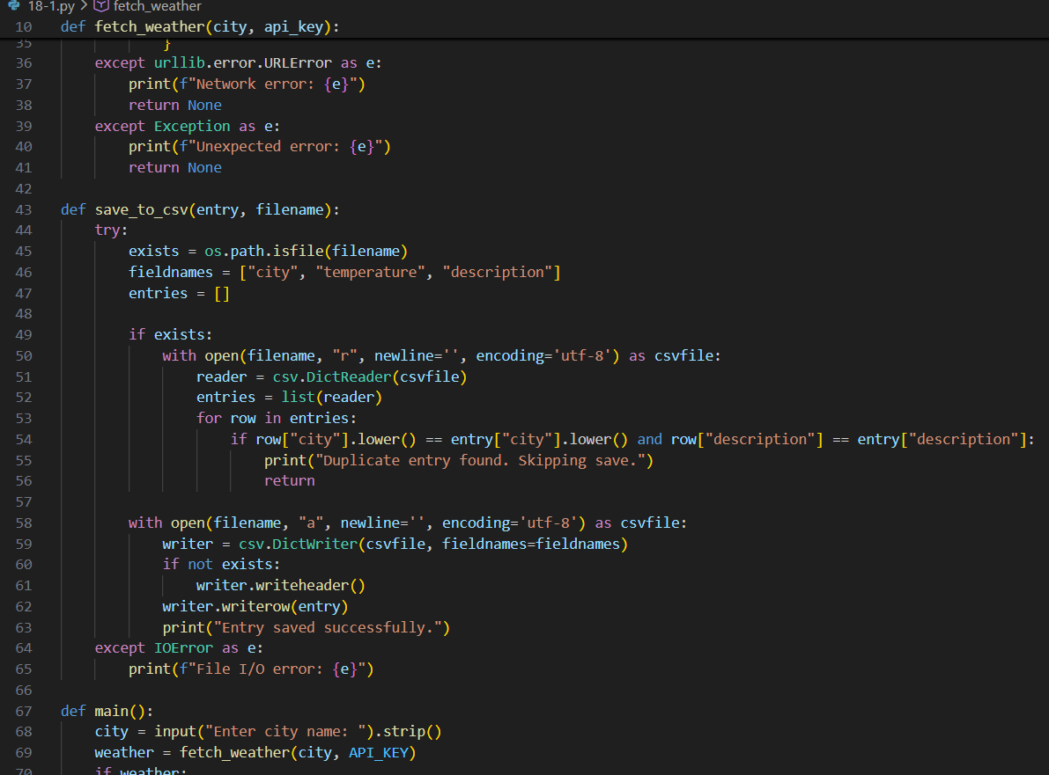  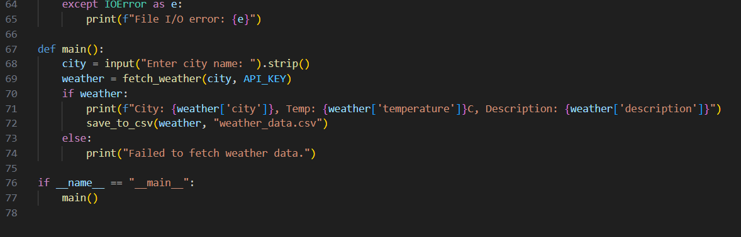  OUTPUT:  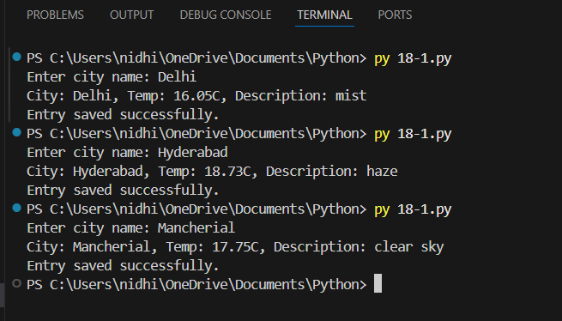  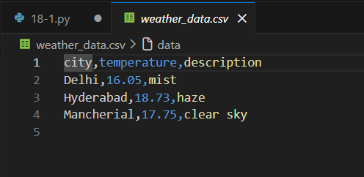  Lab Question 2: Currency Exchange Rate API  A financial startup needs a tool to convert amounts between currencies using an exchange rate API. However, the API occasionally fails due to server downtime.  - Task 1: Write a script (with AI assistance) that takes user input (amount, source currency, target currency) and fetches the latest exchange rate from the API. Include errors in handling invalid currency codes.  - Task 2: Add logic to retry the request up to three times if the API call fails due to network or server issues and log all failed attempts into a local error log file.  PROMPT:  Generate Python code for a currency converter script that takes user input (amount, source currency, target currency), fetches the latest exchange rate from an API, handles invalid currency codes, retries up to three times on API or network errors, and logs failures to a local error log file.  CODE:  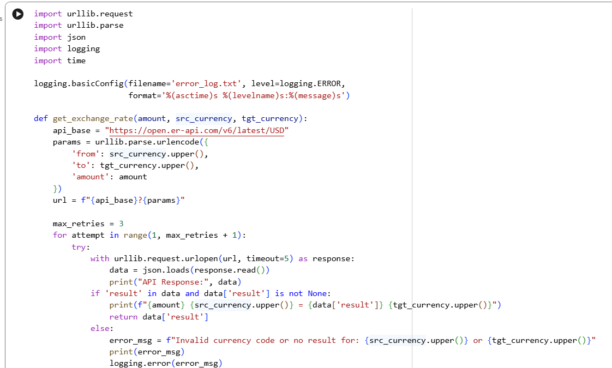  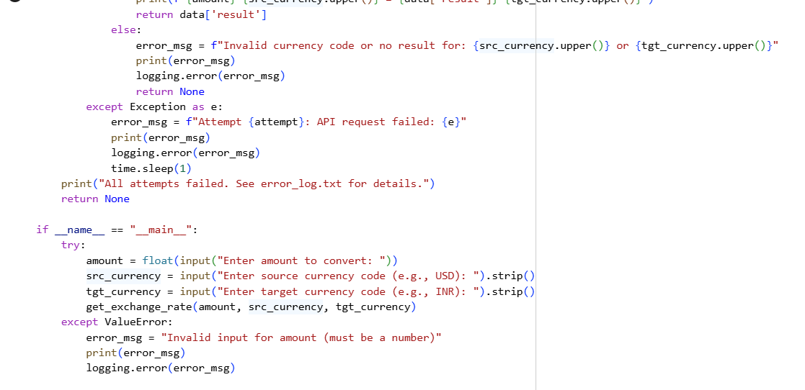  OUTPUT:  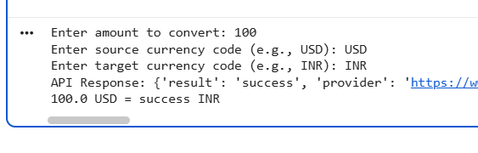  Lab Question 3: News Headlines API  A news aggregator wants to display the latest technology news headlines using a news API. Sometimes, the API responds slowly or returns incomplete data.  - Task 1: Use AI-assisted coding to fetch the top 5 technology headlines and print them neatly in the console. Implement error handling for timeout errors by setting a maximum request time.  - Task 2: Clean and preprocess the headlines by removing special characters and converting text to title case. Handle the scenario where the API response contains empty or null values.  PROMPT:  Generate a Python script that fetches the top 5 latest technology news headlines from a public news API, prints them neatly in the console, handles timeout errors with a set maximum request time, cleans and preprocesses headlines by removing special characters and converting to title case, and gracefully handles empty or null API responses  CODE:  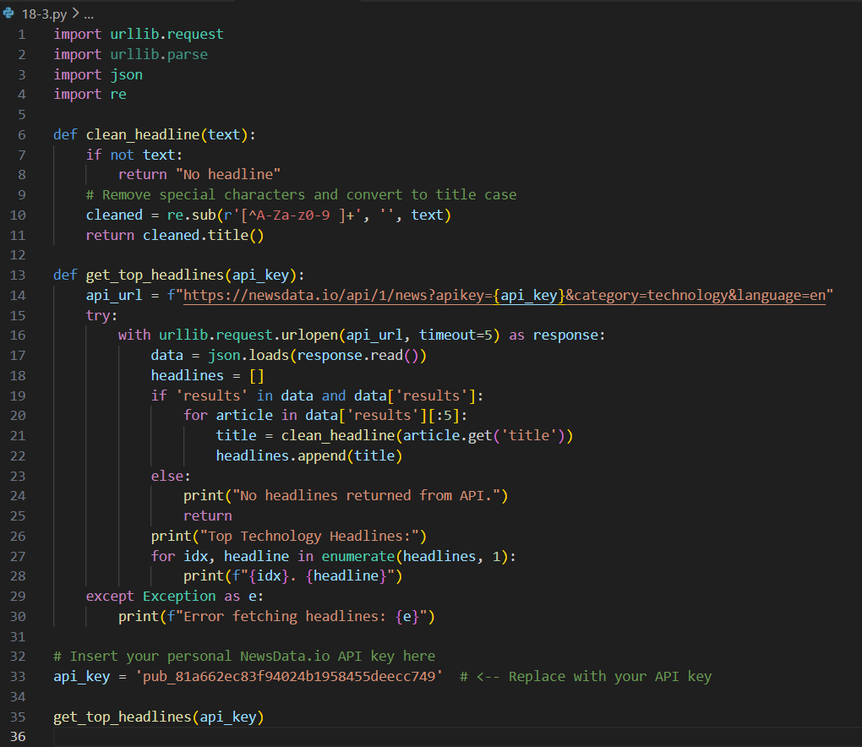  OUTPUT:  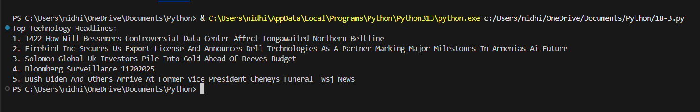 |  |  |  |  |  | Week 9 - Monday

