SCHOOL OF COMPUTER SCIENCE AND ARTIFICIAL INTELLIGENCE |  |  |  |  | DEPARTMENT OF COMPUTER SCIENCE ENGINEERING
Program Name: B. Tech |  |  |  | Assignment Type: Lab |  |  | Academic Year:2025-2026
Course Coordinator Name |  |  |  | Venkataramana Veeramsetty
Instructor(s) Name |  |  |  | Dr. V. Venkataramana (Co-ordinator)  Dr. T. Sampath Kumar  Dr. Pramoda Patro  Dr. Brij Kishor Tiwari  Dr.J.Ravichander  Dr. Mohammand Ali Shaik  Dr. Anirodh Kumar  Mr. S.Naresh Kumar  Dr. RAJESH VELPULA  Mr. Kundhan Kumar  Ms. Ch.Rajitha  Mr. M Prakash  Mr. B.Raju  Intern 1 (Dharma teja)  Intern 2 (Sai Prasad)  Intern 3 (Sowmya)  NS_2 ( Mounika)
Course Code |  |  | 24CS002PC215 | Course Title |  | AI Assisted Coding
Year/Sem |  |  | II/I | Regulation |  | R24
Date and Day  of Assignment |  |  | Week6 - Monday | Time(s)
Duration |  |  | 2 Hours | Applicable to  Batches
Assignment Number:19.5(Present assignment number)/24(Total number of assignments)
 | Q.No. | Question |  |  |  |  |  | Expected Time  to complete
 | 1 | Lab 19 – Code Translation: Converting between programming languages  Lab Objective  The objective of this lab is to familiarize students with AI-assisted code translation across programming languages. Students will:  - Understand the challenges of syntax, semantics, and library differences when converting code between languages.  - Learn to use AI coding assistants to generate equivalent code in another language, while critically evaluating the correctness and efficiency of the translated version.  - Practice debugging and refining translated code to ensure functional equivalence and error-free execution.  - Develop the skill to create cross-language solutions, preparing students to work in diverse programming environments.  Lab Question 1: Sorting Algorithm Translation  You are part of a multinational development team. The backend is written in Java, but a new module requires a Python implementation of the same algorithm for integration with a data science pipeline.  - Task 1: Use AI-assisted coding to translate a given Java bubble sort program into Python. Verify that the translated code works correctly.  - Task 2: Introduce errors in the Python version to check if the input list is empty or contains non-numeric values.  PROMPT:  Translate a Java bubble sort program into Python code using AI assistance. Include error checking in the Python version to ensure it raises appropriate errors when the input list is empty or contains non-numeric values. Demonstrate the working code and error handling using relevant test cases.  CODE:  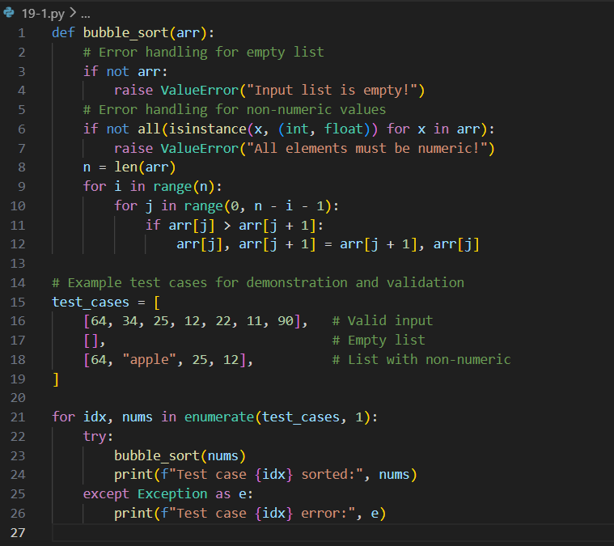  OUTPUT:  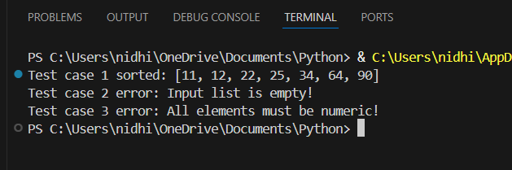  Lab Question 2: File Handling Translation  A company’s legacy codebases stores and processes files in C++, but the analytics team needs an equivalent program in JavaScript (Node.js) for integration with a web dashboard.  - Task 1: Translate a given C++ file read-and-write program into JavaScript using AI assistance. Ensure the script reads a text file and writes processed output to a new file.  - Task 2: Add error handling in the JavaScript version to gracefully handle missing files or permission errors.  PROMPT:  Translate a Python script that fetches weather data from an API using HTTP requests into a complete Java program. The Java version should make the same API call, print the response, and include error handling for invalid API keys, request timeouts, or no internet connection.  CODE:  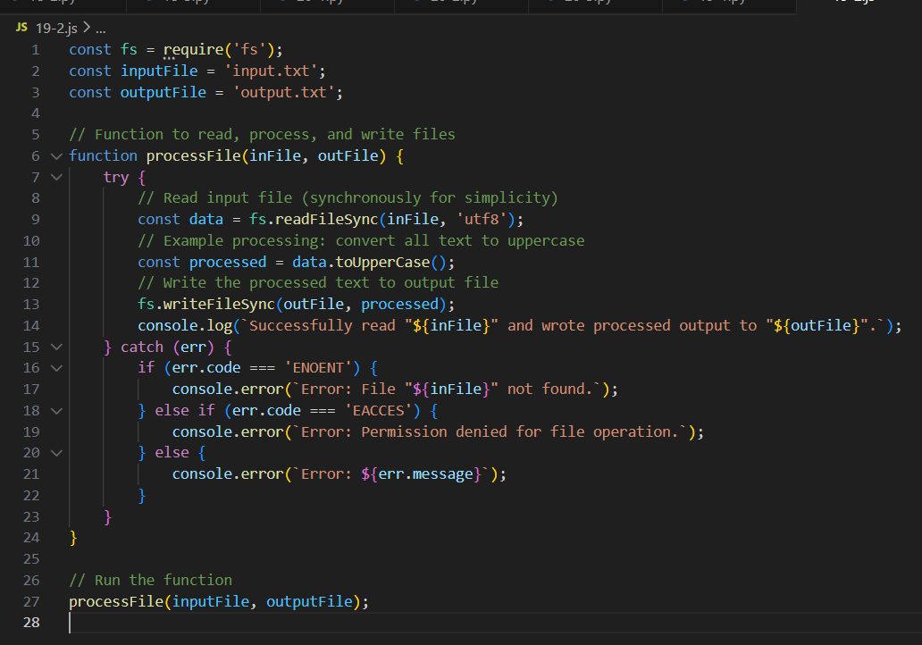  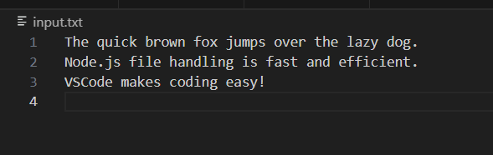  Lab Question 3: API Call Translation  Your team developed a prototype in Python to fetch weather data from an API, but the production environment only supports Java.  - Task 1: Translate the Python script (that makes an API call and prints the response) into Java using AI-assisted coding. Ensure equivalent functionality.  - Task 2: Add proper error handling in the Java version for cases such as invalid API key, request timeout, or no internet connection.  PROMPT:  Translate a C++ file read-and-write program into JavaScript (Node.js). The JavaScript version should read from a text file, process its contents, write the output to a new file, and include error handling for missing files or permission errors.  CODE:  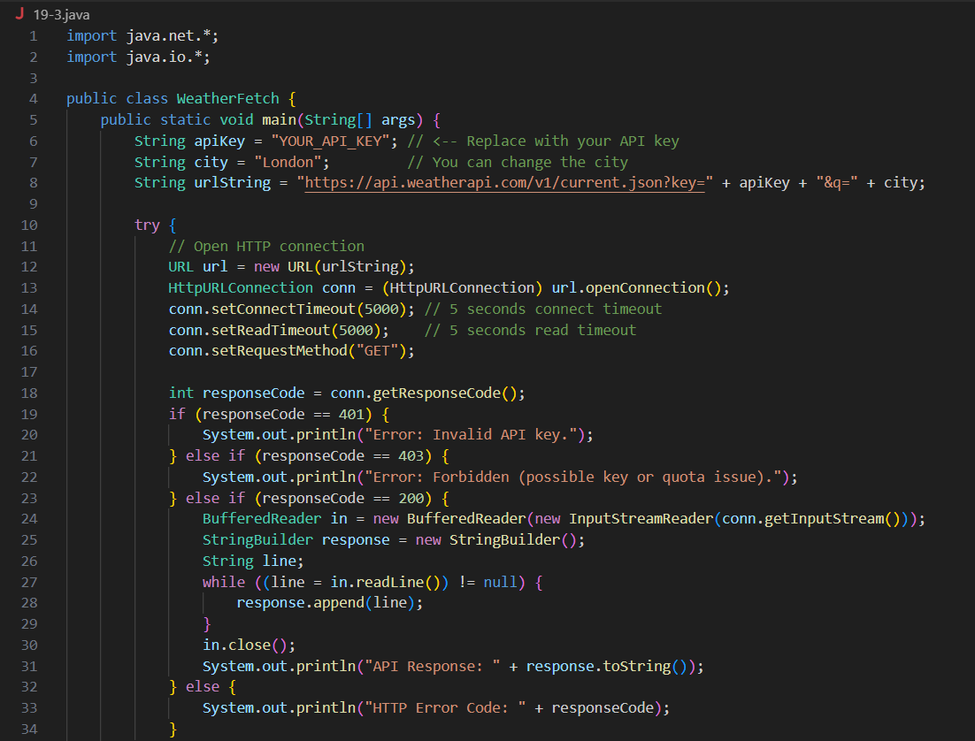  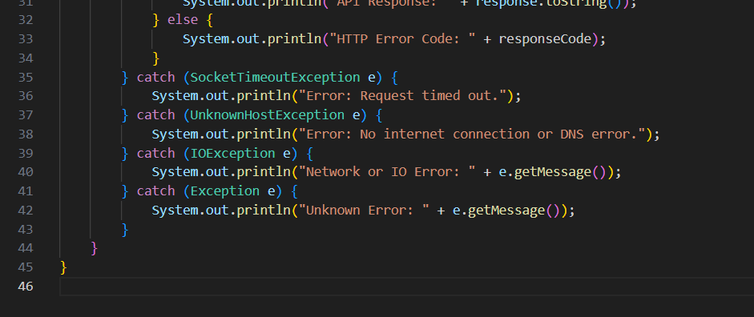 |  |  |  |  |  | Week 10 - Friday

