# AI ASSISTED CODING LAB TEST-1:

Name : Nidhi Kachwal

HT No : 2403A51T01

Section : Batch 18

**QUESTION 1:**

Write a Python code to calculate the sum of odd and even numbers in a given list using GitHub Copilot along with VS Code. Use zero shot prompting.

**Prompt:**

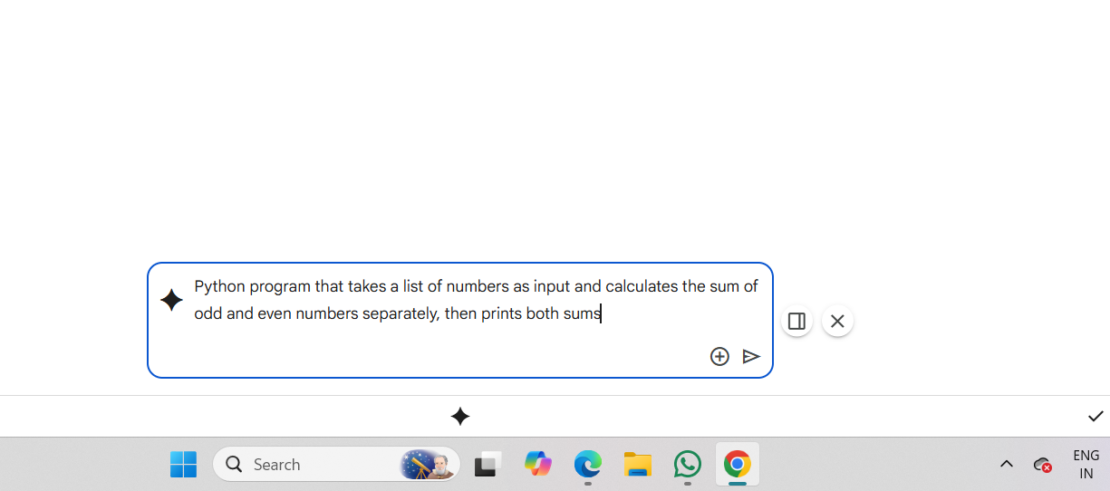

**Code:**

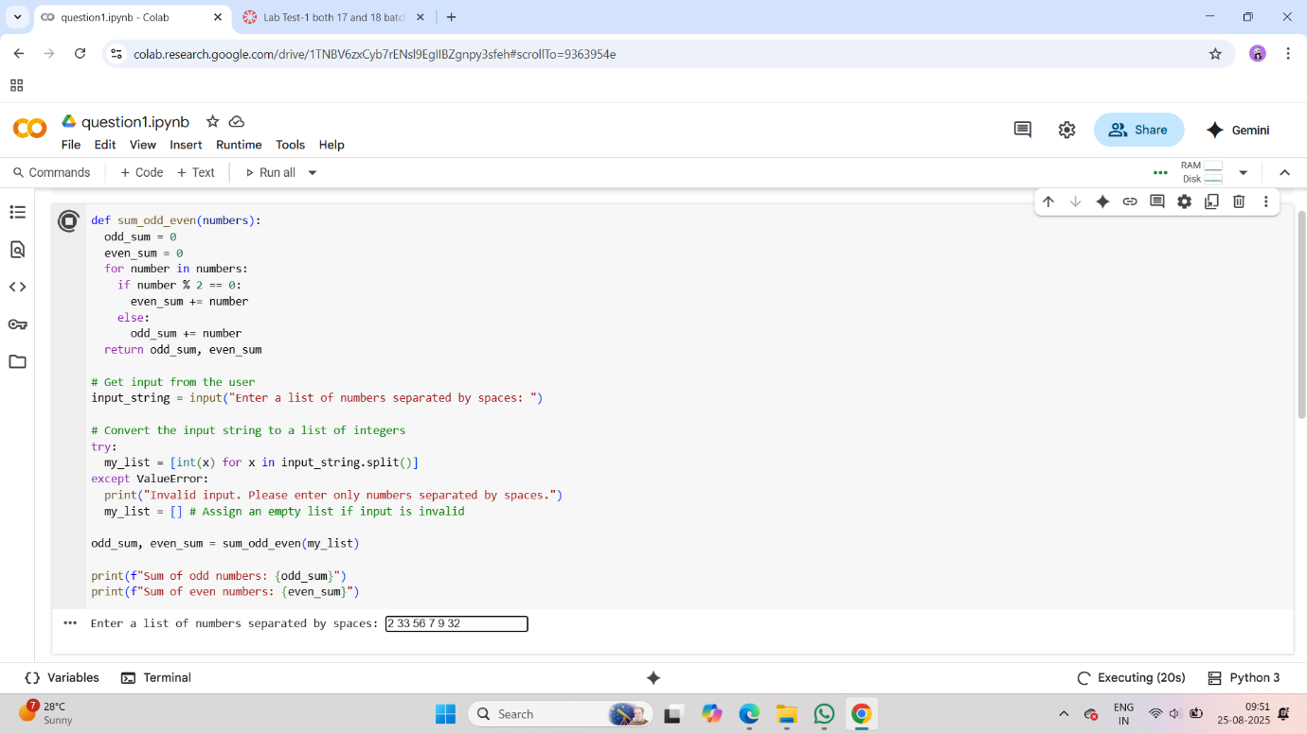

**Output:**

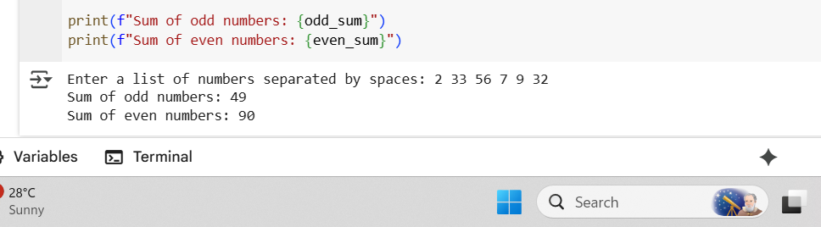

**QUESTION 2:**

Write a Python code for given a list of integers, remove duplicates and print the sorted result. GitHub Copilot along with VS Code. Use one shot prompting.

**Prompt:**

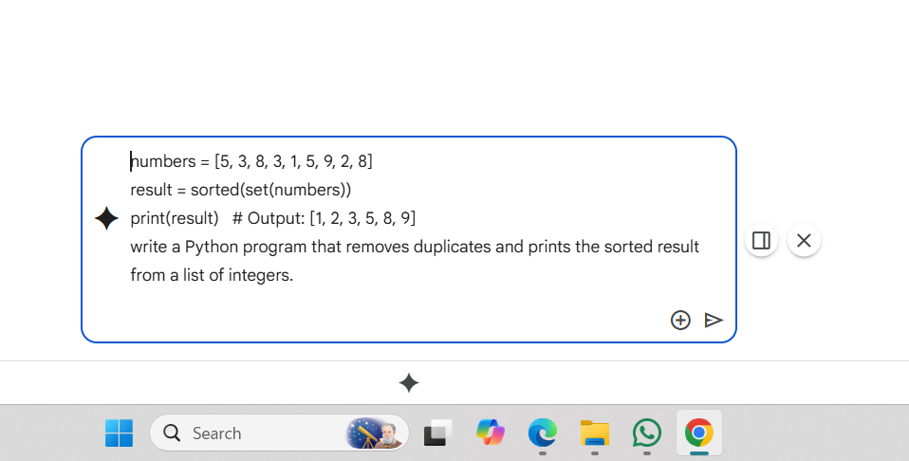

**Code:**

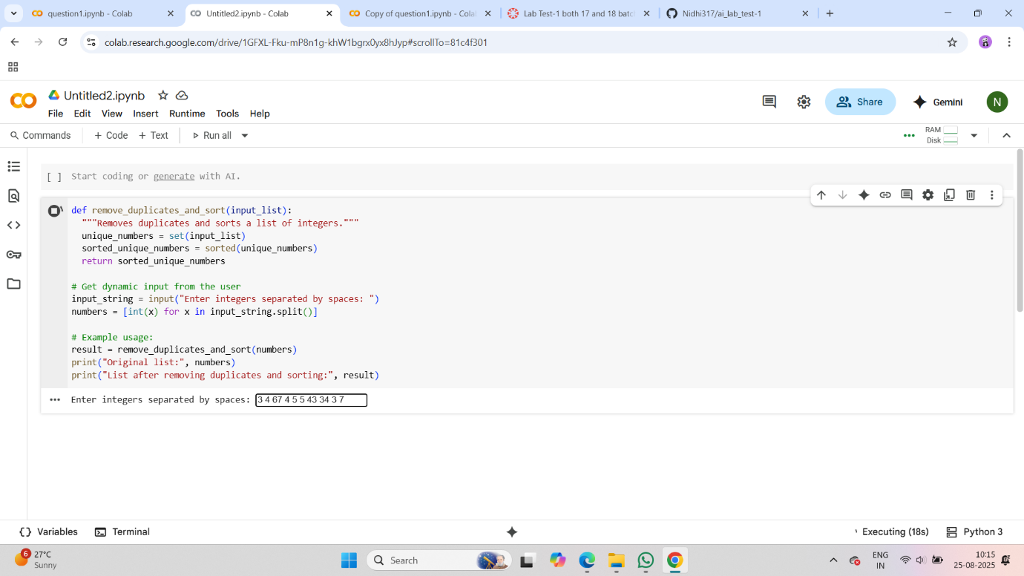

**Output:**

