Name: Nidhi
Course: BDA400 - Data Science Tools and Techniques
Assignment 5 Technical Analysis using R, Development Phase
GitHub Repository: https://github.com/Nidhi8975/TechnicalAnalysis/tree/main/Assignment5_Development
How to run my code
- Clone the folder Assignment5_Development from my TechnicalAnalysis repository.
- Open RStudio and open run_examples.R.
- Set the working directory to the folder: Session > Set Working Directory > To Source File Location.
- Click Source. It loads the nine function files and runs every example. The expected results are in the comments next to each line.
- Each indicator is also in its own file (sma.R, ema.R, macd.R, stdev.R, linreg.R, rsi.R, stoch_rsi.R, crossover.R, crossunder.R). macd.R needs ema.R, and stoch_rsi.R needs rsi.R and sma.R, so they load those files automatically if needed.

Figure 1. Output from run_examples.R executed in RStudio.
The screenshot below shows the successful execution of run_examples.R and the output generated by the different technical analysis functions.
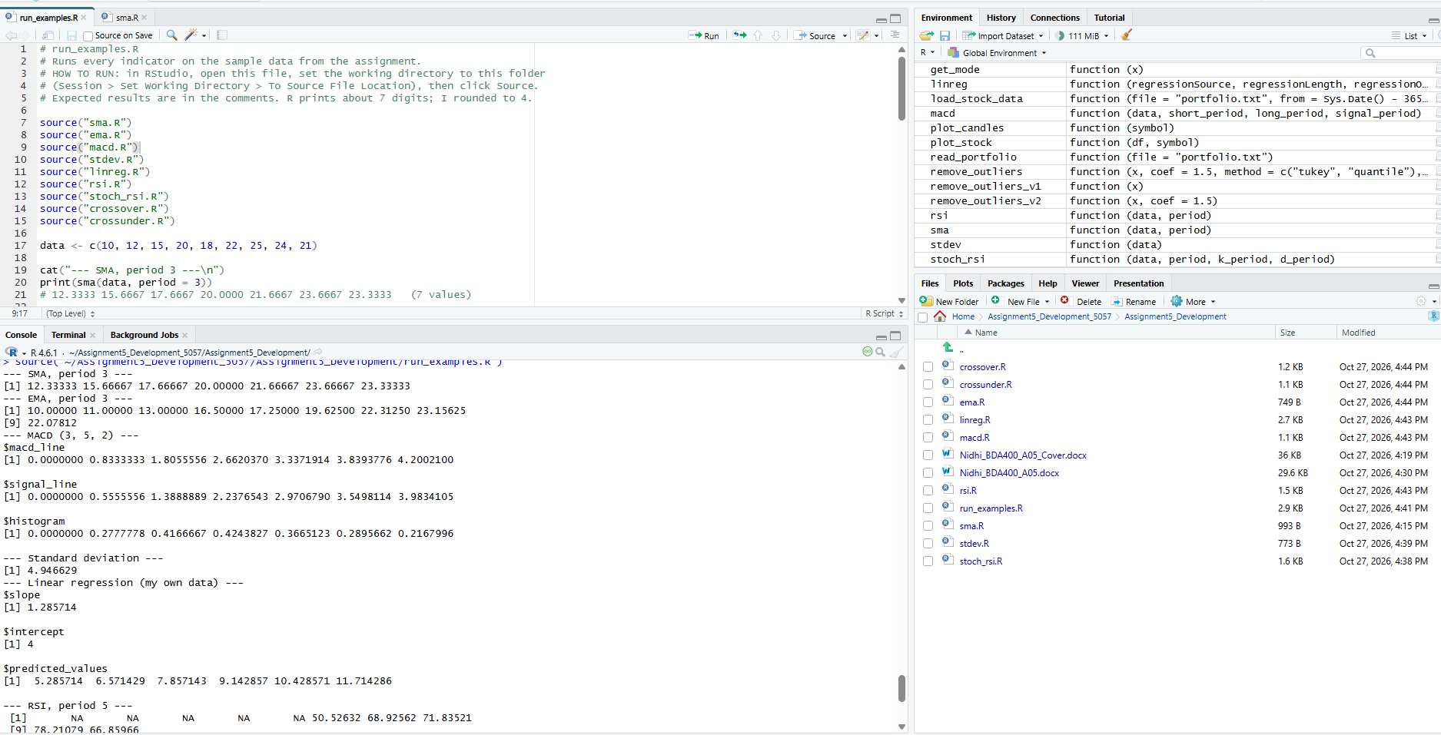

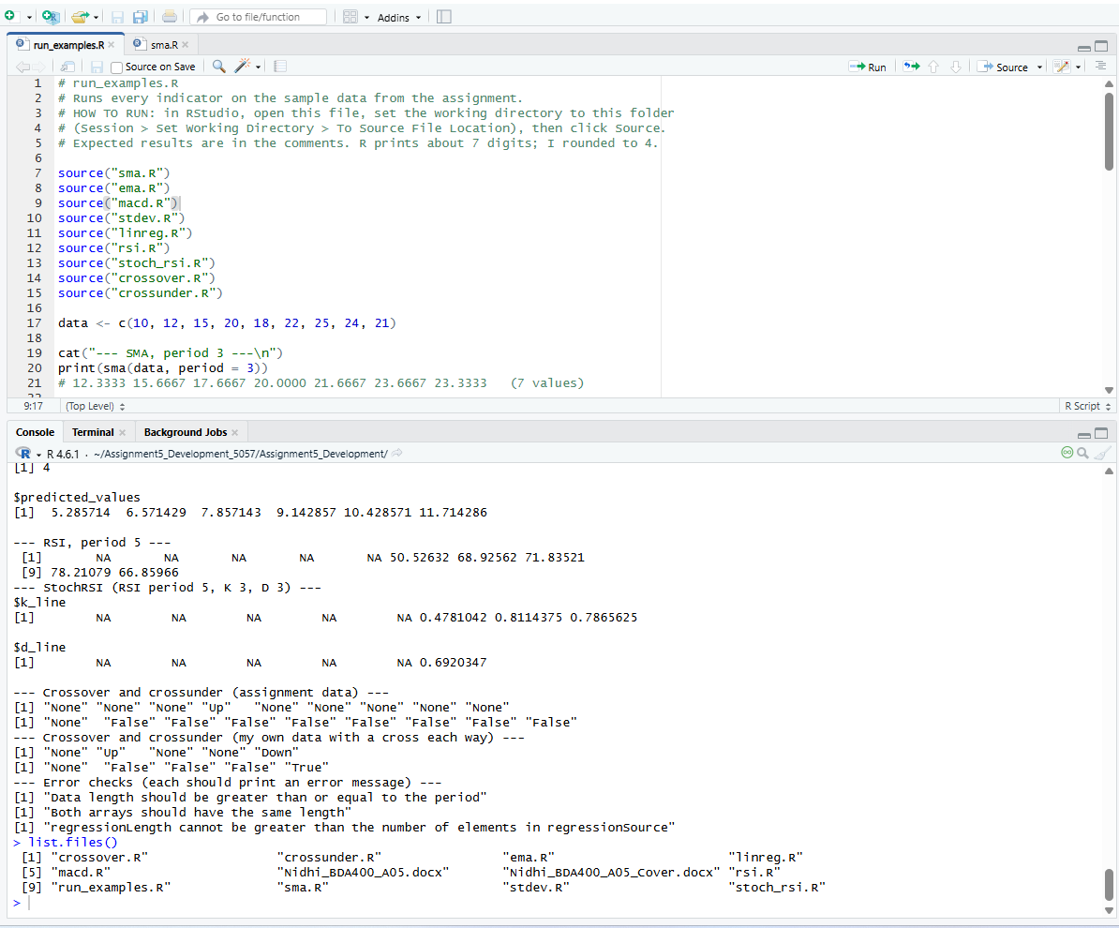
Explanation of Each Indicator
1. Simple Moving Average (SMA) - sma(data, period)
The Simple Moving Average calculates the average of a set number of values. In my function, I used a loop to go through the data and calculate the average for each group of values. This helps smooth out short-term fluctuations and makes trends easier to identify. If the period is larger than the amount of data provided, the function returns an error.
Example: Using a period of 3 on the sample data returns a series of moving averages based on groups of 3 values.
2. Exponential Moving Average (EMA) - ema(data, period)
The Exponential Moving Average is similar to the SMA, but it gives more importance to recent values. This makes it respond faster to changes in the data. I used the standard EMA formula and calculated each new value using the previous EMA result.
Example: When a period of 3 is used, the EMA follows recent price movements more closely than the SMA.
3. Moving Average Convergence Divergence (MACD) - macd(data, short_period, long_period, signal_period)
The MACD is a popular indicator used to identify changes in trends. It compares a short-term EMA with a long-term EMA. My function calculates the MACD line, the signal line, and the histogram, then returns all three values together in a list.
Example: The output shows how the relationship between the short-term and long-term averages changes over time.
4. Standard Deviation - stdev(data)
Standard deviation measures how spread out values are from the average. A larger value means the data varies more, while a smaller value means the data is closer to the mean. I calculated it manually using the population standard deviation formula instead of using R's built-in function.
Example: For the sample data, the standard deviation shows the amount of variation in the values.
5. Linear Regression - linreg(regressionSource, regressionLength, regressionOffset)
Linear regression is used to find the best-fit line through a group of data points. My function calculates the slope and intercept of the line and then generates predicted values. This can be used to identify whether the data is generally moving upward or downward.
Example: When applied to sample data, the function returns the regression line information and predicted values.
6. Relative Strength Index (RSI) - rsi(data, period)
The RSI measures the strength of recent gains compared to recent losses. It produces values between 0 and 100. Traders often use RSI values above 70 or below 30 as possible signals that a market has moved too far in one direction.
In my implementation, I calculated gains and losses first and then applied the RSI formula using a smoothing method.
Example: The function returns a series of RSI values after enough data points have been collected.
7. Stochastic RSI - stoch_rsi(data, period, k_period, d_period)
The Stochastic RSI is based on RSI values rather than prices. It measures where the current RSI sits relative to its recent range. My function first calculates RSI values and then applies stochastic and smoothing calculations to create the %K and %D lines.
Example: The resulting values move between 0 and 1 and can help identify potential momentum changes.
8. Crossover - crossover(arr1, arr2)
The crossover function checks whether one series moves above or below another series. It returns "Up" when the first series crosses above the second series and "Down" when it crosses below.
Example: In the sample data, the function identifies the point where the crossover occurs.
9. Crossunder - crossunder(arr1, arr2)
The crossunder function checks whether one series moves from above another series to below it. This can be used to identify possible downward trend signals. The function returns "True" when a crossunder occurs and "False" otherwise.
Example: The sample data shows whether a crossunder event occurs during the series.
Things in the pseudocode I noticed
- The SMA function returns fewer values than the original data because an average can only be calculated once enough values are available for a complete window.
- The linear regression pseudocode uses one more data point than I initially expected. I followed the provided logic so my results would match the assignment requirements.
- The RSI pseudocode produces slightly different values compared to some textbook examples because of the way the first averages are calculated.
- The Stochastic RSI example in the assignment required more data points than were available, so I used a smaller period for testing purposes.
- The crossover and crossunder pseudocode use slightly different output labels ("Up/Down" versus "True/False"). I followed the provided pseudocode to keep the results consistent with the assignment.
How I checked my work
I tested each function using the sample data provided in the assignment instructions. After creating the functions, I ran several examples and checked whether the output matched the expected calculations. I also tested some error conditions, such as using a period larger than the available data, to make sure the functions handled invalid input correctly.
The expected values are written in the comments in run_examples.R.
I ran run_examples.R in RStudio and reviewed the output in the console. The results matched the expected values included in the comments. 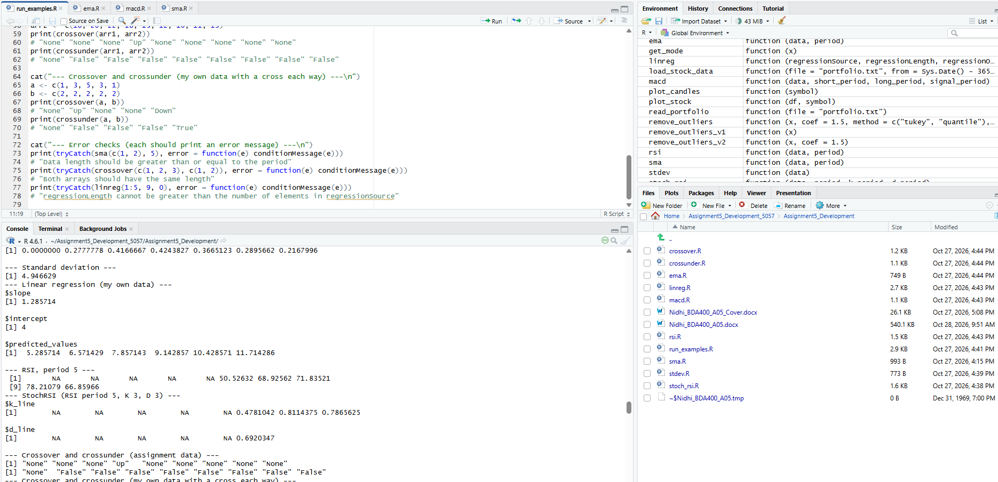
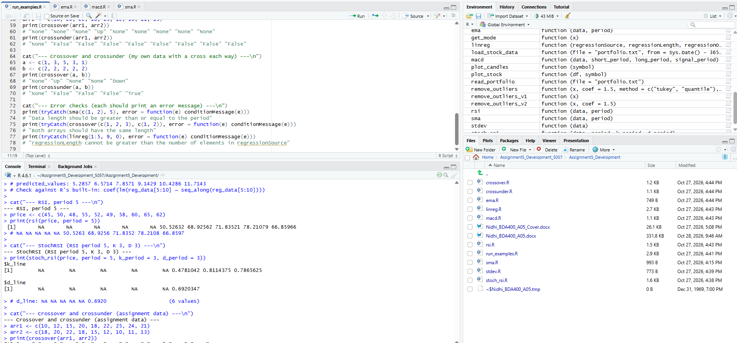
AI help
I used Microsoft Copilot to help me understand the assignment requirements, explain the indicator formulas, and review my R code. I modified the code as needed, tested the functions using example data, and prepared the final report myself. I am responsible for the accuracy of the submitted work.

Conclusion
This assignment helped me understand how several common technical analysis indicators are calculated behind the scenes. Implementing the functions manually using base R allowed me to better understand the underlying formulas rather than relying on existing packages. The project also improved my ability to debug code, test results, and organize R programs across multiple files.

