Technical Analysis using R - Preliminary Stage
Name: Nidhi
Course: BDA400 - Data Science Tools and Techniques
Assignment 2
Date: 10/23/2026
This report shows every step I took to set up GitHub, R, and RStudio, install the packages, and write the functions that load stock data and calculate basic statistics.

Step 1: GitHub account and repository
- I went to github.com and clicked Sign up.
- I entered my email, made a password and a username, and verified my email.
- I installed Git by following the git-guides install page for my operating system.
- I clicked the + icon at the top right, then New repository.
- I named the repository TechnicalAnalysis, set it to Public, and clicked Create repository.
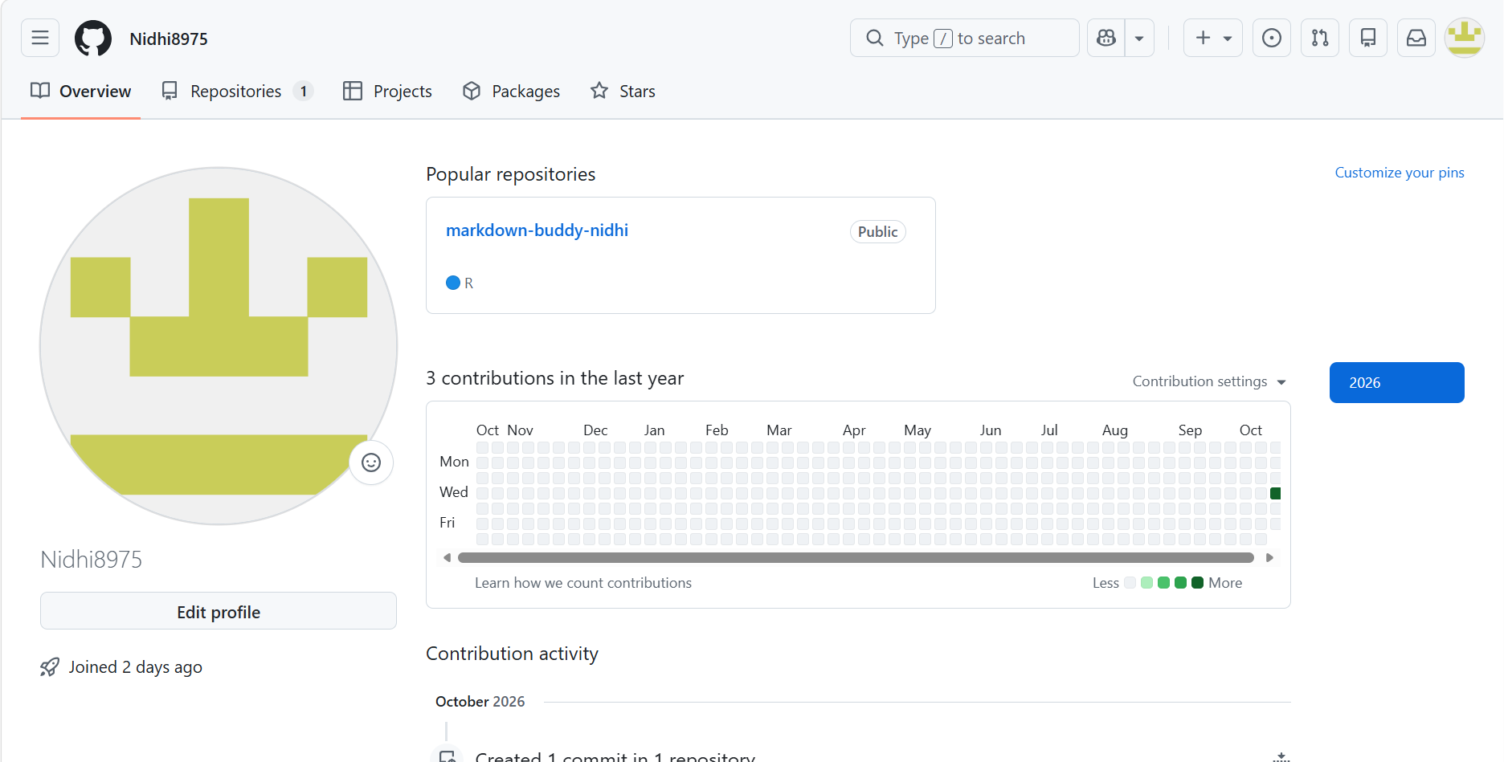
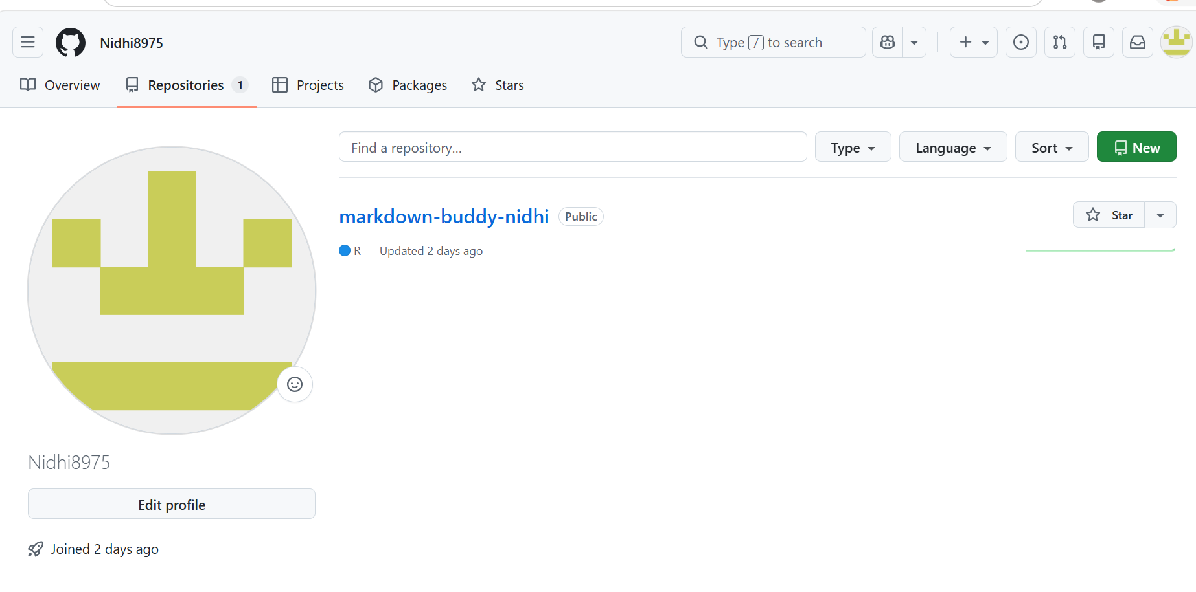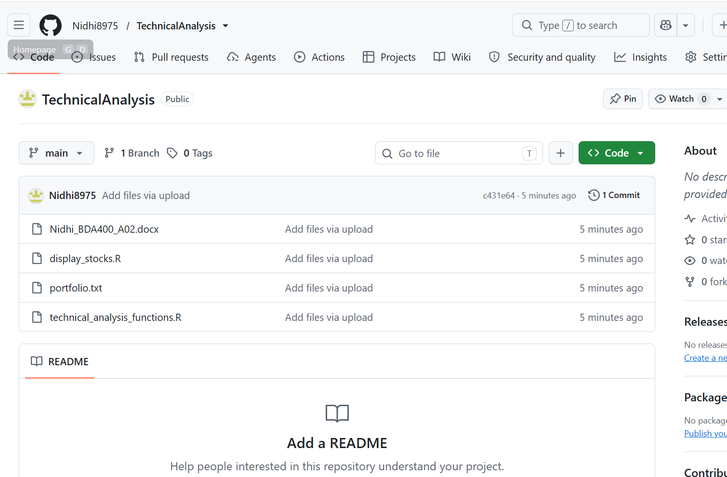

Step 2: Installing R and RStudio
- I went to cran.rstudio.com and clicked Download R for my operating system.
- I opened the downloaded installer and clicked through the setup with the default options.
- Then I went to the Posit website and downloaded RStudio Desktop.
- I installed RStudio the same way, using the default options.
- I opened RStudio. The console showed the R version, so I knew R and RStudio were working together.
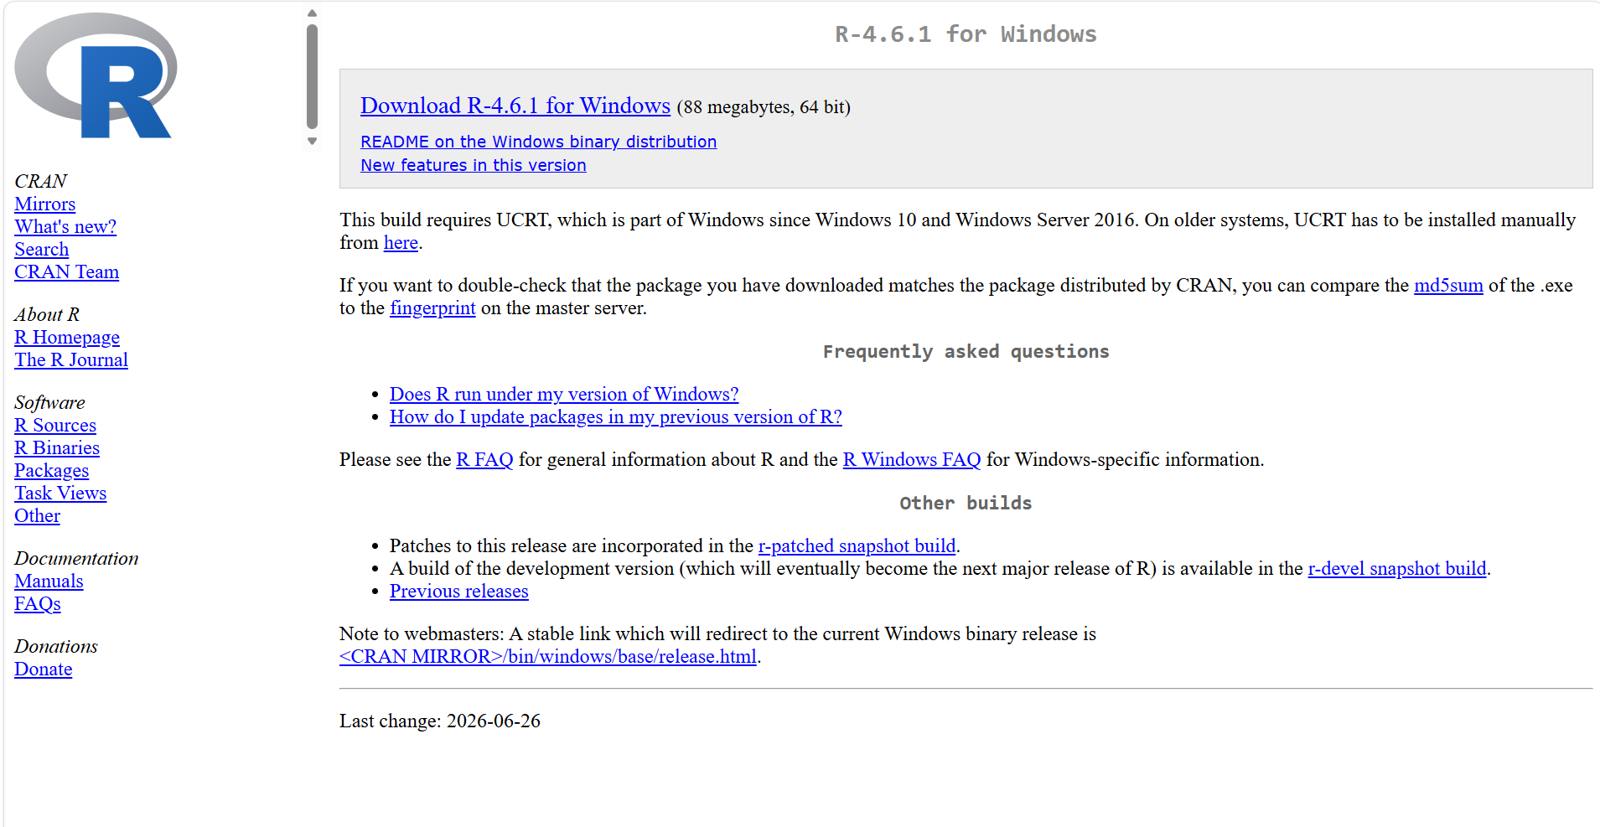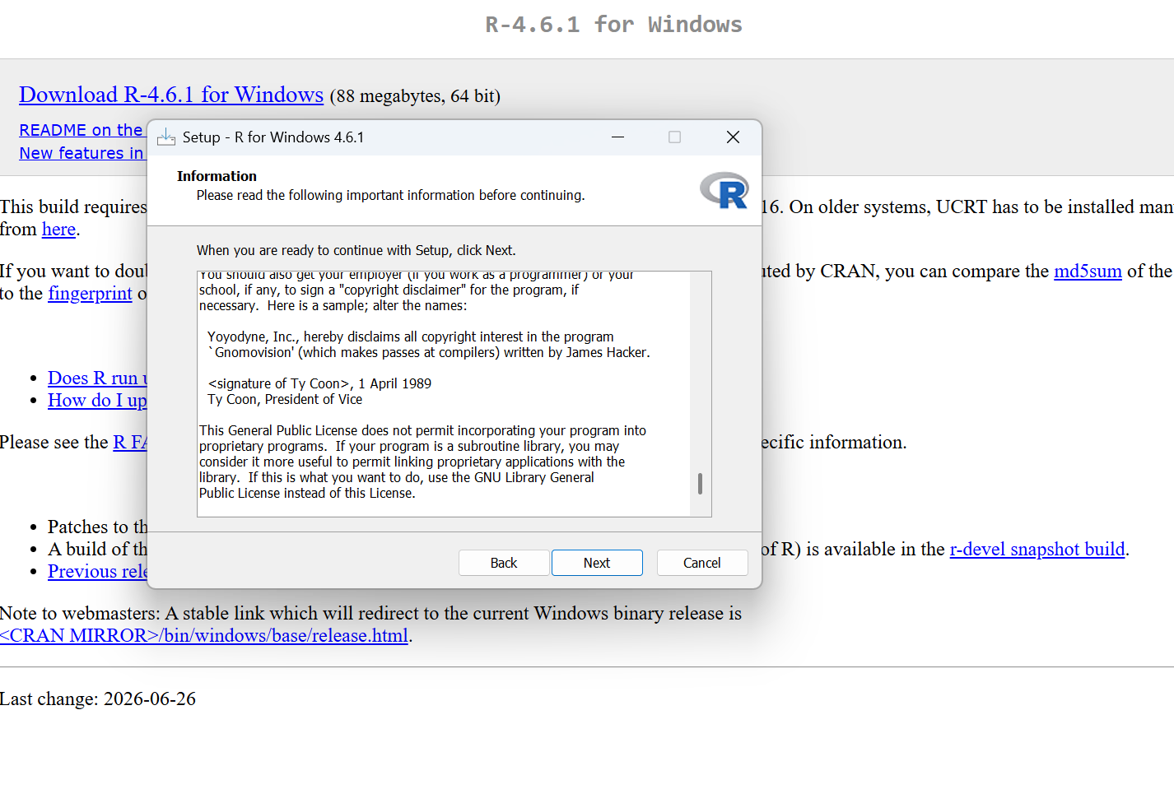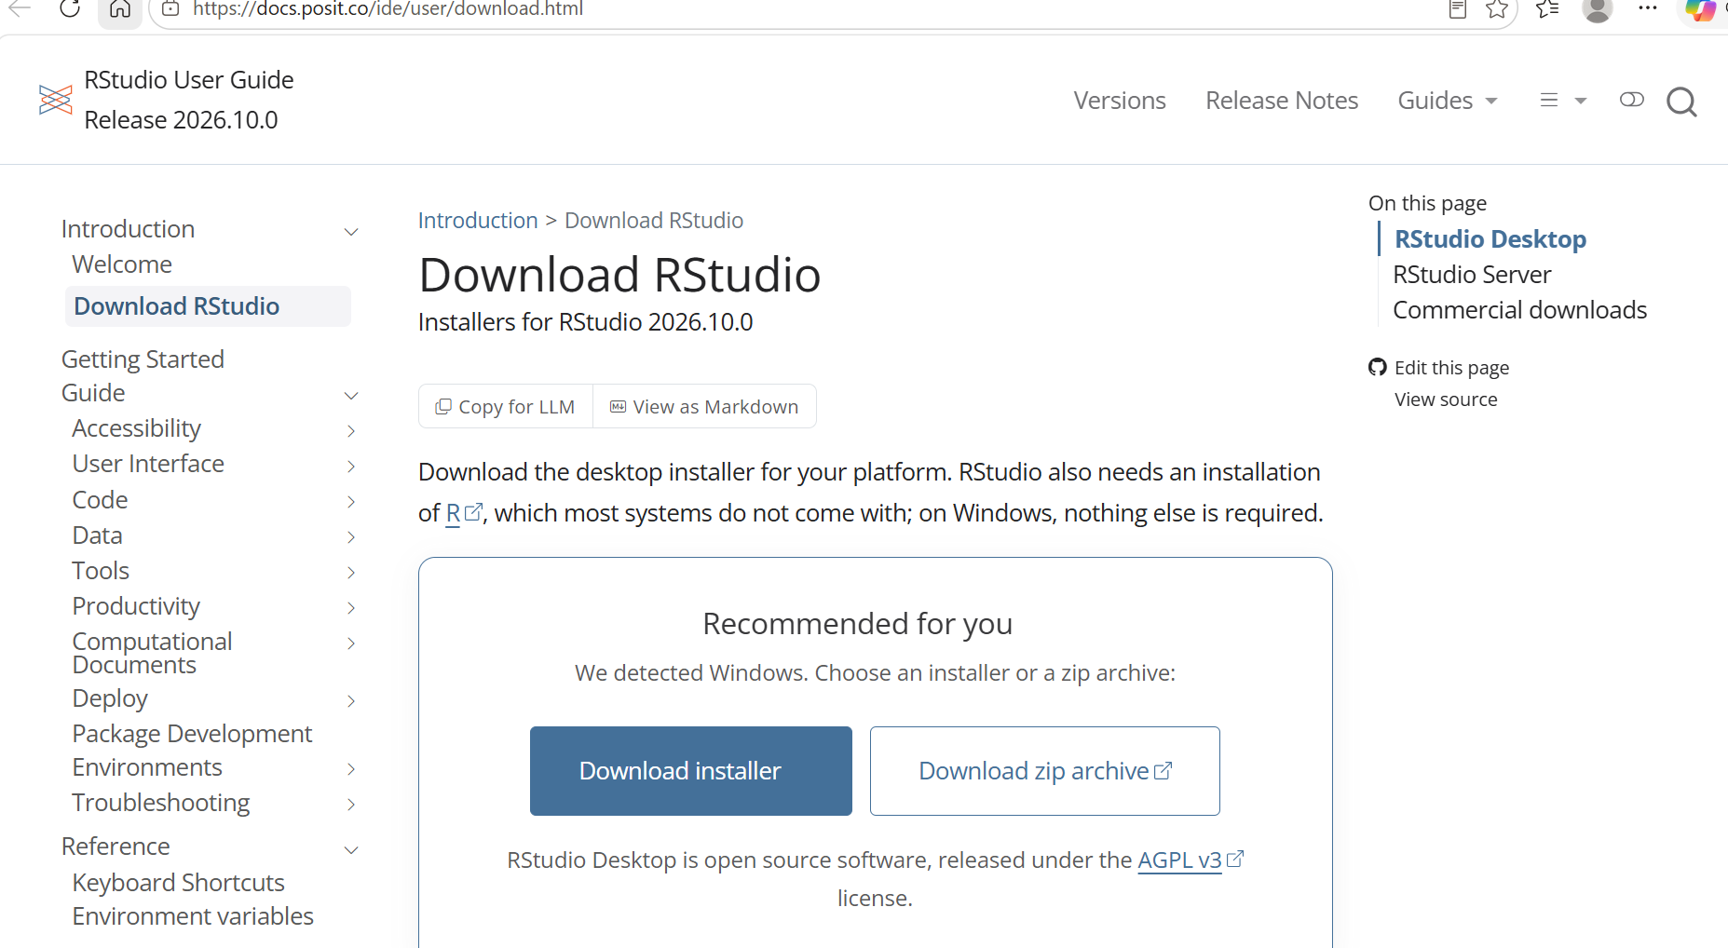
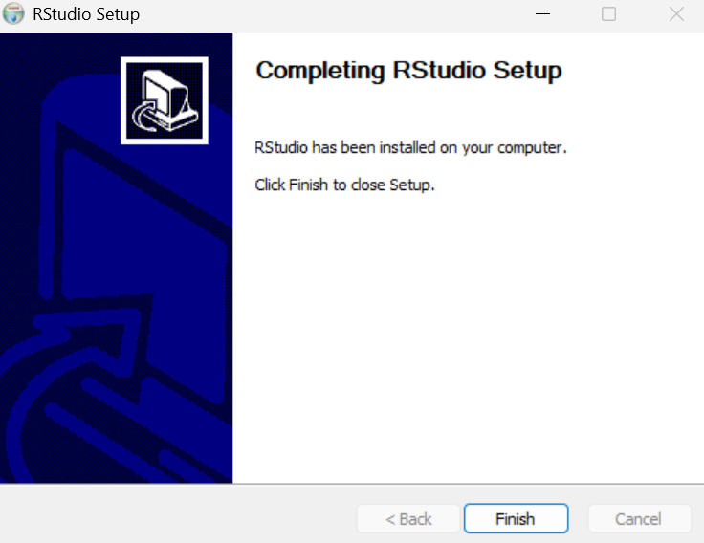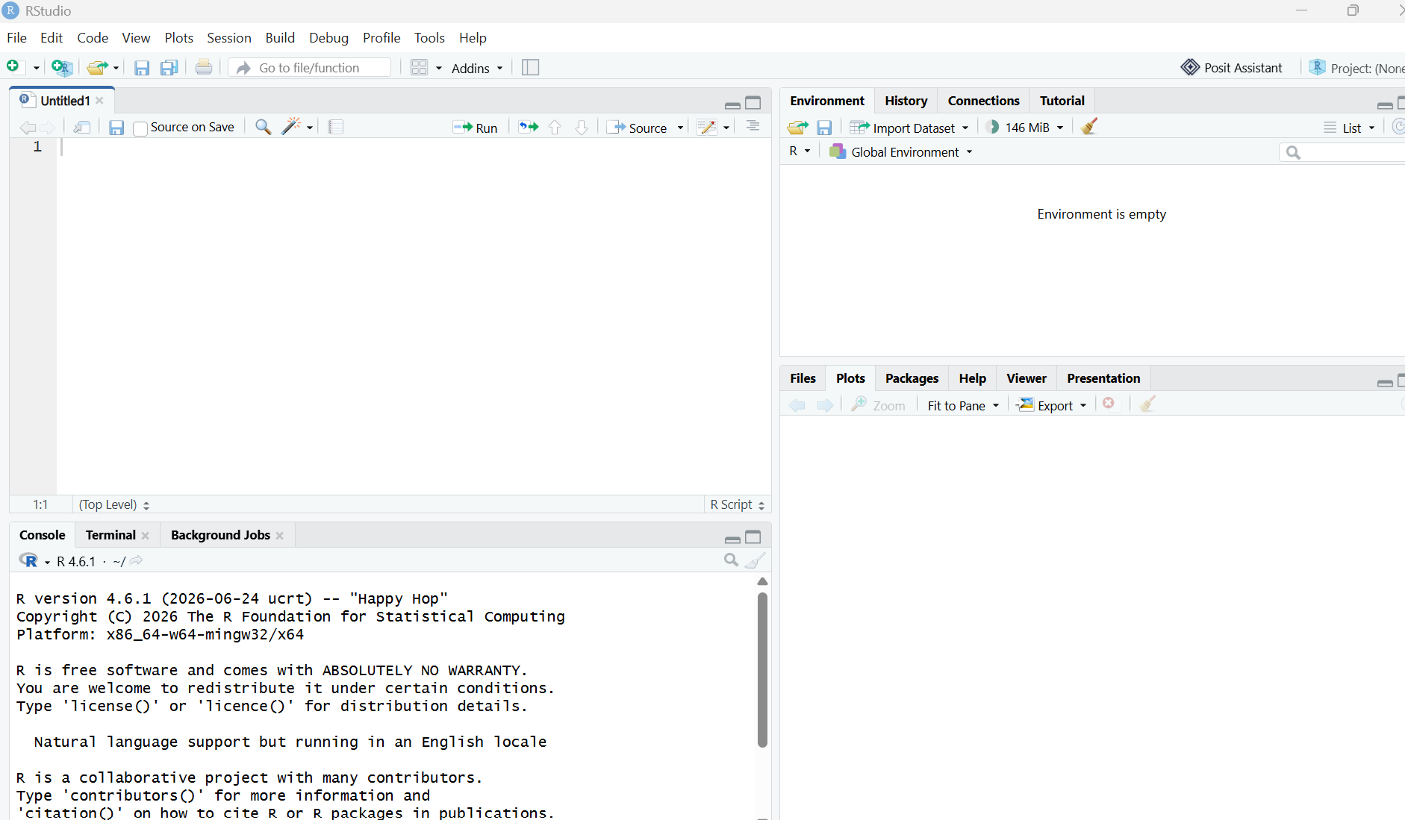

Step 3: Installing the R packages
I needed quantmod to download stock data and TTR for the moving average. In the RStudio console I typed:
install.packages(c("quantmod", "TTR"))
When it finished, I checked that both packages load without errors:
library(quantmod)
library(TTR)

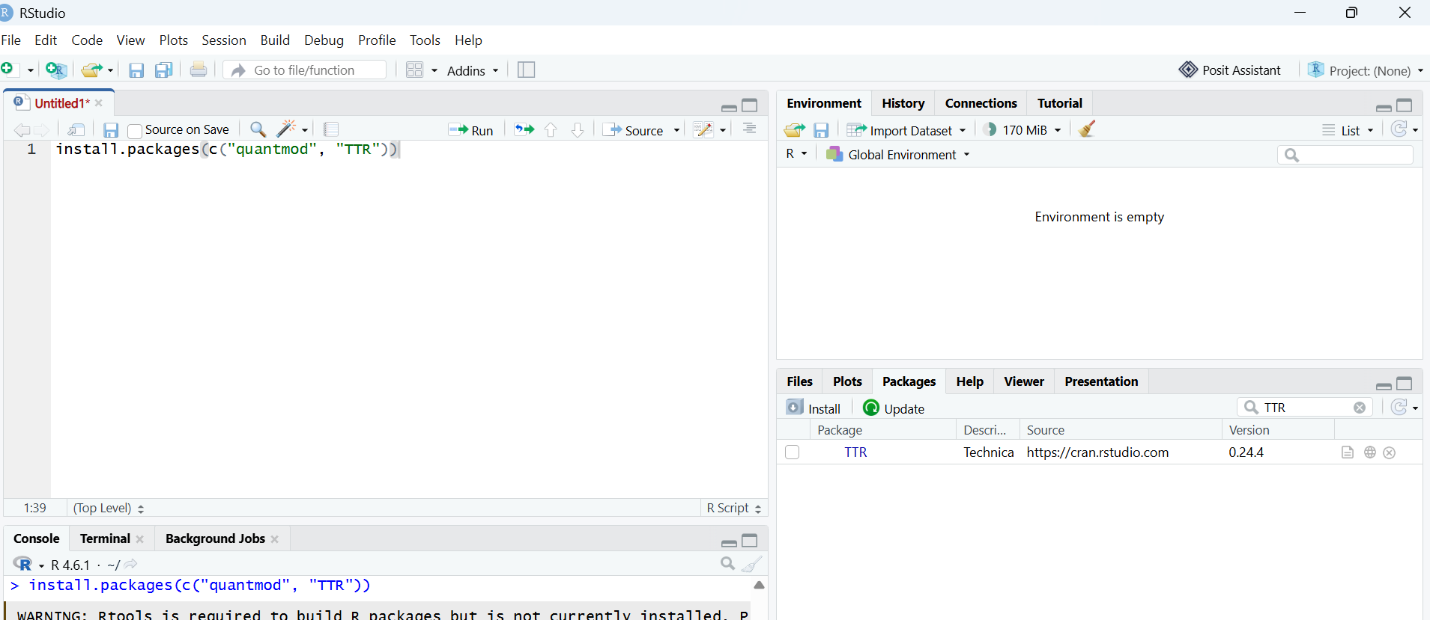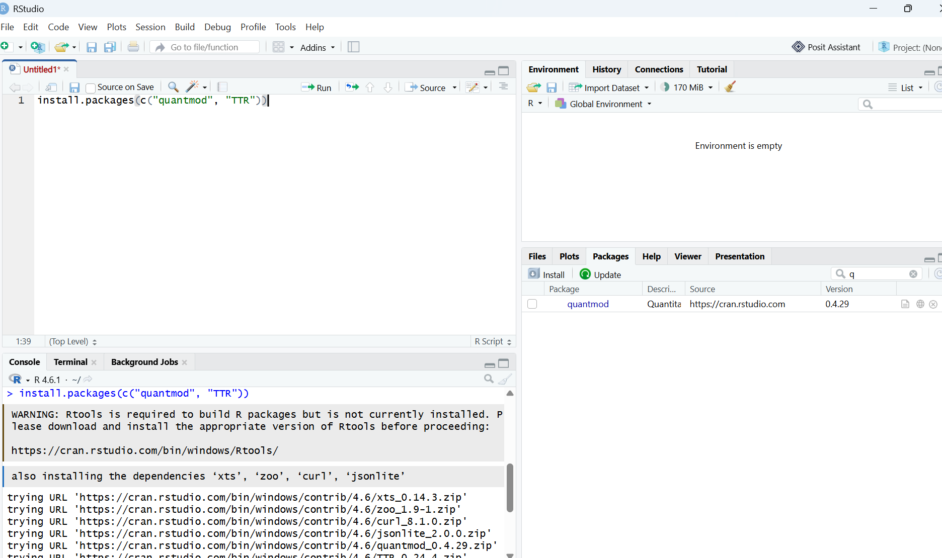Step 4: Project setup and portfolio.txt
I made a plain text file called portfolio.txt with one stock symbol per line. I picked five big companies:
AAPL
MSFT
GOOG
AMZN
NVDA
AAPL is Apple, MSFT is Microsoft, GOOG is Google (Alphabet), AMZN is Amazon, and NVDA is Nvidia. I saved the file in the same folder as my R scripts.

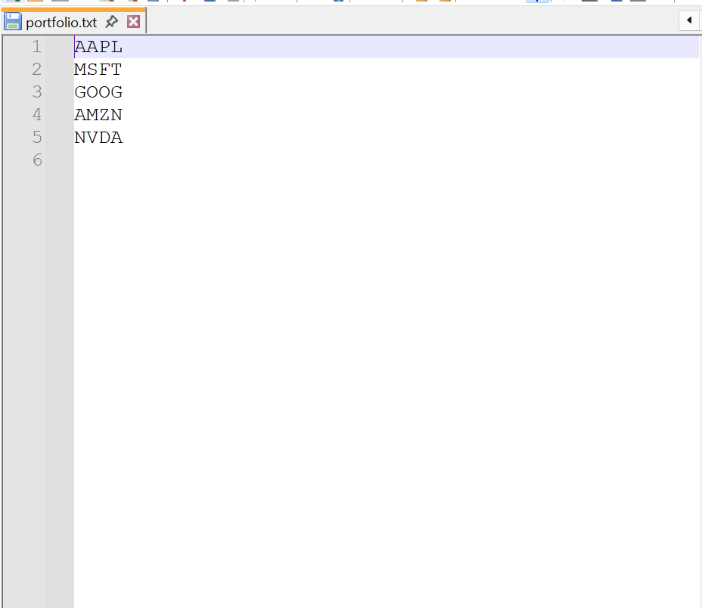Step 5: Function to load the stock data
My file technical_analysis_functions.R has two functions for this:
- read_portfolio():- This function reads the stock symbols stored in portfolio.txt and returns them as a list. Blank lines are ignored so that only valid stock symbols are processed.
- load_stock_data() :- This function downloads historical stock data from Yahoo Finance. Each stock is stored in its own data frame, making it easy to analyze multiple stocks at the same time.
Main part of the code:
xts_data <- getSymbols(sym, src = "yahoo", from = from, to = to,
auto.assign = FALSE)
out <- data.frame(Date = index(xts_data), coredata(xts_data))
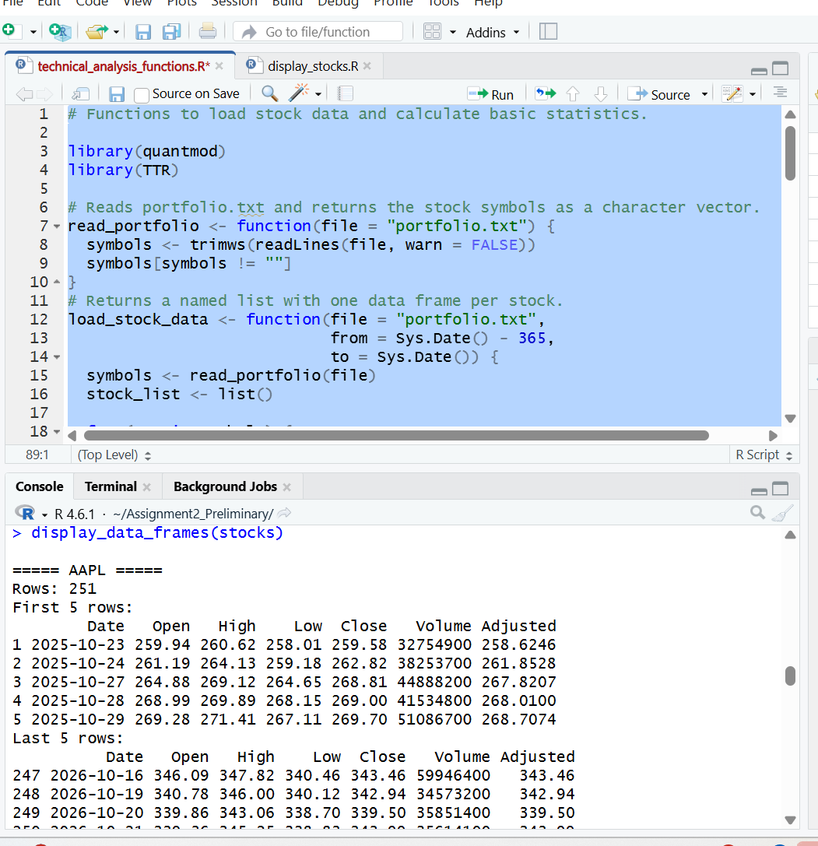

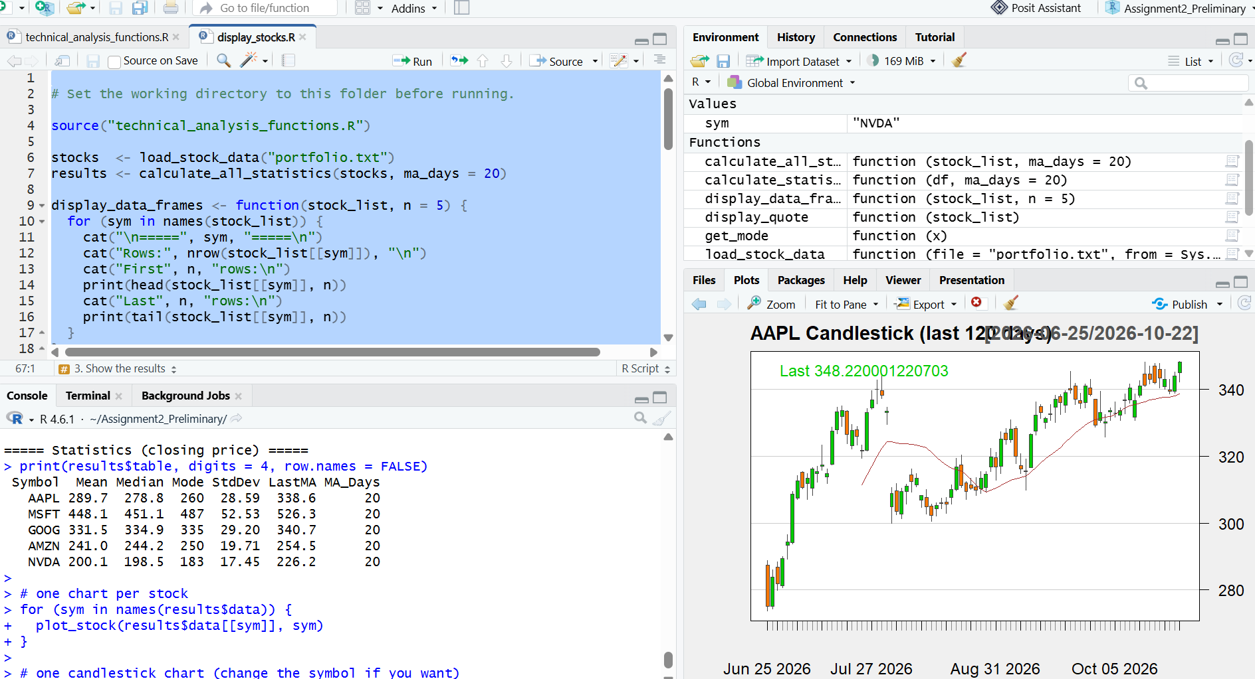

Step 6: Function to calculate statistics
Calculate_statistics() :- This function calculates statistics such as mean, median, mode, standard deviation, and moving average for one stock. These measures help summarize the stock's historical performance.
calculate_all_statistics():- Runs this for every stock and puts the results into one table, one row per stock.
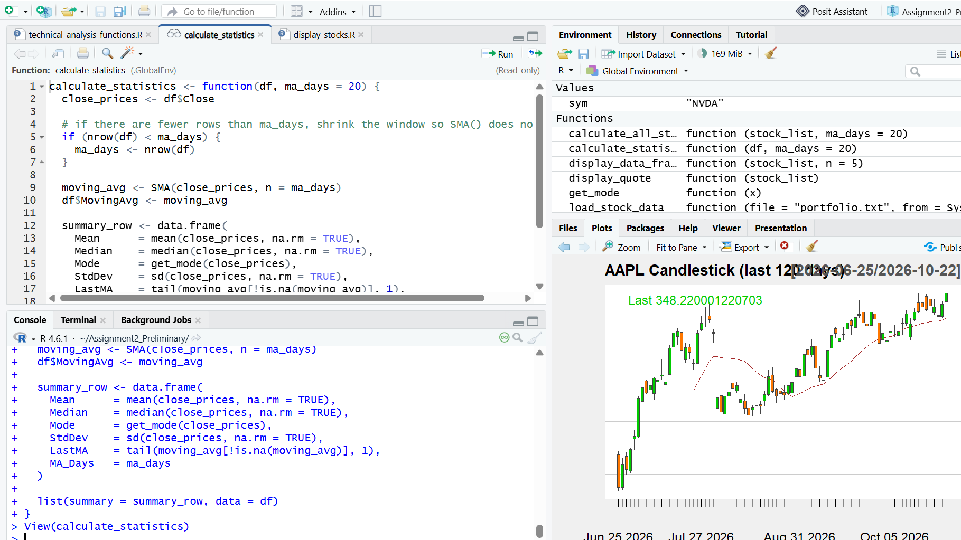

Step 7: Displaying the data and charts
display_stocks.R loads everything and shows the stocks in four ways:
- display_data_frames(): the first and last rows of each stock, like a raw data table.
- display_quote(): a short line per stock with the latest close, the change, and the volume, like the top of a Yahoo Finance page.
- plot_stock(): a line chart of the closing price with the 20-day moving average on top.
- plot_candles(): a candlestick chart with a 20-day moving average, which is the style Yahoo Finance uses.
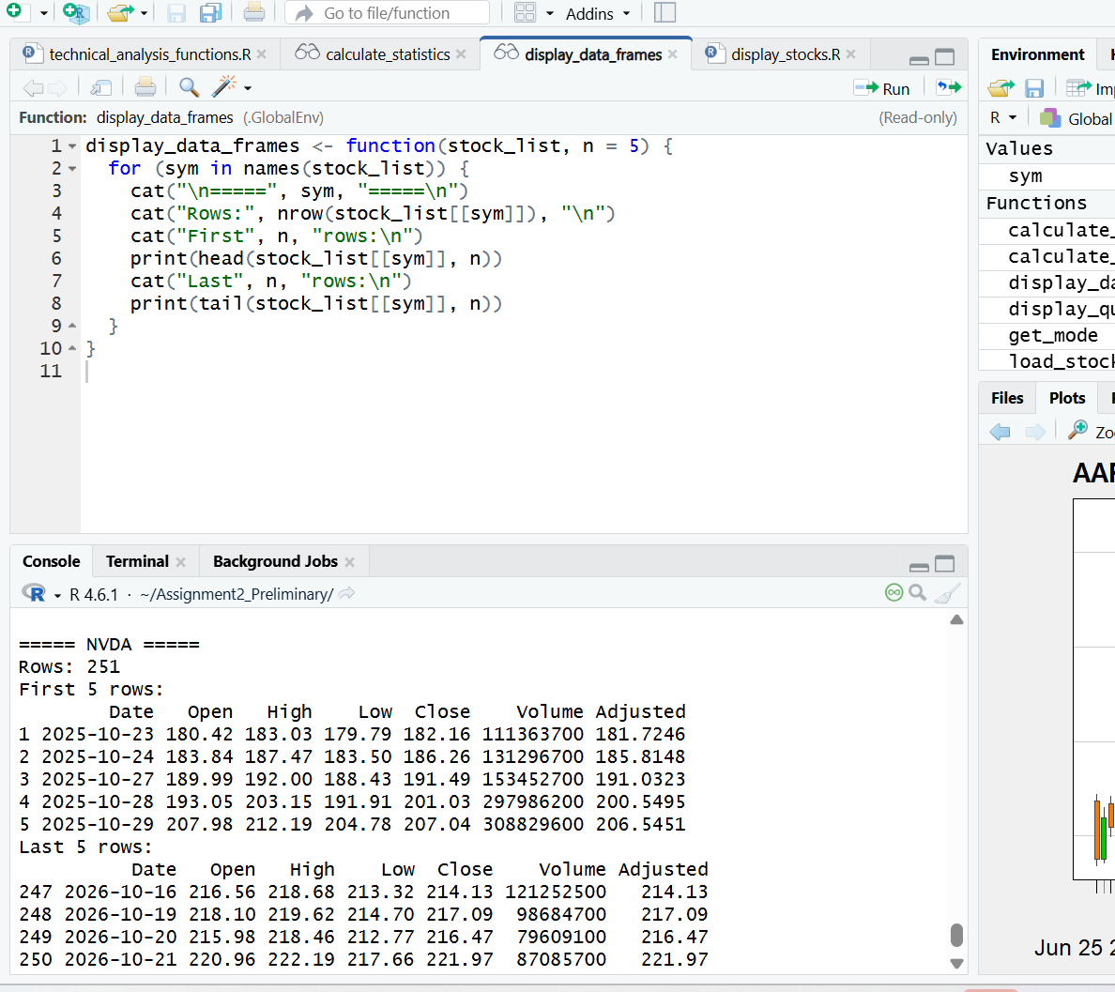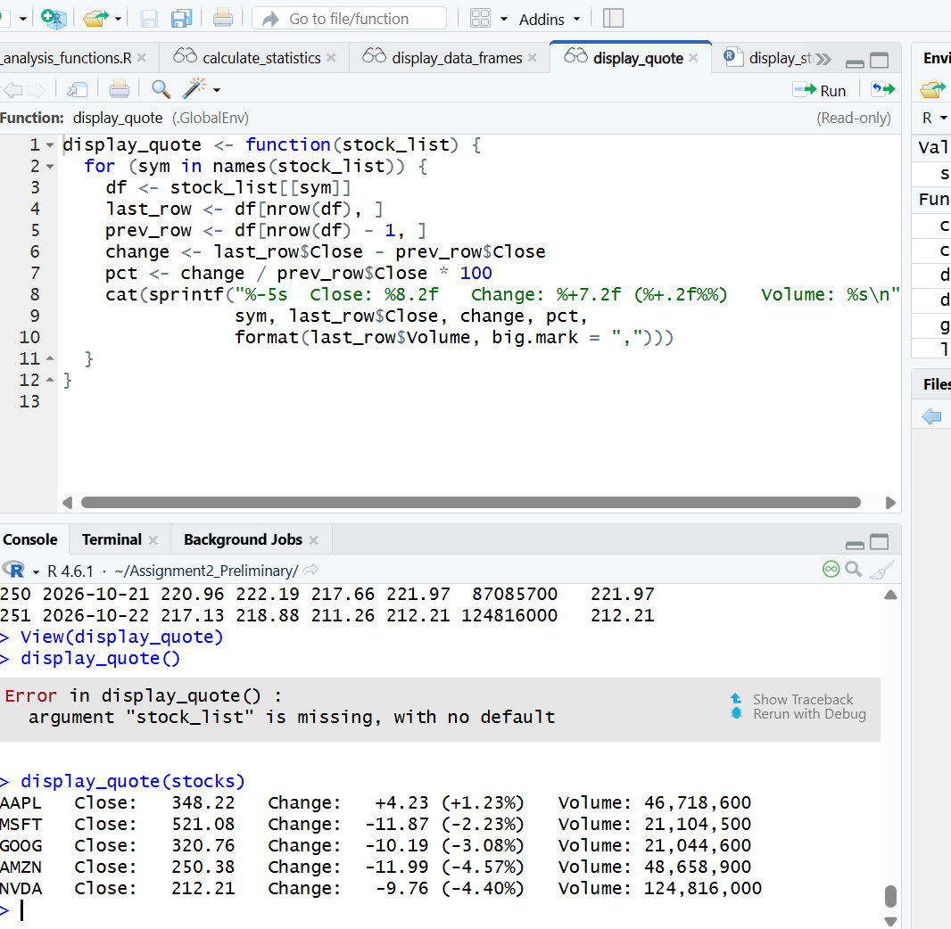

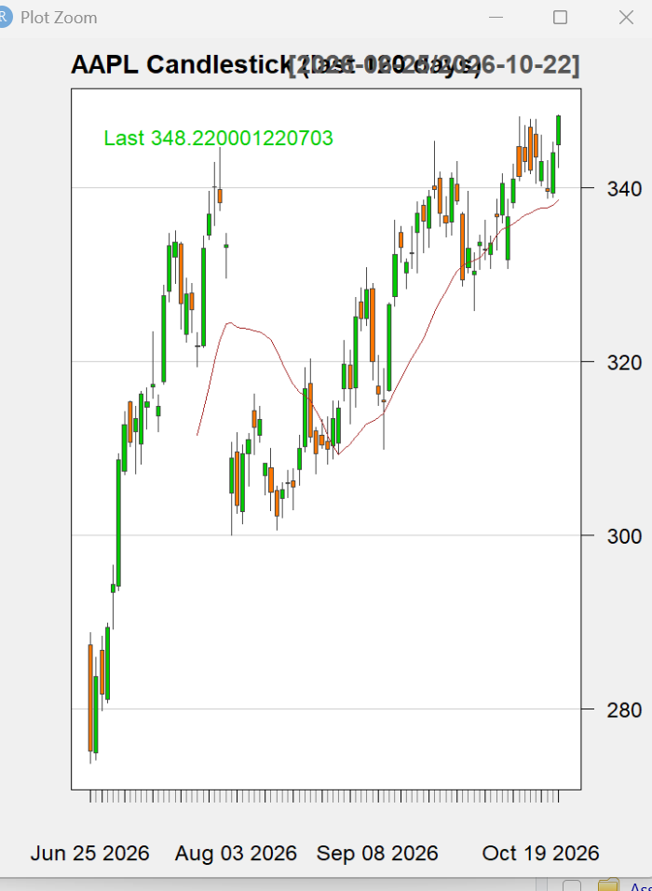
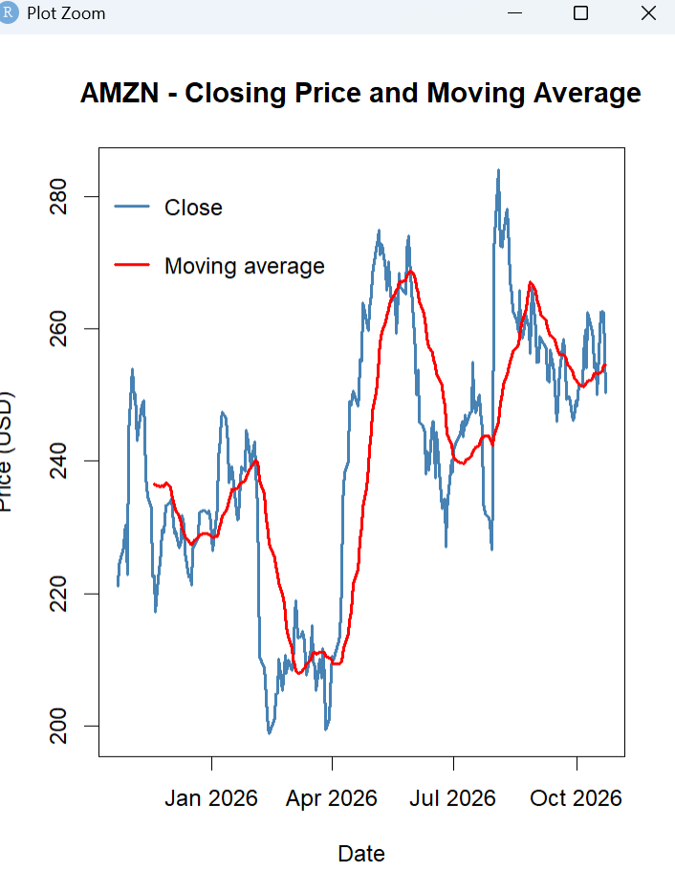

Step 8: Pushing to GitHub
I put these files in the Assignment2_Preliminary folder of my TechnicalAnalysis repo: portfolio.txt, technical_analysis_functions.R, display_stocks.R, and this report.

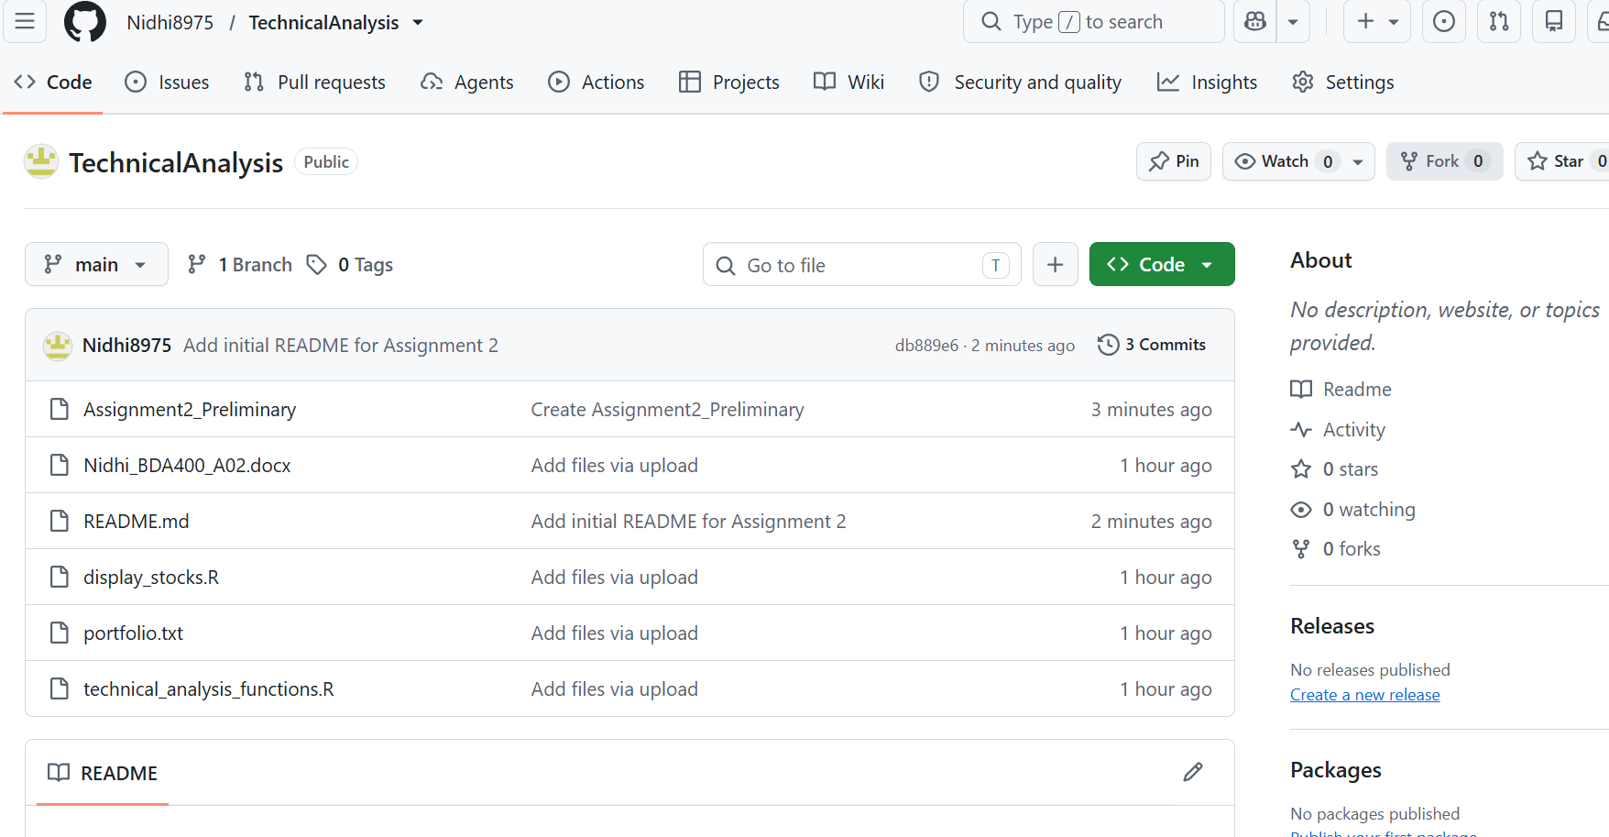Problems I ran into
While completing this assignment, I encountered a few challenges. The first challenge was installing and configuring the required packages. Another challenge was understanding how stock market data is stored after being downloaded from Yahoo Finance using the quantmod package. I also spent time troubleshooting chart displays and verifying that the moving average calculations were correct. Testing with multiple stock symbols helped me confirm that the functions were working properly.

Conclusion
This assignment helped me learn how to use R to download stock market data, perform statistical analysis, and create charts for technical analysis. I also gained experience using GitHub to manage project files and organize assignment work.

AI help
I used ChatGPT to help me understand some R concepts, improve the formatting of the report, and organize the documentation. All code was reviewed and tested by me before submission.

