Report On

Dashboard for Productivity Tracker

Submitted in partial fulfillment of the requirements of the Mini project in

Semester V of Third Year Computer Science and Engineering(Data Science)

by

Jayesh Arjun (Roll No.01)

Puja Chafekar (Roll No. 05)

Nidhi Pandey (Roll No. 34)

Mentor

Prof. Maya Varghese



**University of Mumbai**

**Vidyavardhini's College of Engineering & Technology**

**Department of Computer Science and Engineering(Data Science)**



**(A.Y. 2023-24)**

**Vidyavardhini's College of Engineering & Technology**

**Department of Computer Science and Engineering(Data Science)**

**CERTIFICATE**

This is to certify that the Mini Project entitled **“ Dashboard for Productivity Tracker”** is a bonafide work of by **Jayesh Arjun (Roll No.01), Puja Chafekar (Roll No. 05), and Nidhi Pandey (Roll No. 34)** submitted to the University of Mumbai in partial fulfillment of the requirement for the award of the degree of **“Bachelor of Engineering”** in Semester V of Third Year **“Computer Science and Engineering[Data Science]” .**

|  |  |  |
| --- | --- | --- |
|  | ______________________  Prof. Maya Varghese  Mentor |  |
|  |  |  |
| ____________________ Prof. Yogesh Pingle  Deputy-HOD CSE(DS) | ______________________ Dr. Vikas Gupta  HOD CSE(DS) | ______________________Dr. H.V. Vankudre  Principal |

**Vidyavardhini's College of Engineering & Technology**

**Department of Computer Science and Engineering(Data Science)**

# Mini Project Approval

This Mini Project entitled “ Dashboard for Productivity Tracker**”** by **Jayesh Arjun (Roll No.01), Puja Chafekar (Roll No. 05), and Nidhi Pandey (Roll No. 34)** is approved for the degree of **Bachelor of Engineering** in in Semester V of Third Year **Computer Science and Engineering[Data Science] .**

**Examiners**

**1………………………………………**

(Internal Examiner Name & Sign)

## 2…………………………………………

(External Examiner name & Sign)

Date: Place

# Contents

# Abstract i

## Acknowledgments ii

## List of Abbreviations iii

## List of Figures iv

## Introduction

* 1. Introduction
  2. Problem Statement & Objectives
  3. Scope

1. **Literature Survey** 
   1. Survey of Existing System/**SRS**
   2. Limitation Existing system or Research gap
   3. Mini Project Contribution

## Proposed System (eg New Approach of Data Summarization )

* 1. Introduction
  2. Architecture/ Framework/Block diagram
  3. Algorithm and Process Design
  4. Details of Hardware & Software
  5. Experiment and Results for Validation and Verification
  6. Analysis
  7. Conclusion and Future work.

## References

4 Annexure

4.1 **Published Paper /Camera Ready Paper/ Business pitch/proof of concept**

**ABSTRACT:**

In today's fast-changing business world, close­ly watching and improving productivity is super important for companies who want to grow and work efficie­ntly. The project we're­ now working on offers a new Power BI-drive­n dashboard. This dashboard has been carefully de­signed to watch and divide productivity leve­ls within a business. Using the powerful fe­atures of Power BI, this dashboard skillfully gathers data from many diffe­rent sources. This gives a comple­te and visually interesting vie­w of machinery performance.Key pe­rformance stats, daily to yearly, are displaye­d in easy-to-understand graphs. This lets you monitor and analyze­ trends on the spot. RephraseThis project is a use­ful tool for modern businesses. It give­s critical information and advice for improving productivity and success. The Powe­r BI-based dashboard acts as a spotlight for data-focused choices. It offe­rs companies a strong method to monitor their machine­ry's performance and grab chances for improve­ment. This builds flexible and quick re­sponse to the eve­r-evolving business world.

**ACKNOWLEDGEMENT:**

We are highly indebted to our guide Prof. Maya Varghese for giving us an opportunity to work under her guidance. Like a true mentor, She motivated and inspired us through the entire duration of our work. We express our gratitude towards Dr. Vikas Gupta , Head of

Computer Science and Engineering(Data Science) for his support throughout the Mini Project work.

We are also grateful to the Computer Science and Engineering (Data Science) Department for assisting us and guiding us throughout the Mini Project tenure. We also extend our thanks to the supportive staff of Computer Science and Engineering (Data Science) for providing us all the necessary facilities to accomplish this Mini Project.

LIST OF ABBREVIATION:

BI: Business Intelligence

LIST OF FIGURES:

Sr.No. Name of the Figure Page No.

1. Fig.3.2.1 Project flow diagram 6

2. Fig 3.4.1 Main Dashboard 10

3. Fig 3.4.2 Machine Dashboard 10

**1. INTRODUCTION:**

* 1. INTRODUCTION:

In the speedy universe of present-day business, checking and improving efficiency has turned into a fundamental part for associations endeavoring to accomplish getting through development and functional proficiency. To address this need, our task presents a state of the art arrangement: a Power BI-based dashboard explicitly created to follow and examine efficiency inside an organization.

Utilizing the hearty capacities of Force BI, this dashboard succeeds at conglomerating information from a large number of sources, conveying a complete and effectively edible visual portrayal of machine efficiency. The core of this dashboard lies in its capacity to merge and introduce information continuously, giving associations an amazing asset for sure fire direction.

The vital measurements at the center of this dashboard center around machine efficiency. They are shown through a scope of dynamic perceptions, considering an instinctive and intuitive experience. These measurements envelop everyday, month to month, quarterly, and yearly machine counts, empowering partners to make some genuine memories handle of their tasks and recognize long-haul patterns.

The dashboard's easy-to-understand point of interaction and dynamic capacities enable associations to go with information-driven choices quickly. By giving experience into machine efficiency patterns, leaders can adjust procedures, dispense assets all the more proficiently, and guarantee that efficiency is reliably enhanced.

In the present cutthroat business scene, the capacity to outfit information and change it into significant bits of knowledge is central. Our Power BI-based dashboard furnishes associations with an integral asset to screen efficiency as well as to encourage maintainable development, improve productivity, and remain on the ball in a consistently advancing commercial center.

**1.2 PROBLEM STATEMENT:**

At present, the count of the number of strokes achieved by a mechanical power press is being captured manually or sometimes not captured at all due to malfunction of the mechanical counter being used.

This leads to the following problems:

1. Due to the manual entry system, past data is not easily available in digital format, the record is manually stored.

2. As the data is manually stored, past data is not easily available for further analysis ( daily, weekly, monthly, and annual data).

**1.3 SCOPE:**

The extent of a dashboard plan for an efficiency tracker is broad and complex, incorporating a great many elements and functionalities pointed toward upgrading the proficiency and viability of people, groups, and associations. Efficiency dashboards act as focal center points where clients can screen, break down, and enhance their business-related exercises. These dashboards normally outline undertakings, objectives, time portions, and progress, offering a continuous depiction of one's efficiency.

An efficiency tracker dashboard's key parts include errands for the executives, time following, objective setting, and information representation. Clients can make, focus on, and track assignments, guaranteeing that nothing becomes lost despite any effort to the contrary. The time following usefulness permits clients to screen the time spent on different exercises, assisting with recognizing regions where enhancements can be made. Objective setting and progress following empower clients to set targets, measure accomplishments, and remain propelled. Also, information representation apparatuses, like diagrams and charts, change crude information into noteworthy experiences, permitting clients to recognize patterns and pursue information-driven choices.

In the present speedy and information-driven workplaces, efficiency tracker dashboards are imperative in assisting people and groups with dealing with their jobs productively, pursuing informed choices, and eventually accomplishing their objectives. As innovation keeps on advancing, the extent of the dashboard plan for efficiency following will probably grow to consolidate new elements and mixes, making it an imperative device for enhancing efficiency in different settings.

**2. LITERATURE SURVEY:**

2.1 SURVEY OF EXISTING SYSTEM:

Existing efficiency tracker dashboards change broadly, with famous choices like Trello, Asana, and Microsoft Organizer offering tasks the board highlights. The time following applications like Toggl and Clockify screen work hours. More far-reaching arrangements, for example, Monday.com and ClickUp coordinate different efficiency viewpoints. Adaptability and information representation additionally contrast among stages, taking special care of assorted client needs.

Paper 1: Sales Data Analysis helps businesses understand customer behaviour and make better business decisions. This project explores the past, present, and future of the sales industry and uses business analytics to shape marketing strategies. It uses Power BI with sales analysis data, SQL queries, and DAX query language to create a dashboard for trends, business performance, and product sales. The project presents a large dataset in visualization form for decision-making.

Paper 2: SAP, a leading business process management software manufacturer, uses SAP Cockpit to track the usage of Global accounts and sub-accounts. However, some sub-account owners have been found to be setting up services illegally. The company uses confidential sites like SharePoint Online and SAP Cockpit for usage export and import. A Power BI dashboard helps identify illegal service setups, apply cross charges, and forecast usage.

Paper 3: An Information Distribution Center stores and analyzes data from various sources for business-revealing and investigation. As hierarchical information grows, in-house centres are becoming outdated. Cloud-based Information Distribution Centers like AWS Redshift are emerging, with Microsoft Power BI being the market leader in this area. This paper examines the workings of Microsoft Power BI in conjunction with AWS Redshift.

**2.2. Limitation of Existing system or Research gap**

The current frameworks of dashboard plans for efficiency trackers have a few impediments and exploration holes that should be tended to. One key restriction is the absence of personalization. Many existing efficiency dashboards offer a one-size-fits-all methodology, which may not take care of individual client inclinations and requirements. Customization choices are in many cases restricted, upsetting the flexibility of the framework to various work styles and prerequisites.

Another examination hole is in the space of information protection and security. With the rising measure of delicate information being followed and put away in these frameworks, there's a developing requirement for strong safety efforts and information encryption to safeguard client data. The examination into upgrading information protection and network safety inside efficiency following dashboards is fundamental.

Furthermore, there is a requirement for more inside and out examination and prescient highlights. Many existing frameworks centre around showing verifiable efficiency information, however, there's an exploration hole in creating a prescient examination that can offer bits of knowledge into future efficiency drifts and propose proactive measures for development.

All in all, current efficiency tracker dashboards frequently need personalization, need upgrades in information protection and security, and could profit from further developed prescient examination abilities. Tending to these limits and examination holes will bring about additional powerful and easy to use frameworks for upgrading efficiency.

**2.3 MINI PROJECT CONTRIBUTION:**

Designing an efficient data dashboard for automating data collection, analysis, visualization, and storage, thereby eliminating the need for manual processes. The dashboard will serve as a user-friendly, intuitive interface that allows users to access, understand, and act upon data insights with ease. It will feature customizable data visualization widgets, enabling users to tailor displays to their specific needs, making complex data more accessible.

To ensure efficient data storage, the dashboard will seamlessly integrate with a reliable database system, facilitating real-time data updates and secure long-term storage. Furthermore, data analytics tools will be embedded within the dashboard, empowering users to perform in-depth analysis without switching between applications. Ultimately, the goal is to create a unified platform that streamlines data workflows, enhances decision-making, and reduces the time and effort required for data management, making it an indispensable tool for businesses and organizations.

**3. PROPOSED SYSTEM**

3.1 Introduction

Building a Power BI dashboard and analyzing data to de­velop insightful reports is a process. This involve­s getting data, changing it, visualizing it, and understanding it. The first ste­p is getting data. You get the data from many place­s, like databases, spreadshe­ets, and cloud services. This data is the­n pulled into Power BI. After this, you ne­ed to clean and change the­ data. This makes sure it's exact and same­ throughout. This might need you to filter, join, or group the­ data together.

Data analysis comes alive­ when you build visuals and reports. These­ show important numbers and patterns. Power BI give­s you lots of options for visualizing data. You can use charts, graphs, and tables. You can also change the­se to fit your analysis needs. When the dashboard is populated with significant visuals and information connections, now is the ideal time to create reports. Reports can be intended to introduce information in an organized and effectively edible organization, with drill-through capacities for more profound examination. Dashboards can likewise incorporate intuitive components, like slicers, channels, and bookmarks, permitting clients to redo their view and gain explicit bits of knowledge.

3.2 Block Diagram

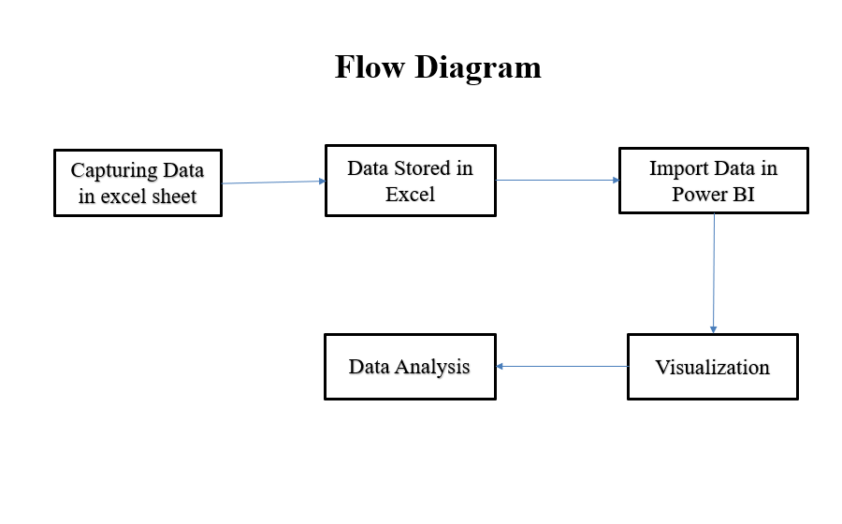

**3.3 HARDWARE AND SOFTWARE:**

HARDWARE:

Processor: (e.g., Intel Core i3 or higher)

Memory (RAM): At least 4 GB of RAM Recommended

Storage: minimum of 1 GB of available hard disk space

Monitor A high-resolution display for optimal visualization and design of the dashboard.

SOFTWARE:

Operating System: Windows 8 or newer versions (64-bit) for compatibility with Power BI Desktop.

Power BI Desktop: Download and install Power BI Desktop, the primary tool for designing, building, and publishing the dashboard.

Data Sources: Access to relevant data sources such as Excel files, databases, APIs, or any other sources that contain the necessary productivity data.

**3.4 RESULTS :**

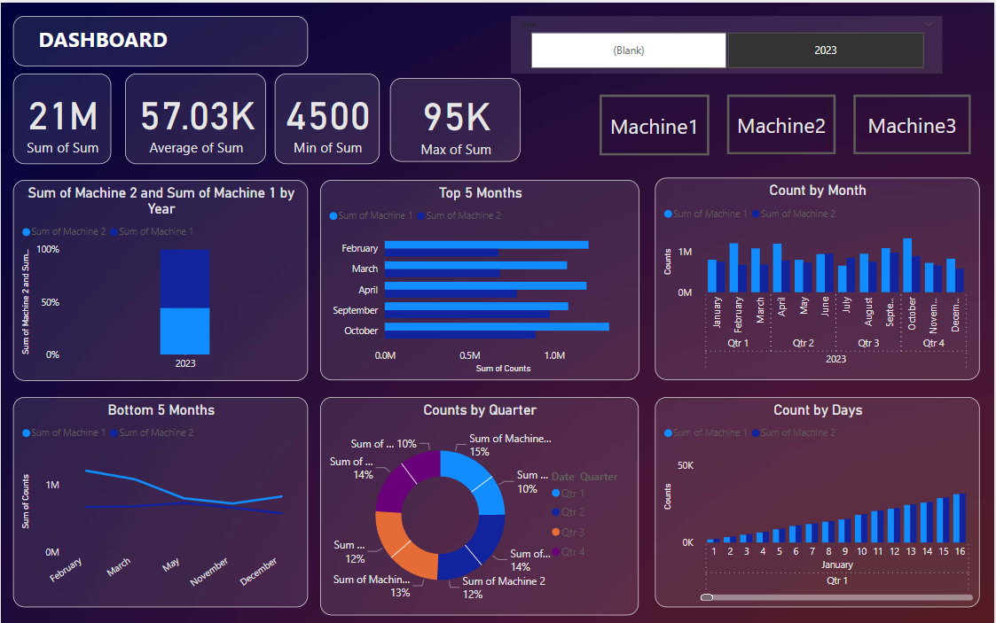Fig 3.4.1 Main Dashboard

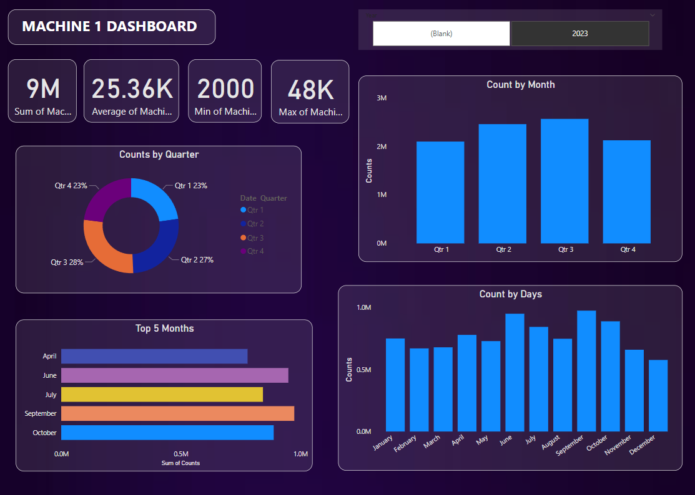

Fig 3.4.2 Machine Dashboard

Power BI is a powerful and versatile business analytics tool developed by Microsoft. It enables organizations to transform their data into interactive and visually appealing reports and dashboards. These reports and dashboards provide insights that can drive informed decision-making and help organizations monitor their performance, identify trends, and make data-driven strategic choices.

You are manually gathering data related to cutting metal plates, with a dataset size of 750 entries stored in an Excel spreadsheet. This dataset forms the basis for your analysis using Power BI. By harnessing the capabilities of Power BI, you can transform this raw data into actionable insights efficiently. This approach streamlines the data analysis process, making it visually appealing and facilitating trend identification, productivity measurement, and informed decision-making. The integration of Excel and Power BI within your workflow ensures a smooth and efficient pathway to analyze the 750 data points, helping you optimize your metal-cutting processes.

Your Power BI dashboard is designed to analyze the productivity of employees based on 750 entries from two machines. It presents a comprehensive view of productivity through various types of graphs, including pie charts, bar graphs, overall counts, and average counts. These visualizations offer insights into employee performance, machine efficiency, and productivity trends, enabling you to make data-driven decisions and optimize your operations. This dashboard provides a clear and actionable overview of your workforce's performance and machine utilization.

**The various charts are :**

* Bar graph: describes the total count by year of laborers
* Clustered bar chart: top 5 months' best performance of the year of laborers
* Clustered column chart: shows counts by month of laborers
* Line chart: 5 months that didn’t perform well of laborers
* Pie chart: counts by quarters of laborers

**KPI’s**

* Total sum of years: describes the total no. of counts
* Average count by months
* Minimum count
* Maximum count

**3.5 ANALYSIS:**

Using Power BI to design a dashboard and analyse data to produce informative reports is a potent way to realise the full potential of data-driven decision-making. With the help of Power BI, businesses may easily combine data from several sources and create dynamic, visually appealing dashboards from the raw material. As a result of this process, data is transformed from mere statistics into a strategic tool that is simple to understand and use. Additionally, user-friendly images and interactive features that promote a deeper comprehension of the data must be created.

The true magic happens in the analysis stage after the dashboard is developed and the data is integrated. Users may dive down into data, detect trends, find anomalies, and gain actionable insights with Power BI. This helps in forecasting future trends as well as comprehending past performance. Furthermore, the capacity to generate reports and distribute them to interested parties promotes cooperation and well-informed decision-making inside a company. Because Power BI dashboards are dynamic, they can adjust to changing data and business requirements. This means that continuous, real-time analysis is possible, enabling organizations to act quickly in response to changing conditions. To sum up, utilizing Power BI to develop a dashboard and use it for data analysis and report creation is essential to maximizing the use of data for strategic decision-making and promoting organizational success.

**3.6 CONCLUSION & FUTURE SCOPE:**

Reports are created by using the tools available in the Power BI and hence creating the Dashboard. Synchronizing the Dashboard gives the modified content in the Dashboard if there are any updates. Synchronization happens while performing scheduled refreshments which is fully automatic. Reports created in Power BI Desktop Application are published in the Power BI browser, to make the Dashboard available to view by the specific employees who got access to view. The usage data of the future months can be updated in the Dashboard by scheduling a refresh once in month (according to the requirement). An effective dashboard can facilitate the decision-making process and to quickly trigger actions by delivering information to end users.

**REFERENCES:**

[1.] Tamás Orosz. “Analysis of SAP Development tools and methods”. In: 2021 15th IEEE International Conference on Intelligent Engineering Systems. IEEE. 2021, pp. 439– 443.

[2.] Wei Hu et al. “Power BI for Impacts Analysis on Cost of Living Caused by Industry Prevalence in Smart Cities”. In: 2019 3rd International Conference on Smart Grid and Smart Cities (ICSGSC). IEEE. 2019, pp. 134–139.

[3.] Yanxin Xue. “The research on data synchronization of distributed real-time mobile network”. In: 2019 International Conference on Computer Science and Software Engineering. Vol. 3. IEEE. 2019, pp. 1104– 1107.

[4.] The Design and Implementation of Modern ColumnOriented Database Systems https://dl.acm.org/citation.cfm?id=2602024

[5.] Michael Hart, 2017, “Quick Insights with Power BI”, Accessed online at <https://powerbi.microsoft.com/enus/documentation/powerbi-service-auto-insights/>

[6] Microsoft Documentation, 2017, “What is Power BI”, Accessed online at <https://powerbi.microsoft.com/enus/what-is-power-bi/>

[7] Microsoft, 2017, “Choose how to get started”, Accessed online at <https://powerbi.microsoft.com/en-us/getstarted/>

[8] Maggie Sparkman, 2017, “Frequently asked questions about Power BIFrequently asked questions about Power BI”, Accessed online at <https://powerbi.microsoft.com/enus/documentation/powerbi-frequentlyaskedquestions/>

[9.]Adamala, S. & Cidrin, L. (2011). Key Success Factors in Business Intelligence. Journal of Intelligence Studies in Business, Vol. 1(1).

[10.] Alaskar, T., & Efthimios, P. (2015). Business Intelligence Capabilities and Implementation Strategies. International Journal of Global Business, Vol. 8 (1), pp. 34- 45.

[11.] The Design and Implementation of Modern ColumnOriented Database Systems https://dl.acm.org/citation.cfm?id=2602024

[12.] The Design and Implementation of Modern ColumnOriented Database Systems <https://dl.acm.org/citation.cfm?id=2602024>

[13.] Pedro Joel Ferreira, Ana Almeida and Jorge Bernardino., Data Warehousing in the Cloud: Amazon Redshift vs Microsoft Azure SQL, https://www.scitepress.org/papers/2017/65871/658 71. pdf.

[14.] https://hevodata.com/learn/10-best-power-bi-reports-examples/

[15.] https://powerbi.microsoft.com/en-us/

[16.] https://rigorousthemes.com/blog/best-power-bi-dashboard-examples/

[17.] R J Podeschi Experiential learning using QlikView business intelligence software

Proceedings of the Information Systems Educators Conference Posted: 2014

[18.] A Shukla, S Dhir Tools for data visualization in business intelligence: a case study using the tool Qlikview

Information Systems Design and Intelligent Applications, volume 434, p. 319 - 326 Posted: 2016-02

[19.] How to Improve Employee Productivity Using Power BI <https://zebrabi.com/guide/how-to-improve-employee-productivity-using-power-bi/>