**Smart India Hackathon 2020  
Sinhgad Academy of Engineering, Pune(1-3508206436)**

**Team Name:** Elit **Team code:** RK_59

**Team Leader Name:** Mayur Darkunde

**Idea/Approach Details:**

**Problem Statement:**Cyber Crime Prevention   
**Organization Name:**Bureau of Police Research and Development

**Idea Description:**

**The solution includes providing a software solution which will have following features:**

* User-friendly Graphical User Interface (GUI)
* Tips for preventing Cyber-bullying
* Provides data privacy and data security
* Used Flask to create the API for trained model and launched it using Heroku web hosting service
* Built a LSTM and RNN model for text classification as abusive or non-abusive
* Built a deep learning model for image and video processing
* For Every Bully tweet auto reply is generated with email link to report the bully tweet
* Used Gmail SMTP server to send mail
* One Click reporting through sending screenshots of bullying
* Dashboard provides insights of Bullying incidents
* Built a simple chat-bot using Android Studio
* Detecting the abusive message/comments/images/videos/linksa
* before that are hurtful or profane are never posted on forum
* Easy understanding and analysis of bully incidents

**Architecture:**

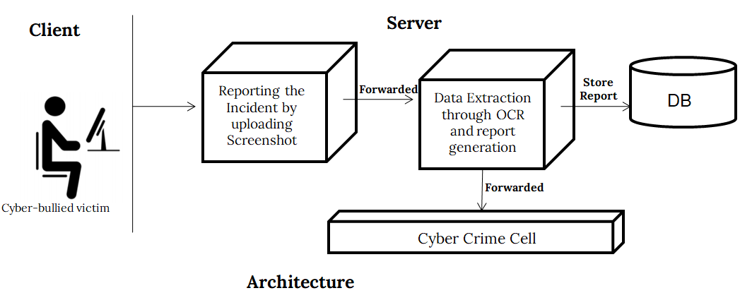

**Prototype:**

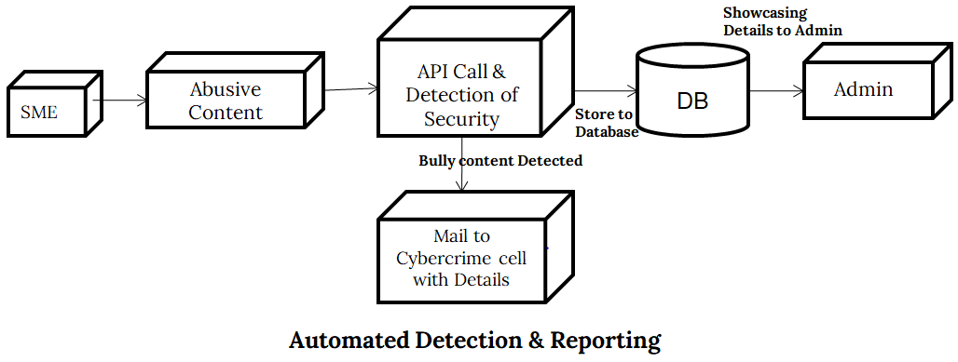

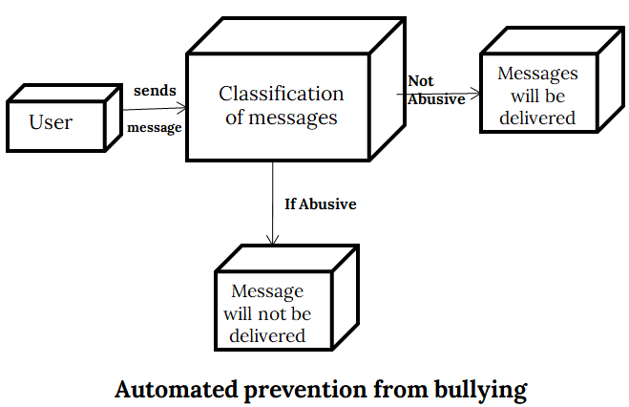

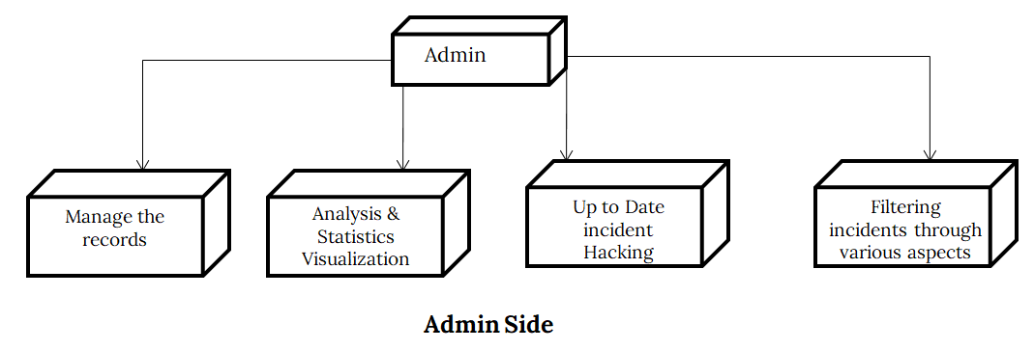

**Technology Stack:**

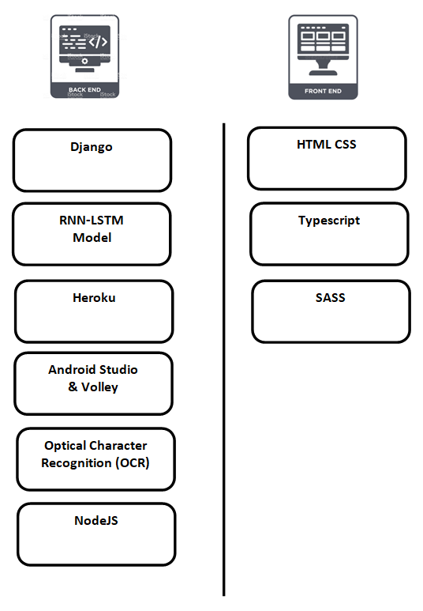

**Use Case:**

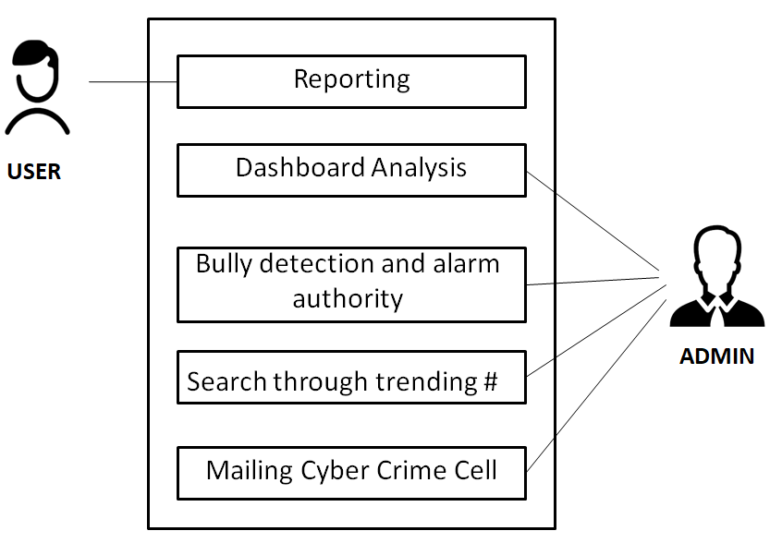

**Dependencies:**

* **User:** Reporting of incidents along with the proof.
* **Cyber Crime Cell:** Verification of reported incident, labeling and taking action for the same

**Show Stopper:**

* Internet Slangs