Batch: A1 Roll No.: 1911004

Experiment / assignment / tutorial No. 2

Grade: AA / AB / BB / BC / CC / CD /DD

Signature of the Staff In-charge with date

TITLE: To study and implement Booth’s Multiplication Algorithm.

AIM: Booth’s Algorithm for Multiplication
______________________________________________________________________
Expected OUTCOME of Experiment:

CO 2-Detail working of the arithmetic logic unit and its sub modules
_____________________________________________________________________
Books/ Journals/ Websites referred:

- Carl Hamacher, Zvonko Vranesic and Safwat Zaky, “Computer Organization”, Fifth Edition, TataMcGraw-Hill.
- William Stallings, “Computer Organization and Architecture: Designing for Performance”, Eighth Edition, Pearson.
3. Dr. M. Usha, T. S. Srikanth, “Computer System Architecture and Organization”, First Edition, Wiley-India.
_____________________________________________________________________
Pre Lab/ Prior Concepts:

It is a powerful algorithm for signed number multiplication which generates a 2n bit product and treats both positive and negative numbers uniformly. Also the efficiency of the algorithm is good due to the fact that, block of 1’s and 0’s are skipped over and subtraction/addition is only done if pair contains 10 or 01
Flowchart:
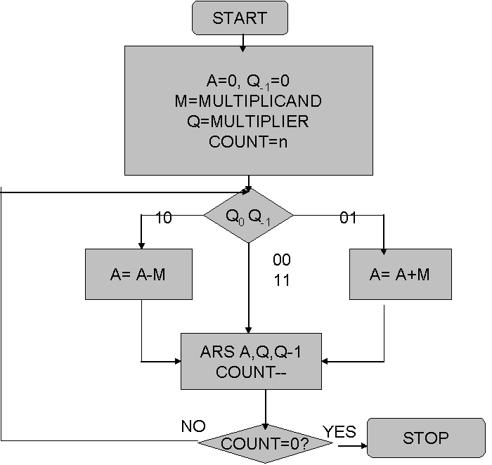
Design Steps:
- Start
- Get the multiplicand (M) and Multiplier (Q) from the user
- Initialize A= Q₋₁ =0
- Convert M and Q into binary
- Compare Q₀ and Q₋₁ and perform the respective operation.
Q₀ Q₋₁ | Operation
00/11 | Arithmetic right shift
01 | A+M and Arithmetic right shift
10 | A-M and Arithmetic right shift
6..Repeat steps 5 till all bits are compared
7. Convert the result to decimal form and display
8. End

Implementation:
import java.util.*;
class BoothMultiplication{
static int countBit=4; //min no of bits
public static void main(String Arr[]){
Scanner ob=new Scanner(System.in);
int Q1=0,m1,q1,nBitM,nBitQ;
int i,j,n,k;
//Q1 = Q(-1) bit
//m1=decimal M
//q1=decimal Q
System.out.println("\nEnter the two nos");
System.out.print("Enter M = ");
m1=ob.nextInt();
nBitM=countBit(m1);//noOfBitOF M
System.out.print("Enter Q = ");
q1=ob.nextInt();
nBitQ=countBit(q1);//noOfBitOF M
System.out.println("\n\n A Q\t\tQ(-1)");
if(nBitM>=nBitQ && nBitM>=4){
countBit=nBitM;
}
else if(nBitQ>=nBitM && nBitQ>=4){
countBit=nBitM;
}
int A[]=new int[countBit];
int m[]=new int[countBit];
int m2[]=new int[countBit];
int q[]=new int[countBit];
for(i=0;i<countBit;i++){
A[i]=0;//initially A is 0000
}
decimal(m1,m);
decimal(q1,q);
for(i=countBit;i>0;i--){
for(j=0;j<countBit;j++){
m2[j]=m[j];
}
if(q[countBit-1]==0 && Q1==1){
System.out.println("\t\t\t\t\t\tA <-- A+M");
A=add(A,m2);
display(A,q,Q1,m);
System.out.println();
}
if((q[countBit-1]==1&&Q1==1)||(q[countBit-1]==0&&Q1==0)){
//no A<-- A + M
//no A<-- A - M
}
if(q[countBit-1]==1 && Q1==0){
int c[]=complement2(m2);//taking 2's complement
System.out.println("\t\t\t\t\t\tA <-- A-M");
A=add(A,c);
display(A,q,Q1,m);
System.out.println();
}
Q1=q[countBit-1];
System.out.println("\t\t\t\t\t\tRight Shift ");
shift(A,q);
display(A,q,Q1,m);
System.out.println("\t\t\t\t\t\tCount--");
System.out.println("\t-\t-\t-\t-\t-\t-");
System.out.println();
}
ob.close();
}
static int countBit(int no) { //count Bits needed
int noBit=0,i,n1=no,r;
while(n1!=0) {
r=n1%2;
noBit++;
n1/=2;
}
return noBit;
}
static void decimal(int t,int m[]){
int i=0,k=0,c=0,t1=t;
int A[]=new int[100];
while(t1!=0){
A[i]=t1%2;
t1/=2;
c++;
i++;
}
for(int j=c,b=0;j >= 0;j--,b++)
m[b]=A[j];
}
static void display(int A[],int q[],int Q1,int m[]) //display A Q Q(-1)
{ int i;
for(i=0;i < countBit;i++)
System.out.print(A[i]);
System.out.print("\t");
for(i=0;i < countBit;i++)
System.out.print(q[i]);
System.out.print(" \t");
System.out.print(Q1);
System.out.print("\t");
}
static int[] add(int A[],int m1[])//add()
{
int carry=0,i;
int sum[]=new int[countBit];
for(i=countBit-1;i >= 0;i--)
{
sum[i]=(A[i]+m1[i]+carry)%2;
carry=(A[i]+m1[i]+carry)/2;
}
return sum;
}

static int[] complement2(int m1[])//2s Complement()
{
int i;
int z[]=new int[countBit];
for(i=0;i<countBit-1;i++){
z[i]=0;
}
z[countBit-1]=1;
for(i=0;i<m1.length;i++) {
if(m1[i]==0)
m1[i]=1;
else
m1[i]=0;
}
int compliment2[]=add(m1,z);
return compliment2;
}
static void shift(int A[],int q[]){ //shift()
int b=A[countBit-1]; int i;
for(i=countBit-2;i>=0;i--){
A[i+1]=A[i];
q[i+1]=q[i];
} q[0]=b;
}
} //class ends

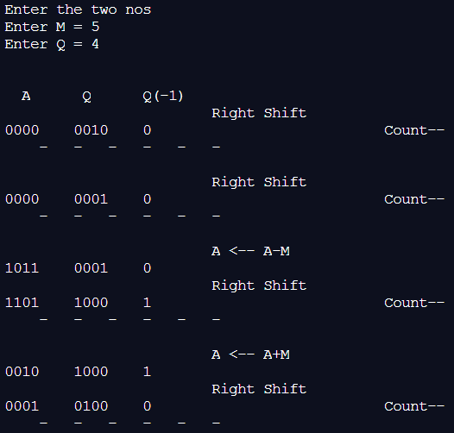
Example:
M=5=0101 Q=4=0100 -M=1011

Step No | A | Q | Q₋₁ | Step
0 | 0000 | 0100 | 0 | Initial
1 | 0000 | 0010 | 0 | Right shift
2 | 0000 | 0001 | 0 | Right shift
3 | 1011 | 0001 | 0 | A ←A-M
3 | 1101 | 1000 | 1 | Right shift
4 | 0010 | 1000 | 1 | A← A+M
4 | 0001 | 0100 | 0 | Right shift

AQ=(00010100)₂= (20)₁₀
Conclusion:
Booth’s Algorithm was Studied and implemented in Java to get Product of 2 numbers

Post Lab Descriptive Questions:
- Explain advantages and disadvantages of booth algorithm

- ADVANTAGES
- Positive and Negative numbers can be multiplied using this booth’s algorithm
- This algorithm works fast for numbers which can represented with in 6bits
- Has less number of conversions

- DISADVANTAGES
- Multiplication for Larger numbers for which the binary equivalent is more than 7 bits becomes a bit tricky to calculate and follow up thus end up with wrong product
- In some cases the choice of number of bit to take might be wrong thus answer might result wrong

Date: 25-08-2020 Signature of faculty in-charge

