Batch: A1 Roll No.: 1911004

Experiment / assignment / tutorial No. 3

Grade: AA / AB / BB / BC / CC / CD /DD

Signature of the Staff In-charge with date

TITLE : To study and implement Restoring method of division

AIM : The basis of algorithm is based on paper and pencil approach and the operation involve repetitive shifting with addition and subtraction. So the main aim is to depict the usual process in the form of an algorithm.
____________________________________________________________________________________________________________________________________________
Expected OUTCOME of Experiment:

CO 2-Detail working of the arithmetic logic unit and its sub modules
CO 3-Understand the Central processing unit with addressing modes and working of control unit
_____________________________________________________________________
Books/ Journals/ Websites referred:

- Carl Hamacher, Zvonko Vranesic and Safwat Zaky, “Computer Organization”, Fifth Edition, TataMcGraw-Hill.
- William Stallings, “Computer Organization and Architecture: Designing for Performance”, Eighth Edition, Pearson.
- Dr. M. Usha, T. S. Srikanth, “Computer System Architecture and Organization”, First Edition, Wiley-India.
_____________________________________________________________________
Pre Lab/ Prior Concepts:
The Restoring algorithm works with any combination of positive and negative numbers.

Flowchart for Restoring of Division:
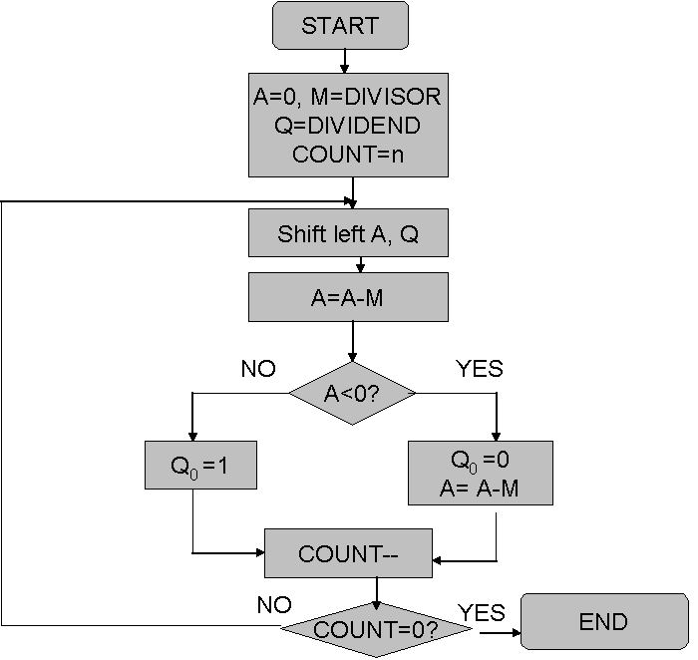
Design Steps:
- Start
- initialize A=0, M=Divisor, Q=Dividend and count=n (no of bits)
- Left shift A, Q
- If MSB of A and M are same
- Then A=A-M
- Else A=A+M
- If MSB of previous A and present A are same
- Q₀=0 & store present A
- Else Q₀=0 & restore previous A
- Decrement count.
- If count=0 go to 11
- Else go to 3
- STOP
Example:
import java.util.*;
class restoringDiv { //restoringDivision
public static void main(String[] args) {
Scanner ob=new Scanner(System.in);
int m,q,i,j,k,R,Q_;
System.out.print("Enter M (Divisor) = ");
m=ob.nextInt();
System.out.print("Enter Q (Dividend) = ");
q=ob.nextInt();
int M[]=binary(m); int Q[]=binary(q);
int M_[]=complement2(M); int A[]=new int[M.length];
System.out.print("M = \t");
for(i=(M.length-1);i>=0;i--) {
System.out.print(M[i]+" ");
}
System.out.print("\t\t -- M = \t");
for(i=(M.length-1);i>=0;i--) {
System.out.print(M_[i]+" ");
}
System.out.print("\nQ = \t");
for(i=(Q.length-1);i>=0;i--) {
System.out.print(Q[i]+" ");
}
System.out.print("\t\t A = \t");
for(i=(M.length-1);i>=0;i--) {
System.out.print(A[i]+" ");
}
System.out.println("\n A\t\t Q \t \t \t STEP");
display(A, Q);System.out.print("\t \t \t Initial");
System.out.println("\n\t---\t---\t---\t---\t---\t---");
for(i=Q.length-1;i>=0;i--){
shift(A,Q); display(A,Q);
System.out.println("\t \t \t Left Shift");//Left Shifting
A=add(A,M_); display(A,Q);
System.out.println("\t \t \t A <-- A - M");//A <-- A - M
if(A[Q.length-1]==1){ //Set Q0 = 0 & A<-A+M_
Q[0]=0; display(A,Q);
System.out.println("\t \t \t Set Q0 = 0 ");
A=add(A,M); display(A,Q);
System.out.println("\t \t \t A <-- A + M");
}else if(A[Q.length-1]==0){ //set Q0=1
Q[0]=1; display(A,Q);
System.out.println("\t \t \t Set Q0 = 1 ");
} System.out.println("\t---\t---\t---\t---\t---\t---");
}R=decimal(A);Q_=decimal(Q);
System.out.println("\tREMAINDER = "+R+"\tQUOTIENT = "+Q_);
ob.close(); } // main() ends
public static void display(int a[],int[] q) {//display A,Q
for(int i=a.length-1;i>=0;i--) {
System.out.print(a[i]+" ");
}System.out.print("\t");
for(int i=q.length-1;i>=0;i--) {
if(q[i]==9){ //to print _
System.out.print("_ ");
}else if(q[i]==0 ||q[i]==1){
System.out.print(q[i]+" ");
}}} // display() ends
public static int[] binary(int n) { //decimal to binary
int bin[]=new int[5]; int i=0,j;
while(n!=0){
bin[i]=n%2;
n/=2;
i++;
}return bin;
} // binary() ends
static int decimal(int n[]) { //binary to decimal
int D=0,i;
for(i=0;i<n.length;i++) {
D+=(n[i]*((int)Math.pow(2,i)));
}return D;
} // decimal() ends
public static int[] complement2(int n[]) { //2s Complement
int c[]=new int[n.length],z[]=new int[n.length]; int i,j,k;
for(i=0;i<c.length;i++){
z[i]=0;
if(n[i]==1){
c[i]=0;
}else{
c[i]=1;
} }z[0]=1;
int c2[]=add(c,z);
return c2;
} // complement() ends
public static int[] add(int A[],int m1[]) { //add()
int carry=0;
int sum[]=new int[5];
for(int i=0;i<5;i++){
sum[i]=(A[i]+m1[i]+carry)%2;
carry=(A[i]+m1[i]+carry)/2;
}return sum;
} // add () ends
public static void shift(int A[],int q[]) { //shift() left shift
int i,b=q[(A.length-1)]; // b=Q[A.length-1]
for(i=A.length-1;i>0;i--){
A[i]=A[i-1];
q[i]=q[i-1];
} A[0]=b; //A[0]=b
q[0]=9; //replacement for _ in Q0
} } //class ends

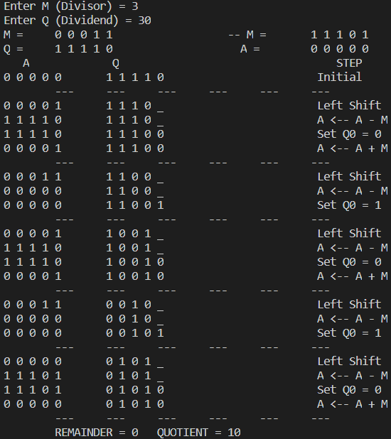
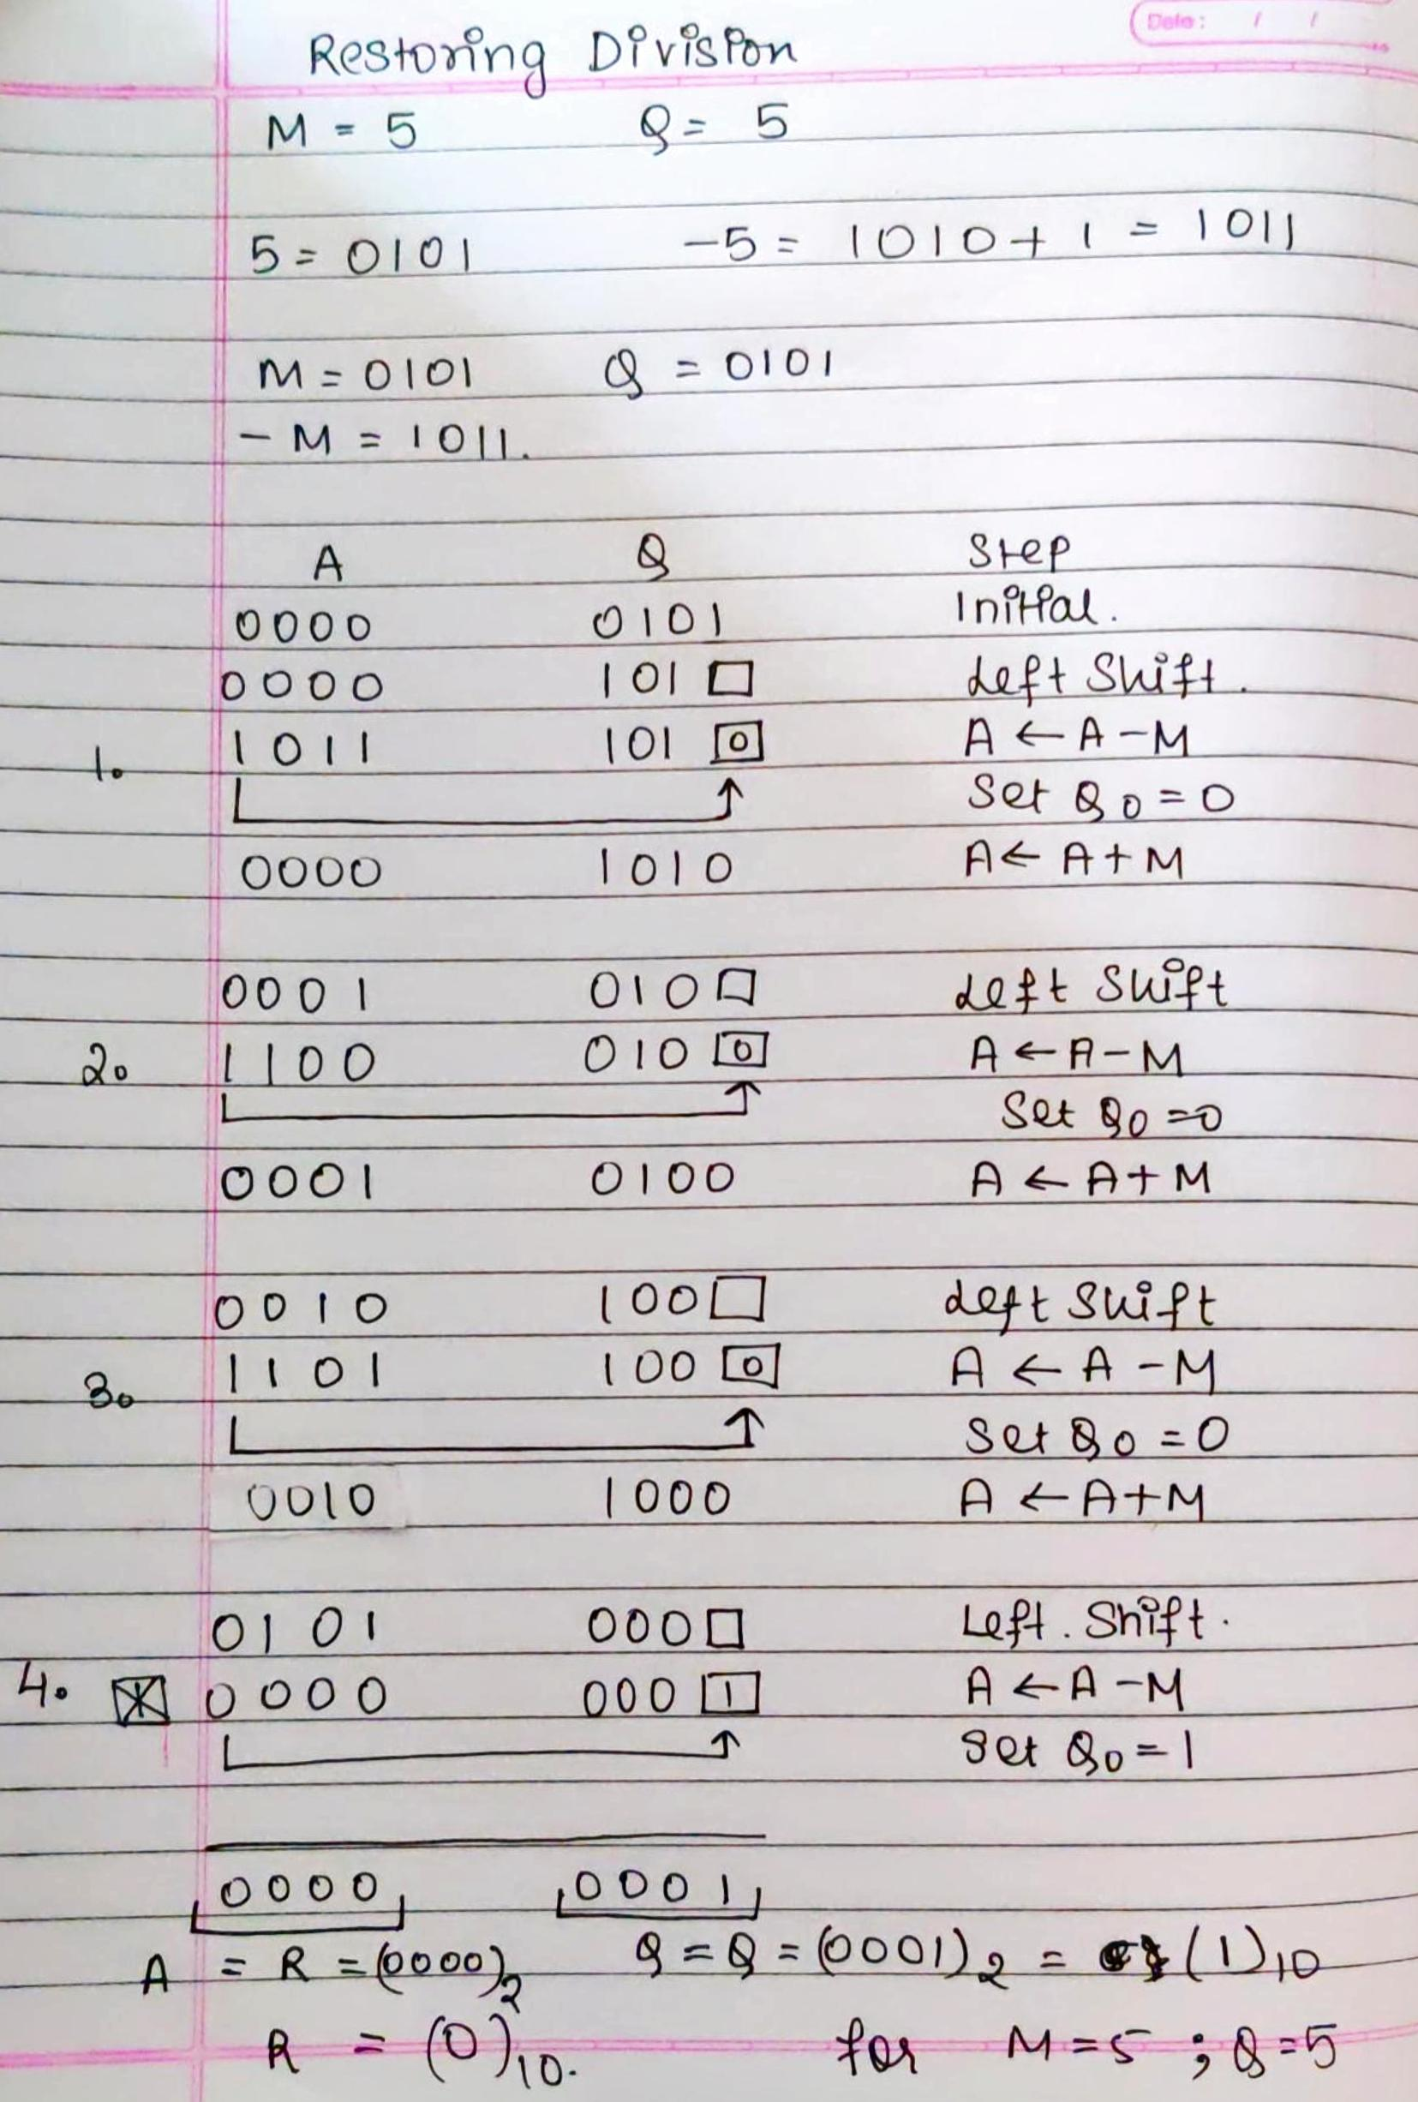
Conclusion:
We understood the concept of Restoring Division & implemented in java to find Quotient and Remainder of 2 Numbers.

Post Lab Descriptive Questions

- What are the advantages of restoring division over non restoring division?

- In restoring division the original value of A in the current Step is maintained as First ADDITION IS PERFORMED A← A- M then we DO SUBSTRACTION A← A+M

- Although there is not much difference still we will need an extra bit to be maintained in the partial remainder as to keep the track of sign in the problem

Date: 01-09-2020 Signature of faculty in-charge

