Batch: A1 Roll No.: 1911004

Experiment / assignment / tutorial No. 4

Grade: AA / AB / BB / BC / CC / CD /DD

Signature of the Staff In-charge with date

TITLE : To study and implement Non Restoring method of division

AIM : The basis of algorithm is based on paper and pencil approach and the operation involve repetitive shifting with addition and subtraction. So the main aim is to depict the usual process in the form of an algorithm.
______________________________________________________________________
Expected OUTCOME of Experiment:

CO 2-Detail working of the arithmetic logic unit and its sub modules
CO 3-Understand the Central processing unit with addressing modes and working of control unit
_____________________________________________________________________
Books/ Journals/ Websites referred:

- Carl Hamacher, Zvonko Vranesic and Safwat Zaky, “Computer Organization”, Fifth Edition, TataMcGraw-Hill.
- William Stallings, “Computer Organization and Architecture: Designing for Performance”, Eighth Edition, Pearson.
3. Dr. M. Usha, T. S. Srikanth, “Computer System Architecture and Organization”, First Edition, Wiley-India.
_____________________________________________________________________
Pre Lab/ Prior Concepts:
The Non Restoring algorithm works with any combination of positive and negative numbers.

Flowchart for Non Restoring of Division:
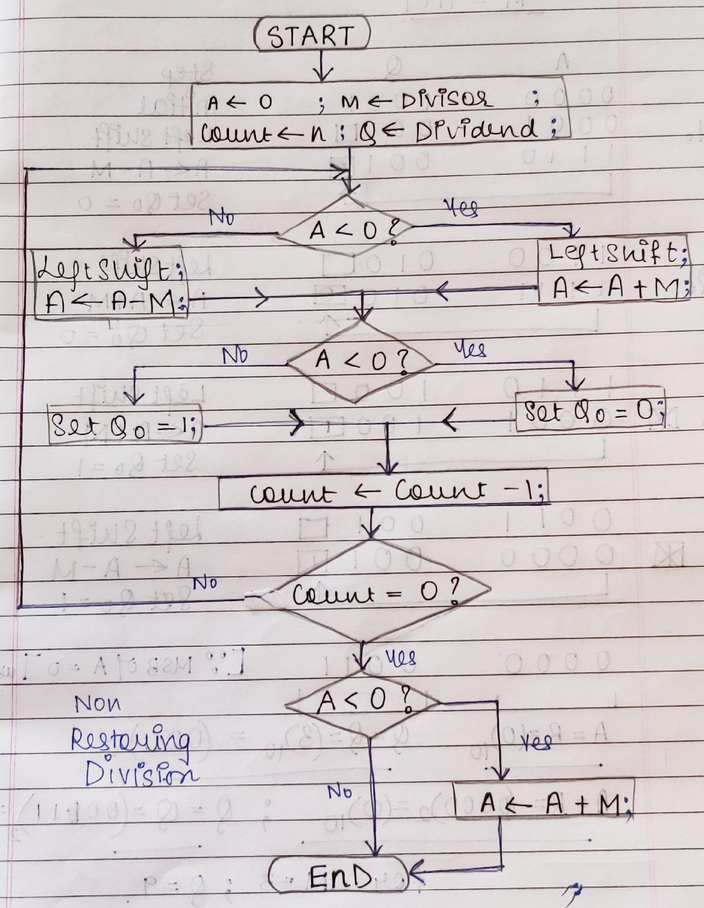
Example:

import java.util.*;
class Main { //nonRestoringDivision
public static void main(String[] args) {
Scanner ob=new Scanner(System.in);
int m,q,i,j,k,R,Q_;
System.out.print("Enter M (Divisor) = ");
m=ob.nextInt();
System.out.print("Enter Q (Dividend) = ");
q=ob.nextInt();
int M[]=binary(m); int Q[]=binary(q);
int M_[]=complement2(M); int A[]=new int[M.length];
System.out.print("M = \t");
for(i=(M.length-1);i>=0;i--) {
System.out.print(M[i]+" ");
}
System.out.print("\t\t -- M = \t");
for(i=(M.length-1);i>=0;i--) {
System.out.print(M_[i]+" ");
}
System.out.print("\nQ = \t");
for(i=(Q.length-1);i>=0;i--) {
System.out.print(Q[i]+" ");
}
System.out.print("\t\t A = \t");
for(i=(M.length-1);i>=0;i--) {
System.out.print(A[i]+" ");
}System.out.println("\n A\t\t Q \t \t \t STEP");
display(A, Q);System.out.print("\t \t \t Initial");
System.out.println("\n\t---\t---\t---\t---\t---\t---");
for(i=Q.length-1;i>=0;i--){
if(A[A.length-1]==1) {
shift(A,Q);
display(A,Q);
System.out.println("\t \t \t Left Shift"); //Left Shifting
A=add(A,M);
display(A,Q);
System.out.println("\t \t \t A <-- A + M"); //A <-- A + M
}else if(A[A.length-1]==0){
shift(A,Q);
display(A,Q);
System.out.println("\t \t \t Left Shift");//Left Shifting
A=add(A,M_);
display(A,Q);
System.out.println("\t \t \t A <-- A - M");//A <-- A - M
}
if(A[Q.length-1]==1){ //Set Q0 = 0
Q[0]=0;
display(A,Q);
System.out.println("\t \t \t Set Q0 = 0 ");
} else if(A[Q.length-1]==0){ //set Q0=1
Q[0]=1;
display(A,Q);
System.out.println("\t \t \t Set Q0 = 1 ");
} System.out.println("\t---\t---\t---\t---\t---\t---");
}
if(A[A.length-1]==1){ //A[A.length-1]==1 then A <-- A + M
A=add(A,M);
display(A,Q);
System.out.println("\t \t \t A <-- A + M");
System.out.println("\t---\t---\t---\t---\t---\t---");
} // finding decimal R,Q from A,Q respectively
R=decimal(A);Q_=decimal(Q);
System.out.println("\tREMAINDER = "+R+"\tQUOTIENT = "+Q_);
ob.close(); } // main() ends
public static void display(int a[],int[] q) {//display A,Q
for(int i=a.length-1;i>=0;i--) {
System.out.print(a[i]+" ");
}System.out.print("\t");
for(int i=q.length-1;i>=0;i--) {
if(q[i]==9){ //to print _
System.out.print("_ ");
}else if(q[i]==0 ||q[i]==1){
System.out.print(q[i]+" ");
} } } // display() ends
public static int[] binary(int n) { //decimal to binary
int bin[]=new int[5];
int i=0,j;
while(n!=0){
bin[i]=n%2;
n/=2;
i++;
}return bin;
} // binary() ends
static int decimal(int n[]) { //binary to decimal
int D=0,i;
for(i=0;i<n.length;i++) {
D+=(n[i]*((int)Math.pow(2,i)));
}return D;
} // decimal() ends
public static int[] complement2(int n[]) { //2s Complement
int i,j,k;
int c[]=new int[n.length],z[]=new int[n.length];
for(i=0;i<c.length;i++){
z[i]=0;
if(n[i]==1){
c[i]=0;
}else{
c[i]=1;
} }z[0]=1;
int c2[]=add(c,z);
return c2;
} // complement() ends
public static int[] add(int A[],int m1[]) { //add()
int carry=0; int sum[]=new int[5];
for(int i=0;i<5;i++){
sum[i]=(A[i]+m1[i]+carry)%2;
carry=(A[i]+m1[i]+carry)/2;
}return sum;
} // add () ends
public static void shift(int A[],int q[]) { //shift() left shift
int i,b=q[(A.length-1)]; // b=Q[A.length-1]
for(i=A.length-1;i>0;i--){
A[i]=A[i-1];
q[i]=q[i-1];
}
A[0]=b; //A[0]=b
q[0]=9; //replacement for _ in Q0
} //shift() left shift ends
} //class ends

Output:
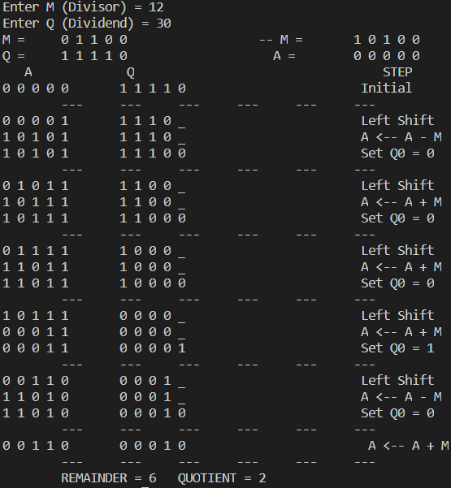

Example:
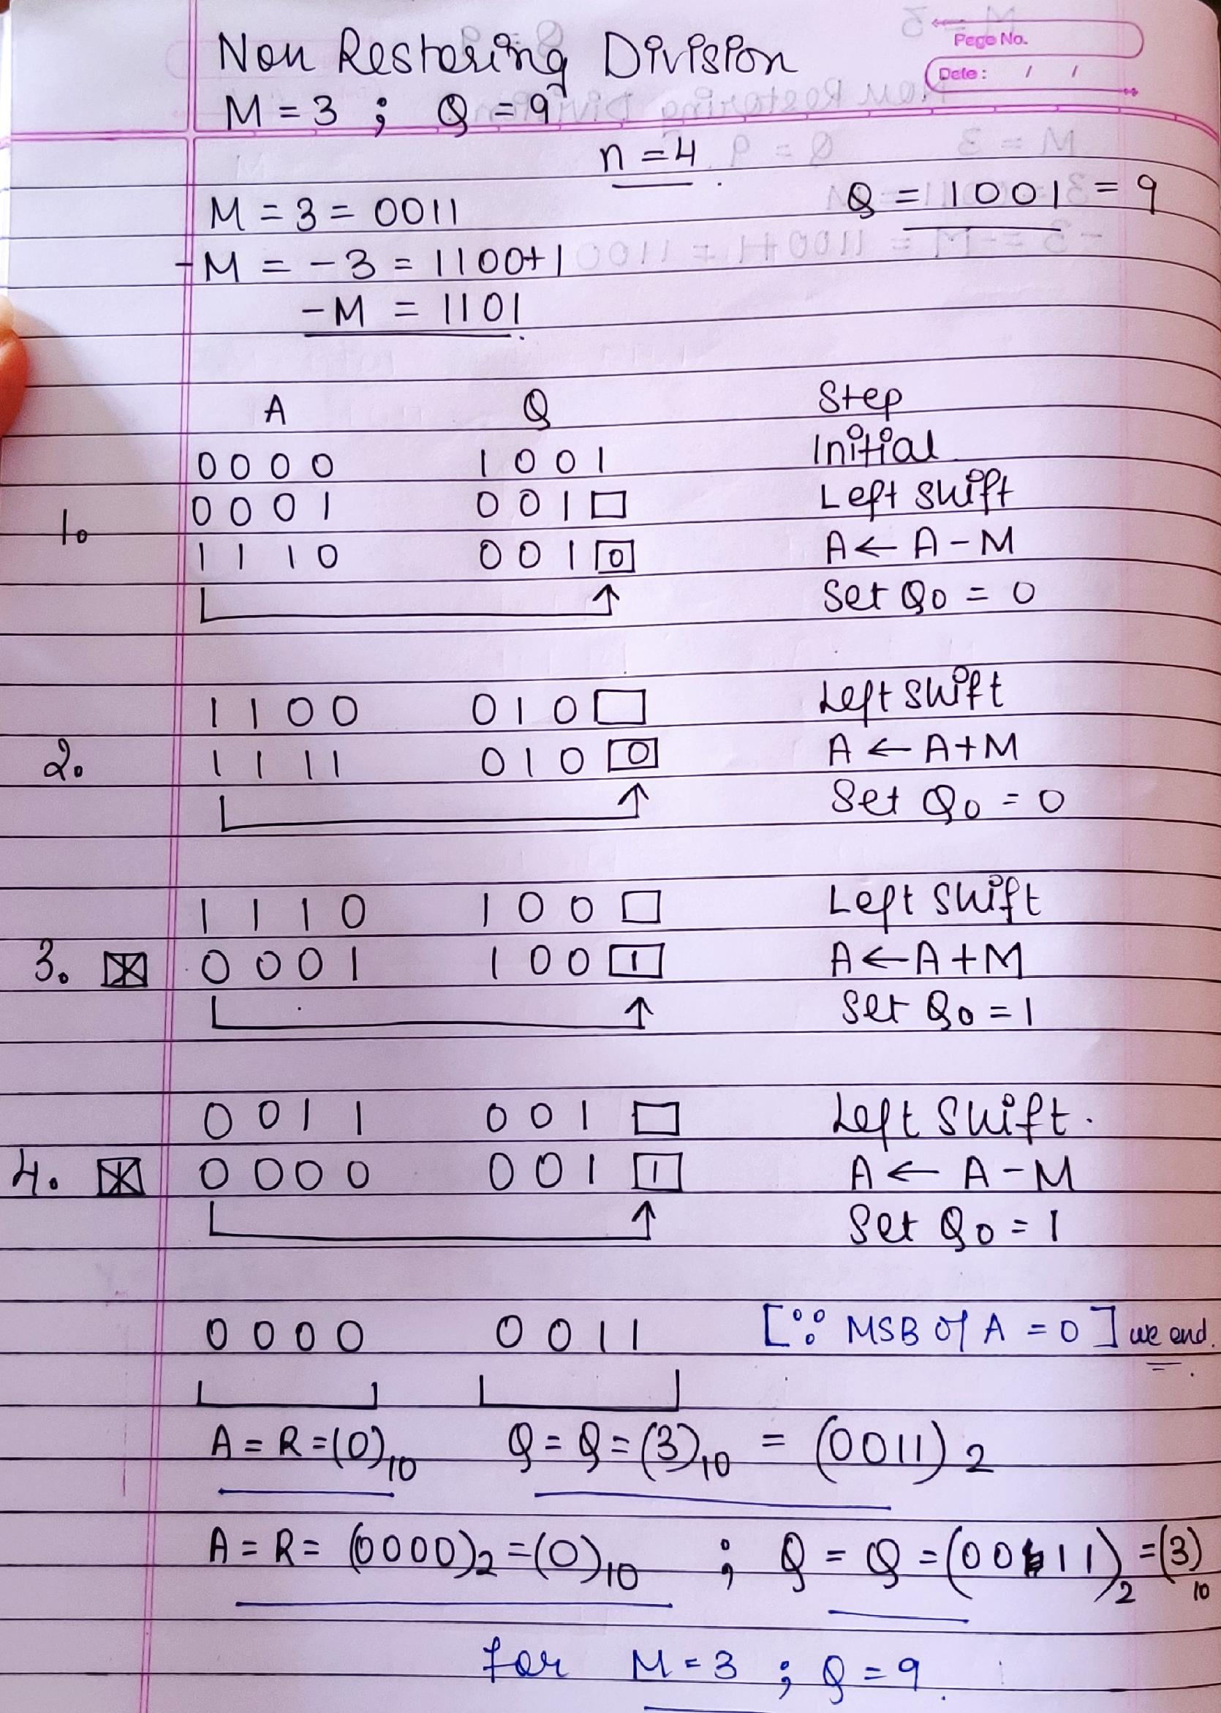

Conclusion:
We understood the concept of Non Restoring Division & implemented it in Java to find the Quotient and Remainder of 2 Numbers.

Post Lab Descriptive Questions

- What are the advantages of non restoring division over restoring division?

- We don’t need to Restore back the value of A after Setting Q₀ Bit to either 0 or 1 in Non Restoring like it is in Restoring Division . Thus we save on 1 operation & time .
- Test subtraction is not required; the sign bit determines whether an addition or subtraction is used ( (A← A + M ) or (A← A - M) ) after we have shifted Left A,Q & then we set Q₀ = 1 or Q₀ = 0 .

Date 08/09/2020 Signature of the Staff In-charge

