Batch: A1 Roll No.: 1911004

Experiment / assignment / tutorial No. 5

Grade: AA / AB / BB / BC / CC / CD /DD

Signature of the Staff In-charge with date

TITLE: Implementation of IEEE-754 floating point representation

AIM: To demonstrate the single and double precision formats to represent floating point numbers.
______________________________________________________________________
Expected OUTCOME of Experiment:

CO 2-Detail working of the arithmetic logic unit and its sub modules
___________________________________________________________________
Books/ Journals/ Websites referred:
- Carl Hamacher, Zvonko Vranesic and Safwat Zaky, “Computer Organization”, Fifth Edition, TataMcGraw-Hill.
- William Stallings, “Computer Organization and Architecture: Designing for Performance”, Eighth Edition, Pearson.
_____________________________________________________________________
Pre Lab/ Prior Concepts:
The IEEE Standard for Floating-Point Arithmetic (IEEE 754) is a technical standard for floating point computation established in 1985 by the Institute of Electrical and Electronics Engineers (IEEE). The standard addressed many problems found in the diverse floating point implementations that made them difficult to use reliably and portably. Many hardware floating point units now use the IEEE 754 standard.
The standard defines:
- arithmetic formats: sets of binary and decimal floating-point data, which consist of finite numbers (including signed zeros and subnormal numbers), infinities, and special "not a number" values (NaNs)
- interchange formats: encodings (bit strings) that may be used to exchange floating-point data in an efficient and compact form
- rounding rules: properties to be satisfied when rounding numbers during arithmetic and conversions
- operations: arithmetic and other operations (such as trigonometric functions) on arithmetic formats
- exception handling: indications of exceptional conditions (such as division by zero, overflow, etc

CODE

import java.util.*;
class IEEEfloatingPoint {
static int signBit=0; //default positive no so SignBit 0
static int w[],f[],N[],B[],B_[],SPE[],DPE[],P[],pos1st1,pos_,e;
public static void main(String[] args) {
Scanner ob=new Scanner(System.in);
System.out.print("\nENTER THE FLOATING POINT NO. = ");
double n=ob.nextDouble();
int i,j,k; //assuming that n is positive so signBit=0
if(n<0){
signBit=1;
} n=Math.abs(n);
int x=((int)n); //int part of n
double y=n-x;//floating point value of n
w=binaryI(x); //binary of integer part
f=binaryF(y); //binary of floating part
B=new int[w.length+f.length+1]; //entire binary no of n
B_=B;
display();
ob.close();
} //main() ends
public static int[] binaryI(int x) { //for binary of int part
int bin[]=new int[11];//can handle 2^11 no
int i=0;
while(x!=0){
bin[i]=x%2;
i++;
x/=2;
} System.out.println();
return bin;
}
public static int[] binaryF(double y) { //for binary of floating point
int bin[]=new int[32];
int i=0,w=0;//whole no in binary
double d=y;//floating no
i=0;
do{
d=d*2;
w=((int)d);
bin[i]=w;
d=d-w;
++i;
}while(((d!=y) || (d!=0.00) )&& (i<=31));
return bin;
}
public static int normalize(int b[]){
int e=0;
for(int i=0;i<b.length;i++){
if(b[i]==1){
pos1st1=i;
break;
}
} System.out.println("\nAFTER NORMALIZATION");
e=pos_-pos1st1;
if(e>=0){
for(int i=pos_+1;i>pos1st1+1;i--){
b[i]=b[i-1];
}
b[pos1st1+1]=9; //represents .
}else{
for(int i=pos_+1;i<pos1st1;i++){
b[i]=b[i+1];
}b[pos1st1]=9;
}
for(int i=0;i<b.length;i++) {
if(B[i]==1 || B[i]==0)
System.out.print(B[i]+" ");
else
System.out.print(". ");
} int j=-1;
for(int i=b.length-1;i>=0;i--){
j++;
if(b[i]==9){
break;
}
} N=new int[j];
j=0;
for(int i=b.length-1;j<N.length;i--,j++) {
N[j]=b[i];
} return e;
}
public static int[] bias(int e) {
int singlePE=(e+127),doublePE=(e+1023);
int P[]=new int[2];
P[0]=singlePE;
P[1]=doublePE;
return P;
}
public static void displayPrecision(int signBit,int PE[],int N[]) {
int i;
System.out.print("\t | "+signBit+" | ");
for(i=(PE.length-1);i>=0;i--){
System.out.print(PE[i]+" ");
} System.out.print(" | ");
for(i=(N.length-1);i>=0;i--) {
System.out.print(N[i]+" ");
}
}
public static void display() {
int i,j,k;
System.out.println(" SIGN BIT = " +signBit);
System.out.println("BINARY OF INTEGER PART");
for(i=(w.length-1),j=0;i>=0;i--,j++) {
B[j]=w[i];
System.out.print(w[i]+" ");
} B[j]=9; //9 represents . in int[] B[]
pos_=j-1;
System.out.println("\nBINARY OF FLOATING PART");
for(i=0,k=0;i<f.length;i++,k++) {
B[j+k+1]=f[i];
System.out.print(f[i]+" ");
} System.out.println("\nBINARY OF NUMBER");
for(i=0;i<B.length;i++) {
if(B[i]==1 || B[i]==0)
System.out.print(B[i]+" ");
else
System.out.print(". ");
} e=normalize(B);
System.out.print("\nN = ");
for(j=N.length-1;j>=0;j--){
System.out.print(N[j]+" ");
} System.out.println("\nE = "+e);
P=bias(e);
System.out.print("\nSINGLE PRECISION BINARY = \t"+(e+127)+" ");
SPE=binaryI(P[0]);
for(i=(SPE.length-1);i>=0;i--){
System.out.print(SPE[i]+" ");
} System.out.print("\nDOUBLE PRECISION BINARY = \t"+(e+1023)+" ");
DPE=binaryI(P[1]);
for(i=(DPE.length-1);i>=0;i--){
System.out.print(DPE[i]+" ");
} System.out.println("\n\n\t \t \t SINGLE PRECISION = 32 BITS\n");
System.out.println(" | SIGN BIT| 8 BIT BIASED EXPONENT| 23 BIT (FRACTION = N) \n");
displayPrecision(signBit,SPE,N);
System.out.println("\n\n\t \t \t DOUBLE PRECISION = 64 BITS\n");
System.out.println(" | SIGN BIT| 11 BIT BIASED EXPONENT| 52 BIT (FRACTION = N) \n");
displayPrecision(signBit,DPE,N);
}
} //class ends

EXAMPLE
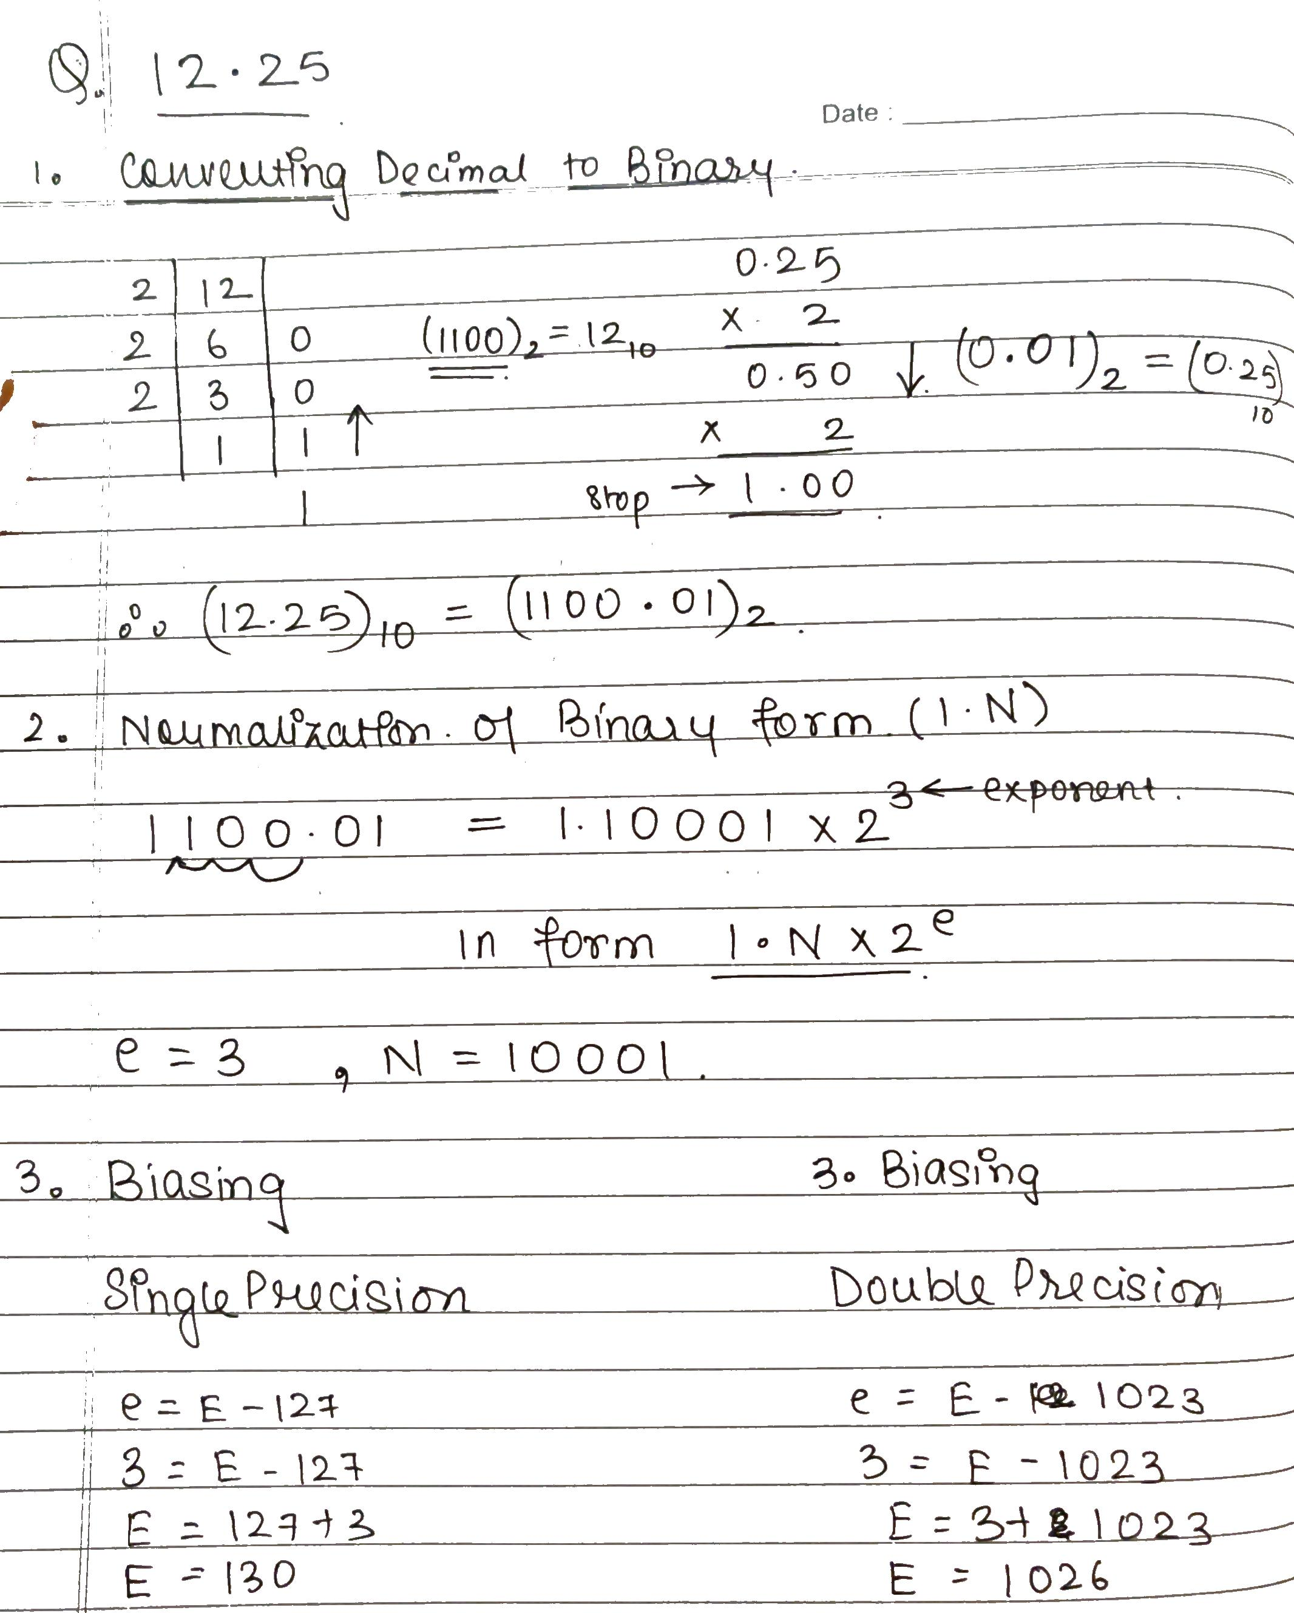
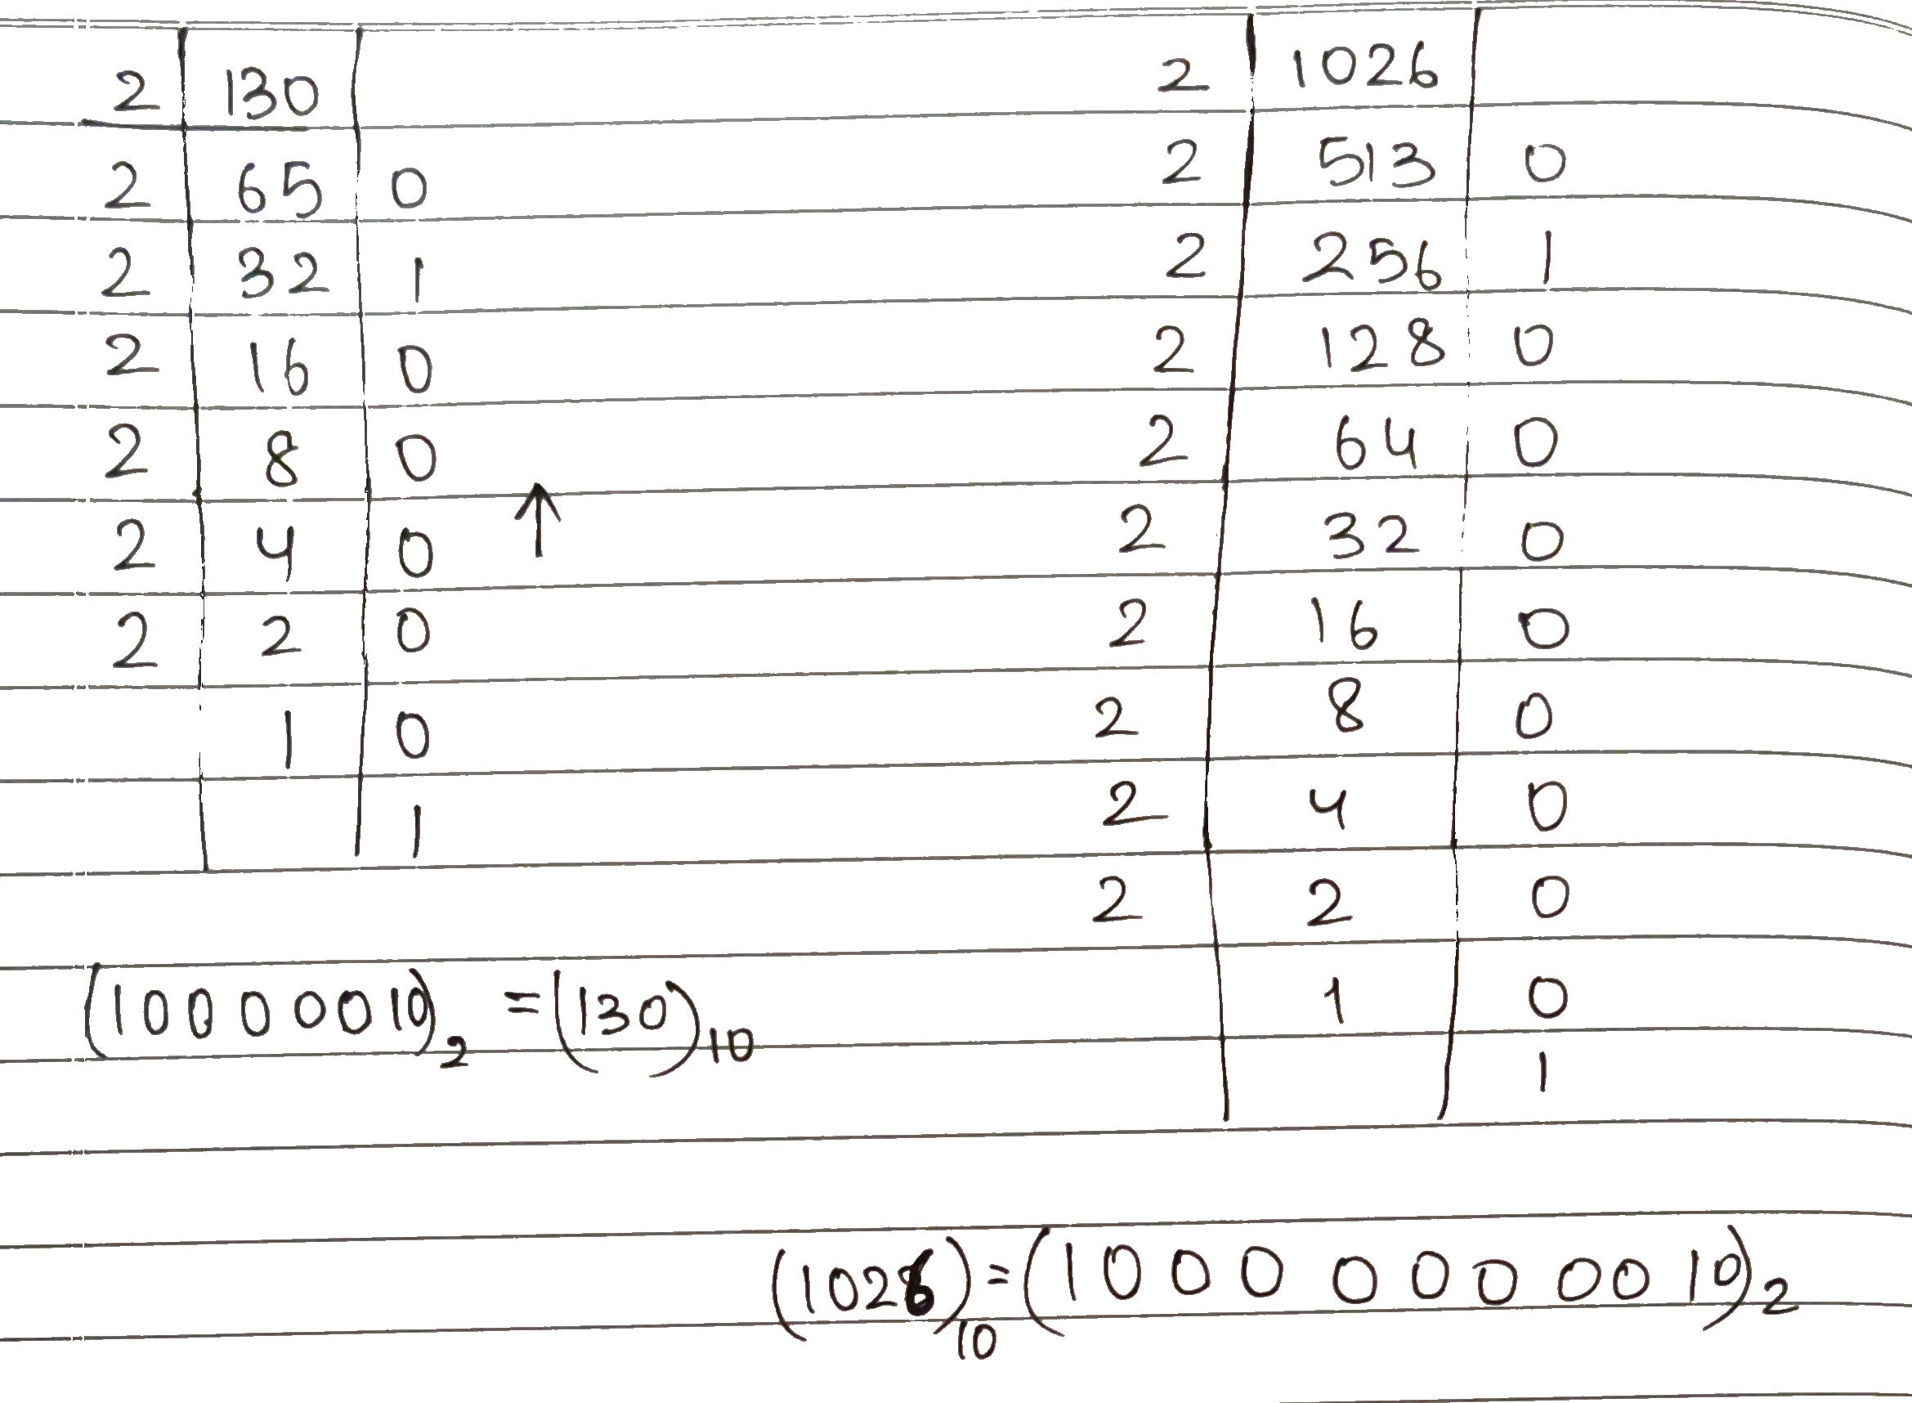
SINGLE PRECISION
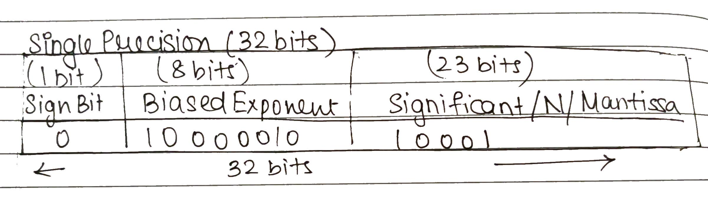

DOUBLE PRECISION
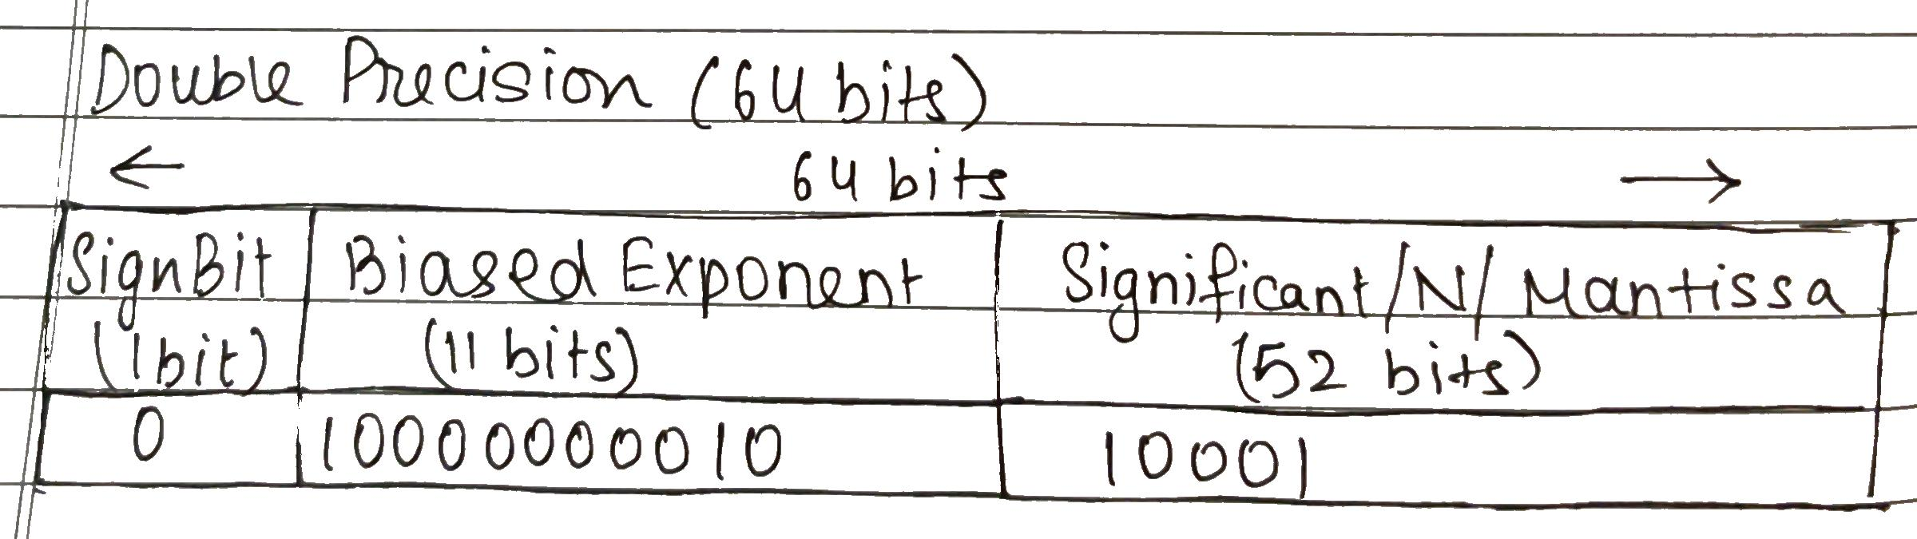

OUTPUT

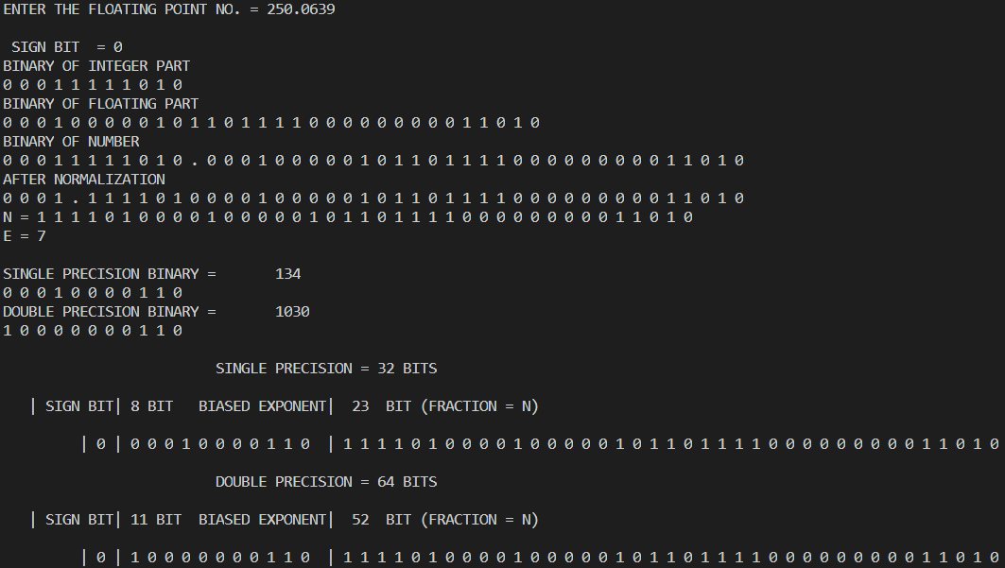
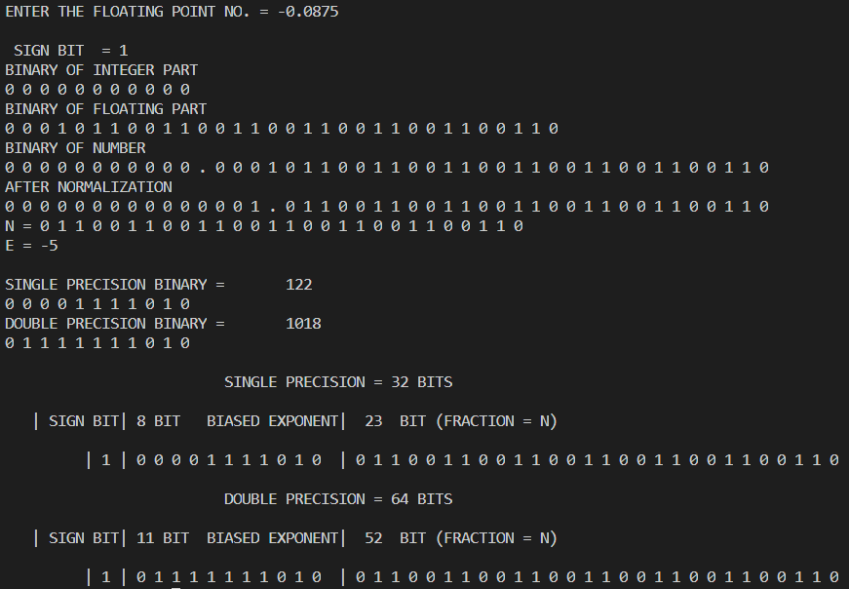

CONCLUSION
We understood the concept of IEEE-754 floating point representation & implemented it in Java to find the of IEEE-754 floating point representation of given numbers .

Post Lab Descriptive Questions
- Give the importance of IEEE-754 representation for floating point numbers?
- It helps us to represent the floating-point decimal number to floating-point binary number

- It also makes floating point computation easier

- Since we have Single & Double precision we can deal with very small & large numbers too.

- It also gives us in sight if number is negative/positive

- Though it can’t represent all numbers precisely yet gives an idea of number of significant digits in the representation using fraction bits

Date: 15-09-2020 Signature of faculty in-charge

