Batch: A1 Roll No.: 1911004

Experiment / assignment / tutorial No. 7

Grade: AA / AB / BB / BC / CC / CD /DD

Signature of the Staff In-charge with date

TITLE: Study of RISC and CISC Architecture

AIM: Understanding RISC and CISC Architecture
_________________________________________________________________________________________________________________
Expected OUTCOME of Experiment:
CO 3 - Understand the Central processing unit with addressing modes and working of control unit
__________________________________________________________________
Books/ Journals/ Websites referred:

- Carl Hamacher Zvonko Vranesic Safwat Zaky,’Computer Organization’, 5thEdition,TataMcGraw-Hill.
- William Stallings,’Computer Organization &Architecture:Designing for Performance’,8thEdition, Pearson.
- Dr.M.Usha,T.S.Srikanth,“Computer System Architecture and Organization”,1st Edition, Wiley-India.
_____________________________________________________________________

Pre Lab/ Prior Concepts:

Reduced Set Instruction Set Architecture (RISC)
The main idea behind is to make hardware simpler by using an instruction set composed of a few basic steps for loading, evaluating and storing operations just like a load command will load data, store command will store the data.
Complex Instruction Set Architecture (CISC)
The main idea is that a single instruction will do all loading, evaluating and storing operations just like a multiplication command will do stuff like loading data, evaluating and storing it, hence it’s complex.
Both approaches try to increase the CPU performance
RISC ARCHITECTURE
- Diagram of RISC Architecture: - REDUCED INSTRUCTION SET COMPUTER

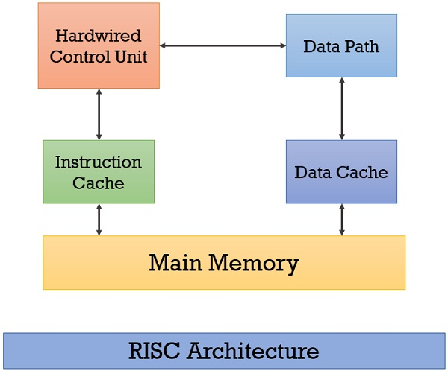

- Brief Explanation of each component
- HARDWIRED CONTROL UNIT
- it is circuitry approach & faster execution
- costly as compared to Microprogrammed Control Unit
- MAIN MEMORY
- holds instruction set & data set which then goes into instruction & data cache respectively
- thus connected to instruction & data cache
- DATA CACHE
- the data / operands which is to be used are also stored here
- thus it is temporary storage of data
- INSTRUCTION CACHE
- from here the next instructions to be decoded & performed is stored
- thus it is temporary storage of instruction
- DATA PATH
- the data from data cache comes into this 1st then is transferred to Hardwired Control Unit

➔ 2 way data , instruction flow in each component

- RISC Processor Instruction Set Examples with explanation (Any 2)
- Instruction of RISC are of fixed size
- Less number of Instruction are used
- Instructions are simple
- It uses LOAD & STORE instruction to access & save data at memory , operands
- STORE FFFFH , A; // LOAD SOURCE, DESTINATION;
- here data from register A will be stored in FFFFH location;
- it stores the data from source register to destination Address;

- LOAD A , FFFFH; // LOAD DESTINATION, SOURCE;
- here data from location FFFFH will be stored at the register A;
- it loads the data from source address to destination register;

- A= B+C //if we have to add data & store into A accumulator
LOAD R1,B; // load data from B to R1;
LOAD R2,C; // load data from C to R2;
ADD R3, R1, R2; // add data from R1,R2 & store ADD in to R3 ;
STORE R3,A; // store data from R3 to A;
- more registers are used

CISC ARCHITECTURE
- Diagram of CISC Architecture: - COMPLEX INSTRUCTION SET COMPUTER.
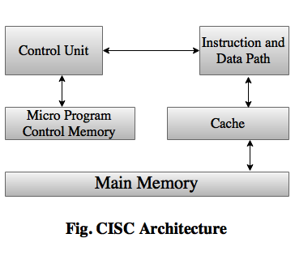
- Brief Explanation of each component
- MICROPROGRAMMED CONTROL UNIT & MEMORY
- it is implemented using programming approach & slow execution
- less costly as compared to Hardwired Control Unit
- MAIN MEMORY
- holds instruction set & data set
- thus connected to cache
- CACHE
- from here the next instructions to be decoded & performed is stored
- the data / operands which is to be used are also stored here
- thus it is temporary storage of data & instruction
- DATA & INSTRUCTION PATH
- the data & instruction from cache comes into this 1st
- then is transferred to Microprogrammed Control Unit & Memory

- 2 way data , instruction flow in each component but micro-program control memory & main memory aren’t connected

- CISC Processor Instruction Set Examples with explanation (Any 2)
- Instruction of CISC are of variable size
- More number of instructions are used
- Instructions are complex
- It uses MOV instruction to access & save data at memory , operands
- MOV A, B; // MOV DESTINATION, SOURCE;
- data from B will be stored into A
- data from source B will be stored into destination A accumulator

- MVI A, FFH; // MOV DESTINATION, SOURCE;
- data FFH will be stored into A
- data FFH (source) will be stored into destination A accumulator

- A= B+C //if we have to add data & store into A accumulator
MOV A,C // data from C is moved to A
ADD A,B // data from B is added to A which has C’s data
- thus less registers are used

Post Lab Descriptive Questions

Write a tabular comparative analysis of RISC v/s CISC

RISC | CISC
REDUCED INSTRUCTION SET COMPUTER | COMPLEX INSTRUCTION SET COMPUTER
Less no of instructions are used ; they are of fix length | More no of instructions are used ; they are of variable length
Pipelining is easy | Pipelining is difficult
More no of registers are used | Less no of registers are used
An instruction takes single clock Cycle to be executed | An instruction can take more than single clock Cycle to be executed
More Software complexity ;  Less Processors complexity | Less Software complexity ;  More Processors complexity

Conclusion :-
RISC & CISC Architecture were studied during this experiment ; along with difference between them.

Date: 29-09-2020 Signature of faculty in-charge

