Batch: BCT1 Roll No. 1911004
Experiment No. 3

Title: Implementation of PoS and PoW in block chain

Objective: Understand PoS and PoW in block chain
Expected Outcome of Experiment:

CO | Outcome
CO4 | Grasp the in-depth understanding of Blockchain, Smart Contracts & how it works.

Books/ Journals/ Websites referred:

Abstract: -
Blockchain technology is the concept or protocol behind the running of the blockchain. Blockchain technology makes cryptocurrencies (digital currencies secured by cryptography) like Bitcoin work just like the internet makes email possible. The blockchain is an immutable (unchangeable, meaning a transaction or file recorded cannot be changed) distributed digital ledger (digital record of transactions or data stored in multiple places on a computer network) with many use cases beyond cryptocurrencies. Immutable and distributed are two fundamental blockchain properties. The immutability of the ledger means you can always trust it to be accurate. Being distributed protects the blockchain from network attacks. Each transaction or record on the ledger is stored in a “block.” The information contained in a block is dependent on and linked to the information in a previous block and, over time, forms a chain of transactions.
Related Theory: -
Proof-of-Work Blockchains
The PoW consensus mechanism is among the most widely utilized methods in blockchain, and was popularized first by Bitcoin. The defining components of PoW systems are miners and the electricity they expend to make the calculations that verify bitcoin (BTC) transactions. Miners operate computer hardware to run network nodes that employ computational power to algorithmically solve mathematical puzzles called proofs of work. The miner who solves the puzzle first confirms the most recent block of transactions on the blockchain. The successful miner then broadcasts the new block to all other nodes, which in turn confirm its accuracy and add that block to their copy of the blockchain, building a verifiable record of data for the whole network. This verification process represents consensus. Only once this data is confirmed can a new block be added to the network. Miners receive newly minted cryptocurrency, the block reward, (in the case of Bitcoin, they receive BTC) for being the first to validate a new block of data and add it to the PoW blockchain. Proof-of-Work blockchains aim to produce blocks at consistent intervals — Bitcoin, for example, generates one block about every ten minutes. PoW networks are limited in terms of their speed and scale because the process for proving work is so energy intensive. Moreover, PoW networks are coded to be more or less difficult relative to the amount of computational power on the network. You may think of computational power as simply competition — more computational power equals more competition, which equals harder proofs of work. But despite their limitations of speed and scalability, PoW blockchains have historically provided better security, while maintaining meaningful decentralization. Because PoW systems are distributed, it is extremely expensive for a malicious actor to take over the blockchain by controlling the majority of computing power on the network. The hardware, electricity, and computational costs are typically too high to surmount. However, the same features that make PoW blockchains secure also make the barriers to participating in the network as a node high. Operating a mining rig and paying for the associated hardware and electricity costs is too expensive for the average user, and mining on many major networks has been monopolized by large-scale mining operators that have amassed influence in network governance. Another drawback of PoW networks is that they are energy intensive and thus environmentally damaging. The computational power needed to solve proofs of work requires an immense amount of electricity. For example, in 2021 the Bitcoin network had the same annual carbon footprint as the nation of New Zealand and used as much electricity as Chile. Tech development in the blockchain industry has focused significantly on remediating the environmental drawbacks of crypto mining, and a number of alternative solutions have emerged.
Proof-of-Stake Blockchains
Proof of Stake is the second most popular consensus mechanism and solves many of the disadvantages found on Proof-of-Work blockchains like lack of speed, poor scalability, inefficient energy consumption, and high barrier to entry. Examples of current industry-leading PoS blockchains include Polkadot, Avalanche, and Cardano. Ethereum, which was originally designed as a PoW blockchain, is in the process of transitioning to a PoS blockchain called Ethereum 2.0. Instead of miners validating transactions, PoS blockchains simply have validators. Validators are network node operators that validate data, similarly to PoW systems, but there is no energy-intensive computational process to earn the right to validate. Instead of working to solve proofs of work, validators “stake” some of the blockchain’s native tokens to become eligible for selection as a validator node. The prospective validator will essentially stake crypto tokens native to the blockchain to serve as collateral. When it comes time to validate the data held in a transaction block on a PoS blockchain, the system randomly selects a validator to confirm the data. While random to an extent, certain variables can make it more likely for a validator to be chosen, including the number of tokens a validator has staked. When the block is confirmed, that validator is typically rewarded with network transaction fees, and the process begins with a new block. Proof-of-Stake blockchains keep the network secure and validators honest by requiring validators to stake their tokens. If validators act maliciously or incompetently, they lose their stake and access to the network through a process called “slashing.” This incentive structure ensures that validators have more to gain through lawful operation than by breaking the rules.
There are many different variations on how this general process works. Since validators on PoS blockchains do not have to invest in expensive hardware and high electricity costs, the barrier to entry to PoS blockchains for validators is arguably lower. However, if you wish to become a validator, you still must have a sufficient amount of crypto to stake. This amount varies between blockchains, but can reach into the thousands of dollars worth of tokens. PoS blockchains have also been criticized as plutocratic, because the amount of influence validators have over the network is often proportional to the size of their stake. In terms of sustainability, PoS blockchains are arguably better for the environment than PoW networks because they consume significantly less electricity. Proponents argue, therefore, that there should be a focus on employing PoS consensus mechanisms in future blockchain projects. Delegated Proof of Stake (or DPoS) is a popular evolution of the Proof of Stake concept, whereby users of the network elect delegates to validate the next block. Delegates can also be called witnesses or block producers. Using DPoS, you vote for delegates by pooling your tokens into a staking pool and linking those to a particular delegate. Proponents say DPoS is a more decentralized and egalitarian process for achieving consensus than Proof of Stake alone.
Implementation Details:
- Enlist all the Steps followed and various options explored
We implemented PoW & PoS (Random Voting, Coin Age)
For PoW we taking have data & nonce with timestamp which is hashed and used where this hash has a difficulty set for a blockchain and thus we show proof of work.
For PoS we taking Miner’s name & stake for working of PoS coinage & random voting with each pass stake age & random number voted & multiplied with stake and then maximum of final stake are let to mine blockchain.
- Code & Output
Proof Of Work:
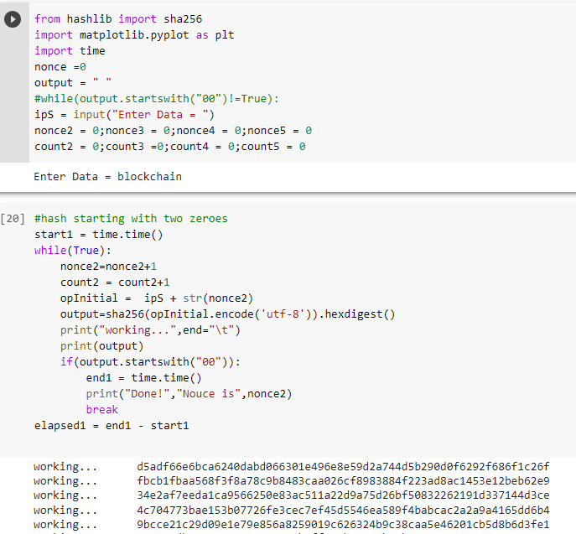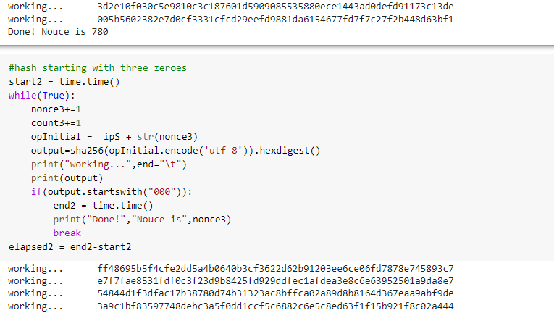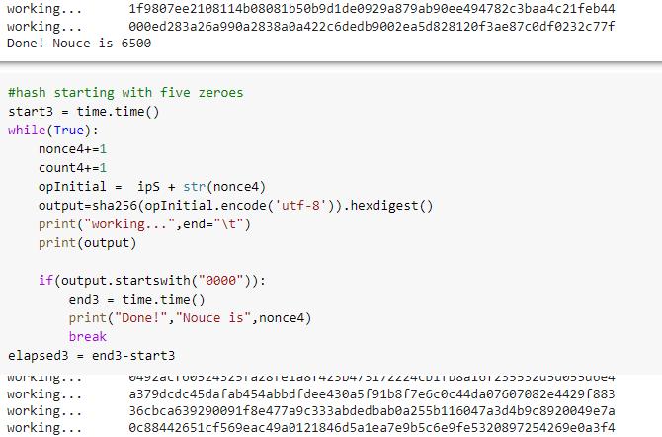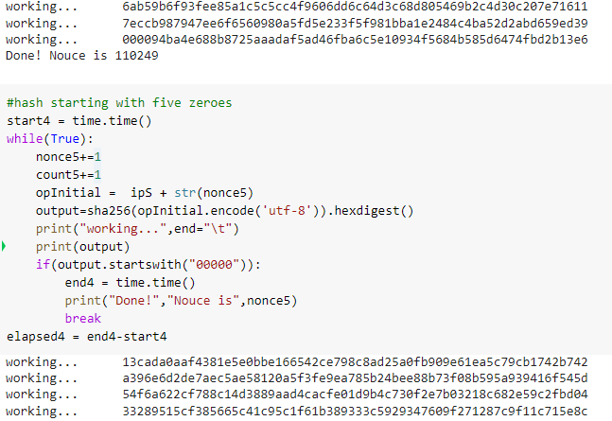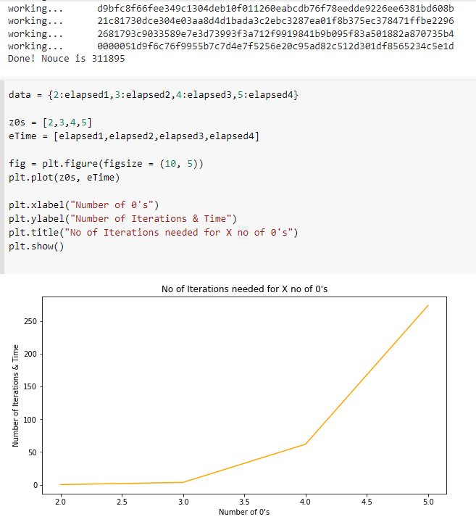
Coin Age:
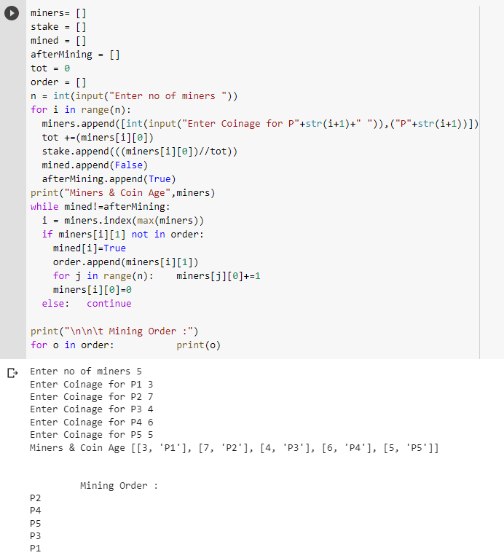
Random Voting:
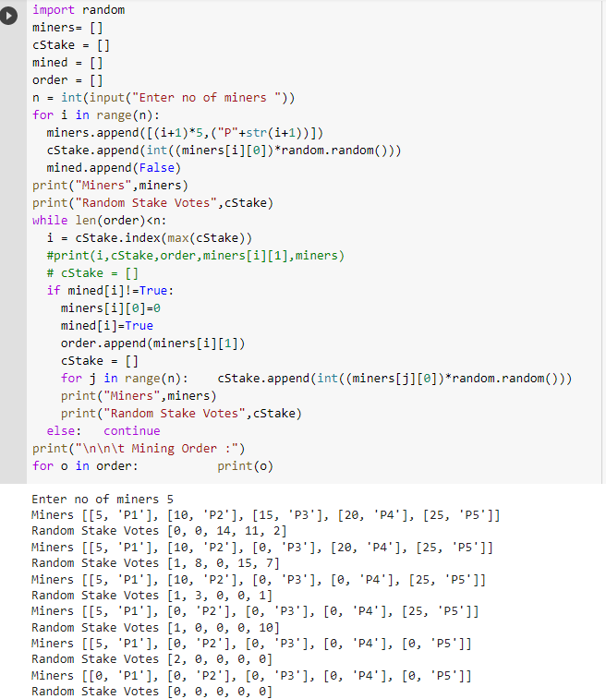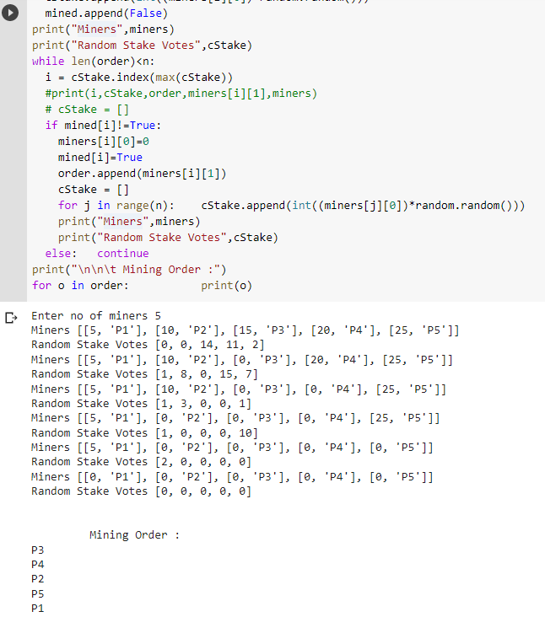

- Explain the Importance of the approach followed by you
POW is well-tested and used in many cryptocurrency projects. DDoS attacks on a blockchain employing this algorithm are impossible with today’s computing technology. However, the high energy cost, increased strain on the environment, associated adverse media coverage, increasing centralization of mining operations, and low transaction throughput will likely make it unviable in the long run. Communities are increasingly concerned about high energy costs of Bitcoin mining. The PoS algorithm provides for a more scalable blockchain with higher transaction throughput, and a few projects have adopted it already, for e.g., DASH cryptocurrency. However, it’s less secure than the completely decentralized POW algorithm. It’s possible to buy a majority of the coins in the network, become the staker of choice, and validate wrong transactions as part of an attack. However, the market economy has a natural safety valve for this, because the price of the coin will rise significantly when someone tries to buy such massive amount of coins, making the attackers’ job far more difficult. It’s also possible for a staker to turn rogue and validate wrong transactions. If the planned implementation of PoS in a protocol as famous as Ethereum goes well, then the crypto community will probably be reasonably assured about the ability of the PoS algorithm to keep the network safe. That may tilt the scale in favour of the PoS, and only time will tell which one will be the blockchain consensus algorithm for the future.
Conclusion:-
We successfully understood and stimulated the implementation and working of Proof of Work & Proof of Stake (Coin Age, Random Voting) in python.

