Batch: CSM1 Roll No.: 1911004

Experiment / Assignment / Tutorial No: 1

Grade: AA / AB / BB / BC / CC / CD /DD
Signature of the Staff In-charge with date

Experiment: 1

Title: Simulation of Single Server System: Grocery Counter Problem.

Problem Statement:
A small grocery store has only one checkout counter. Customer arrives at this check out counter at random from 1 to 8 minutes. The service time varies from 1 to 6 minutes. The problem is to analyze the system by simulating the arrival & service of 20 customers.

Expected Outcome of Experiment:

Index | Outcome
CO1 | Understand the concepts of discrete event simulation and its importance in business, science, engineering, industry and other services.
CO2 | Ability to analyse and apply general principles of event scheduling algorithm & various statistical methods on different applications.

Books/ Journals/ Websites referred:

- Jerry Banks, John Carson, Barry Nelson, and David M. Nicol, “Discrete Event System Simulation”; Fifth Edition, Prentice-Hall.
- Averill M Law, “System Modeling & Analysis”; 4th Edition TMH.
- Banks C M , Sokolowski J A, “Principles of Modeling and Simulation”, Wiley

Pre Lab/ Prior Concepts:
Objective:
In order to evaluate the system performance, the evaluation is done by varying the arrival time & service time probability distribution.
a) Let the arrival distribution be uniformly distributed between 1 to 8 minutes.
b) Let service time distribution be changed

Service  Time(minutes) | 1 | 2 | 3 | 4 | 5 | 6
Probability | 0.05 | 0.1 | 0.1 | 0.3 | 0.25 | 0.1

c) Perform simulation for 20 more customers & compare result.

Theory:

Characteristics of Queuing System:

The key elements of queuing system are customers & servers. The term customer can refer to people, machines, and trucks. The server might refer to receptionist, person etc.

1) Calling population: The population of potential customer is referred to as calling population. In systems with large population the calling population is usually assumed to as infinity. E.g., Potential of customer of bank. The actual population may be finite. The main difference between finite & infinity population is how arrival rate is definite.

2) System Capacity: The system capacity has no limit meaning that any no. of units comes & wait in line. In many queuing systems there is a limit to no. of customers that may be waiting.

3) Nature Of Arrivals: Arrivals for service occur at a time in random fashion and once they join waiting line, they are served.

4) Service Mechanism: The units are served in order of their arrival by a single server or a channel. The service times of successive arrivals are denoted by s1, s2, s3

5) Queuing Discipline: It refers to the logical ordering of customers that will be chosen for service when a server becomes full.

6) State Of System: It is no. of units in system & states of server busy / idle.

7) Events:
- It is state of circumstances that occurs on instantaneous change in the state of system of possible events.
- The Entry of a unit in the system.
- Departure of unit from system on completion of service.

8) Simulation Clock: It is used to track simulation time. Random nos. is used in simulation for inter arrival & service time.

Conceptual Model:
The grocery store with one checkout counter is simulated by using an event scheduling simulation, simulation table is used to record successive system snapshot as time advances. The simulation requires mainly a service time distribution an inter arrival time of customers.

Characteristics of System:

I) Calling Population: Infinite in nature.
II) System capacity: Infinite.
III) Nature of Arrival: Random arrival nature.
IV) Service Mechanism: At a time only one customer is served.
V) Queuing Discipline: Customers are chosen in FIFO manners.

System State:
I) Waiting time in queue.
II) Time customer spends in the system.

Entities:
The entities in single channel queue are customer & server.

Events:
In single channel queuing system, following events occurs;
a) Arrival Event
b) Departure Event

Activities:
They are inter arrival time of customers & service time distribution.

Delay:
It refers to customer’s time spent in waiting for service.

Use of Random Nos:
- Random digit can be used to form random numbers by selecting a proper no. of digit for each random no. and placing decimal point to left of value selected.
- RAND () function can be used to generate random nos. in simulation.

Real Time Example:

I) Consider Telephone Bill Payment System
II) Customers firm single channel queue.
III) Customer is chosen in FIFO manner.

Result:
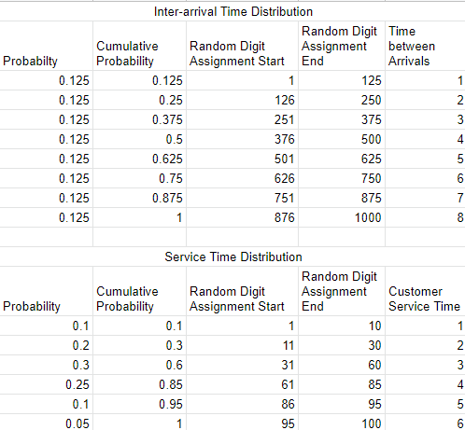
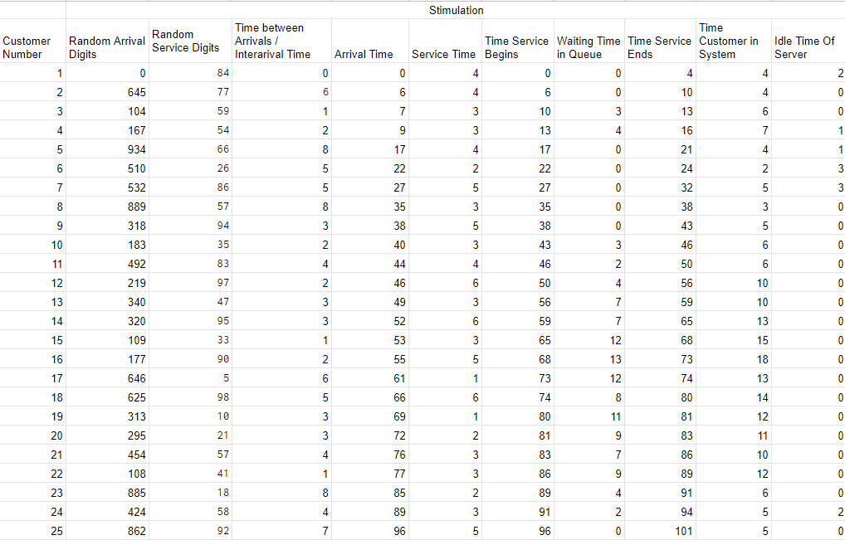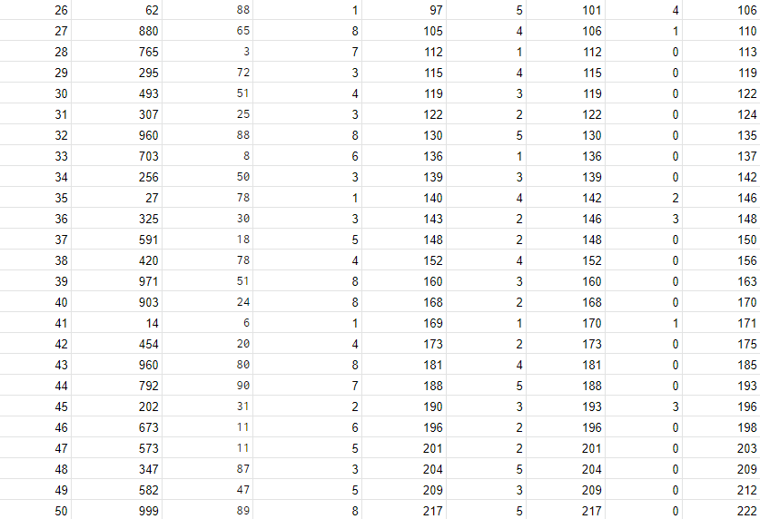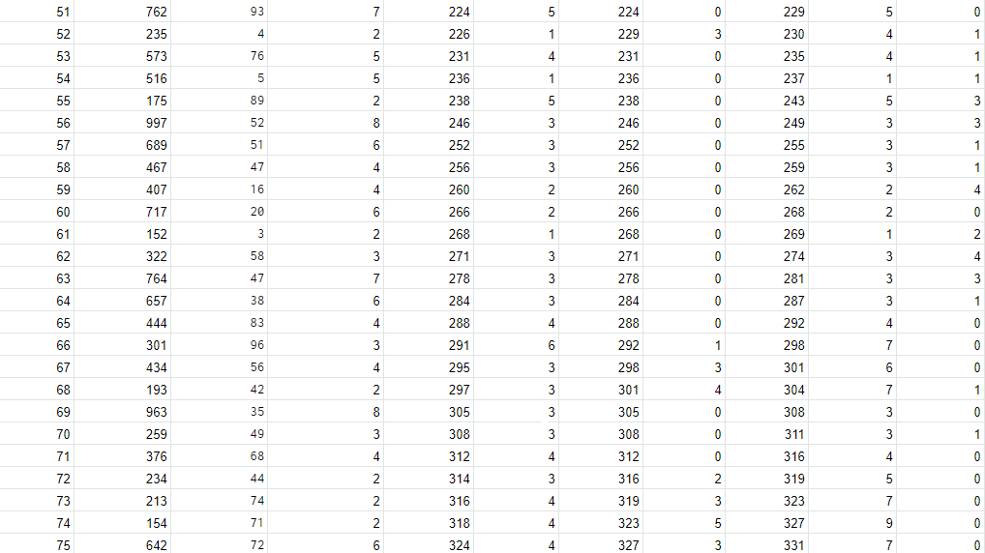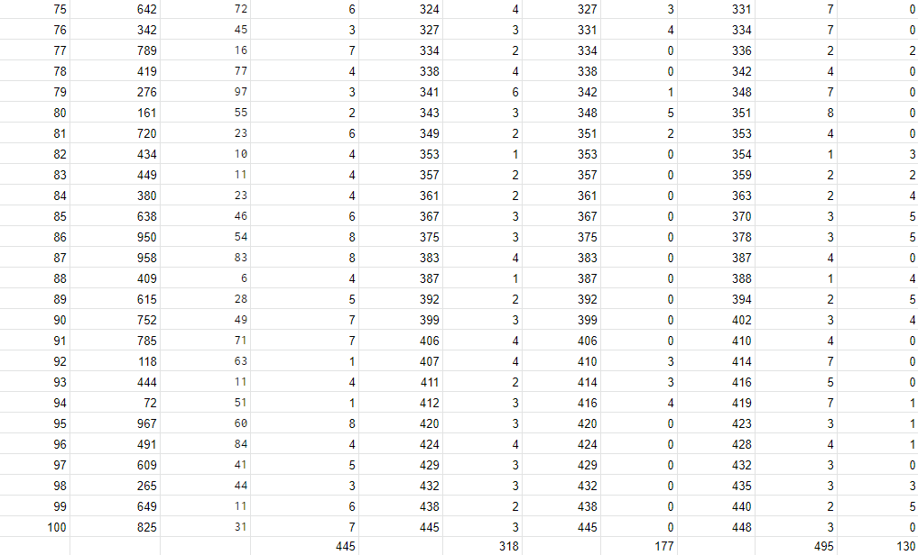

Performance Measures (in sec):

Average Waiting Time = (Total time customers wait in queue) / (Total no. of Customers)

Prob. of Customers waiting = (No. of Customers who waits) / (Total no. of Customers)

Prob. of Idle Server = (Total Idle Time of Server) / (Total runtime of simulation)

Average Time between Arrival = (Total Time between arrivals) / (No. of arrivals)

Average Waiting Time of Those Who Wait = (Total Time Customer waits in system) / (Total no. of Customers)

Average Time Customers Spends in System = (Total Time Customer spends in system) / (Total no. of Customers)
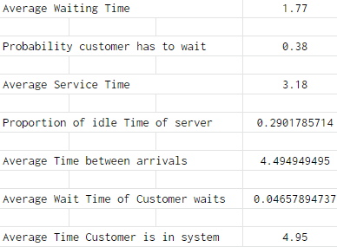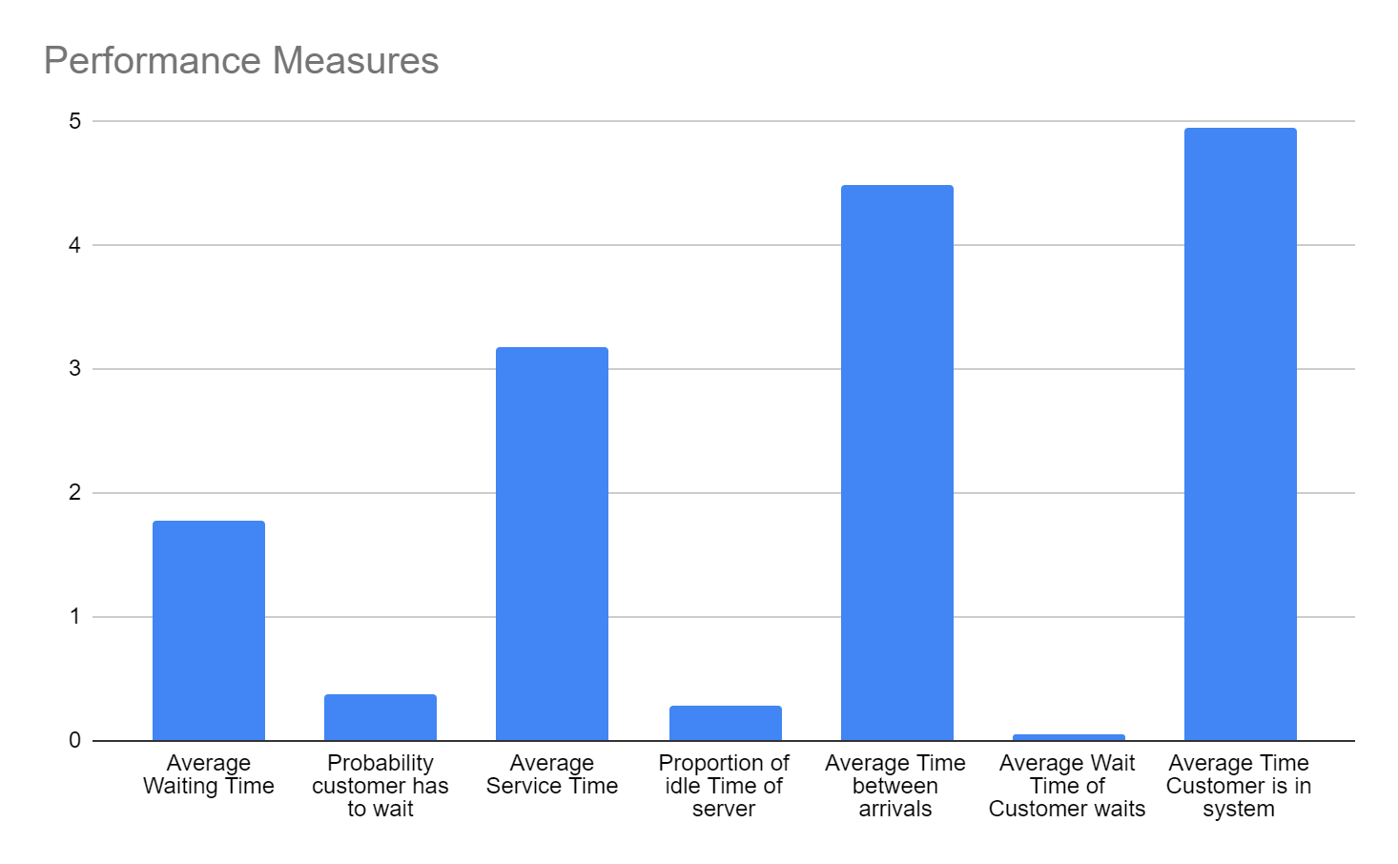

Conclusion: Thus, we successfully simulated for the Single Server System - Grocery Counter Problem

Post Lab Questions:

- Plot the frequency of waiting time in queue & frequency distribution of average waiting times for 20 trails.
