Batch: BCT1
Roll No.: 1911004
Experiment No. 2

Title: Creation of a private block chain cryptocurrency
Objective:
Implement a private blockchain network with miner, sender, receiver and transactions being carried as any block chain network.
Expected Outcome of Experiment:

CO | Outcome
CO1 | Build your own Blockchain businesses with acquired knowledge.

Books/ Journals/ Websites referred:
- Bitcoin.com
- Blockchain.org
- Investopedia.com
Abstract:-
A blockchain is a type of distributed ledger technology (DLT) that consists of growing list of records, called blocks, that are securely linked together using cryptography. Each block contains a cryptographic hash of the previous block, a timestamp, and transaction data (generally represented as a Merkle tree, where data nodes are represented by leaves). The timestamp proves that the transaction data existed when the block was created. Since each block contains information about the previous block, they effectively form a chain (compare linked list data structure), with each additional block linking to the ones before it. Consequently, blockchain transactions are irreversible in that, once they are recorded, the data in any given block cannot be altered retroactively without altering all subsequent blocks. Blockchains are typically managed by a peer-to-peer (P2P) computer network for use as a public distributed ledger, where nodes collectively adhere to a consensus algorithm protocol to add and validate new transaction blocks. Although blockchain records are not unalterable, since blockchain forks are possible, blockchains may be considered secure by design and exemplify a distributed computing system with high Byzantine fault tolerance.
Related Theory: -
Practically speaking, Bitcoin is a form of digital money that (1) exists independently of any government, state, or financial institution, (2) can be transferred globally without the need for a centralized intermediary, and (3) has a known monetary policy that arguably cannot be altered. At a deeper level, Bitcoin can be described as a political, philosophical, and economic system.
Thanks to the combination of the technical features it integrates, the wide array of participants and stakeholders it involves, and the process for making changes to the protocol. Bitcoin can refer to the Bitcoin software protocol as well as to the monetary unit, which goes by the ticker symbol BTC.
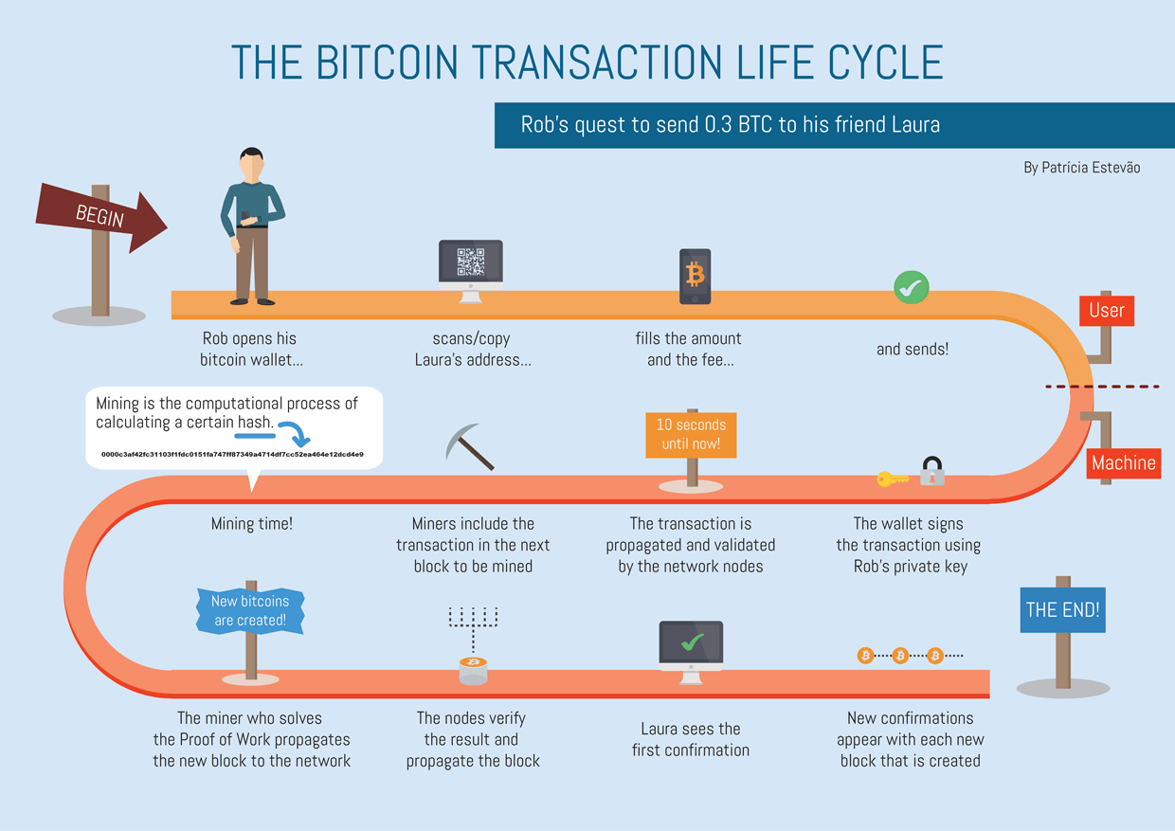
Decentralized: Nobody controls or owns the Bitcoin network, and there is no CEO. Instead, the network consists of willing participants who agree to the rules of a protocol
Distributed: All Bitcoin transactions are recorded on a public ledger that has come to be known as the 'blockchain.'
Transparent: The addition of new transactions to the blockchain ledger and the state of the Bitcoin network at any given is arrived upon by consensus and in a transparent manner according to the rules of the protocol.
Peer-to-peer: Although nodes store and propagate the state of the network , payments effectively go directly from one person or business to another. This means there’s no need for any ‘trusted third party’ to act as an intermediary.
Immutable: It use hashes which can help detect any changes in data of blocks
Implementation Details:
1. Enlist all the Steps followed and various options explored
There are a number of stages that are taken, including:
a. There are three different sorts of users: Miner, Sender, and Receiver;
b. There are a number of stages that are taken, including:
c. The system has an account-based style of operation.
d. Before sending money, a sender must first establish a Transaction object, which encrypts the recipient's and sender's information and requires a digital signature using the sender's private key.
d. Before sending money, a sender must first establish a Transaction object, which encrypts the recipient's and sender's information and requires a digital signature using the sender's private key.
e. The miner then confirms the transaction by doing the following three steps:
1. verifies if a digital signature is authentic
2. Verifies that the user has enough money in his account.
f. The data is finally sent on the block after being hashed with a SHA256 hash value if the conditions are met.
g. The miner must solve the proof-of-work puzzle with a difficulty set to two zeros h before delivering the block.
h. The miner's transaction is accepted if he performs PoW. He receives a reward of 5 bitcoins, and the sender's and receiver's funds are updated appropriately. Each block includes the block number, previous block's hash, the merkel root hash, the timestamp, and the nonce.
2. Explain your program logic, classes and methods used.
Methods used as follows :
1. public static void main() : to execute java program
2. Create_Digital_Signature()
3. Verify_Digital_Signature()
4. HashandPow()
5. Signin()
6. Create_SHA256_hash()
Code:
import java.util.*;
import java.io.*;
import java.security.*;
import java.nio.charset.StandardCharsets;
class Main {
private static final String
SIGNING_ALGORITHM
= "SHA256withRSA";
private static final String RSA = "RSA";
public static int blocknumber =0;
public static int nonce =0;
public static Block blockchain[] = new Block[10];
public static void main(String[] args) {
for(int i=0;i<10;i++){
blockchain[i]=null;
}
int p=0;
Transaction array[] = new Transaction[10];
byte [][] datarec = new byte[10][];
byte [][] origdata = new byte [10][];
PublicKey publickeys[] = new PublicKey[10];

for(int k=0;k<10;k++){
datarec[k] = null;
publickeys[k]=null;
origdata[k] = null;
}
System.out.println("Blockchain with Genesis Block");
createBlockchain(null);
while(true){
System.out.println("Block Chain");
User miner = new User(1,"Miner","Miner","miner1",0);
User sender = new User(2,"Sender","Sender","sender1",100);
User receiver = new User(3,"Receiver","Receiver","receiver1",200);
User[] users = new User[3];
users[0] = miner;
users[1] = sender;
users[2] = receiver;
KeyPairGenerator keyPairGen = null;
KeyPair keyPair = null;
PublicKey publicKey = null;
PrivateKey privateKey = null;
try {
keyPairGen = KeyPairGenerator.getInstance("RSA");
keyPairGen.initialize(2048);
keyPair = keyPairGen.genKeyPair();
publicKey = keyPair.getPublic();
privateKey = keyPair.getPrivate();
}
catch (Exception e5){
}
for(int i=0;i<3;i++){
System.out.println("Username = "+users[i].id+"\tPassword = "+users[i].password);
}
Main obj2 = new Main();
int user;
user =obj2.signin(users);
Scanner sc = new Scanner (System.in);
if(user ==1){
System.out.println("Your current balance = "+users[0].crypto);
System.out.println("Miner authenticated Successfully!");
System.out.println("The list of invalidate transactions(as of now) are :");
for(int a=0;a<p;a++){
if(array[a]!=null){
System.out.println("Sr no = "+a+" Sender id = "+array[a].s_id+" Receiver id= "+array[a].r_id+" Amount = "+array[a].amount);
}
}
int t_id;
System.out.println("Select a Transaction you want to validate ");
t_id = sc.nextInt();
System.out.println("Chosen transaction Sender id = "+array[t_id].s_id+" Amount= "+array[t_id].amount+"current validation status = "+array[t_id].valid);
System.out.println("Chosen Transaction digital signature = "+byteArrayToHex(datarec[t_id]));
System.out.println("Click 'y' to validate digital signature ");
char input ;
boolean authenticated =false;
input = sc.next().charAt(0);

System.out.println("\tStep 1: Authenticate digital signature ");
try{
authenticated = Verify_Digital_Signature(origdata[t_id], datarec[t_id], publickeys[t_id]);
}
catch (Exception e7){
}
if(authenticated==true){
System.out.println("sucessfully authenticated transaction!");
}
else{
System.out.println("transaction is not authenticated !");
}
System.out.println("\tStep 2: verifying the UTXOs");
int amount_trans = array[t_id].amount;
boolean validated = false;
if(amount_trans<= users[1].crypto){
validated = true;
System.out.println("Successfully validated transaction!");
}
else {
System.out.println("Invalid Transaction");
}
if((validated==true)&&(authenticated==true)){
byte shasign[]=null;
boolean solved=false;
System.out.println("Transaction can now be added to block!");
System.out.println("\tSTEP 3: checking proof of work");
shasign = HashandPoW(datarec[t_id]);
if(shasign!=null){
solved=true;
}
if(solved==true){
System.out.println("Miner amount= "+users[0].crypto);
users[0].crypto = users[0].crypto+ 5;
System.out.println("Miner amount updated = "+users[0].crypto);
System.out.println("Sender amount= "+users[1].crypto);
users[1].crypto = users[1].crypto-amount_trans;
System.out.println("Sender amount updated = "+users[1].crypto);
System.out.println("Receiver amount= "+users[2].crypto);
users[2].crypto = users[2].crypto+amount_trans;
System.out.println("Receiver amount updated= "+users[2].crypto);
System.out.println("You given 1 crypto to your current balance = "+users[0].crypto);
datarec[t_id] = null;
publickeys[t_id]=null;
origdata[t_id] = null;
array[t_id].valid = true;
System.out.println("Current status of transaction = ");
System.out.println("Chosen transaction sender id = "+array[t_id].s_id+" amount= "+array[t_id].amount+"current validation status = "+array[t_id].valid);
array[t_id]=null;
System.out.print("\n");
System.out.println("\tSTEP 4: Adding Block to the BlockChain");
boolean created = createBlockchain(shasign);
}
}
}
else if(user==2){
System.out.println("Sender authenticated Successfully");

int amount,choice;
System.out.println("Enter 1.Check your current balance \t 2.Transfer money");
choice = sc.nextInt();
if(choice==1){
System.out.println("Your current balance = "+users[1].crypto);
}
else{
System.out.println("Enter the amount to transfer = ");
amount = sc.nextInt();
Transaction obj = new Transaction(1,2,amount);
array[p]=obj;
ByteArrayOutputStream bos = new ByteArrayOutputStream();
ObjectOutputStream oos;
try{
oos = new ObjectOutputStream(bos);
oos.writeObject(obj);
oos.flush();
}
catch (IOException e){
byte [] data = bos.toByteArray();
origdata[p] = data;
try{

byte signature[] = Create_Digital_Signature(data, privateKey);
datarec[p]=signature;
publickeys[p]= publicKey;
System.out.println("Added Signature to record");
}
catch (Exception e4){
}
p++;}}
else if (user==3){
System.out.println("Receiver authenticated Successfully");
System.out.println("Your current balance = "+users[2].crypto);
}
}
}
public static byte[] HashandPoW(byte[] signeddata){
boolean pow=false;
nonce =0;
String signeddatavar = byteArrayToHex(signeddata),check ="",temp="";
byte[] shasign=null;
while(true){
temp = signeddatavar;
System.out.println("nonce = "+nonce);
temp = temp+Integer.toString(nonce);
try{
shasign = getSHA(temp);
check = byteArrayToHex(shasign);
if(check.startsWith("00")&&!(check.startsWith("000"))){
System.out.println("Solved using PoW of nonce = "+nonce);
System.out.println("SHA256 of Signed Data = "+check);
pow = true;
break;
}
}
catch(NoSuchAlgorithmException e){

}
nonce++;

}
return shasign;
}

int signin(User []users){
Scanner sc = new Scanner(System.in);
System.out.print("Enter the Username = ");
int idcheck = sc.nextInt();
int i;
System.out.print("Enter the Password = ");
String password = sc.next();
boolean found=false;
for( i=0;i<3;i++){
if(users[i].id==idcheck){
System.out.println("yes");
if(users[i].password.equals(password)){
found = true;
break;
}
}
}

return (i+1);

}
public static byte[] Create_Digital_Signature(
byte[] input,
PrivateKey Key)
throws Exception{
Signature signature
= Signature.getInstance(
SIGNING_ALGORITHM);
signature.initSign(Key);
signature.update(input);
return signature.sign();
}
public static KeyPair Generate_RSA_KeyPair()
throws Exception{
SecureRandom secureRandom
= new SecureRandom();
KeyPairGenerator keyPairGenerator
= KeyPairGenerator
.getInstance(RSA);
keyPairGenerator
.initialize(
2048, secureRandom);
return keyPairGenerator
.generateKeyPair();
}

public static boolean
Verify_Digital_Signature(
byte[] input,
byte[] signatureToVerify,
PublicKey key)//signature with Private key is verified by public key
throws Exception{
Signature signature
= Signature.getInstance(
SIGNING_ALGORITHM);
signature.initVerify(key);
signature.update(input);
return signature
.verify(signatureToVerify);
}

public static String byteArrayToHex(byte[] a) {
StringBuilder sb = new StringBuilder(a.length * 2);
for(byte b: a)
sb.append(String.format("%02x", b));
return sb.toString();
}
public static byte[] getSHA(String input) throws NoSuchAlgorithmException{
MessageDigest md = MessageDigest.getInstance("SHA-256");
return md.digest(input.getBytes(StandardCharsets.UTF_8));
}
public static boolean createBlockchain(byte[]shdata){
String prevhash;

if(blocknumber==0) {
String init= "0000000000000000000000000";
byte [] initarr = init.getBytes();
String prevhashinit="00";
Block genesis = new Block(initarr,nonce,prevhashinit,blocknumber);
blockchain[blocknumber] = genesis;
blocknumber++;
}

else{
prevhash = byteArrayToHex(blockchain[blocknumber-1].data);
Block newblock = new Block(shdata,nonce,prevhash,blocknumber);
blockchain[blocknumber]=newblock;
blocknumber++;
}

int i=0;
while(blockchain[i]!=null){
System.out.println("Block number = "+blockchain[i].blocknumber);
System.out.println("Nounce = "+blockchain[i].nonce);
System.out.println("Previous Block's Hash = "+blockchain[i].prevHash);
System.out.println("Hash root of data = "+byteArrayToHex(blockchain[i].data));
System.out.println("Timestamp = "+blockchain[i].timestamp);
System.out.print("\n");
i++;
}
return false;
}
}
Output:
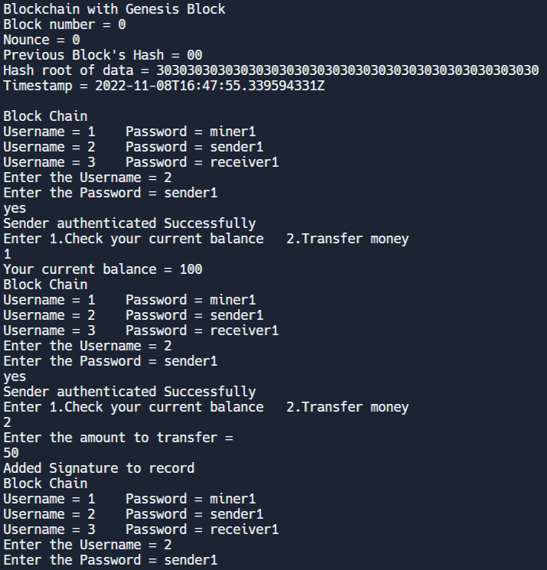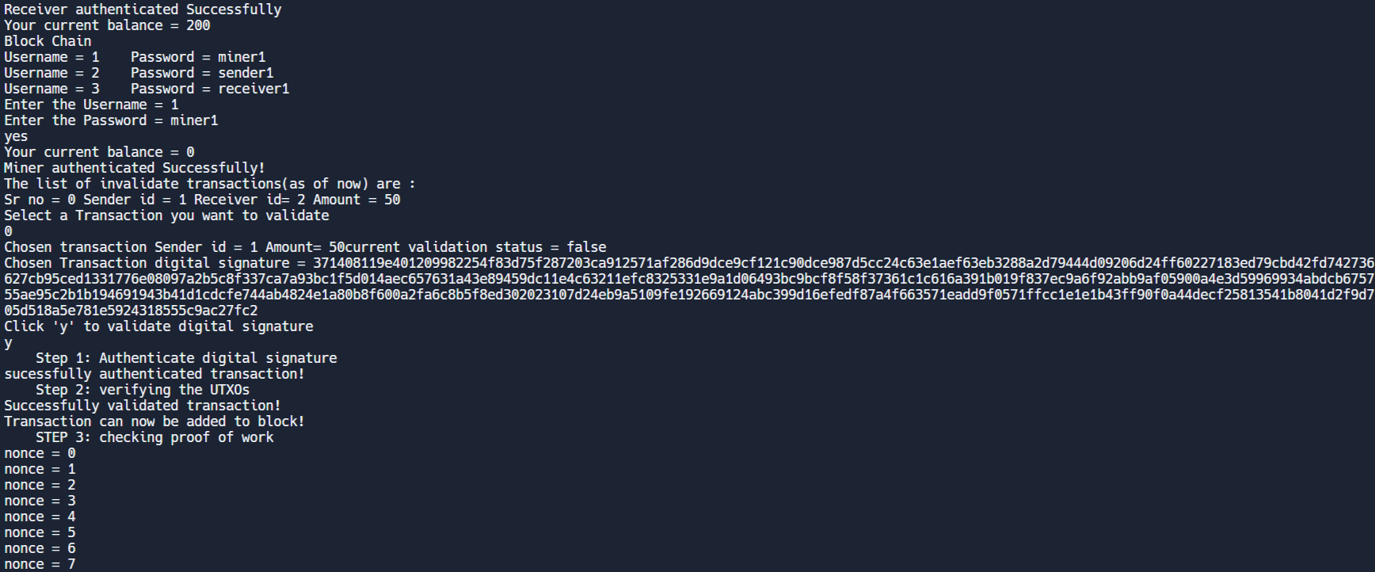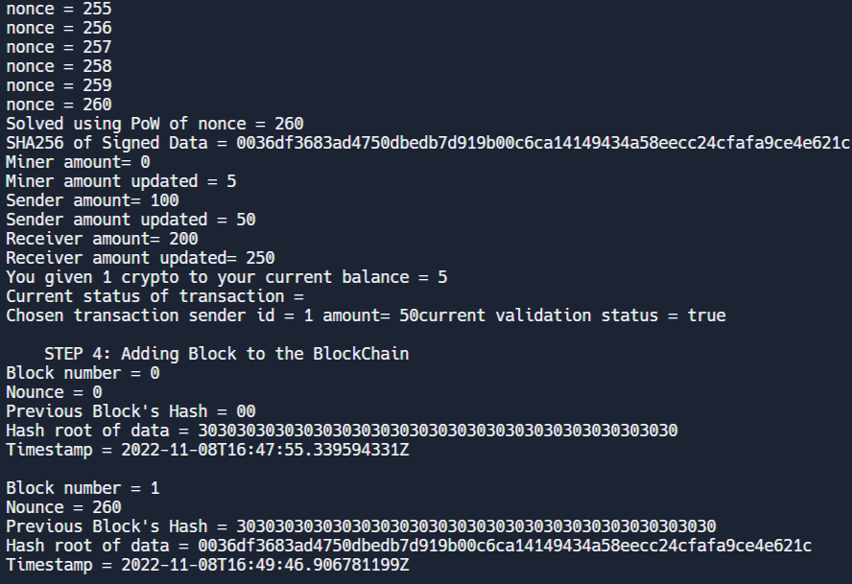
3. Explain the Importance of the approach followed by you
We defined a miner, sender, receiver to valid & transfer the transactions across network and used SHA256 & Digital Signature to verify Sender & hash Block Data, basic UTXO model to check double spending.
Conclusion:-
We understood the concept of blockchain & bitcoin and tried implementing it to carry transaction in private blockchain network in java.

