Batch: A1 Roll No.: 1911004

Experiment / assignment / tutorial No. 2

Grade: AA / AB / BB / BC / CC / CD /DD

Signature of the Staff In-charge with date

Experiment No.: 2

TITLE: Building and configuring simple topology using Network tool - CISCO PACKET TRACER

AIM: To build and configure simple network topology using CISCO Packet Tracer.
____________________________________________________________________
Packet Tracer is a network simulation program that allows students to experiment with network behaviour and ask “what if” questions. Packet Tracer provides simulation, visualization, and authoring, assessment, and collaboration capabilities and facilitates the teaching and learning of complex technology concepts.
____________________________________________________________________
Expected Outcome of Experiment:
CO1: Explain the fundamentals of the data communication networks, reference models, topologies, physical media, devices, simulators and identify their use in day to day networks.
_______________________________________________________________
Books/ Journals/ Websites referred:
- http://www.google.com
- A. S. Tanenbaum, “Computer Networks”, Pearson Education, Fourth Edition
- B. A. Forouzan, “Data Communications and Networking”, TMH, Fourth Edition
- CISCO PACKET TRACER 6.0.1 (free download)
___________________________________________________________________ Pre-Lab/ Prior Concepts: Simple Network flow
__________________________________________________________________
New Concepts to be learned: Purpose of this lab is to become familiar with building topologies in Packet Tracer.
___________________________________________________________________
Stepwise-Procedure:

Creating a simple LAN network using packet tracer:
Step 1: Select two PCs (PC0 and PC1) from the end devices and one fast ethernet switch (2950/24 ports)

Step 2: Connect PCs and switch via copper cable from the panel. Connection can be verified by appearance of all green dots on the links.

Step 3: For PCs to communicate click on PC0.
- Dialog box for PC0 appears
- Click on desktop applications by packet tracer.
- Go to IP configuration.
- Enter IP address to identify host i.e. PC0 (for example: 192.168.1.1)
- Subnet mask-by default already set one can change it as per his/her specification.

Step 4: Repeat step 3 for PC1

Step 5: Ping both the PCs and check their working status.

Step 6: Simple PDU (Protocol Data Unit) to simulate network traffic by sending ICMP PDU to assess the network traffic. View simulation in simulation mode

IMPLEMENTATION: (printout of simulation code)

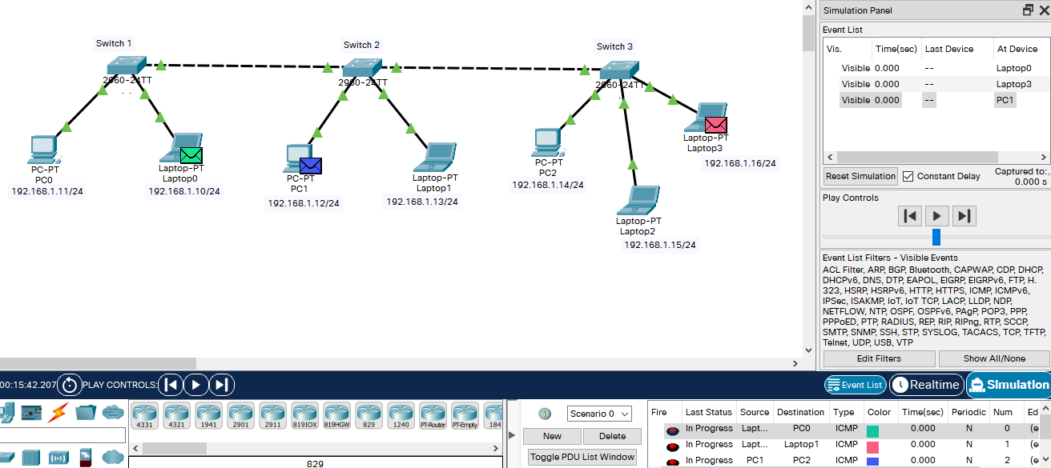
From source
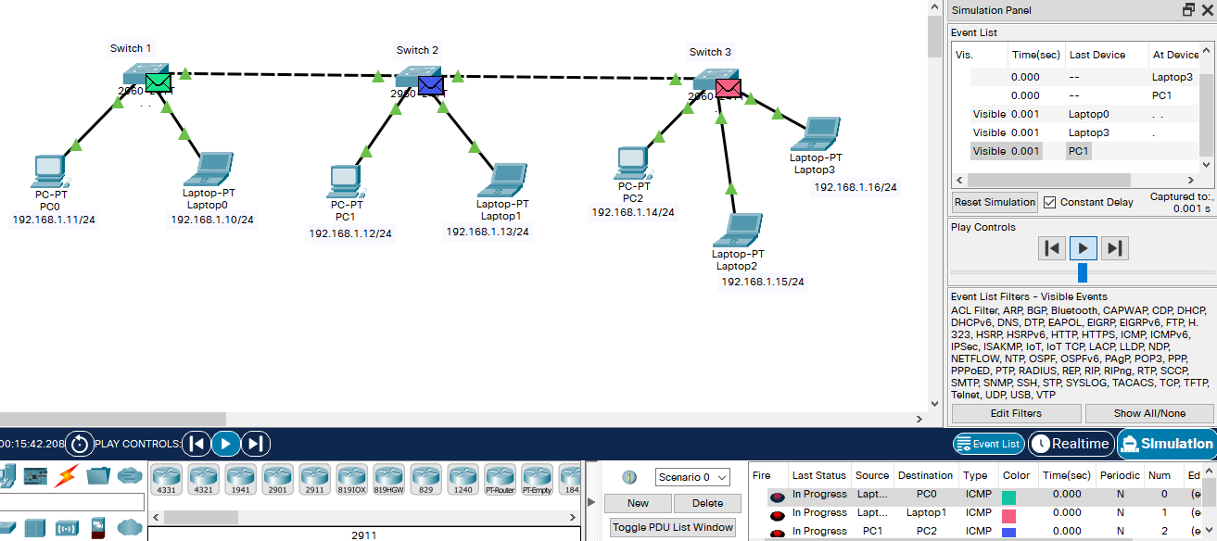
from source to switches
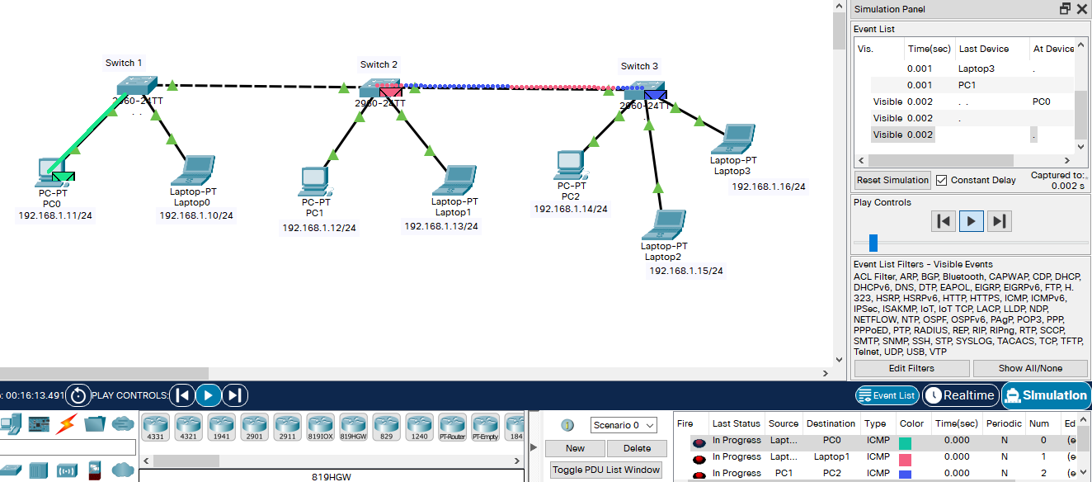

to/from switches
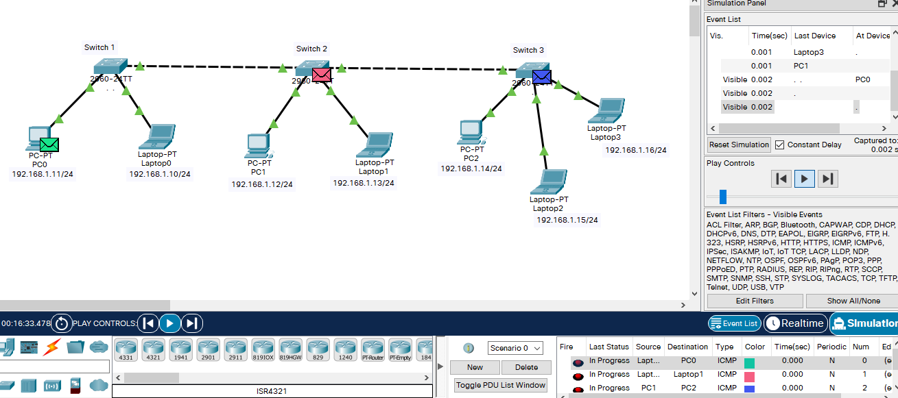
to destination and to/from switches
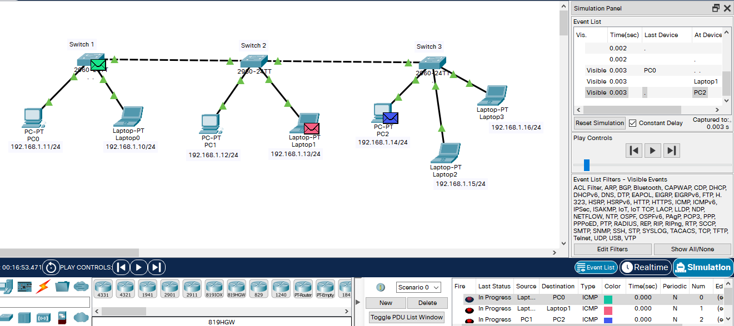
to destination & back to switch for successful transfer to destination
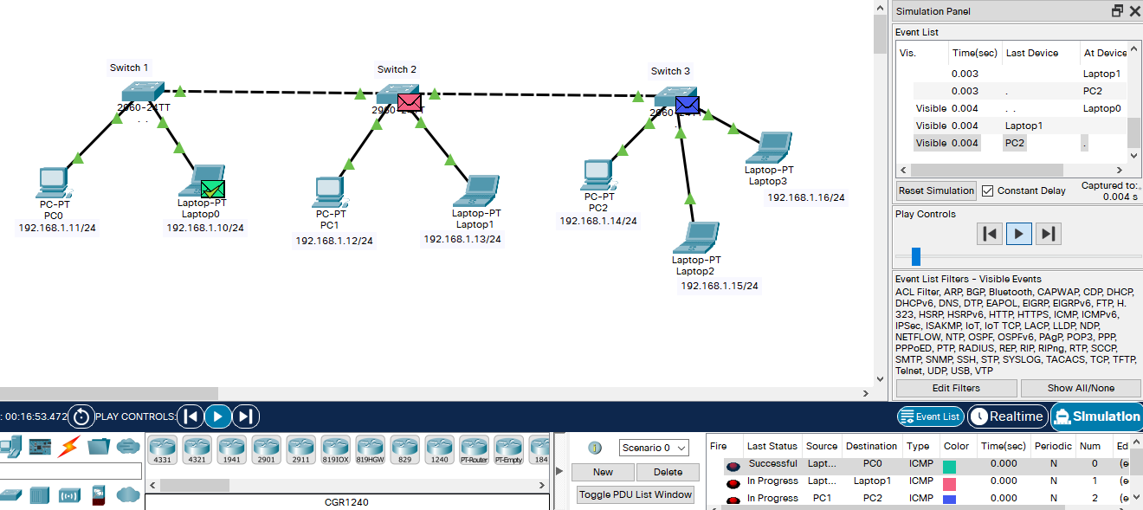
successful transfer notification & back to switch for successful transfer to destination
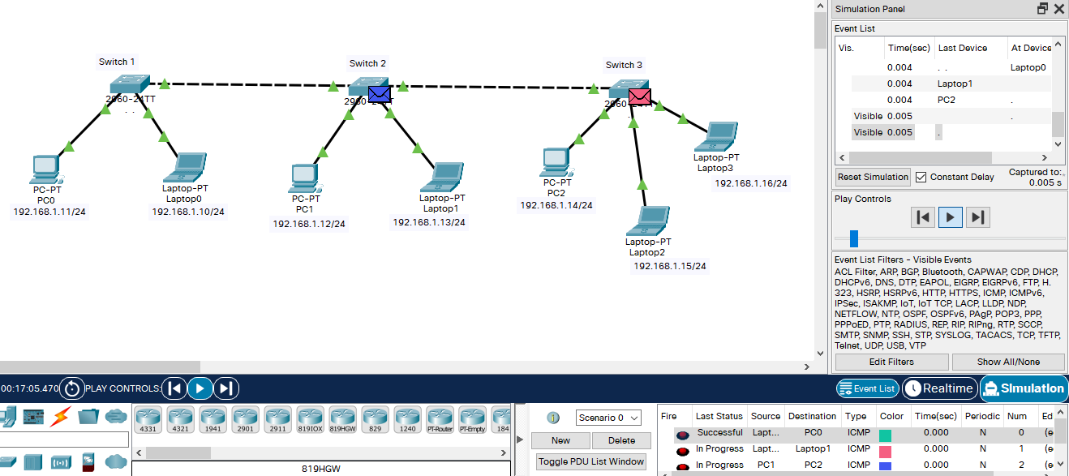
back to switch for successful transfer to destination
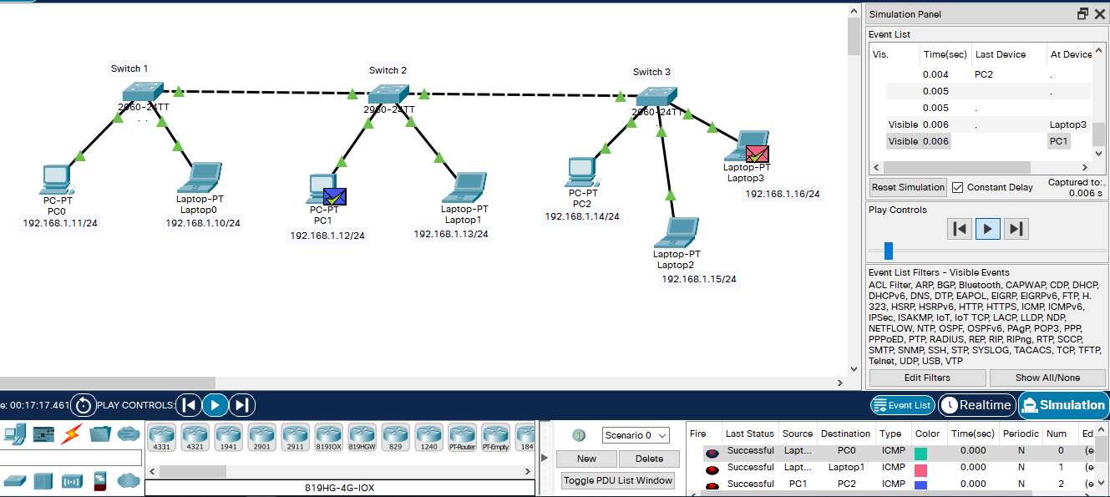
successful transfer notification

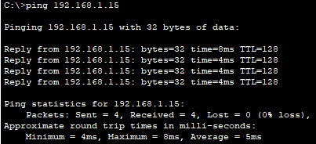
ping 192.168.1.15

CONCLUSION:
We have successfully used the cisco packet tracer and simulated packet transmission across devices connected in network topology.

Post Lab Questions

- List features of CISCO packet tracer.
- Cisco Packet Tracer has two workspaces—logical and physical. The logical workspace allows users to build logical network topologies by placing, connecting, and clustering virtual network devices. The physical workspace provides a graphical physical dimension of the logical network, giving a sense of scale and placement in how network devices such as routers, switches, and hosts would look in a real environment. The physical view also provides geographic representations of networks, including multiple cities, buildings, and wiring closets.
- Cisco Packet Tracer provides two operating modes to visualize the behaviour of a network—real-time mode and simulation mode. In real-time mode the network behaves as real devices do, with immediate real-time response for all network activities. In simulation mode the user can see and control time intervals, the inner workings of data transfer, and the propagation of data across a network.
- Latest version of cisco packet tracer has following new features:
  - DHCP service for IPv6
  - DHCPv6 commands in IOS15
  - IOS 15 support for Catalyst 2960 switch. The IOS 15 image has to be downloaded by TFTP or FTP from a server device to be available on a switch
  - Improved scripting and variable management Activity Wizard
- It also supports following protocols:
- Application - FTP , SMTP, POP3, HTTP, TFTP, Telnet, SSH, DNS, DHCP, NTP, SNMP, AAA, ISR VOIP, SCCP config and calls ISR command support, Call Manager Express
- Network Access/Interface - Ethernet (802.3), 802.11, HDLC, Frame Relay, PPP, PPPoE, STP, RSTP, VTP, DTP, CDP, 802.1q, PAgP, L2 QoS, SLARP, Simple WEP, WPA, EAP
- Transport - TCP and UDP, TCP Nagle Algorithm & IP Fragmentation, RTP
- Network - BGP, IPv4, ICMP, ARP, IPv6, ICMPv6, IPSec, RIPv1/v2/ng, Multi-Area OSPF, EIGRP, Static Routing, Route Redistribution, Multilayer Switching, L3 QoS, NAT, CBAL, Zone-based policy firewall and Intrusion Protection System on the ISR, GRE VPN, IPSec VPN

Date: 24/08/2021 Signature of faculty in-charge

