Batch: A1 Roll No.: 1911004

Experiment / assignment / tutorial No. 3

Grade: AA / AB / BB / BC / CC / CD /DD

Signature of the Staff In-charge with date

Experiment No.: 3

TITLE: Implementation of 11 bit Hamming Code for Computer Networks
_____________________________________________________________________
AIM: To implement Layer 2 Error Control schemes: Hamming Codes.
_____________________________________________________________________
Expected Outcome of Experiment:
CO: Learning the hamming code error detection
__________________________________________________________________
Books/ Journals/ Websites referred:
- A. S. Tanenbaum, “Computer Networks”, Pearson Education, Fourth Edition
- B. A. Forouzan, “Data Communications and Networking”, TMH, Fourth Edition
____________________________________________________________________
Pre Lab/ Prior Concepts:
Data Link Layer, Error Correction/Detection, Types of Errors
___________________________________________________________________
New Concepts to be learned: Hamming Code.
___________________________________________________________________
Stepwise-Procedure:
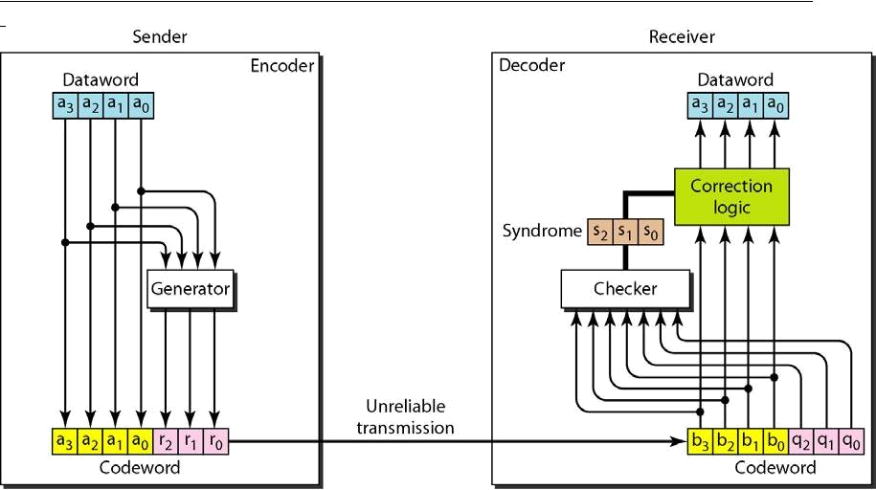
Consider data stream of 7 bits. Number it from 1 from left hand side of the data stream.
Add parity bits like P_{0 ,} P_{1,} |  |  |  | and P2 etc. into the positions 2’s power like at 1,2,4,8.
1 | 0 | 1 P₈ 1 1 0 P₄ 1 P₂ P₁
D11 D10 |  | D9 | D7 D6 | D5 | D3

P₁ ₌ D3 EXOR D5 EXOR D7 EXOR D9 EXOR D11 = 1

P₂ ₌ D3 EXOR D6 EXOR D7 EXOR D10 EXOR D11= 1

P₃ ₌ D5 EXOR D6 EXOR D7 = 1

P₄ ₌ D9 EXOR D10 EXOR D11 = 1

10111101111

This is the hamming code which is to be transferred to the destination. Again, the same mechanism is implemented at the receiver end.

If we get the values 0000 then no error, if other than 0000 then error.

IMPLEMENTATION:

Code:
import java.util.*;
class Main {
public static void main(String[] args) {
Scanner ob=new Scanner(System.in);
System.out.print("Enter data: ");
String data=ob.next();
int d=data.length();
int r=0,j=0,r_=0;
while(Math.pow(2,r)< d+r+1)
r++;//2^r<d+r+1
int enc[]=new int[d+r];
for(int i=0;i<enc.length;i++)
enc[i]=-1;//set default
for(int i=(enc.length)-1;i>=0;i--){
if(Math.log(i+1)/Math.log(2)!=(int)(Math.log(i+1)/Math.log(2))){
enc[i]=Character.getNumericValue(data.charAt(j));
j++;
}
}
for(int i=0;i<r;i++){
int pos[]= new int[enc.length];
pos = partiyPosition(enc,i);//parityPosition
enc[(int)Math.pow(2,i)-1]=parity(enc, pos);//parity for parity position found
System.out.print("\nP"+ ((int)Math.pow(2,i)-1)+ ": " + enc[(int)Math.pow(2,i)-1] );
}// parity calculated
System.out.print("\nThe hamming code is: ");
for(int i=(enc.length)-1;i>=0;i--){
System.out.print(enc[i]);
}
System.out.println();
System.out.print("\nEnter receiver side data: ");
String received=ob.next();
int rec[]=new int[received.length()];
j=0;
for(int i=(rec.length)-1;i>=0;i--){
rec[i]=Character.getNumericValue(received.charAt(j));j++;
}
r_=0;
while(Math.pow(2,r_)<rec.length) {r_++;//2^r<d+r+1 }
int red[]=new int[r_];
for(int i=0;i<r_;i++){
int pos[]= new int[rec.length];
pos= partiyPosition(rec,i); //parity
red[i]=parity(rec, pos);
System.out.print("\nS"+ ((int)Math.pow(2,i)-1)+ ": " + red[i] );
} //parity for receiver side
boolean iserr=false;
for(int i=red.length-1;i>=0;i--){
if(red[i]==1)
iserr=true;//finding error
}System.out.println();
if(!iserr)
System.out.println("No error detected at receiver side.");
else{
int e=bin(red);
System.out.println("Error detected at postion "+e);
if(rec[e-1]==1)
rec[e-1]=0;
else
rec[e-1]=1;
} //correction
System.out.print("Corrected hamming code: ");
for(int i=rec.length-1;i>=0;i--)
System.out.print(rec[i]);
System.out.print("\nData word: ");
for(int i=(rec.length)-1;i>=0;i--){
if(Math.log(i+1)/Math.log(2)!=(int)(Math.log(i+1)/Math.log(2)))
System.out.print(rec[i]);
}System.out.println("");//entered data
}
public static int[] partiyPosition(int enc[],int p){
int parityPositions[]= new int[enc.length],j=0,k=(int)Math.pow(2,p);//which data & parity position to consider & skip for finding parity
for(int i=1; i<=enc.length;i++){
if(enc[i-1]==-1)
continue;
else{
if((i&k)!=0){
parityPositions[j]=i;
j++;
}
}
}
return parityPositions;
}
public static int parity(int enc[], int pos[]){
int i=0, res=0;
while(pos[i]!=0){
res^=enc[pos[i]-1];
i++;
}//exor
return res;
}
public static int bin(int arr[]){
int res=0;
for(int i=0;i<arr.length;i++)
res+=(arr[i]*Math.pow(2,i));
return res;
}//binary to decimal
}
Output:
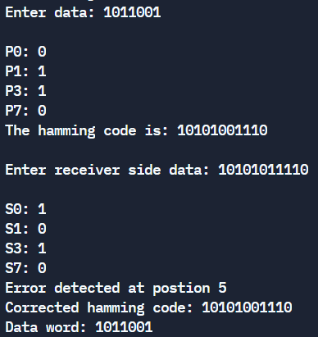

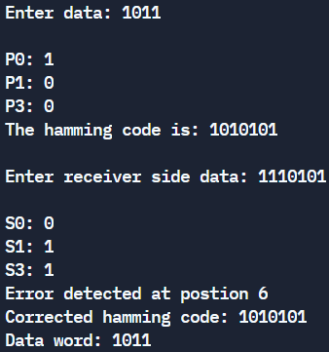

CONCLUSION:
We successfully understood & implemented Hamming Code for Error Detection in java.

Post Lab Questions

- State advantages of hamming code.

Advantages of Hamming Code are:
- It can provide error detection and also indicates the bit which contains an error for correction.
- It is very easy and best to use in computer memory and single-bit error correction and detection.
- It is cost-effective if a data stream contains single-bit errors.

