Batch: A1 Roll No.: 1911004

Experiment / assignment / tutorial No. 4

Grade: AA / AB / BB / BC / CC / CD /DD

Signature of the Staff In-charge with date

Experiment No.: 4

TITLE: Implementation of Checksum for Computer Networks
______________________________________________________________________
AIM: To implement Layer 2 Error Control schemes: Checksum.
______________________________________________________________________
Expected Outcome of Experiment:
CO: Implementing and learning about the error control scheme: Checksum
__________________________________________________________________
Books/ Journals/ Websites referred:
- A. S. Tanenbaum, “Computer Networks”, Pearson Education, Fourth Edition
- B. A. Forouzan, “Data Communications and Networking”, TMH, Fourth Edition
____________________________________________________________________
Pre Lab/ Prior Concepts:
Data Link Layer, Error Correction/Detection, Types of Errors
___________________________________________________________________
New Concepts to be learned: Checksum.
___________________________________________________________________

Checksum :
A checksum is a simple type of redundancy check that is used to detect errors in data.
Errors frequently occur in data when it is written to a disk, transmitted across a network or otherwise manipulated. The errors are typically very small, for example, a single incorrect bit, but even such small errors can greatly affect the quality of data, and even make it useless.
In its simplest form, a checksum is created by calculating the binary values in a packet or other block of data using some algorithm and storing the results with the data. When the data is retrieved from memory or received at the other end of a network, a new checksum is calculated and compared with the existing checksum. A non-match indicates an error; a match does not necessarily mean the absence of errors, but only that the simple algorithm was not able to detect any.
Simple Checksum:

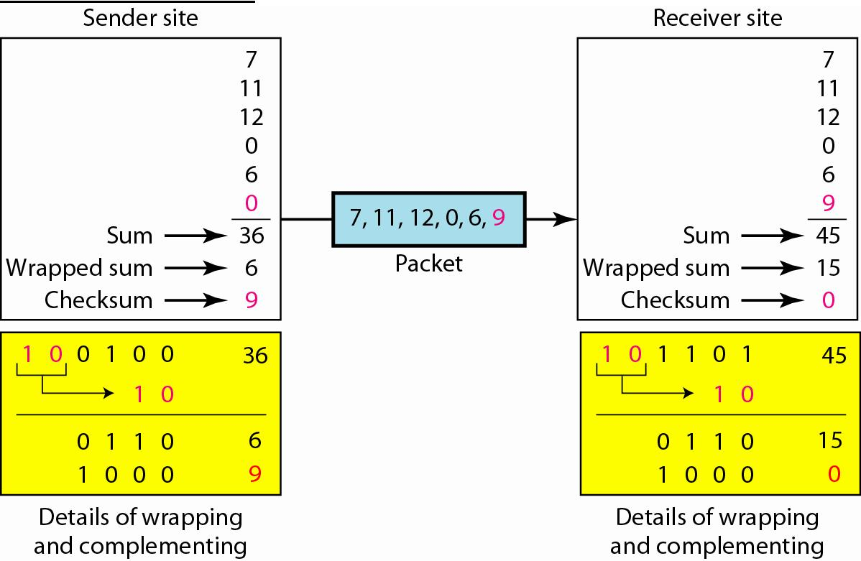

Internet Checksum
The following process generates Internet Checksum

Assume the packet header is: 01 00 F2 03 F4 F5 F6 F7 00 00
(00 00 is the checksum to be calculated)

The first step is to form 16-bit words.
0100 F203 F4F5 F6F7

The second step is to calculate the sum using 32-bits.
0100 + F203 + F4F5 + F6F7 = 0002 DEEF

The third step is to add the carries (0002) to the 16-bit sum.
DEEF + 002 = DEF1

The fourth step is to take the complement. (1s becomes 0s and 0s become 1s)
~DEF1 = 210E

So the checksum is 21 0E.

The packet header is sent as: 01 00 F2 03 F4 F5 F6 F7 21 0E

* At the receiver, the steps are repeated.

The first step is to form 16-bit words.
0100 F203 F4F5 F6F7 210E

The second step is to calculate the sum using 32-bits.
0100 + F203 + F4F5 + F6F7 + 210E = 0002 FFFD

The third step is to add the carries (0002) to the 16-bit sum.
FFFD + 0002 = FFFF which means that no error was detected.

(In 1s complement, FFFF is 0000 or zero.)

Example:
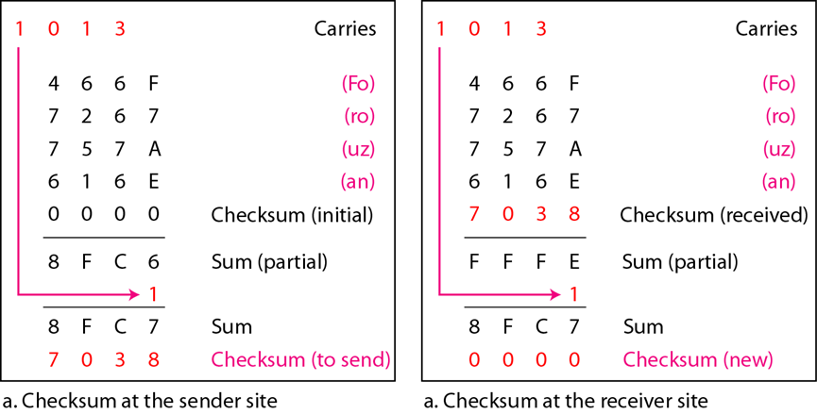

IMPLEMENTATION: (printout of codes)
Code:
def toHex(msg):
hexMsg = [hex(ord(c))[2:] for c in msg]
#extra space for Odd len
if(len(msg) % 2 != 0): hexMsg.append(hex(ord(" "))[2:])
grp = []# Grouping
for i in range(0, len(hexMsg)-1, 2): grp.append(hexMsg[i] + hexMsg[i + 1])
return grp
def complement(s):#
s_ = ''
for c in s: s_ += hex(15-int(c, 16))[2:]
return s_
def findSum(data):
Sum = '0'*len(data[0]);carry = '0'*len(data[0])
for d in data:
Sum = hex(int(Sum,16)+int(d,16))
Sum = Sum[2:]
if (len(data[0])<len(Sum)):
c = len(Sum)-len(data[0])
Sum = hex(int(Sum[0:c],16)+int(Sum[c:],16))[2:]
elif(len(data[0])<len(Sum)):
c = len(data[0])-len(Sum);carry = ('0'*c)
else: pass
Sum = hex(int(Sum,16)+int(carry,16))[2:]
print("Paritial Sum =",Sum)
return Sum
def findCheckSum(data):
Sum = findSum(data)
print("Sender side checksum =",complement(Sum))
return complement(Sum)
def validateCheckSum(checksum,sData,rData):
Sum = findSum(rData)
rChecksum = complement(Sum)
print("Receiver side checksum =",rChecksum)
if (checksum==rChecksum): return True
else: return False
sender = input("Enter Sender Data = ")
checksum = findCheckSum(toHex(sender))
receiver = input("Enter Receiver Data = ")
msgFlag = validateCheckSum(checksum,toHex(sender),toHex(receiver))
if (msgFlag==True): print("Sender & Receiver Data are same as CheckSum = 0.\nStatus : Accepted")
else: print("Sender & Receiver Data are not same CheckSum != 0.\nStatus : Rejected")

Output:
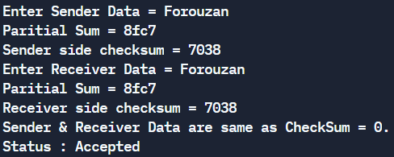

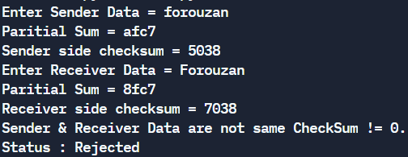
CONCLUSION:
We have successfully understood and implemented the concept of checksum in python.

Post Lab Questions

- State the advantages and disadvantages of Internet Checksum.

Advantage:
The checksum detects all the errors involving an odd number of bits as well as the error involving an even number of bits.

Disadvantage:
The main problem is that the error goes undetected if one or more bits of a subunit is damaged and the corresponding bit or bits of a subunit are damaged and the corresponding bit or bits of opposite value in second subunit are also damaged. This is because the sum of those columns remains unchanged.

