Batch: A1 Roll No.: 1911004

Experiment / assignment / tutorial No. 9

Grade: AA / AB / BB / BC / CC / CD /DD
Signature of the Staff In-charge with date

Experiment No.:9

TITLE: Implement simple Client Server Model using TCP Java/Python Socket programming.
___________________________________________________________________
AIM: Implementation simple Client Server Model using TCP/UDP Java Socket programming.

Expected Outcome of Experiment:
CO:
Demonstrate Transport layer concepts like flow control, error control, congestion, sockets, QoS in wired technology.
_________________________________________________________________
Books/ Journals/ Websites referred:
- Java: The Complete Reference by Herbert Schildt
- Java Network Programming, 4th Edition by Elliotte Rusty Harold
- B. A. Forouzan, “Data Communications and Networking”, TMH, Fifth Edition
__________________________________________________________________
Pre-Lab/ Prior Concepts:
Java Programming, TCP and UDP communication
___________________________________________________________________
New Concepts to be learned: Java Socket Programming ___________________________________________________________________

Theory:
Socket programming is a programming schema in which sockets are used and manipulated to create a connection between software. Sockets are used to connect software either between different computers or within the same computer so the programs can share data. Socket programming is used with instant messaging, Internet browsers, file sharing programs, and anything that forces the computer to connect to a system. Most sockets are programmed automatically, but some operating systems (OS) place this responsibility in the hands of the user.
Socket programming involves using a list of commands to connect a socket from one computer to another. For example, for an instant messenger program to work, it must connect to a second computer. To make this connection, a socket is employed. By forging the connection, the two computers are now able to link together and speak to one another.
Peer-to-peer (P2P) programs are special cases when it comes to socket programming. Most programs act either as a client or a server. A P2P program acts as both, which is why users are able to download files from one person while files are downloaded from the user at the same time.
While most socket programming is used so two computers can interact, it also is useful for two programs in the same computer. Known as interprocessing, this allows one program to take information from another program and use it. For example, if one program is a slideshow creator and needs information from a video program to play videos in the slide, then a socket is made to connect the slideshow and video programs. Interprocessing is common, but not as common as using sockets between two computers.
When using socket programming, the programmer and user must remember that sockets are bidirectional. This means both computers can speak to one another while also taking data from each other. Opening up a computer to another system can be dangerous, because the other side will be able to launch an attack if its user is malicious. This is rare, though, and connecting a socket to another system is usually safe.
Sockets usually are made automatically on the OS, or with limited programming. In OS interfaces where the command line is used often, the user will frequently have to forge the sockets manually. This forces the user to know some basic socket programming so these important connections can be made. If the socket is not created, then the computer will not be able to communicate with other systems, limiting the computer’s usefulness.

IMPLEMENTATION: (printout of code)
Code:
import socket
def ServerSide(): #server.py
try:
S = socket.socket()
print("Socket for Server created...")
portNo = 55555 #port no
S.bind(('', portNo)) #for socket to listen from all ip
print("Binding Socket to port", str(portNo) +"...")
S.listen(3)
print("Socket is Listening...")
con, addTuple = S.accept()
print("Connected to",addTuple)
flag = True;print("Connected...")
con.send("to server".encode())
con.recv(1024).decode()
while flag:
op = (input("Do you want to continue? 1.Yes \t 0.No \t Enter "))
if (op=='0'):
flag = False
con.send("\n\tServer Left".encode())
con.close()
print("Exiting...")
break
break
msg = input("Enter Message for client = ")
con.send(msg.encode())
print("\tClient - ",con.recv(1024).decode())
S.close()
except Exception as e: print(e)
def ClientSide(): #client.py
try:
S = socket.socket()
print("Socket for Client created...")
portNo = 55555#port no
ip = "127.18.0.1"
S.connect((ip,portNo))
flag = True
print("Connected...",S.recv(1024).decode())
S.send("to client".encode())
while flag:
print("\tServer -",S.recv(1024).decode())
op = (input("Do you want to continue? 1.Yes \t 0.No \t Enter "))
if (op=='0'):
flag = False
S.send("\n\tClient Left".encode())
S.close()
print("Exiting...")
break
break
msg = input("Enter Message for server = ")
S.send(msg.encode())
#print("\tServer -",S.recv(1024).decode())
S.close()
except Exception as e: print(e)
ServerSide()
ClientSide()

Output:
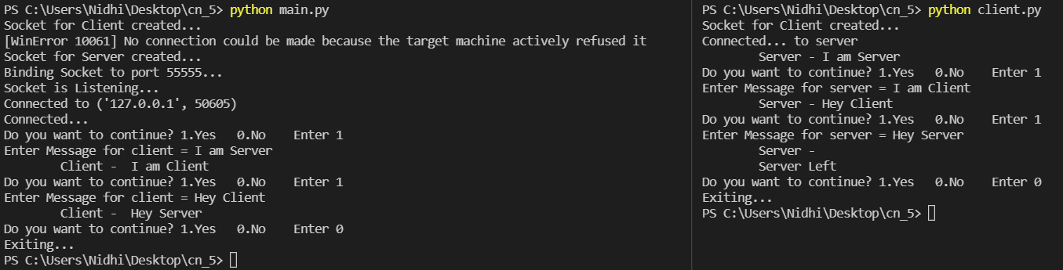

CONCLUSION:
We have successfully understood the concept of Socket programming with TCP/UDP protocol and implemented it.

Post Lab Questions

- Explain 3-way handshake in TCP.
Ans:
THREE-WAY HANDSHAKE or a TCP 3-way handshake is a process which is used in a TCP/IP network to make a connection between the server and client. It is a three-step process that requires both the client and server to exchange synchronization and acknowledgment packets before the real data communication process starts.
Three-way handshake process is designed in such a way that both ends help you to initiate, negotiate, and separate TCP socket connections at the same time. It allows you to transfer multiple TCP socket connections in both directions at the same time.
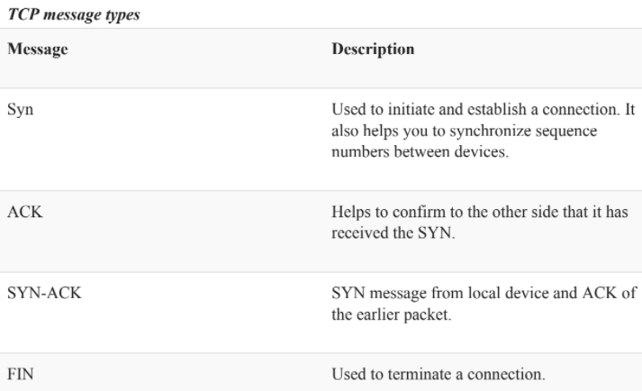
TCP Three-Way Handshake Process
TCP traffic begins with a three-way handshake. In this TCP handshake process, a client needs to initiate the conversation by requesting a communication session with the Server:
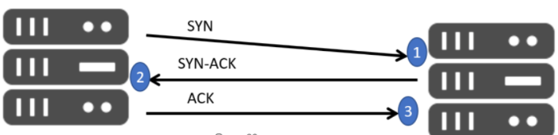
CLIENT SERVER
- Step 1: In the first step, the client establishes a connection with a server. It sends a segment with SYN and informs the server about the client should start communication, and with what should be its sequence number.
- Step 2: In this step server responds to the client request with SYN-ACK signal set. ACK helps you to signify the response of segment that is received and SYN signifies what sequence number it should able to start with the segments.
- Step 3: In this final step, the client acknowledges the response of the Server, and they both create a stable connection will begin the actual data transfer process.
Real-World example
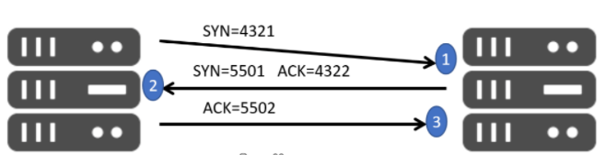
HOST X SERVER
Here is a simple example of the three-way handshake process that is consists of three steps:
- Host X begins the connection by sending the TCP SYN packet to its host destination. The packets contain a random sequence number (For example, 4321) that indicates the beginning of the sequence numbers for data that the Host X should transmit.
- After that, the Server will receive the packet, and it responds with its sequence number. It's response also includes the acknowledgment number, that is Host X's sequence number incremented with 1 (Here, it is 4322).
- Host X responds to the Server by sending the acknowledgment number that is mostly server's sequence number that is incremented by 1.
After the data transmission process is over, TCP automatically terminates the connection between two separate endpoints.
- How is an IP address represented in Java?
Ans:
IP address is defined as an object in java. An IP address contains network number and host number. An Object only listens to its method. The method defines the role of the object. Likewise an IP address in java is totally managed by its method where it's created. That method is bound to the class InetAdress.
- What is the difference between the Server Socket class and the Socket class in Java?
Ans:
- java.net.ServerSocket - This class implements server sockets. A server socket waits for requests to come in over the network. It performs some operation based on that request, and then possibly returns a result to the requester.
- java.net.Socket - This class implements client sockets (also called just "sockets"). A socket is an endpoint for communication between two machines.

