Batch: A1 Roll No.: 1911004

Experiment / assignment / tutorial No. 10

Grade: AA / AB / BB / BC / CC / CD /DD

Signature of the Staff In-charge with date

Experiment No.:10

TITLE: Flow control Mechanism: Go-Back- N ARQ Sliding Window Protocol using Socket programming
___________________________________________________________________
AIM: Implementation of Flow Control Mechanism: Stop and Wait ARQ and Go-Back- N Sliding Window Protocol ARQ using sockets.

Expected Outcome of Experiment:
CO3: Demonstrate various network layer protocols and network design using IP addressing concepts
__________________________________________________________________
Books/ Journals/ Websites referred:
- A. S. Tanenbaum, “Computer Networks”, Pearson Education, Fourth Edition
- B. A. Forouzan, “Data Communications and Networking”, TMH, Fourth Edition
__________________________________________________________________
Pre-Lab/ Prior Concepts:
Java Socket Programming, Flow Control, Go-Back-Stop and Wait
___________________________________________________________________
New Concepts to be learned: Window Flow Control ___________________________________________________________________

Design of Go-Back-N ARQ

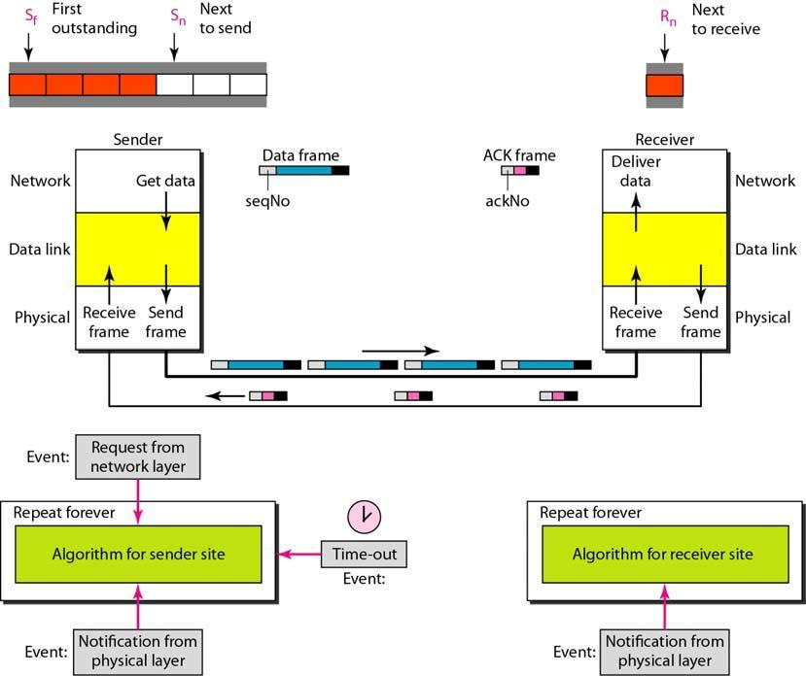

- Take data from user about how many bit windows is case of go back n and selective repeat.

- Generate frames randomly and show the transmission

- Generate the random number for the frame to be lost.

- For Go – Back – N transmit all the frames after that number till max number

- For Selective repeat transmit the selected frame which is not received by the receiver.

IMPLEMENTATION: (printout of code)
Code:
Sender.py
import socket
import threading
import time

host = socket.gethostname()
port = 5000

serverSocket = socket.socket()
serverSocket.bind((host, port))

serverSocket.listen(5)
print("Server is Listening")
receiver, address = serverSocket.accept()
print("Connection from = " + str(address))

message = input("Send a message to the receiver = ")
frameSize = int(input('Enter the frame size = '))

receiver.send(str(len(message)).encode())
receiver.send(str(frameSize).encode())

class Sender(threading.Thread):
cnt = 0
sendingWindow = frameSize
while(cnt<len(message)):
if (len(message) - cnt < frameSize):
sendingWindow = len(message)-cnt
print('Sending Frames from',cnt,'to',cnt+sendingWindow)
for i in range(sendingWindow):
receiver.send(message[cnt].encode())
print('Sent:',message[cnt])
cnt+=1
time.sleep(1)
time.sleep(3)
ack = receiver.recv(1024).decode()
if ack == 'lost':
print('No Acknowledgement received!')
print('Resending frames:',(cnt-sendingWindow),'to',(cnt))
cnt -= sendingWindow
else:
print('Acknowlegment ',ack)
if(int(ack) != cnt):
print('Resending frames:',int(ack),'to',int(ack)+sendingWindow)
cnt = int(ack)
print('Message sent from Sender!')

sender = Sender()
sender.start()

Receiver.py
import socket
import random

host = socket.gethostname()
port = 5000

receiver = socket.socket(socket.AF_INET, socket.SOCK_STREAM)
receiver.connect((host, port))

print('Receiver is Ready')

msgLen = int(receiver.recv(1024).decode())
frameSize = int(receiver.recv(1024).decode())

msgReceived = []
rMsgLen = 0

error = random.randint(1,msgLen//frameSize)*frameSize
print('Error at',error)
flag = 0
while True:
cnt = 0
cnt_ = 0
receiveingWindow = frameSize
while(cnt<msgLen):
if ((msgLen-cnt_ < frameSize) ):
receiveingWindow = msgLen-cnt_
print('Receiving Frames from',cnt,'to',(cnt+receiveingWindow))
for i in range(receiveingWindow):
rChar = receiver.recv(1024).decode()
if flag == 1:
print('Received this window already..')
if flag!=1:
print('Received',rChar)
msgReceived.append(rChar)
cnt +=1
cnt_+=1
print(msgReceived)
if(flag == 1):
print('Re-sending Acknowledgment...')
receiver.send(str(cnt).encode())
flag = 0
cnt_+=3
else:
print('Sending Acknowledgement...')
if cnt == error :
print('Acknowledgement lost!')
receiver.send('lost'.encode())
flag = 1
cnt_-=3
else:
receiver.send(str(cnt).encode())
if cnt==msgLen:
break
print("Receive Completed!")
Output:
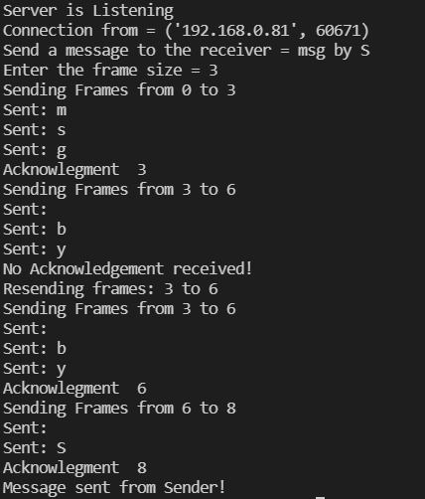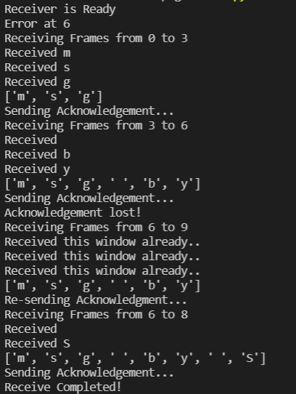
CONCLUSION:
We successfully understood Go Back N Protocol and implemented it in python.

Post Lab Questions

- Compare Go-Back-N and Stop and Wait.
GO BACK N | STOP & WAIT
Sender window size is N and Receiver window size is 1. | Sender window size is 1 and Receiver window size is 1
Acknowledgement type is cumulative. | Acknowledgement type is individual
Minimum Sequence Number is N+1 where N is number of packets sent. | Minimum Sequence Number is 2
In-order delivery only are accepted at receiver end | No specific order is needed at receiver end
In case of packet drop, number of retransmission is N | In case of packet drop, number of retransmission is 1

- What is Flow Control and why it is necessary?
Ans: In data communications, flow control is the process of managing the rate of data transmission between two nodes to prevent a fast sender from overwhelming a slow receiver. It provides a mechanism for the receiver to control the transmission speed, so that the receiving node is not overwhelmed with data from transmitting node. Flow control mechanisms can be classified by whether or not the receiving node sends feedback to the sending node. Flow control is important because it is possible for a sending computer to transmit information at a faster rate than the destination computer can receive and process it. This can happen if the receiving computers have a heavy traffic load in comparison to the sending computer, or if the receiving computer has less processing power than the sending computer.
Flow control helps in:
- Prevention of any buffer overflows in the receiver as the data rate is controlled.
Indicating whether a transmission was successful or not.
- Indicating whether a transmitter/receiver/connection is alive or dead. Time-outs help in this part.
- Ensures complete data transfer
- Ensures ordering to some extent in the data transfer depending on the algorithm.
But output of most algorithms is always an ordered set of frames even if the path and delay in transmission of each frame were different.
- The maximum window size for data transmission using the selective reject protocol with n-bit frame sequence numbers is
a) 2n b) 2n-1 c) 2n-1 d)2n-2
Ans) 2^{n-1}

