Batch: A1 Roll No.: 1911004

Experiment No. 01

Grade: AA / AB / BB / BC / CC / CD /DD

Signature of the Staff In-charge with date

TITLE: Exploring basic Commands of UNIX: Shell, Processes, Files
_____________________________________________________________________

AIM: To Explore basic commands for handling File system under Unix/Linux using shell scripts.(Creating groups, chown , chmod , directory name, tty , diff, umask).
______________________________________________________________________
Expected Outcome of Experiment:

CO 1. To introduce basic concepts and functions of operating systems.
_____________________________________________________________________
Books/ Journals/ Websites referred:

- Silberschatz A., Galvin P., Gagne G. “Operating Systems Principles”, Willey Eight edition.
- Achyut S. Godbole , Atul Kahate “Operating Systems”, McGraw Hill Third Edition.
- Sumitabha Das “ UNIX Concepts & Applications”, McGraw Hill Second Edition.
_____________________________________________________________________
Pre Lab/ Prior Concepts:

An operating system (OS) is a resource manager. It takes the form of a set of software routines that allow users and application programs to access system resources (e.g. the CPU, memory, disks, modems, printers network cards etc.) in safe efficient and abstract way.
- The operating system kernel is in direct control of the underlying hardware. The kernel provides low-level device, memory and processor management functions (e.g. dealing with interrupts from hardware devices, sharing the processor among multiple programs, allocating memory for programs etc.)
- Basic hardware-independent kernel services are exposed to higher-level programs through a library of system calls (e.g. services to create a file, begin execution of a program, or open a logical network connection to another computer).
- Application programs (e.g. word processors, spreadsheets) and system utility programs (simple but useful application programs that come with the operating system, e.g. programs which find text inside a group of files) make use of system calls. Applications and system utilities are launched using a shell (a textual command line interface) or a graphical user interface that provides direct user interaction.
Operating systems can be distinguished from one another by the system calls, system utilities and user interface they provide, as well as by the resource scheduling policies implemented by the kernel.
UNIX has been a popular OS for more than two decades because of its multi-user, multi-tasking environment, stability, portability and powerful networking capabilities.
Linux is a free open source UNIX OS for PCs.Linux has all of the components of a typical OS :
- Kernel
The Linux kernel includes device driver support for a large number of PC hardware devices (graphics cards, network cards, hard disks etc.), advanced processor and memory management features, and support for many different types of file systems. In terms of the services that it provides to application programs and system utilities, the kernel implements most BSD and SYSV system calls, as well as the system calls described in the POSIX.1 specification.
The kernel (in raw binary form that is loaded directly into memory at system startup time) is typically found in the file /boot/vmlinuz, while the source files can usually be found in /usr/src/linux.
- Shells and GUIs
Linux supports two forms of command input: through textual command line shells similar to those found on most UNIX systems (e.g. sh - the Bourne shell, bash - the Bourne again shell and csh - the C shell) and through graphical interfaces (GUIs) such as the KDE and GNOME window managers.
- System Utilities
Virtually every system utility that you would expect to find on standard implementations of UNIX has been ported to Linux. This includes commands such as ls, cp, grep, awk, sed, bc, wc, more, and so on. These system utilities are designed to be powerful tools that do a single task extremely well (e.g. grep finds text inside files while wc counts the number of words, lines and bytes inside a file). Users can often solve problems by interconnecting these tools instead of writing a large monolithic application program.
- Application programs
Linux distributions typically come with several useful application programs as standard. Examples include the emacseditor, xv (an image viewer), gcc (a C compiler), g++ (a C++ compiler), xfig (a drawing package), latex (a powerful typesetting language) and soffice (StarOffice, which is an MS-Office style clone that can read and write Word, Excel and PowerPoint files).
______________________________________________________________________
Description of Commands and options:
- cp: copying files
- rm: command is used to delete files
- mv: mv stands for move. mv is used to move one or more files or directories from one place to another in a file
- chmod: change directory permissions
- Chown: change the file Owner or group
- ps: used to list the currently running processes and their PIDs
- top: to show the Linux processes
- kill: built-in command which is used to terminate processes manually
- cat: It reads data from the file and gives their content as output. It helps us to create, view, concatenate files
- more: view the text files in the command prompt, displaying one screen at a time in case the file is large
- less: displays file contents or command output one page at a time in your terminal
- head: writes to standard output a specified number of lines or bytes of each of the specified files, or of the standard input
- tail: outputting the last part of files given to it via standard input
- cd: change directory command
- pwd: It prints the path of the working directory, starting from the root
- ln: used to create a hard link or a symbolic link (symlink) to an existing file or directory
- mkdir: create directories
- rmdir: used remove empty directories from the filesystem
- hostname: used to obtain the DNS(Domain Name System) name and set the system's hostname or NIS(Network Information System) domain name
- w: provides a quick summary of every user logged into a computer
- uname: print basic system information
Implementation details:
Explore all the following Unix commands:
- Unix file operations
Navigating filesystem and managing files and access permissions i.e.
ls, cp, rm , mv, chmod, chown ,chgrp
- ls – stands for list all. To list all files of current directory.
Syntax: ls
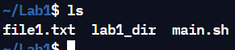
Options:
- ls -l: It will show the list in a long list format.
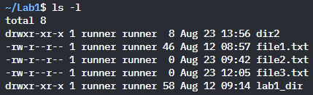
- ls -lh This command will show you the file sizes in human readable format. Size of the file is very difficult to read when displayed in terms of byte. The (ls -lh)command will give you the data in terms of Mb, Gb, Tb, etc.
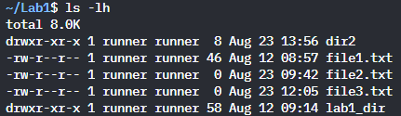
- ls -R: It will display the content of the sub-directories also.
- cp - stands for copy. This command is used to copy files or group of files or directory. It creates an exact image of a file on a disk with different file name. cp command requires at least two filenames in its arguments.
Syntax:
cp [OPTION] Source Destination
cp [OPTION] Source-1 Source-2 Source-3 Source-n Directory
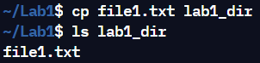

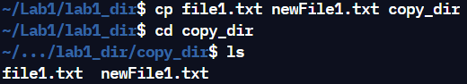
Options:
- cp -i: Prompt before overwrite.
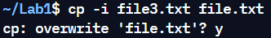
- cp -r or cp -R: Copying directory structure. With this option cp command shows its recursive behavior by copying the entire directory structure recursively.
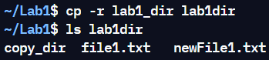

- rm – stands for remove here. rm command is used to remove objects such as files, directories, symbolic links and so on from the file system like UNIX. To be more precise, rm removes references to objects from the filesystem, where those objects might have had multiple references (for example, a file with two different names). By default, it does not remove directories.
Syntax:
rm [option]... FILE...
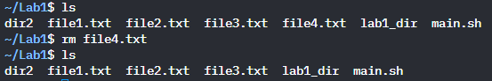
Options:
- rm -i (Interactive Deletion): This option ask the user for confirmation before removing each file, you have to press y for confirm deletion, any other key leaves the file un-deleted.
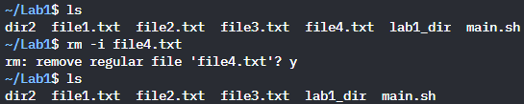
- rm -r (Recursive Deletion): With -r(or -R) option rm command performs a tree-walk and will delete all the files and sub-directories recursively of the parent directory. At each stage it deletes everything it finds. Normally, rm wouldn’t delete the directories but when used with this option, it will delete.
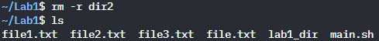

- mv - stands for move. mv is used to move one or more files or directories from one place to another in file system like UNIX. It has two distinct functions:
(i) It rename a file or folder.
(ii) It moves group of files to different directory.
No additional space is consumed on a disk during renaming. This command normally works silently means no prompt for confirmation.
Syntax :
mv source stination
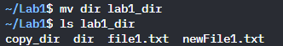
Options :
- mv -i (Interactive): This option makes the command ask the user for confirmation before moving a file that would overwrite an existing file, you have to press y for confirm moving, any other key leaves the file as it is. This option doesn’t work if the file doesn’t exist, it simply rename it or move it to new location.
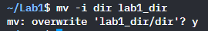
- mv -b(backup): With this option it is easier to take a backup of an existing file that will be overwritten as a result of the mv command. This will create a backup file with the tilde character(~) appended to it.
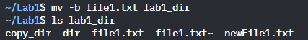
- chmod - is used to change the access mode of a file.The name is an abbreviation of change mode.
Syntax :
chmod [Options]... Numeric_Mode file...
chmod [reference][operator][mode] file...
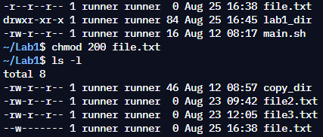

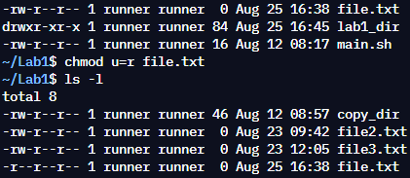
Options:
- chmod -v: It displays output message when the permission of the file is changed but also when it is retained.

- chown – stands for change owner. change the ownership of a file to match the user/group of an existing reference file.
Syntax :
chown [option]… [OWNER][:[GROUP]] FILE…
chown [option]… –reference=RFILE FILE…
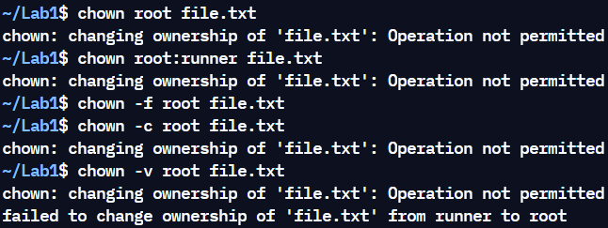
Options:
- chown -v: It displays output message when the permission of the file is changed but also when it is retained.
- -f: It supresses most of the error messages.
- -c: Reports when a file is changed
- chgrp – stands for change group. It is used to change the group ownership of a file or directory.
Syntax :
chgrp [option]… GROUP FILE…
chgrp [option]… –reference=RFILE FILE…
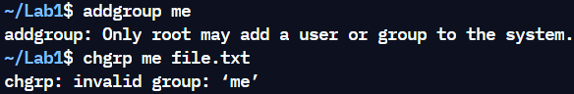
Options:
- -v: It displays output message when the permission of the file is changed but also when it is retained.
- -f: It supresses most of the error messages.
- -c: Reports when a file is changed
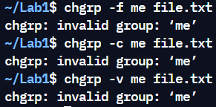 Didn’t get excecuted on online repl env

- Text file operations in Unix
Most of important configuration in Unix is in clear text files, these commands will let you quickly inspect files or view logs:
cat , more , less , head, tail , grep
- cat - reads data from the file and gives their content as output. It helps us to create, view, concatenate files.
Syntax :
cat [options...] filename
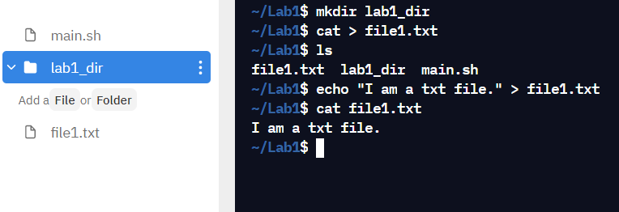
Options:
- cat file1 file2: It displays the concatenated contents of the files.
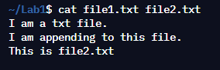

- cat -n: It numbers all output lines.
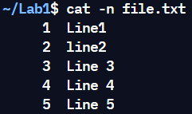
- more - displays the content of a file like 'cat'. The difference is that, in case of larger files, 'cat' command output will scroll off your screen while 'more' command displays output one screenful at a time.
Syntax :
more [options...] [-num] [+/pattern] [+linenum] [file_name]
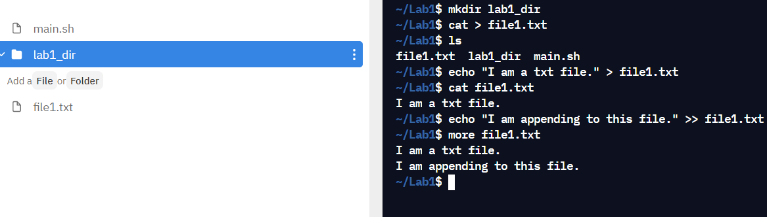
[-options]: any option that you want to use in order to change the way the file is displayed. Choose any one from the followings: (-d, -l, -f, -p, -c, -s, -u)
[-num]: type the number of lines that you want to display per screen.
[+/pattern]: replace the pattern with any string that you want to find in the text file.
[+linenum]: use the line number from where you want to start displaying the text content.
[file_name]: name of the file containing the text that you want to display on the screen.
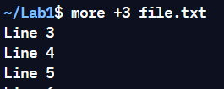

Options:
- more -d : Use this command in order to help the user to navigate. It displays “[Press space to continue, ‘q’ to quit.]” and displays “[Press ‘h’ for instructions.]” when wrong key is pressed.
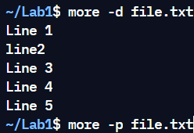
- more -p : This option clears the screen and then displays the text

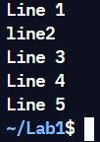
- less – it is used to read contents of text file one page(one screen) per time. It has faster access because if file is large, it don’t access complete file, but access it page by page.The 'less' command is same as 'more' command but include some more features.It automatically adjust with the width and height of the teminal window, while 'more' command cuts the content as the width of the terminal window get shorter.
Syntax :
less [options...] [filename]
Options:
- less -E : causes less to automatically exit the first time it reaches end of file.
- less -p pattern : it tells less to start at the first occurrence of pattern in the file.
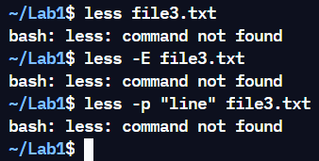
Didn’t get output as using online compiler repl.
- head - prints the top N number of data of the given input. By default, it prints the first 10 lines of the specified files. If more than one file name is provided then data from each file is preceded by its file name.
Syntax :
head [options...] [filename]
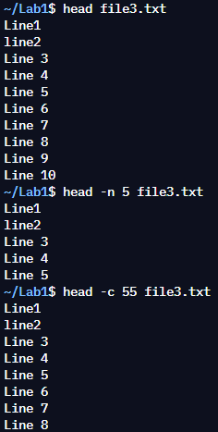
Options :
- head -n num: Prints the first ‘num’ lines instead of first 10 lines. num is mandatory to be specified in command otherwise it displays an error.
- head -c num: Prints the first ‘num’ bytes from the file specified. Newline count as a single character, so if head prints out a newline, it will count it as a byte. num is mandatory to be specified in command otherwise displays an error.

- tail - it prints the last N number of data of the given input. By default it prints the last 10 lines of the specified files. If more than one file name is provided then data from each file is precedes by its file name.
Syntax :
tail [options...] [filename]
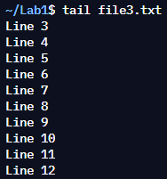
Options:
- tail -n num: Prints the last ‘num’ lines instead of last 10 lines. num is mandatory to be specified in command otherwise it displays an error. This command can also be written as without symbolizing ‘n’ character but ‘-‘ sign is mandatory. Tail command also comes with an ‘+’ option which is not present in the head command. With this option tail command prints the data starting from specified line number of the file instead of end. For command: tail +n file_name, data will start printing from line number ‘n’ till the end of the file specified.
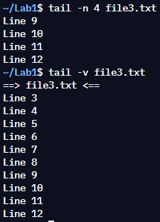
- tail -v: By using this option, data from the specified file is always preceded by its file name.

- grep - it filter searches a file for a particular pattern of characters, and displays all lines that contain that pattern. The pattern that is searched in the file is referred to as the regular expression (grep stands for globally search for regular expression and print out).
Syntax :
grep [options...] pattern [filename]
Options:
- grep -i :The -i option enables to search for a string case insensitively in the give file.
- grep -c: We can find the number of lines that matches the given string/pattern
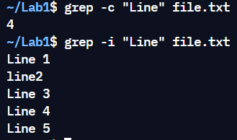

- Unix directory management commands
Navigating filesystems and managing directories:
cd, pwd , ln, mkdir, rmdir
- cd - stands for change directory command. It is used to change current working directory.
Syntax :
cd [directory]
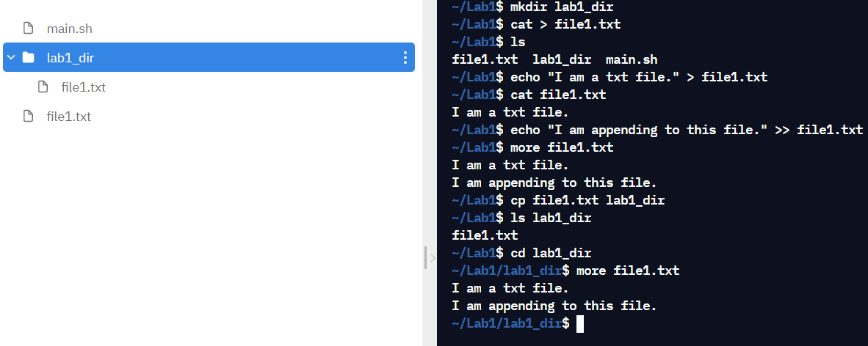
Options :
- cd dir_1/dir_2/dir_3: This command is used to move inside a directory from a directory
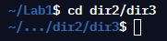
- cd /: this command is used to change directory to the root directory, The root directory is the first directory in your filesystem hierarchy.
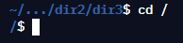

- pwd - stands for Print Working Directory. It prints the path of the working directory, starting from the root. As the name states, command ‘pwd’ prints the current working directory or simply the directory user is, at present. It prints the current directory name with the complete path starting from root (/).
Syntax :
pwd
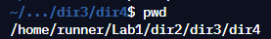
Options:
- pwd -L: Prints the symbolic path.
- pwd -P: Prints the actual path.
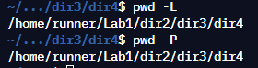
- ln - it is used to create links between files. Create hard links by default
Syntax:
ln [option]... [-T] Target link_name(1st form)
ln [option]... Target... Directory (2nd form)
ln [option]... -t directory Target... (3rd form)
1st form: This form is simple, the source file with destination link name you have to specify.
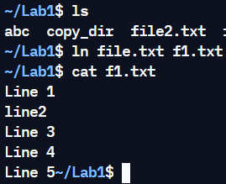
2nd form: Here, we have to give source file and directory as a link, simply the source file will be copied to the directory which you specify.
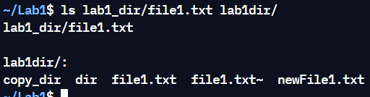
3rd form: Here, we will specify the directory name and a file to be linked to the directory. It is mostly same to 2nd form.
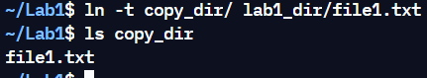
Options:
- ln -t: Specify the directory in which to create the links
- ln -s: Make symbolic links instead of hard links.
- mkdir - it is used to create a new directory whose parent is the current directory.
Syntax :
mkdir [options...] [directories ...]
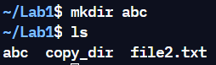
Options :
- mkdir -v : It displays a message for every directory create
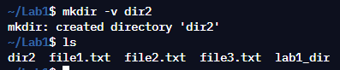
- mkdir -p: A flag which enables the command to create parent directories as necessary. If the directories exist, no error is specified.
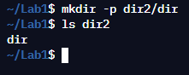
- rmdir - it is used remove empty directories from the filesystem in Linux. If the specified directory has some directories or files in it then this cannot be removed by rmdir command.
Syntax :
rmdir [options...] [directories ...]
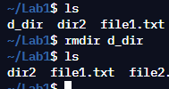
Options:
- rmdir -v, –verbose: This option displays verbose information for every directory being processed.
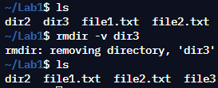
- rmdir -p: In this option each of the directory argument is treated as a pathname of which all components will be removed, if they are already empty, starting from the last component.
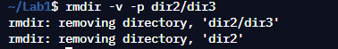

- Unix system status commands
Most useful commands for reviewing hostname configuration and vital stats:
hostname, w, uname
- hostname - it is used to obtain the DNS(Domain Name System) name and set the system’s hostname or NIS(Network Information System) domain name.
Syntax :
hostname [option] [file]
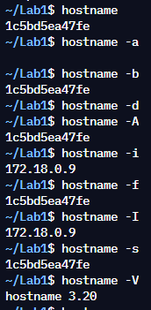
Options:
- -a : This option is used to get the alias name of the host system(if any).

- -b : Used to always set a hostname. Default name is used if none specified.
- -d : This option is used to get the Domain if local domains are set. It will not return anything(not even a blank line) if no local domain is set.
- w - it is used to show who is logged on and what they are doing.
Syntax :
w [options] user [...]
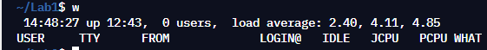
Options :
- w -h : This option doesn’t print the header.
- w -u : This option will ignore the username while figuring out the current process and cpu times.
- w -s : This option uses the short format. It will not print the login time, JCPU or PCPU times.
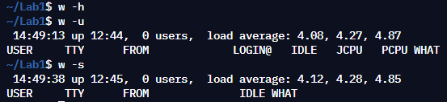
- uname - it displays the information about the system.
Syntax :
uname [option]
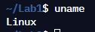
Options :
- -s : It prints the kernel name.
- -n : It prints the hostname of the network node(current computer).
- -r: It prints the kernel release date.
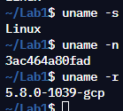
- Process management
Listing processes and confirming their status, and stopping processes if needed:
ps, top, kill
- ps - it is used for viewing information related with the processes on a system which stands as an abbreviation for “Process Status”. ps command is used to list the currently running processes.
Syntax :
ps [options]
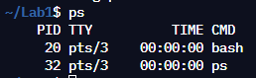
Options:
- -A : View all the running processes .
- -a : View all processes except both session leaders and processes not associated with a terminal.
- -d : View all the processes except session leaders
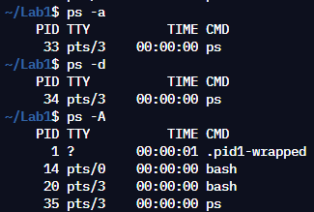
- top - it is used to show the processes. It provides a dynamic real-time view of the running system.
Syntax :
top [options]

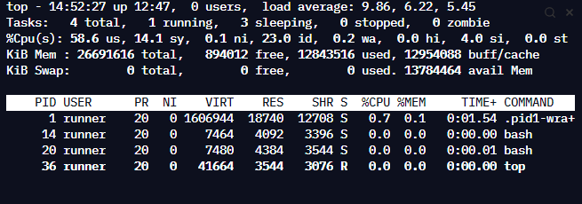
Options:
- top -n : Exit Top Command After Specific repetition
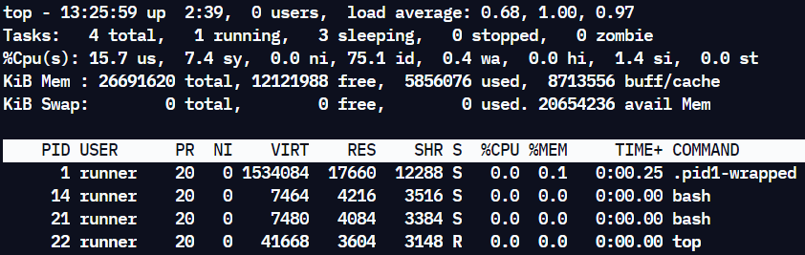
- top -u user : Display Specific User Process
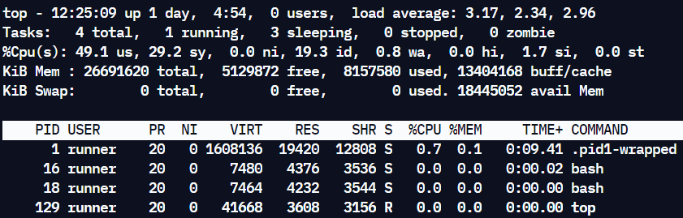
- top -h : Shows top command syntax
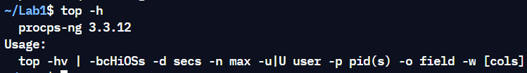

- kill - it is used to terminate processes manually. kill command sends a signal to a process which terminates the process.
Syntax :
kill [options]
Options:
- kill -l :To display all the available signals you can use below command option
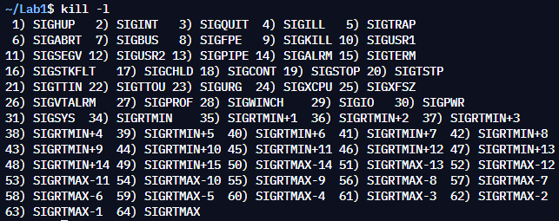
- kill pid : To show how to use a PID with the kill command.
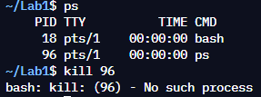
- Unix users commands
These commands allow you to get basic information about Unix users in your environment.
whoami , id, groups, passwd , who, last
- whoami - it displays the username of the current user when this command is invoked.
Syntax :
whoami [options]
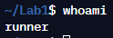
Options:
- whoami -help : It gives the help message and exit.
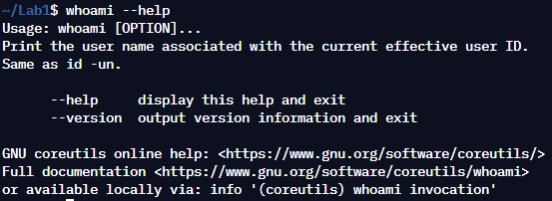
- whoami --version : It gives the version information and exit.
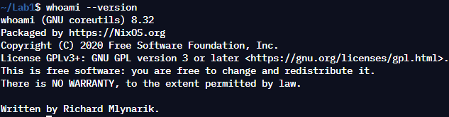
- id - it used to find out user and group names and numeric IDs (UID or group ID) of the current user or any other user in the server.
Syntax :
id [option][user]
Options:
- -g : Print only the effective group id.
- -G : Print all Group IDs.
- -r : Prints real ID instead of numbers.
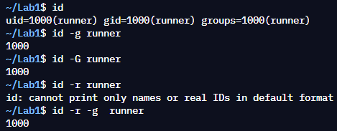
- groups - it is used to access collection of users.
Syntax :
groups [username]
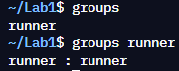
- passwd - it is used to change user password .
Syntax :
passwd [options] [LOGIN]
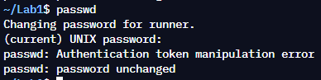
Options:
- passwd -d : Delete a user's password (make it empty).
- passwd --e : Immediately expire an account's password.
- passwd -l : Lock the password of the named account.
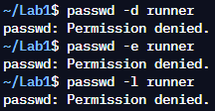
Didn’t get output as no permission on online repl bash.

- who - it is used to find out the following information :
Time of last system boot,Current run level of the system,List of logged in users and more.
Syntax :
who [options] [filename]
Options :
- who -r: To display current run level of the system
- who -a: To display all details of current logged in user
- who -u: To show list of users logged in to system
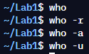
Didn’t get output on executing who command as using online compiler repl.

- last - it is used to display the list of all the users logged in and out since the file /var/log/wtmp was created.
Syntax :
last [options] [username...] [tty...]
Options:
- -[number]: This option is used to specify the number of lines to display.
- -R: This option is used to hide the host-name field.
- -F: This option is used to display the login and logout time including the dates.
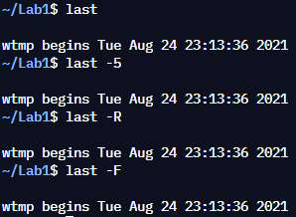

Conclusion:
We successfully understood, implemented & used Linux Commands.
Post Lab Descriptive Questions

- Explain different functions of operating system.
- Important functions of operating systems:
- Memory Management – The operating system manages the Primary Memory or Main Memory. Main memory is made up of a large array of bytes or words where each byte or word is assigned a certain address. Main memory is a fast storage and it can be accessed directly by the CPU. For a program to be executed, it should be first loaded in the main memory. An Operating System performs the following activities for memory management.
It keeps tracks of primary memory, i.e., which bytes of memory are used by which user program. The memory addresses that have already been allocated and the memory addresses of the memory that has not yet been used. In multi programming, the OS decides the order in which process are granted access to memory, and for how long. It Allocates the memory to a process when the process requests it and deallocates the memory when the process has terminated or is performing an I/O operation.
- Processor Management – In a multi programming environment, the OS decides the order in which processes have access to the processor, and how much processing time each process has. This function of OS is called process scheduling. An Operating System performs the following activities for processor management.
Keeps tracks of the status of processes. The program which perform this task is known as traffic controller. Allocates the CPU that is processor to a process. De-allocates processor when a process is no more required.
- File Management – A file system is organized into directories for efficient or easy navigation and usage. These directories may contain other directories and other files. An Operating System carries out the following file management activities. It keeps track of where information is stored, user access settings and status of every file and more… These facilities are collectively known as the file system.
- Coordination between other software and users – Operating systems also coordinate and assign interpreters, compilers, assemblers and other software to the various users of the computer systems

- What are the default permission assigned by Unix for Directory.
- The default umask value is 0022, which decides the default permission for a new file or directory. Default permission for a directory is 0777, for files the permissions are 0666 from which the default umask value 0022 is deducted to get the newly created files or directory permission.
Final default permission for a file is calculated as shown below:
- Default file permission: 666
- Default umask : 022
- Final default file permission: 644
Final default permission for a directory is calculated as shown below:
- Default directory permission: 777
- Default umask: 022
- Final default directory permission: 755

- Give difference between DOS and WINDOWS.
DOS | WINDOWS
DOS is single tasking & command line operating system. | Windows is multitasking & graphical operating systems.
It consumes low power, less memory in comparison of windows. | It consumes high power, consumes more memory than DOS.
It does not support networking. | It supports networking
It is complex in terms of using | It is simple for using.
It does not share time | It can share time.

- Explain Booting Process.

- When our computer is switched on, It can be started by hardware such as a button press, or by software command, a computer's central processing unit (CPU) has no software in its main memory, there is some process which must load software into main memory before it can be executed.
After the computer is turned on, a specific program needs to load in the computer's main memory which is Operating System. In the Booting process, System will check all the hardware's and Software's those are installed or attached with the system and all the Files those are required for running a system, also loads into memory.
ROM also reads the information stored in these files.At the Time of Booting all Instructions will be read required to start the system.

Date: 26-08-2021 Signature of faculty in-charge

