Batch: A1 Roll No.: 1911004

Experiment No. 10

Grade: AA / AB / BB / BC / CC / CD /DD

Signature of the Staff In-charge with date

TITLE: Design and implement 2 pass Macro Processor
_____________________________________________________________________

AIM: To learn working of two pass macro pre-processor and databases required for implementation of Macro Processor.
___________________________________________________________________
Expected Outcome of Experiment:

CO 5. To understand the designing and implementation of system software like Assembler, Macro preprocessor and linker loader
____________________________________________________________________
Books/ Journals/ Websites referred:

1. Jhon J. Donovan : Systems programming, Tata McGraw Hill
_____________________________________________________________________
Pre Lab/ Prior Concepts:

How macros are used in assembly language Program.

Algorithm for PASS – I
- Set MDTC(macro definition table counter) to 1
- Set MNTC(macro name table counter) to 1
- Read next statement from source program
- If this source statement is pseudo-opcode MACRO (start of macro definition) then goto step 5 else goto step 16
- Read next statement from source program(macro name line)
- Enter macro name found in step 5 in name field of MNT(macro name table) and Also enter current value of MDTC in MDT index field of MNT
- Increment MNTC by 1
- Prepare argument list array
- Enter macro name into MDT at index MDTC
- Increment MDTC by one
- Read next statement from source program.
- Create and substitute index notation for arguments in the source statement if any
- Enter this line into the MDT
- Increment MDTC by one
- Check if currently red source statement is pseudo-opcode MEND. If yes then goto step 3 else goto step 11
- Write source program statement as it is in file(output of pass 1 s.p.)
- Check if pseudo opcoce END(end of source program) is encountered . If yes goto step 18 else goto step 19
- goto PASS – II
- Go to step 3
- end of PASS –I

Algorithm for PASS – II
- Read next statement from source program(from output s.p. file of pass I)
- Search in MNT for match with operation code(mnemonic)
- If macro name found the goto step 4 else goto step 11
- Retrieve MDT index from MNT and store it in MDTP(macro definition table pointer).
- Set up argument list array (store actual parameter in ala)
- Increment MDTP by 1
- Retrieve line pointer by MDTP from MDT
- Substitute index notation by actual parameter from argument list array if any
- Check if currently retrieved line is pseudo opcode MEND, if yes go to step 1 else goto step 10
- Write the statement formed in step 8 to expanded source file and go to step 6
- Write source statement directly into expanded source file
- Check if pseudo opcode END(end of s.p. output of pass I) encountered, if yes goto step 13 else goto step 1
- End of PASS-II

Stepwise-Procedure:
- Read a Source Program as input.
- Recognise the Macro Definition and
- Create Macro Name Table (MNT), and Macro Definition Table (MDT), and Prepare ALA.
- Recognise the Macro Call statement
- Update the Macro Definition Table Pointer(MDTP), and Prepare ALA.
- Expand the macro call by reading instructions from the MDT.

Sample input and output:
Input file:

MACRO
INCR1 &FIRST,&SECOND=DATA9
A 1,&FIRST
L 2,&SECOND
MEND
MACRO
INCR2 &ARG1,&ARG2
L 3,&ARG1
ST 4,&ARG2
MEND
PRG2 START
USING *,BASE
INCR1 DATA1,DATA12
INCR2 DATA3,DATA4
FOUR DC F'4'
FIVE DC F'5'
BASE EQU 8
TEMP DS '1'F
DROP 8
END

Sample Output:

Intermediate source file generated by Pass-I
PRG2 START
USING *,BASE
INCR1 DATA1,DATA12
INCR2 DATA3,DATA4
FOUR DC F'4'
FIVE DC F'5'
BASE EQU 8
TEMP DS '1'F
DROP 8
END
Macro Name Table (MNT) created by Pass-1
INDEX MACRO NAME MDT INDEX
-------------------------------------------------------------
1 INCR1 1
2 INCR2 5

Argument List Array (ALA) created by Pass-1 for INCR1 Macro
INDEX ARGUMENT
---------------------------------------
1 &FIRST
2 &SECOND

Argument List Array (ALA) created by Pass-1 for INCR2 Macro
INDEX ARGUMENT
---------------------------------------
1 &ARG1
2 &ARG2

Macro Definition table (MDT) created by Pass-1

INDEX DEFINITION
------------------------------------------------------
1 INCR1 &FIRST,&SECOND
2 A 1,#1
3 L 2,#2
4 MEND
5 INCR2 &ARG1,&ARG2
6 L 3,#1
7 ST 4,#2
8 MEND

Output generated by Pass-II

Argument List Array (ALA) created for INCR1 Macro call
INDEX ARGUMENT
---------------------------------------
1 DATA1
2 DATA12

Argument List Array (ALA) created for INCR2 Macro call
INDEX ARGUMENT
---------------------------------------

1 DATA3
2 DATA4
Expanded Source code generated by Pass-2

PRG2 START
USING *,BASE
A 1,DATA1
L 2,DATA12
L 3,DATA3
ST 4,DATA4
FOUR DC F'4'
FIVE DC F'5'
BASE EQU 8
TEMP DS '1'F
DROP 8
END

Implementation details: (printout of code)
from prettytable import PrettyTable
class Pass1():
def __init__(self):
self.opcodes = {}
self.mdt = []
self.inter_code = []
self.ala = {}
self.mnt = []
self.fcode = []
self.LC = 0

def read(self, file):
with open(file, 'r') as f:
code = [line.strip().replace(', ', ',').replace(' ,', ',')
for line in f.readlines()]
self.code = code
return code

def lna(self, line):
aa = line.split()
if len(aa) == 3:
label = aa[0]
name = aa[1]
args = aa[2]
elif len(aa) == 2:
label = False
name = aa[0]
args = aa[1]
else:
label = False
name = aa[0]
args = None
return label,name,args

def passer(self, code):
flag = 0
for line in code:
if flag == 0 and line.lower() == 'macro':
flag = 2
elif flag == 2:
self.mdt.append(line)
# line = re.sub(r'=.*,*', '', line)
label, name, args = self.lna(line)
if args: arg_list = args.split(',')
else: arg_list = []
self.mnt.append([name, len(self.mdt)])
ala_list = []
if label:
ala_list.append([0, label])
for i in range(len(arg_list)):
if '=' in arg_list[i]:
ar = arg_list[i].split('=')[0]
else:
ar = arg_list[i]
ala_list.append([i+1,ar])
self.ala[name] = ala_list
flag = 1
elif flag == 1:
ala = self.ala[name]
for i in range(len(ala)):
line = line.replace(ala[i][1], f'#{ala[i][0]}')
self.mdt.append(line)
if line.lower() == 'mend':
flag = 0
else:
self.inter_code.append(line)
return
def printall(self):
print('Intermediate Code:')
print(*self.inter_code, sep='\n')
print('\n\nMNT Table:')
x = PrettyTable()
x.field_names = ['Index', 'Macro Name', 'MDT Index']
x.align['Macro Name'] = "l"
for i in range(len(self.mnt)):
x.add_row([i+1, self.mnt[i][0], self.mnt[i][1]])
print(x)
for name, ala in self.ala.items():
print(f'\n\nALA Table for {name} Macro')
x = PrettyTable()
x.field_names = ['Index', 'Argument']
x.align['Argument'] = "l"
for i in range(len(ala)):
x.add_row([ala[i][0], ala[i][1]])
print(x)
print('\n\nMDT Table:')
x = PrettyTable()
x.field_names = ['Index', 'Definition']
x.align['Definition'] = "l"
for i in range(len(self.mdt)):
x.add_row([i+1, self.mdt[i]])
print(x)
return
def run(self):
code = self.read("input.txt")
self.passer(code)
self.printall()
print('\n\n\n')
print('End Of Pass 1\n\n')
return
def make_ala(self, name, de, call):
ala = []
call_list = []
if call:
call_list = call.split(',')
de_list = []
if de:
de_list = de.split(',')
count = 1
for i in call_list:
if '=' in i:
e, r = i.split('=')
for j in self.ala[name]:
if j[1] == e:
ala.append([j[0], r])
break
else:
for j in self.ala[name]:
if j[0] == count:
ala.append([j[0], i])
break
count += 1
ala.sort()
pre = [i[0] for i in ala]
if len(ala) != len(de_list):
for i in de_list:
if '=' in i:
e, r = i.split('=')
for j in self.ala[name]:
if j[1] == e and j[0] not in pre:
ala.append([j[0], r])
break
if len(ala) != len(de_list):
print('Args Error',1)
exit(1)
for i in range(len(ala)-1):
if ala[i][0] == ala[i + 1][0]:
print('Args Error',2)
exit(1)
return ala
return
def sub_macro(self, line):
label, name, args = self.lna(line)
st_index = -1
for i in self.mnt:
if name == i[0]:
st_index = i[1]
if st_index == -1:
print('error')
exit(1)
l2, n2, args2 = self.lna(self.mdt[st_index - 1])
if name != n2:
print('error')
exit(1)
ala = self.make_ala(name, args2, args)
if label:
ala.append([0,label])
for mac_s in self.mdt[st_index:]:
if mac_s.lower() == 'mend':
break
for i in range(len(ala)):
mac_s = mac_s.replace(f'#{ala[i][0]}', ala[i][1])
self.fcode.append(mac_s)
return

def Pass2(self):
for line in self.inter_code:
f = line.split()
if len(f) == 3 and (self.ala.get(f[1], False) or self.ala.get(f[1], False) == []):
self.sub_macro(line)
elif len(f) < 3 and (self.ala.get(f[0], False) or self.ala.get(f[0], False) == []):
self.sub_macro(line)
else:
self.fcode.append(line)
print('Expanded Source Code by Pass 2:\n')
print(*self.fcode, sep='\n')
for name, ala in self.ala.items():
print(f'\n\nALA Table for {name} Macro')
x = PrettyTable()
x.field_names = ['Index', 'Argument']
x.align['Argument'] = "l"
for i in range(len(ala)):
x.add_row([ala[i][0], ala[i][1]])
print(x)

Pass1 = Pass1()
Pass1.run()
Pass1.Pass2()
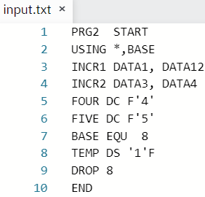
Output:
Pass 1:
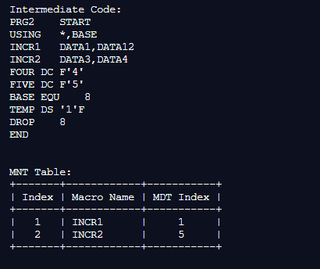
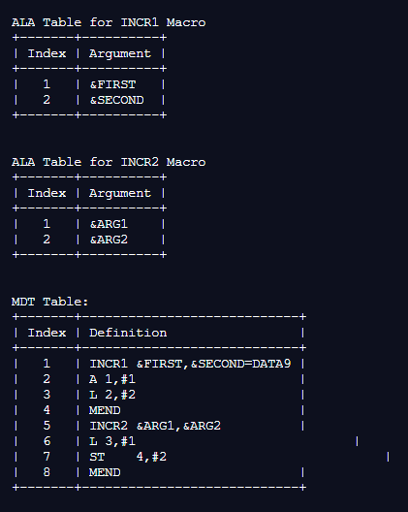
Pass 2:
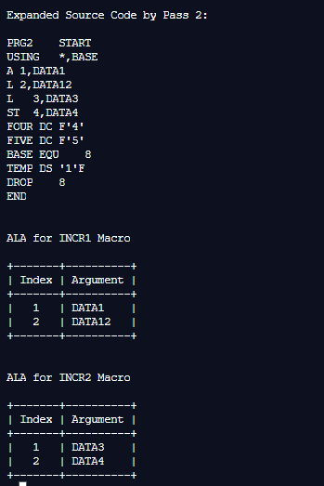
Conclusion:

We understood & implemented the working of two pass macro pre-processor and databases required for implementation of Macro Processor in python.

Post Lab Subjective Questions

- What are the tasks performed by macro processor?
Ans -
- Expanding the macros - The macro processor replaces each macro instruction with the corresponding group of source language statements.
- Macro processor processes the
  - Macro definitions
    - Define macro name, group of instructions
  - Macro invocation (macro calls)
    - A body is simply copied or substituted at the point of call
  - Expansion with substitution of parameters
    - Arguments are textually substituted for the parameters
    - The resulting procedure body is textually substituted for the call

- What is the purpose of pass1 macro processor?
Ans - The purpose of pass 1 macro processor is to use as Macros too suffer from forward reference problem. Pass 1 is used to recognize macro definition save macro definition.

- What is the purpose of pass 2 macro processor?
Ans - The purpose of pass 2 macro processor is to use as Macros too suffer from forward reference problem. Pass 2 expands all macro invocation statements.

- What is the purpose of MDT table?
Ans - The purpose of Macro Definition Table (MDT) is to store the body of macro definitions.

- What is the purpose of MNT table?
Ans – The purpose of Macro Name Table (MNT) is to store the names of macros.

- What is the use of MDI & MDLC?
Ans – MDI & MDLC stands for Macro definition indicator (MDI) and macro definition level counter (MDLC). The MDI and MDLC are the switches used to keep track of macro calls and macro definition.

Post Lab objective Questions

- In which way a macro processor for assembly language can be implemented?
- Independent two pass processor
- Independent One pass Processor
- Processor incorporated into pass I of 2-pass Assembler
- All of these above

ANS: d. All of these above

- Advantage of incorporating the Macro Processor in Pass I of assembler is that
  - Many functions have to be implemented twice
  - Functions are combined and it is not necessary to create intermediate file as output from the macro processor and input to the assembler.
  - More Flexibility is provided to the programmer in that he may use all the features of the assembler in conjunction with macros.
  - All of these above.

ANS: d. All of these above

Date: 04-12-2021 Signature of faculty in-charge

