Batch: A1 Roll No.: 1911004

Experiment No. 02

Grade: AA / AB / BB / BC / CC / CD /DD

Signature of the Staff In-charge with date

TITLE: Shell Programming and system calls
_____________________________________________________________________
AIM: To study the shell script and write the program using shell.
______________________________________________________________________
Expected Outcome of Experiment:

CO 1. To introduce basic concepts and functions of operating systems.
_____________________________________________________________________
Books/ Journals/ Websites referred:

- Silberschatz A., Galvin P., Gagne G. “Operating Systems Principles”, Willey Eight edition.
- William Stallings “Operating Systems” Person, Seventh Edition
Edition.
- Sumitabha Das “ UNIX Concepts & Applications”, McGraw Hill Second Edition.
_____________________________________________________________________
Pre Lab/ Prior Concepts:

The shell provides you with an interface to the UNIX system. It gathers input from you and executes programs based on that input. When a program finishes executing, it displays that program's output.

Shell Scripts
The basic concept of a shell script is a list of commands, which are listed in the order of execution. A good shell script will have comments, preceded by a pound sign, #, describing the steps.

Steps to create a Shell Script:
create a file using any text editor say vi, gedit, nano etc
1.$ vi filename

2.Insert the script/ commands in file and save the file to execute the file we need to give execute permission to the file
3.$ chmod 775 filename
4.Now execute the above file using any of following methods:
$ sh filename
OR
$ ./filename

NOTE: Before adding anything to your script, you need to alert the system that a shell script is being started. This is done using the shebang construct. For example −
#!/bin/sh.
______________________________________________________________________
Description of the application to be implemented:
- Write a shell Script that accepts two file names as command line arguments and compare two file contents and check whether contents are same or not. If they are same, then delete second file.

- Write a shell script that accepts integer and find the factorial of number.

- Write a shell script for adding users.

- Write a shell script for counting no of logged in users.

- Write a shell script for counting no of processes running on system
Program for System Call:
- Write a Program for creating process using System call (E.g fork()) Create a child process. Display the details about that process using getpid and getppid functions. In a child process, Open the file using file system calls and read the contents and display.
Implementation details:(printout of code / screen shot)
- Compare 2 files
Code:
echo "Enter file 1 : "
read f1
if [ ! -f "$f1" ]
then
echo "File $f1 not found..."
exit
fi
echo "Enter file 2 : "
read f2
if [ ! -f "$f2" ]
then
echo "File $f2 not found..."
exit
fi
if cmp -s $f1 $f2
then
echo "File $f1 $f2 have same content.Deleting $f2 ..."
rm $f2
echo "$f2 Deleted."
else
echo "$f1 $f2 have different content."
fi
Output:
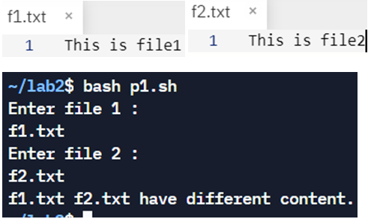
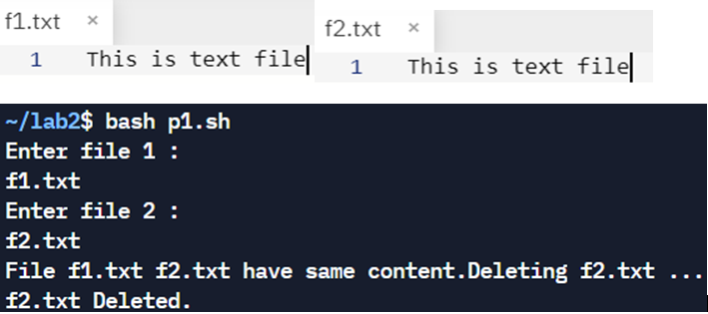
- Factorial Program
Code:
#!/bin/bash
#factorial program 2
echo "Factorial Program"
echo "Enter a no = "
read n
fac=1
if [ $n -gt 1 ]
then
for((i=2;i<=n;i++))
{
fac=$((fac*i))
}
fi
echo "Factorial of $n = $fac"
Output: 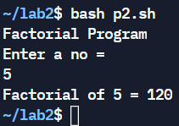 Factorial Program

- Add Users
Code:
#!/bin/bash
# Write a shell script for adding users.
read -p "Enter Username : " username
read -s -p "Enter Password : " password
useradd -m $username
echo -e "User has been added to system!"
Output: Used locally machine screen shot
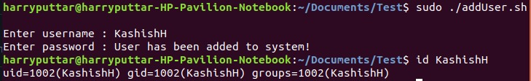

- Counting no of logged in user
Code:
#!/bin/bash
# Write a shell script for counting no of logged in users
who | wc -l
Output: on a local machine
on repl online env 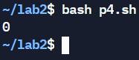

- Counting no of processes running on system
Code:
#!/bin/bash
# Write a shell script for counting no of processes running on system
ps -e | wc -l
Output: 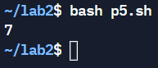
- Program for System Call
Code:
#include<stdio.h>
#include<stdlib.h>
#include<sys/types.h>
#include<unistd.h>
int main(){
int v = fork();
if(v<0){ //unsuccessful child creation
printf("Child Process wasn't created\n");
}else if(v==0){ //child process zero returned
printf("I m Child Process\n");
printf("My Process id = %d\n",getpid());
printf("Parent Process id = %d\n",getppid());
FILE *f;
f=fopen("text.txt","r");
if(f==NULL){
printf("\nFile Read Error...\n");
}else{
printf("Contents are:- \n");
char c;
while((c=fgetc(f))!=EOF)
printf("%c",c);
fclose(f);
}
}else{//parent process non zero returned
printf("I m Parent Process\n");
printf("My Process id = %d\n",getpid());
printf("Grand Parent Process id = %d\n",getppid());
printf("Child Process id = %d\n",v);
}
return 0;
}
Output:
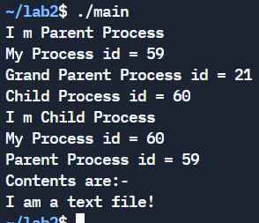 System Program
Conclusion:
We successfully understood, implemented & executed the concept of various shell & system programs on Linux.

Post Lab Descriptive Questions
- Explain in brief: Meta Characters, Positional Parameters and command substitution with example.
- Meta Character: Unix Shell provides various meta characters which have special meaning while using them in any Shell Script and causes termination of a word unless quoted.A character may be quoted (i.e., made to stand for itself) by preceding it with a \.
? | matches with a single character while listing files in a directory
* | matches more than one character
[] | Match one of a list or range (for example, ["abc", "def"] or [1..9]).
^ | Match any line or string that starts with a pattern (for example, ^gnome).
- Example:
ls file?? | All files with 2 characters after file. eg file20
ls ?file | All files with 1 characters before file eg. 1file
- Positional Parameters: Positional parameters in a shell script are nothing but the command line arguments passed to a shell script. The following are some of the positional parameters used:
$3 | Total number of arguments
$0 | Command or the script name
$1,$2,$3 | First, second and third args respectively
$* | All the command line arguments starting from $1
- Example: Output
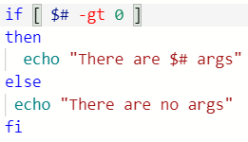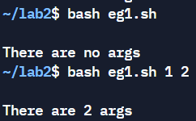
- Command Substitution: Command substitution is the mechanism by which the shell performs a given set of commands and then substitutes their output in the place of the commands.
- Example & Output:
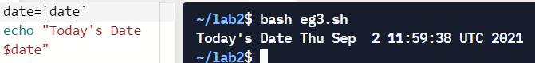

Date: 09-09-2021 Signature of faculty in-charge

