Batch: A1 Roll No.: 1911004

Experiment No. 03

Grade: AA / AB / BB / BC / CC / CD /DD

Signature of the Staff In-charge with date

TITLE: Implementation of Basic Process management algorithms – Non Pre-emptive ( FCFS , SJF, priority)
_____________________________________________________________________

AIM: To implement basic Non –Pre-emptive Process management algorithms ( FCFS , SJF , Priority)
______________________________________________________________________
Expected Outcome of Experiment:

CO 2. To understand the concept of process, thread and resource management.
_____________________________________________________________________
Books/ Journals/ Websites referred:

- Silberschatz A., Galvin P., Gagne G. “Operating Systems Principles”, Willey Eight edition.
- Achyut S. Godbole , Atul Kahate “Operating Systems” McGraw Hill Third
Edition.
- William Stallings, “Operating System Internal & Design Principles”, Pearson.
- Andrew S. Tanenbaum, “Modern Operating System”, Prentice Hall.
_____________________________________________________________________
Pre Lab/ Prior Concepts:

Most systems have a large number of processes with short CPU bursts interspersed between I/O requests and a small number of processes with long CPU bursts. To provide good time-sharing performance, we may preempt a running process to let another one run. The ready list, also known as a run queue, in the operating system keeps a list of all processes that are ready to run and not blocked on some I/O or other system request, such as a semaphore. Then entries in this list are pointers to the process control block, which stores all information and state about a process.
When an I/O request for a process is complete, the process moves from the waiting state to the ready state and gets placed on the run queue.
The process scheduler is the component of the operating system that is responsible for deciding whether the currently running process should continue running and, if not, which process should run next. There are four events that may occur where the scheduler needs to step in and make this decision:
- The current process goes from the running to the waiting state because it issues an I/O request or some operating system request that cannot be satisfied immediately.
- The current process terminates.
- A timer interrupt causes the scheduler to run and decide that a process has run for its allotted interval of time and it is time to move it from the running to the ready state.
- An I/O operation is complete for a process that requested it and the process now moves from the waiting to theready state. The scheduler may then decide to preempt the currently-running process and move this ready process into the running state.
The decisions that the scheduler makes concerning the sequence and length of time that processes may run is called the scheduling algorithm (or scheduling policy). These decisions are not easy ones, as the scheduler has only a limited amount of information about the processes that are ready to run. A good scheduling algorithm should:
- Be fair – give each process a fair share of the CPU, allow each process to run in a reasonable amount of time.
- Be efficient – keep the CPU busy all the time.
- Maximize throughput – service the largest possible number of jobs in a given amount of time; minimize the amount of time users must wait for their results.
- Minimize response time – interactive users should see good performance
- Minimize overhead – don’t waste too many resources. Keep scheduling time and context switch time at a minimum.
- Maximize resource use – favor processes that will use underutilized resources. There are two motives for this. Most devices are slow compared to CPU operations. We’ll achieve better system throughput by keeping devices busy as often as possible. The second reason is that a process may be holding a key resource and other, possibly more important, processes cannot use it until it is released. Giving the process more CPU time may free up the resource quicker.
- Avoid indefinite postponement – every process should get a chance to run eventually.
_____________________________________________________________________
Description of the application to be implemented:
- First-Come, First-Served Scheduling:
- Jobs are executed on first come, first serve basis.
- Easy to understand and implement but poor in performance as average, wait time is high
- Its implementation is based on FIFO queue.

Shortest job first :
- Best approach to minimize waiting time.
- Easy to implement in Batch systems where required CPU time is known in advance.
- Impossible to implement in interactive systems where required CPU time is not known.
- The processer should know in advance how much time process will take.

Priority scheduling
- Priority scheduling is one of the most common scheduling algorithms in batch systems.
- Each process is assigned a priority. Process with highest priority is to be executed first and so on.
- Processes with same priority are executed on first come first served basis.
- Priority can be decided based on memory requirements, time requirements or any other resource requirement.
Implementation details: (printout of code)
Code for First-Come, First-Served Scheduling:
n=int(input("Enter no of process = "))
pId=[input("Enter Process Id for Process {} = ".format(i+1)) for i in range(n)]
burstTime=[int(input("Enter Burst Time for Process {} = ".format(i+1))) for i in range(n)]
waitingTime=[0]
for i in range(1,n):
waitingTime.append(waitingTime[i-1]+burstTime[i-1])
turnaroundTime=[]
for i in range(n):
turnaroundTime.append(waitingTime[i]+burstTime[i])
print("Process Id\tBurst Time\tWaiting Time\tTurn Around Time")
for _ in range(n):
print(" {} \t {} \t {} \t {} ".format(pId[_],burstTime[_],waitingTime[_],turnaroundTime[_]))
avgWaitingTime = sum(waitingTime)/n
avgTurnaroundTime=sum(turnaroundTime)/n
print("Average Waiting Time for {} Processes = {} ms".format(n,avgWaitingTime))
print("Average Turn Around Time for {} Processes = {} ms".format(n,avgTurnaroundTime))

Output: 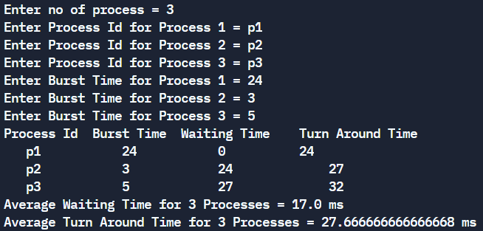
Code for shortest job first:
n=int(input("Enter no of process = "))
pId=[input("Enter Process Id for Process {} = ".format(i+1)) for i in range(n)]
burstTime=[int(input("Enter Burst Time for Process {} = ".format(i+1))) for i in range(n)]
proc = []
for p in range(n):
pT = (burstTime[p],pId[p])
proc.append(pT)
proc.sort()
TotWt = 0;turnTAt = 0;
waitingTime=[(0,proc[0][1])]
for i in range(1,n):
bT_,p_=proc[i-1]#for i-1 th process
bT,p=proc[i]#for ith process
waitingTime.append((waitingTime[i-1][0]+bT_,p))
TotWt+=waitingTime[i-1][0]+bT_
turnaroundTime=[]
for i in range(n):
turnaroundTime.append((waitingTime[i][0]+proc[i][0],proc[i][1]))
turnTAt+=waitingTime[i][0]+proc[i][0]
print("Process Id\tBurst Time\tWaiting Time\tTurn Around Time")
for _ in range(n):
print(" {} \t {} \t {} \t {} ".format(proc[_][1],proc[_][0],waitingTime[_][0],turnaroundTime[_][0]))
avgWaitingTime = TotWt/n
avgTurnaroundTime=turnTAt/n
print("Average Waiting Time for {} Processes = {} ms".format(n,avgWaitingTime))
print("Average Turn Around Time for {} Processes = {} ms".format(n,avgTurnaroundTime))

Output: 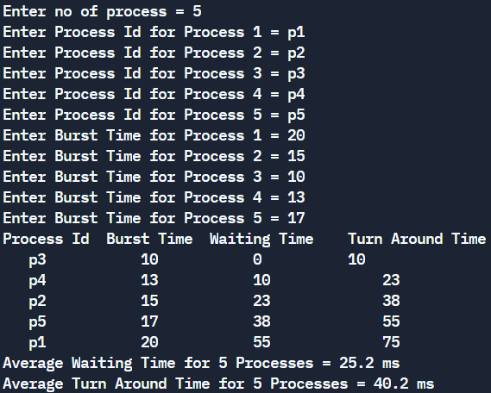
Code for Priority scheduling:
n=int(input("Enter no of process = "))
pId=[input("Enter Process Id for Process {} = ".format(i+1)) for i in range(n)]
burstTime=[int(input("Enter Burst Time for Process {} = ".format(i+1))) for i in range(n)]
priority =[int(input("Enter Priority of Process {} = ".format(i+1))) for i in range(n)];proc = [];
for p in range(n):
pT = (priority[p],burstTime[p],pId[p])
proc.append(pT)
proc.sort()
TotWt = 0;turnTAt = 0;
waitingTime=[(0,proc[0][2])]
for i in range(1,n):
prio_o,bT_,p_=proc[i-1]#for i-1 th process
prio,bT,p=proc[i]#for ith process
waitingTime.append((waitingTime[i-1][0]+bT_,p))
TotWt+=waitingTime[i-1][0]+bT_
turnaroundTime=[]
for i in range(n):
turnaroundTime.append((waitingTime[i][0]+proc[i][1],proc[i][2]))
turnTAt+=waitingTime[i][0]+proc[i][0]
print("Process Id\tBurst Time\tPriority\tWaiting Time\tTurn Around Time")
for _ in range(n):
print(" {} \t {} \t {} \t {} \t {} ".format(proc[_][2],proc[_][1],proc[_][0],waitingTime[_][0],turnaroundTime[_][0]))
avgWaitingTime = TotWt/n
avgTurnaroundTime=turnTAt/n
print("Average Waiting Time for {} Processes = {} unit".format(n,avgWaitingTime))
print("Average Turn Around Time for {} Processes = {} unit".format(n,avgTurnaroundTime))

Output: 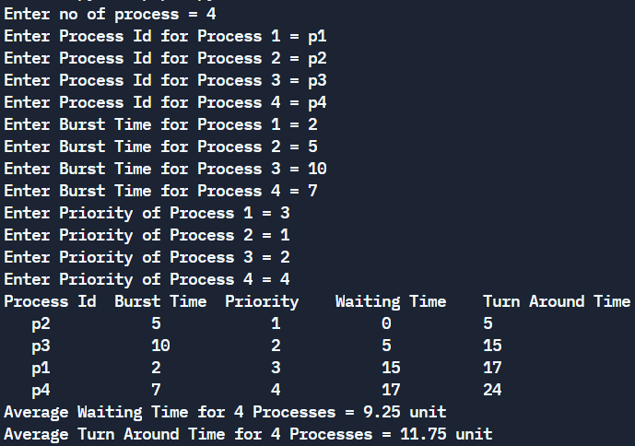
Conclusion: We successfully understood & implemented various non-preemptive algorithms in python.
Post Lab Objective Questions

  - What is the ready state of a process?
a) when process is scheduled to run after some execution
b) when process is unable to run until some task has been completed
c) when process is using the CPU
d) none of the mentioned
Ans: a) when process is scheduled to run after some execution

  - A process stack does not contain
a) function parameters
b) local variables
c) return addresses
d) PID of child process
Ans: d) PID of child process

  - A process can be terminated due to
a) normal exit
b) fatal error
c) killed by another process
d) all of the mentioned
Ans: d) all of the mentioned

Date : 22-09-2021 Signature of faculty in-charge

