Batch: A1 Roll No.: 1911004

Experiment No. 04

Grade: AA / AB / BB / BC / CC / CD /DD

Signature of the Staff In-charge with date

TITLE: Implementation of Basic Process management algorithms - Preemptive (SRTN, RR, priority )
_____________________________________________________________________
AIM: To implement basic Process management algorithms ( Round Robin,SRTN, Priority)
______________________________________________________________________
Expected Outcome of Experiment:

CO 2. To understand the concept of process, thread and resource management.
_____________________________________________________________________
Books/ Journals/ Websites referred:

- Silberschatz A., Galvin P., Gagne G. “Operating Systems Principles”, Willey Eight edition.
- Achyut S. Godbole , Atul Kahate “Operating Systems” McGraw Hill Third Edition.
- William Stallings, “Operating System Internal & Design Principles”, Pearson.
- Andrew S. Tanenbaum, “Modern Operating System”, Prentice Hall.
_____________________________________________________________________
Pre Lab/ Prior Concepts:

Most systems have a large number of processes with short CPU bursts interspersed between I/O requests and a small number of processes with long CPU bursts. To provide good time-sharing performance, we may preempt a running process to let another one run. The ready list, also known as a run queue, in the operating system keeps a list of all processes that are ready to run and not blocked on some I/O or other system request, such as a semaphore. Then entries in this list are pointers to the process control block, which stores all information and state about a process.
When an I/O request for a process is complete, the process moves from the waiting state to the ready state and gets placed on the run queue.
The process scheduler is the component of the operating system that is responsible for deciding whether the currently running process should continue running and, if not, which process should run next. There are four events that may occur where the scheduler needs to step in and make this decision:
- The current process goes from the running to the waiting state because it issues an I/O request or some operating system request that cannot be satisfied immediately.
- The current process terminates.
- A timer interrupt causes the scheduler to run and decide that a process has run for its allotted interval of time and it is time to move it from the running to the ready state.
- An I/O operation is complete for a process that requested it and the process now moves from the waiting to theready state. The scheduler may then decide to preempt the currently-running process and move this ready process into the running state.
The decisions that the scheduler makes concerning the sequence and length of time that processes may run is called the scheduling algorithm (or scheduling policy). These decisions are not easy ones, as the scheduler has only a limited amount of information about the processes that are ready to run. A good scheduling algorithm should:
- Be fair – give each process a fair share of the CPU, allow each process to run in a reasonable amount of time.
- Be efficient – keep the CPU busy all the time.
- Maximize throughput – service the largest possible number of jobs in a given amount of time; minimize the amount of time users must wait for their results.
- Minimize response time – interactive users should see good performance
- Minimize overhead – don’t waste too many resources. Keep scheduling time and context switch time at a minimum.
- Maximize resource use – favor processes that will use underutilized resources. There are two motives for this. Most devices are slow compared to CPU operations. We’ll achieve better system throughput by keeping devices busy as often as possible. The second reason is that a process may be holding a key resource and other, possibly more important, processes cannot use it until it is released. Giving the process more CPU time may free up the resource quicker.
- Avoid indefinite postponement – every process should get a chance to run eventually.
_____________________________________________________________________
Description of the application to be implemented:
- Round Robin Algorithm
Round Robin is a CPU scheduling algorithm where each process is assigned a fixed
time slot in a cyclic way.

- It is simple, easy to implement, and starvation-free as all processes get fair share of CPU.
- One of the most commonly used technique in CPU scheduling as a core.
- It is preemptive as processes are assigned CPU only for a fixed slice of time at most.
The disadvantage of it is more overhead of context switching.

Shortest Remaining Time First Algorithm :
This Algorithm is the preemptive version of SJF scheduling. In SRTF, the execution of the process can be stopped after certain amount of time. At the arrival of every process, the short term scheduler schedules the process with the least remaining burst time among the list of available processes and the running process.
Once all the processes are available in the ready queue, No preemption will be done and the algorithm will work as SJF scheduling. The context of the process is saved in the Process Control Block when the process is removed from the execution and the next process is scheduled. This PCB is accessed on the next execution of this process.

Priority scheduling:
In Preemptive Priority Scheduling, at the time of arrival of a process in the ready queue, its Priority is compared with the priority of the other processes present in the ready queue as well as with the one which is being executed by the CPU at that point of time. The One with the highest priority among all the available processes will be given the CPU next.
The difference between preemptive priority scheduling and non-preemptive priority scheduling is that, in the preemptive priority scheduling, the job which is being executed can be stopped at the arrival of a higher priority job.
Once all the jobs get available in the ready queue, the algorithm will behave as non- preemptive priority scheduling, which means the job scheduled will run till the completion and no preemption will be done.

Implementation details: (printout of code)
Code – Round Robin :
n=int(input("Round Robin\nEnter no of process = "))
quantum = int(input("Enter Time Quantum = "))
pId=[input("Enter Process Id for Process {} = ".format(i+1)) for i in range(n)]
burstTime=[int(input("Enter Burst Time for Process {} = ".format(i+1))) for i in range(n)]
remP = burstTime[:]#rem proc
arrivalTime=[int(0) for i in range(n)] ; allPDone = [int(0) for i in range(n)]
waitTime = [0]*n ; turnAT = [0]*n ; totalT = 0 ; ganttChart = []
while(remP!=allPDone):
for i in range(n):
if (remP[i]<=0): continue
elif (remP[i]>0):
_t = totalT
if (remP[i]>quantum):
totalT+=quantum
remP[i]-=quantum
else:
totalT+=remP[i]
waitTime[i] = totalT - burstTime[i]
turnAT[i] = waitTime[i] + burstTime[i]
remP[i]-=remP[i]
ganttChart.append((_t,pId[i]))
print("\nProcess Id\t Arrival Time\t Burst Time\t TurnAround Time\t Waiting Time")
for i in range(0,n): print(f' \t {pId[i]}\t\t \t \t{arrivalTime[i]}\t\t \t \t {burstTime[i]}\t\t\t \t {turnAT[i]}\t\t \t \t {waitTime[i]}')
print("Gantt Chart =",ganttChart)
print("Average waiting time = %.5f ms"%(sum(waitTime)/n))
print("Average turn around time = %.5f ms"%(sum(turnAT)/n))
Output:
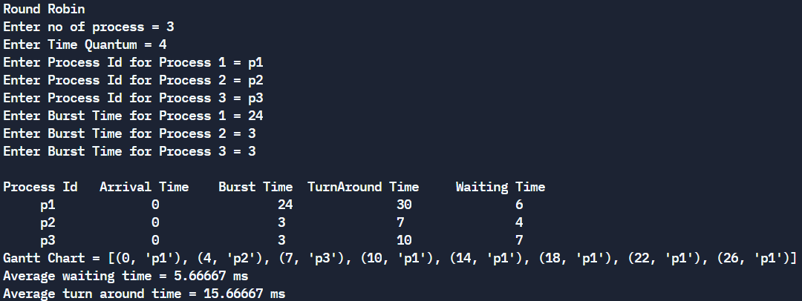
Code – Shortest Remaining Time First:
n=int(input("Enter no of process = "))
pId=[input("Enter Process Id for Process {} = ".format(i+1)) for i in range(n)]
burstTime=[int(input("Enter Burst Time for Process {} = ".format(i+1))) for i in range(n)]
remP = burstTime[:]#rem proc
arrivalTime=[int(input("Enter Arrival Time of Process {} = ".format(i+1))) for i in range(n)]#input("Enter Arrival Time for Process {} = ".format(i+1))
ganttChart = [0]
allPDone = [int(0) for i in range(n)] ; waitTime = [0]*n ; turnAT = [0]*n
compT = [0]*n ; totalT = 0 ; currentT = 0 ; pDone = 0 ; Q = {}
ganttChart[0] = pId[arrivalTime.index(min(arrivalTime))]
while(pDone!=n):
if(currentT in arrivalTime):
i = arrivalTime.index(currentT)
Q[i] = remP[i]
minRemPT = min(Q.values())
minRemP = [p for p in Q if Q[p]==minRemPT]
if (len(minRemP)>1):
arrT = [arrivalTime[p] for p in minRemP]
p = arrivalTime.index(min(arrT))
else: p = minRemP[0]
Q.pop(p)
currentT+=1 ; remP[p]-=1
if (remP[p]==0):
compT[p]= currentT
turnAT[p]=compT[p]-arrivalTime[p]
waitTime[p] = turnAT[p]-burstTime[p]
pDone+=1
else: Q[p]=remP[p]
if(ganttChart[-1]!=pId[p]): ganttChart.append(pId[p])
print("\nShortest remaining time first:")
print("\nProcess Id\t Arrival Time\t Burst Time\t Completion Time\t TurnAround Time\t Waiting Time")
for i in range(0,n):
print(f' \t {pId[i]}\t\t \t \t {arrivalTime[i]}\t\t \t \t {burstTime[i]}\t\t \t \t {compT[i]}\t\t \t \t {turnAT[i]}\t\t \t \t {waitTime[i]}')
print("Gantt Chart =",ganttChart)
#waitingTime=[0]
print("Average waiting time = %.5f ms"%(sum(waitTime)/n))
print("Average turn around time = %.5f ms"%(sum(turnAT)/n))

Output:
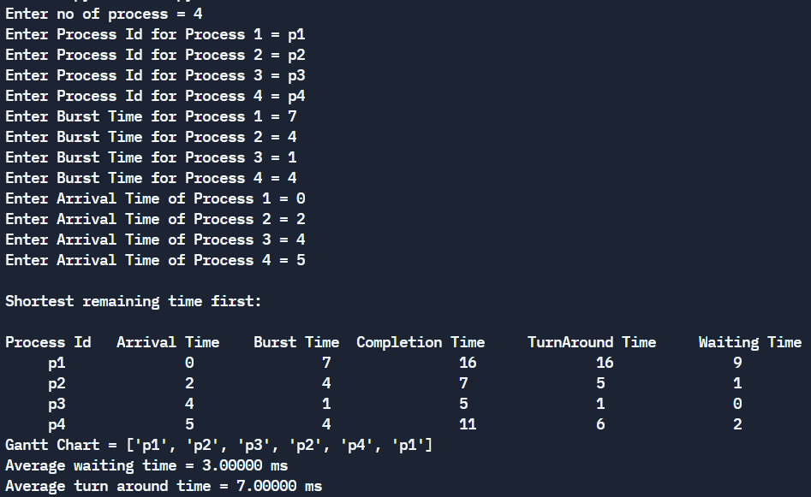
Code – Preemptive Priority Algorithm :
n=int(input("Enter no of process = "))
pId=[input("Enter Process Id for Process {} = ".format(i+1)) for i in range(n)]
burstTime=[int(input("Enter Burst Time for Process {} = ".format(i+1))) for i in range(n)]
pri=[int(input("Enter Priority of Process {} = ".format(i+1))) for i in range(n)]
remP = burstTime[:]#rem proc Time
arrivalTime=[int(input("Enter Arrival Time of Process {} = ".format(i+1))) for i in range(n)]#input("Enter Arrival Time for Process {} = ".format(i+1))
ganttChart = [0]
allPDone = [int(0) for i in range(n)];waitTime = [0]*n;turnAT = [0]*n;compT = [0]*n
totalT = 0;currentT = 0;pDone = 0;Q = {}
ganttChart[0] = pId[arrivalTime.index(min(arrivalTime))]
while(pDone!=n):
if(currentT in arrivalTime):
i = arrivalTime.index(currentT)
Q[i] = pri[i]
p = list(Q.keys())[list(Q.values()).index(min(Q.values()))]
Q.pop(p)
currentT+=1 ; remP[p]-=1
if (remP[p]==0):
compT[p]= currentT
turnAT[p]=compT[p]-arrivalTime[p]
waitTime[p] = turnAT[p]-burstTime[p]
pDone+=1
else: Q[p]=pri[p]
if(ganttChart[-1]!=pId[p]): ganttChart.append(pId[p])
print("\nPreemptive Priority Algo:\n\nProcess Id\t Arrival Time\t Burst Time\t Priority\t Completion Time\t TurnAround Time\t Waiting Time")
for i in range(0,n): print(f' \t{pId[i]}\t\t \t {arrivalTime[i]}\t \t \t {burstTime[i]}\t\t \t\t {pri[i]}\t\t\t \t {compT[i]}\t \t \t {turnAT[i]}\t \t \t \t {waitTime[i]}')
print("Gantt Chart =",ganttChart)
print("Average waiting time = %.5f unit"%(sum(waitTime)/n))
print("Average turn around time = %.5f unit"%(sum(turnAT)/n))

Output:
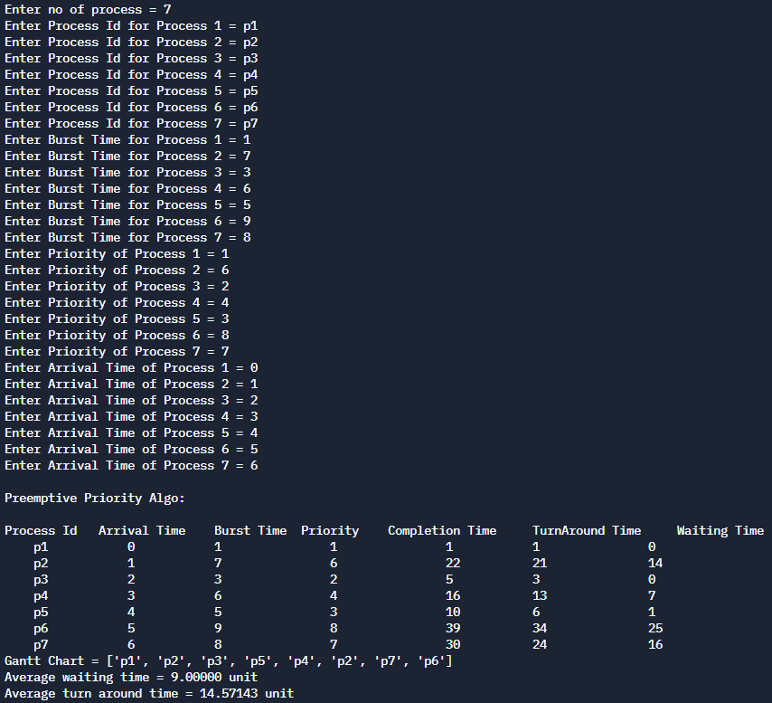
Conclusion:
We successfully understood & implemented preemptive algorithms in python.
Post Lab Descriptive Questions

- Consider three processes, all arriving at time zero, with total execution time of 10, 20 and 30 units, respectively. Each process spends the first 20% of execution time doing I/O, the next 70% of time doing computation, and the last 10% of time doing I/O again. The operating system uses a shortest remaining compute time first scheduling algorithm and schedules a new process either when the running process gets blocked on I/O or when the running process finishes its compute burst. Assume that all I/O operations can be overlapped as much as possible. For what percentage of time does the CPU remain idle?

- Answer:
Let three processes be p0, p1 and p2. Their execution time is 10, 20 and 30 respectively. p0 spends first 2 time units in I/O, 7 units of CPU time and finally 1 unit in I/O. p1 spends first 4 units in I/O, 14 units of CPU time and finally 2 units in I/O. p2 spends first 6 units in I/O, 21 units of CPU time and finally 3 units in I/O.

idle p0 p1 p2 idle
2 9 23 44 47

Total time spent = 47

Idle time = 2 + 3 = 5

Percentage of idle time = (5/47)*100 = 10.6 %

- What is Starvation?
- Answer:
Starvation is the phenomena in which a process is not able to acquire the desired resources (like processor, I/O device etc.) for a very long time to progress with its execution. This can happen due to drawbacks of scheduling algorithms. Scheduling algorithms are used to decide to which process the resource(s) needs to be given next.
Example:
- In Shortest Job First Algorithm, if there is a process with a rather large CPU burst waiting for its execution and a stream of processes with smaller CPU burst keep entering the ready queue (a queue consisting of those processes which are ready to execute), then the CPU will always be allocated to the process with the shorter CPU burst and there is a probability that the process with the large CPU burst might never get the CPU to complete its execution and starve.
- In Priority Scheduling, a constant stream of high priority processes might starve one or more lower priority process(es) as the CPU will always be allocated to the process with highest priority.

There are various solutions for the problem of starvation. In Priority Scheduling, Aging is used to increase the priority of all the processes in the ready queue at constant intervals of time so as to make sure that every process will ultimately reach top priority and execute. Various other methods exist.

Date: 30-09-2021 Signature of faculty in-charge

