Batch: A1 Roll No.: 1911004

Experiment No. 05

Grade: AA / AB / BB / BC / CC / CD /DD

Signature of the Staff In-charge with date

TITLE: Implementation of Process synchronization algorithms using semaphore - producer consumer problem , reader-writers problem
_____________________________________________________________________

AIM: Implementation of Process synchronization algorithms using semaphore - producer consumer problem, reader-writers problem
______________________________________________________________________
Expected Outcome of Experiment:

CO 3. To understand the concepts of process synchronization and deadlock.
_____________________________________________________________________
Books/ Journals/ Websites referred:

- Silberschatz A., Galvin P., Gagne G. “Operating Systems Principles”, Willey Eight edition.
- Achyut S. Godbole , Atul Kahate “Operating Systems” McGraw Hill Third
Edition.
- William Stallings, “Operating System Internal & Design Principles”, Pearson.
- Andrew S. Tanenbaum, “Modern Operating System”, Prentice Hall.
_____________________________________________________________________
Pre Lab/ Prior Concepts:

Knowledge of Concurrency, Mutual Exclusion, Synchronization, Deadlock, Starvation.
_____________________________________________________________________

Description of the chosen process synchronization algorithm:
Readers-Writer problem is a classic example of synchronization problem. There is a shared resource which should be accessed by multiple processes. There are two types of processes in this context. They are reader & writer. Any number of readers can read from the shared resource simultaneously, but only one writer can write to the shared resource. When a writer is writing data to the resource, no other process can access the resource. A writer cannot write to the resource if there are non-zero number of readers accessing the resource. From, the above problem statement, it is evident that readers have higher priority than writer. If a writer wants to write to the resource, it must wait until there are no readers currently accessing that resource.
Here, we use one mutex m and a semaphore w. An integer variable read count is used to maintain the number of readers currently accessing the resource. The variable read count is initialized to 0. A value of 1 is given initially to m and w. Instead of having the process to acquire lock on the shared resource, we use the mutex m to make the process to acquire and release lock whenever it is updating the read count variable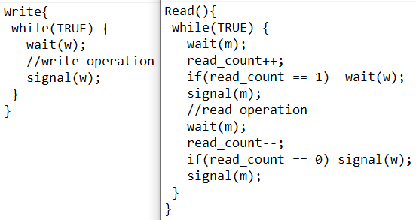
Implementation details: (printout of code)
Producer – Consumer:
Code:
print("Consumer/Producer Problem")
def wait(semaphore):
semaphore -= 1
return semaphore

def signal(semaphore):
semaphore += 1
return semaphore

def producer(item):# producer adds data into buffer
global mutex, empty, full, buffer
empty = wait(empty)
mutex = wait(mutex)
print("\nProducer produces item ", item)
buffer.append(item)
mutex = signal(mutex)
full = signal(full)
print("Buffer =", buffer)

def consumer():# consumer consumes data from buffer
global mutex, empty, full, buffer
full = wait(full)
mutex = wait(mutex)
print("\nConsumer consumes item ", buffer.pop(0))
mutex = signal(mutex)
empty = signal(empty)
print("Buffer =", buffer)

n = int(input("Enter size of buffer = "))
buffer = [];mutex = 1;empty = n;full = 0

while True:
choice = int(input("1.Producer \t2.Consumer \t0. Quit \nEnter Choice = "))
if choice == 1: # if process !locked and the buffer !full
if mutex == 1 and empty != 0:
item = input("Enter item to add = ")
producer(item)
else:
print("Buffer =", *buffer)
print("Buffer is Full...")
elif choice == 2: # if process !locked and the buffer ! empty
if mutex == 1 and full != 0:
consumer()
else:
print("Buffer is Empty...")
elif choice == 0: break
else: print("Invalid choice")
Output:
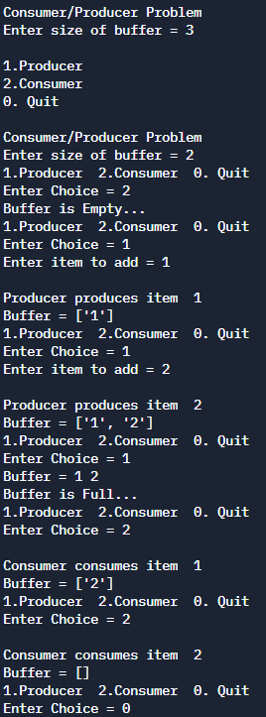
Readers-Writers:
Code:
import threading
import time
print("Readers-Writers")
rCnt = 0;mutex = threading.Lock();rwMutex = threading.Lock()

def wait_mutex():
global mutex
while mutex==0: continue
mutex=0
def wait_rw():
global rwMutex
while rwMutex==0: continue
rwMutex=0
def signal_mutex():
global mutex
mutex=1
def signal_rw():
global rwMutex
rwMutex=1

def reader():
global rCnt,mutex,rwMutex
while True:
mutex.acquire()#wait
rCnt+=1
print(f'Number of current readers: {rCnt}')
if rCnt == 1:
rwMutex.acquire()#wait
mutex.release()#signal
print(f'Read by {threading.current_thread().name}')
time.sleep(2)#read time
mutex.acquire()#wait
rCnt-=1
if rCnt == 0:
rwMutex.release()#signal
mutex.release()#signal
print(f'{threading.current_thread().name} has finished reading...')
break

def writer():
global mutex,rwMutex
while True:
rwMutex.acquire()#wait
print(f'Write by {threading.current_thread().name}')
time.sleep(3)#write time
rwMutex.release()#signal
print(f'{threading.current_thread().name} has finished writing...')
break
def begin():
T1 = threading.Thread(target=writer, name='Thread-1')
T2 = threading.Thread(target=writer, name='Thread-2')
T3 = threading.Thread(target=reader, name='Thread-3')
T4 = threading.Thread(target=reader, name='Thread-4')

T1.start();T2.start();T3.start();T4.start()
T1.join();T2.join();T3.join();T4.join()
print('Read & Write completed...')
begin()
Output:
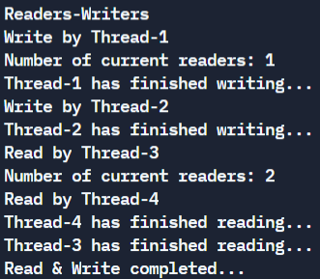
Conclusion:
We successfully understood & implemented the producer-consumer & readers-writers program in python.
Post Lab Objective Questions

- A semaphore is a shared integer variable
  - That can’t drop below zero
  - That can’t be more than
  - That can’t drop below one
Ans: a) That can’t drop below zero
- Mutual exclusion can be provided by the
  - Mute locks
  - Binary semaphores
  - Both a and b
  - None of these
Ans: c) Both a and b
- A monitor is a module that encapsulates
  - Shared data structures
  - Procedures that operate on shared data structure
  - Synchronization between concurrent procedure invocation
  - All of the above
Ans: d) All of the above
- To enable a process to wait within the monitor
  - A condition variable must be declared as condition
  - Condition Variables must be used as Boolean objects
  - Semaphore must be used
  - All of the above
Ans: a) A condition variable must be declared as condition

Date: 27-10-2021 Signature of faculty in-charge

