Batch: A1 Roll No.: 1911004

Experiment No. 06

Grade: AA / AB / BB / BC / CC / CD /DD

Signature of the Staff In-charge with date

TITLE: Implementation of dining philosopher problem using threads.
_____________________________________________________________________

AIM: Implementation of Process synchronization algorithms using threads – Dining Philosopher problem
______________________________________________________________________
Expected Outcome of Experiment:

CO 2. To understand the concept of process, thread and resource management.
CO 3. To understand the concepts of process synchronization and deadlock.
_____________________________________________________________________
Books/ Journals/ Websites referred:

- Silberschatz A., Galvin P., Gagne G. “Operating Systems Principles”, Willey Eight edition.
- Achyut S. Godbole , Atul Kahate “Operating Systems” McGraw Hill Third
Edition.
- William Stallings, “Operating System Internal & Design Principles”, Pearson.
- Andrew S. Tanenbaum, “Modern Operating System”, Prentice Hall.
_____________________________________________________________________
Pre Lab/ Prior Concepts:

Knowledge of Concurrency, Mutual Exclusion, Synchronization, Deadlock, Starvation, threads.
_____________________________________________________________________

Description of the chosen process synchronization algorithm:
This solution avoids deadlock by never waiting for a chopstick while having one in hand. A philosopher should only be allowed to pick their chopsticks if both are available at the same time. Deadlock is avoided by never waiting for a chopstick while holding a chopstick.
- Every Philosopher needs two forks in order to eat.
- Every Philosopher may pick up the forks on the left or right but only one fork at once.
- Philosophers only eat when they had two forks. We have to design such a protocol i.e. pre and post protocol which ensures that a philosopher only eats if he or she had two forks.
- Each fork is either clean or dirty.
Implementation details: (printout of code)
import threading
import time
chopsticks = [threading.Lock() for i in range(5)];currentEater = []
print("Dining Philosopher")

class Philosopher(threading.Thread):
def __init__(self,index):
threading.Thread.__init__(self)
self.index = int(index)
def run(self):
global chopsticks
global currentEater
while True:
print('Philosopher',self.index,'is thinking...\n')
chopsticks[self.index].acquire()
chopsticks[(self.index+1)%5].acquire()
currentEater.append(self.index)
print('Philosopher',self.index,'is eating....\n')
print('Current eaters = ',currentEater)
time.sleep(2.5)
print('Philosopher',self.index,'has finished eating\n')
currentEater.remove(self.index)
chopsticks[self.index].release()
chopsticks[(self.index+1)%5].release()
break
p0 = Philosopher(0);p1 = Philosopher(2);p2 = Philosopher(1);p3 = Philosopher(3);p4 = Philosopher(4)
p0.start();p1.start();p2.start();p3.start();p4.start()
p0.join();p1.join();p2.join();p3.join();p4.join()
Output:
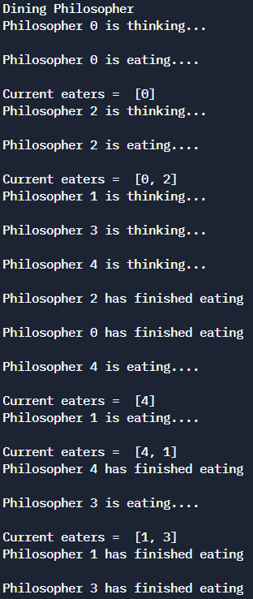
Conclusion: Thus, we have successfully understood and implemented the concept of Dining Philosopher using threads in python.
Post Lab Descriptive Questions
- Differentiate between a monitor, semaphore and a binary semaphore?
Ans – Monitor - Same as lock block. Limited to single process. Light weight. Allows single thread at a time.
Binary Semaphore - Can be shared across processes. Heavy weight compared to Monitor. Allows single thread at a time.
Semaphore - Similar to Mutex but allows multiple threads at the same time which can be configured. A Semaphore with count 1 is Mutex.
- Define clearly the dining-philosophers problem?
The Dining Philosopher Problem states that K philosophers seated around a
circular table with one chopstick between each pair of philosophers. There is one
chopstick between each philosopher. A philosopher may eat if he can pickup the two
chopsticks adjacent to him. One chopstick may be picked up by any one of its adjacent
followers but not both.
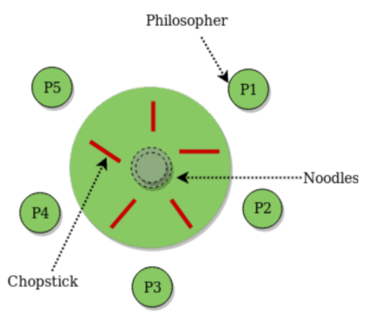
- Identify the scenarios in the dining-philosophers problem that leads to the deadlock situations?
Ans - The following conditions are necessary and sufficient for a system to be in
deadlock: - mutual exclusion: multiple threads cannot simultaneously hold the
same resource
- hold and wait: threads can hold one resource while waiting for another
- no pre-emption: it is impossible to force a thread to relinquish a resource until it has completed its task
- circular wait: there is a thread that is currently waiting for another thread, which is currently waiting for another thread, which is currently waiting on the first thread.

The circular wait condition can be easily explained using a resource allocation graph. The graph is drawn according to the following rules:
- vertices represent either threads (drawn as ovals) or resources (drawn as rectangles).
- an edge from a thread to a resource indicates that the thread is waiting to acquire the resource
- an edge from a resource to a thread indicates that the thread is holding the resource
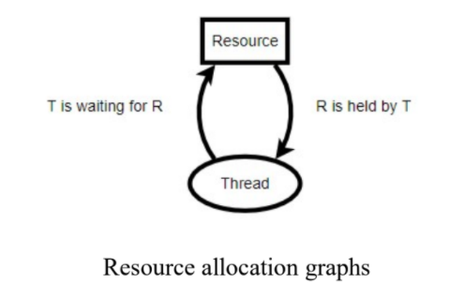

Assuming mutual exclusion, no pre-emption, and hold and wait, the system is deadlocked if and only if there is a (directed) cycle in the resource allocation graph. Here is the graph for the deadlocked dining philosopher’s scenario described above:
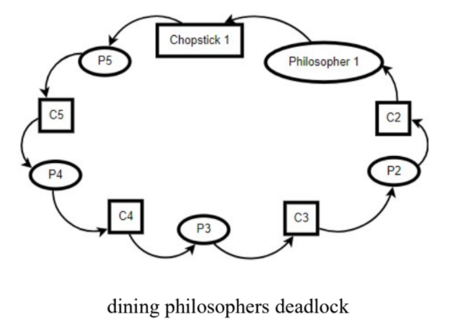
Date: 31-10-2021 Signature of faculty in-charge

