Batch: A1 Roll No.: 1911004

Experiment No. 07

Grade: AA / AB / BB / BC / CC / CD /DD

Signature of the Staff In-charge with date

TITLE: Simulate Bankers Algorithm for Deadlock Avoidance
_____________________________________________________________________

AIM: Implementation of Banker’s Algorithm for Deadlock Avoidance
______________________________________________________________________
Expected Outcome of Experiment:

CO 3. To understand the concepts of process synchronization and deadlock.
________________________________________________________________
Books/ Journals/ Websites referred:

- Silberschatz A., Galvin P., Gagne G. “Operating Systems Principles”, Willey Eight edition.
- Achyut S. Godbole , Atul Kahate “Operating Systems” McGraw Hill Third Edition.
- William Stallings, “Operating System Internal & Design Principles”, Pearson.
- Andrew S. Tanenbaum, “Modern Operating System”, Prentice Hall.
_____________________________________________________________________
Pre Lab/ Prior Concepts:

Knowledge of deadlocks and all deadlock avoidance methods.
Description of the application to be implemented:
The Banker's algorithm is a resource allocation and deadlock avoidance algorithm developed by Edsger Dijkstra.

DATA STRUCTURES
(where n is the number of processes in the system and m is the number of resource types)
The various data structures used with bankers algorithm are:
- Total_resource[ n ]: A 1-D matrix of size n. It stores the total resources of each type in a system.
- Max[m, n]: A 2-D matrix where each process stores the maximum demand of resources (Rj) of process Pi.
- Allocation [m , n]: A 2-D matrix which stores the current allocation status of all resource types to various processes in the system.
- Need [m , n]: A 2-D matrix which tells the current remaining resource need of each process. It is the maximum demand of a process and the current allocation status.
Need[ i,j]= Max[i , j ] - Allocation [i , j].
- Avail[ n ]: A 1-D matrix which stores the current available instances of each resource type.
Implementation details: (printout of code)
Code:
from prettytable import PrettyTable

processTable = PrettyTable(["Process", "Allocation", "Max Need","Remaining Need"])
numPro = int(input('Enter the number of processes: '))
numRes = int(input('Enter the number of resources: '))
totalResources = [int(x) for x in (input('Enter the total resource for each one: ')).split()]
allocation = [];maxN = [];sumAllocated = [];available = [];work = [];remaining_need = [];safeSeq = [];finish = [False for i in range(numPro)]

for i in range(numPro):
temp = []
print("Process ",i)
for j in range(numRes):
#print('Resource ',j,end=" ")
temp.append(int(input("Resource{} = ".format(j))))
allocation.append(temp)
for i in range(numPro):
temp = []
print("Process "+str(i))
for j in range(numRes):
#print('Max need of Resource'+str(j),end=" ")
temp.append(int(input('Max need of Resource{} = '.format(j))))
maxN.append(temp)
i = 0
while i<numRes:
Sum = 0
for process in allocation: Sum +=process[i]
sumAllocated.append(Sum)
i+=1
for i in range(numRes):
available.append(totalResources[i]-sumAllocated[i])
work.append(totalResources[i]-sumAllocated[i])
for i in range(numPro):
temp = []
for j in range(numRes): temp.append(maxN[i][j] - allocation[i][j])
remaining_need.append(temp)
print(remaining_need)
check = 1
falseCnt = numPro;falseCntPrev = numPro
while False in finish:
for i in range(numPro):
check = 1
for j in range(numRes):
if (remaining_need[i][j] > work[j]) or (finish[i] == True): check = 0
if check == 1:
for k in range(numRes): work[k] += allocation[i][k]
finish[i] = True
falseCnt -=1
safeSeq.append(('P'+str(i)))
print('Process P'+str(i)+' ACCEPTED')
else: print('Process P'+str(i)+' REJECTED')
print('Resources required',remaining_need[i])
print('Work',work)
print('\n')
if falseCnt == falseCntPrev:
print('Deadlock')
break
else: falseCntPrev = falseCnt

for i in range(numPro): processTable.add_row([str('P'+str(i)),allocation[i],maxN[i],remaining_need[i]])
print(processTable)
print('Safe Sequence: ',safeSeq)

Output:
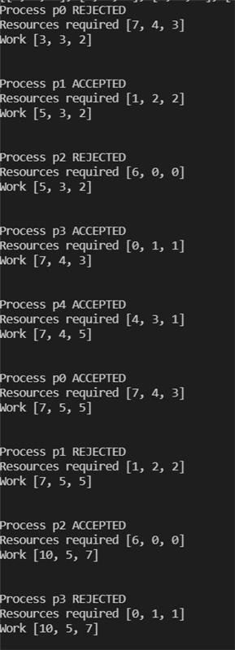
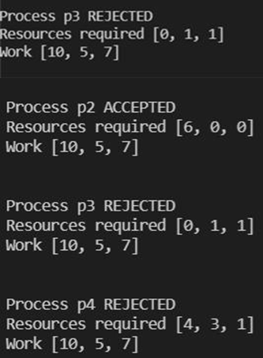
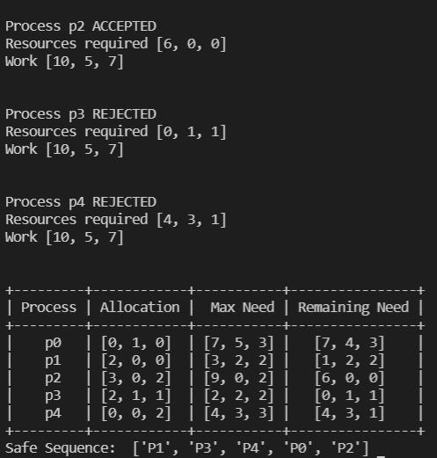
Conclusion:
We successfully understood the concept of Banker’s algorithm to avoid deadlock and implemented it in python.
Post Lab Objective Questions

- The wait-for graph is a deadlock detection algorithm that is applicable when:
  - All resources have a single instance
  - All resources have multiple instances
  - Both a and b
  - None of the above
Ans: a) All resources have a single instance
- Resources are allocated to the process on non-sharable basis is _
  - Hold and Wait
  - Mutual Exclusion
  - No pre-emption
  - Circular Wait
Ans: b) Mutual Exclusion
- Which of the following approaches require knowledge of the system state?
  - Deadlock Detection
  - Deadlock Prevention
  - Deadlock Avoidance
  - All of the above
Ans: d) All of the above
- Consider a system having ‘m’ resources of the same type. These resources are shared by 3 processes A, B, C which have peak time demands of 3, 4, 6 respectively. The minimum value of ‘m’ that ensures that deadlock will never occur is
a) | 11
b) | 12
c) | 13
d)  A | 14
Ans: | c.13
Post Lab Descriptive Questions
1. Consider a system with total of 150 units of memory allocated to three processes as shown:

Process | Max | Hold
P1 | 70 | 45
P2 | 60 | 40
P3 | 60 | 15
Apply Banker’s algorithm to determine whether it would be safe to grant each of the following request. If yes, indicate sequence of termination that could be possible.
- The P4 process arrives with max need of 60 and initial need of 25 units.
- The P4 process arrives with max need of 60 and initial need of 35 units.
Answer:
- Yes it will be safe. The table becomes:

Process Id | Max | Hold | Need
P1 | 70 | 45 | 25
P2 | 60 | 40 | 20
P3 | 60 | 15 | 45
P4 | 60 | 25 | 35

The system is in a safe state.
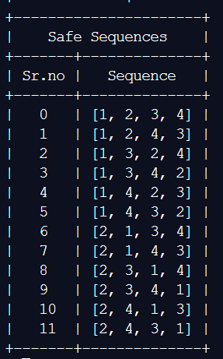
- No. If P4 wants to hold 35 units, then total remaining resources=15(150-Total(Hold)). The table becomes:
Process Id | Max | Hold | Need
P1 | 70 | 45 | 25
P2 | 60 | 40 | 20
P3 | 60 | 15 | 45
P4 | 60 | 35 | 25

Therefore, no safe state is available. Cannot process the request.

Date: 17-11-2021 Signature of faculty in-charge

