Batch: A1 Roll No.: 1911004

Experiment No. 08

Grade: AA / AB / BB / BC / CC / CD /DD
Signature of the Staff In-charge with date

TITLE: Disk Scheduling Algorithms
_____________________________________________________________________

AIM: Implementation of Disk Scheduling Algorithm like FCFS, SSTF, SCAN, CSCAN, LOOK.
_____________________________________________________________________
Expected Outcome of Experiment:

CO 4. To understand various Memory, I/O and File management techniques.
_____________________________________________________________
Books/ Journals/ Websites referred:

- Silberschatz A., Galvin P., Gagne G. “Operating Systems Principles”, Willey Eight edition.
- Achyut S. Godbole , Atul Kahate “Operating Systems” McGraw Hill Third
Edition.
- William Stallings, “Operating System Internal & Design Principles”, Pearson.
- Andrew S. Tanenbaum, “Modern Operating System”, Prentice Hall.
_____________________________________________________________________
Pre Lab/ Prior Concepts:
- Knowledge of disk scheduling algorithm.
- Calculation of seek time and transfer time etc.

Description of the application to be implemented:
First Come-First Serve (FCFS):
FCFS is the simplest of all the Disk Scheduling Algorithms. In FCFS, the requests are addressed in the order they arrive in the disk queue.
Advantages:
- Every request gets a fair chance
- No indefinite postponement
Disadvantages:
- Does not try to optimize seek time
- May not provide the best possible service

Shortest Seek Time First (SSTF):
In SSTF (Shortest Seek Time First), requests having shortest seek time are executed first. So, the seek time of every request is calculated in advance in the queue and then they are scheduled according to their calculated seek time. As a result, the request near the disk arm will get executed first. SSTF is certainly an improvement over FCFS as it decreases the average response time and increases the throughput of system.
Advantages:
- Average Response Time decreases
- Throughput increases
Disadvantages:
- Overhead to calculate seek time in advance

Elevator (SCAN):
In SCAN algorithm the disk arm moves into a particular direction and services the requests coming in its path and after reaching the end of disk, it reverses its direction and again services the request arriving in its path. So, this algorithm works as an elevator and hence also known as elevator algorithm. As a result, the requests at the midrange are serviced more and those arriving behind the disk arm will have to wait.
Advantages:
- High throughput
- Low variance of response time
- Average response time
Disadvantages:
- Long waiting time for requests for locations just visited by disk arm

CSCAN:
In SCAN algorithm, the disk arm again scans the path that has been scanned, after reversing its direction. So, it may be possible that too many requests are waiting at the other end or there may be zero or few requests pending at the scanned area.
These situations are avoided in CSCAN algorithm in which the disk arm instead of reversing its direction goes to the other end of the disk and starts servicing the requests from there. So, the disk arm moves in a circular fashion and this algorithm is also similar to SCAN algorithm and hence it is known as C-SCAN (Circular SCAN).
Advantages:
- Provides more uniform wait time compared to SCAN

LOOK:
It is similar to the SCAN disk scheduling algorithm except for the difference that the disk arm in spite of going to the end of the disk goes only to the last request to be serviced in front of the head and then reverses its direction from there only. Thus it prevents the extra delay which occurred due to unnecessary traversal to the end of the disk.

Implementation details: (printout of code)
Code:
FCFS
sec=[int(i) for i in input('Enter Disk Queue Sequence = ').split(' ')]
head=int(input('Enter the Head Position = '));Sum=0;seq=[]
for i in range(len(sec)):
Sum+=abs(head-sec[i])
seq.append(sec[i])
head=sec[i]
print("Seek Sequence = ",seq);print('Seek time = ',Sum,' with Average Seek time = ',(Sum/len(sec)))

SSTF
sec = [int(num) for num in input('Enter Disk Queue Sequence = ').split(' ')]
n = len(sec);head = int(input('Enter the Head = '));seq = [];Sum = 0
seq.append(head)
for i in range(len(sec)):
noNear = sec[min(range(len(sec)), key=lambda l: abs(sec[l] - head))]
diff = abs(noNear - head)
Sum += diff
head = noNear
sec.remove(noNear)
seq.append(noNear)
print("Seek Sequence :", seq);print("Seek time :", Sum,"with Average Seek time :", Sum/len(seq))

SCAN
sec=[int(num) for num in input('Enter Disk Queue Sequence = ').split(' ')]
n=len(sec);Sum=0;inDir=[];oppDir=[];seq = []
head=int(input('Enter the Head = '))
prev=int(input('Enter Previous Head Position = '))
maxC=int(input('Enter Maximum Cell No = '))
if head>prev:
for j in range(len(sec)):
if sec[i]>=head:inDir.append(sec[j])
else:oppDir.append(sec[j])
inDir.sort()
oppDir.sort(reverse=True)
print('In direction = ',inDir,'\tOpposite direction = ',oppDir)
for j in range(len(inDir)):
Sum+=abs(head-inDir[j])
seq.append(inDir[j])
head=inDir[i]
Sum+=maxC-1-head
head=maxC-1
for j in range(len(oppDir)):
Sum+=abs(head-oppDir[j])
seq.append(oppDir[j])
head=oppDir[j]
else:
for i in range(len(sec)):
if sec[i]<=head:inDir.append(sec[i])
else:oppDir.append(sec[i])
inDir.sort(reverse=True)
oppDir.sort()
print('In direction = ',inDir,'\tOpposite direction = ',oppDir)
for i in range(len(inDir)):
Sum+=abs(head-inDir[i])
seq.append(inDir[i])
head=inDir[i]
Sum+=head
head=0
for i in range(len(oppDir)):
Sum+=abs(head-oppDir[i])
seq.append(oppDir[i])
head=oppDir[i]
print("Seek Sequence = ",seq)
print('Seek Distance = ',Sum,'with Average seek Distance = ',(Sum/len(sec)))

CSCAN
sec=[int(num) for num in input('Enter Disk Queue Sequence = ').split(' ')]
n=len(sec);Sum=0;inDir=[];oppDir=[];seq = []
head=int(input('Enter the Head = '))
prev=int(input('Enter Previous Head Position = '))
maxC=int(input('Enter Maximum Cell No = '))
if head>prev:
for i in range(len(sec)):
if sec[i]>=head: inDir.append(sec[i])
else: oppDir.append(sec[i])
inDir.sort();oppDir.sort()
print('In direction = ',inDir,'\tOpposite direction = ',oppDir)
for i in range(len(inDir)):
Sum+=abs(head-inDir[i])
head=inDir[i]
if len(oppDir)>0:
Sum+=2*(maxC-1)-head-oppDir[0]
head=oppDir[0]
for i in range(1,len(oppDir)):
Sum+=abs(head-oppDir[i])
head=oppDir[i]
else:
for i in range(len(sec)):
if sec[i]<=head: inDir.append(sec[i])
else: oppDir.append(sec[i])
inDir.sort();oppDir.sort()
print('In direction = ',inDir,'\tOpposite direction = ',oppDir)
for i in range(len(inDir)):
Sum+=abs(head-inDir[i])
head=inDir[i]
if len(oppDir)>0:
Sum+=head+oppDir[0]
head=oppDir[0]
for i in range(2,len(oppDir)):
Sum+=abs(head-oppDir[i])
head=oppDir[i]
print('Seek distance = ',Sum,'with Average seek distance = ',(Sum/len(sec)))

LOOK
sec=[int(num) for num in input('Enter Disk Queue Sequence = ').split(' ')]
n=len(sec);Sum=0;inDir=[];oppDir=[];seq = []
head=int(input('Enter the starting of the head = '))
prev=int(input('Enter previous position of head = '))
if head>prev:
for i in range(len(sec)):
if sec[i]>=head: inDir.append(sec[i])
else: oppDir.append(sec[i])
inDir.sort();oppDir.sort(reverse=True)
print('In direction = ',inDir,'\tOpposite direction = ',oppDir)
for i in range(len(inDir)):
Sum+=abs(head-inDir[i])
seq.append(inDir[i])
head=inDir[i]
for i in range(len(oppDir)):
Sum+=abs(head-oppDir[i])
seq.append(oppDir[i])
head=oppDir[i]
else:
for i in range(len(sec)):
if sec[i]<=head: inDir.append(sec[i])
else: oppDir.append(sec[i])
inDir.sort(reverse=True);oppDir.sort()
print('In direction = ',inDir,'\tOpposite direction = ',oppDir)
for i in range(len(inDir)):
Sum+=abs(head-inDir[i])
seq.append(inDir[i])
head=inDir[i]
for i in range(len(oppDir)):
Sum+=abs(head-oppDir[i])
seq.append(oppDir[i])
head=oppDir[i]
print("Seek Sequence = ",seq);print('Seek Distance = ',Sum,'with Average seek Distance = ',(Sum/len(sec)))

CLOOK
sec=[int(num) for num in input('Enter Disk Queue Sequence = ').split(' ')]
n=len(sec);Sum=0;inDir=[];oppDir=[];seq = []
head=int(input('Enter the starting of the head = '))
prev=int(input('Enter previous position of head = '))
if head>prev:
for i in range(len(sec)):
if sec[i]>=head: inDir.append(sec[i])
else: oppDir.append(sec[i])
inDir.sort();oppDir.sort(reverse=True)
print('In direction = ',inDir,'\tOpposite direction = ',oppDir)
for i in range(len(inDir)):
Sum+=abs(head-inDir[i])
seq.append(inDir[i])
head=inDir[i]
Sum+=abs(head-oppDir[0])
head=oppDir[0]
for i in range(len(oppDir)):
Sum+=abs(head-oppDir[i])
seq.append(oppDir[i])
head=oppDir[i]
else:
for i in range(len(sec)):
if sec[i]<=head: inDir.append(sec[i])
else: oppDir.append(sec[i])
inDir.sort(reverse=True);oppDir.sort()
print('In direction = ',inDir,'\tOpposite direction = ',oppDir)
for i in range(len(inDir)):
Sum+=abs(head-inDir[i])
seq.append(inDir[i])
head=inDir[i]
Sum+=abs(head-oppDir[0])
head=oppDir[0]
for i in range(len(oppDir)):
Sum+=abs(head-oppDir[i])
seq.append(oppDir[i])
head=oppDir[i]
print("Seek Sequence = ",seq);print('Seek Distance = ',Sum,'with Average seek Distance = ',(Sum/len(sec)))

Output:
FCFS
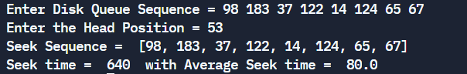
SSTF
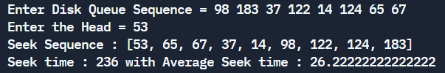
SCAN
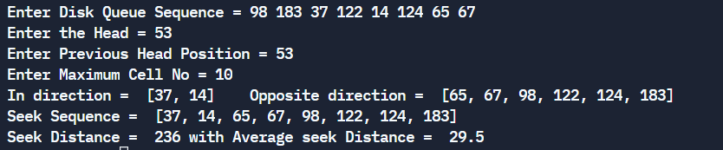
CSCAN
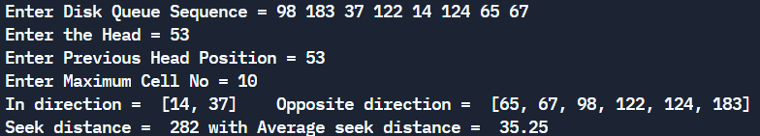
LOOK
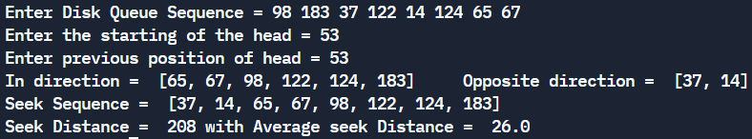
CLOOK
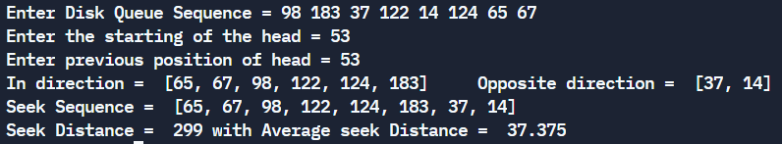
Conclusion:
We have successfully understood the concept of all disk scheduling algorithms and implemented in python.

Post Lab Descriptive Questions

- A disk drive has 200 cylinders numbered from 0 to 199. The disk head is initially at cylinder 53. The queue of pending requests in FIFO order is :
98, 183, 37, 122, 14, 124, 65, 67.
Starting from the current head position, what is the total distance travelled (in cylinders) by disk arm to satisfy the requests using CSCAN and Look. Illustrate with figures in each case.
CSCAN:
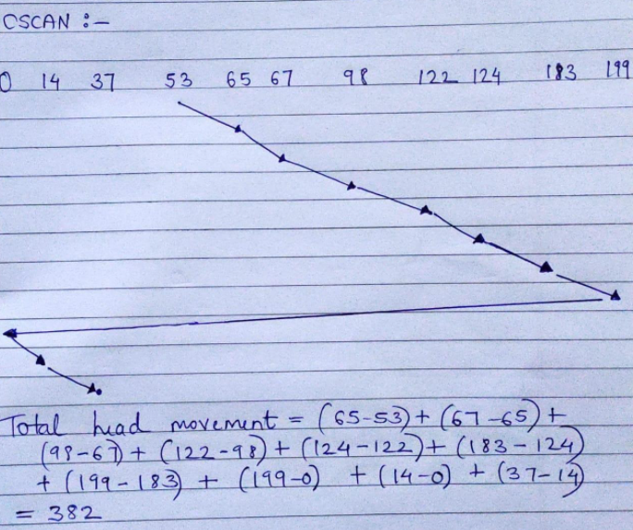LOOK:
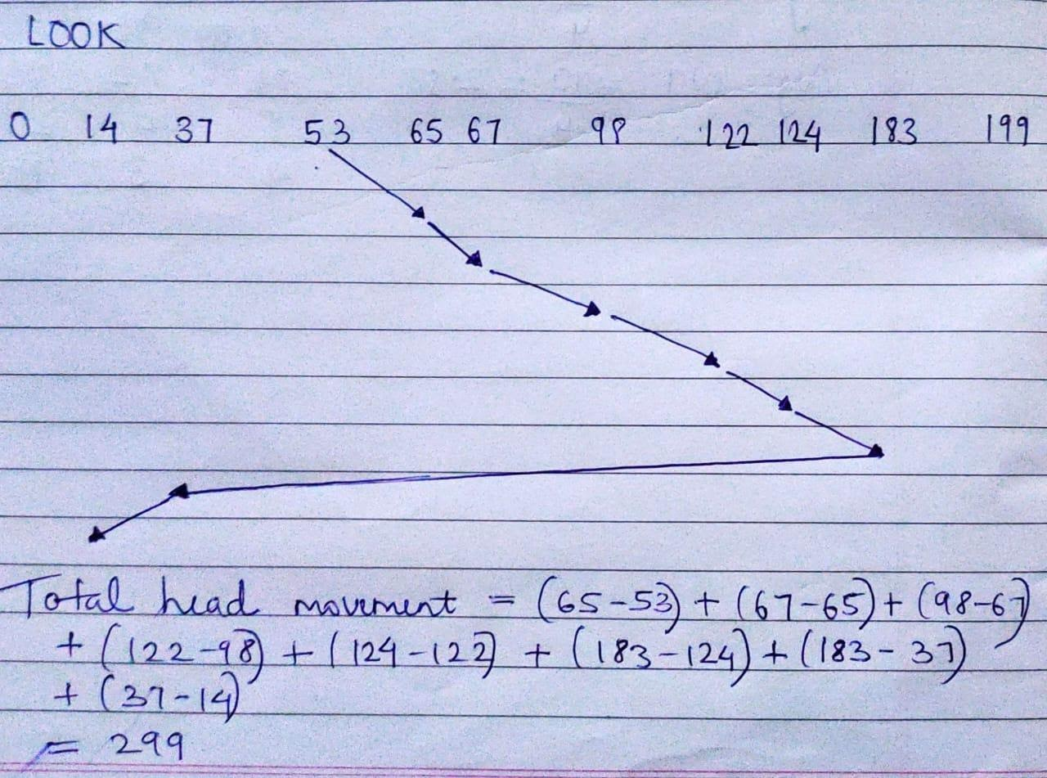

Post Lab Objective Questions

- In a hard disk, what rotates about a central spindle
  - Disk
  - Platter
  - Sector
  - None of the above
Ans: b.Platter
- The time required to move the disk arm to the required track is known as
  - Latency time
  - Access time
  - Seek time
  - None of the above
Ans: c. Seek time

Date 24-11-2021 Signature of faculty in-charge

