Batch: A1 Roll No.: 1911004

Experiment No. 09

Grade: AA / AB / BB / BC / CC / CD /DD

Signature of the Staff In-charge with date

TITLE: Design and implement 2 pass assembler
_____________________________________________________________________
AIM: To understand designing and implementation of two pass assembler.
_____________________________________________________________________
Expected Outcome of Experiment:

CO 5. To understand the designing and implementation of system software like Assembler, Macro preprocessor and linker loader
______________________________________________________________________
Books/ Journals/ Websites referred:

1. John J. Donovan : Systems programming, Tata McGraw Hill.

_____________________________________________________________________
Pre Lab/ Prior Concepts:
An assembler is a translator that translates an assembler program into a conventional machine language program. Basically, the assembler goes through the program one line at a time, and generates machine code for that instruction. Then the assembler proceeds to the next instruction. In this way, the entire machine code program is created. For most instructions this process works fine, for example for instructions that only reference registers, the assembler can compute the machine code easily, since the assembler knows where the registers are.
Consider an assembler instruction like the following
JMP LATER
...
...
LATER:
This is known as a forward reference. If the assembler is processing the file one line at a time, then it doesn't know where LATER is when it first encounters the jump instruction. So, it doesn't know if the jump is a short jump, a near jump or a far jump.
So, Assembler scan the code twice. The first time, just count how long the machine code instructions will be, just to find out the addresses of all the labels. Also, create a table that has a list of all the addresses and where they will be in the program. This table is known as the symbol table. On the second scan, generate the machine code, and use the symbol table to determine how far away jump labels are, and to generate the most efficient instruction.

This is known as a two-pass assembler. Each pass scans the program, the first pass generates the symbol table and the second pass generates the machine code. I have created a listing of an assembler program that has the machine code listed, and the symbol table listed.

Algorithm for pass 1:
Step 1: Start
Step 2: Initialize location counter to zero.
Step 3: Read opcode field of next instruction.
Step 4: Search opcode in pseudo opcode table.
Step 5: If opcode is found in Pseudo Opcode Table
Step 5.1: If it is ‘DS’ or ‘DC’
Adjust location counter to proper alignment.
Assign length of data field to ‘L’
Go to step 9
Step 5.2: If it is ‘EQU’
Evaluate operand field
Assign value to symbol in label field
Go to step 3
Step 5.3: If it is ‘USING’ or ‘DROP’ Go to step 3
Step 5.4: If it is ‘END’
Assign storage locations to literals
Go to step 12
Step 6: Search opcode in Machine Opcode Table.
Step 7: Assign it’s length to ‘L’.
Step 8: Process any literals and enter them into Literal Table.
Step 9: If symbol is there in label field assign current value of Location Counter to symbol.
Step 10: Location Counter = Location Counter + L.
Step 11: Go to step 3
Step 12: Stop.

Algorithm for Pass 2:
Step 1: Start
Step 2: Initialize location counter to zero.
Step 3: Read opcode field of next instruction.
Step 4: Search opcode in pseudo opcode table.
Step 5: If opcode is found in Pseudo Opcode Table
Step 5.1: If it is ‘DS’ or ‘DC’
Adjust location counter to proper alignment.
If it is ‘DC’ opcode form constant and insert in assembled program
Assign length of data field to ‘L’
Go to step 6.4
Step 5.2: If it is ‘EQU’ or ‘START’ ignore it.Go to step 3
Step 5.3: If it is ‘USING’
Evaluate operand and enter base reg no. and value into base table
Go to step 3
Step 5.3: If it is ‘DROP’
Indicate base reg no. available in base table Go to step 3
Step 5.4: If it is ‘END’
Generate literals for entries in Literal table
Go to step 12
Step 6: Search opcode in Machine Opcode Table.
Step 7: Get opcode byte and format code.
Step 8: Assign it’s length to ‘L’.
Step 9: Check type of instruction.
Step 10: If it is of ‘RR’ type
Step 10.1: Evaluate both register expressions and insert into second byte.
Step 10.2: Assemble instruction.
Step 10.3: Location Counter = Location Counter + L.
Step 10.4: Go to step 3
Step 11: If it is of ‘RX’ type
Step 11.1: Evaluate register and index expressions and insert into second byte.
Step 11.2: Calculate effective address of operand.
Step 11.3: Determine appropriate displacement and base register
Step 11.2: Put base and displacement into bytes 3 and 4
Step 11.3: Location Counter = Location Counter + L.
Step 11.4: Go to step 10.2
Step 12: Stop.

Stepwise-Procedure:
- Read a Source Program as input.
- Consider Mnemonic Opcode Table (MOT), Pseudo-op table (POT), Location Counter (LC).
- Create symbols Table (SYMTAB) and literal Table (LITAB), and intermediate code(IC).
- Update the Location Counter (LC).
Sample input and output:
Example : 1
Input file:
PRGAM START 0
USING * , 15
LA 15, SETUP
SR TOTAL, TOTAL
AC EQU 2
INDEX EQU 3
TOTAL EQU 4
DATABASE EQU 13
SETUP EQU *
USING SETUP, 15
L DATABASE, =A(DATA1)
USING DATAAREA, DATABASE
SR INDEX, INDEX
LOOP L AC, DATA1(INDEX)
AR TOTAL, AC
A AC, =F'5'
ST AC, SAVE(INDEX)
A INDEX, =F'4'
C INDEX, =F'8000'
BNE LOOP
LR 1, TOTAL
BR 14
LTORG

SAVE DS 2000F
DATAAREA EQU *
DATA1 DC F'25, 26, 27'
END

Sample Output:
Symbol Table created by Pass-1

Symbol Value Length R/A
---------------------------------------------------------------
PRGAM 0 1 R
AC 2 1 A
INDEX 3 1 A
TOTAL 4 1 A
DATABASE 13 1 A
SETUP 6 1 R
LOOP 12 4 R
SAVE 64 4 R
DATAAREA 8064 1 R
DATA1 8064 4 R

Literal Table created by Pass-1

Literal Value Length R/A
--------------------------------------------------------------
A(DATA1) 48 4 R
F'5' 52 4 R
F'4' 56 4 R
F'8000' 60 4 R

Object code generated by Pass-2

Loc Mnemonic Operand
------------------------------------
0 LA 15, 6 (0,15)
4 SR 4, 4
6 L 13, 42 (0,15)
10 SR 3, 3
12 L 2, 0 (3,13)
16 AR 4, 2
18 A 2, 46 (0,15)
22 ST 2, 58 (3,15)
26 A 3, 50(0,15)
30 C 3, 54(0,15)
34 BC 7, 6 (0,15)
38 LR 1, 4
40 BCR 15, 14
48 8064
52 X’00000005’
56 X’00000004’
60 8000
64 -------- 2000 entries.
8064

Sample input and output:
Example:
Input file:
PRGAM1 START 0
USING *, 15
SR 4, INDEX
SR 5, INDEX
L 3,=F’5’
INDEX EQU 3

LOOP L 2, SETUP
A 2,=F’49’
ST 2, DATA
A 4,=F'4'
LA 1, TOTAL
BNE LOOP
BR 14
LTORG
SETUP DC F’34’
TOTAL DC F’8’
DATA DS 10F
END

ID Symbol Value Length R/A
---------------------------------------------------------------------------
1 PRGAM1 0 1 R
2 INDEX 3 1 A
3 LOOP 8 4 R
4 SETUP 52 4 R
5 DATA 60 4 R
6 TOTAL 56 4 R

Literal Table created by Pass-1

LIT-No Literal Value Length R/A
-------------------------------------------------------------------------------
1 F'5' 40 4 R
2 F'49' 44 4 R
3 F'4' 48 4 R

Intermediate code generated by Pass 1

START 0
USING *, 15
0 SR 4, ID#2
2 SR 5, ID#2
4 L 3, LT#1
8 L 2, ID#4
12 A 2, LT#2
16 ST 2, ID#5
20 A 4, LT#3
24 LA 1, ID#6
28 BNE ID#3
32 BR 14
34 ----------
52 DC F’34’
56 DC F’8’
60 DS 10F
100 END

Code generated by Pass 2

0 SR/ 1B 4, 3
2 SR/1B 5, 3
4 L 3, 40(0,15)
8 L 2, 52(0,15)
12 A 2, 44(0,15)
16 ST 2, 60(0,15)
20 A 4, 48(0,15)
24 LA 1, 56(0,15)
28 BC 7, 8(0,15)
32 BR 14
34 ‘ ‘
40 X’00000005’
44 X’00000031’
48 X’00000004’
52 X’00000022’
56 X’00000008’
60 X’0000000A’
100

Implementation details:
Code :
import re
import math
from prettytable import PrettyTable
from pprint import pprint

class Pass1():
def __init__(self):
self.opcodes = {}
self.sym_table = {}
self.lit_table = []
self.inter_code = []
self.LC = 0
def ret(self):
return self.inter_code , self.lit_table, self.sym_table
def potmotget(self):
for op in ['START', 'USING', 'EQU', 'LTORG', 'END']:
self.opcodes[op] = 0
for op in ['SR', 'AR', 'LR']:
self.opcodes[op] = 2
for op in ['ST', 'L', 'LA', 'A', 'C', 'BC', 'DC', 'DS', 'BNE', 'BR', 'BCR']:
self.opcodes[op] = 4
def read(self, file):
with open(file, 'r') as f:
code = [line.strip().replace(', ', ',').replace(' ,', ',') for line in f.readlines()]
self.code = code
return code
def add_label(self, word):
if self.sym_table.get(word, False):
print(f'Error: Label {word} used twice')
else:
sym = {
'symbol': word,
'value': self.LC,
'length': 1,
'R/A': 'R'
}
self.sym_table[word] = sym
return
def add_op(self, word, cmd):
if self.opcodes.get(word, -1) >= 0:
if word == 'DS' or word == 'DC':
self.LC = math.ceil(self.LC/4)*4
if word == 'DS':
self.L = int(cmd[2][:-1]) * 4
else:
self.L = len(cmd[2][2:-1].split(',')) * 4
return
elif word == 'EQU':
self.add_label(cmd[0])
self.sym_table.get(cmd[0])['value'] = self.LC if cmd[2] == '*' else int(cmd[2])
self.sym_table.get(cmd[0])['R/A'] = 'R' if cmd[2] == '*' else 'A'
elif word == 'USING' or word == 'DROP':
flag = 2
elif word == 'END' or word == 'LTORG':
oldLC = self.LC
self.LC = math.ceil(self.LC / 8) * 8
for i in self.lit_table:
if not i['value']:
i['value'] = self.LC
self.LC += i['length']
if word == 'END':
self.flag = 3
return oldLC
self.L = self.opcodes.get(word)
return
def add_operand(self, word):
ops = word.split(',')
for op in ops:
if op[0] == '=':
lit = {
'literal': op,
'value': None,
'length': 4,
'R/A': 'R'
}
self.lit_table.append(lit)
return
def passer(self, code):
for cmd in code:
cmd = cmd.split()
self.L = 0
flag = 0
if len(cmd) == 3:
self.add_op(cmd[1],cmd)
self.add_operand(cmd[2])
if cmd[1] not in ['END','EQU']:
self.add_label(cmd[0])
self.inter_code.append([cmd[1], cmd[2], self.LC])
elif len(cmd) == 2:
self.add_op(cmd[0],cmd)
self.add_operand(cmd[1])
self.inter_code.append([cmd[0], cmd[1], self.LC])
else:
oldLC = self.add_op(cmd[0], cmd)
self.inter_code.append([cmd[0], '', oldLC])
continue
self.LC += self.L
if 'EQU' not in cmd:
print(*cmd)
def run(self):
self.potmotget()
code = self.read('input.txt')
self.passer(code)
print('\n\n\n')
sym = PrettyTable(['Symbol','Value', 'Length', 'R/A'])
for k,v in self.sym_table.items():
sym.add_row([k, v['value'],v['length'], v['R/A']])
lit = PrettyTable(['Literal','Value', 'Length', 'R/A'])
for d in self.lit_table:
lit.add_row([d['literal'], d['value'],d['length'], d['R/A']])
print('Symbol Table: \n',sym)
print('\nLiteral Table: \n',lit)
print('End Of Pass 1\n\n\n\n\n')
return self.ret()

class Pass2():
def __init__(self, code, lit, sym):
self.code = code
self.lit_table = lit
self.sym_table = sym
self.LC = 0
self.base_table = {}
def define_pot(self):
self.pot = ['START', 'END', 'LTORG', 'USING', 'DC', 'DS', 'EQU']
return
def define_mot(self):
self.mot = {
'LA': (4, 'RX'),
'SR': (2, 'RR'),
'AR': (2, 'RR'),
'LR': (2, 'RR'),
'BR': (2, 'RR'),
'L': (4, 'RX'),
'A': (4, 'RX'),
'ST': (4, 'RX'),
'C': (4, 'RX'),
'BNE': (4, 'RR')
}
return
def searchlit(self, op):
for lit in self.lit_table:
if lit['literal'] == op: return True
return False

def getlit(self, op):
for lit in self.lit_table:
if lit['literal'] == op:
return lit['value']
return False
def offset(self, typ, operands, base):
[op1, op2] = operands.split(',')
index = 0
if typ == 'RR':
if op1 in self.sym_table:
op1 = self.sym_table[op1]['value']
if op2 in self.sym_table:
op2 = self.sym_table[op2]['value']
return f'{op1}, {op2}'
elif typ == 'RX':
if op1 in self.sym_table:
op1 = self.sym_table[op1]['value']
if op2 in self.sym_table:
off, reg = self.offset_comp(op2, 's', base)
op2 = f'{off}({index}, {reg})'
elif self.searchlit(op2):
off, reg = self.offset_comp(op2, 'l', base)
op2 = f'{off}({index}, {reg})'
elif '(' in op2:
index = re.findall(r'\(\w+\)', op2)[0][1:-1]
index2 = self.sym_table[index]['value']
if '=' not in op2:
op2 = op2.split('(')[0]
off, reg = self.offset_comp(op2, 's', base)
op2 = f'{off}({index2}, {reg})'
else:
off, reg = self.offset_comp(index, 's', base)
op2 = f'{off}({index2}, {reg})'
return f'{op1}, {op2}'

def offset_comp(self, operand, arg, base):
if arg == 's': oval = self.sym_table[operand.replace('=','')]['value']
else: oval = self.getlit(operand)
mini = math.inf
for reg, content in base.items():
content = int(content)
if abs(oval - content) < mini:
mini = oval - content
mreg = reg
return mini, mreg
def run(self):
self.define_mot()
self.define_pot()
machineCode = []
for cmd in self.code:
self.LC = cmd[2]
if cmd[0] in self.pot:
op = cmd[0]
if op == 'USING':
l, r = cmd[1].split(',')
if r in self.sym_table:
r = self.sym_table[str(r)]['value']

if l in self.sym_table:
l = self.sym_table[str(l)]['value']

self.base_table[str(r)] = self.LC if l == '*' else l

elif op == 'DS' or op == 'DC':
if cmd[1].startswith('F'):
cmd[1] = re.findall(r'\d+', cmd[1])
store = self.LC
for operand in cmd[1]:
machineCode.append(f'{store} {operand}')
store += 4
elif cmd[1].endswith('F'):
machineCode.append(f'{self.LC} ---{cmd[1][:-1]} entries')
elif op == 'EQU' or op == 'START': pass
elif op == 'DROP': pass
elif op == 'END' or op == 'LTORG':
store = self.LC
to_assign = []
if store % 8:
store = (store // 8 + 1) * 8
for literal in self.lit_table:
if literal['value'] == store:
to_assign.append((store, literal))
store += 4
for val, const in to_assign:
found = re.findall(
r"\(\w+\)|\d+", const['literal'])[0]
if '(' in found:
found = found[1:-1]
found = self.sym_table[found]['value']
machineCode.append(f'{val} {found}')
elif self.mot.get(cmd[0], False):
if cmd[0] == 'BR':
machineCode.append(f'{self.LC} BCR 15, {cmd[1]}')
elif cmd[0] == 'BNE':
if cmd[1] in self.sym_table:
off, reg = self.offset_comp(
cmd[1], 's', self.base_table)
machineCode.append(
f'{self.LC} BC 7, {off}(0, {reg})')
elif cmd[1] in self.lit_table:
off, reg = self.offset_comp(
cmd[1], 'l', self.base_table)
machineCode.append(
f'{self.LC} BC 7, {off}(0, {reg})')
else:
machineCode.append(
f'{self.LC} BC 7, {self.sym_table[cmd[1]][1]}')
else:
val = self.offset(self.mot[cmd[0]][1], cmd[1], self.base_table)
machineCode.append(f'{self.LC} {cmd[0]} {val}')

print('Machine code:\n\n', *machineCode, sep='\n')
print("\n\nBase Table:")
base_t = PrettyTable(['Base Register','Offset'])
for k,v in self.base_table.items():
base_t.add_row([k,v])
print(base_t)
print('\n\nEnd of Pass 2')
Pass1 = Pass1()
code, lit, sym = Pass1.run()
Pass2 = Pass2(code, lit, sym)
Pass2.run()
Output:
Input code file:
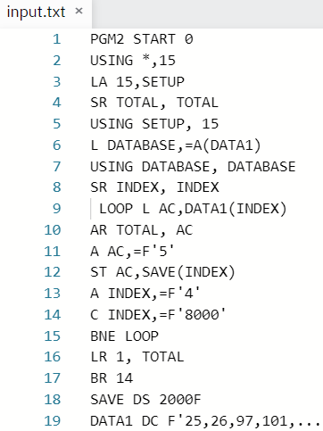
Pass 1 output:
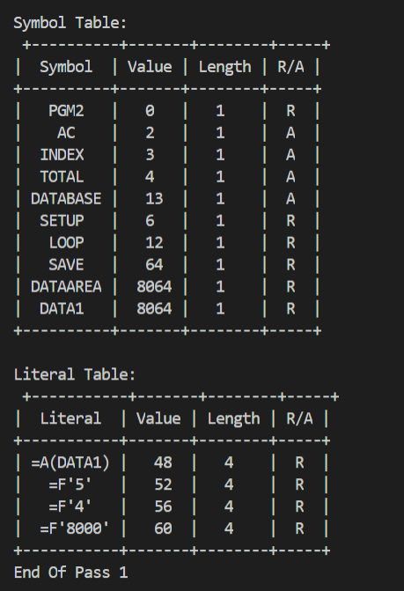
Pass 2 output:
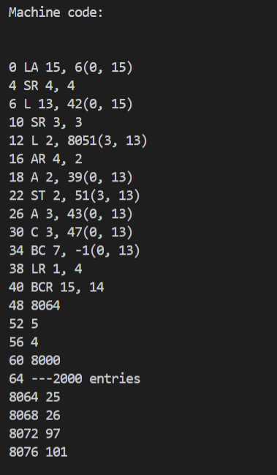
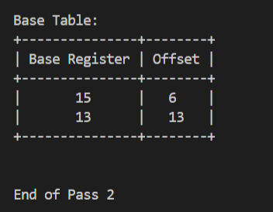
Conclusion: We understood the concept of the two-pass assembler for Assembly code, & was implemented for both Pass-1 and Pass-2 in python.

Post Lab Descriptive Questions

- What is the purpose of pass1 of assembler?
Answer: Pass 1 determines the locations of all the symbols, labels and so forth. The first pass generally needs to determine the shape of the resulting object code. This means:
- Which portions will be included or excluded. That means resolving any conditional compilation directives.
- The exact set of instructions to assemble. This means expanding any include directives, repeat directives, macros, and so forth.
- The addresses all of the instructions assemble at. This requires knowing the size of each instruction in particular.
  - If the assembler assembles to an absolute-address object file, then this means resolving the absolute address of each instruction.
  - If it assembles to a relocatable object file, then this means determining which section each instruction goes in, and what its relative address is within the section.
- The addresses of all labels in the program, and the values of all symbols defined, e.g. with EQU or SET style directives.

- What is the purpose of pass2 of assembler?

Answer: Pass 2 resolves all the references that weren’t resolved in Pass 1, especially forward references. Pass-2 of assembler generates machine code by converting symbolic machine-opcodes into their respective bit configuration (machine understandable form). It generates data for literals and look for values of symbols. It stores all machine-opcodes in MOT table (op-code table) with symbolic code, their length and their bit configuration. It will also process pseudo-ops and will store them in POT table (pseudo-op table).

- What are the functions of POTGET, MOTGET,LTSTO,BTSTO,LITASS?
Answer:
POTGET - Search the pass 1 pseudo-op table (POT)
MOTGET - Search MOT for a match with the current instruction
LTSTO - Store literals in LT. Do not store same literal twice.
BTSTO - Enter data into appropriate entry in BT
LITASS - Assign storage locations to each literal in the LT

- What is the difference between MOT of pass1 &pass2?
Answer: In pass 1, MOT table contains only Mnemonic name and length field.
In pass 2, MOT table contains Mnemonic name, length, binary code, and format field.
- What are the examples of fixed tables? Why are they called fixed tables?
Answer: POT (Pseudo Opcode Table) and MOT(Machine Opcode table) are examples of fixed tables. They are called so because their content are not filled in or altered during the assembly process.

- What are the examples of variable tables? What is the purpose of variable tables?
Answer: ST (Symbol Table), LT (Literal table) and BT (Base Table) are examples of variable tables. They are called so because their content are filled in or altered during the assembly process.

- What are various operations before transferring control to pass2?
Answer: Purpose of Pass 1 is to define symbols & literals, generate intermediate code then pass it onto pass-2.
1. Determine length of machine instructions (MOTGET1), .i.e. Separate the symbol, mnemonic opcode, operand fields .
2. Keep track of Location Counter (LC) i.e. Perform LC processing.
3. Remember values of symbols until pass 2 (STSTO) i.e. Build the symbol table.
4. Process some pseudo ops. E.g. EQU, DS (POTGET1) 5. Remember literals (LITSTO).

Post Lab Objective Questions

- The computer language generally translated to pseudo code
a. Assembler b. Machine
- Pascal d. FORTRAN
ANS: a. Assembler

- Simple two pass assembler does which of the functions in the first pass?
- It allocate space for the literals
- It computes the total length of the program
- It build the symbol table for the symbol and their values.
- All of these
ANS: d. All of these

- Symbol table implementation is based on the property of locality of reference is
- Linear list
- Search tree
- Hash table
- self organisation List
ANS: d. Self Organization List

- A self-relocating program is one which
- cannot be made to execute in any area of storage other than the one designated for it at the time of its coding or translation
- consists of a program and relevant information for its relocation
- can itself perform the relocation of its address-sensitive portions
- All of the above
ANS: c. can itself perform the relocation of its address-sensitive portions

- Assembler is
- a program that automate the translation of assembly language into machine language
- a program that accepts a program written in a high level language and produces an object program
- a program that places programs into memory and prepares them for execution
- is a program that appears to execute a source program as if it were machine language
ANS: a. a program that automate the translation of assembly language into machine language

Date: 04-12-2021 Signature of faculty in-charge

