Batch: A1 Roll No : 1911004
Experiment No. 1a

Title: Encryption Decryption Algorithms
Objective:
To implement Shift cipher, Combined Transposition Approach, Cryptanalysis
Expected Outcome of Experiment:
CO | Outcome
CO2 | Identify the principles of cryptographic techniques and Apply various cryptographic algorithms for securing systems

Books/ Journals/ Websites referred:
- Behrouz A Fourouzan, Debdeep Mukhopadhyay, “Cryptography and Network”, 2nd edition, TMH.
- William Stallings, “Cryptography and Network Security: Principles and Practice” 5th edition, Pearson

Abstract: -
Cryptography:
It is the science and study of hiding any text so that only the intended recipients or authorized people can read it and that is any text even using things like invisible ink or the mechanical cryptography machines of the past.
Public-key cryptography uses a concept called key pair encryption; consists of a public key and a private key. With key pair encryption, Data is encrypted with a public key, but can only be decrypted with the corresponding private key. The strength of both public key and the private key depends on the degree of the computational impracticality of the encryption algorithm.
In Public key cryptography, a person can encrypt a message with recipient’s public key and it can only be decrypted with the private key that only the recipient knows.

Related Theory: -
Shift Cipher:
In cryptography the shift cipher, is one of the simplest and most widely known encryption techniques. It is a type of substitution cipher in which each letter in the plaintext is replaced by a letter some fixed number of positions down the alphabet. For example, with a left shift of 3, D would be replaced by A, E would become B, and so on. The method is named after Julius Caesar, who used it in his private correspondence.
Transposition Cipher:
- A transposition cipher does not substitute one symbol for another (as in substitution cipher), but changes the location of these symbols.
- It reorders (jumbles) the given plain-text to give the cipher-text.
- They are of two types: Keyed and Keyless Transposition Cipher.
Keyless Transposition Cipher:
- In this cipher technique, the message is converted to ciphertext by either of two permutation techniques:
a. Text is written into a table column-by-column and is then transmitted row-by-row.
b. Text is written into a table row-by-row and is then transmitted column-by-column
- The first method (a) is also popularly known as Rail-fence cipher
- E.g., We need to send the message “DEFENDTHEEASTWALL”. Arranging into tables we get:
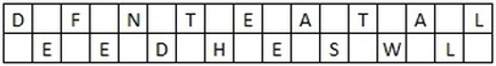
Now, the message is sent row-by-row. So Ciphertext is “DFNTEATALEEDHESWL”(Note: the no. of rows is 2 by default, unless specified)Now, the message is sent row-by-row. So Ciphertext is “DFNTEATALEEDHESWL”(Note: the no. of rows is 2 by default, unless specified)
- Similarly for the (b) method, we can arrange the same above message into tables with four columns.
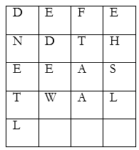
The Data is then transmitted column-by-column as “DNETLEDEWFTAAEHSL”The Data is then transmitted column-by-column as “DNETLEDEWFTAAEHSL”
Keyed Transposition cipher:
- In this approach, rather than permuting all the symbols together, we divide the entire plaintext into blocks of predetermined size and then permute each block independently.
- Suppose A wants to send a message to B “WE HAVE AN ATTACK”. Both A and B agreed to had previously agreed oved the blocks size as 5. So the blocks would be as:
WEHAVWEHAV EANATEANAT TACKXTACKX
- The last character X is a bogus character so as to complete the block size of 5.
- A and B is using the following key for encryption and decryption:
4 | 1 | 3 | 2 | 5
1 | 2 | 3 | 4 | 5

Implementation Details:
1. Enlist all the Steps followed and various options explored
- Implemented Shift Cipher
- Implemented Combined Transposition Ciphers

2. Explain your program logic, classes and methods used.
Shift cipher:
Input is restricted to only upper-case letters. User has to enter the plaintext and key value. Function used are encryption and decryption –
Encryption: Forms matrix from plain text, then forms the encrypted matrix using key and forms the cipher text
Decryption: Forms matrix from cipher text, then forms the decrypted matrix using key and forms the decrypted text.
Combination Transposition Cipher:
Input:
- String of Letter (Both cases), Numbers, Spaces and symbols
- No of columns if for keyless approach.
- List of space separate key value if keyed and combination approach selected.
Functions used are encryption and decryption -
Encryption: Forms matrix from plain text, then forms the encrypted matrix using key and forms the cipher text
Decryption: Forms matrix from cipher text, then forms the decrypted matrix using key and forms the decrypted text.
3. Explain the Importance of the approach followed by you
Shift cipher:
Input is restricted to only upper-case letters. User has to enter the plaintext and key value.
Function for encryption: Used to convert plain text to cipher text using the entered key value
Function for decryption: Used to decrypt cipher text using the entered key value
Combination Transposition Ciphers
Plain text is taken as input from the user and also the key.
Function for encryption:
Used to convert plain text to cipher text. Plaintext is arranged in a matrix whose number of columns (say c) is equal to length of key and number of rows is calculated using c and length of plaintext. Encrypted matrix is formed using the key. The matrix is then read column wise thus forming the cipher text.
Function for decryption:
Used to decrypt cipher text. Cipher text is arranged in a matrix column wise whose number of columns (say c) is equal to length of key and number of rows is calculated using c and length of plaintext. Decrypted matrix is formed using the key. The matrix is then read row wise thus forming the original plain text.
Code & Output:
#shift cipher
def encrypt(plaintext,Key):
en = ""
for c in plaintext:
if c.isupper():
en+=chr(((ord(c)-65+Key)%26)+65).lower()
elif c.islower():
en+=chr(((ord(c)-97+Key)%26)+97).upper()
elif c.isdigit():
en+=chr(((ord(c)-48+Key)%10)+48)
else: en+=c
return en
def decrypt(cipher,Key):
de = ""
for c in cipher:
if c.isupper():
de+=chr(((ord(c)-65-Key)%26)+65).lower()
elif c.islower():
de+=chr(((ord(c)-97-Key)%26)+97).upper()
elif c.isdigit():
de+=chr(((ord(c)-48-Key)%10)+48)
else: de+=c
return de
plaintext = input("Enter PlainText = ")
Key = int(input("Enter the Key = "))
cipher = encrypt(plaintext,Key)
print("The CipherText = ",cipher)
print("The Decrypted Text = ",decrypt(cipher,Key))
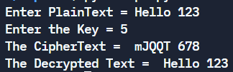
#Combine Transposition
import math
def encrypt(pt,key):
columns = len(key)
rows = math.ceil(len(pt)/columns)
matrix = []
enc_matrix = []
for i in range(0,rows):
matrix.append(['#']*columns)
enc_matrix.append(['#']*columns)
r=0
c=0
for i in pt: #putting the plaintext in matrix
matrix[r][c]=i
c+=1
if c== columns:
c=0
r+=1
print("\nMatrix of Plaintext: ")
for i in matrix:
print(i)
for i in range(rows):
for j in range(columns):
temp=matrix[i][key[j]-1]
enc_matrix[i][j]=temp
cipher_text=[]
for i in range(columns):
for j in range(rows):
cipher_text.append(enc_matrix[j][i])
print("\nEncrypted matrix: ")
for i in enc_matrix:
print(i)
cipher_text=''.join(cipher_text)
print("\nCipher text: ",cipher_text)
return cipher_text
def decrypt(ct, key):
columns = len(key)
rows = math.ceil(len(ct)/columns)
enc_matrix = []
dec_matrix = []
for i in range(0,rows):
enc_matrix.append(['#']*columns)
dec_matrix.append(['#']*columns)
r=0
c=0
for i in ct: #putting the ciphertext in matrix
enc_matrix[r][c]=i
r+=1
if r== rows:
r=0
c+=1
print("\nMatrix formed from cipher text:")
for i in enc_matrix:
print(i)

decrypted_text=[]
for i in range(rows):
for j in range(columns):
temp=enc_matrix[i][j]
dec_matrix[i][key[j]-1]=temp

print("\nDecrypted matrix: ")
for i in dec_matrix:
print(i)
r=0
c=0
for i in range(len(ct)):
decrypted_text.append(dec_matrix[r][c])
c+=1
if c== columns:
c=0
r+=1
decrypted_text=''.join(decrypted_text)
decrypted_text = decrypted_text.replace("#","")
print("\nDecrypted plain text: ",decrypted_text)
plaintext = input("Enter the text = ")
key = list(map(int,input("Enter the key = ").split()))
print("Key =",key)
if(len(key)<=len(plaintext)):
ct = encrypt(plaintext,key)
decrypt(ct, key)
else:
print("Invalid Key")
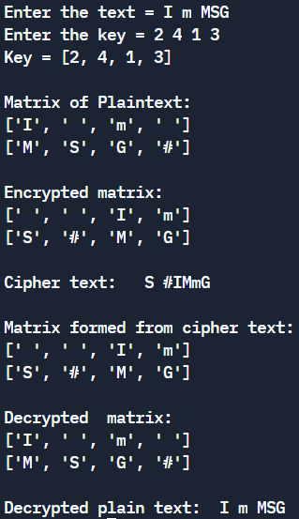
Conclusion: -
We successfully understood the concept of Shift Cipher, Combined Transposition & implemented them in python.

