Batch A1
Roll No 1911004
Experiment No. 7

Title: OTP using Challenge- Response

Objective:
To send a challenge to client when, the client tries to access login and provide it with a challenge and allow access based on validating the result send by client.

Expected Outcome of Experiment:

CO | Outcome
CO5 | Implement various Authentication mechanisms for Applications

Books/ Journals/ Websites referred:
https://www.techwithtim.net/tutorials/socket-programming/
Abstract: -
Sockets allow communication between two different processes on the same or different machines. To be more precise, it's a way to talk to other computers using standard Unix file descriptors. In Unix, every I/O action is done by writing or reading a file descriptor. A file descriptor is just an integer associated with an open file and it can be a network connection, a text file, a terminal, or something else.
To a programmer, a socket looks and behaves much like a low-level file descriptor. This is because commands such as read() and write() work with sockets in the same way they do with files and pipes.
Sockets allow communication between two different processes on the same or different machines. To be more precise, it's a way to talk to other computers using standard Unix file descriptors. In Unix, every I/O action is done by writing or reading a file descriptor. A file descriptor is just an integer associated with an open file and it can be a network connection, a text file, a terminal, or something else.
To a programmer, a socket looks and behaves much like a low-level file descriptor. This is because commands such as read() and write() work with sockets in the same way they do with files and pipes.
Socket programming is a way of connecting two nodes on a network to communicate with each other. One socket(node) listens on a particular port at an IP, while other socket reaches out to the other to form a connection. Server forms the listener socket while client reaches out to the server. They are the real backbones behind web browsing. In simpler terms there is a server and a client.
Related Theory: -
Challenge Response Authentication Mechanism (CRAM) is the most often used way to authenticate actions. They are a group of protocols in which one side presents a challenge (to be answered) and the other side must present a correct answer (to be checked/validated) to the challenge in order to get authenticated.
Ways CRAM is executed –
- CAPTCHA: The Completely Automated Public Turing Test to Tell Computers and Humans Apart. CAPTCHA is used to prevent spam and auto-registration of new accounts for email or websites.
- SSH (Secure Shell): SSH is a cryptographic network protocol for operating network services securely over an unsecured network.
- Password: The password is sent to the server for validation by matching with the correct password.
- Salted Challenge Response Authentication Mechanism (SCRAM, a variant of CRAM): The challenge is salted with a hash to make sure the password is used for only one time. The hash is sent to the server for matching with the hash of the correct password for match and not the match of the plain text password itself. So, the password is not revealed preventing the Man-in- the-Middle attack and replay attacks because the password can be used only once.
- Biometrics: The biometric details (retina scan, fingerprint scan) that are unique are recorded and every time a user wants to authenticate himself, he has to present his biometric credentials to the authenticating system for validation.

Common attacks on CRAMs –
- Eavesdropping
- Phishing Attacks
- Pharming Attacks
- Man-In-The-Middle Attacks
- DNS Cache Poisoning Attacks
- Trojans Attacks
- Man-In-The-Phone Attacks
- Browser Poisoning Attacks
- Dictionary Attacks
- Brute-Force Attacks
- zero-knowledge password proof
- Reusable password attacks
Limitations –
A fundamental problem with passwords is that passwords are used repeatedly. When a password is received by the server, the server cannot determine if the real user is entering the password or not.
Newer CRAMs also employ cryptography so that the hash of the passwords are matched and not the plain passwords.

Some examples of cryptographic CRAMs –
SCRAM – Salted Challenge Response Authentication Mechanism
CRAM-MD5
Implementation Details:
Code:
Server side:
import socket
import random
import threading

server = socket.socket()
names_funcs={}
host = '127.0.0.1'
port = 1250

try: server.bind((host, port))
except socket.error as e: print(str(e))

def start():
server.listen(5)
while True:
client, address = server.accept()
print('Connected to ' + address[0] , ':', str(address[1]))
thread = threading.Thread(target=handle_client, args=(client, address ))
thread.start()
print('[Active Connections] =' + str(threading.active_count() - 1))
server.close()

def ReverseNumber():
x=random.randint(10000,40000)
return x,int(str(x)[::-1])

def Equation():
x=random.randint(1,20)
response=pow(x,2)+(5*x)+3
return x,response

def SumOfDigit():
x=random.randint(1000,9999)
n=x
sum=0
while n>0:
r=n%10
sum+=r
n//=10
return x,sum

def handle_client(connection, address):
connection.send(str.encode('Are you a first time user? Enter 1.Yes 0.No = '))
response=connection.recv(1024)
response=int(response.decode('utf-8'))
connection.send(str.encode('Enter your name '))
data = connection.recv(1024)
data=data.decode('utf-8')
reply ="\nWelcome " + data
connection.sendall(str.encode(reply))
if response==1:
connection.sendall(str.encode('Select a challenge: \n1)Reverse number \n2)Solve Equation x^2+5x+3 \n3)Sum of digits of number \n'))
choice=connection.recv(1024)
choice=int(choice.decode('utf-8'))
names_funcs[data]=choice
else:
choice=names_funcs[data]

if choice==1: x_send,otp_response=ReverseNumber()
elif choice==2: x_send,otp_response=Equation()
else: x_send,otp_response=SumOfDigit()

reply1="Based on challenge selected previously, ans this "+str(x_send)
connection.sendall(str.encode(reply1))
reply=connection.recv(1024)
reply=int(reply.decode('utf-8'))
if reply==otp_response: reply2="Authentication successful!!"
else: reply2="Authentication failed!"
connection.sendall(str.encode(reply2))
print('Disconnected ' + address[0] + ':' + str(address[1]))
print('[Active Connections] = ' + str(threading.active_count() - 2))
connection.close()
print("Server is starting..")
print('Waiting for Connection...')
start()
Client side:
import socket
client = socket.socket()
host = '127.0.0.1'
port = 1250
print('Waiting for connection')
try: client.connect((host, port))
except socket.error as e: print(str(e))
response=client.recv(1024)
print(response.decode('utf-8'))
yn=input()
client.sendall(str.encode(yn))
yn=int(yn)
response=client.recv(1024)
print(response.decode('utf-8'))
name=input()
client.sendall(str.encode(name))
response = client.recv(1024)
print(response.decode('utf-8'))
if yn==1:
response=client.recv(1024)
print(response.decode('utf-8'))
choice=input()
client.sendall(str.encode(choice))
response=client.recv(1024)
print(response.decode('utf-8'))
reply=input()
client.sendall(str.encode(reply))
response=client.recv(1024)
print(response.decode('utf-8'))
client.close()
1. Enlist all the Steps followed and various options explored
Answer:

This is a client-server-based algorithm, for mutual authentication using Challenge Response.
The communication between client and server is established using socket programming in python.
Server Side:
Server handles multiple clients at a time by creating threads for each. For each client,
- Firstly, it asks the client if it is first time user and takes input name of the client.
- If the client is a first-time user, then the client is asked to select a challenge else previously chosen challenge is used.
- Based upon the challenge, the value x for which the challenge is to be solved is send to client.
- Once the response is received from the client it is checked with actual answer.
- If the response matches the actual answer the client is authenticated else not.

Client Side:
- The client connects to server
- If the client is a first-time user then the client selects the challenge response else previously chosen challenge is used.
- The client receives value of x for which the challenge is to be solved.
- The client sends the response.
- If the response matches the actual answer on the server side the client is authenticated else not.

2. Explain your program logic, classes and methods used.
Answer:
server.py:
The socket is created and the server starts listening. Once a client is connected the steps mentioned in Answer 1, are followed.
Methods:
start(): So the server starts listening and connects to a client. Here a thread is created for each client.
handle_client(): Sends messages to server and receives replies according to the steps mentioned in Answer 1.
Challenges:
- reverse_number(): returns x and the actual expected answer which is reverse of x
- equation(): returns x and the actual expected answer which is obtained by substituting x in the equation x^2+5x+3.
- sum_of_digits(): returns x and the actual expected answer which is sum of the digits of x.
client.py:
The client socket establishes a connection to the server socket.
Once the connection is established the client receives the messages from the server and sends the replies as mentioned in the steps of Answer 1.
If the client is a first-time user, the client selects one of the challenge response from
1) Reverse number
2) Solve equation x^2+5x+3
3) Sum of digits of number else previously chosen response is selected.
The client sends a response based on x value which is send by server. If the response matches the actual answer on the server side the client is authenticated else not.

3. Explain the Importance of the approach followed by you
Answer: Multiple clients are managed by creating thread for each client so that one client is not kept on waiting due to some other client. Also, option to select from three challenges is given to the client.

Output:

Server is started:
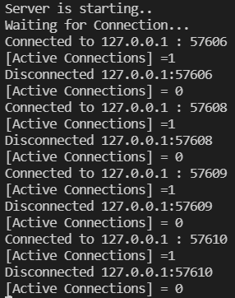

First client comes in:
First client:
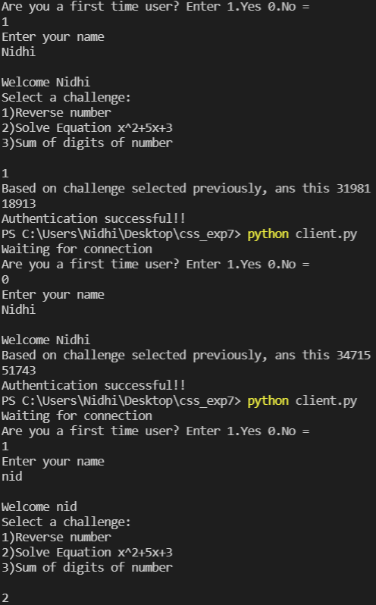
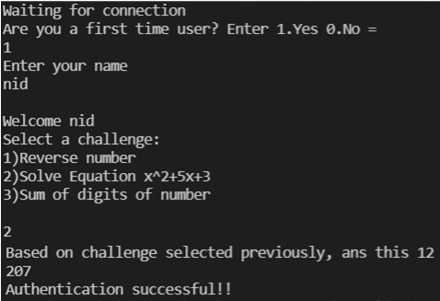
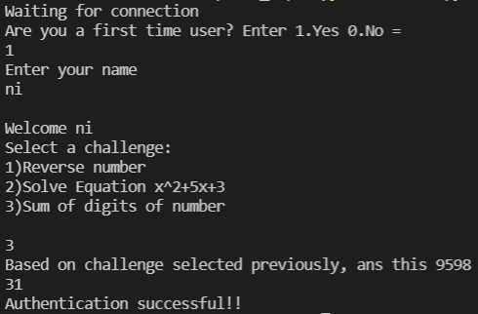
Server side:
Conclusion: - Thus, we understood and implemented the concept of Authentication and Validation of the Response from Client based on the Challenge given from Server side using socket programming and threading.

