Batch: A1 Roll No 1911004
Experiment No. 9

Title: Implementation of CAPTCHA for Security of systems

Objective: To implement as randomized as possible CAPTCHA for restricting web crawlers

Expected Outcome of Experiment:
CO | Outcome
CO5 | Illustrate Secure software design principles and apply them for secure software development

Books/ Journals/ Websites referred:
https://www.cloudflare.com/learning/how-captchas-work/
https://support.google.com/a/answer/192139
Abstract: -
CAPTCHA stands for Completely Automated Public Turing test to tell Computers and Humans Apart. In other words, CAPTCHA determines whether the user is real or a spam robot. CAPTCHAs stretch or manipulate letters and numbers, and rely on human ability to determine which symbols they are. Here, we have implemented image captcha by first generating the captcha string using the algorithm and then embedding it in the image.
Related Theory: -
Classic CAPTCHAs, which are still in use on some web properties today, involve asking users to identify letters. The letters are distorted so that bots are not likely to be able to identify them. To pass the test, users have to interpret the distorted text, type the correct letters into a form field, and submit the form. If the letters don't match, users are prompted to try again.
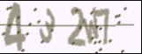
The idea is that a computer program such as a bot will be unable to interpret the distorted letters, while a human being, who is used to seeing and interpreting letters in all kinds of contexts – different fonts, different handwritings, etc. – will usually be able to identify them.
The best that many bots will be able to do is input some random letters, making it statistically unlikely that they will pass the test. Thus, bots fail the test and are blocked from interacting with the website or application, while humans are able to continue using it like normal.
Advanced bots are able to use machine learning to identify these distorted letters, so these kinds of CAPTCHA tests are being replaced with more complex tests. Google reCAPTCHA has developed a number of other tests to sort out human users from bots.
Types of captchas explored:
- Image captcha
A CAPTCHA test is made up of two simple parts: a randomly generated sequence of letters and/or numbers that appear as a distorted image, and a text box. To pass a test and prove your human identity, simply type the characters you see in the image into the text box.
- Audio captcha:
Audio CAPTCHAs that rely instead on human audio perception were introduced as a non-visual alternative but are much more difficult for web users to solve. In audio CAPTCHAs, this often means text is synthesized and mixed in with background noise, such as music or unidentifiable chatter.
Implementation Details:
1. Enlist all the Steps followed and various options explored
Ans:
- Generate a random number between 4 and 6, this will be the length of the captcha string.
- For each character, generate another random number between 1 to 10, if it is less than 6, a random number between 0 to 9 is added to the string else a random alphabet is generated.
- The captcha string is embedded into the image using a python library for it which distorts the string and adds noise to it to make it difficult for bots to interpret.
- Input captcha string from user and match it with the generated one.
- If it matches, verified else retry.

2. Explain your program logic, classes and methods used.
Ans:
Program logic:
This program basically uses the above algorithm to generate a captcha string every time. This string is embedded into an image and stored which is viewed by user and user enters the string. The entered string is then matched with the generated one and thus verification is done.
Inbuilt functions and libraries used:
Libraries used are-
- Random: For generating random numbers between the given range.
- Captcha: To generate image captcha
- PIL – To generate image for generated text.
3. Explain the Importance of the approach followed by you
This approach generates a random string based on the algorithm of random string generation of captcha and embeds the same in an image which distorts the string and noise to the image which can be further used to verify.
Code:
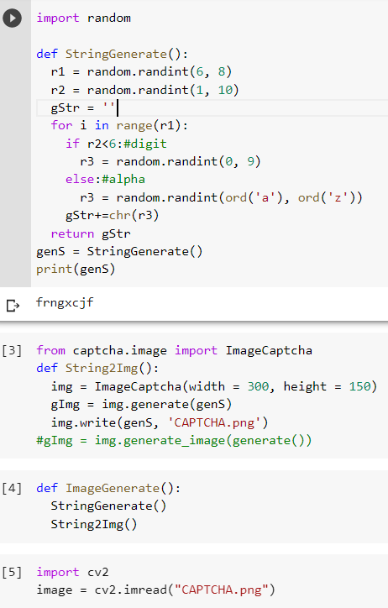
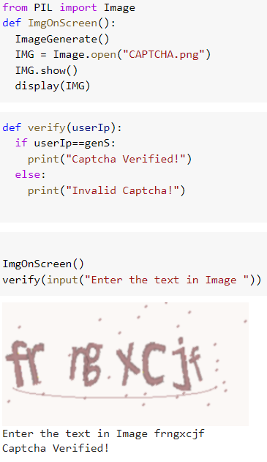
Output:
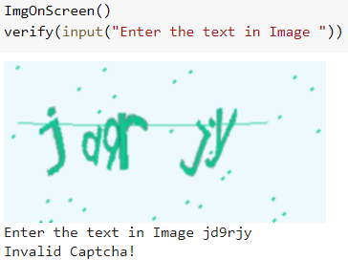
Conclusion: -
We successfully understood the concept of Captcha and implemented it in python.

