Batch: ML1 Roll No.: 1911004

Experiment / Assignment / Tutorial No. 1

Title: Python Essentials for Machine Learning.

Aim: To understand & implement Python basics, libraries for machine learning applications.

Expected Outcome of Experiment:

CO1: Describe the basics of machine learning.

Books/ Journals/ Websites referred:
- https://www.python.org/about/
- Learn more about Anaconda: anaconda.com/why-anaconda/
- Jupyter Documentation: https://jupyter.org/documentation
- Google Colab: https://colab.research.google.com/notebooks/intro.ipynb
- Stanford cs231 : http://cs231n.github.io/python-numpy-tutorial/
- Numpy: https://numpy.org/
- Pandas : https://pandas.pydata.org/
- https://opensource.com/article/18/10/machine-learning-python-essential-hacks- and-tricks

Machine Learning With Python:
Machines need to be programmed to carry out particular actions. There are about 700 major and minor programming languages in the world to date. These languages have developed over the years according to the needs of the time. Many of the languages are just new and improved versions of older languages. As computers and computer-related businesses grew, the need for programming languages increased as well.
As artificial intelligence evolved, the usefulness of a programming language for machine training became added criteria for its popularity. As of 2019, the top three languages were Java, Python, and C/C++. Excluding C, the other languages are object oriented.
Introduction to Python
Python was first developed and released in the year 1990 by Guido van Rossum, a Dutch mathematician, at the Centrum Wiskunde & Informatica in the Netherlands. One very interesting fact to note is that the name Python was, surprisingly, not taken from the notorious reptile, but rather from the equally notorious comedy group Monty Python that Guido was fond of.
According to the official Python website, “Python is an interpreted, object-oriented, high-level programming language with dynamic semantics.”
In simpler terms,
- It is an interpreted language, which means it allows instructions to be executed freely and directly, without any prior compilation required;
- It uses objects that contain data and code;
- It follows a language style that is easy for human beings to interpret; and
- It allows information to be updated according to time.
Python’s popularity first peaked around 2003, and ever since then it has retained its position as a highly acclaimed programming language. Its popularity can mainly be attributed to its features, which are listed in the next section.

Key Python Features
Python was mainly developed to improve code readability and to reduce the amount of coding required to program a machine. Apart from this, it has a variety of unique features and provisions that make our overall programming experience smooth and easy.
These features include the following:
- Open-source license: This means it is free to download, modify, and redistribute under an OSI-approved license.
- Readability: It has a very easy-to-read syntax.
- Cross-platform working: It can run on any operating system, including Linux, Windows, Mac OS, etc.
- Extensive standard library: It consists of many useful libraries that can be used for a variety of applications.
- Easily integrated: It can easily be integrated with other languages like C, C++, Java, etc.
- Supports object-oriented and procedure-oriented programming: It primarily follows OOP, but it also makes room for POP, which is one of the most unique features of Python.
- Allows GUI programming: It has several libraries that allow users to develop graphic user interfaces quickly and easily.
- Large community: It has a huge community of coders, making it easier to make improvements, get help, solve issues, and develop new ideas.
Python’s Competitors
As mentioned earlier, there are multitudes of other programming languages that are used in various fields and for various purposes. In the area of machine learning for artificial intelligence, some common programming languages that people use, other than Python, include the following:
R: It is mainly used for visual representations, as graphs can be created very easily with just a few lines of code. It thus allows for exploratory data analysis.
Java: It is one of the oldest languages in the world of computer programming. It is great in terms of speed, reliability, and security.
Scala: Its runtime is extremely fast, and it can be used to develop complex pieces of code. It is moderately easy for a beginner to pick up.
Julia: It is high level, scalable, dynamic, and quick. It also provides some powerful native tools that can be implemented for machine learning.
C++: It has a high speed, a sufficient set of libraries and tools, and is most efficient when it comes to using statistical techniques.
Python as a Preferred Language for Machine Learning
Machine learning can become quite a complex process, especially when the data is massive, the model is extensive, and the objective is challenging. That said, it requires a language that simplifies its process and makes it less tedious for the developer.
When compared to other programming languages, Python stands out for the following reasons:
- It works seamlessly across different platforms. Thus, developers need not worry about using only one platform. They can easily distribute and use the Python code. A lot of other languages don’t offer this feature, or are limited in their cross-platform abilities, and hence need to be used only on a single platform.
- It consists of a vast list of machine learning–specific libraries, utilities, and frameworks, which can be used by developers to make their programming faster and easier. Other languages don’t have such an extensive selection.
- Its code is simple, readable, and concise. It is, therefore, easier for a developer to focus their attention on the machine learning problem at hand, rather than having to worry too much about writing the correct code and following the correct syntax, which most of the other languages require.
- It has a large community of developers who frequently use the language. This makes it less of a task for us to ask questions about any issues that arise while programming. It also allows Python developers to come together to discuss tips and ideas with one another. Other programming languages either have a smaller community or no community at all.
Python’s Machine Learning Libraries
First, we will understand what a library is.
A library in the programming world is a collection of methods and functions that allow a user to perform various tasks without having to write the necessary code for it.
We use libraries to save time while we program. Python has a huge array of open-source machine learning libraries, including, but not limited to, the following:
Pandas: The Pandas library provides users with the ability to handle large datasets. It provides tools for reading and writing data, cleaning and altering data, and so on.
Numpy: The Numpy, or Numerical Python, library provides users with a powerful array of computing abilities. It tackles the problem of slow mathematical computations and allows users to perform huge calculations with the help of multi-dimensional arrays.
Scipy: The Scipy library is used for scientific and technical computations. It works on Numpy’s multi-dimensional arrays.
Scikit-Learn: The Scikit-Learn library consists of various features and methods that have specially been made to assist users in their machine learning requirements. It makes use of the Numpy library, specifically when it comes to array operations.
TensorFlow: The Tensorflow library is an increasingly popular library that provides users with a large set of flexible and accessible tools for machine learning. You will be learning more about TensorFlow later on in this book.
With the help of these libraries, we can develop our machine learning program quickly and easily.
Other Applications of Python
Due to the diverse functionality of Python as a programming language, its utility is not limited to artificial intelligence alone. It is used for a variety of other applications as well. Some of these applications include the following:
- Web development
- Data analysis
- Educational purposes
- Software testing
- Computer graphics
- Game development
- Scientific and numeric computing
- Desktop GUIs

Installing Python

As mentioned before, Python is free to download. There are several ways to download and install Python onto your system, based on your OS and your preference.
One method of installing Python is from the official Python website, which provides an installer that users can download and run on their computers.
Another method of installing Python is with the help of package installers like Homebrew that make installation more convenient.

Anaconda is an open-source distribution of the Python and R programming languages. It is free for us to download and use on our system.
It was created to make our machine learning process easier, mainly by making package installation simpler. It has an easy-to-use interface and comes with Python pre-installed on it. It also makes our task of installing the Jupyter Notebook application much easier, as we will see in the next chapter.

Let us now learn how Anaconda can be installed onto our systems.

Installing Python with Anaconda

Before we begin, we must have a look at the system requirements given in the Anaconda documentation, just to make sure that our system will be able to support Anaconda without any trouble. To download Anaconda, we need to follow these steps:
1. Go to the Anaconda website (https://www.anaconda.com/distribution/) and find the download option for your OS, as shown in Figure 1.

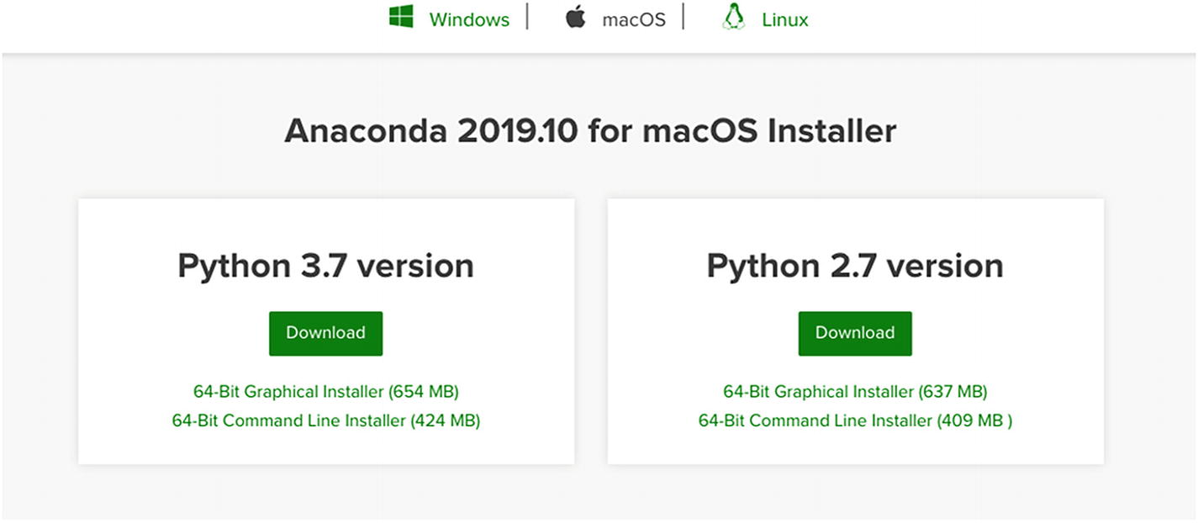
Figure 1 choosing the right version to download and install

2. Since Anaconda comes pre-installed with Python, it gives you the option to select the version of Python that you want to install when you download the Anaconda application. Select the latest Python version available and click on the Download button. Here, I have selected Python 3.7 for my Mac OS.

3. Once Anaconda is downloaded, locate the file on the computer and double-click on it to begin the installation.

4. Once the installation is completed, you will be able to see the Anaconda Navigator icon in your list of applications. Click on it.

5. You will see a screen showing you a couple of useful programming-related applications. You will also see that, by default, a base (root) environment has been created that contains Python and its libraries.

6. It is always good to create a new working environment, other than the base. To do so, click on the Create button. In the dialog box that appears, you can give your new environment a name, select your Python version, and then click the Create button, as shown in Figure 2.

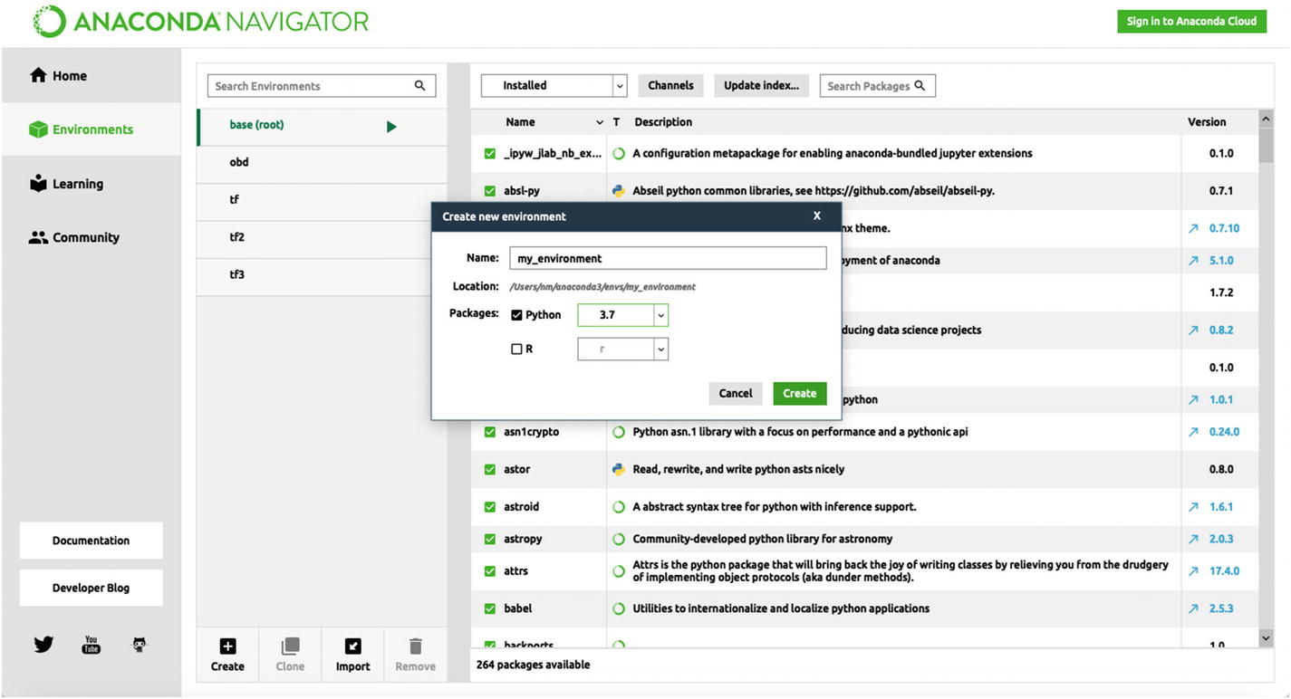
Figure: 2 Creating a new Python environment
7. Once your environment is created, you need to select it as your working environment. Once you do that, you will be able to see a list of installed and uninstalled packages by clicking on “Environments,” then choosing the “Installed” or “Not installed” option accordingly from the drop-down menu at the top, as shown in Figure 3 and 4. You can even search for a specific package by entering its name.

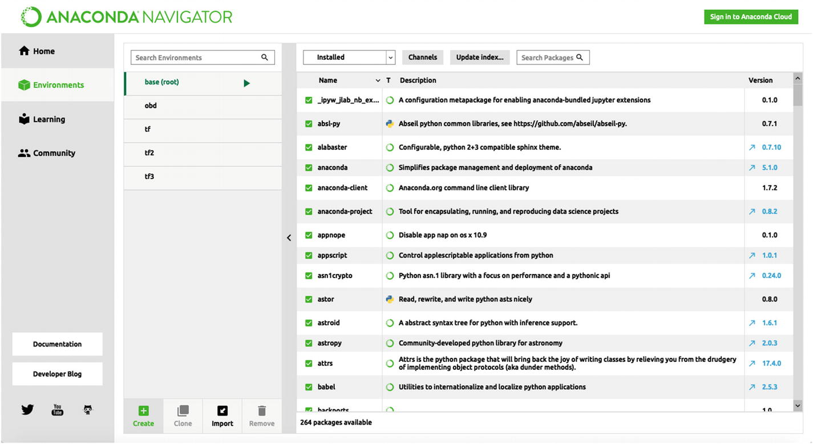
Figure: 3 List of installed packages
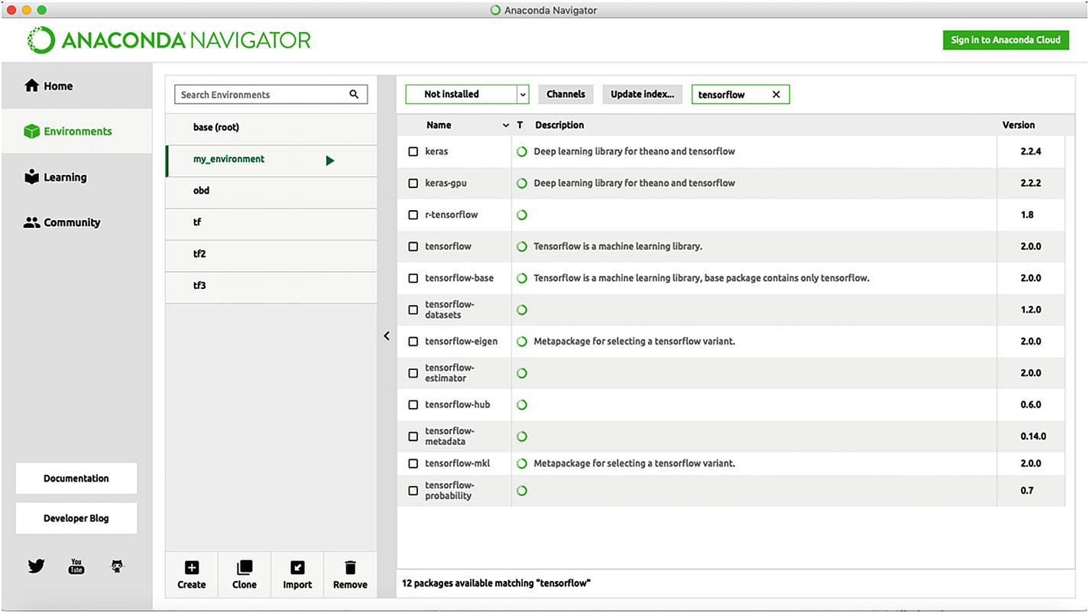
Figure: 4 List of uninstalled packages

8. You can now begin installing some of the necessary libraries that you will need for machine learning, including Pandas, NumPy, SciPy, Scikit-learn, TensorFlow, Matplotlib, and Seaborn. Search for these libraries, select them by clicking on the check box to their left, then click the Apply button, as shown in Figure 5.

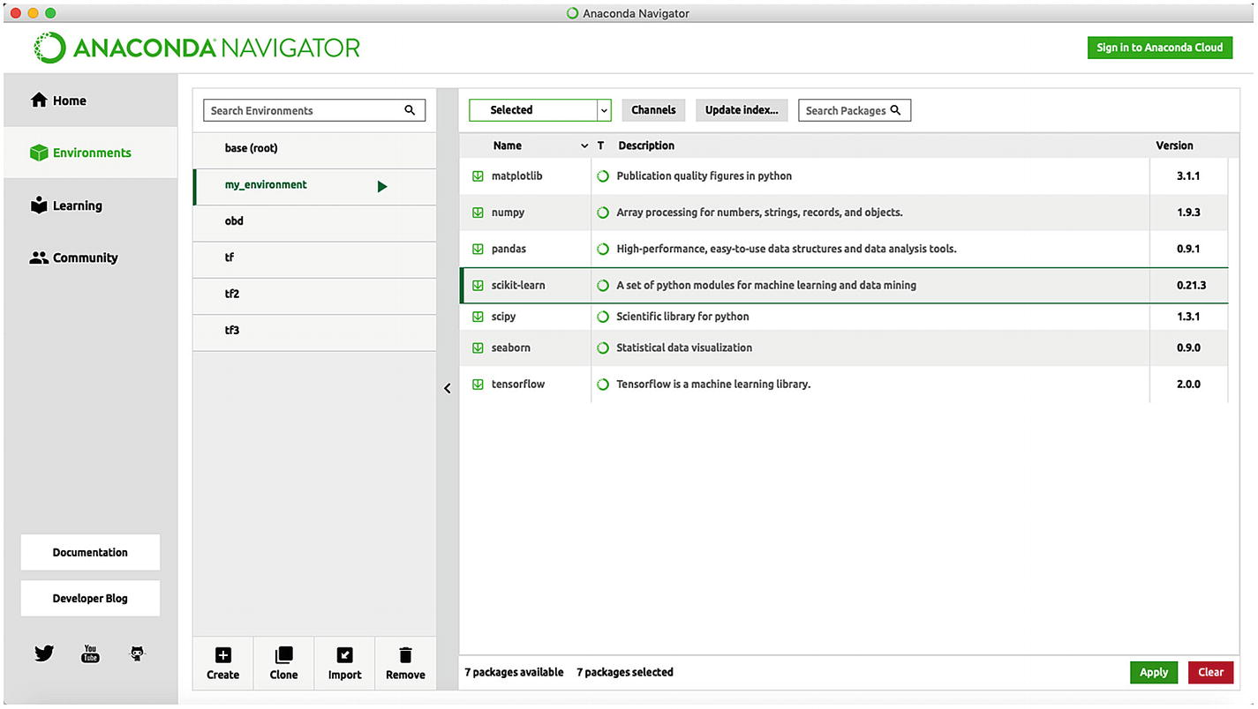
Figure 5: List of selected packages to be installed

There you have it! Your Python environment is now downloaded, installed, and ready for use!

Python Interpreters:

One of the key features of Python is that it is an interpreted language, while other programming languages like Java, C, and C++ are all compiled languages.

Let’s understand the difference between the two.

- A compiled language takes the entire program and translates it from machine code to source code in order to obtain the required output. These languages therefore have a faster runtime, but are not cross-platform.
- An interpreted language executes the code directly by reading each line one by one and then running it to obtain the required output. These languages therefore have a slightly slower runtime, but are cross-platform.
- There are newer technologies being developed to tackle this issue of slow runtime, like the “just-in-time” compiler, which compiles the program during its execution instead of before it.
- Now, when we say that Python is an interpreted language, it does not mean that it is not compiled at all. Compilation happens for a Python program, but it is not explicitly shown to the programmer. The code is compiled into bytecode, which is a low-level form of the original code. This bytecode is then executed by the Python virtual machine.

- In this way, Python runs the code directly, is not restricted to a particular platform, and is not too slow with regard to execution speed.

There are several types of interpreters that Python can use to run a program. Let’s have a brief look some of the most common ones:

- CPython : This is the default implementation of Python. It is most popularly used as it is most compatible with Python packages and with extension modules that are written in C. It is the reference implementation of Python, which means that all the different versions of Python are implemented in C.

- Jython (formerly JPython) : This is an implementation of Python that is written in Java and Python. It translates Python code into Java bytecode, and then executes it on a Java virtual machine. This allows Python code to run on Java platforms. It also allows users to use a Java class like a Python module.

- IronPython : This is an implementation of Python that was developed for Microsoft’s .NET framework. It uses Python libraries as well as .NET framework libraries. It also provides an interactive console and dynamic compilation support for improved performance.

- PyPy: This Python implementation was written in RPython, which is a subset of the Python programming language. It uses a just-in-time compiler, which gives it a quick runtime speed. It is meant to provide maximum compatibility with CPython, while strengthening performance.

- Stackless Python : This implementation was, like CPython, written with Python and C. It gets its name from the fact that it does not depend on the C call for its stack. It uses the C stack between function calls, and then clears it out. It makes use of microthreads, and supports task serialization, tasklets, communication channels, and more.

- MicroPython : This is a small, open source Python implementation that was written in C and is compatible with Python 3. It allows us to write simple Python code instead of complex low-level language code, and it can be run on microcontroller hardware. It has a range of modules from Python’s standard library, as well as some extra libraries that are specific to MicroPython, which can be used to program the board.

Now that we know what interpreters are, we need to know how to interact with them. One of the most generic ways to do so is by using something known as a Python shell.

The Python Shell

In computing, a shell acts as a medium between the user and the interpreter. With the help of the shell, the programmer can input some code and receive the necessary output. The shell waits for the user to enter a command or a line of code. It then executes this code and displays the obtained result.

It is called a shell because it is the outermost layer of the operating system. It can provide users with either a command-line interface (CLI) or a graphical user interface (GUI), depending on what is required for that particular operation.

The Python shell, or the Python interactive shell, also called the Python REPL shell, takes a Python command and executes it, displaying the required outcome. The term REPL is an acronym for the systematic flow of events that occurs during this process, as follows:
Read: It reads or takes in an input from the user.

Eval: It evaluates the input.

Print: It prints or displays the output to the user.
Loop: It loops or repeats the process.

This shell interface is meant to be simple, easy, and great for beginners to get the hang of programming on a computer.

Opening the Python Shell
This task is much easier than it sounds. It is basically a two-step process that can be accomplished in a flash.
1. First, you need to open the command-line interface of your operating system. For example, on Mac OS and Linux, it would be the Terminal, while on Windows; it would be the command prompt. See Figure 6.
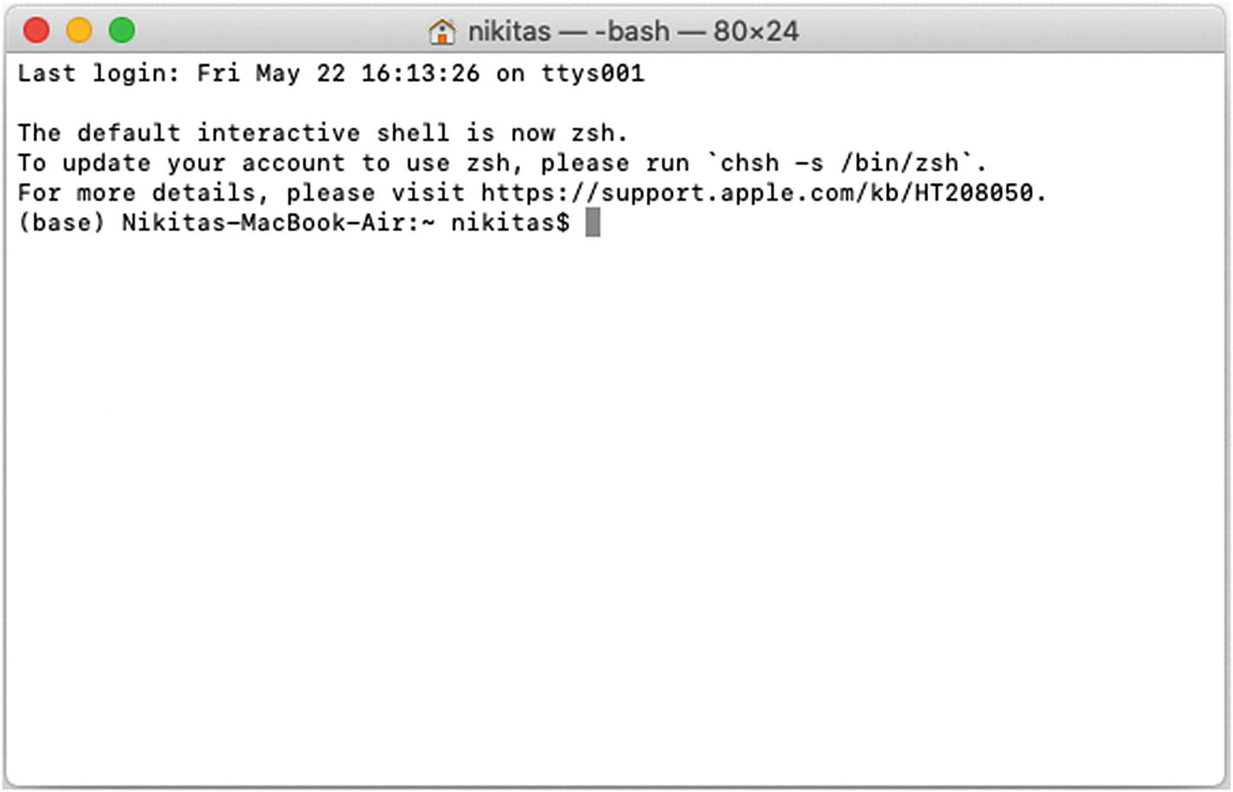
Figure 6 The Mac OS Terminal

2. Next, in this interface, type the following:

python

Hit the Enter key. This should give the output shown in Figure 7.
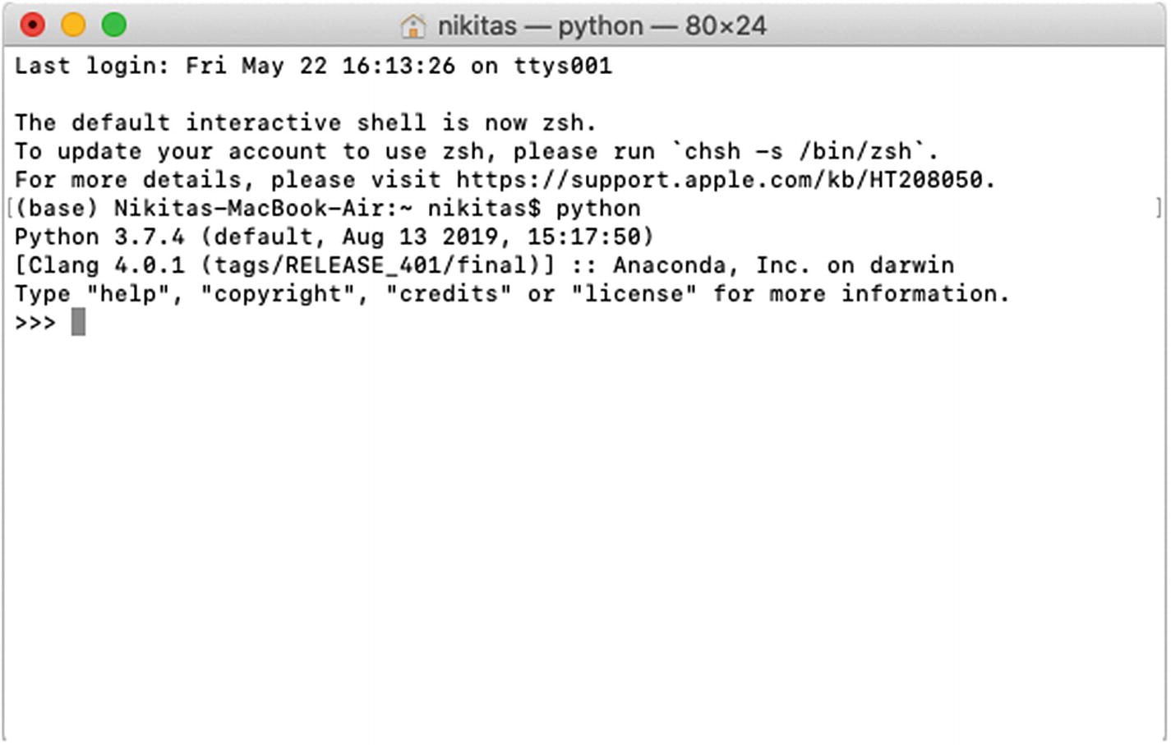
Figure 7 The Python shell

We are now in the Python REPL shell! This is one of the simplest interfaces that we can use to program with Python. This Python shell can now accept input as a Python command and execute it to display the necessary output. Some simple examples are shown in Figure 8, where I have performed some single-digit arithmetic operations (addition and subtraction).
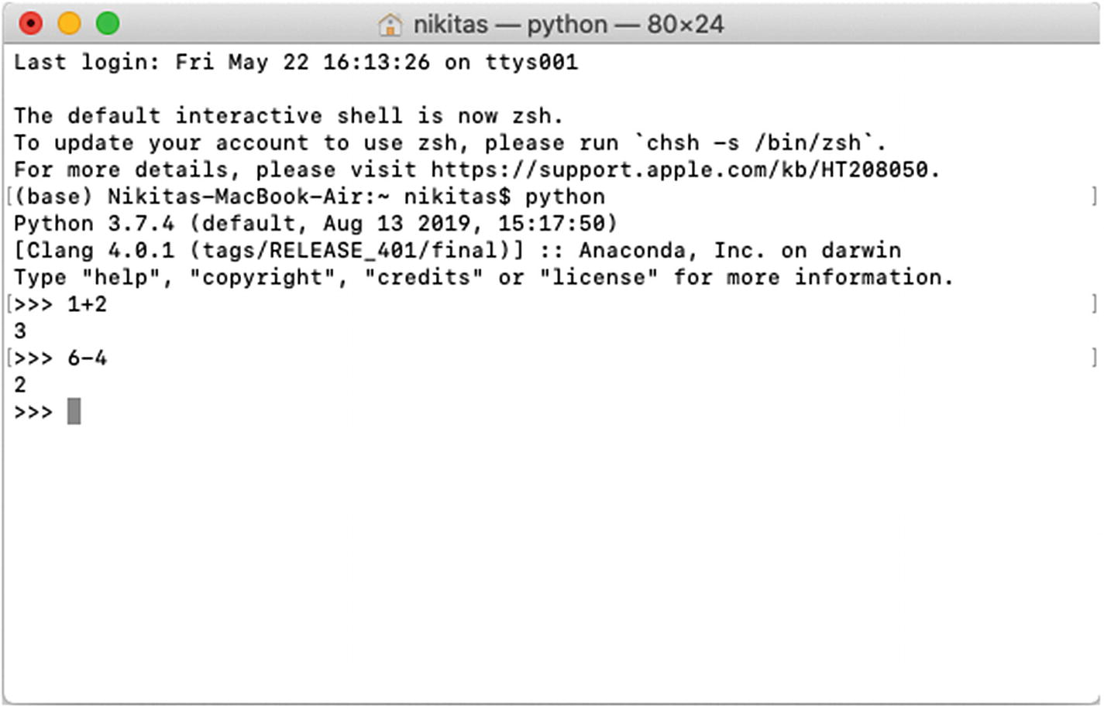
Figure 8 Arithmetic operations in the Python shell
We can use the help() command to explore different features within Python. To exit the Help window and return to the Python shell, press q and then Enter. See Figure 9.
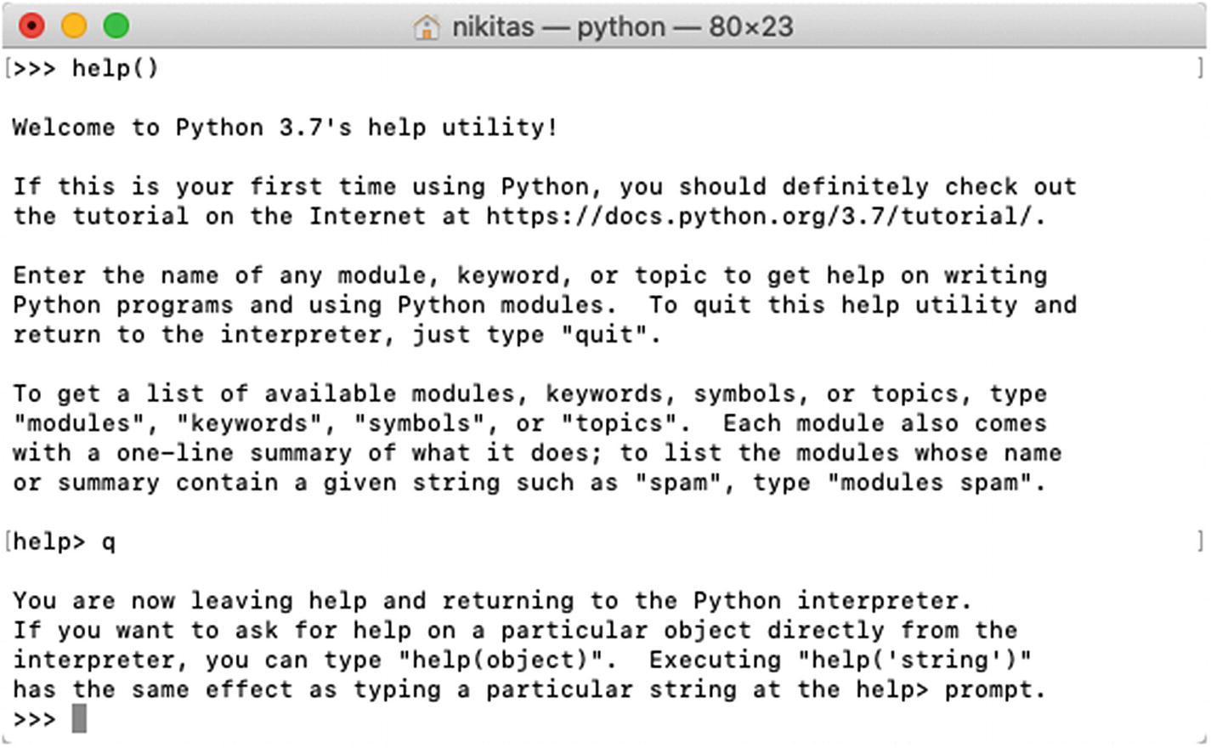
Figure 9: The Help window in Python

Exiting the Python Shell
Once we are done programming with Python, we will need to exit the Python programming environment by closing the shell. We can do this by typing in the following command:
exit()
This exits the Python interactive shell and returns back to the main command-line interface of the OS. The reason we use the brackets at the end of the command is because we are calling the exit function in order to exit from the shell. See Figure 10.
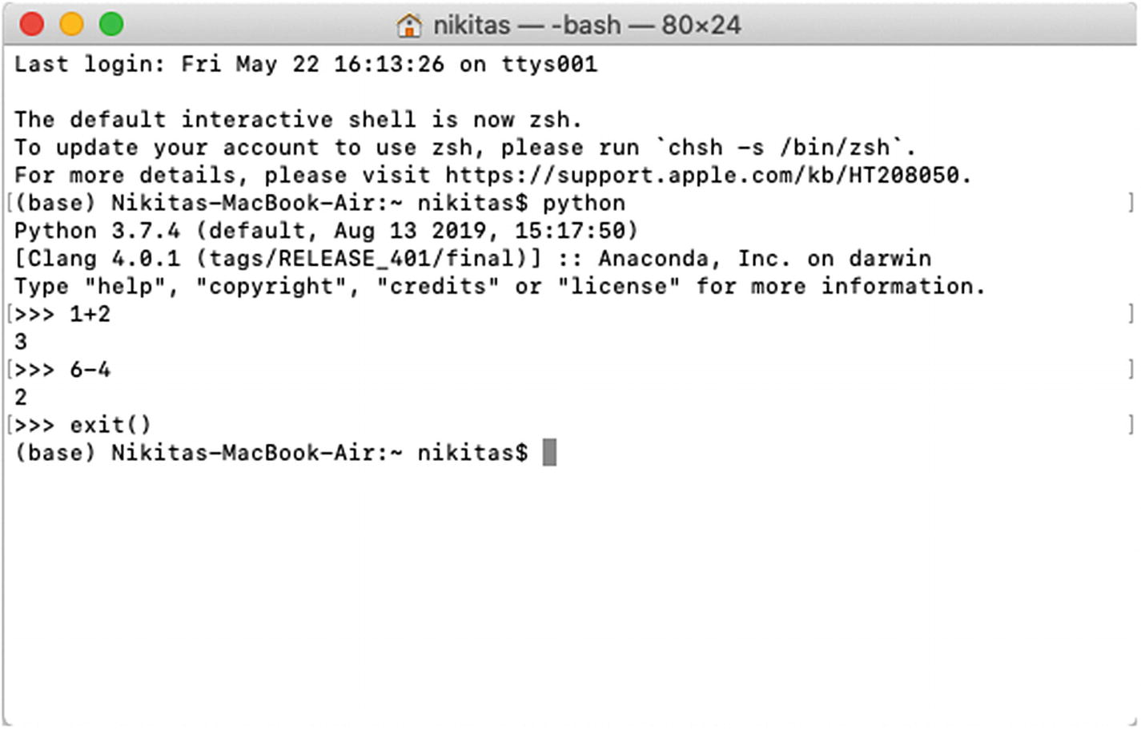
Figure 10: Exiting the Python shell

The keyboard shortcut for this step is ctrl+D on Mac OS and Linux, and ctrl+Z+Enter on Windows.

Conclusion:
We have successfully understood & implemented different operations using NumPy, pandas and scikit learn in Collab.

Post lab Questions:

- Role of Pandas, Numpy, Matlotlib and Scikitlearn libraries for data analysis in machine learning applications.
- Numpy Introduction (creating, accessing numpy arrays, Linear algebra using numpy)
NumPy is a Python library used for working with arrays.
It also has functions for working in domain of linear algebra, fourier transform, and matrices.
Once NumPy is installed, import it in your applications by adding the import keyword.
NumPy is used to work with arrays. The array object in NumPy is called ndarray.
We can create a NumPy ndarray object by using the array() function.
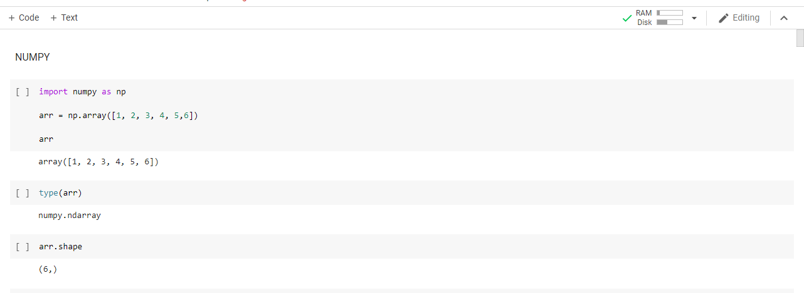
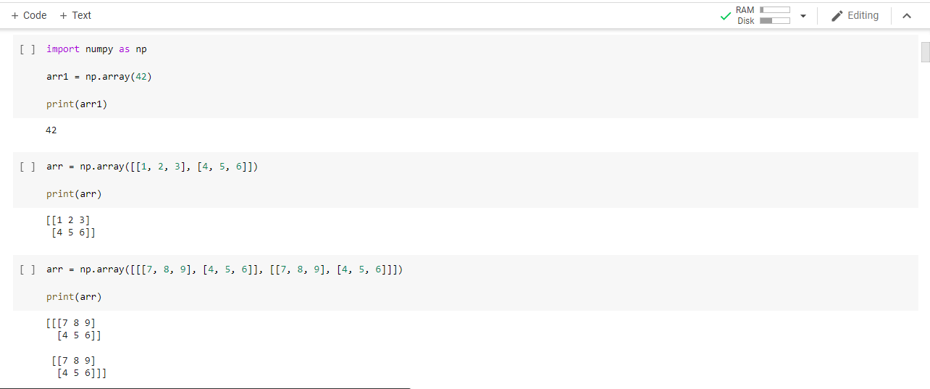
A dimension in arrays is one level of array depth (nested arrays).
Arrays can have 0 dimensions, 1 ,2 ,3 dimensions and so on.
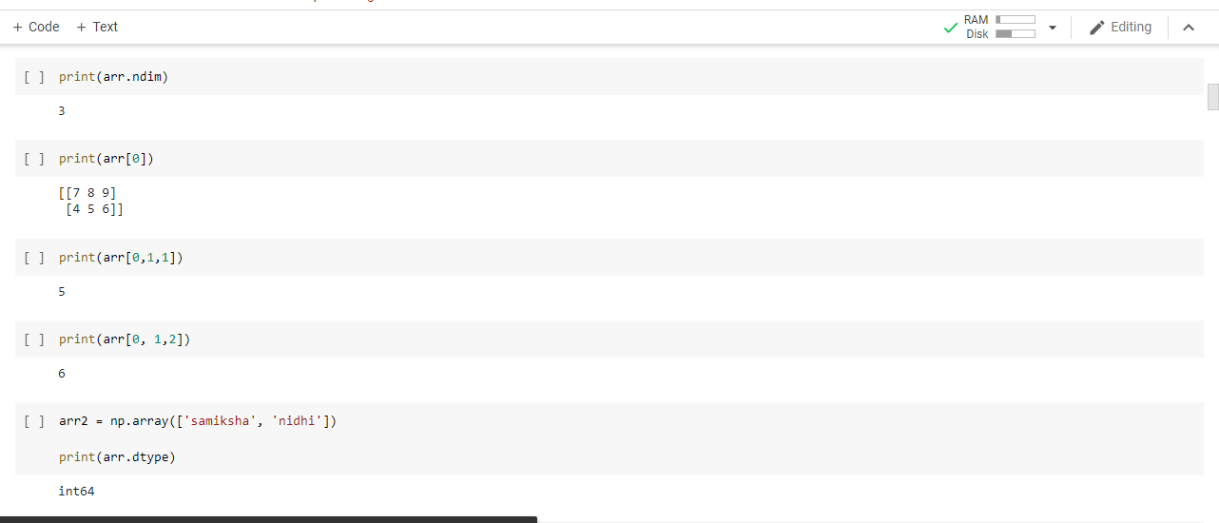
Array indexing is the same as accessing an array element.
You can access an array element by referring to its index number.
The indexes in NumPy arrays start with 0, meaning that the first element has index 0, and the second has index 1 etc.
NumPy offers the random module to work with random numbers.
The random module's rand() method returns a random float between 0 and 1.
The randint() method takes a size parameter where you can specify the shape of an array.

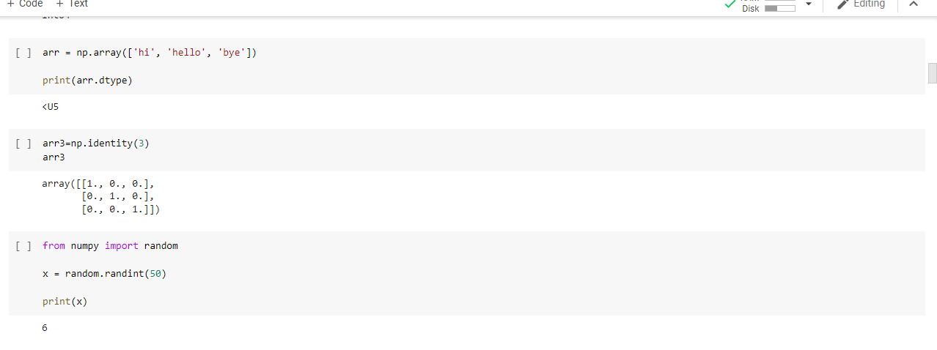
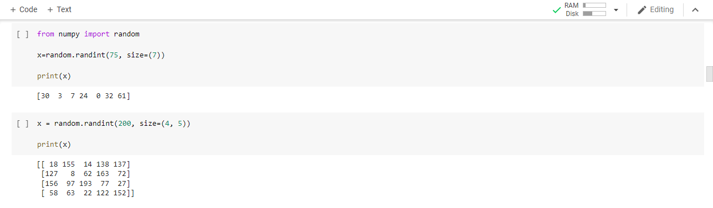

The shape of an array is the number of elements in each dimension.
Reshaping means changing the shape of an array.
The shape of an array is the number of elements in each dimension.
By reshaping we can add or remove dimensions or change number of elements in each dimension.
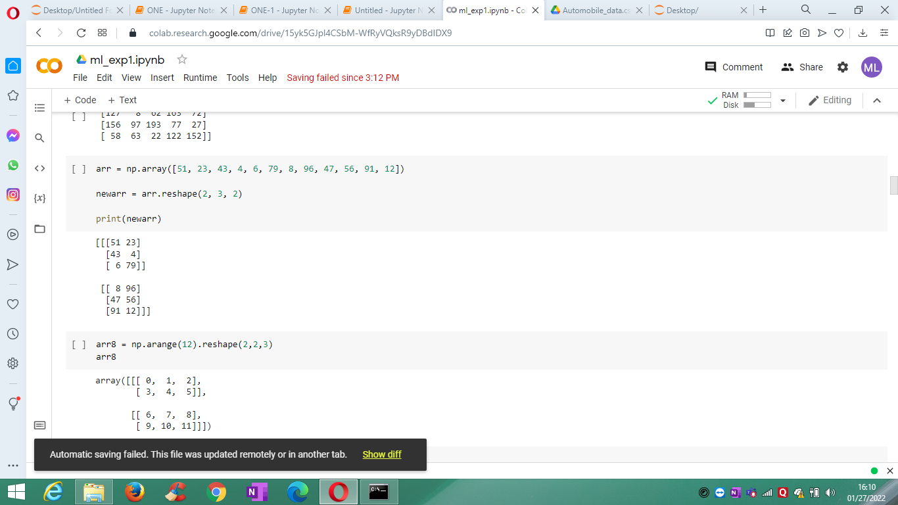

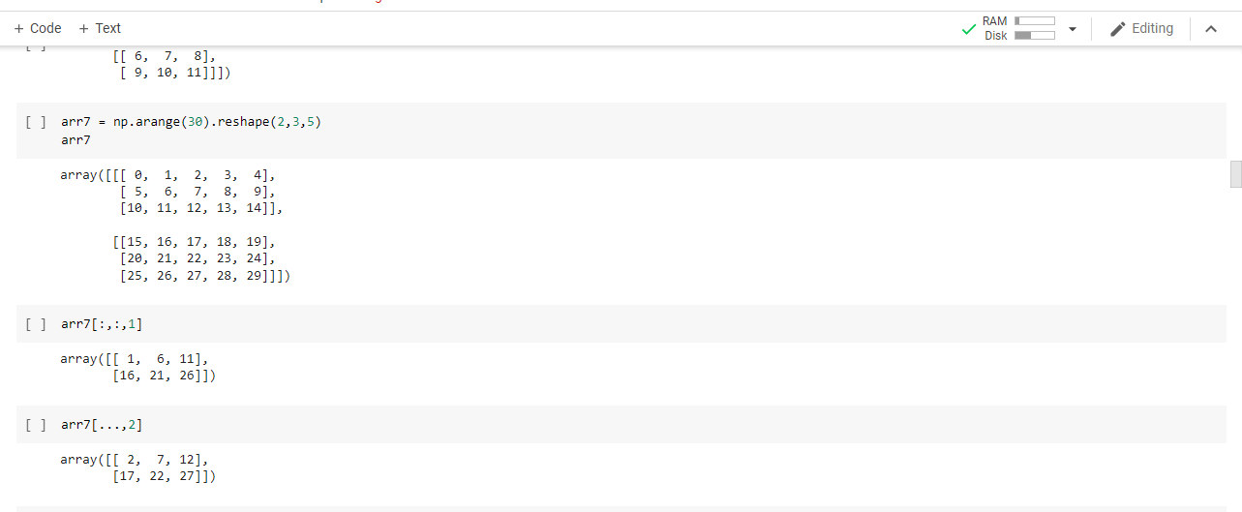

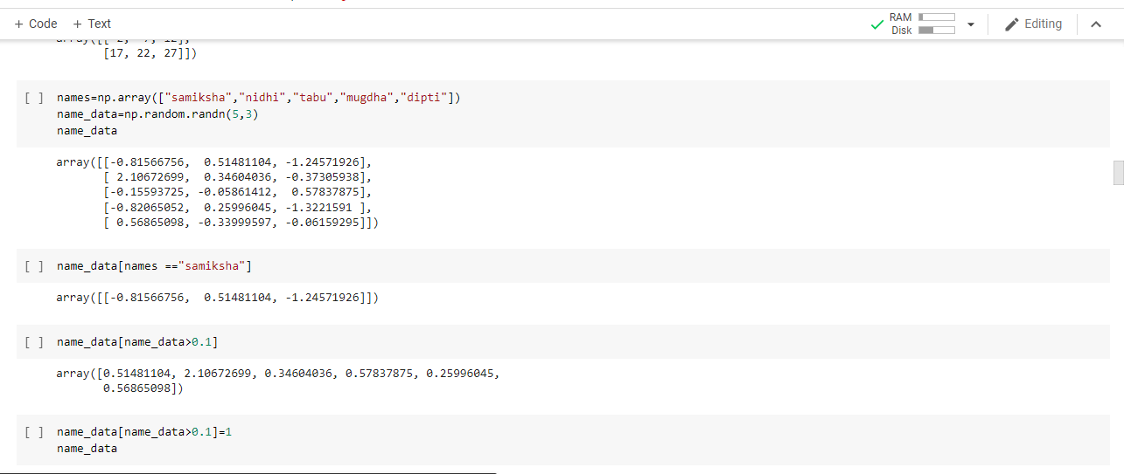

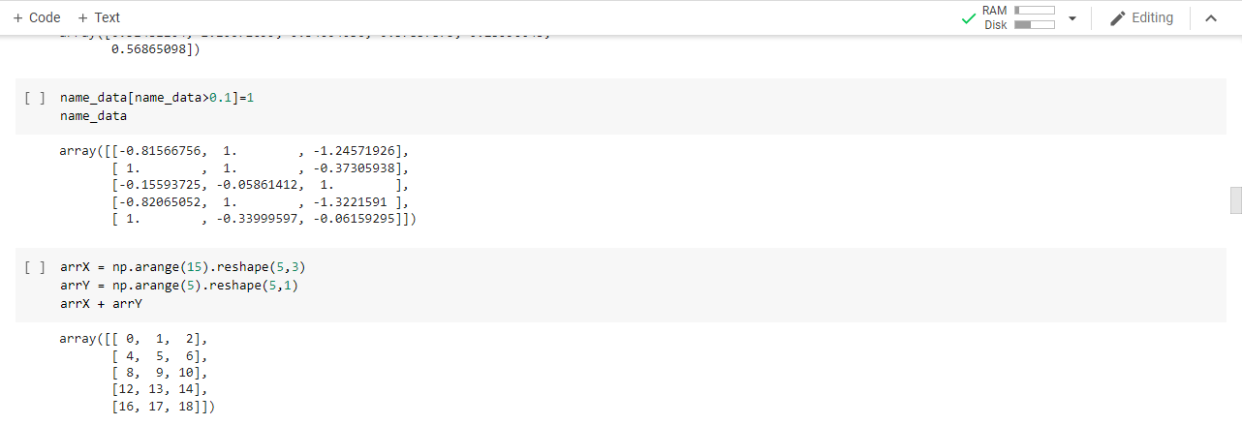

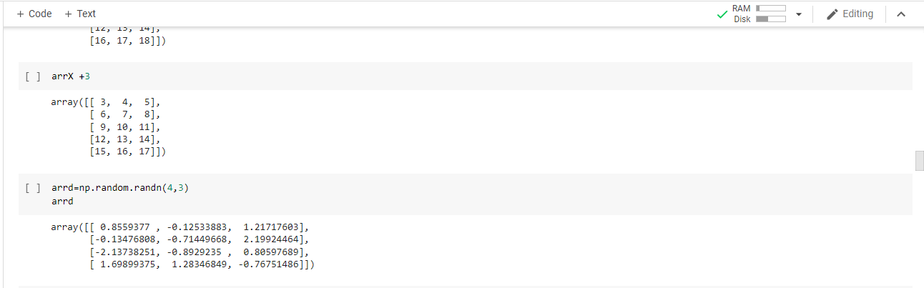

modf. Return the fractional and integral parts of an array, element-wise. The fractional and integral parts are negative if the given number is negative.
linalg.solve(a, b)
Solve a linear matrix equation, or system of linear scalar equations.
numpy.linspace
Return evenly spaced numbers over a specified interval.
Returns num evenly spaced samples, calculated over the interval [start, stop].
The endpoint of the interval can optionally be excluded.

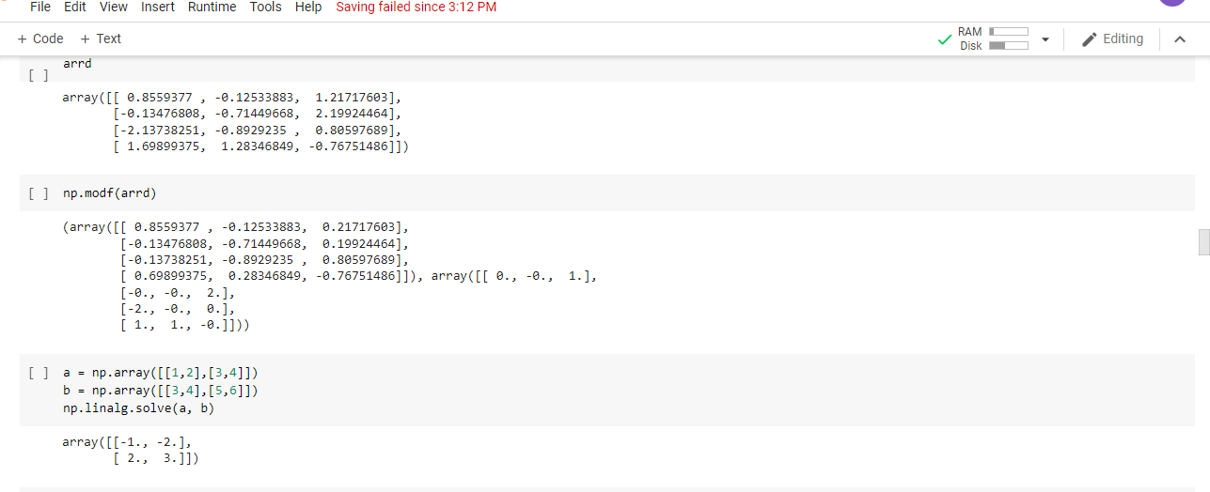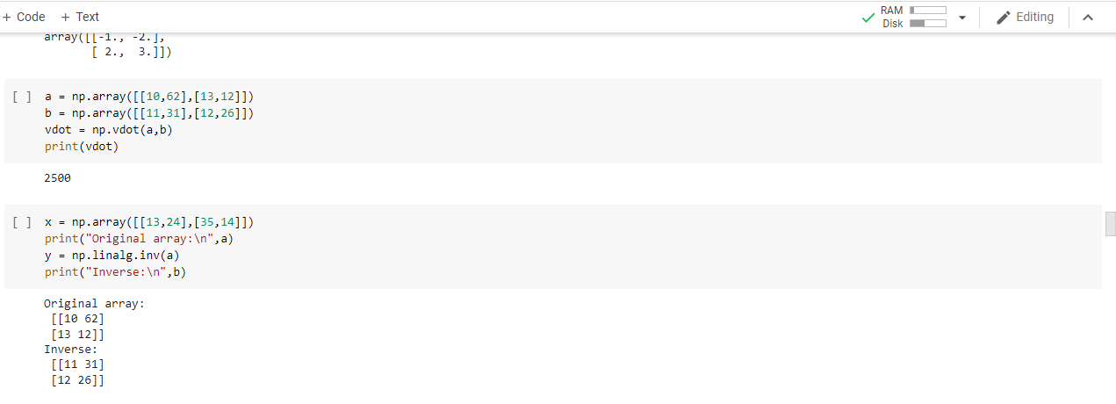

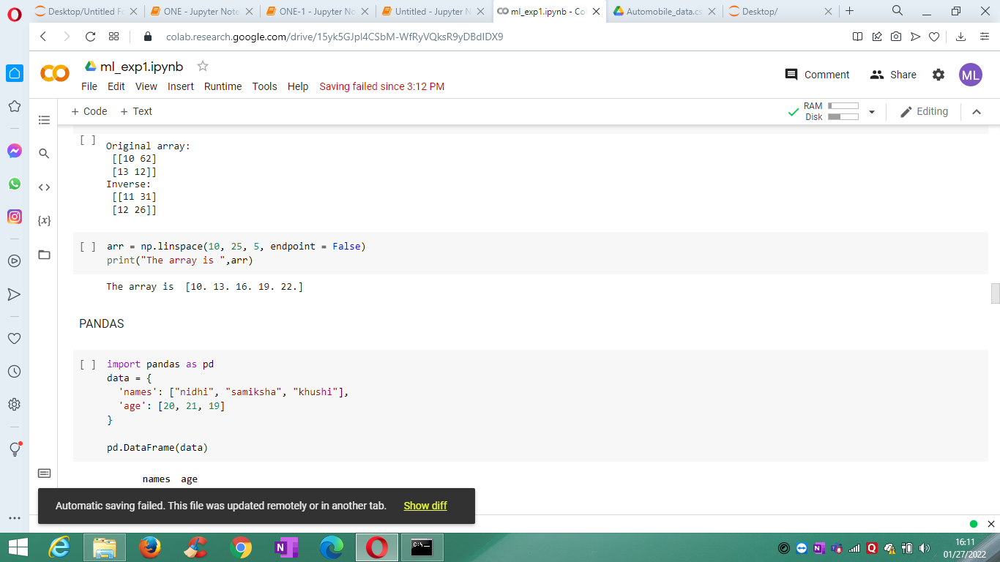

- Pandas (reading data from data frame, operations on data frame, Concatenating data frames)
Pandas is a Python library used for analyzing the data.
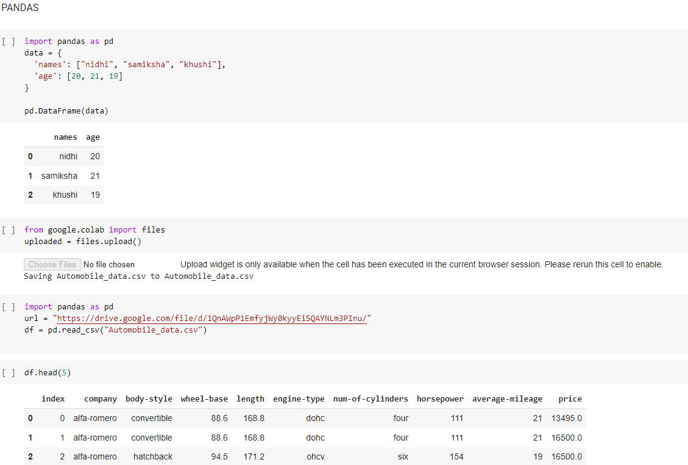
A Pandas DataFrame is a 2 dimensional data structure, like a 2 dimensional array, or a table with rows and columns.
1st 5 rows,Last 5 rows,using loc[:] - slicing of DataFrame
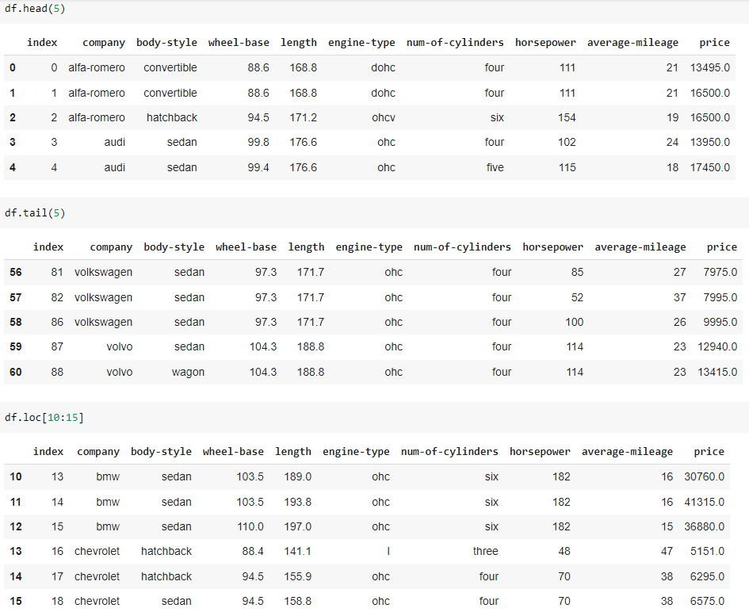
Clean the dataset and update the CSV file
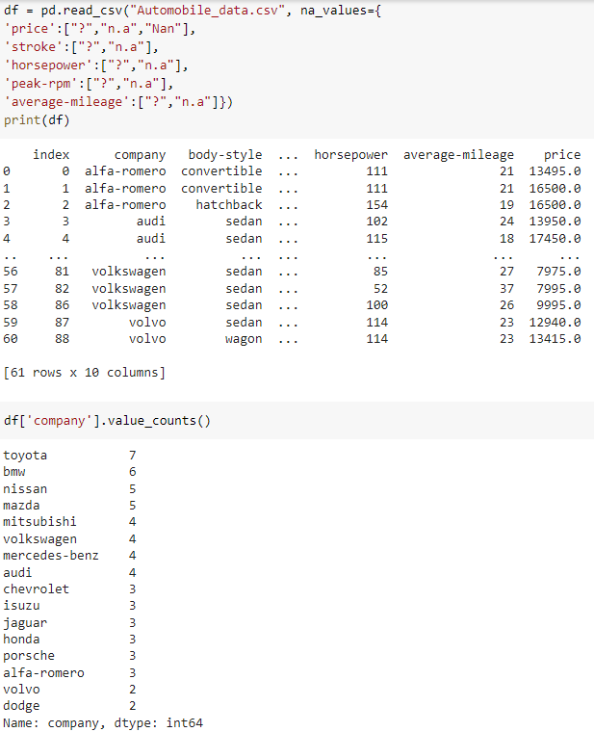
& count no of different company
Find the most expensive, less expensive car company name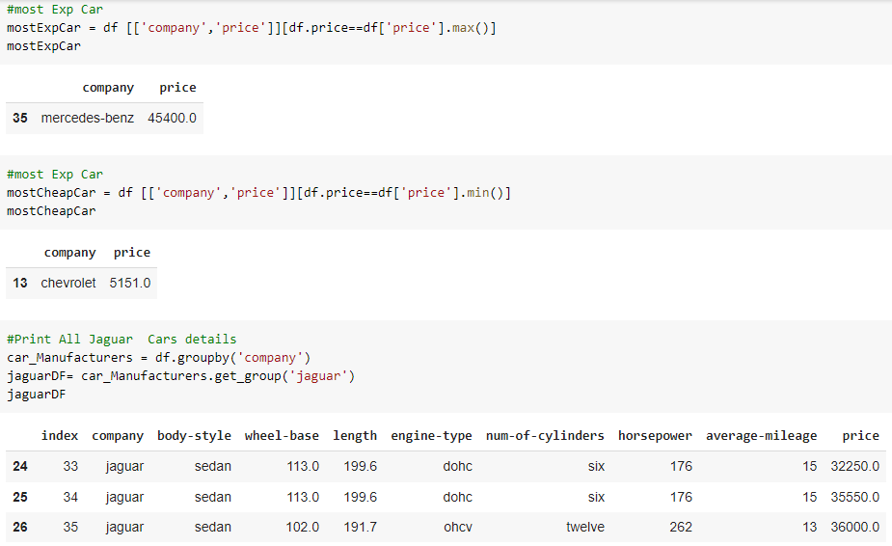
Print all details of Jaguar Car Company
Print Average mileage of the company & Merge 2 df DataFrames & print it.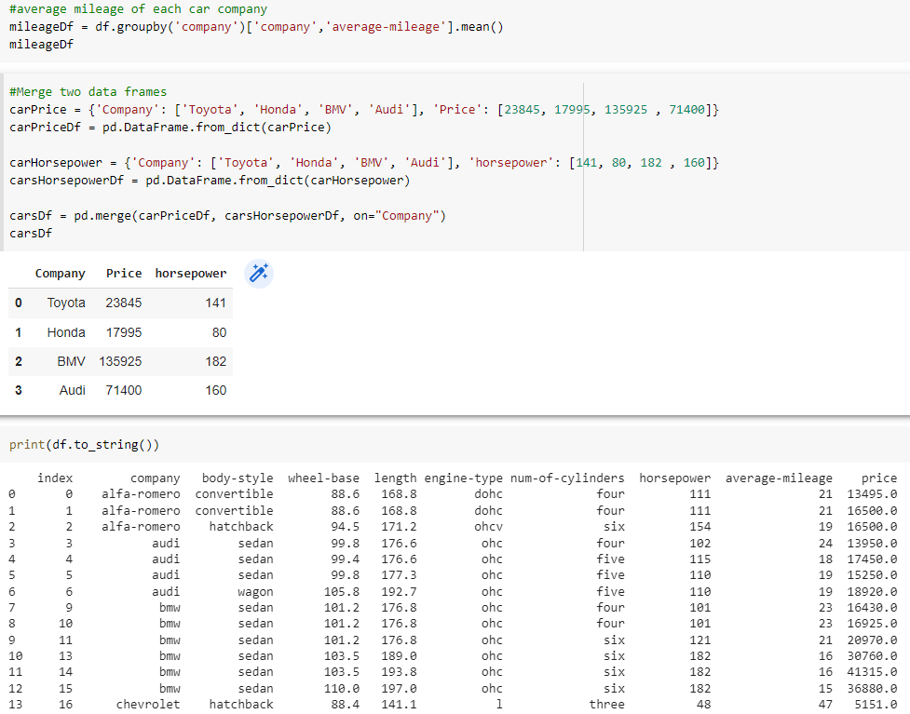
Convert df DataFrame to string & print it.
- Explore Scikit learn Python ML library.
It is package that provides efficient versions of a large number of common algorithms & characterized by a clean, uniform, & streamlined API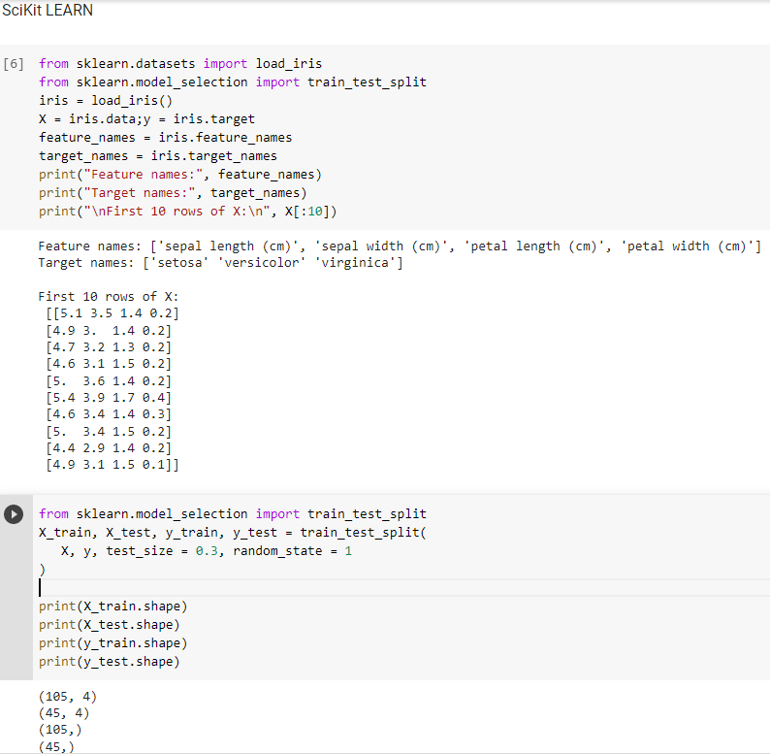
As we have 4 features in the iris dataset so we should have 4 columns in the feature matrix let’s figure it out by using target
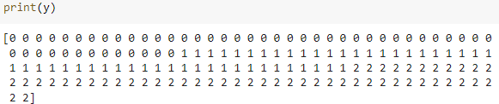
Iris target stored 150 values of iris species
Split arrays or matrices into random train and test subsets returns list containing train-test split of inputs. Test Size + Train Size = 1. Here, according to our need we can pass test/train size; random_state is the seed used by the random number generator.

