Batch: ML1 Roll No.: 1911004

Experiment / Assignment / Tutorial No 3

Title: Implementation of linear Regression.

Aim: To understand & implement linear regression using python.

Expected Outcome of Experiment:

CO2: Describe and apply supervised learning methods.

Books/ Journals/ Websites referred:
https://medium.com/swlh/gradient-descent-algorithm-3d3ba3823fd4
https://colab.research.google.com/?utm_source=scs-index
3rd Edition

Theory of Linear Regression:

The term “linearity” in algebra refers to a linear relationship between two or more variables. If we draw this relationship in a two-dimensional space (between two variables), we get a straight line.

Linear regression performs the task to predict a dependent variable value (y) based on a given independent variable (x). So, this regression technique finds out a linear relationship between x (input) and y(output). Hence, the name is Linear Regression. If we plot the independent variable (x) on the x-axis and dependent variable (y) on the y-axis, linear regression gives us a straight line that best fits the data points, as shown in the figure below.

We know that the equation of a straight line is basically:

Figure
source

The equation of the above line is:

Y= mx + b

Where b is the intercept and m is the slope of the line. So basically, the linear regression algorithm gives us the most optimal value for the intercept and the slope (in two dimensions). The y and x variables remain the same, since they are the data features and cannot be changed. The values that we can control are the intercept(b) and slope(m). There can be multiple straight lines depending upon the values of intercept and slope. Basically, what the linear regression algorithm does is it fits multiple lines on the data points and returns the line that results in the least error.

This same concept can be extended to cases where there are more than two variables. This is called multiple linear regression.

Problem Definition:

- Generate synthetic dataset (linear and nonlinear both) for e.g., y = (x/2) + sin(x) + Gaussian noise or take any function of your choice.
- Fit the regression model using sklearn library.
- Fit the regression model on the data using gradient descent algorithm and its different variants.
- Calculate parameters and compare error values.
Screenshots of code and out put

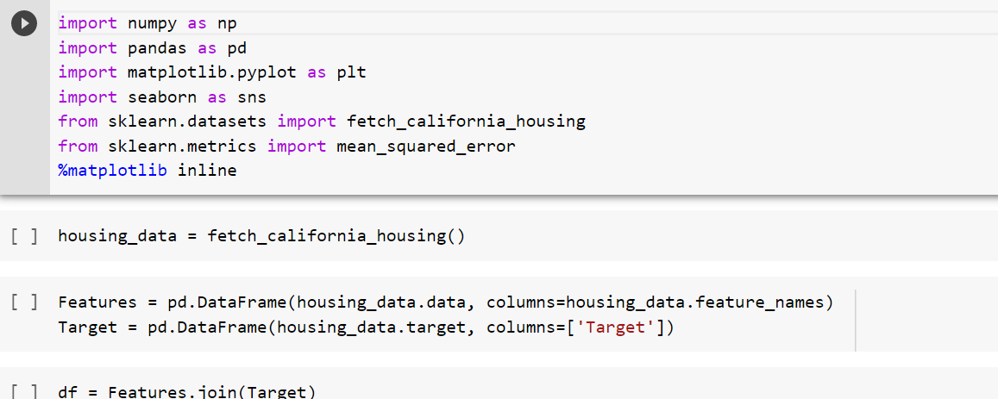

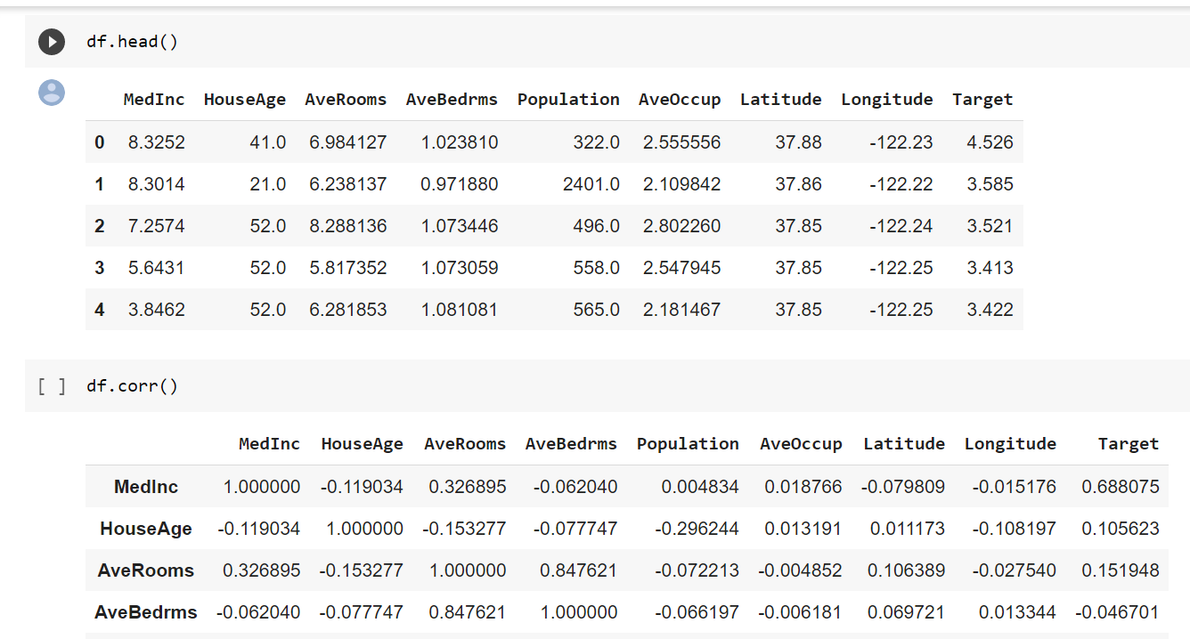

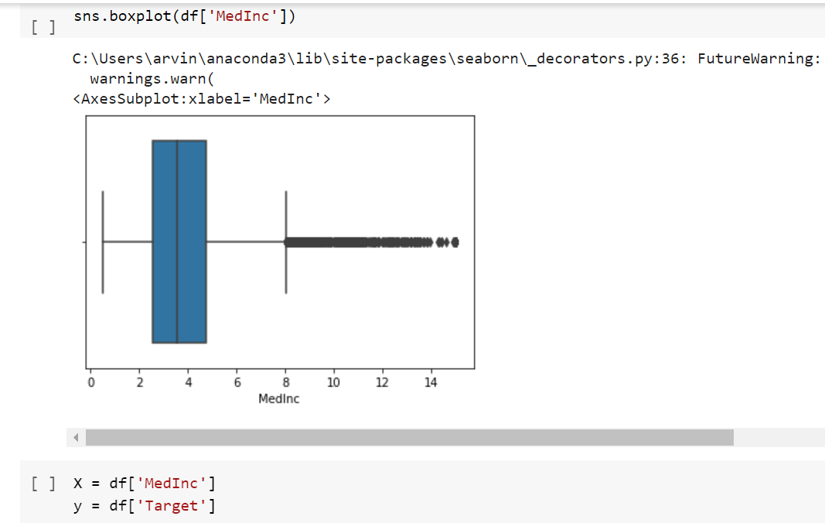

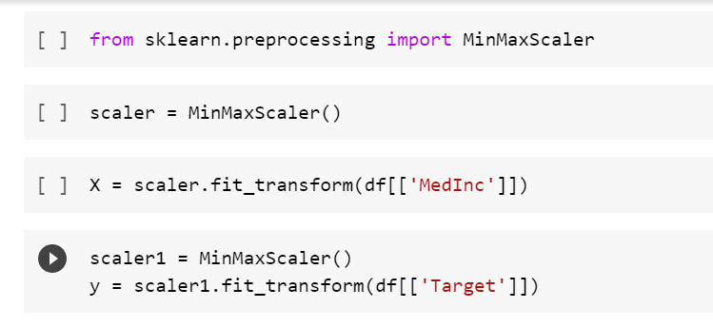

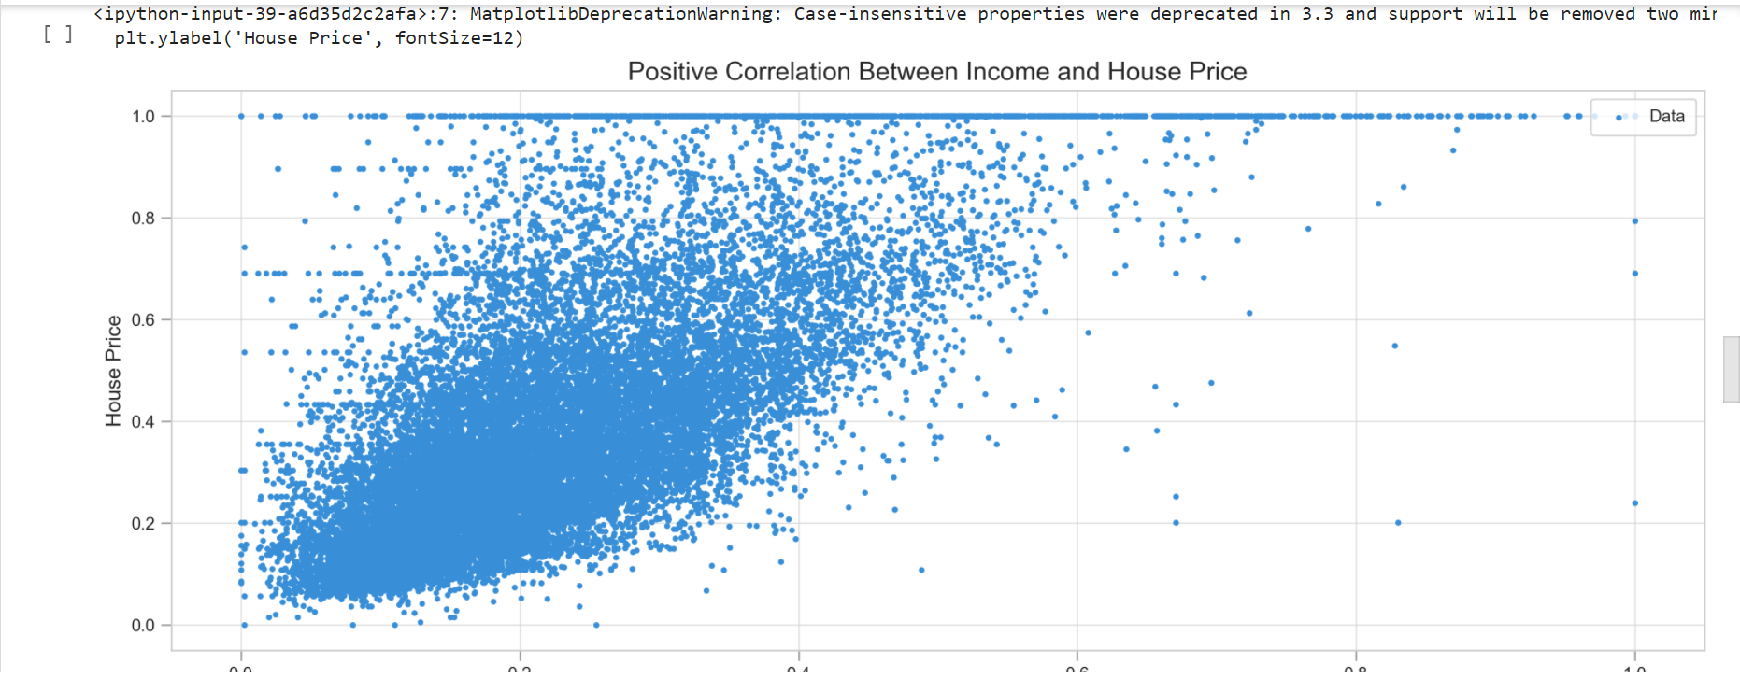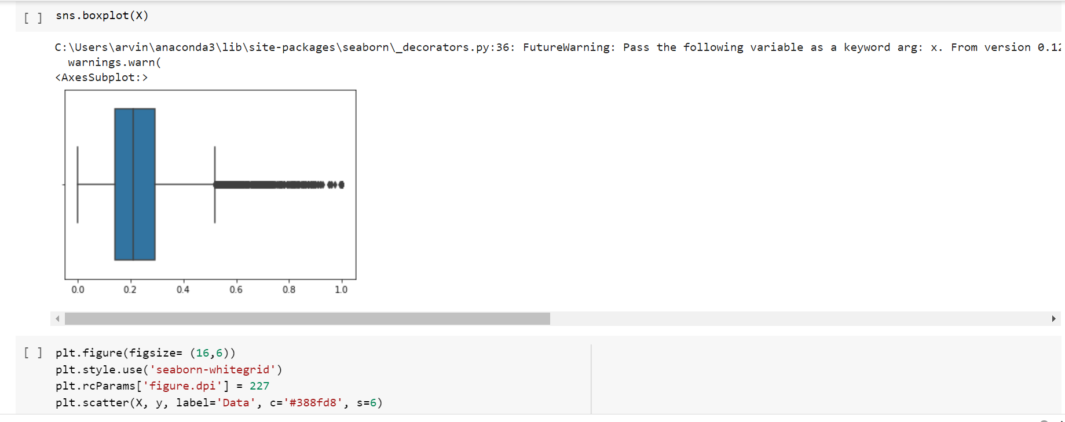

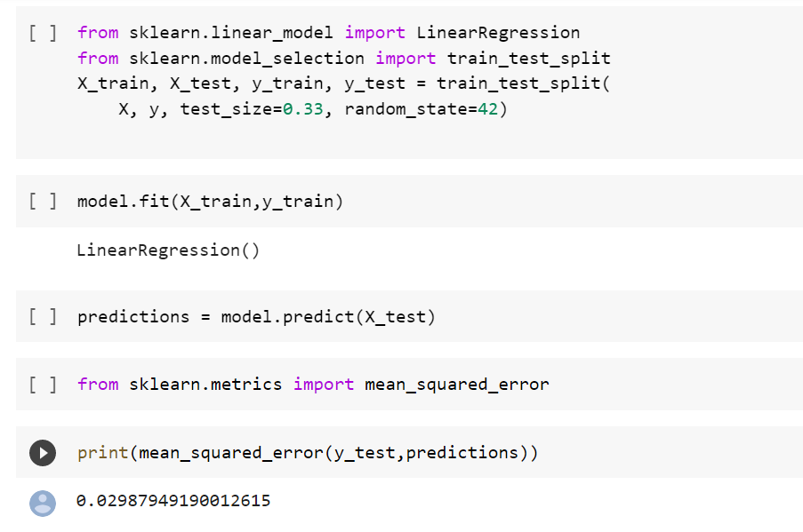

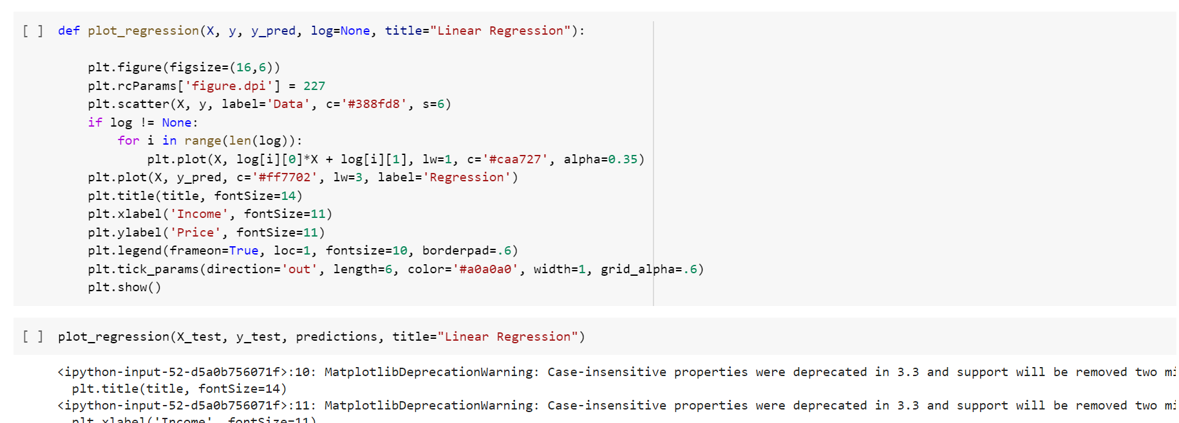

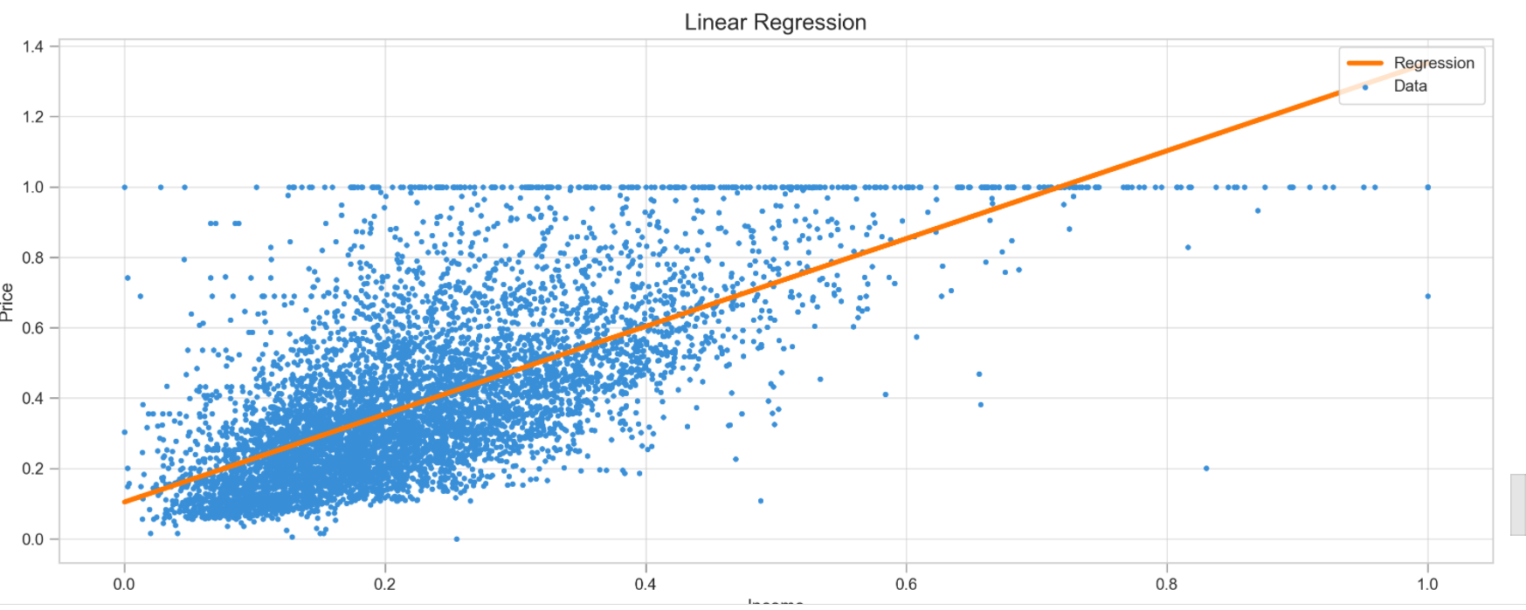

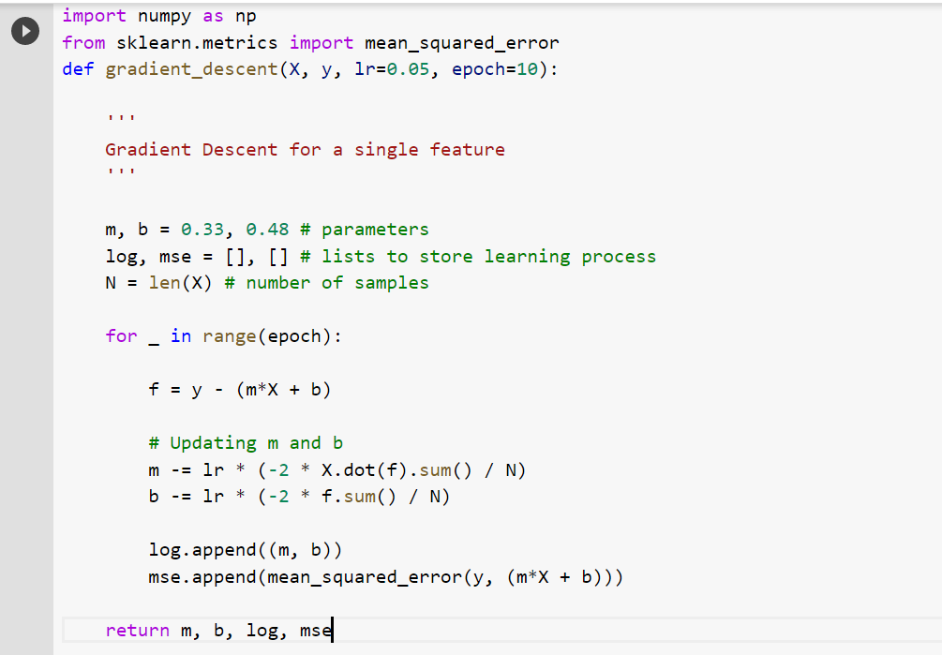

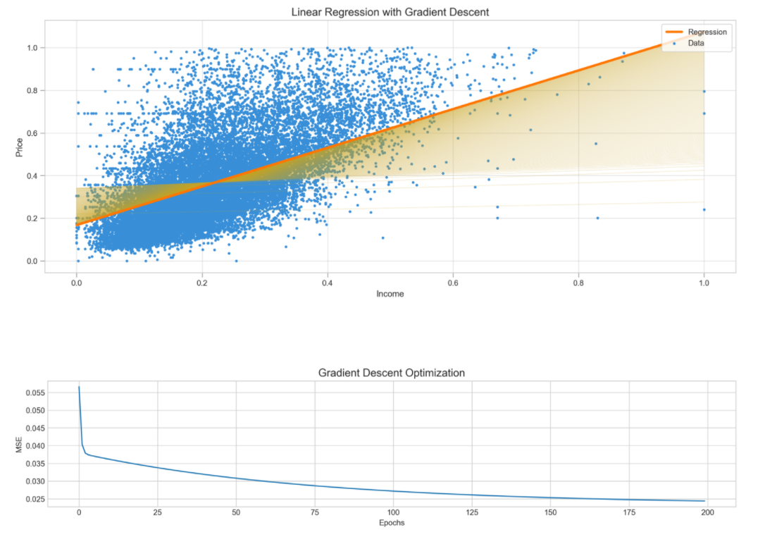

API/ Function/ Libraries used are :
- Numpy
- Pandas
- Matplotlib
- SciKitLearn
- Seaborn

Conclusion:
Thus, we have successfully understood linear regression and gradient descent & implemented it in python.

