Batch: ML1 Roll No.: 1911004

Experiment / Assignment / Tutorial No. 2

Title: Data Preprocessing and feature engineering in machine learning.

Aim: To understand & implement various data preprocessing and feature engineering techniques using Python for machine learning applications.
Expected Outcome of Experiment:

CO1: Describe the basics of machine learning.

Books/ Journals/ Websites referred:
- https://www.python.org/about/
- https://www.upgrad.com/blog/data-preprocessing-in-machine-learning/
- https://towardsdatascience.com/data-preprocessing-concepts-fa946d11c825
- Data Mining: Concepts &Techniques by Jiawei Han, MichelineKamber, Jian Pei

Introduction
What is a feature and why we need the engineering of it? Basically, all machine learning algorithms use some input data to create outputs. This input data comprise features, which are usually in the form of structured columns. Algorithms require features with some specific characteristic to work properly. Here, the need for feature engineering arises. Feature engineering efforts mainly have two goals:
- Preparing the proper input dataset which is compatible with the machine learning algorithm requirements.
- Improving the performance of machine learning models.

Different Preprocessing Techniques:

1. Imputation
2. Handling Outliers
3. Binning
4. Log Transform
5. One-Hot Encoding
6. Grouping Operations
7. Feature Split
8. Scaling

Code: Exp2 NoteBook Link
Output:
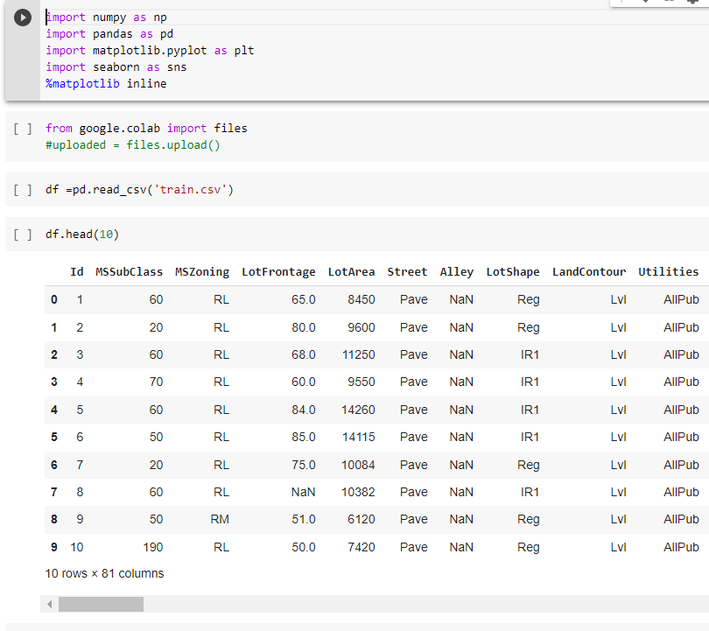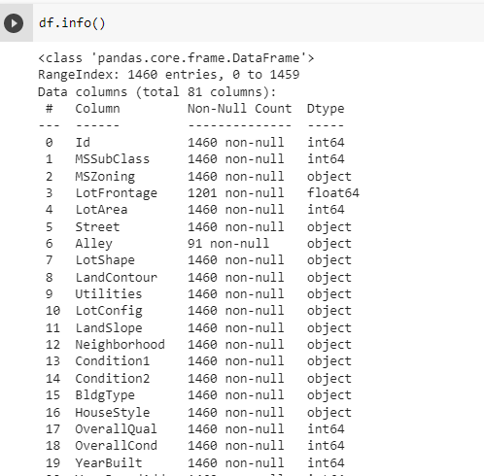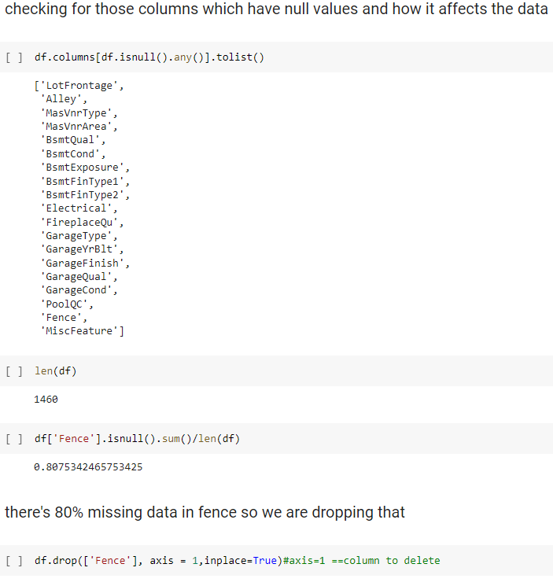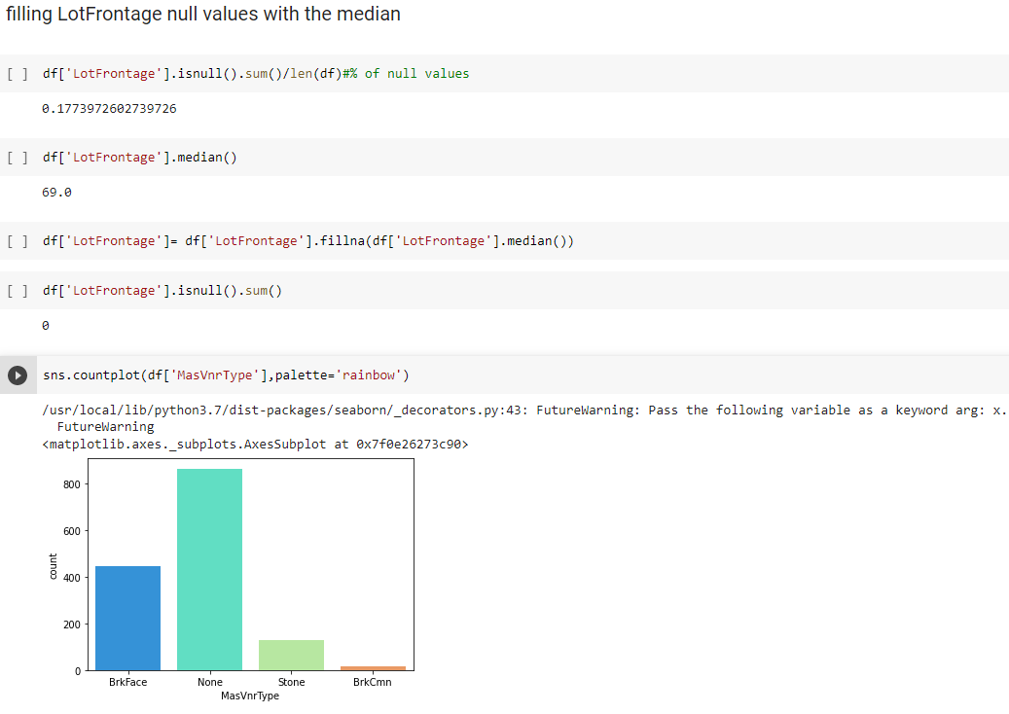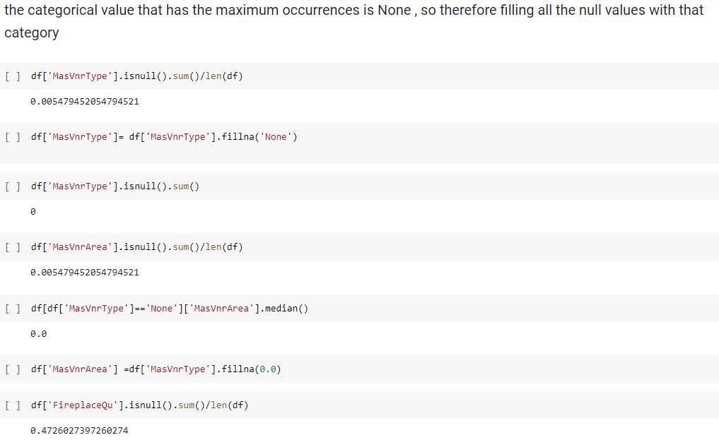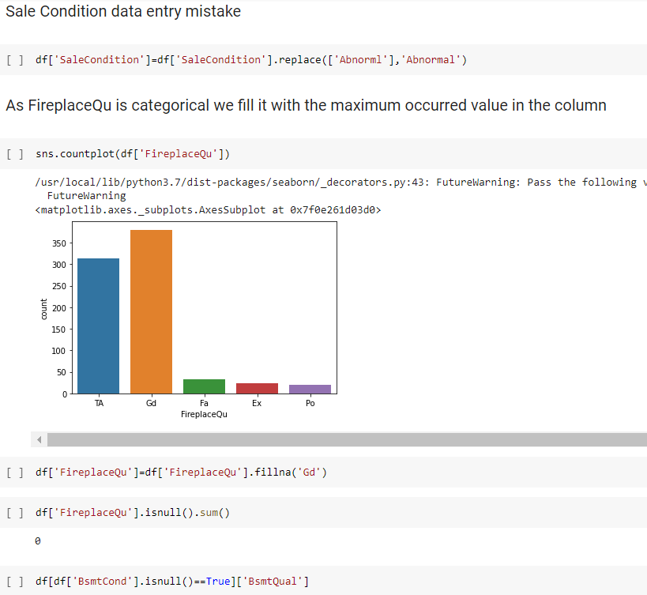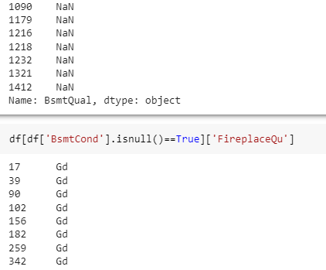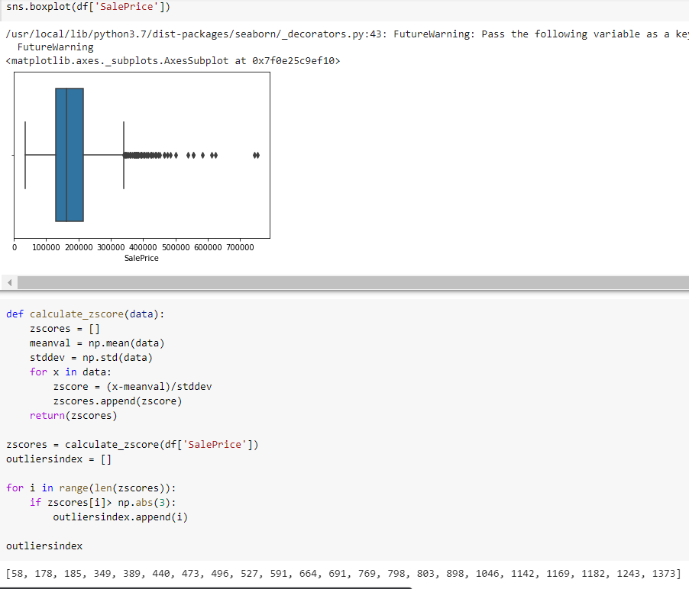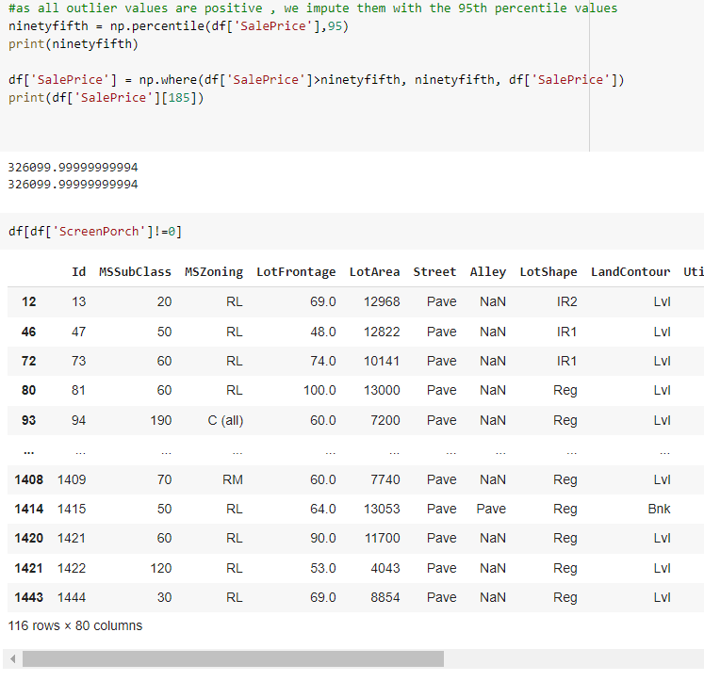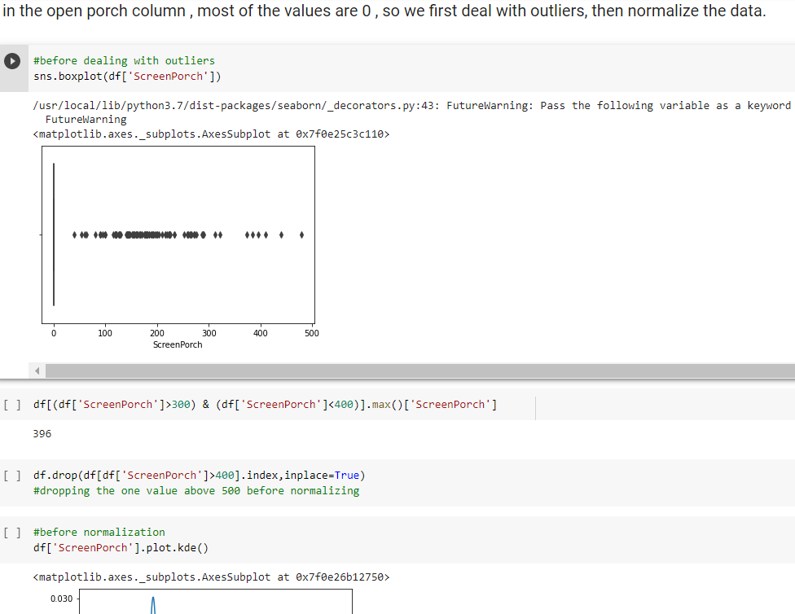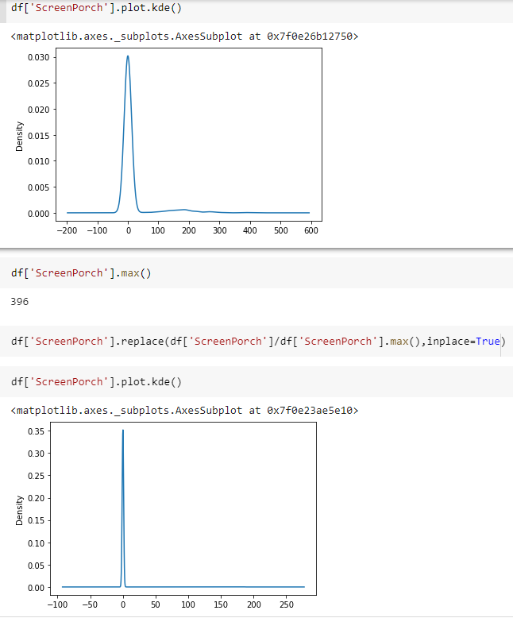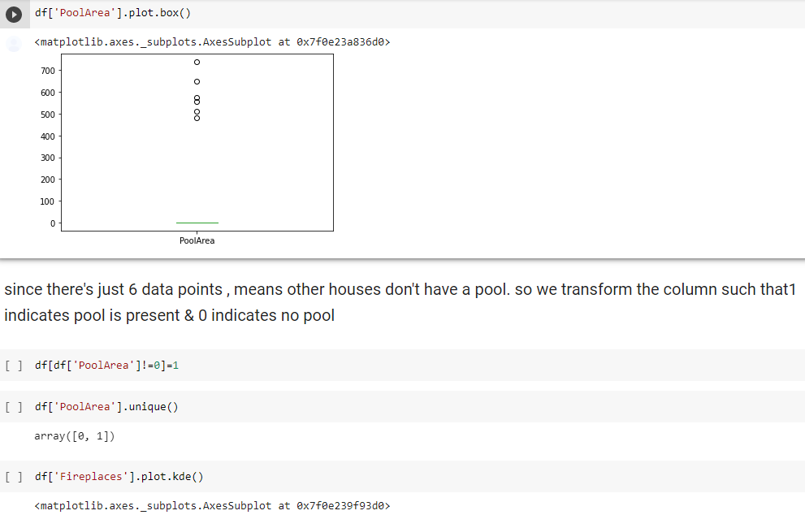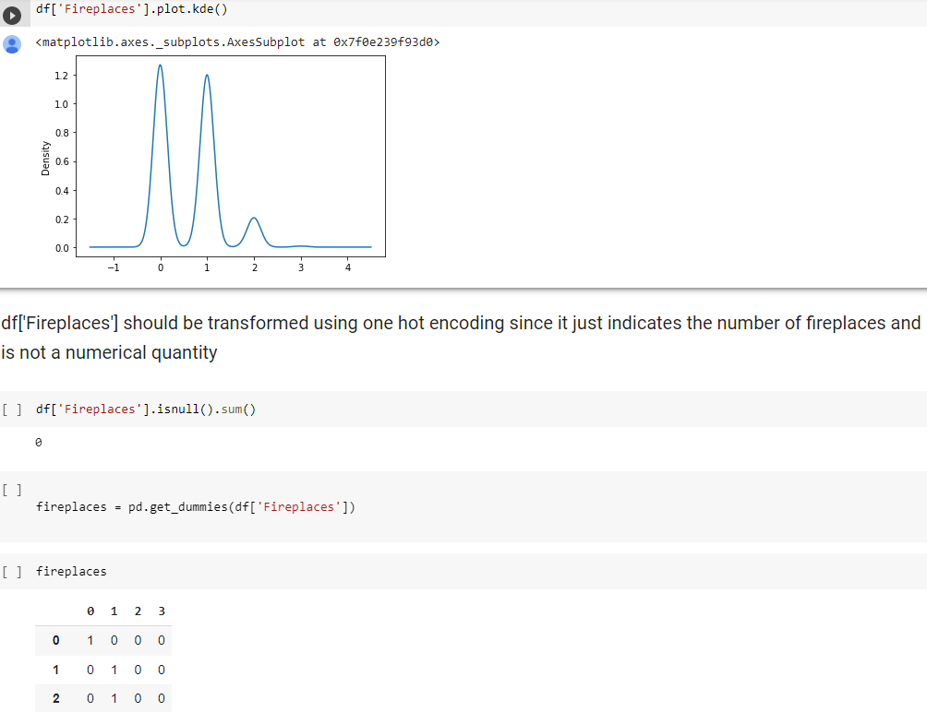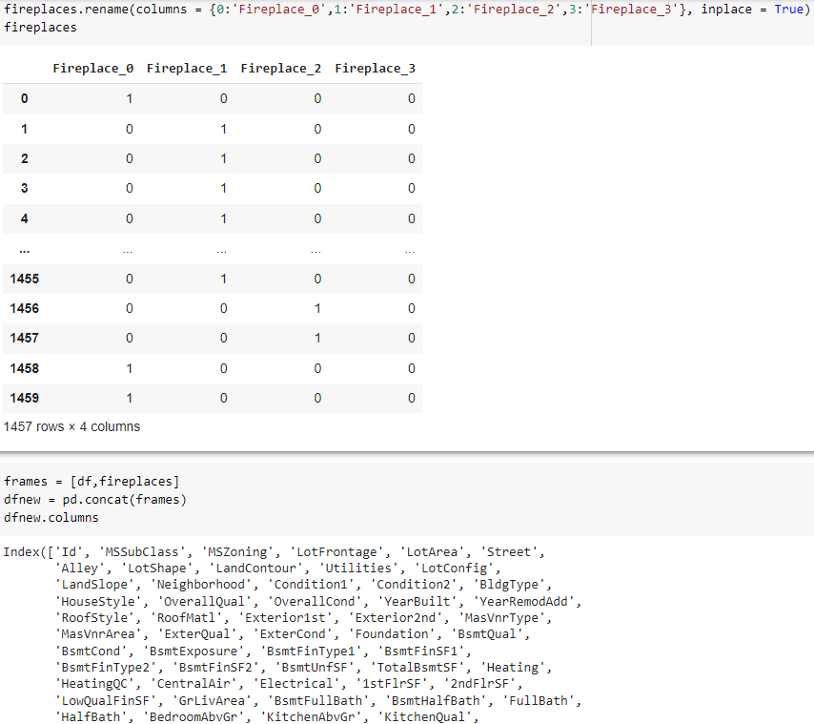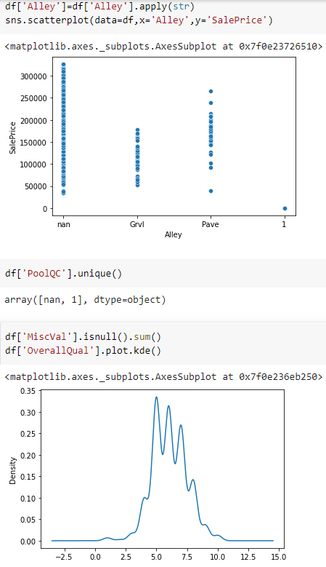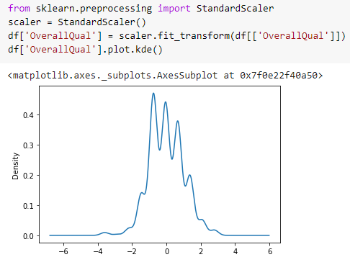

Conclusion:
We successfully learnt and implemented various pre-processing techniques on the chosen dataset.

Post lab Questions:

- Explain following text Pre-processing techniques with example:
- Tokenization
- Stemming
- Lemmatization
- Tokenization describes splitting paragraphs into sentences, or sentences into individual words. For the former Sentence Boundary Disambiguation(SBD) can be applied to create a list of individual sentences. This relies on a pre-trained, language specific algorithms like the Punkt Models from NLTK.
Sentences can be split into individual words and punctuation through a similar process. Most commonly this split across white spaces, for example:
IN:"He did not try to navigate after the first bold flight, for the reaction had taken something out of his soul."

OUT:['He', 'did', 'not', 'try', 'to', 'navigate', 'after', 'the', 'first', 'bold', 'flight', ',', 'for', 'the', 'reaction', 'had', 'taken', 'something', 'out', 'of', 'his', 'soul', '.']
- Stemming is a kind of normalization for words. It is a technique where a set of words in a sentence are converted into a sequence to shorten its lookup. The words which have the same meaning but have some variation according to the context or sentence are normalized. Stemming is hence a way to find the root word from variations of the word. There are several stemming models, including Porter and Snowball.

IN:
["It never once occurred to me that the fumbling might be a mere mistake."]OUT:
['it', 'never', 'onc', 'occur', 'to', 'me', 'that', 'the', 'fumbl', 'might', 'be', 'a', 'mere', 'mistake.'],

It is easy to see where reductions may produce a “root” word that isn’t an actual word. This doesn’t necessarily adversely affect its efficiency, but there is a danger of “overstemming” were words like “universe” and “university” are reduced to the same root of “univers”.

- Lemmatization is the algorithmic process of finding the lemma of a word depending on their meaning. Lemmatization usually refers to the morphological analysis of words, which aims to remove inflectional endings. It helps in returning the base or dictionary form of a word, which is known as the lemma.

The stemmed form of leafs is: leaf
The stemmed form of leaves is: leav
The lemmatized form of leafs is: leaf
The lemmatized form of leaves is: leaf
The difference between Stemming and Lemmatization can be understood with the example provided below.
Original Word | After Stemming | After Lemmatization
goose | goos | goose
geese | gees | goose

In the last row- goes changes to goe while stemming but for lemmatization, it has converted into go which is meaningful.

